Document control
Document | Hydris Field Glasses: Complete Product Documentation (HFG-ALL)
Version | 2.0
Status | Draft for review
Owner | Product and engineering, Hydris
Audience | Everyone building, deploying, operating, reviewing or evaluating Hydris Field Glasses
Product | Hydris Field Glasses: website, operator console, glasses app, Android app, API
Source of truth | docs/product/_combined.md in tarun-km/hydrisview (this Word file is generated from it)
Classification | Confidential: Hydris, Inc. and named partners
Revision history
Version | Date | Author | Changes
2.0 | October 2026 | Product and engineering, Hydris | Single volume combining all thirteen product documents

Contents
1 Product Documentation Suite 10
1.1 The documents 10
1.2 Where to start 11
1.3 The product on one page 12
1.4 How the Word editions are made 13
1.5 Status conventions 15
2 Product Requirements Document 16
2.1 Executive summary 16
2.2 Vision and product principles 17
2.3 Problem and market context 18
2.4 Personas 20
2.5 Jobs to be done and user journeys 22
2.6 Product surfaces and scope 23
2.7 Functional requirements 26
2.8 Non-functional requirements 63
2.9 Data and AI requirements 66
2.10 Success metrics and KPIs 69
2.11 Release plan and milestones 70
2.12 Dependencies 73
2.13 Risks and mitigations 76
2.14 Open questions 77
2.15 Glossary 77
2.16 Appendix: traceability to other documents 78
3 Architecture 80
3.1 Architectural drivers 80
3.2 System context 82
3.3 Containers 83
3.4 API: a modular monolith 85
3.5 Domain model 88
3.6 Data architecture and tenancy 89
3.7 Identity, sessions and tokens 91
3.8 Devices and pairing 93
3.9 Telemetry and alarms 97
3.10 Realtime 98
3.11 Audit document scanning 100
3.12 Voice assistant 103
3.13 Client applications 104
3.14 Deployment topologies 107
3.15 Cross-cutting concerns 111
3.16 Architecture decision records 113
3.17 Quality attributes 115
3.18 Scalability path 116
3.19 Technical debt register 117
3.20 Future architecture 119
4 Data Model 121
4.1 Data principles 121
4.2 Domain overview 122
4.3 Entity relationship model 124
4.4 Data dictionary 133
4.5 Enumerations 158
4.6 JSON column schemas 160
4.7 State models 163
4.8 Tenancy and row-level security 168
4.9 Module access patterns 171
4.10 Indexing and query patterns 172
4.11 Data quality rules 173
4.12 Data lifecycle and retention 175
4.13 Volumes and growth 177
4.14 Binary and image storage 178
4.15 Migrations 179
4.16 Seed and demo data 180
4.17 Privacy classification 181
4.18 Mobile and client-side data 183
4.19 Analytics and event model 184
4.20 Future schema changes 185
4.21 Open questions and unverified facts 186
5 API Reference 187
5.1 How to read this reference 187
5.2 Overview and conventions 189
5.3 Authentication and sessions 192
5.4 Authorization 198
5.5 Errors 202
5.6 Rate limiting 207
5.7 Idempotency and concurrency 208
5.8 Realtime events 208
5.9 Health 211
5.10 Authentication module 212
5.11 Organization module 215
5.12 Plant hierarchy and records module 218
5.13 Telemetry module 224
5.14 Alarms module 228
5.15 Inspections module 232
5.16 Maintenance module 236
5.17 Devices and pairing module 239
5.18 Realtime module 242
5.19 Insights module 242
5.20 Voice assistant module 243
5.21 Audit documents module 243
5.22 Glasses UI profiles module 246
5.23 Simulation module 247
5.24 Public website module 248
5.25 Background jobs and cron 248
5.26 Client libraries 248
5.27 Change history and deprecation policy 249
5.28 Planned API 249
6 Mobile App Specification 251
6.1 Product summary and goals 251
6.2 Relationship to the Meta AI app 253
6.3 Architecture 254
6.4 Navigation 258
6.5 Screen specifications 260
6.6 Data layer and networking 278
6.7 Audit scan pipeline 283
6.8 Voice 288
6.9 Notifications 289
6.10 Permissions 290
6.11 Design system 291
6.12 Accessibility 292
6.13 Performance budgets 293
6.14 Offline behaviour and sync 294
6.15 Security 294
6.16 Build and release 295
6.17 Testing 298
6.18 Feature status and roadmap 299
7 Glasses Integration 301
7.1 Scope and status 301
7.2 Hardware and capabilities 302
7.3 Runtimes and architecture 304
7.4 The Meta AI app dependency 306
7.5 DAT lifecycle 306
7.6 Web bridge contract 314
7.7 Glasses web viewport 317
7.8 Pairing with the Hydris account 320
7.9 Setup guide 321
7.10 Troubleshooting 322
7.11 Limitations and known gaps 323
7.12 Glasses state model and console view 323
7.13 Data flows and network use 324
7.14 Hardware acceptance tests 325
7.15 Frequently asked questions 326
7.16 Privacy 326
7.17 Roadmap 327
8 Design System and UX Guidelines 328
8.1 Design principles 328
8.2 Design system architecture 330
8.3 Brand and colour system 331
8.4 Typography 337
8.5 Spacing, radius and elevation 339
8.6 Iconography 341
8.7 Component library 341
8.8 Data visualisation guidelines 351
8.9 Layout grids 351
8.10 Navigation patterns 357
8.11 Interaction patterns 361
8.12 Motion 373
8.13 Accessibility 374
8.14 Content and voice guidelines 375
8.15 Localisation 376
8.16 Dark and light themes 376
8.17 Design QA checklist 377
8.18 Governance and contribution 378
8.19 Future work 380
9 Deployment and Infrastructure 382
9.1 Deployment at a glance 382
9.2 Where Hydris runs today 383
9.3 Target topologies 386
9.4 Environment matrix 394
9.5 Configuration reference 395
9.6 Build and release pipeline 397
9.7 Proposed CI/CD with GitHub Actions 398
9.8 Database migrations and rollback 401
9.9 Background jobs and scheduling 404
9.10 Android app distribution 405
9.11 Observability 408
9.12 Backup and disaster recovery 410
9.13 Scaling and capacity 412
9.14 Cost model 413
9.15 India data residency and regulatory hosting 414
9.16 Customer onboarding and provisioning 416
9.17 Go-live checklist 417
9.18 Known gaps and decisions 418
10 Security and Privacy 420
10.1 Security principles 420
10.2 System overview and trust boundaries 421
10.3 Data classification 422
10.4 Threat model 422
10.5 Authentication and sessions 425
10.6 Device and glasses security 427
10.7 Authorization 430
10.8 API security 432
10.9 Secrets management 433
10.10 Mobile security 435
10.11 AI safety 435
10.12 Camera and bystander privacy 438
10.13 Worker privacy and monitoring ethics 439
10.14 Compliance mapping 439
10.15 Retention schedule 440
10.16 Audit logging 440
10.17 Vulnerability management 441
10.18 Incident response 442
10.19 Security roadmap 443
10.20 Known gaps register 443
11 QA and Test Plan 445
11.1 Purpose, scope and principles 445
11.2 Quality strategy and test pyramid 446
11.3 Current automated coverage 448
11.4 Test environments and data 455
11.5 Manual test charters by surface 457
11.6 Hardware and device matrix 459
11.7 Acceptance criteria by feature 460
11.8 Non-functional testing 474
11.9 Defect management 477
11.10 Release quality gates and pilot exit criteria 479
11.11 Traceability from requirements to tests 481
11.12 Proposed CI test pipeline 483
11.13 Quality metrics dashboard 485
11.14 Risk-based testing 486
11.15 Schedule, roles and open questions 488
12 Operations and Support Runbook 489
12.1 Operating model 489
12.2 Customer onboarding 492
12.3 Routine operations 498
12.4 Glasses fleet management 500
12.5 Android app distribution and updates 505
12.6 Audit document operations 506
12.7 Alarm operations and escalation 509
12.8 Support procedures and troubleshooting 511
12.9 Incident management 524
12.10 Monitoring and health checks 526
12.11 Data requests 527
12.12 Demo environment management 528
12.13 Release and change management 530
12.14 Training curriculum 531
12.15 Operations KPIs 532
12.16 Support contact and escalation templates 532
12.17 Appendices 533
13 Product Roadmap and Future Features 535
13.1 How to read this roadmap 535
13.2 Where the product is today 536
13.3 Vision and horizons 537
13.4 Timeline Q4 2026 to Q4 2027 539
13.5 Themes and epics 540
13.6 Future features in depth 542
13.7 Prioritisation 552
13.8 Known gaps and tech debt to close 553
13.9 Dependencies and risks 555
13.10 Success metrics per horizon 556
13.11 Release cadence 557
13.12 Open questions 557

This volume combines the full Hydris Field Glasses documentation suite. Each part is one document; its chapters keep their original order.

1 Product Documentation Suite
NOTE
HFG-IDX v2.0 · Draft for review · Owner: Product, Hydris. The index to every Hydris Field Glasses product document, who each one is for, and how they fit together

Hydris Field Glasses puts live plant telemetry, guided inspections, approved procedures, audit-record scanning and a grounded voice assistant in the field of view of wastewater and effluent treatment operators. One account powers four surfaces: the website, the operator console, the glasses app and the native Android app, all backed by one API.
This suite is the reference for building, deploying, operating and evolving that product. Every document has a Markdown source in this folder (the source of truth, reviewed like code) and a branded Word edition in word/ with a cover, document control, a contents page, numbered chapters, diagrams and captioned tables.

1.1 The documents
Table 1. The Hydris Field Glasses documentation suite
# | Document | ID | Answers | Primary readers
00 | Documentation Index | HFG-IDX | What exists and where to start | Everyone
01 | Product Requirements | HFG-PRD | What we build, for whom, why, and how we measure success | Product, leadership, engineering, pilots
02 | Architecture | HFG-ARC | How the system is structured and why | Engineering
03 | Data Model | HFG-DAT | Every table, field, state and tenancy rule | Engineering, data, security
04 | API Reference | HFG-API | Every endpoint, payload, error and event | Engineering, integrators
05 | Mobile App Specification | HFG-MOB | The native Android app, screen by screen | Mobile engineering, design, QA
06 | Glasses Integration | HFG-GLS | How Ray-Ban Meta and display glasses connect | Engineering, field support
07 | Design System and UX | HFG-DSN | Tokens, components and hands-free interaction rules | Design, front-end, mobile
08 | Deployment and Infrastructure | HFG-DEP | Where Hydris runs and how it ships | Platform engineering
09 | Security and Privacy | HFG-SEC | Threats, controls, privacy and compliance mapping | Security, legal, customers
10 | QA and Test Plan | HFG-QA | How quality is proven, release by release | QA, engineering
11 | Operations Runbook | HFG-OPS | Onboarding, support, troubleshooting, incidents | Customer success, support
12 | Roadmap and Future Features | HFG-RMP | Where the product goes next, and in what order | Leadership, product, partners

Figure 1. How the documents relate: requirements flow into design and build documents, which flow into run and prove documents

1.2 Where to start
Table 2. Suggested reading paths by role
If you are | Read first | Then
New to Hydris | 01 Product requirements (executive summary and personas) | 02 Architecture (system context), 12 Roadmap
Back-end engineer | 02 Architecture, 03 Data model | 04 API reference, 09 Security, 10 QA
Android engineer | 05 Mobile app spec, 06 Glasses integration | 07 Design system, 04 API reference
Web or console engineer | 07 Design system, 04 API reference | 02 Architecture, 10 QA
Designer | 07 Design system, 01 Product requirements (journeys) | 05 Mobile app spec
Platform or DevOps | 08 Deployment, 09 Security | 11 Operations runbook
Customer success or support | 11 Operations runbook | 06 Glasses integration, 01 Product requirements
Customer security reviewer | 09 Security and privacy | 03 Data model, 08 Deployment
Leadership or investor | 01 Product requirements, 12 Roadmap | 08 Deployment (cost model)

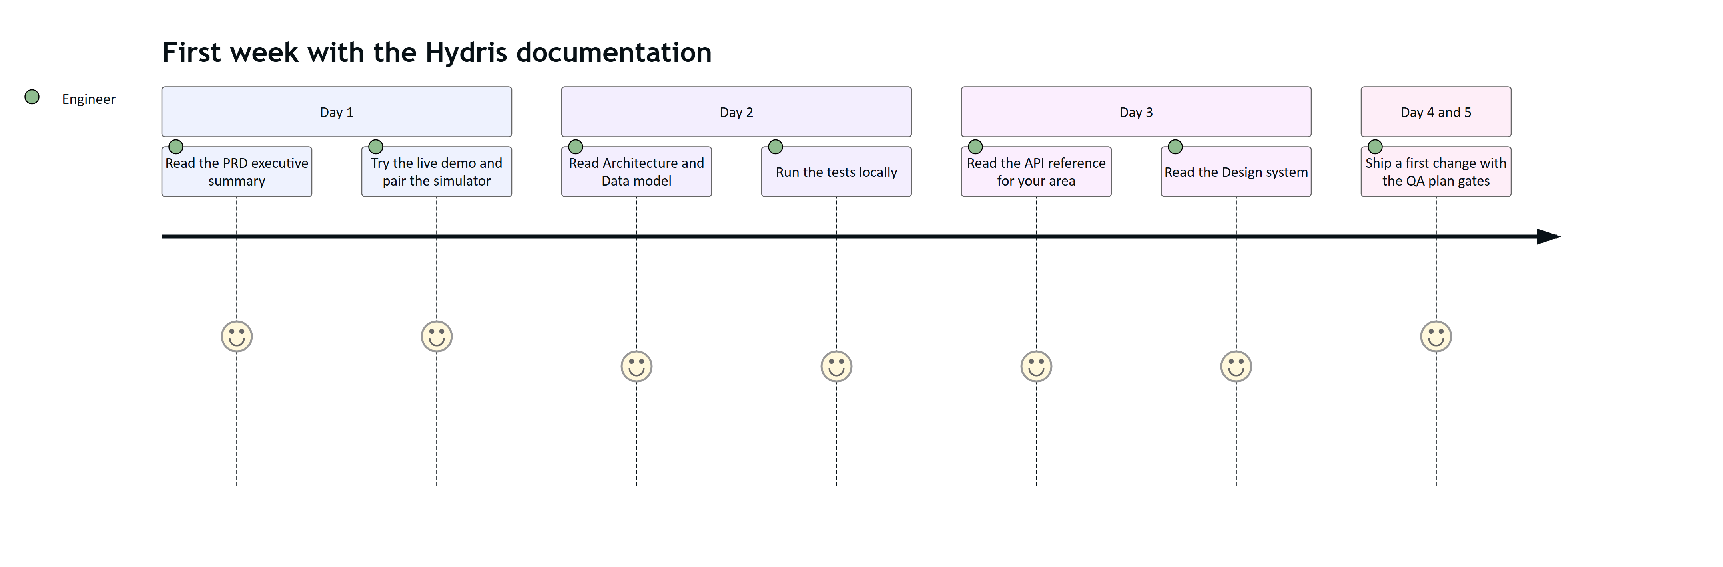
Figure 2. Reading journey for a new engineer joining the Hydris team

1.3 The product on one page
4  product surfaces  website, console, glasses app, Android app |  | 1  account everywhere  the same data on every surface |  | 2  people per audit record  field review, then a different approver |  | 12  documents  in this suite

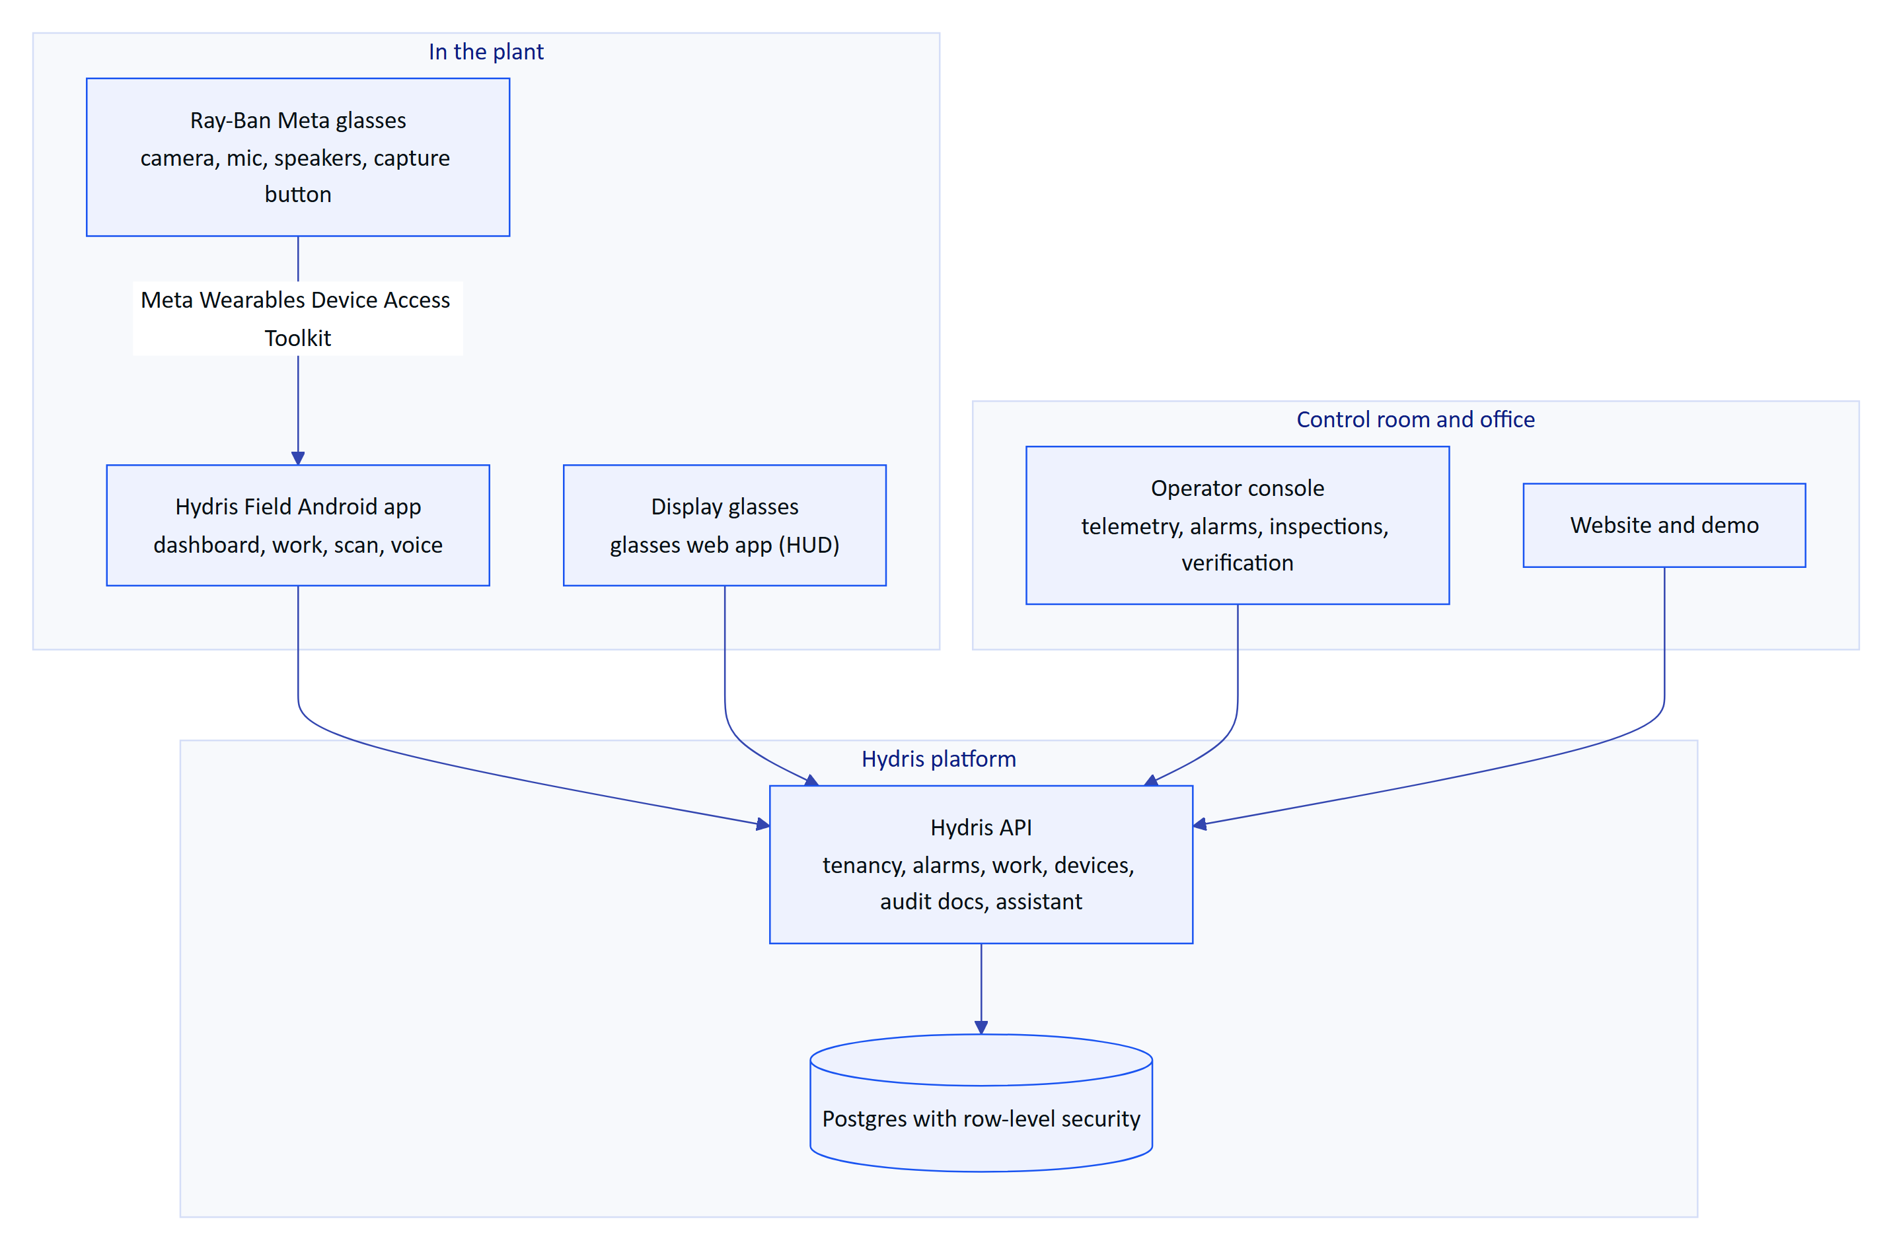
Figure 3. Hydris Field Glasses at a glance
The core loops the product supports:
- See and act on the plant: live readings and alarms reach the operator on the glasses or phone, with acknowledgement and investigation from the field.
- Do the work right: inspections and maintenance rounds with checklists and approved SOPs, hands-free.
- Turn paper into verified records: scan a paper audit sheet with the glasses or phone camera; values are read twice on the device, checked for plausibility, confirmed by a reviewer against the paper and approved by a second person before a searchable PDF is produced.
- Ask the plant: "Hey Hydris, what is the current pH?" is answered from the account's own data, never invented.

1.4 How the Word editions are made
The Word files are generated, so they never drift from the Markdown. Edit the Markdown, then rebuild.
cd docs/product/tools
npm install
node check.js # every diagram renders, front matter and house style
node build.js # Markdown and Mermaid to branded Word files in ../word
powershell -File finalize.ps1 # Windows with Word: fill contents pages, export PDFs to ../word/pdf
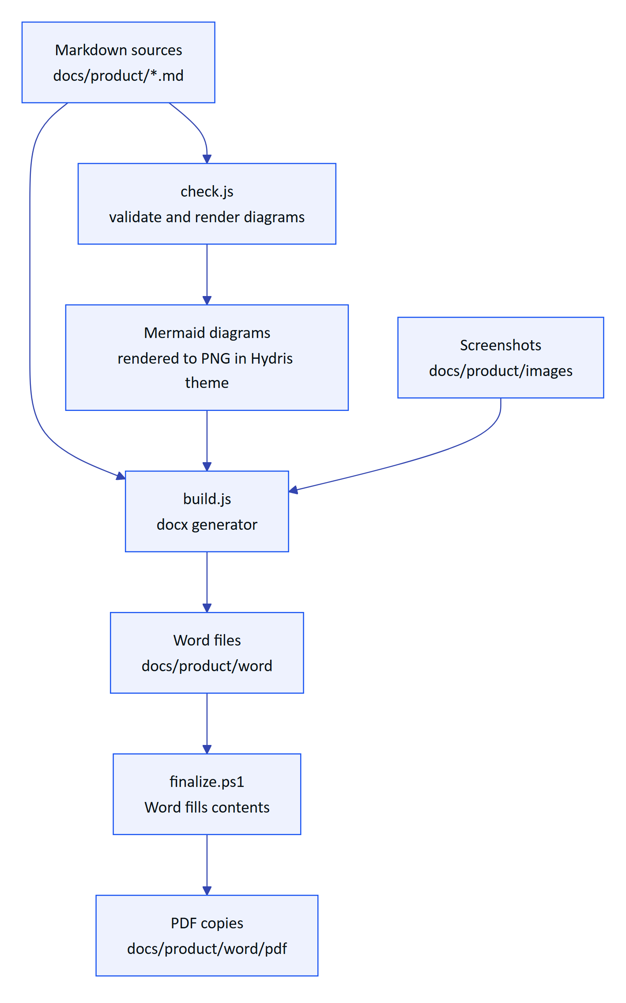
Figure 4. Documentation build pipeline
NOTE
Authoring conventions (captions, callouts, KPI tiles, diagram types, house style) are in tools/AUTHORING.md. Screenshots of the web surfaces can be refreshed from the live site with node screenshots.js.

1.5 Status conventions
Every document uses the same status words so readers can tell what exists today from what is planned.
Table 3. Status vocabulary used across the suite
Status | Meaning
Built | In the code on main and exercised by tests or the live demo
Partial | Exists but incomplete, or only on some surfaces
Planned | Agreed direction, not yet built
Target | A goal value, not a measurement
Estimate | A modelled value, labelled with its assumptions

IMPORTANT
Ray-Ban Meta support depends on Meta's Wearables Device Access Toolkit and the Meta AI app, which stays installed on the phone for pairing, permissions and firmware. Hydris replaces the Meta AI app for daily work, not for those functions. See 06 Glasses integration.

2 Product Requirements Document
NOTE
HFG-PRD v2.0 · Draft for review · Owner: Product, Hydris. What Hydris Field Glasses must do for wastewater operators, why, how we will know it works, and what ships when

This document is the single statement of what Hydris Field Glasses is for and what it must do. It is written for the people who build the product, the people who sell and deploy it, and the plant teams who will use it. Every statement about the current product was checked against the repository on main at commit 07cca23 (22 October 2026). Where the code and an earlier document disagree, the code wins and this document says so.
Each requirement carries a stable ID, a MoSCoW priority, a status and an acceptance criterion. Status labels mean exactly this:
- Built: implemented on main and exercised by the product today (in the live demo or in automated tests).
- Partial: implemented in part, or implemented in code but not yet validated where it matters (for example on physical Ray-Ban Meta glasses).
- Planned: not in the repository. It is a commitment to build, with a target phase in the release plan.
Targets (latency, accuracy, adoption) are labelled as targets. None of them is a measured result unless the text names the measurement.

2.1 Executive summary
Wastewater plant operators spend their shift walking the plant: reading instruments, checking pumps and blowers, sampling effluent, writing values on paper logs, and responding to alarms that usually reach a control room before they reach the person standing next to the equipment. The records they produce are the evidence a plant shows to its regulator, and much of that evidence still lives on paper.
Hydris Field Glasses puts the live state of the plant, the next task and the approved procedure in the operator's line of sight, hands free, and turns every reading, check and paper record they touch into a trustworthy digital record. It does this through five connected surfaces that share one API, one tenant model and one permission matrix:
- A public website with a live, synthetic glasses demo.
- An operator console for supervisors, managers and administrators.
- A glasses heads-up app (web) that runs on smart-glasses runtimes, in a phone layout, and inside a browser simulator.
- A native Android app, Hydris Field, which connects Ray-Ban Meta glasses through Meta's Wearables Device Access Toolkit (DAT 1.0.1).
- A multi-tenant API with row-level security, realtime events and an append-only audit trail.
67  automated tests passing  26 domain + 41 API, run locally on 22 Oct 2026 |  | 5  product surfaces  website, console, glasses app, Android app, API |  | 143  API routes  across 15 modules in apps/api/src/modules |  | 12  glasses screens  UI_SCREENS in packages/domain/src/uiprofile.ts

6  roles  38 permissions in packages/domain/src/roles.ts |  | 16  measurands  pH to residual chlorine, with unit normalization |  | 42  database tables  23 enums, RLS on every tenant table |  | 10  demo scenarios  deterministic, demo tenants only

The platform core is built and running at https://hydrisview.vercel.app in demo mode (named guest accounts on synthetic plant data). The main gaps before a customer pilot are: validation of the glasses paths on physical Ray-Ban Meta hardware, email delivery for invitations and password resets, continuous integration, a scheduled-job cadence that suits real data on serverless hosting, and an offline outbox in the Android app. The release plan (chapter "Release plan and milestones") sequences these into a hardening phase, a pilot at one or two Indian plants in Q1 2027, and general availability in Q2 2027.
DECISION
Hydris is read-only towards the plant. It never writes to PLCs, SCADA or equipment. The grounded assistance endpoint says so in every response ("Hydris does not control equipment", apps/api/src/modules/insights.ts), and the voice assistant's tools are all read-only (apps/api/src/modules/voice-assistant.ts). This keeps Hydris outside the plant's control-system safety case and is a precondition for every requirement in this document.

IMPORTANT
Ray-Ban Meta glasses reach third-party apps only through Meta's DAT, and the glasses are paired, registered and permissioned through the Meta AI app. Hydris cannot replace the Meta AI app; it must stay installed on every operator phone. The Android app checks for it (GlassesManager.metaAiInstalled(), package com.facebook.stella) and sends the user there to connect.

2.2 Vision and product principles

2.2.1 Vision
Every operator in a water or wastewater plant sees what matters, does the next right thing, and leaves behind a record that stands up to an audit, without putting down their tools.
In three years we want Hydris to be the default way an Indian ETP, STP or CETP runs its rounds, responds to alarms and keeps its compliance records, and a credible choice for plants in other markets with similar discharge-monitoring obligations.

2.2.2 Product principles
These principles settle design arguments. When two requirements conflict, the principle higher in this list wins.
Table 4. Product principles and how the code already applies them
# | Principle | What it means in practice | Where the code applies it
P1 | Safety first, read-only towards the plant | Never issue a control command. Point to the approved procedure and the supervisor for safety-critical actions | /assist safety notice; assistant system prompt in voice-assistant.ts
P2 | Never show a guess as a value | Missing data is "no data", never zero. Stale values are marked and excluded from health roll-ups | freshness() in packages/domain/src/freshness.ts
P3 | Every number has provenance | A reading says where it came from (instrument, manual, lab, simulator) and when | TELEMETRY_SOURCES, DB check telemetry_synthetic_source_ck
P4 | History is never overwritten | Corrections append; the original stays visible | Telemetry corrections, audit document extracted values, audit_events
P5 | Humans verify, machines assist | AI and OCR propose; a person confirms; a different person approves | Audit document four-eyes rule in audit-docs.ts
P6 | Glance, then act | A screen on the glasses answers one question. Voice answers are one or two sentences | HUD screens; assistant SYSTEM prompt
P7 | Hands busy, still in control | Every operator action works with directional input or voice; the camera only runs on explicit intent | useHudInput in apps/web/src/glasses/input.ts; scan screens
P8 | Tenant isolation is enforced by the database, not by convention | RLS on every tenant table; every request runs as hydris_app with app.org_id | drizzle/0001_rls.sql, db/tenant.ts
P9 | Synthetic data can never reach a customer tenant | Simulator readings are refused for non-demo organizations | ingest() in modules/telemetry.ts
P10 | One account everywhere | The same user, permissions and data on console, glasses and phone | Shared API; Android HydrisApi.kt uses the web session contract

2.2.3 What Hydris is not
- Not a SCADA, DCS or historian. It reads from them (Planned connectors) and never replaces them.
- Not a general-purpose chatbot. The assistant answers only from the tenant's own data and approved documents.
- Not a laboratory information management system. It records lab results as telemetry with source = lab and will integrate with a LIMS later (Planned).
- Not a consumer glasses app. It is an enterprise tool distributed to managed devices.

2.3 Problem and market context

2.3.1 The operator's day today
Effluent treatment plants (ETPs), sewage treatment plants (STPs), water treatment plants (WTPs) and common effluent treatment plants (CETPs) run continuously, with shift operators walking fixed rounds. The facility kinds Hydris models are exactly these (FACILITY_KINDS in packages/domain/src/catalog.ts). A typical round covers intake and screening, equalization, aeration, clarification, filtration, disinfection, sludge handling and the discharge point, which are the process areas Hydris models (PROCESS_AREA_KINDS).
Four problems recur:
- Paper rounds drift from reality. Readings are written on clipboards, transcribed later, and diverge from instrument values. Nobody can tell which value was observed and which was copied.
- Alarms reach the wrong person. Alarms land in a control room or on a panel. The operator nearest the pump finds out last. Acknowledging an alarm and actually fixing the condition get conflated, so the record shows alarms "cleared" that were never resolved.
- Compliance evidence is unsearchable. Logbooks, lab sheets, calibration certificates and inspection checklists are paper. Producing evidence for an inspection means digging through files.
- Phones are the wrong tool at the asset. Gloves, ladders, wet hands and sampling bottles make phones awkward. Smart glasses free the hands, but there is no industrial software for them.

2.3.2 Regulatory context
Hydris is designed around discharge-monitoring regimes, and it states only what is well established about them:
- India. Discharges are regulated under the Water (Prevention and Control of Pollution) Act, 1974, through consents to establish and operate issued by State Pollution Control Boards (SPCBs) and Pollution Control Committees. General discharge standards are set under the Environment (Protection) Rules, 1986, with plant-specific limits in each consent. In 2014 the Central Pollution Control Board (CPCB) directed the 17 categories of highly polluting industries, and CETPs, to install online continuous effluent and emission monitoring systems (OCEMS) connected to the CPCB and SPCB servers (CPCB online monitoring).
- United States. Point-source discharges need National Pollutant Discharge Elimination System (NPDES) permits, with monitoring results reported through Discharge Monitoring Reports.
- European Union. The Urban Waste Water Treatment Directive (originally 91/271/EEC, recast in 2024) sets treatment and monitoring requirements for urban wastewater.
The common thread is that plants must monitor continuously, keep records that can be retrieved and trusted, and show who did what and when. Hydris does not certify compliance. It produces records (telemetry with provenance, inspection results, verified audit documents and an append-only audit trail) that make compliance easier to demonstrate.
NOTE
Hydris does not replace OCEMS reporting to CPCB or SPCB servers, and it is not a certified OCEMS. A plant's OCEMS analyzers can feed Hydris through the gateway ingestion API (FR-022) so operators see the same values the regulator sees.

2.3.3 Why glasses, why now
Three things changed. Consumer-grade camera glasses (Ray-Ban Meta) are light, affordable and socially acceptable on a plant floor. Meta opened a device access toolkit (DAT) that lets third-party Android and iOS apps use the glasses' camera, microphone, capture button and speakers. And large language models can now answer spoken questions from structured plant data reliably enough to be useful, provided they are grounded and constrained (chapter "Data and AI requirements").

2.3.4 Competitive landscape (qualitative)
Table 5. Alternatives a plant uses today and where Hydris differs
Alternative | Strength | Gap Hydris fills
Paper logbooks and clipboards | Familiar, no devices needed | No provenance, no search, no realtime alarms, transcription errors
SCADA/HMI in the control room | Authoritative live data and control | Not at the asset; no rounds, no paper-record digitization
Generic mobile forms apps | Cheap digital checklists | Not hands-free, no live telemetry context, no alarm lifecycle, no verified OCR
Remote-assist video apps for glasses | Expert sees what the operator sees | No plant data model, no rounds, no records
CMMS / EAM suites | Strong maintenance planning | Heavy, desktop-first, weak in the field, no glasses

2.4 Personas
Hydris has seven personas. Six map one to one onto the roles in packages/domain/src/roles.ts; the platform administrator is a flag on the user (users.is_platform_admin).
Table 6. Personas, roles and primary surfaces
Persona | Role in code | Primary surface | Top needs
Field operator (Ravi) | field_operator | Glasses, Android app | Next task, live values at the asset, acknowledge alarms, record readings, scan paper logs, ask by voice
Shift supervisor (Meena) | supervisor | Console, Android app | Dispatch rounds, triage and assign alarms, review inspections, verify scanned documents
Maintenance engineer (Arjun) | maintenance_engineer | Android app, glasses | Work orders, checklists, investigate and resolve alarms, SOPs at the asset
Plant manager (Priya) | factory_manager | Console | KPIs and reports, alarm rules, approve audit documents, devices and people
Compliance auditor (Mr Rao) | viewer (read plus report.read) | Console, PDF exports | Tamper-evident trail, approved documents, exports for the regulator
Organization admin (IT lead) | org_admin | Console | Members and invitations, sites, glasses UI profiles, all permissions
Hydris platform admin | users.is_platform_admin | Console /console/platform | Create and suspend customer organizations

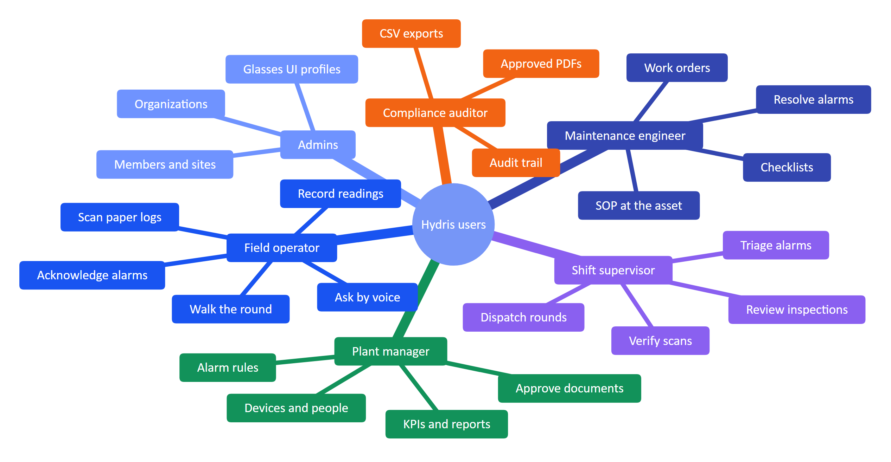
Figure 5. Personas and their jobs to be done

2.4.1 Persona detail

Field operator
Ravi is 28, a diploma holder with six years on ETP shifts. He works 8-hour rotating shifts, often alone at night. He wears gloves and safety glasses, carries a sampling bottle and a radio, and has an Android phone in his pocket. His English reading is good; he speaks Hindi and Tamil at home. He wants fewer forms, clear instructions, and to be told quickly when something near him is wrong. He fears being blamed for a reading he copied from someone else.
What success looks like for Ravi: his round is on the glasses in order, each asset shows its live values with how fresh they are, he records a reading with two taps or a sentence, and his paper log becomes a verified PDF without retyping.

Shift supervisor
Meena runs a shift of four operators across two plants. She lives in the console during the day and on her phone at night. She needs to see open alarms by severity, who has them, and which rounds are late. She verifies scanned audit documents against the paper before her manager approves them.

Maintenance engineer
Arjun moves between pumps, blowers and dosing systems. He needs the work order, the checklist and the equipment manual at the asset, and he needs to close the loop on alarms: investigate, fix, resolve with a note.

Plant manager
Priya is accountable to the SPCB for discharge compliance and to her management for uptime and cost. She configures alarm rules, approves audit documents, decides which glasses features each role sees, and reads the reports.

Compliance auditor
Mr Rao is an internal or third-party auditor. He needs read-only access to approved records, the verification trail of every scanned document, and exports. He must never be able to change anything.

Administrators
The organization admin manages members, invitations, sites and glasses UI profiles. The Hydris platform admin creates and suspends customer organizations and has no access to tenant data by default.

2.5 Jobs to be done and user journeys

2.5.1 Jobs to be done
Table 7. Jobs to be done, with the requirements that serve them
# | Job statement | Served by
J1 | When I start my round, I want my assigned inspections in order, so I do not miss an asset | FR-040, FR-041, FR-059
J2 | When I stand at an asset, I want its live readings and how fresh they are, so I can trust what I record | FR-021, FR-026, FR-095
J3 | When an alarm fires near me, I want to acknowledge it and see the recommended action and SOP, so the right person is accountable | FR-031, FR-032, FR-033, FR-112
J4 | When I fill a paper log or receive a lab sheet, I want to capture it once and have it verified, so the record is searchable and defensible | FR-060 to FR-069
J5 | When my hands are busy, I want to ask by voice and hear a short answer grounded in our data | FR-071, FR-072, FR-074
J6 | As a manager, I want to control what each role sees on the glasses without shipping an app update | FR-054
J7 | As an admin, I want to pair, reassign, suspend or revoke a pair of glasses in seconds | FR-050 to FR-053, FR-057
J8 | As an auditor, I want every approved document and every change traceable to a person and a time | FR-065, FR-066, FR-082
J9 | As a prospect, I want to try the product in minutes without talking to sales | FR-083, FR-091, FR-102

2.5.2 Journey: an operator's shift
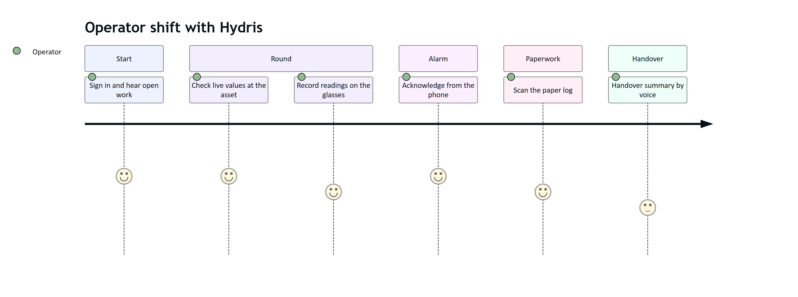
Figure 6. Field operator journey across one shift (satisfaction 1 to 5, target state)
The shift journey shows where the product is strong today (alarm acknowledgement, scanning, voice lookups) and where it is weakest: the handover summary is a Planned capability, and inspection execution on the Android app is Planned (FR-044). Inspections are executed on the glasses heads-up app today.

2.5.3 Journey: from paper record to approved evidence
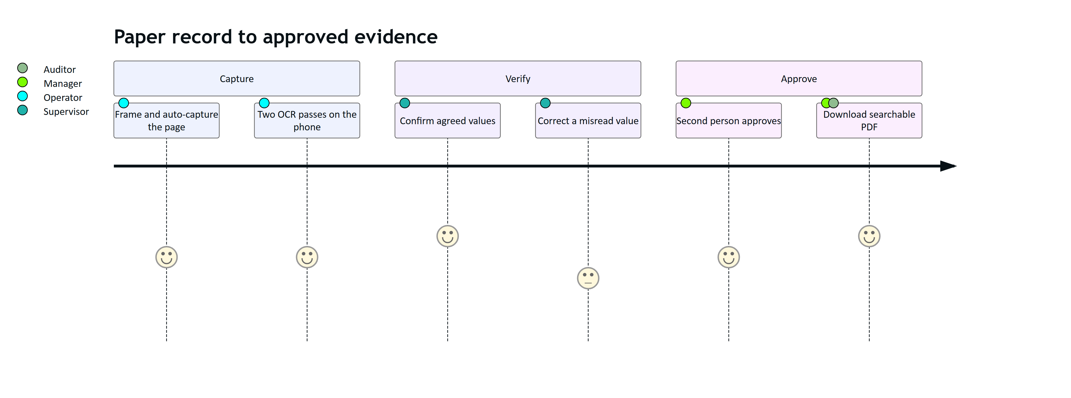
Figure 7. Supervisor and manager journey for a scanned audit document

2.5.4 Journey: evaluating Hydris
A prospect lands on the website, opens the live glasses demo (/glasses?demo=1, fully client-side synthetic data), and then signs in to the console or the Android app in demo mode with just their name (POST /auth/demo). Each guest gets an org_admin account in the demo tenant with personal copies of the demo owner's scheduled inspections and open maintenance tasks (apps/api/src/core/demo-guests.ts). Nothing they do affects other guests' work, and all data is clearly labelled synthetic.

2.6 Product surfaces and scope

2.6.1 System context
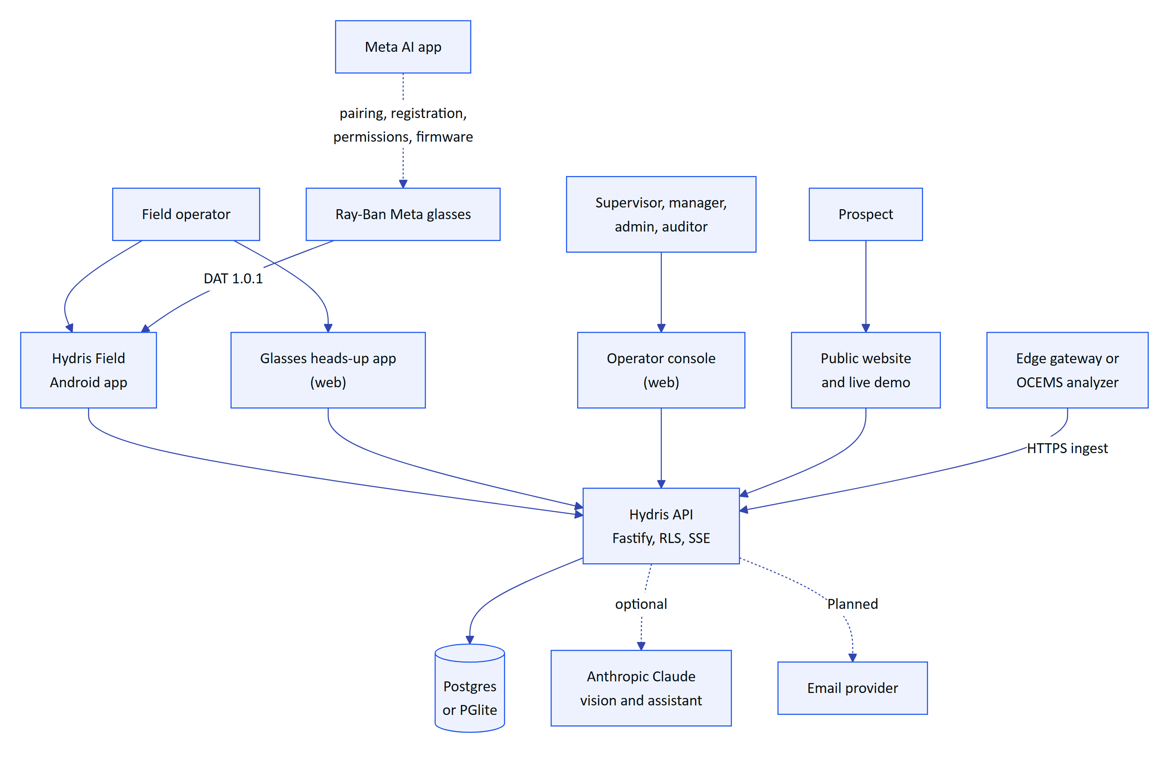
Figure 8. System context: people, Hydris surfaces and external systems

2.6.2 Surfaces
Table 8. Product surfaces, where they live and their status
Surface | Code | What it does | Status
Public website | apps/web/src/app/(site) | Seven pages (/, /product, /technology, /operations, /demo, /contact, /privacy), live glasses demo, contact and demo-request form | Built
Operator console | apps/web/src/app/console/** | Sixteen navigation sections in five groups (Operate, Work, Plant, People and devices, Insight) plus Admin, account and platform pages | Built
Glasses heads-up app | apps/web/src/app/glasses, apps/web/src/glasses/* | Twelve screens, directional input, offline inspection queue, audit scan, voice assistant, phone layout | Built (web). Native glasses display rendering Planned
Simulator and pairing | /simulator, /pair | Browser glasses simulator; approve a pairing code by QR or typed code | Built
Android app "Hydris Field" | apps/android | Sign-in, home, work, alarms, sensors, audit scan with ML Kit OCR, "Hey Hydris", glasses connection and registration through DAT | Partial: built in code, glasses paths not validated on hardware
Android WebView bridge | apps/glasses-bridge-android | Hosts the glasses web app and bridges DAT camera, speech, capture button and voice invocation | Partial: superseded by the native app for pilot
API | apps/api | 143 routes in 15 modules, RLS tenancy, SSE realtime, jobs, demo mode | Built

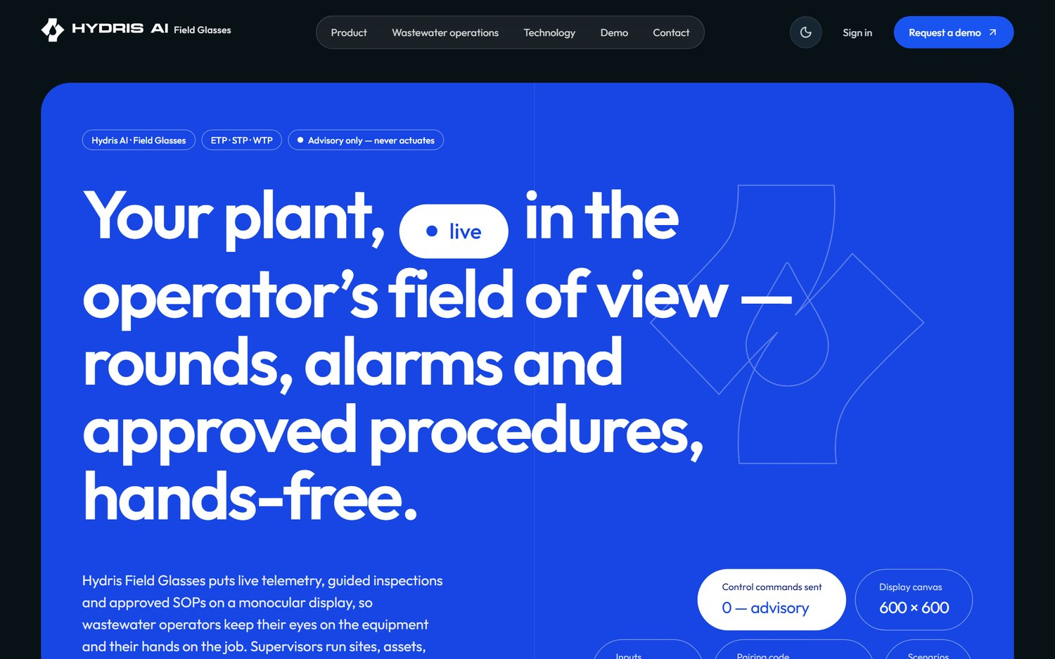
Figure 9. The public website home page
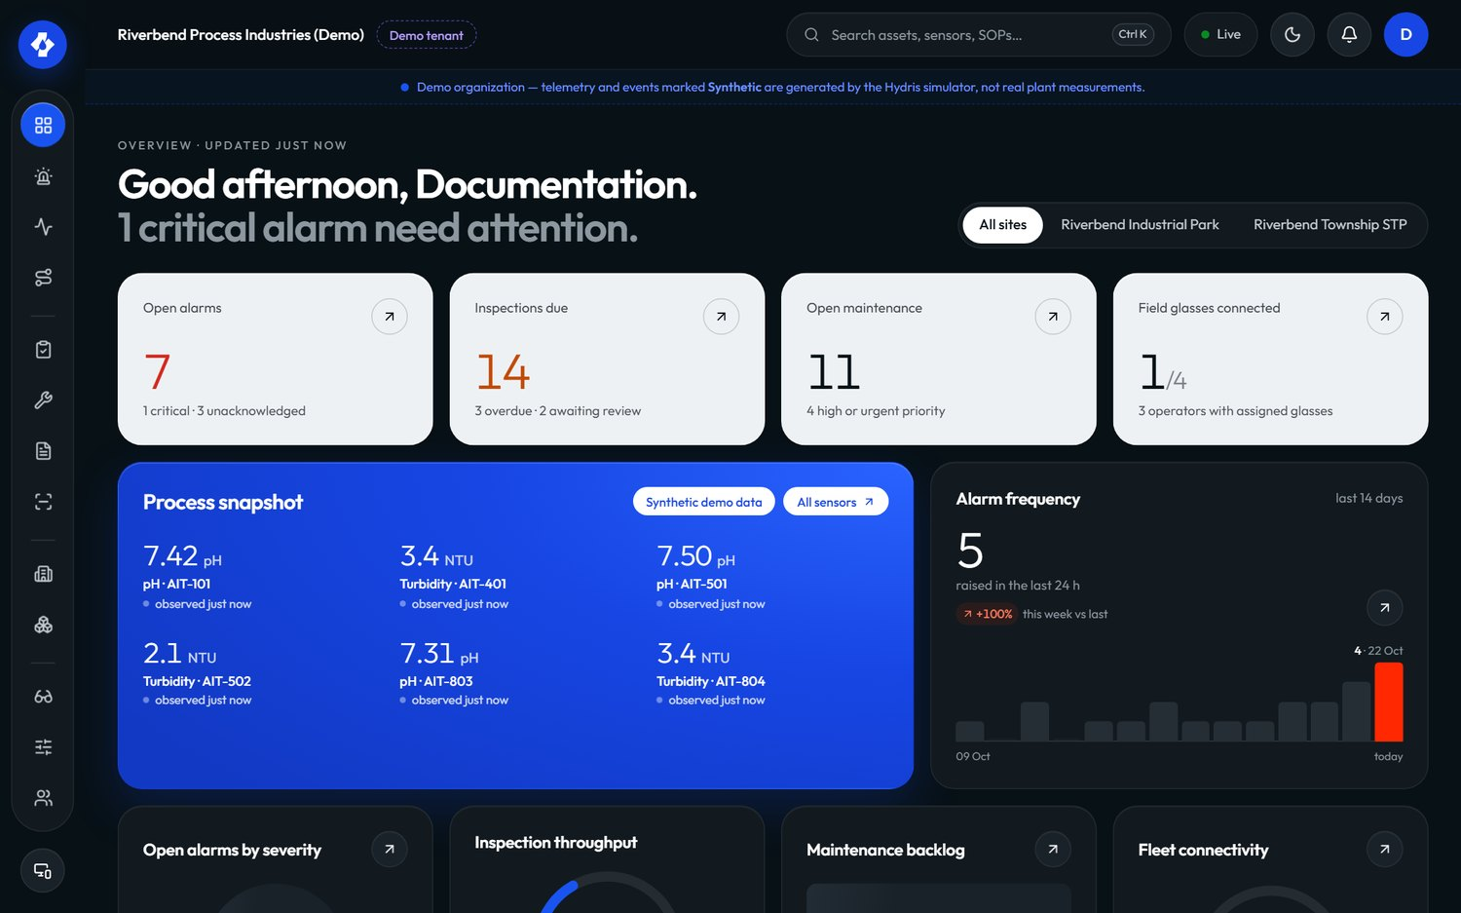
Figure 10. The operator console overview: KPIs, open alarms and live measurements

2.6.3 Feature map
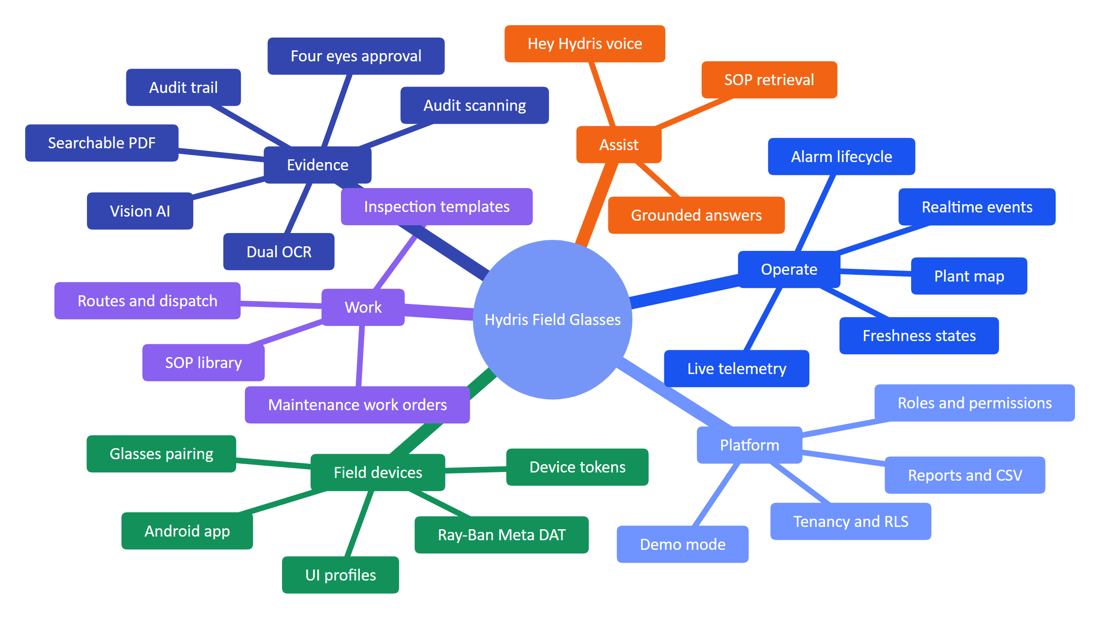
Figure 11. Feature map of the platform by capability area

2.6.4 In scope and out of scope
Table 9. Scope boundaries for the pilot and GA releases
Area | In scope | Out of scope
Plant control | Read-only display of values, alarms and procedures | Any write to PLC, SCADA or equipment; setpoint changes
Data ingestion | HTTPS gateway push, manual and lab entry; MQTT and OPC UA adapters (Planned) | Direct fieldbus integration (Modbus, Profibus) inside Hydris
Devices | Ray-Ban Meta through DAT on Android; glasses web app on other runtimes and in a phone layout | Building custom glasses hardware; iOS before GA
Compliance | Records with provenance, verification and audit trail; exports | Certified OCEMS reporting to CPCB or SPCB servers; legal e-signature certification before FR-068
AI | Grounded answers from tenant data; vision extraction with human verification | Autonomous decisions; free-form generation of procedures; answers from the open internet
Accounts | Invitations, MFA, sessions, SSO (Planned) | Self-serve signup for customer tenants (demo mode only)
Languages | English UI and voice | Hindi, Tamil, Marathi and Gujarati voice (Planned, Advanced phase)

2.7 Functional requirements

2.7.1 How to read the requirement tables
Each table lists ID, requirement, MoSCoW priority (Must, Should, Could, Won't this release), status, acceptance criterion and the surfaces involved (W website, C console, G glasses app, A Android app, P API). IDs from version 1.0 are unchanged. New IDs take the next free number inside the area's block of ten; new areas start a new block (FR-090 Android app, FR-100 website and demo, FR-110 documents and SOPs, FR-120 insights and compliance).
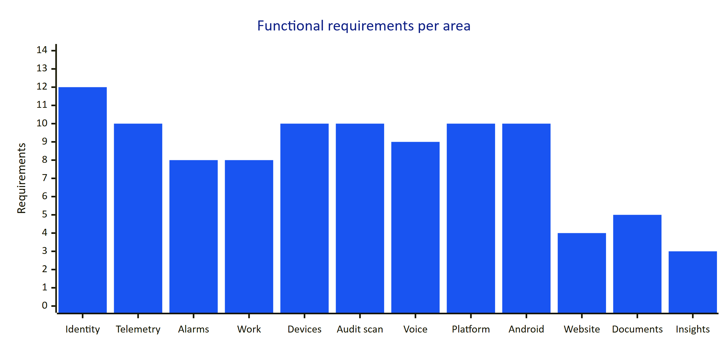
Figure 12. Requirements per functional area in this edition

2.7.2 Identity, tenancy and access
Hydris is multi-tenant from the first line of code. Every tenant table has row-level security; every request runs SET LOCAL ROLE hydris_app with the organization in app.org_id, so the database enforces isolation even if application code has a bug. Roles are a fixed matrix of six roles and 38 permissions; the API enforces it on every request and clients use it only to decide what to show.
Table 10. Identity, tenancy and access requirements
ID | Requirement | Pri | Status | Acceptance criteria | Surface
FR-001 | Email and password sign-in with lockout after 5 failed attempts for 15 minutes | M | Built | Sixth attempt within the window returns 423 account_locked; lockout clears after 15 min (TTL.lockoutMs) | C, A, P
FR-002 | TOTP MFA (setup, enable, disable, verify step) with the secret encrypted by DATA_KEY | S | Built | MFA user cannot obtain a session without a valid code; secret is never stored in clear | C, P
FR-003 | Refresh-token rotation with family revocation on reuse (30 s multi-tab grace) | M | Built | Reusing a rotated refresh token outside the grace window revokes the whole family | C, G, A, P
FR-004 | Invitations with a 7-day token and role assignment that cannot escalate above the inviter (assignableRoles) | M | Built (delivery depends on FR-086) | A factory manager cannot invite an org admin; expired tokens are refused | C, P
FR-005 | Password reset with a 30-minute single-use token | M | Partial | Token works once and expires in 30 min. Gap: the email is written to mail_outbox and not sent | C, P
FR-006 | Multi-organization membership and organization switch | S | Built | A user in two orgs switches with /auth/switch-org and sees only the new org's data | C, P
FR-007 | Site-scoped permissions for every role except org_admin | M | Built | A site-scoped supervisor cannot read alarms of another site (403/404) | All
FR-008 | Database-enforced tenant isolation (RLS) | M | Built | Cross-tenant reads return no rows even with a crafted ID (API test suite) | P
FR-009 | Session listing and revocation | S | Built | Revoking a session ends it on the next refresh | C, P
FR-010 | Platform organization management (create, suspend) | M | Built | Suspended org members cannot sign in to that org | C, P
FR-011 | Single sign-on with SAML 2.0 and OIDC per organization | S | Planned (GA) | An org admin configures an IdP; users sign in with it; local passwords can be disabled | C, A, P
FR-012 | Fixed role matrix: six roles, 38 permissions, no escalation path | M | Built | can(role, permission) is the only check; unit tests cover the matrix | All

NOTE
The Android app does not yet complete an MFA challenge. If an account has MFA enabled, the app tells the user to sign in on the web console first (LoginScreen.kt). That gap is tracked as FR-099.

2.7.3 Plant model and telemetry
The plant model is a hierarchy: site, facility (ETP, STP, WTP, CETP, other), process area (13 kinds), asset (14 types), and sensors on assets. Sensors measure one of 16 measurands with defined units and decimals (MEASURAND_DEFS). Readings carry a source (gateway, manual, lab, simulator) and a quality. Freshness is derived from the sensor's expected interval: live within 2 times the interval, delayed within 5 times, stale beyond, and no_data when nothing was ever received.
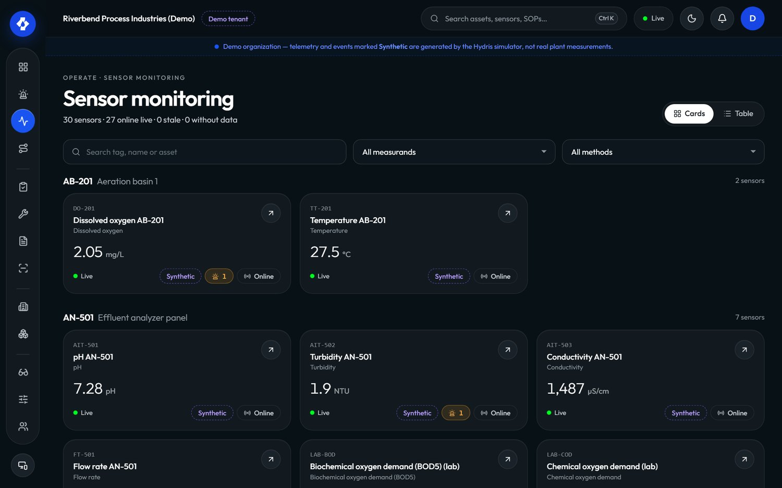
Figure 13. Sensor monitoring in the console: live values with freshness and provenance
Table 11. Plant model and telemetry requirements
ID | Requirement | Pri | Status | Acceptance criteria | Surface
FR-020 | Site, facility, process area and asset hierarchy with map positions, archive and restore | M | Built | Archived assets disappear from glasses and assistant answers and can be restored | C, G, P
FR-021 | Sensors for 16 measurands with unit normalization | M | Built | A reading in a compatible unit is stored in the canonical unit | C, P
FR-022 | HTTPS gateway ingestion POST /ingest/v1/readings with an hgw_ API key, up to 500 readings per call, idempotent on sensor and timestamp | M | Built | Replaying the same batch creates no duplicates; a revoked key gets 401 | P
FR-023 | Manual and lab entry with provenance | M | Built | Entries show source "Manual" or "Lab" everywhere they appear | C, P
FR-024 | Append-only telemetry corrections (correct or invalidate) | M | Built | The original reading stays visible with its correction and author | C, P
FR-025 | History, raw readings and CSV export per sensor | S | Built | CSV export opens in a spreadsheet without formula injection (leading =+-@ escaped) | C, A, P
FR-026 | Freshness states live, delayed, stale, no data; missing data never shown as a value | M | Built | A sensor with no readings shows "No data", never 0 | All
FR-027 | MQTT and OPC UA ingestion adapters | S | Planned (Advanced) | A gateway publishing over MQTT or OPC UA lands readings with the same guarantees as FR-022 | P
FR-028 | Read-only SCADA and historian connectors | C | Planned (Advanced) | Values from a historian appear with source and timestamp; no write path exists | P
FR-029 | Synthetic data is labelled everywhere and refused for non-demo tenants | M | Built | Simulator readings into a customer org are rejected with synthetic_not_allowed; DB check ties synthetic to source = simulator | All

2.7.4 Alarms
Alarms come from threshold rules (high-high, high, low, low-low) with a deadband (hysteresis) and an on-delay, or from a stale-data rule. An alarm has a severity (critical, high, medium, low) and moves through a five-state lifecycle. Acknowledging records that a person has seen it; it does not change the process. Resolving records that the condition was dealt with and requires a note. Closing archives the event after review.
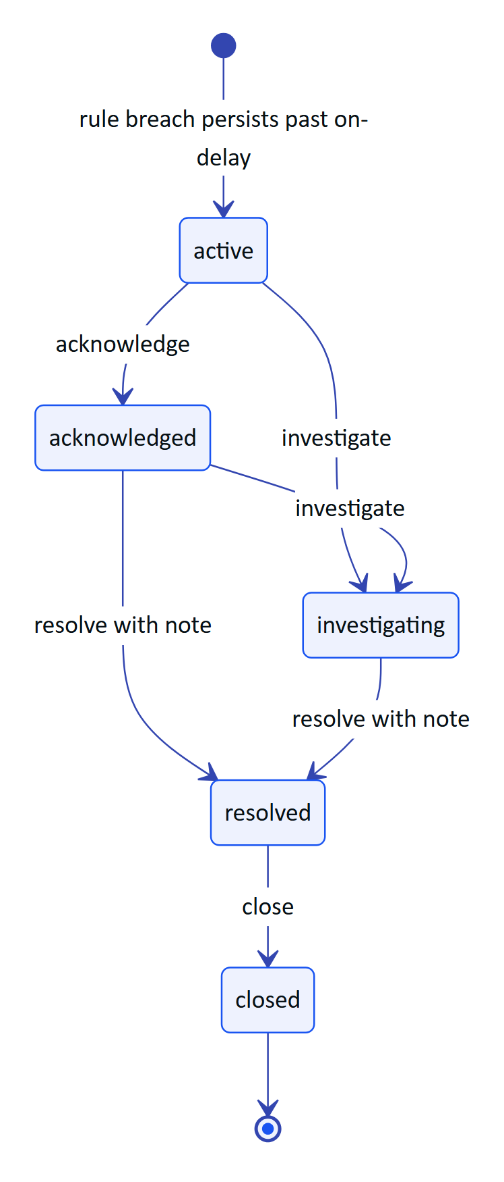
Figure 14. Alarm lifecycle (packages/domain/src/alarms.ts)
Table 12. Alarm transitions, permissions and who holds them
Action | From | To | Permission | Note required | Held by
Acknowledge | active | acknowledged | alarm.acknowledge | No | All roles except viewer
Investigate | active, acknowledged | investigating | alarm.investigate | No | Admin, manager, supervisor, maintenance engineer
Resolve | acknowledged, investigating | resolved | alarm.resolve | Yes | Admin, manager, supervisor, maintenance engineer
Close | resolved | closed | alarm.close | No | Admin, manager, supervisor

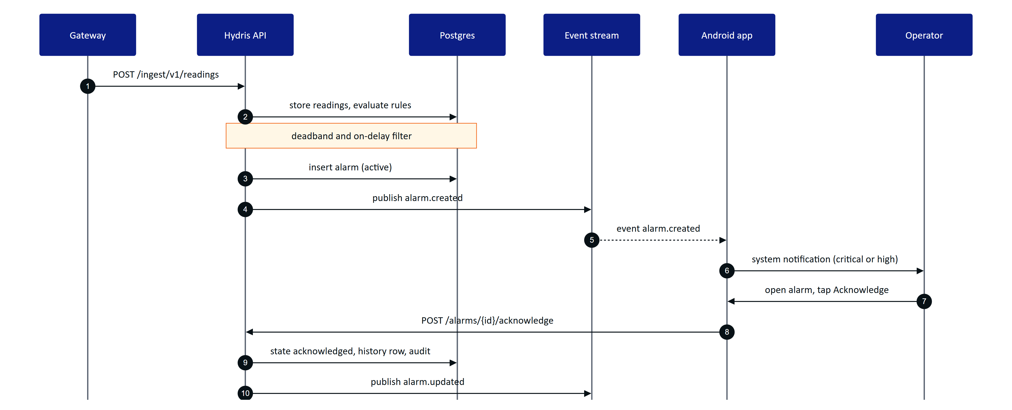
Figure 15. From a sensor reading to an acknowledged alarm on the operator's phone
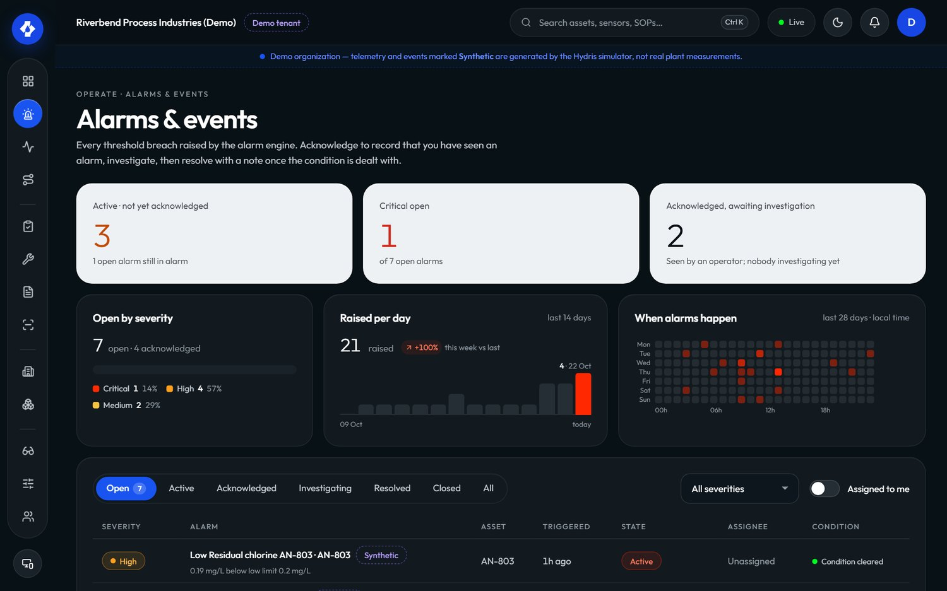
Figure 16. Alarms and events in the console
Table 13. Alarm requirements
ID | Requirement | Pri | Status | Acceptance criteria | Surface
FR-030 | Threshold rules (high-high, high, low, low-low, stale) with deadband and on-delay | M | Built | A value oscillating inside the deadband does not raise or clear repeatedly; a breach shorter than the on-delay raises nothing | C, P
FR-031 | Lifecycle active, acknowledged, investigating, resolved, closed; no resolve from active; resolution note required | M | Built | POST /alarms/{id}/resolve without a note returns 400 note_required | C, G, A, P
FR-032 | Assignment, notes, history, recommended action and linked SOP | M | Built | Alarm detail shows history with actors, the rule's procedure and follow-up tasks | C, A, P
FR-033 | Realtime push of alarm events to console, glasses and Android | M | Built | A new alarm appears without reload within the NFR-002 target | C, G, A, P
FR-034 | Push notifications through Firebase Cloud Messaging when the app is not running | S | Planned (GA) | A critical alarm reaches a phone whose app process is stopped | A, P
FR-035 | Stale-data alarms evaluated on a schedule | M | Partial | Long-running server evaluates every 30 s (startJobs). Gap: on Vercel the cron runs once a day (vercel.json, 0 3 * * *) | P
FR-037 | Escalation when an alarm stays unacknowledged (notify supervisor after a configurable time) | S | Planned (Pilot) | An unacknowledged critical alarm notifies the site supervisor after N minutes; the escalation is in the alarm history | C, A, P
FR-038 | Alarm shelving with reason and expiry | C | Planned (GA) | A shelved alarm is hidden from the operator's active list until expiry; shelving is audited | C, P

NOTE
FR-036 from the draft of this edition (Android alarm notifications) was folded into FR-097 to keep Android requirements in one block. The ID is retired and will not be reused.

2.7.5 Inspections and maintenance
Inspection templates are versioned and made of steps of five kinds: check, reading (with expected range), choice (with abnormal options), text and photo. Routes group templates in order and are dispatched to operators. An inspection moves through scheduled, in progress, paused, submitted, then approved or returned (rejected), or cancelled. A reading outside its expected range, a failed check or an abnormal choice marks the step abnormal automatically (stepOutcome).
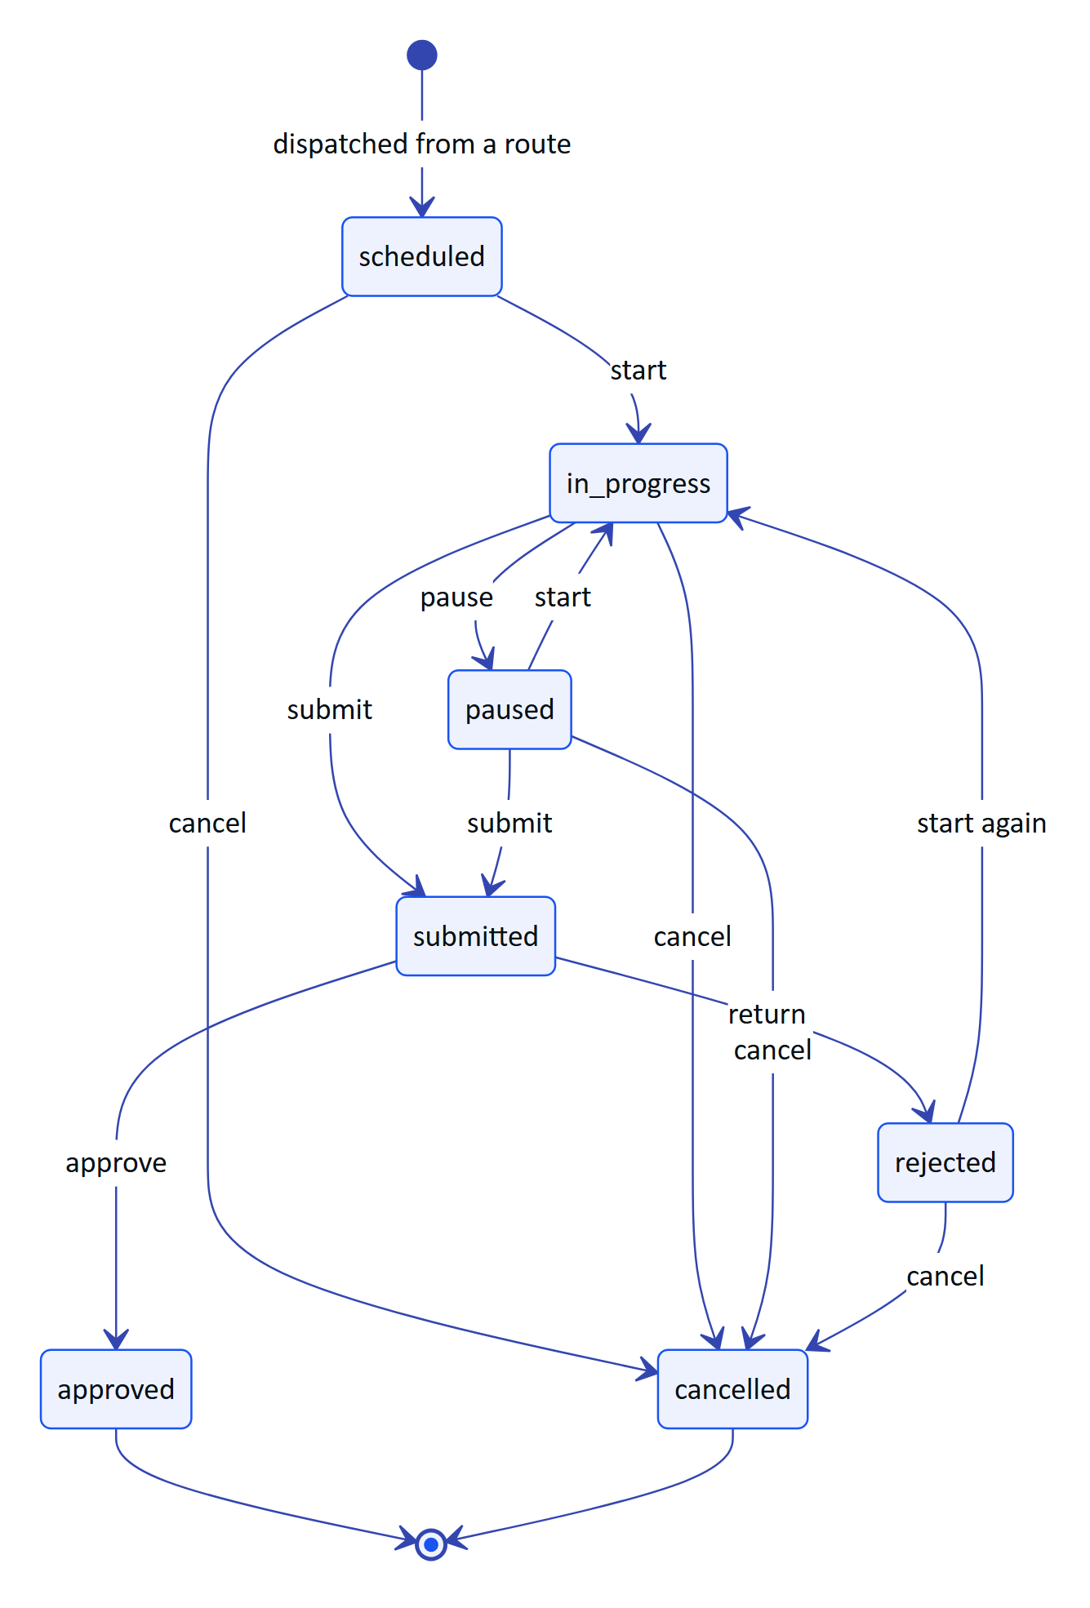
Figure 17. Inspection lifecycle (packages/domain/src/workflows.ts)
On the glasses, every step response is queued locally first and then flushed; replays are idempotent because each response carries a client operation ID (apps/web/src/glasses/data.ts). An operator who loses connectivity mid-round keeps working and the record syncs when the network returns. The "Glasses lose connectivity" demo scenario (glasses_network_loss) exercises exactly this.
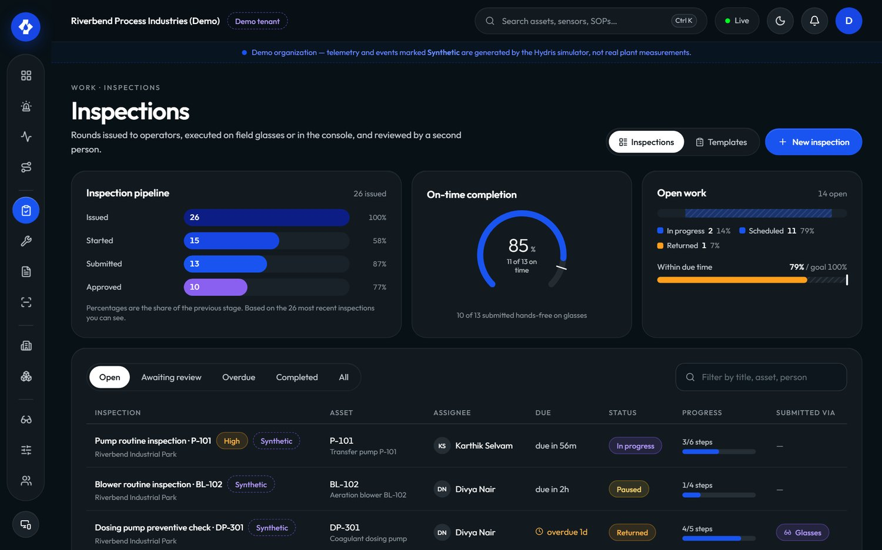
Figure 18. Inspections in the console
Maintenance tasks are corrective, preventive, inspection follow-ups or alarm follow-ups, with a priority (low to urgent), a checklist and an activity log. Their lifecycle is open, assigned, in progress, on hold, completed or cancelled, with reopen from completed or cancelled.
Table 14. Inspection and maintenance requirements
ID | Requirement | Pri | Status | Acceptance criteria | Surface
FR-040 | Versioned inspection templates (check, reading, choice, text, photo) and routes with dispatch | M | Built | Editing a template creates a new version; dispatched inspections keep the version they were created with | C, P
FR-041 | Execution on the glasses with an offline queue and idempotent replay | M | Built | Responses recorded offline appear once after reconnect (Playwright journey) | G, P
FR-042 | Submit, review, approve or return | M | Built | A returned inspection can be restarted and resubmitted; history shows both submissions | C, G, P
FR-043 | Maintenance tasks with checklist, activity and follow-ups from alarms and inspections | M | Built | A follow-up created from an alarm links back to it and shows on the alarm detail | C, A, P
FR-044 | Inspection execution in the Android app (step entry, submit) | S | Planned (Pilot) | An operator completes a round on the phone with the same validation and offline guarantees as FR-041 | A, P
FR-045 | Photo steps captured with the glasses or phone camera | S | Partial | Photo steps and attachments exist (/attachments); the glasses app shows "attach from console" because camera capture is not wired to photo steps | G, A, P
FR-046 | Tick maintenance checklist items from the Android app | M | Built | Ticking an item on the phone updates the console task in realtime | A, P
FR-047 | Recurring preventive maintenance and inspection schedules (calendar or runtime based) | S | Planned (GA) | A weekly route generates inspections automatically; a runtime-hours rule creates a task when crossed | C, P

2.7.6 Devices and glasses
A pair of glasses becomes a Hydris device through a pairing flow shaped like the OAuth 2.0 Device Authorization Grant (RFC 8628). The glasses ask for a challenge and display a short code and a QR link; a signed-in person approves it on another device and chooses the site and operator; the glasses, holding a separate poll secret that is never displayed, then claim a device credential. The QR code never contains a credential.
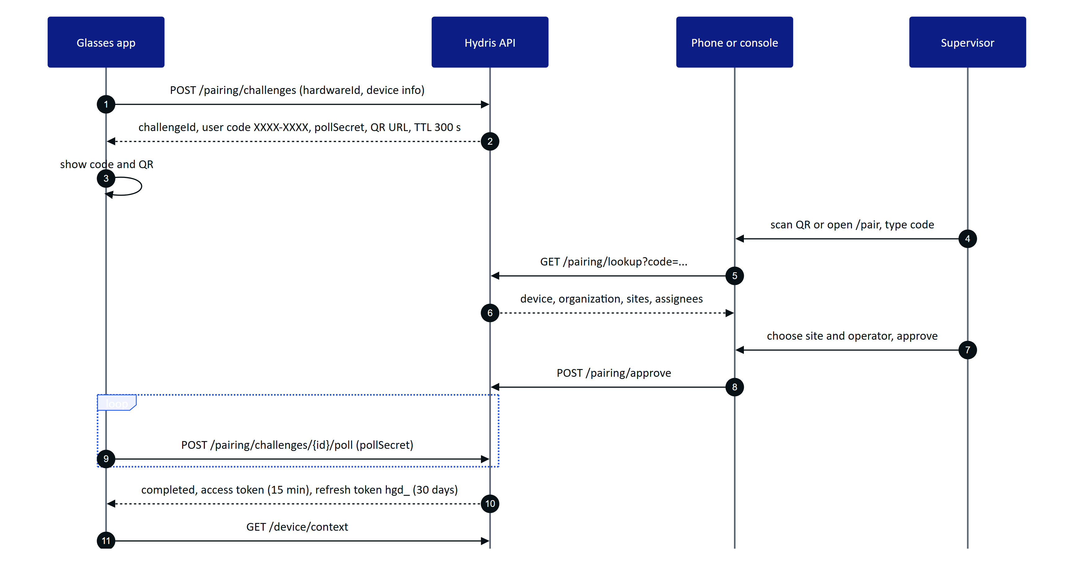
Figure 19. Glasses pairing, an RFC 8628-style device flow (apps/api/src/modules/devices.ts)
Device credentials are short-lived access tokens (15 minutes) plus a rotating 30-day refresh token with reuse detection. A session version on the device record lets an administrator invalidate every outstanding token at once. Suspending, revoking or unassigning a device takes effect on its next request and on the realtime stream's 30-second revalidation.
Device permissions are capped: whatever the assigned operator's role, a device can only do what DEVICE_PERMISSIONS allows. Managers further shape the glasses experience with UI profiles: versioned configurations of which screens are enabled and in what order, which home widgets show, which measurements are allowed and in which order per asset type, which actions are permitted, and layout (density, text scale, handedness). The server enforces the same configuration it sends to the device.
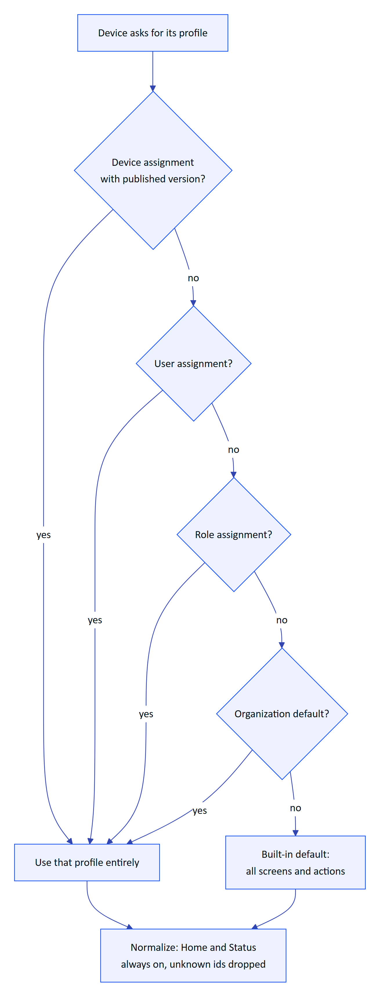
Figure 20. How the effective glasses UI profile is resolved (packages/domain/src/uiprofile.ts)
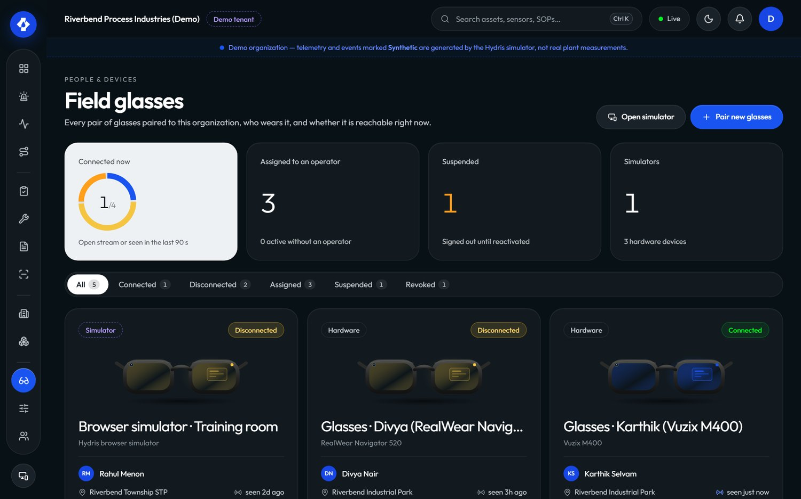
Figure 21. Field glasses in the console: pairing state, assignment and last seen
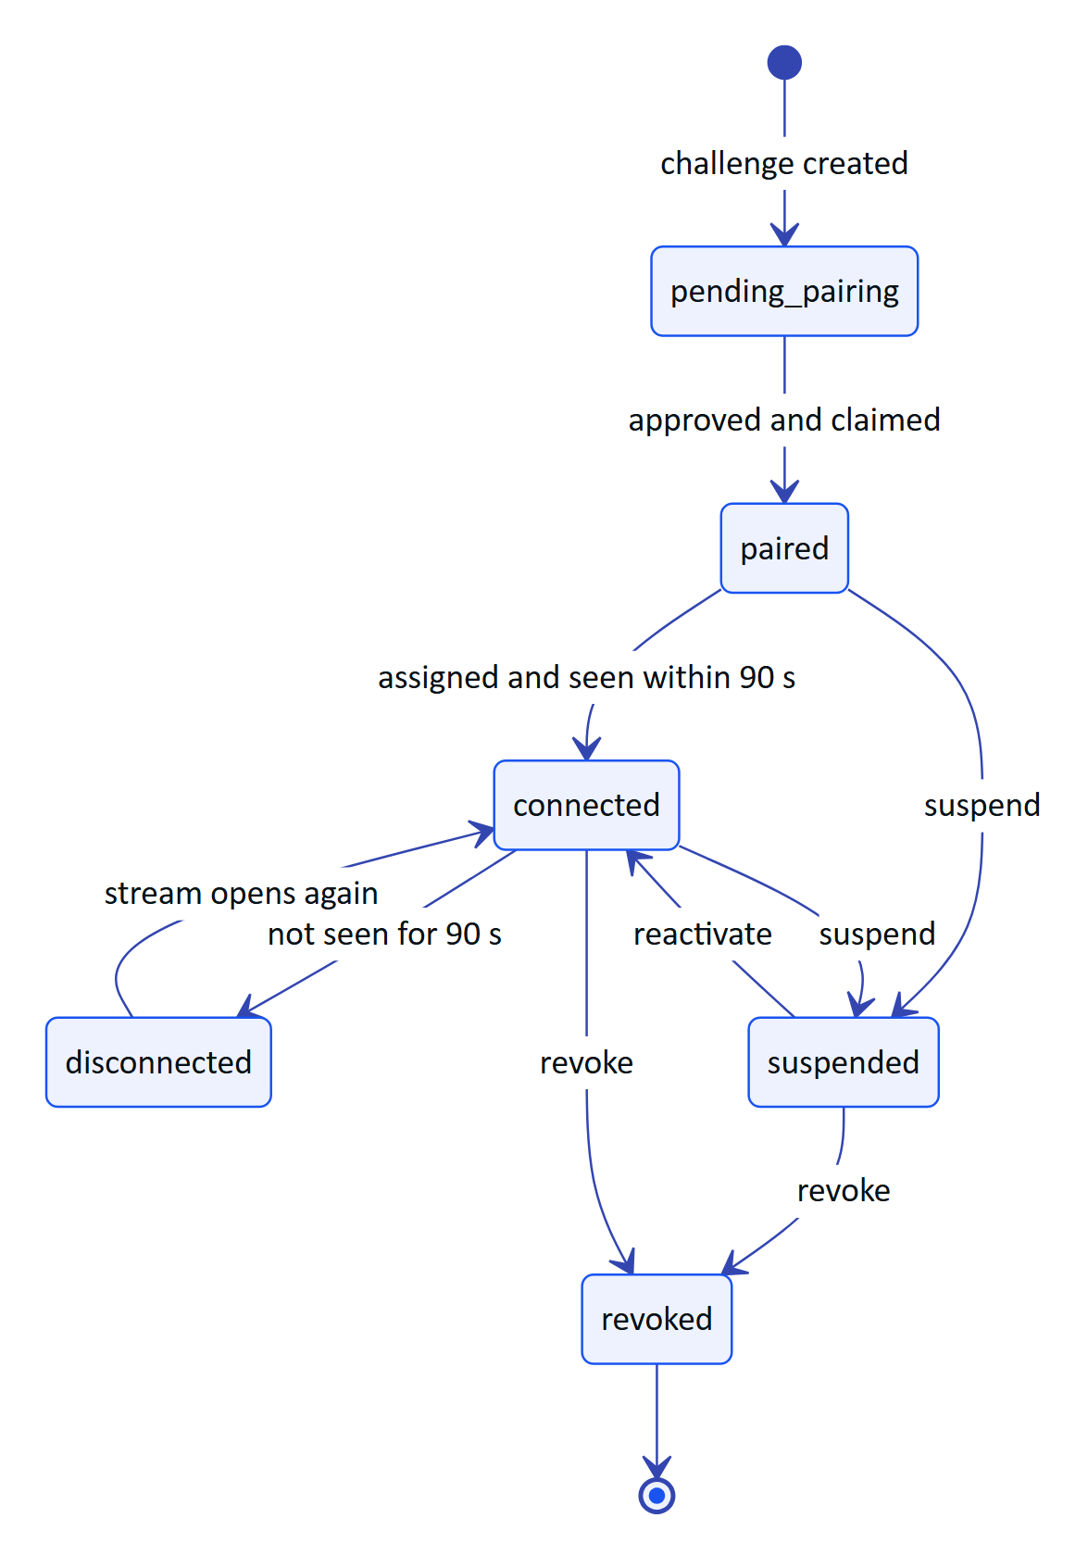
Figure 22. Composite device states shown to administrators (packages/domain/src/devices.ts)
Table 15. Device and glasses requirements
ID | Requirement | Pri | Status | Acceptance criteria | Surface
FR-050 | Pairing with an 8-character code (no 0, O, 1, I, L, U), QR link, 5-minute TTL, 3 s polling, approval with site and assignee | M | Built | Polling faster than 3 s returns slow_down; an expired code cannot be approved; a used code returns already_used (Playwright journey) | G, C, A, P
FR-051 | Device tokens: 15-minute access, 30-day rotating hgd_ refresh with reuse detection, session version | M | Built | Reusing a rotated device refresh token revokes the token family and is audited | G, A, P
FR-052 | Suspend, reactivate, revoke, reassign; revocation effective on next request and within 30 s on the event stream | M | Built | A revoked device's open stream receives session.ended within 30 s | C, P
FR-053 | Device permission ceiling (DEVICE_PERMISSIONS) | M | Built | A device paired to an org admin still cannot manage members | P
FR-054 | UI profiles with draft, publish, rollback; precedence device, user, role, org; live push | S | Built | Publishing a profile changes the glasses screens without a reload; rollback restores the previous version | C, G, P
FR-055 | Ray-Ban Meta camera through DAT (preview stream and full-resolution photo) | M | Partial | Code complete in GlassesManager.kt and the WebView bridge. Gap: not validated on physical glasses | A
FR-056 | Glasses capture button takes the page photo or starts a scan | S | Partial | Short press emits a capture in GlassesManager.captureButton. Gap: not validated on hardware | A
FR-057 | The Android app registers the connected glasses as a Hydris device using the pairing endpoints | M | Partial | Repository.registerGlasses runs challenge, lookup, approve (first permitted site) and poll, then stores device tokens. Gap: depends on a real DAT device id; not validated on hardware | A, P
FR-058 | Log out and unpair from the glasses menu, ending the device's server sessions | M | Built | After /device/logout the device's refresh token is rejected and the glasses can be paired again by anyone | G, A, P
FR-059 | Glasses heads-up app with 12 screens and a six-key directional input vocabulary, plus a phone layout | M | Built | Every screen is reachable with up, down, left, right, select and back; browser back never leaves the app | G

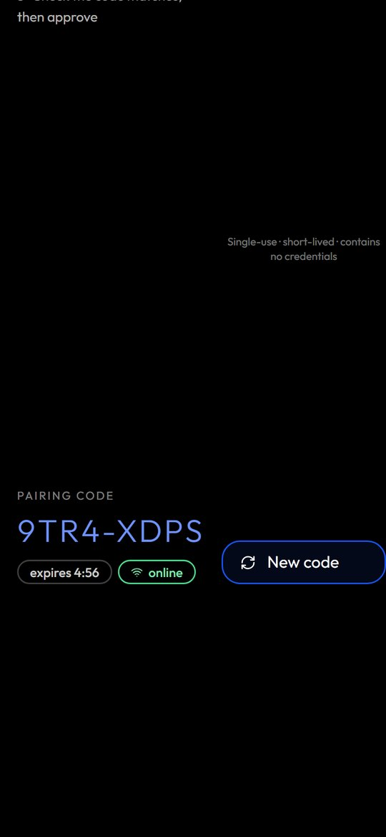
Figure 23. The glasses app in its phone layout with a pairing code

2.7.7 Android app: Hydris Field
The native Android app is the operator's daily driver and the only supported way to reach Ray-Ban Meta glasses for the pilot. It is written in Kotlin with Jetpack Compose, targets Android 12 and later (min SDK 31, matching DAT), and uses the same API and session contract as the web console. It has five tabs (Home, Work, Scan, Hydris, Glasses) plus alarm and sensor detail screens (apps/android/app/src/main/java/ai/hydris/field/ui/Root.kt).
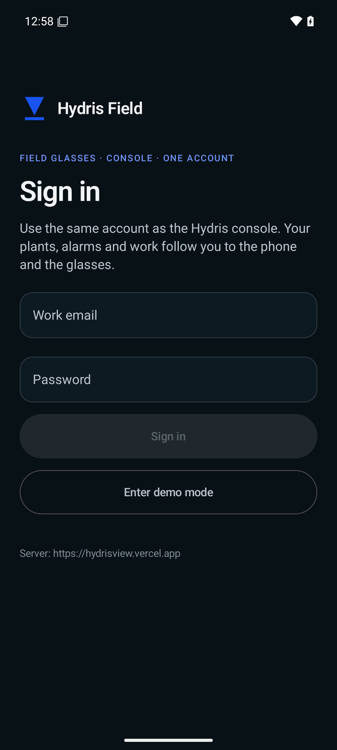
Figure 24. Sign-in on the Android app
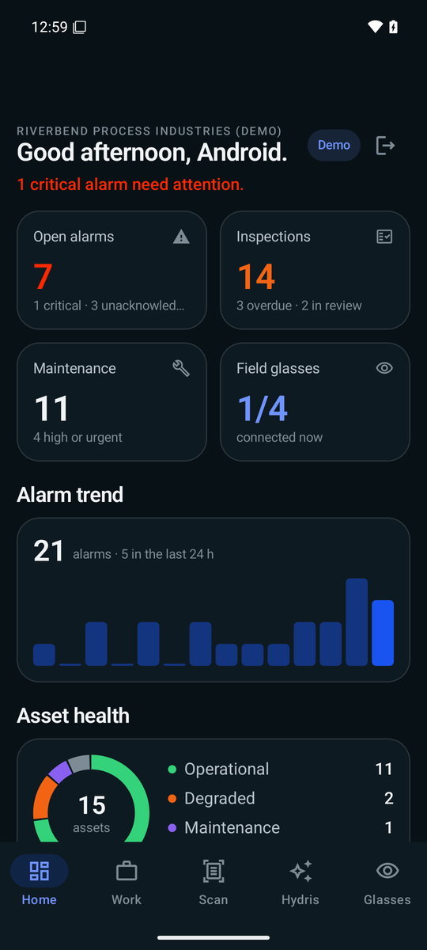
Figure 25. Home: greeting, 14-day alarm trend, asset health and live measurements
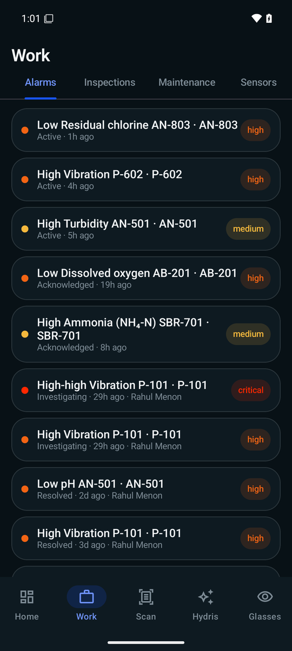
Figure 26. Work: alarms tab with severity and state
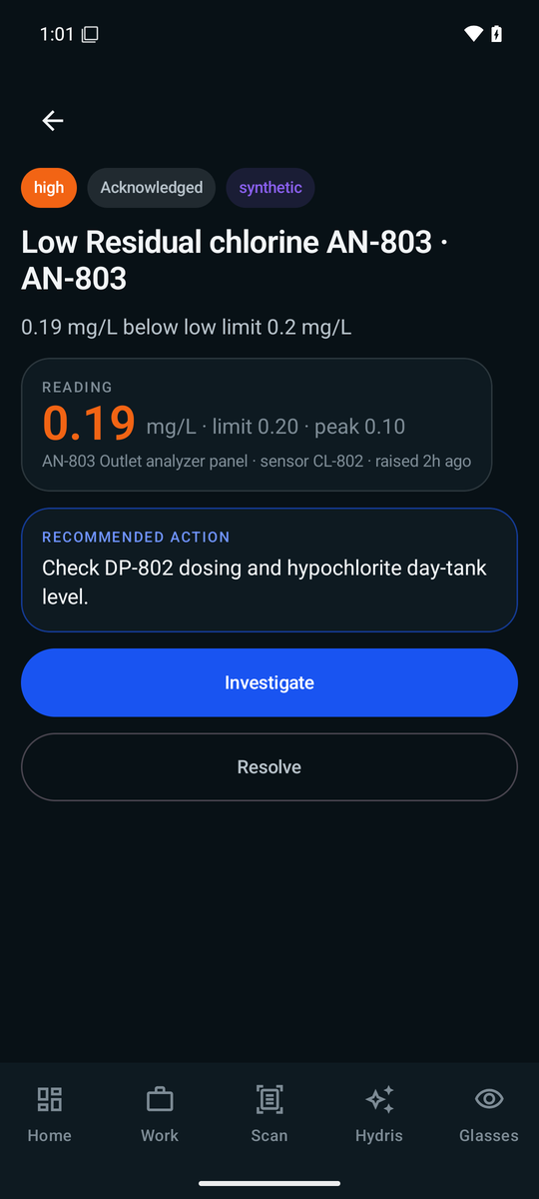
Figure 27. Alarm detail with reading, limit, peak and the next lifecycle action
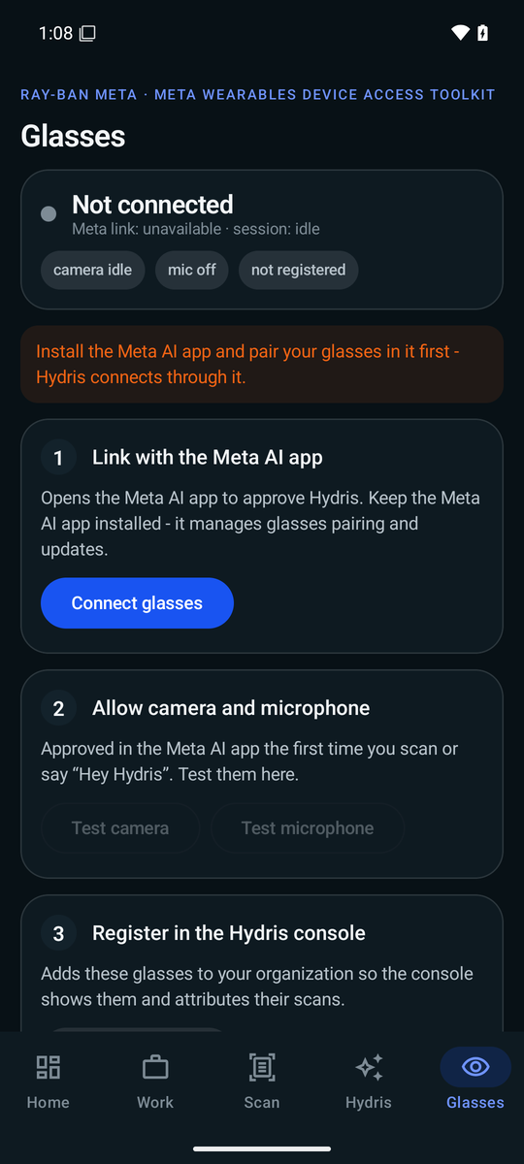
Figure 28. Glasses: link with the Meta AI app, allow camera and microphone, register in the console
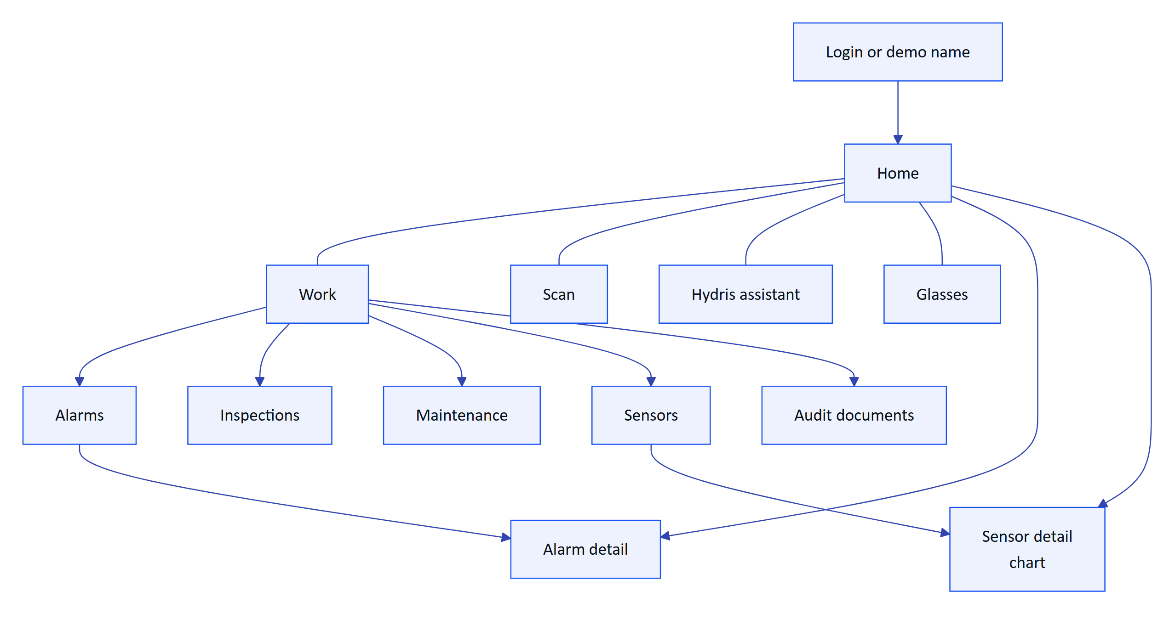
Figure 29. Android app navigation map
Table 16. Android app requirements
ID | Requirement | Pri | Status | Acceptance criteria | Surface
FR-090 | Sign in with the console account; restore the session on restart from the refresh cookie, stored AES-256-GCM encrypted with a non-exportable Android Keystore key | M | Built | Killing and reopening the app restores the session without a password; no credential is stored in plain text (SecureStore.kt) | A
FR-091 | Demo mode sign-in with a name | M | Built | Entering a name of 2 or more characters opens a personal demo account | A
FR-092 | Home: greeting, 14-day alarm trend, asset health, live measurements with freshness and synthetic labels, recent activity | M | Built | Values marked synthetic in demo; stale values show their state | A
FR-093 | Work tabs: alarms, inspections, maintenance, sensors, audit documents | M | Built | Each tab lists only what the user's site scope allows | A
FR-094 | Alarm detail with lifecycle actions | M | Partial | Acknowledge, investigate and close work. Gap: Resolve sends no note, so the API returns note_required; the app also shows actions without checking allowedActions | A, P
FR-095 | Sensor detail with a 144-point history chart and min, typical and max | S | Built | Chart covers the history window with typical range from MEASURAND_DEFS | A
FR-096 | Audit scan from the glasses camera, the phone camera or an imported photo, with guided A4 capture, flattening, two ML Kit OCR passes and up to 6 pages | M | Built (phone). Glasses path Partial (FR-055) | A scan of the sample sheet reaches the console in review with values and engine agreement | A, P
FR-097 | Realtime alarm notifications: active critical or high alarms raise a system notification while the app runs | M | Built | alarm.created on the SSE stream raises a high-priority notification; reconnects resume with Last-Event-ID | A, P
FR-098 | Offline outbox for actions taken without connectivity (Room-backed, idempotent replay) | S | Planned (GA) | Alarm acknowledgements and checklist ticks made offline are sent once when the network returns | A
FR-099 | Complete MFA sign-in in the app | S | Planned (Pilot) | An MFA-enabled operator signs in on the phone with a TOTP code | A, P

RISK
FR-094 is a correctness gap a pilot operator will hit on day one: tapping Resolve in the Android app fails because the API requires a resolution note (FR-031). Fix before pilot: add a note dialog for Resolve and drive the buttons from the API's allowedActions.

2.7.8 Audit document scanning
Audit scanning turns a paper record (inspection checklist, lab report, permit, calibration certificate, maintenance log) into a verified, searchable digital document. The design rule is dual verification: a machine cross-check of every value between independent readings, then a human review of every value and an independent approval by a second person.
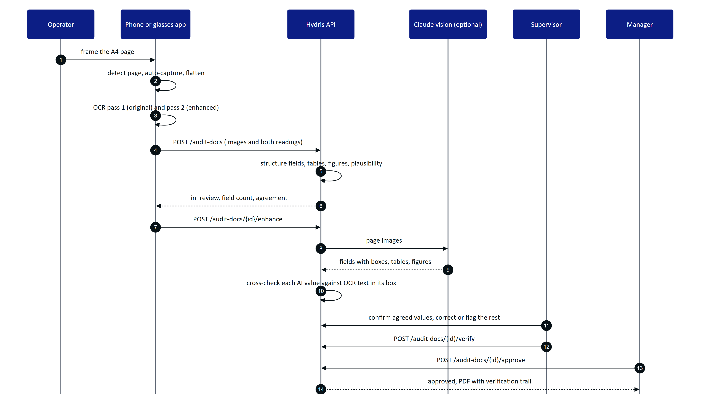
Figure 30. Scan to verified PDF: capture, machine cross-check, human review, approval
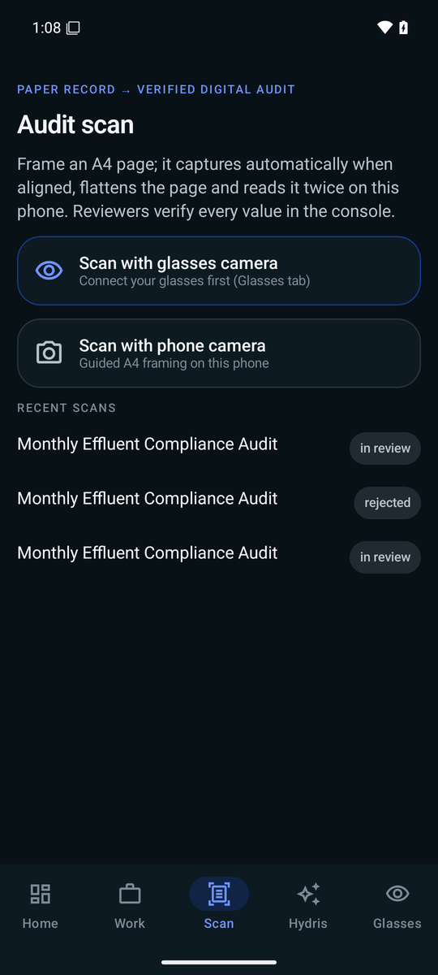
Figure 31. Scan menu on Android: glasses camera, phone camera or import
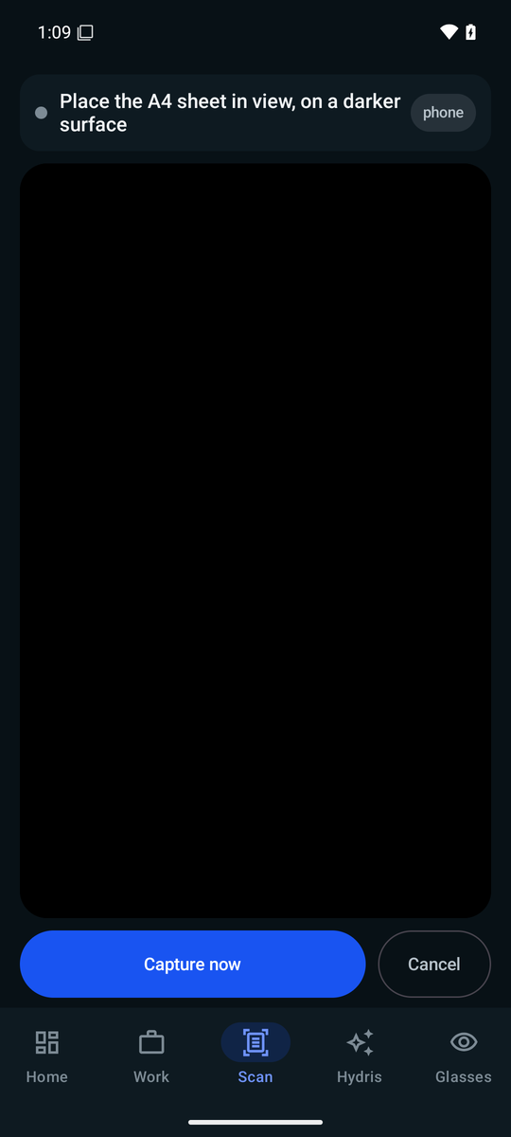
Figure 32. Guided A4 capture: page detected, aligned and steady before auto-capture
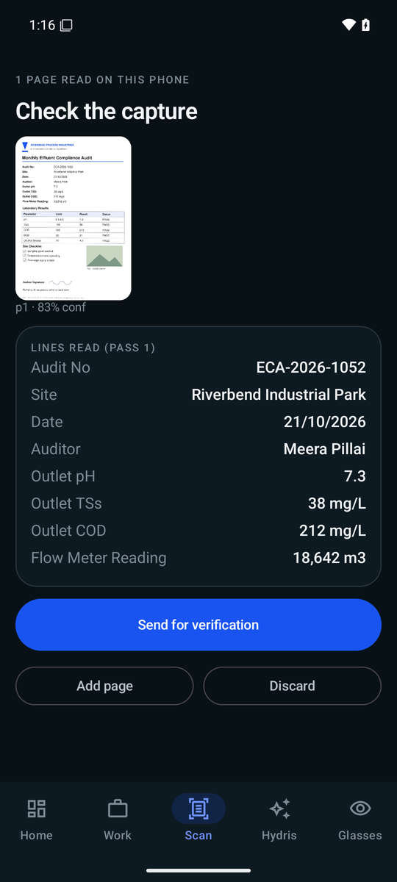
Figure 33. Review the capture: confidence per page and the label and value pairs found
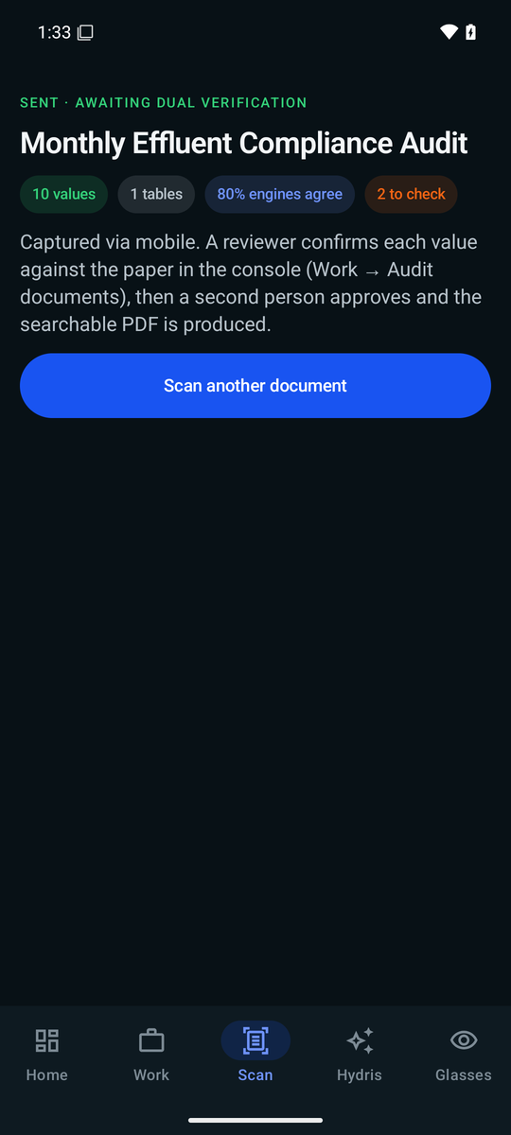
Figure 34. Sent for verification: the next steps for reviewer and approver
The document lifecycle is enforced by the API (apps/api/src/modules/audit-docs.ts). Every review action is appended to audit_document_events; corrections keep the first extracted value; concurrent edits are rejected with a revision check.
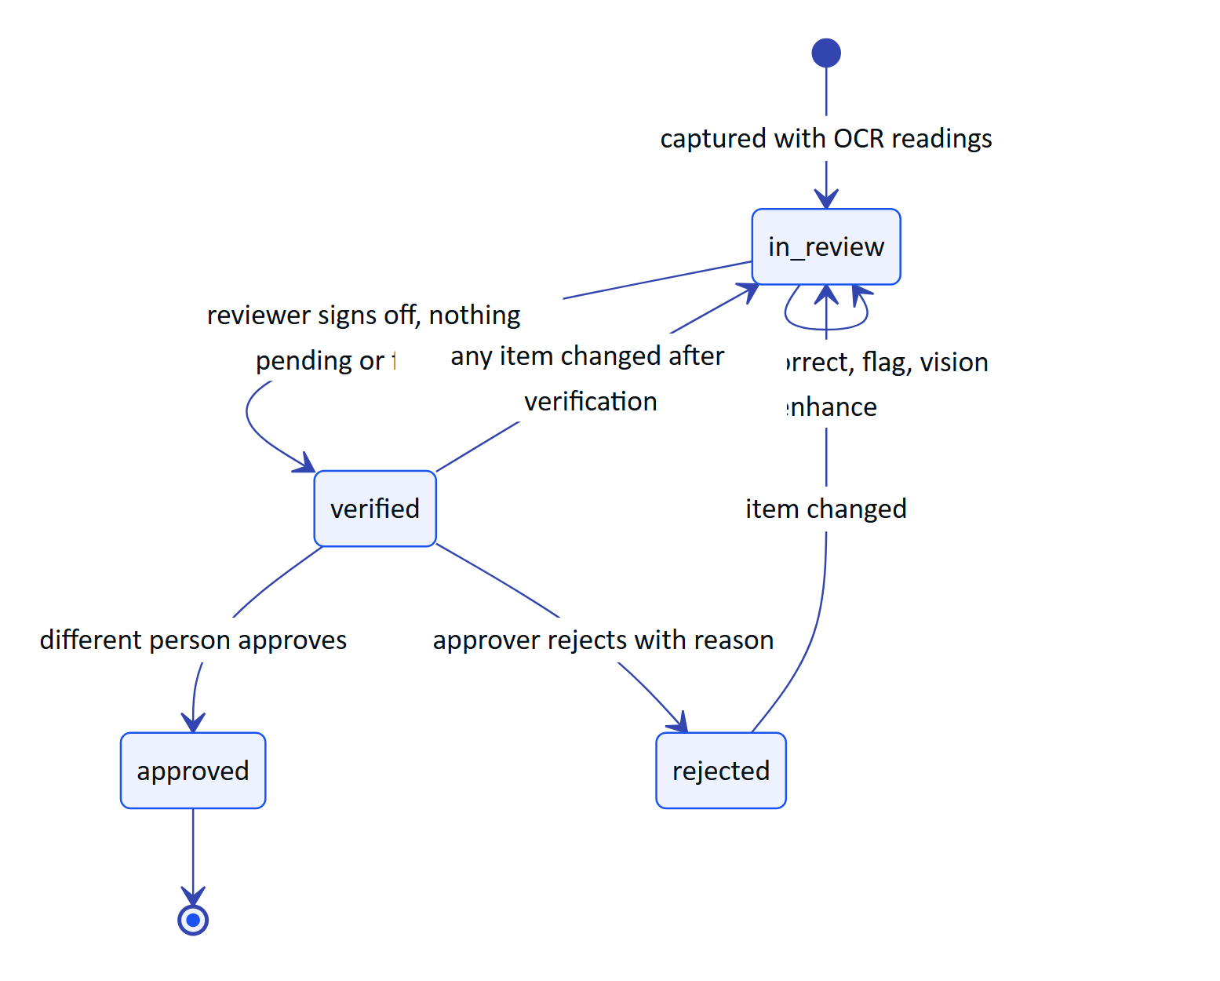
Figure 35. Audit document lifecycle and the four-eyes rule
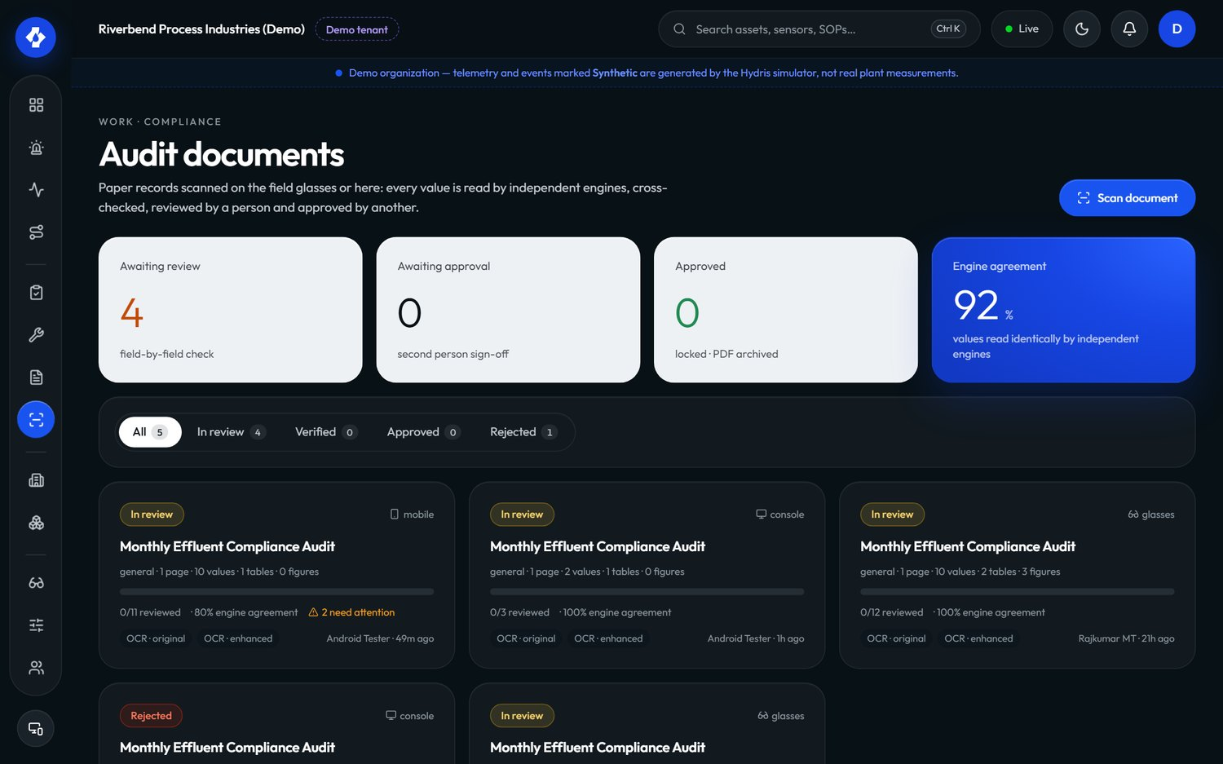
Figure 36. Audit documents in the console: status, engines, agreement and review progress
Table 17. Audit document scanning requirements
ID | Requirement | Pri | Status | Acceptance criteria | Surface
FR-060 | Guided A4 capture with live page detection, auto-capture and perspective correction | M | Built (web docdetect.ts, Android DocDetect.kt with the same thresholds) | Capture fires only when the page is aligned, covers enough of the frame and is sharp | G, A, C
FR-061 | Dual-pass on-device OCR (ocr:original, ocr:enhanced) | M | Built (Tesseract.js on web, ML Kit on Android) | Two readings per page arrive at the API; no page image leaves the device before upload | G, A, C
FR-062 | Structuring into typed fields, tables and figures, with plausibility checks (pH 0 to 14, percentages, temperatures) | M | Built (auditdoc.ts) | An implausible pH is flagged with a message on the field | P
FR-063 | Optional vision engine (Claude) cross-checked against the OCR text inside each value's box | S | Built (needs ANTHROPIC_API_KEY) | Each vision value lists the OCR sources that agree or disagree; without a key the OCR result is kept and aiStatus is unavailable | P
FR-064 | Field review: confirm, correct, flag, reset; original value kept; verify requires zero pending and zero flagged items | M | Built | Verify with one flagged item returns 400 flagged_items; a correction keeps extracted | C, P
FR-065 | Independent approval (four eyes); self-approval only in demo tenants and recorded as such | M | Built | The verifier approving their own document in a customer org gets 403 | C, P
FR-066 | PDF with verification trail, searchable original and reconstructed page | M | Built (core/audit-pdf.ts) | Text in the PDF original is selectable; the cover lists reviewer, approver and times | C, P
FR-067 | Up to 6 pages per document, each image at most 900 KB, JPEG or PNG validated by magic bytes | M | Built | A seventh page or a 1 MB page is refused with a clear message | P
FR-068 | Electronic signature with re-authentication and signature meaning (Part 11-style) | S | Planned (Advanced) | Approving asks for the password or MFA again and records the meaning of the signature | C, P
FR-069 | Bulk-confirm values where at least two independent engines match with confidence of 0.8 or more | S | Built (confirm-agreed) | Only multi-source, matching, confident items change to confirmed; the event lists their IDs | C, P

DECISION
Verification and approval are signed only by a person in the console (p.kind !== 'user' is refused). A device can capture and pre-review, but it cannot verify or approve. This keeps the evidentiary steps tied to an authenticated human session, not to a shared pair of glasses.

2.7.9 Voice assistant and grounded assistance
"Hey Hydris" is a hands-free assistant. The wake phrase is detected on the client with a pattern tolerant of common recognition spellings ("hydras", "hi dris"); the question goes to POST /assistant/ask. The API answers with one of two engines:
- Claude (claude-opus-5-5 with tool use) when an Anthropic credential is configured: natural phrasing and multi-step lookups through five read-only tools (get_readings, get_open_alarms, get_my_work, get_asset, search_procedures), at most five tool rounds.
- A deterministic rules engine otherwise, and as the fallback when the model fails: readings, alarms, my work, asset status, procedures and help. It never guesses; anything else gets "I can't answer that from your plant data".
Every tool is scoped to the caller (RLS plus site scope), so the assistant can only say what the caller could see in the console. Answers return facts (label, value, unit, time, source) so the client can show the evidence under the spoken answer.
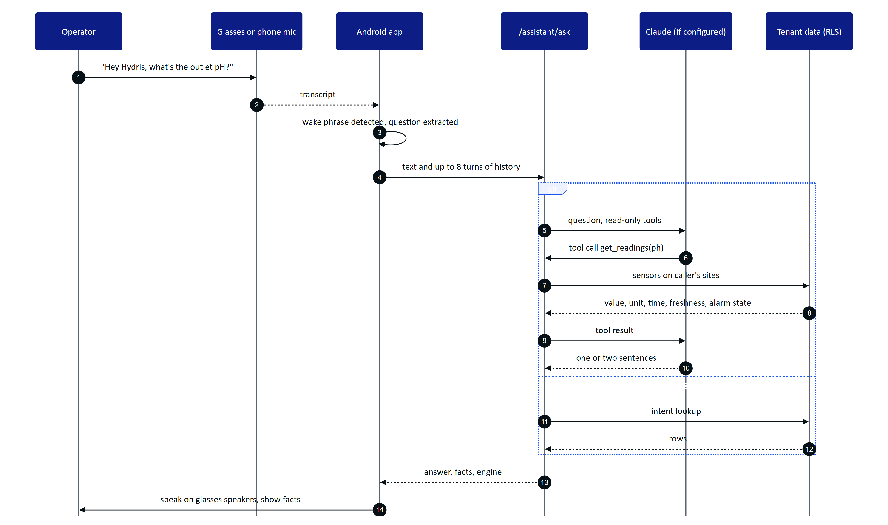
Figure 37. A spoken question answered from the caller's own plant data
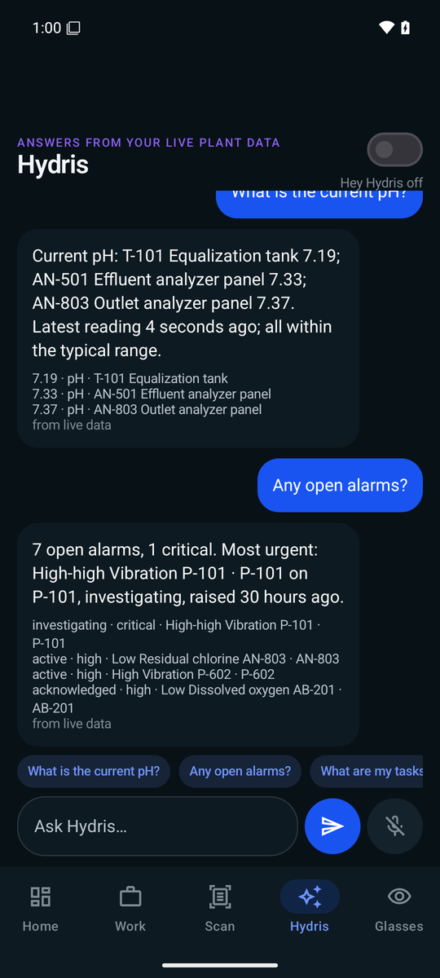
Figure 38. The Hydris assistant on Android: answers with the facts behind them
Table 18. Voice and assistance requirements
ID | Requirement | Pri | Status | Acceptance criteria | Surface
FR-070 | Grounded SOP retrieval (/assist) with passages from approved documents and a safety notice | M | Built | Responses contain only approved documents and always include the safety notice | G, C, P
FR-071 | "Hey Hydris" wake phrase and short spoken answers | M | Built (web Web Speech API; Android SpeechRecognizer and TextToSpeech) | Saying the wake phrase and a question produces a spoken answer; "stop" or "thanks" ends the follow-up window | G, A
FR-072 | /assistant/ask answers only from tenant data through scoped tools; rules fallback never guesses | M | Built | An unknown question returns intent unknown; every number in an answer appears in facts for rules answers | G, A, P
FR-073 | Multi-language voice (Hindi, Tamil, Marathi, Gujarati) | S | Planned (Advanced) | A Hindi question returns a Hindi answer with the same grounding guarantees | G, A, P
FR-074 | Glasses microphone through DAT Speech with phone-microphone fallback; answers played through TextToSpeech on the glasses' open-ear speakers | M | Partial | Phone path built in VoiceEngine.kt. Gap: glasses microphone path not validated on hardware | A
FR-075 | Answers show the facts behind them with source, and label synthetic data | M | Built | A demo answer's facts show "synthetic demo data" | G, A, P
FR-076 | Follow-up questions with conversation history (up to 8 turns accepted by the API) | S | Built | "And the inlet?" after a pH question is answered for the inlet | G, A, P
FR-077 | "Hey Meta, start Hydris" voice invocation opens the assistant | C | Partial (WebView bridge only; DAT feature is experimental) | Voice invocation intent opens the assistant screen | A
FR-078 | The assistant has no write tools and cannot change any record or equipment state | M | Built | The tool list contains only read tools; the system prompt forbids operating equipment | P

2.7.10 Documents and SOPs
Table 19. Document and SOP requirements
ID | Requirement | Pri | Status | Acceptance criteria | Surface
FR-110 | Document library (SOP, manual, datasheet, safety notice, troubleshooting) with draft, approved and archived states, versions, and site, asset or asset-type scope | M | Built | Only document.manage holders approve; versions increment on change | C, P
FR-111 | Only approved documents reach the glasses, the assistant and /assist | M | Built | A draft SOP never appears in a glasses search or assistant answer | G, A, P
FR-112 | Alarm rules link a procedure document shown with the alarm | M | Built | Alarm detail shows the linked SOP title and opens it | C, G, P
FR-113 | SOPs read on the glasses are cached for offline reading | S | Built (glasses/data.ts cache) | A previously opened SOP opens with no network | G
FR-114 | Upload PDF manuals and SOPs with text extraction for retrieval | C | Planned (GA) | An uploaded PDF becomes searchable by /assist after approval | C, P

2.7.11 Insights, reports and platform
Table 20. Platform requirements
ID | Requirement | Pri | Status | Acceptance criteria | Surface
FR-080 | Realtime server-sent events with Last-Event-ID replay; memory or database mode | M | Built | Reconnecting with the last ID replays missed events; DB mode works across serverless instances | C, G, A, P
FR-081 | Reports (inspections, alarms, maintenance, devices, operators) in JSON and CSV | M | Built | Alarm report includes median minutes to acknowledge; inspection report includes on-time rate and glasses share | C, P
FR-082 | Append-only audit trail | M | Built | No API path updates or deletes audit events | C, P
FR-083 | Demo mode: zero-configuration synthetic tenant, named guests, cross-instance pairing | M | Built | A deployment with no environment variables serves a working demo | All
FR-084 | Deterministic simulation scenarios, demo tenants only | M | Built | Ten scenarios run; starting one in a customer org is refused | C, P
FR-085 | In-app notifications | M | Built | Notifications appear in realtime and can be marked read | C, G, A, P
FR-086 | Email delivery (SMTP, SES or Resend) for mail_outbox | M | Planned (Hardening) | Invitation and reset emails arrive; failures retry and are visible to admins | P
FR-087 | Audit log page with filters | M | Built | Auditor filters by action and entity and sees actor, time and IP | C, P
FR-088 | Global search across assets, sensors, documents and work | S | Built (/search) | Typing an asset tag finds the asset and its open work | C, P
FR-089 | Overview dashboard with KPIs, open alarms, health and live measurements | M | Built (/overview) | Console overview and Android home load from the same endpoint | C, A, P

Table 21. Insights and compliance requirements
ID | Requirement | Pri | Status | Acceptance criteria | Surface
FR-120 | Compliance summary per discharge point: daily minimum, maximum and average against consent limits, with data availability | S | Planned (Pilot) | A manager exports a monthly summary for the final outlet with gaps and exceedances marked | C, P
FR-121 | Scheduled report delivery by email | C | Planned (GA) | A weekly alarm report arrives every Monday (depends on FR-086) | P
FR-122 | Shift handover summary generated from the shift's alarms, work and readings, grounded and editable before sending | C | Planned (GA) | The outgoing operator reviews a summary whose every number links to a record | A, C, P

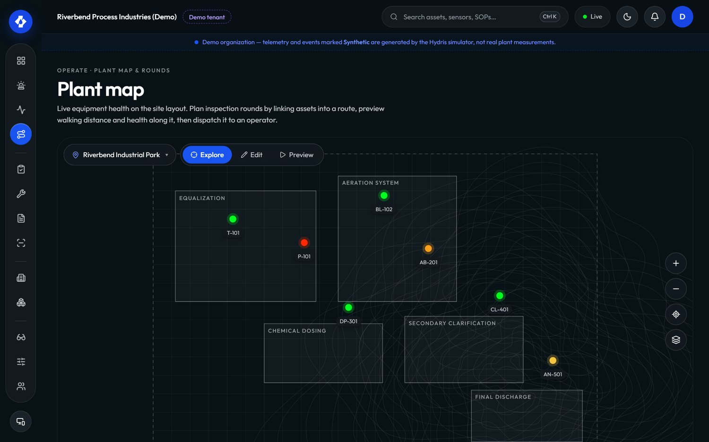
Figure 39. Plant map and rounds in the console

2.7.12 Website, demo and public
Table 22. Website, demo and public requirements
ID | Requirement | Pri | Status | Acceptance criteria | Surface
FR-100 | Marketing website with seven pages and a privacy page | M | Built | Pages render on phone and desktop, light and dark | W
FR-101 | Contact and demo-request form POST /public/inquiries, rate limited to 5 per 10 minutes per client | M | Built | The sixth submission within 10 minutes is refused | W, P
FR-102 | Live glasses demo from the website (/glasses?demo=1&scenario=...), fully client-side, and the browser simulator | M | Built | The demo runs with no API calls and shows scenario events | W, G
FR-103 | Named demo guests: each guest is an org_admin in the demo tenant with personal copies of scheduled inspections and open tasks | M | Built | Two guests acting at once do not see each other's personal work changes | C, A, P

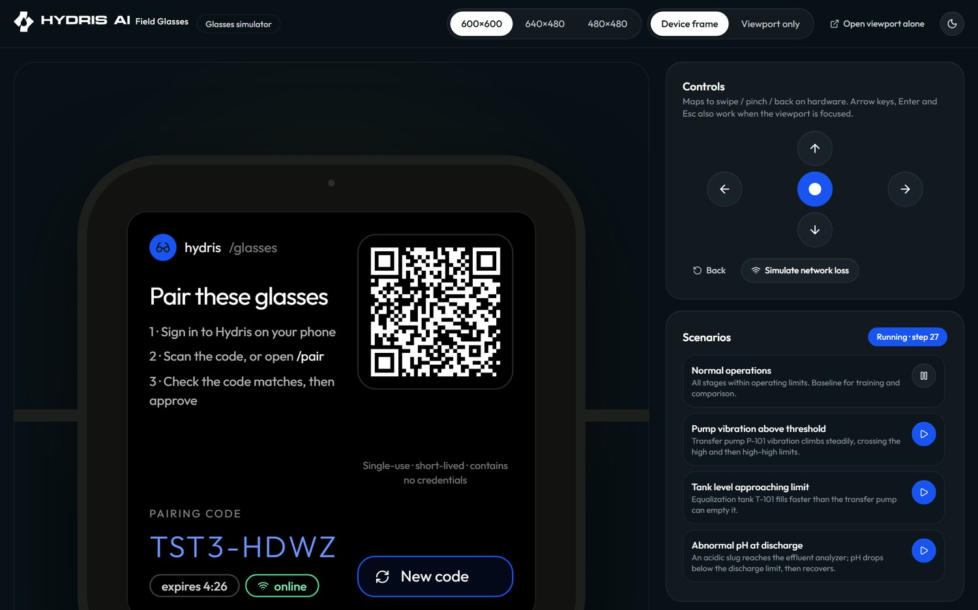
Figure 40. The browser glasses simulator used for demos and testing
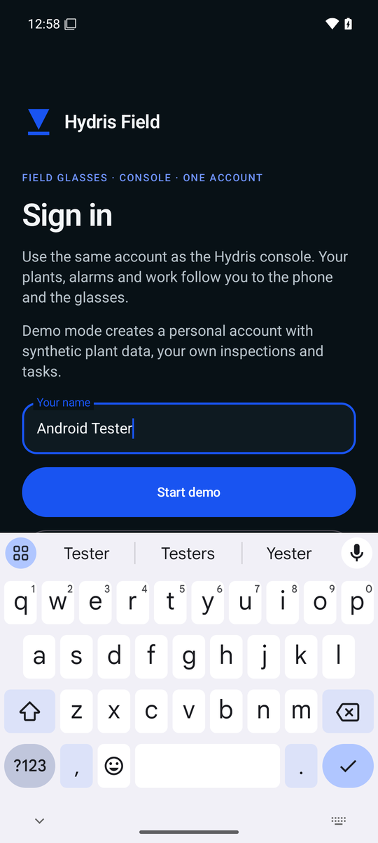
Figure 41. Demo mode on Android: enter your name to get a personal demo account

2.7.13 Requirement status overview
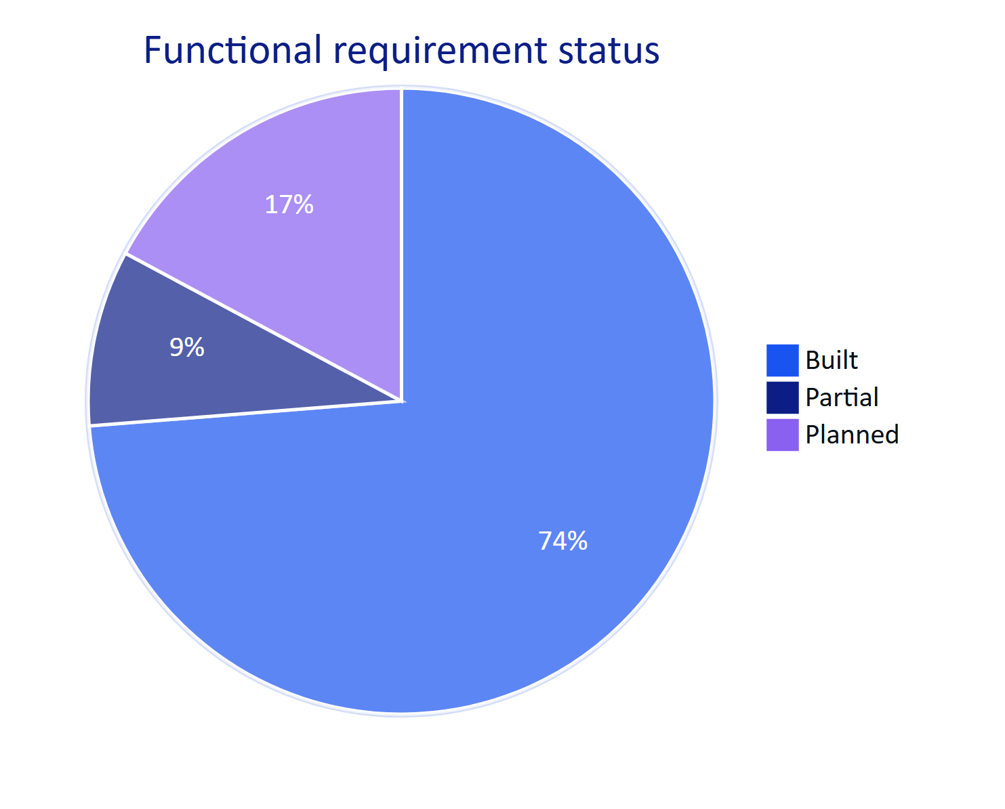
Figure 42. Status of all functional requirements in this edition

2.8 Non-functional requirements
Non-functional requirements apply across surfaces. IDs are new in this edition (version 1.0 listed the same areas without IDs). Values are targets unless a measurement is named.

2.8.1 Performance and responsiveness
Table 23. Performance requirements
ID | Requirement | Pri | Status | Target and verification
NFR-001 | API read latency | M | Partial (not yet measured) | Target p95 under 300 ms for reads in-region; verify with load tests before pilot
NFR-002 | Realtime alarm delivery from creation to client | M | Built (design); not measured | Target 2 s or less. Memory mode is immediate; DB mode polls every 1.5 s (realtime.ts)
NFR-003 | Voice answer time from end of speech to start of spoken answer | M | Partial (not measured) | Targets: 3 s with the rules engine, 8 s with the model engine
NFR-004 | OCR time per page on a mid-range phone | S | Partial (not measured) | Target 15 s or less per page for both passes
NFR-005 | Glasses home screen ready after wake | S | Planned (measure) | Target 2 s from cached context; fresh data within 5 s

2.8.2 Availability, scalability and operations
Table 24. Availability and operations requirements
ID | Requirement | Pri | Status | Target and verification
NFR-006 | Service availability | M | Planned (measure) | Targets: 99.5 % monthly in pilot, 99.9 % at GA, measured by external uptime checks
NFR-007 | Horizontal scale of realtime | M | Built | REALTIME_MODE=db supports serverless and multiple instances; memory mode is single-instance only
NFR-008 | Scheduled jobs (stale rules, pairing expiry, event pruning) run at a cadence suitable for real data | M | Partial | Long-running server: 30 s, 60 s and hourly timers. Vercel: daily cron only; fix in Hardening
NFR-009 | Backups and restore | M | Planned | Daily backups, point-in-time recovery on managed Postgres, restore tested each quarter
NFR-010 | Continuous integration on every change | M | Planned (Hardening) | Typecheck, unit, API and e2e tests on every pull request; no .github workflows exist today

2.8.3 Security and privacy
Table 25. Security and privacy requirements
ID | Requirement | Pri | Status | Target and verification
NFR-011 | Tenant isolation enforced in the database | M | Built | RLS on every tenant table; requests run as hydris_app without BYPASSRLS; API tests cover cross-tenant access
NFR-012 | Short-lived credentials | M | Built | 15-minute access tokens (12 h in demo mode only); rotating refresh tokens with reuse detection
NFR-013 | Rate limiting | M | Built | Global 600 requests per minute per client; sign-in 10 per minute; pairing endpoints 10 to 40 per minute; public form 5 per 10 minutes
NFR-014 | Secrets at rest | M | Built | MFA secrets encrypted with DATA_KEY; tokens stored as SHA-256 hashes; Android credentials in Keystore-backed AES-256-GCM
NFR-015 | Camera only on explicit intent; no continuous recording | M | Built | Camera streams only while a scan screen is open (startPreview and stopPreview); no background capture
NFR-016 | Images stored only for audit documents and attachments | M | Built | No other path persists camera frames
NFR-017 | Data residency in India for Indian customers | S | Planned (GA) | Production database, storage and model inference in an Indian region, documented per tenant
NFR-018 | Independent penetration test before GA | M | Planned (GA) | No open high or critical findings at launch

WARNING
The glasses web app keeps its device refresh token in browser localStorage (apps/web/src/glasses/link.ts). That is acceptable for the simulator and demo, not for production glasses. The native Android app already stores device tokens in the Keystore-backed SecureStore, which is one reason the native app, not the WebView bridge, is the pilot path.

2.8.4 Accessibility, glanceability and hands-free use
Table 26. Accessibility and hands-free requirements
ID | Requirement | Pri | Status | Target and verification
NFR-019 | Glasses text scale per profile | M | Built | Scales 0.9, 1, 1.15 and 1.3 (UI_TEXT_SCALES), clamped to 0.85 to 1.4
NFR-020 | Additive-display friendly design | M | Built (assumption to verify on hardware) | Pure black renders as transparent; 600 by 600 viewport assumption (GLASSES_DISPLAY)
NFR-021 | Every glasses action reachable with six directional keys or voice | M | Built | Keyboard, swipe and simulator controls map to up, down, left, right, select, back
NFR-022 | Spoken answers are short | M | Built | One or two sentences (assistant system prompt); units spoken in words
NFR-023 | Console and Android meet WCAG 2.2 AA | S | Partial (not audited) | Automated and manual accessibility audit before GA; contrast in light and dark themes
NFR-024 | Large touch targets for gloved use on Android | S | Built | Primary buttons are 52 to 54 dp tall in the scan, login and alarm screens

2.8.5 Offline, battery and device constraints
Table 27. Offline and device requirements
ID | Requirement | Pri | Status | Target and verification
NFR-025 | Inspection responses survive connectivity loss on the glasses | M | Built | Queue plus idempotent replay; Playwright journey and glasses_network_loss scenario
NFR-026 | Last context and SOPs readable offline on the glasses | S | Built | Cached with timestamp; shown as cached, never as live
NFR-027 | Android offline outbox | S | Planned (GA) | See FR-098
NFR-028 | Battery: a 4-hour shift on Ray-Ban Meta with up to 20 scans | S | Planned (measure) | Camera streams only on the scan screen; Android preview frames throttled to at most one per 100 ms; speech restarted only while enabled
NFR-029 | Android 12 or later (min SDK 31) | M | Built | Matches DAT requirements

2.8.6 Data integrity and maintainability
Table 28. Data integrity and maintainability requirements
ID | Requirement | Pri | Status | Target and verification
NFR-030 | Provenance on every reading; synthetic data impossible in customer tenants | M | Built | DB check telemetry_synthetic_source_ck; ingest refuses simulator data for non-demo orgs
NFR-031 | Optimistic concurrency on review records | M | Built | Audit document edits carry a revision; stale writes get 409 stale
NFR-032 | Shared domain logic between server and clients | M | Built | State machines, permissions, freshness and voice parsing live in packages/domain; Android ports keep identical thresholds
NFR-033 | Automated test coverage of security-critical paths | M | Built | 67 tests passing (26 domain, 41 API) on 22 Oct 2026; 4 Playwright journeys
NFR-034 | Observability | S | Planned (Pilot) | Structured logs, error tracking and uptime alerts with an on-call runbook

2.9 Data and AI requirements

2.9.1 Data principles
- Tenant data stays in the tenant. All AI calls are made with data the caller is already allowed to see, fetched through the same RLS-scoped queries as the console.
- The model never sees more than it needs. The assistant receives tool results for the question asked, not a dump of the database. Vision extraction receives only the page images of the document being processed.
- Nothing the model says becomes a record without a person. Vision-extracted values enter the review as pending; a reviewer confirms each one and a second person approves.
- Every AI output is attributable. Audit documents record which engines produced each value (engines, sources); assistant responses say which engine answered (engine: claude-opus-5-5 or hydris-rules).
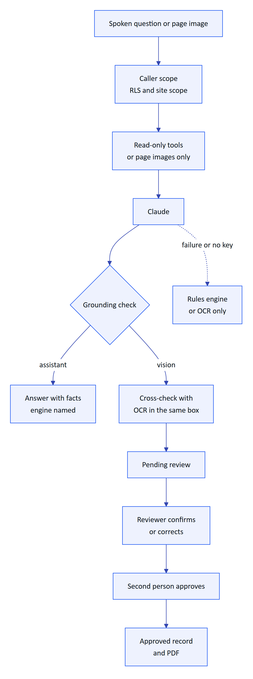
Figure 43. Guardrails between the language model and the plant record

2.9.2 Grounding requirements
Table 29. Data and AI requirements
ID | Requirement | Pri | Status | Acceptance criteria
NFR-035 | The assistant uses only values returned by tools in the same conversation | M | Built (prompt and tool design) | Evaluation set: zero answers containing a number absent from tool results (target)
NFR-036 | The assistant states the age of a reading and says plainly when it is stale, missing, out of range or in alarm | M | Built | Rules answers include "measured N minutes ago"; stale readings add "not current, check the sensor"
NFR-037 | Graceful degradation without the model | M | Built | Any model error falls back to the rules engine; vision failure keeps OCR results with aiStatus = failed and the reason
NFR-038 | Vision transcribes faithfully: no correcting, normalizing or inferring illegible values | M | Built (system prompt) | Illegible areas appear in warnings with low confidence
NFR-039 | Human-in-the-loop for every AI-extracted value | M | Built | No document reaches verified with pending or flagged items
NFR-040 | Model choice and data handling documented per tenant, including region | S | Planned (GA) | Tenant settings show which model provider and region process its data

2.9.3 Accuracy targets
Table 30. AI and OCR quality targets (targets, not measurements)
Measure | Target for pilot | How it will be measured
Fields where independent engines agree (agreement = match) | 90 % or more on typed forms | Agreement score per document in the console; pilot sample of 200 pages
Fields a reviewer has to correct | under 5 % | Ratio of corrected to all reviewed fields
Vision false confidence (value confirmed by engine agreement but wrong on paper) | under 0.5 % | Blind re-check of 100 approved documents
Assistant answers with facts (not "can't answer") | 85 % or more of real operator questions | Intent logging on /assistant/ask (engine, intent)
Assistant answers with a number not in its facts | 0 | Automated check on logged answers and facts

IMPORTANT
The assistant and vision engine run on claude-opus-5-5 when ANTHROPIC_API_KEY is set (voice-assistant.ts, core/vision-extract.ts). Before a customer pilot the tenant must agree to that processing, and the deployment must record where inference runs. Until then, pilots can run with the rules engine and OCR only, which are fully on Hydris infrastructure and the device.

2.10 Success metrics and KPIs

2.10.1 North star
Verified field records per active operator per week: the number of inspections submitted, alarms acknowledged within target, and audit documents approved, divided by the number of operators who used Hydris that week. It rises only when operators use the product in the field and the records it produces are trusted.
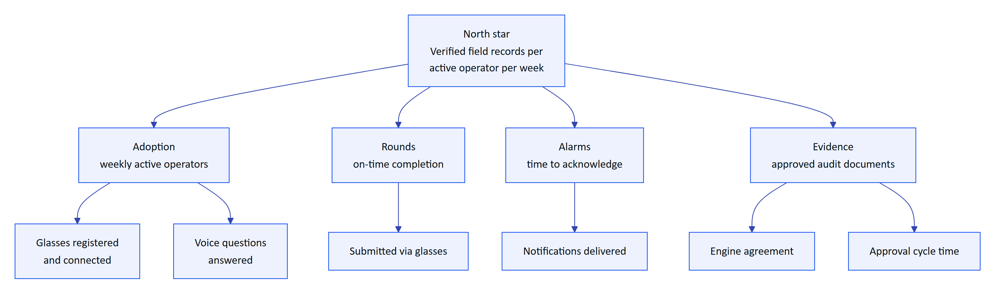
Figure 44. KPI tree: the north star and the input metrics that drive it

2.10.2 Metrics and targets
Table 31. KPIs with definitions, sources and pilot targets
Area | Metric | Definition and source | Pilot target
Adoption | Weekly active operators | Operators with at least one record in a week divided by licensed operators | 70 % or more
Rounds | On-time completion | onTimeRate in the inspections report | 95 % or more
Rounds | Time per inspection | Median start to submit, compared with the paper baseline | 30 % lower than paper
Rounds | Share submitted via glasses | viaGlasses in the inspections report | 50 % or more
Alarms | Time to acknowledge | medianMinutesToAcknowledge in the alarms report | under 5 minutes for critical and high
Alarms | Acknowledged but unresolved backlog | Count of alarms in acknowledged or investigating older than 24 h | Visible daily; trending down
Evidence | Engine agreement | Average agreement score of approved documents | 90 % or more
Evidence | Reviewer edits | Corrected fields divided by reviewed fields | under 5 %
Evidence | Approval cycle | Capture to approval, median | under 24 hours
Voice | Answered with facts | Share of questions with intent other than unknown | 85 % or more
Trust | Hallucinated numbers | Numbers in answers missing from facts | 0
Security | Cross-tenant incidents | Confirmed data exposure across tenants | 0
Security | Device revocation time | Revoke to session.ended on the stream | 30 s or less

NOTE
Most adoption and round metrics already have a data source in /reports/:kind (apps/api/src/modules/insights.ts). The voice and agreement metrics need lightweight logging that is Planned for the pilot (part of NFR-034).

2.11 Release plan and milestones

2.11.1 What has shipped
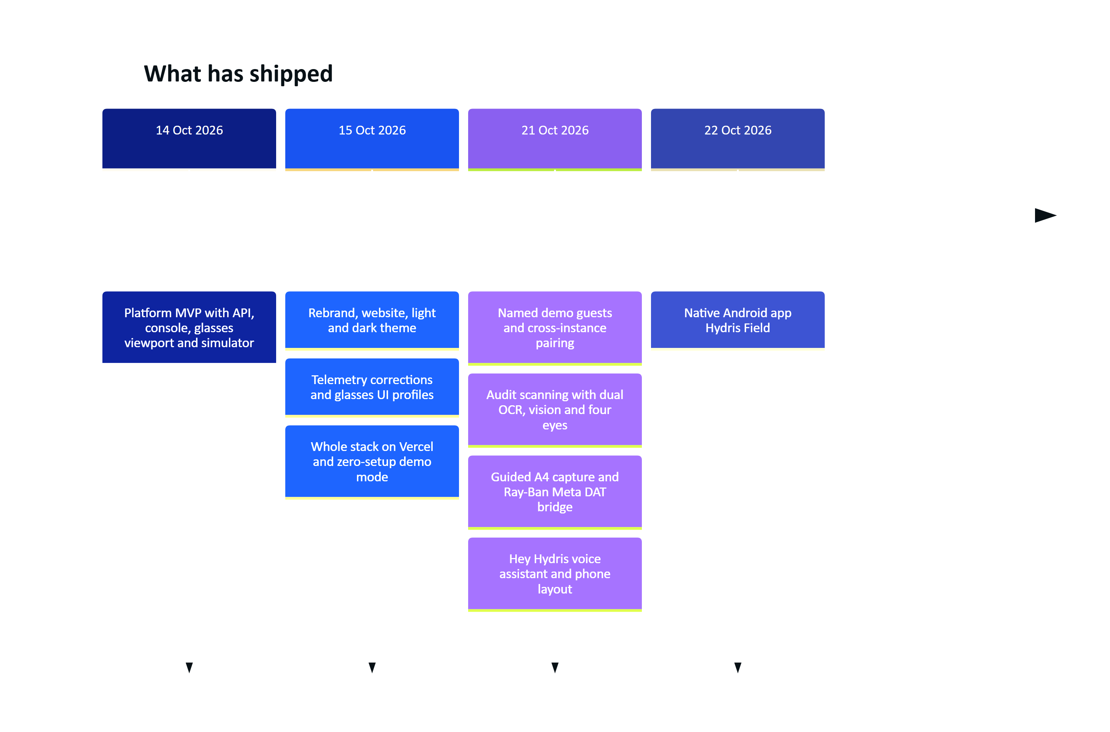
Figure 45. Build history on main (git log, October 2026)

2.11.2 Phases
Table 32. Release phases, scope and exit criteria
Phase | When | Scope | Exit criteria
0. MVP | Done (to October 2026) | API, console, glasses app, simulator, pairing, UI profiles, audit scanning, voice, demo mode, native Android app in code | Live demo; 67 tests passing
1. Hardening | Q4 2026 | Email transport (FR-086), CI (NFR-010), job cadence on serverless (FR-035, NFR-008), Android fixes (FR-094, FR-099), audit page images to object storage, observability baseline | All Must requirements for pilot are Built or have an agreed workaround
2. Hardware validation | Q4 2026 to Q1 2027 | Ray-Ban Meta on the test matrix: camera, capture button, speech, registration (FR-055, FR-056, FR-057, FR-074); battery measurement (NFR-028) | Every glasses requirement moves from Partial to Built or is descoped with a phone fallback
3. Pilot | Q1 2027 | One or two Indian plants (ETP or STP), 10 to 30 operators, gateway ingestion, compliance summary (FR-120), escalation (FR-037), Android inspections (FR-044) | KPI baselines captured; pilot targets met or explained; customer sign-off
4. GA | Q2 2027 | FCM push (FR-034), Android offline outbox (FR-098), SSO (FR-011), India-region production (NFR-017), pen test (NFR-018), recurring schedules (FR-047), Play or MDM distribution | Store or MDM release approved; security review passed
5. Advanced | H2 2027 onwards | MQTT and OPC UA (FR-027), SCADA connectors (FR-028), multi-language voice (FR-073), e-signatures (FR-068), native glasses display, predictive maintenance, LIMS, iOS | Driven by customer demand

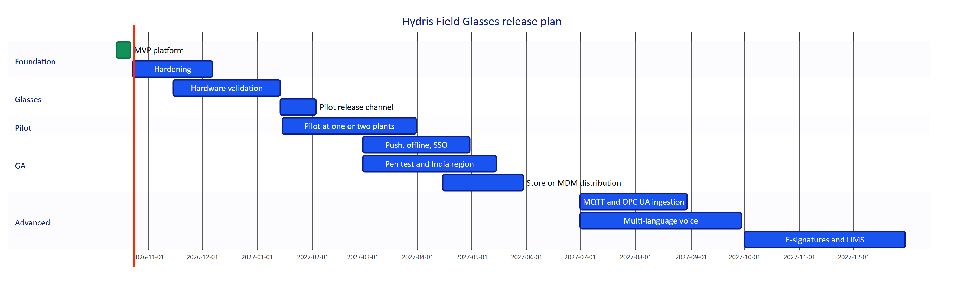
Figure 46. Release plan (indicative dates)

2.11.3 Prioritisation
Planned and Partial work was scored for value to the pilot customer and engineering effort by the product team. The chart is a planning aid, not a measurement.
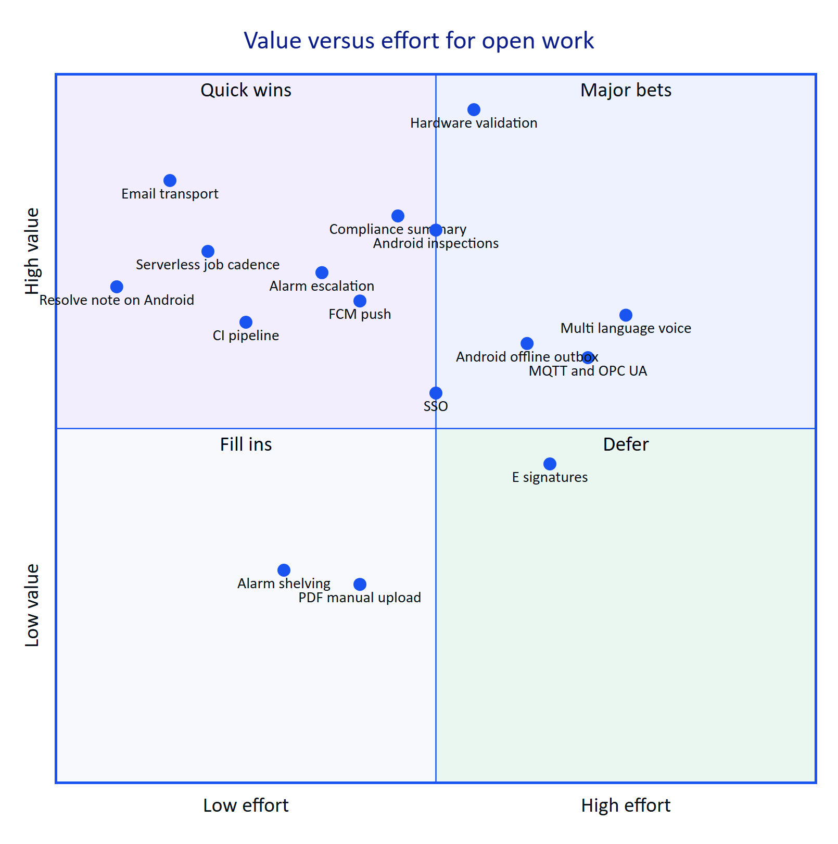
Figure 47. Planned and partial work by value and effort (product team estimate)
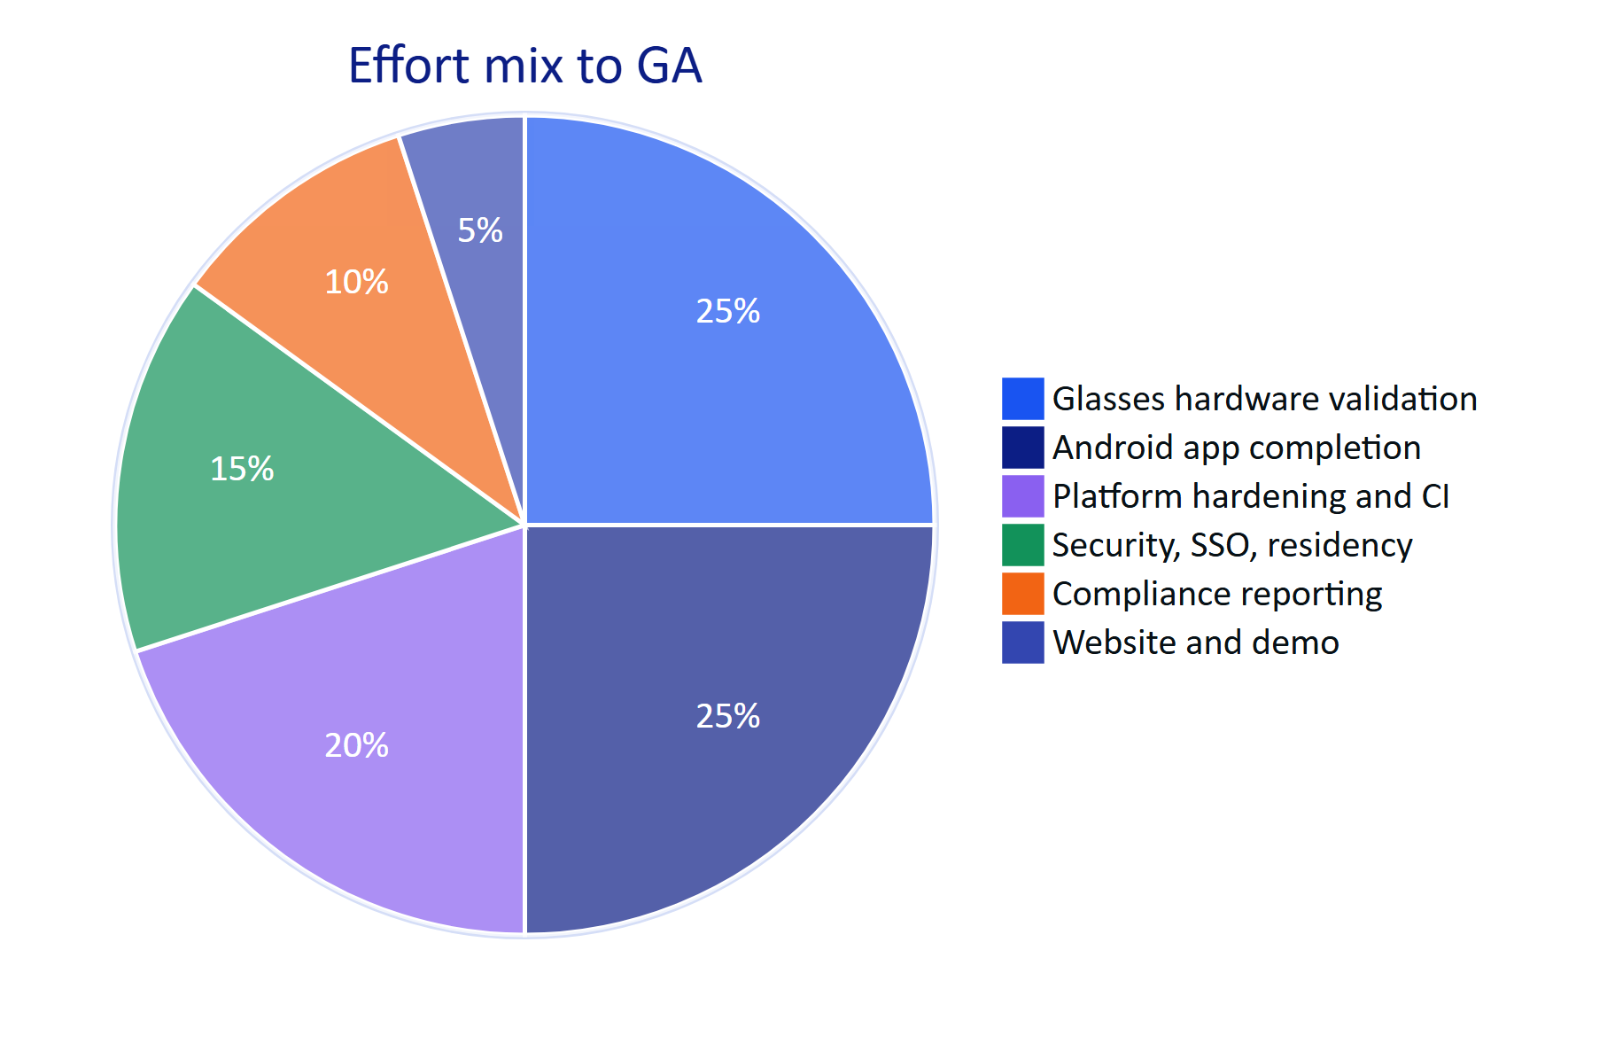
Figure 48. Where the remaining effort goes before GA (product team estimate, share of engineering weeks)
DECISION
The pilot runs on the native Android app, not the WebView bridge. The native app keeps device tokens in the Android Keystore, uses ML Kit for faster on-device OCR, and talks to DAT directly. The bridge remains useful for demonstrations of the web glasses app on hardware.

2.12 Dependencies
Table 33. External dependencies, what Hydris uses them for, and the fallback
Dependency | Used for | Owner | Risk if unavailable | Fallback
Meta AI app (com.facebook.stella) | Glasses pairing, DAT registration, camera and microphone permissions, firmware | Meta | Glasses features unavailable | Phone camera and phone microphone paths work without it
Meta Wearables DAT 1.0.1 and Developer Mode | Camera stream, photo, capture button, speech | Meta | Cannot reach the glasses | Same as above
Wearables Developer Center registration | Production app ID and client token; publishing beyond developer mode | Meta | Cannot distribute beyond test devices | Developer Mode for the pilot; apply early
Vercel | Hosting web, API route handlers, cron, Blob storage | Vercel | Outage of the hosted service | Container deployment (Docker, Render blueprint) is supported
Postgres (Neon or managed) | Primary database with RLS | Provider | Outage | Point-in-time recovery; PGlite for local and demo
Anthropic API | Assistant model and vision extraction | Anthropic | Degraded answers, no vision | Rules engine and OCR-only extraction are built
Google ML Kit text recognition | On-device OCR in the Android app | Google | Lower OCR quality | Tesseract.js path in the web app
Email provider (Planned) | Invitations, resets, scheduled reports | To be chosen | Invitations and resets do not arrive | Admin copies links from mail_outbox

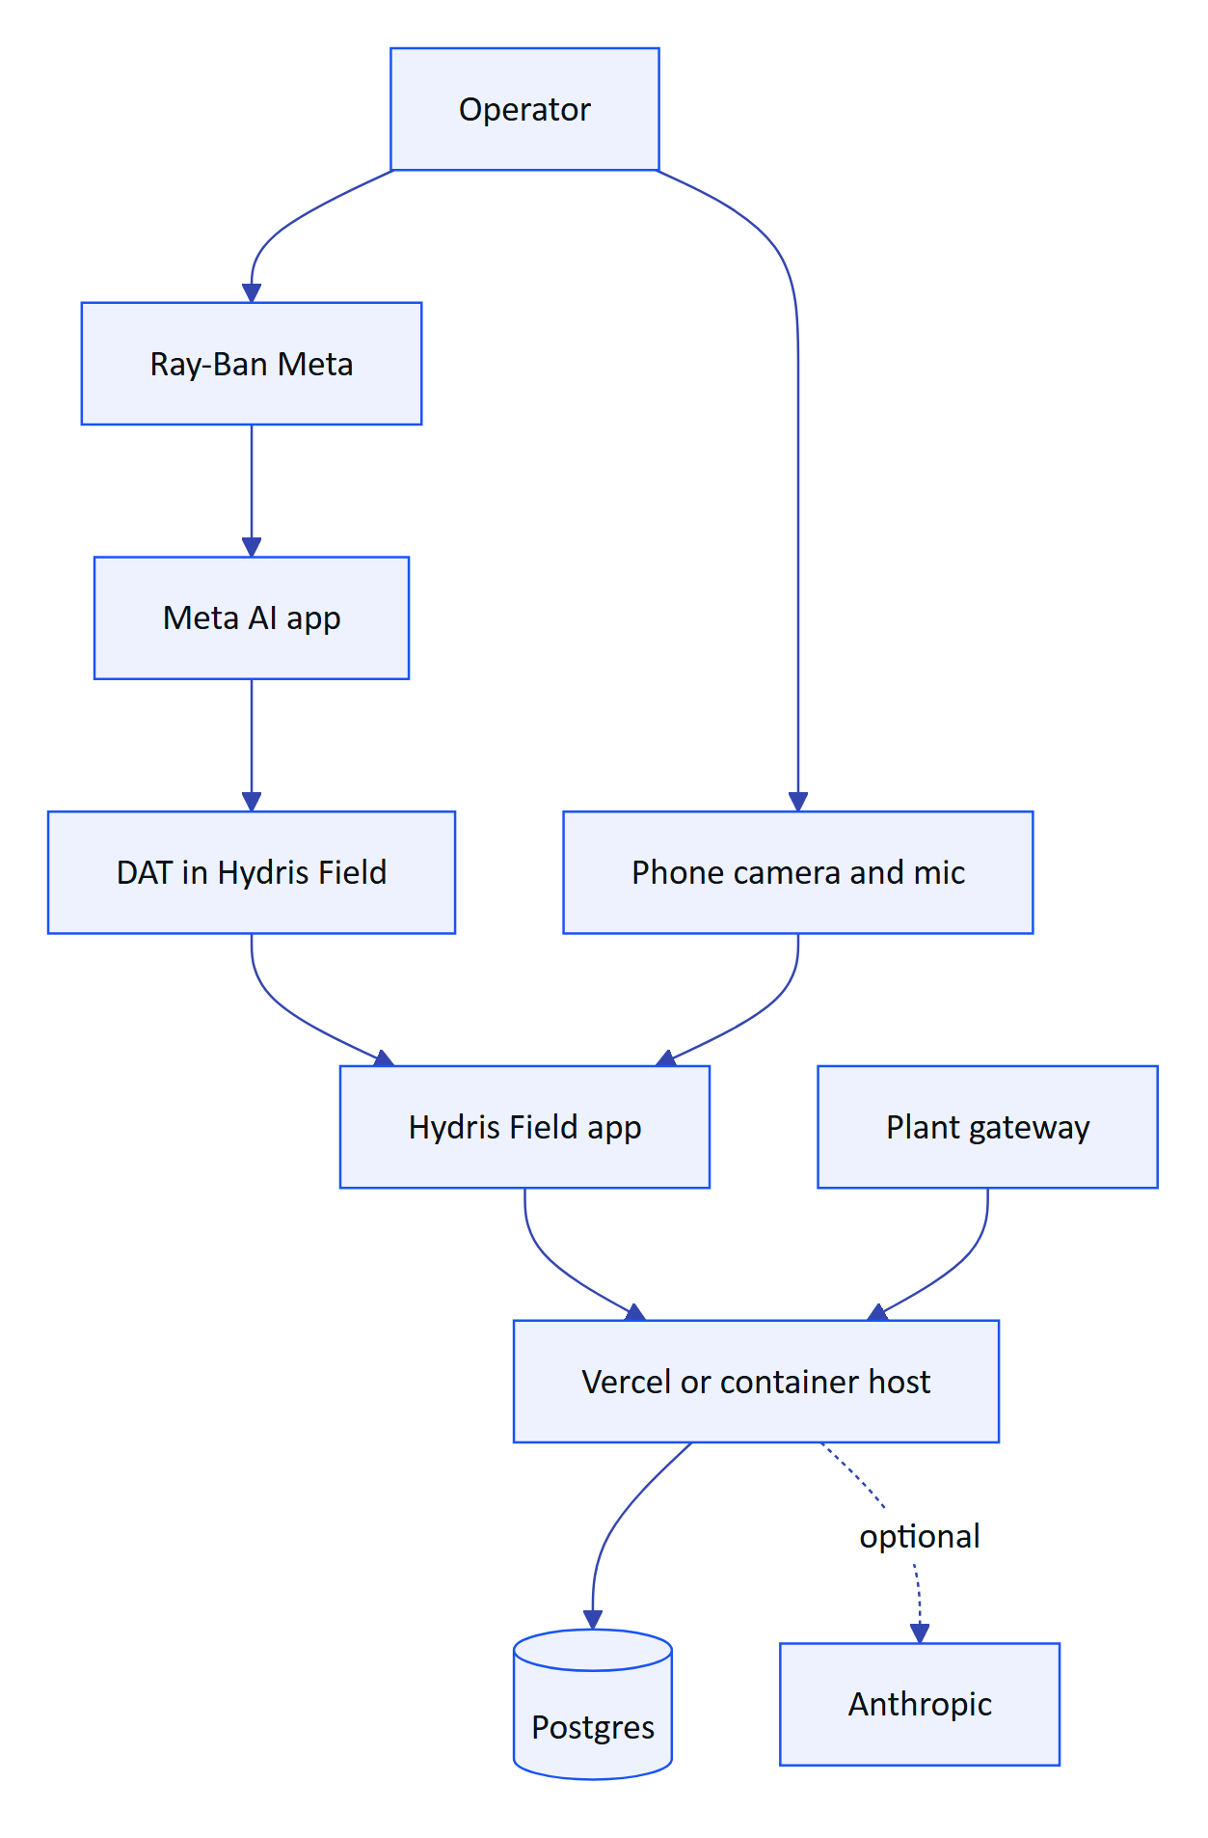
Figure 49. Dependency chain from operator to plant data

2.13 Risks and mitigations
Table 34. Product risks, impact, likelihood and mitigations
# | Risk | Impact | Likelihood | Mitigation | Owner
R1 | Meta DAT publishing remains gated; store submissions not open when we need them | Cannot distribute glasses features at scale | Medium | Pilot in Developer Mode and Developer Center release channels; phone paths ship independently; apply early | Product
R2 | Meta AI app dependency (pairing, registration, permissions, firmware) changes behaviour | Support burden, version drift | Medium | Onboarding checklist; the Glasses screen checks for the Meta AI app and shows link state and a connection log | Mobile
R3 | Glasses paths fail on real hardware | Scan and voice on glasses unusable | Medium | Phase 2 hardware matrix before pilot; phone fallback on every glasses feature | Mobile, QA
R4 | Email not wired | Invitations and resets do not reach users | High until fixed | FR-086 in Hardening; interim admin copy of links | Platform
R5 | Serverless cron runs once a day | Stale-data alarms late on Vercel deployments with real data | High on Vercel Hobby | Move to per-minute cron (Pro plan) or a container host; NFR-008 | Platform
R6 | No CI | Regressions reach the live demo | Medium | NFR-010 in Hardening | Platform
R7 | Android Resolve fails without a note | Operators cannot close the loop on the phone | High | FR-094 fix in Hardening | Mobile
R8 | LLM availability, cost or data-residency objections | Degraded answers; pilot blocked by policy | Medium | Rules engine and OCR-only modes; region-pinned provider option; NFR-040 | Product
R9 | Camera glasses not accepted in a customer's security zones; bystander privacy | Feature disabled on site | Medium | Camera only on intent; UI profile can disable the Scan screen; site camera policy agreed in the pilot contract | Product
R10 | Regulators or auditors do not accept Hydris PDFs as primary records | Paper remains the record | Medium | Keep the searchable original scan inside every PDF; FR-068 e-signatures; early conversations with the SPCB through the pilot customer | Product
R11 | Device refresh token in localStorage on the web glasses app | Token theft on a compromised device | Low for pilot (native app) | Native app with Keystore storage is the pilot path | Security
R12 | Audit page images stored in the database | Database growth and cost | Medium at scale | Move page images to object storage in Hardening | Platform

RISK
The single largest schedule risk is R3 combined with R1: everything that makes Hydris unique on glasses (camera scanning, capture button, glasses microphone) is code-complete but unproven on hardware, and distribution beyond developer mode is in Meta's hands. The plan protects the pilot by making every glasses feature work on the phone first.

2.14 Open questions
Table 35. Open questions, owner and when they must be answered
# | Question | Owner | Needed by
Q1 | Is India among Meta's supported countries for full DAT capabilities and Developer Center access? Written confirmation needed | Product | Before Phase 2
Q2 | When do DAT 1.0 store submissions open, and what review does an unlisted enterprise app need? | Product | Before GA planning
Q3 | Will pilot customers allow camera glasses inside their plants, and in which zones? | Customer success | Pilot contract
Q4 | Which regulators accept a Hydris-generated PDF as the primary record rather than a scanned copy? | Product, pilot customer | Pilot exit
Q5 | Is a separate iOS app needed for pilot or GA customers? | Product | GA planning
Q6 | Must LLM inference run in India for Indian customers, and through which provider? | Security | Before enabling the model for a customer
Q7 | Should acknowledgement on the glasses count as acknowledgement by the assigned operator, or by the device, for compliance reports? | Product, compliance | Pilot
Q8 | What consent-limit data model does FR-120 need (per parameter, per discharge point, per consent version)? | Product | Pilot
Q9 | Which email provider meets deliverability and residency needs (SES Mumbai, Resend, other)? | Platform | Hardening
Q10 | Should the operator handover summary (FR-122) be generated by the model or by deterministic templates? | Product | GA planning

2.15 Glossary
Table 36. Terms used in this document
Term | Meaning
ETP | Effluent treatment plant: treats industrial wastewater before discharge
STP | Sewage treatment plant: treats domestic wastewater
WTP | Water treatment plant: produces process or drinking water
CETP | Common effluent treatment plant: shared ETP serving an industrial cluster
CPCB / SPCB | Central and State Pollution Control Boards in India
OCEMS | Online continuous effluent and emission monitoring system
Consent to operate | SPCB permission that sets a plant's discharge limits
Measurand | A quantity measured by a sensor (pH, dissolved oxygen, COD, and so on)
Freshness | Live, delayed, stale or no data, derived from a sensor's expected interval
Deadband | Hysteresis band that stops an alarm chattering around its threshold
On-delay | Time a breach must persist before an alarm is raised
RLS | Row-level security in Postgres, used for tenant isolation
SSE | Server-sent events, the realtime channel from API to clients
DAT | Meta Wearables Device Access Toolkit for Ray-Ban and Oakley Meta glasses
Meta AI app | Meta's companion app that pairs, registers and updates the glasses
UI profile | Versioned configuration of what a pair of glasses shows and allows
Four eyes | Rule that a second, different person approves what the first verified
Agreement | Whether independent OCR and vision readings of a value match
MoSCoW | Must, Should, Could, Won't prioritisation
Demo mode | Zero-configuration deployment with an in-memory synthetic tenant

2.16 Appendix: traceability to other documents
Each requirement area is specified in more depth in the other documents of the suite. The table shows where to look.
Table 37. Traceability from requirement areas to the documentation suite
Requirement area | ARCHITECTURE | DATA_MODEL | API_REFERENCE | MOBILE_APP_SPEC | GLASSES_INTEGRATION | DESIGN_SYSTEM | DEPLOYMENT | SECURITY_PRIVACY | QA_TEST_PLAN | OPERATIONS_RUNBOOK | ROADMAP
Identity and tenancy (FR-001 to FR-012) | Tenancy, token model | Identity tables, RLS | Auth, org | Sign-in |  |  | Env vars | Controls, STRIDE | Auth tests | Account recovery | Hardening, GA
Telemetry (FR-020 to FR-029) | Telemetry flow | Plant tables | Plant, telemetry | Sensor screens |  | Data states | Jobs | Data classes | Ingestion tests | Gateway onboarding | Advanced
Alarms (FR-030 to FR-038) | Alarm flow | Alarm tables | Alarms | Alarm screens |  | Severity colours | Cron |  | Alarm tests | Alarm triage | Pilot
Work (FR-040 to FR-047) | Offline sync | Work tables | Inspections, maintenance | Work tab | HUD screens |  |  |  | E2E journeys | Rounds setup | Pilot, GA
Devices (FR-050 to FR-059) | Pairing flow | Device tables | Devices, UI profiles | Glasses screen | Capability matrix | HUD | Android distribution | Device threats | Pairing tests | Revoke a device | Phase 2
Android (FR-090 to FR-099) | Containers |  | All client routes | Whole document | DAT flows | Tokens | Play, MDM | Keystore | Hardware matrix | Support | Phase 2 to 4
Audit scanning (FR-060 to FR-069) | Audit scan flow | Audit document tables | Audit documents | Scan screens | Camera bridge | Scan UI | Blob storage | Retention | Audit doc tests | Review backlog | Hardening
Voice (FR-070 to FR-078) | Voice flow |  | Assistant | Assistant screen | Speech bridge | Voice card | Model keys | AI data handling | Voice tests | Model outage | Advanced
Documents (FR-110 to FR-114) |  | Documents | Plant documents |  |  |  |  |  |  | SOP approval | GA
Platform and insights (FR-080 to FR-089, FR-120 to FR-122) | Realtime | Platform tables | Insights, realtime | Home |  | Charts | Topologies | Audit trail | Reports | Backups, incidents | Pilot, GA
Website and demo (FR-100 to FR-103) | Demo topology |  | Public, auth demo | Demo sign-in |  | Website | Demo mode | Demo secrets | Demo tests | Demo resets | Done
Non-functional (NFR-001 to NFR-040) | All | Retention | Errors, limits | Performance budgets | Limits | Accessibility | Scaling, DR | All | Non-functional tests | SLOs | Hardening, GA

NOTE
Every document referenced in this table is part of the suite in docs/product/ and its Word edition in docs/product/word/.

3 Architecture
NOTE
HFG-ARC v2.0 · Draft for review · Owner: Engineering, Hydris. How Hydris Field Glasses is built today, why it is built that way, and how it grows from a pilot plant to a regional fleet

This document describes the software architecture of Hydris Field Glasses: the operator console, the glasses heads-up app and simulator, the native Android companion app "Hydris Field", the API and the shared domain logic. It is written against the repository at commit 07cca23 on main. Every statement about the current system names the file it comes from. Where the code and an older document disagree, the code wins and this document follows the code.
The architecture has one organising idea: one tenant-isolated API, one shared domain model, many thin clients. The website, the console, the glasses HUD, the simulator and the Android app all speak the same JSON and Server-Sent Events contract to one Fastify application. That application can run as a long-lived server, as a container, or inside a Next.js route handler on Vercel, without code changes.
15  API modules  Fastify plugins under `apps/api/src/modules` |  | 147  HTTP routes  Including `/api/health`; counted from the route registrations |  | 42  Database tables  `apps/api/src/db/schema.ts`, 9 SQL migrations |  | 4  Deployable units  Web (with built-in API), API container, Android app, WebView bridge

Status labels used throughout:
Table 38. Status labels
Label | Meaning
Built | On main, exercised by tests or the live demo at https://hydrisview.vercel.app
Partial | On main but incomplete, unverified on hardware, or limited to one topology
Planned | Not in the repository. Design intent only

3.1 Architectural drivers

3.1.1 Business goals and constraints
The architecture is shaped by a small set of goals that come from the product requirements (PRD.md) and from the environment the product runs in: water and wastewater plants (ETPs, STPs, CETPs) where operators wear gloves, stand on ladders and work far from the control room.
Table 39. Architectural drivers
Driver | What it demands of the architecture | Where it shows up
Read-only to the plant | No write path to PLC, SCADA or DCS. Telemetry is pushed in, never pulled out of control networks | POST /api/ingest/v1/readings only accepts readings (modules/telemetry.ts)
Strict tenant isolation | A missing WHERE clause must not leak another customer's data | Postgres RLS on every tenant table (drizzle/0001_rls.sql, db/tenant.ts)
Hands-free field use | Short, spoken, glanceable interactions; tolerate flaky Wi-Fi | Glasses HUD (apps/web/src/glasses), voice (modules/voice-assistant.ts), offline queue (glasses/link.ts)
Defensible records | Every reading, correction and approval must be attributable and append-only | audit_events, telemetry_corrections, audit_document_events grants
Zero-configuration demo | A prospect opens a URL and gets a live, believable plant | Demo mode (apps/api/src/demo.ts, core/demo-shared.ts)
Small team, fast iteration | One language, one repository, one deployable for most customers | TypeScript monorepo, modular monolith
Hardware churn | Meta glasses SDKs change quickly; the display glasses are not yet broadly available | Device integration isolated behind SecureStore, camera and voice adapters

3.1.2 Architecture principles
- The API is the product boundary. Clients hold no business rules that the API does not also enforce. packages/domain/src/roles.ts says it plainly: the matrix is the single source of truth, "the API enforces it on every request and clients only use it to decide what to show".
- Pure logic lives in packages/domain. State machines, threshold evaluation, unit normalisation, OCR structuring and UI profile resolution have no I/O and are unit-tested in isolation.
- Defence in depth for tenancy. Role checks in handlers, site scoping in queries, and row-level security in the database. Any one layer failing does not expose data.
- One ingestion path. Gateways, manual entry, laboratory entry and the simulator all go through ingest() in modules/telemetry.ts. Alarms cannot be raised by a side door.
- Runtime portability. The same buildApp() (apps/api/src/app.ts) runs under server.ts (long-lived), serverless.ts (Vercel) and the test harness.
- Events are hints, the database is truth. Realtime events tell clients what to refetch. Losing or duplicating one never corrupts state.

3.2 System context

3.2.1 Context diagram
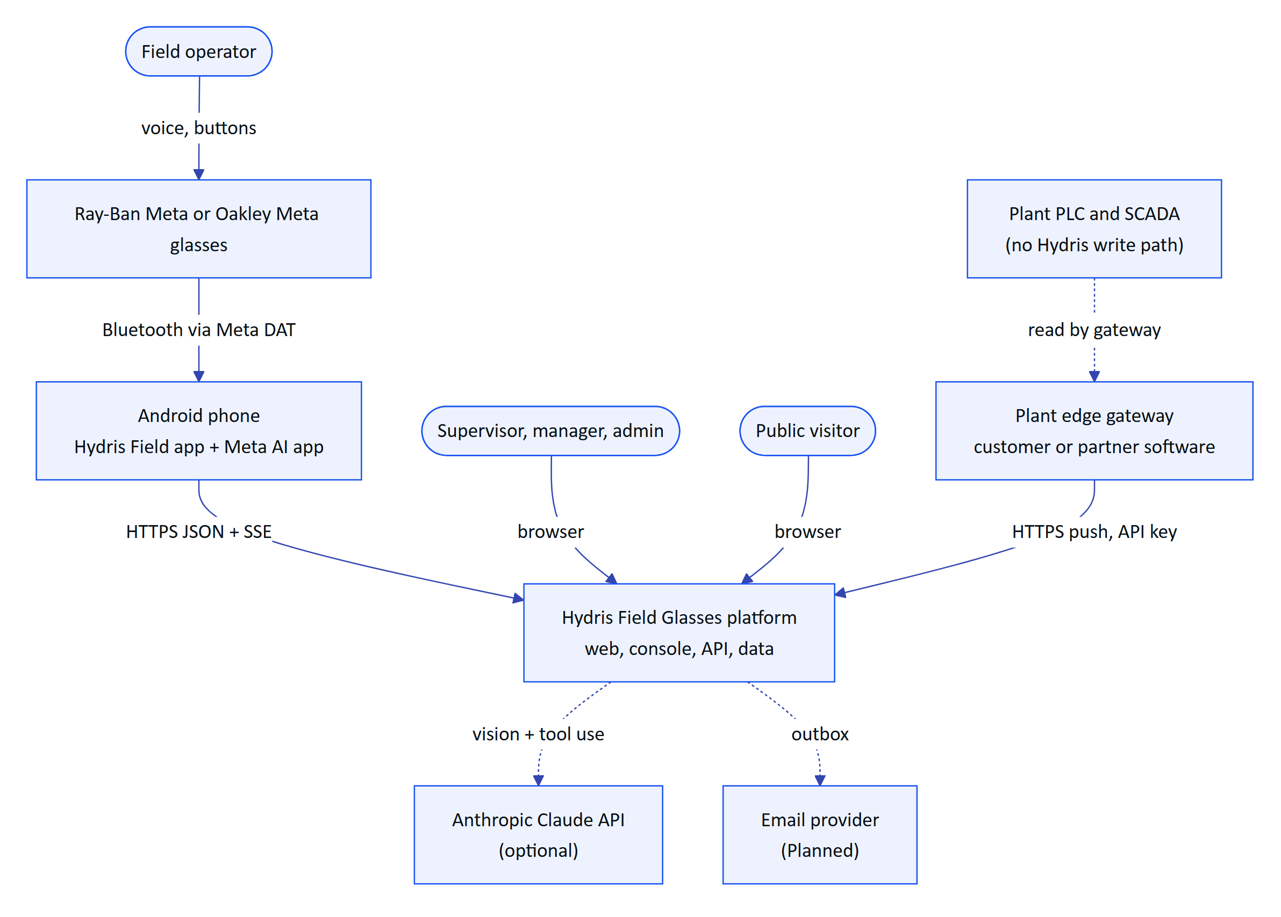
Figure 50. System context (C4 level 1). Hydris sits beside the plant control system, never inside it.

3.2.2 Actors and external systems
Table 40. Actors and external systems
Element | Kind | Interaction | Status
Field operator | Person | Glasses HUD, Android app, voice | Built (web HUD, Android app). Partial on real glasses hardware
Supervisor, maintenance engineer, manager, org admin | Person | Operator console (/console) | Built
Platform admin | Person | /console/platform, /api/platform/organizations | Built
Public visitor | Person | Website, live glasses demo, contact form | Built
Meta glasses | Device | Camera, microphone, capture button through the Meta Wearables Device Access Toolkit (DAT) 1.0.1 | Partial (code complete, limited hardware verification)
Plant edge gateway | System | Pushes readings with a hgw_ key | Built (endpoint). Gateway software itself is Planned
Anthropic Claude API | System | Document vision extraction and voice assistant tool use | Built, optional (enabled by ANTHROPIC_API_KEY)
Email provider | System | Invitations and password reset | Planned. Messages are written to mail_outbox (core/services.ts)

IMPORTANT
Hydris never connects to a PLC, SCADA or DCS and has no endpoint that writes to one. Ingestion is outbound HTTPS from the plant to Hydris. This keeps Hydris outside IEC 62443 control zones and means a compromise of Hydris cannot change the physical process.

3.3 Containers

3.3.1 Container diagram
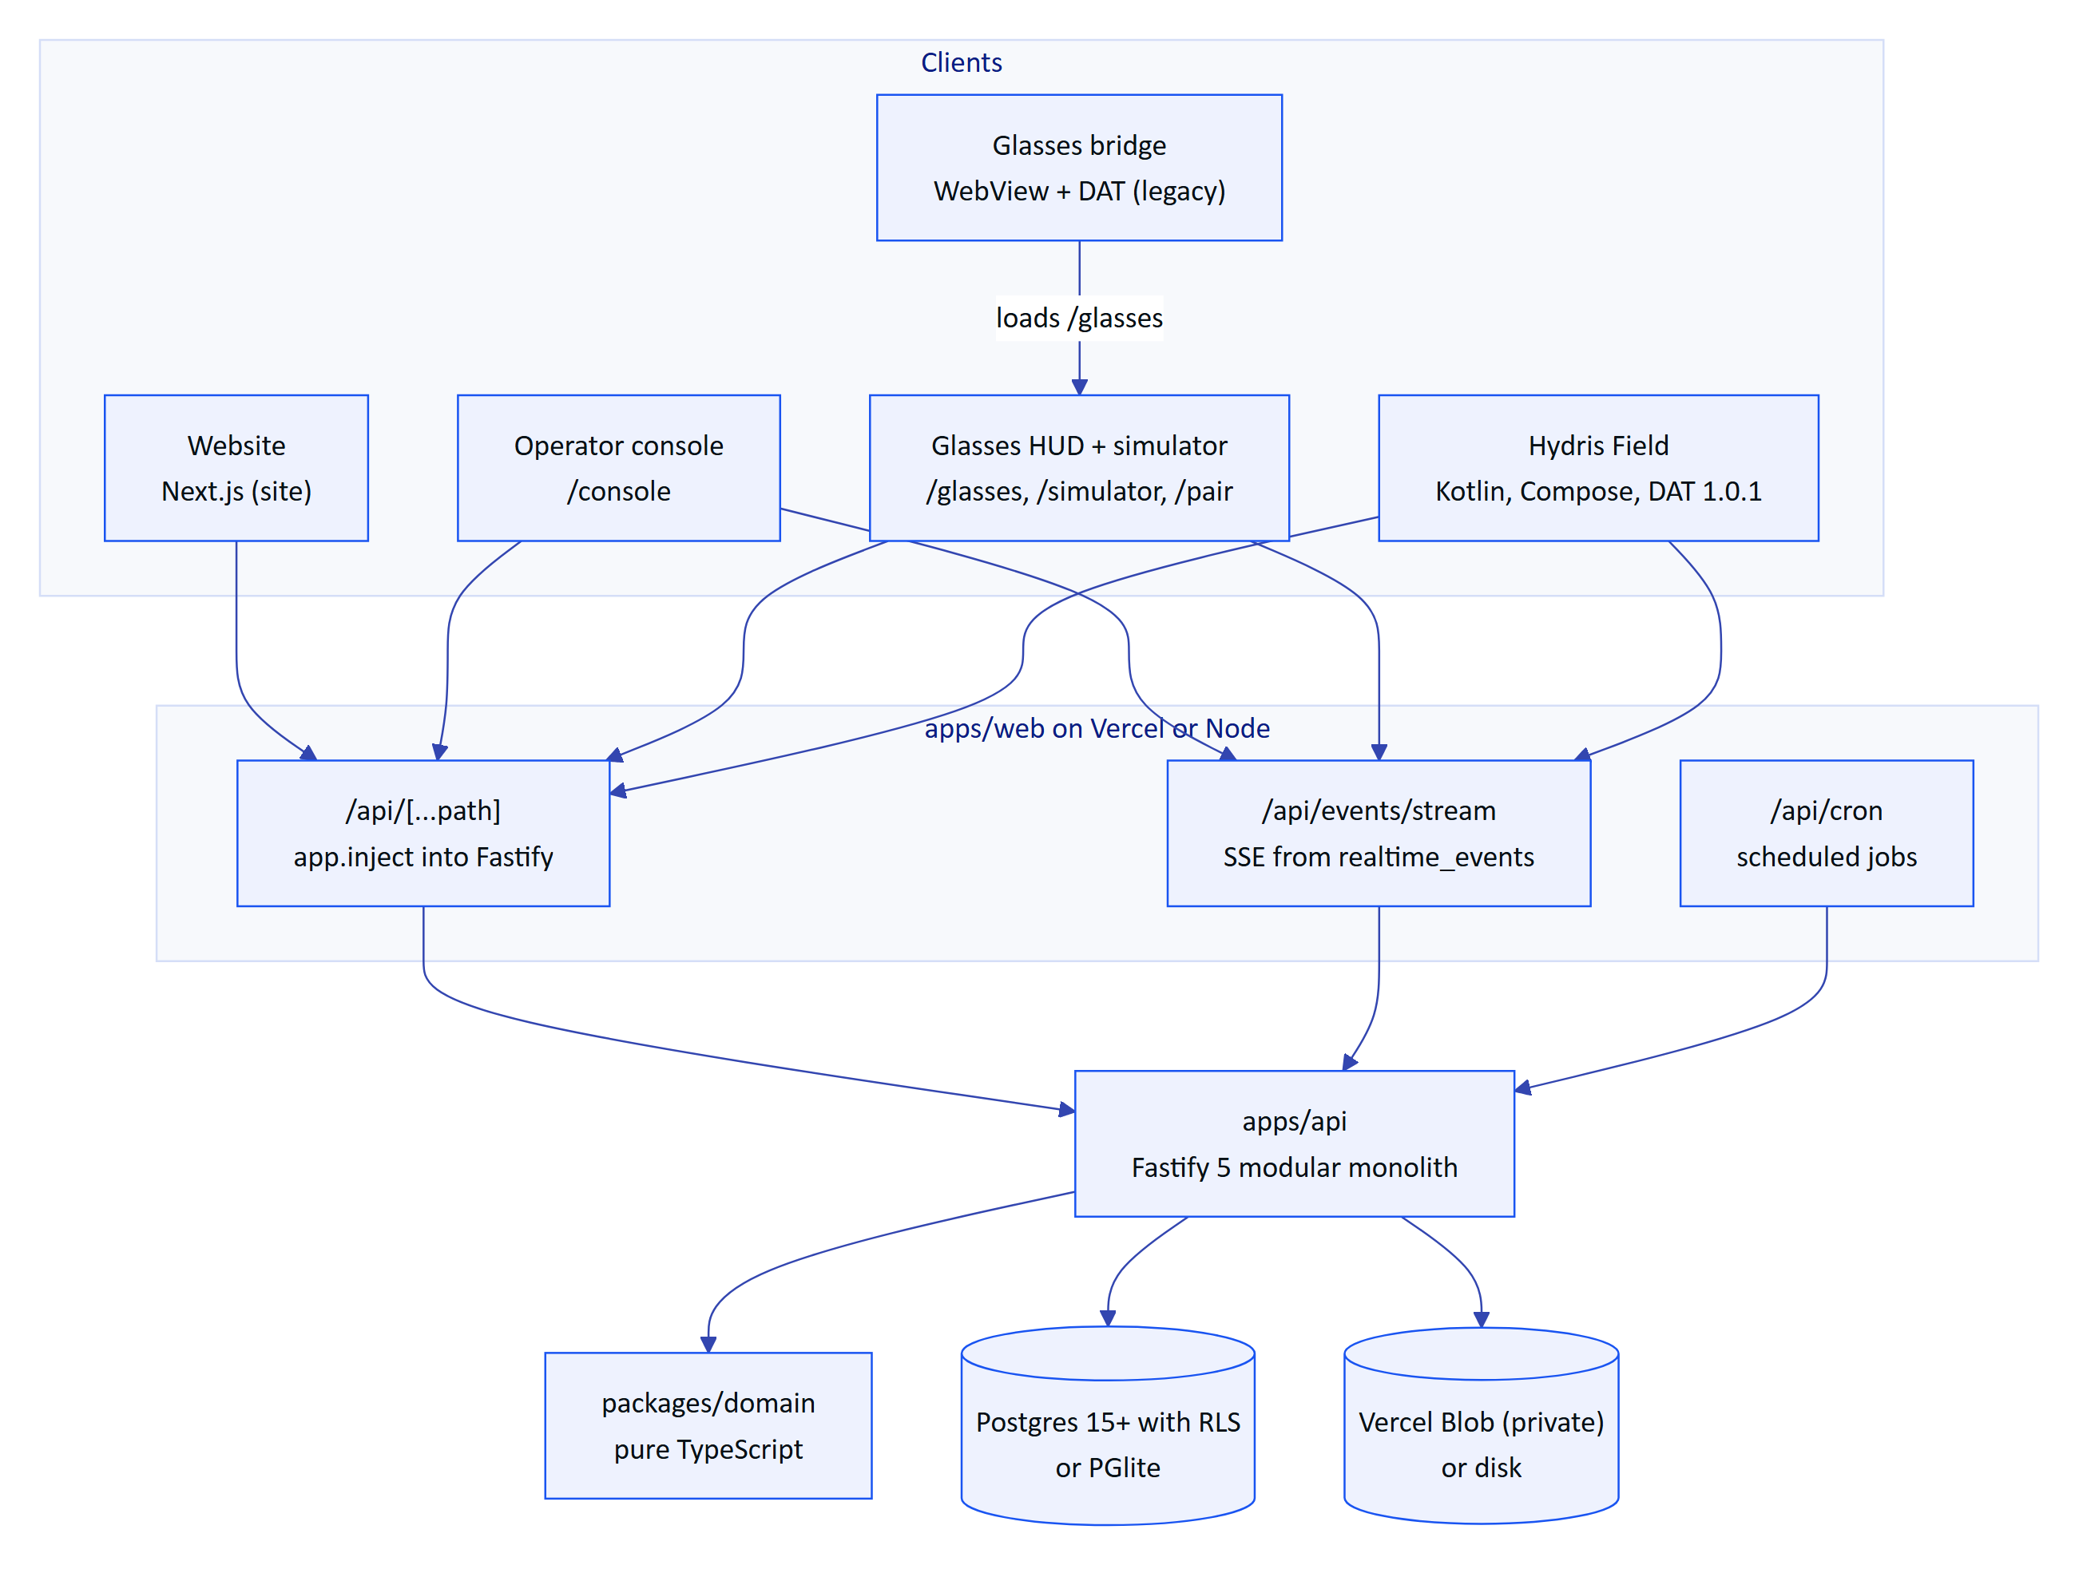
Figure 51. Containers (C4 level 2). The API can run inside the web deployment or as its own container.
Table 41. Containers and technology
Container | Technology (versions from package.json and build.gradle.kts) | Key files | Status
API | Fastify 5.12.7, zod 4.6.7, Drizzle ORM 0.45.4, pg 8.23.1, PGlite 0.5.9, @fastify/jwt, @fastify/rate-limit, @node-rs/argon2, pdf-lib, @anthropic-ai/sdk 0.137.0 | apps/api/src/app.ts, modules/*, core/* | Built
Web | Next.js 16.4, React 19.3, TanStack Query 5, Tailwind 4, Radix UI, Recharts, Tesseract.js 7 | apps/web/src/** | Built
Domain | TypeScript, no runtime dependencies | packages/domain/src/* | Built
Contracts | Placeholder package (export {}) | packages/contracts/src/index.ts | Planned
Hydris Field (Android) | Kotlin, Jetpack Compose (BOM 2026.05.01), OkHttp 4.12, CameraX 1.4.2, ML Kit text recognition 16.0.1, DAT 1.0.1 (core, camera, speech, inputs) | apps/android/app/src/main/java/ai/hydris/field/** | Built (Partial on hardware)
Glasses bridge | Kotlin, Android WebView, DAT 1.0.1 | apps/glasses-bridge-android/.../MainActivity.kt | Partial, superseded by Hydris Field
Database | Postgres 15+ (Neon, Render, Supabase, self-hosted Postgres 17 in Compose) or PGlite in-process | apps/api/drizzle/0000 to 0008 | Built
File storage | Vercel Blob private store or local disk | core/services.ts (createStorage) | Built

3.3.2 Repository layout
The repository is an npm workspaces monorepo (package.json, "workspaces": ["packages/*", "apps/*"], Node 22.x). The web app depends on the API package directly ("@hydris/api": "0.2.0") and imports @hydris/api/serverless, which is how the API runs inside Next.js.
Table 42. Workspaces
Workspace | Package name | Role
packages/domain | @hydris/domain | Roles, permissions, measurands, alarm and workflow state machines, device lifecycle, UI profiles, audit document structuring, voice parsing, simulation scenarios
packages/contracts | @hydris/contracts | Reserved for shared request and response schemas (empty today)
apps/api | @hydris/api | HTTP API, database schema and migrations, seeds, jobs, demo runtime
apps/web | @hydris/web | Website, console, glasses HUD, simulator, pairing page, built-in API route handlers
apps/android | Gradle project | Native operator app with glasses integration (not an npm workspace member in practice: no package.json)
apps/glasses-bridge-android | Gradle project | WebView companion that bridges DAT into the web HUD

DECISION
One monorepo, one language on the server and web. The API, web and domain packages share TypeScript types without a publishing step, and a change to a state machine lands in one commit across server and clients. The Android app is the exception: it mirrors the JSON contract by hand in Models.kt until packages/contracts produces a schema that Kotlin can consume (see the technical debt register).

3.4 API: a modular monolith

3.4.1 Component view
buildApp() in apps/api/src/app.ts creates one Fastify instance, registers shared plugins (helmet, cookie, global rate limit, JWT, multipart), installs the error handler and the glasses UI profile hook, then registers fifteen route modules under the /api prefix. Every module receives the same Ctx (apps/api/src/context.ts): database handle, event bus, configuration, storage adapter and the live-device map.
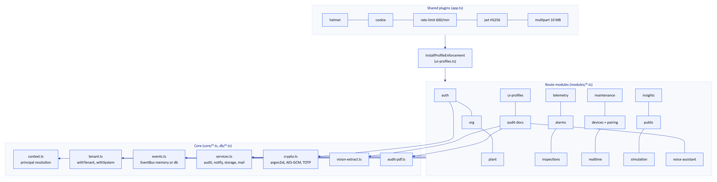
Figure 52. API components (C4 level 3). Modules share the context object and the core services, never each other's tables directly except through exported functions.
Table 43. API modules
Module | Routes | Responsibility | Notable rules
auth.ts | 17 | Login, demo guest login, MFA (TOTP), refresh rotation, logout, invitations, password reset, sessions, org switch | Lockout after 5 failures for 15 min, refresh reuse detection with a 30 s grace
org.ts | 13 | Organization, members, invitations, notifications, audit log, platform organizations | No role escalation (assignableRoles)
plant.ts | 28 | Sites, facilities, process areas, assets, sensors, gateways, documents, attachments, hierarchy, history | Attachments only served through the authorised route
telemetry.ts | 6 | Gateway ingestion, manual and lab entry, downsampled history, CSV export, corrections | Single ingest() path, idempotent on (sensor_id, ts)
alarms.ts | 9 | Alarm rules, alarm list and detail, transitions, stale-data evaluation | Deadband and on-delay, note required to resolve
inspections.ts | 15 | Templates, routes, inspections, step responses, submit and review | Offline replay by clientOpId, revision counter
maintenance.ts | 7 | Work orders, checklists, activity | Transition table in domain/workflows.ts
devices.ts | 16 | Pairing challenges, approval, device refresh, device context, fleet admin | RFC 8628 shape, session version, refresh family revocation
realtime.ts | 1 | GET /api/events/stream (SSE) | Per-connection canReceive authorisation
insights.ts | 4 | Overview KPIs, grounded document assist, search, reports | Read-only
public.ts | 1 | Website contact and demo requests | 5 requests per 10 min
simulation.ts | 3 | Start, stop and inspect demo scenarios | Synthetic data rejected for non-demo tenants
ui-profiles.ts | 13 | Glasses UI profiles, versions, assignments, effective profile | Enforced on device requests by an onRoute hook
audit-docs.ts | 12 | Scanned audit documents: capture, enhance, review, verify, approve, PDF | Four-eyes approval, optimistic concurrency
voice-assistant.ts | 1 | POST /api/assistant/ask | Claude tool use or deterministic rules, 60 per min

Route counts come from the app.get/post/put/patch/delete registrations; devices.ts registers suspend, reactivate and revoke in one loop and is counted as three.

3.4.2 Request lifecycle
Every authenticated request follows the same path. In the built-in API mode on Vercel, the path starts in a Next.js route handler that forwards the request into Fastify with app.inject (apps/web/src/app/api/[...path]/route.ts), so there is no network hop between the web and the API.
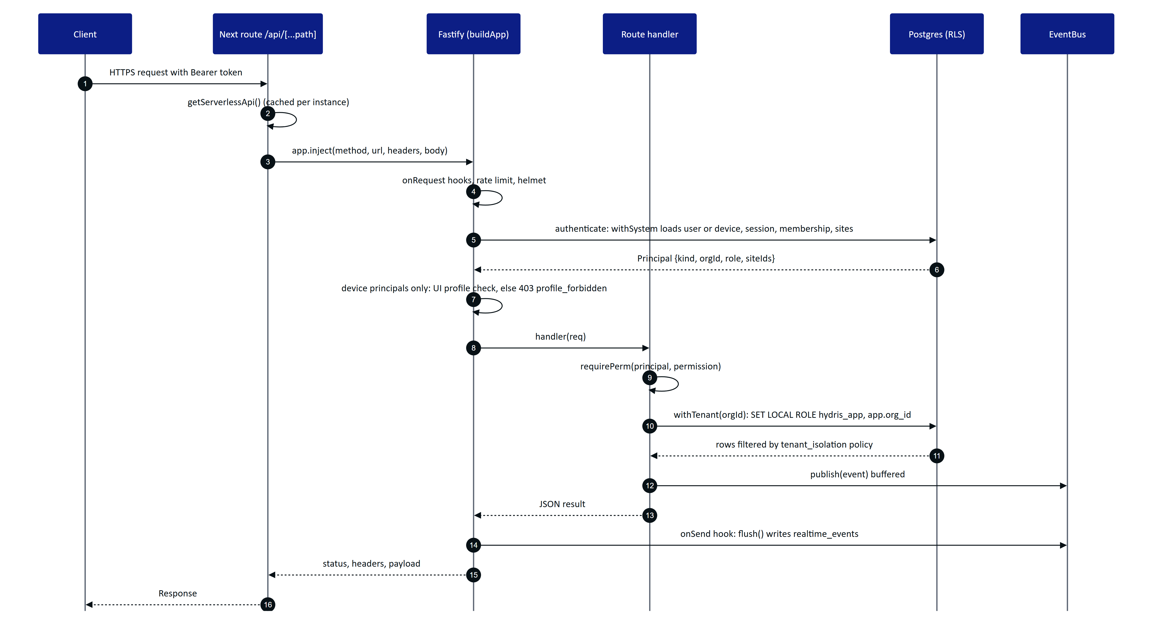
Figure 53. Request lifecycle for an authenticated call in the built-in API mode, from the Next.js route to the RLS-protected query and the event flush.
The order matters in three places:
- Principal resolution re-checks revocation on every request. resolveTokenPrincipal() loads the user status, confirms the session family in auth_sessions has not been revoked, and reloads the membership and site list. A device token is rejected if the device is not active, its session_version changed, or it has no current assignment. Logout and revocation therefore take effect on the next request, not when the 15 minute access token expires.
- The UI profile hook runs after authentication. installProfileEnforcement() is registered before the modules so that its onRoute hook can append a check to the matching routes. It only applies to device principals: a pair of glasses whose profile hides the alarms screen gets 403 profile_forbidden from GET /api/alarms even if the operator's role allows it.
- Events are written after the handler returns. In db realtime mode the bus buffers publishes and the onSend hook calls flush(), so event rows are inserted outside the handler's transaction (core/events.ts).

3.4.3 Error contract
All errors use one shape, produced by the error handler in app.ts and the helpers in core/errors.ts:
{ "error": { "code": "validation_failed", "message": "Some fields are invalid", "details": [{ "path": "readings.0.ts", "message": "Invalid ISO datetime" }] } }
Table 44. Error mapping
Source | Status | Code
HttpError thrown by a handler | As thrown (400, 401, 403, 404, 409) | As thrown, for example note_required, invalid_transition, stale
ZodError from request parsing | 400 | validation_failed, with details[] per field
Rate limiter | 429 | rate_limited
Anything else | 500 | internal_error, message masked as "Unexpected server error", stack logged
API failed to start (route handler) | 503 | service_unavailable with a short detail
SSE route in the wrong realtime mode | 503 | realtime_misconfigured

Records outside the caller's site scope return 404, not 403 (requireSite() in core/principal.ts), so a user cannot probe for the existence of another site's assets or alarms.

3.5 Domain model

3.5.1 Key domain types
packages/domain is the vocabulary of the system. It has no I/O and is imported by the API, the web app and (by convention, mirrored by hand) the Android app.
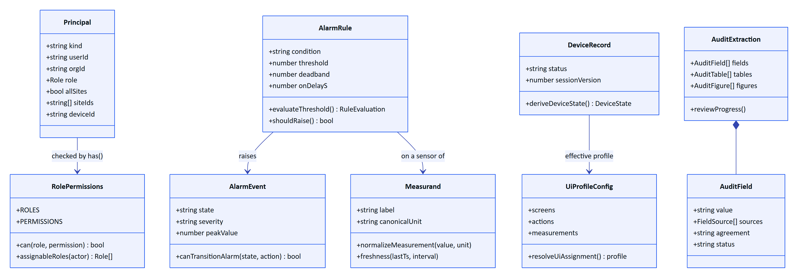
Figure 54. Key domain types and the functions that own their rules (packages/domain/src and apps/api/src/core/principal.ts).
Table 45. Domain modules
File | Owns | Used by
roles.ts | 6 roles, the permission list, ROLE_PERMISSIONS, assignableRoles, SITE_SCOPED_BY_DEFAULT | API authorisation, console navigation, Android visibility
measurands.ts | Measurand definitions (label, units, conversions, typical range, decimals), normalizeMeasurement | Ingestion, charts, voice answers
freshness.ts | live, delayed, stale, no_data from last timestamp and expected interval | Console, HUD, stale-data alarms
alarms.ts | Severities, conditions, states, ALARM_TRANSITIONS, evaluateThreshold (deadband), shouldRaise (on-delay) | Alarm engine, console, HUD
workflows.ts | Inspection and maintenance state machines, step kinds, progress | Inspections and maintenance modules
devices.ts | Device states, deriveDeviceState, pairing alphabet (30 characters), length 8, TTL 300 s, poll interval 3 s | Pairing, fleet views
uiprofile.ts | Screens, widgets, actions, text scales, precedence device then user then role then org | Profile enforcement, HUD
auditdoc.ts | OCR types, key/value and table structuring, cross-check, plausibility, agreement score | Audit scan pipeline on client and server
voice.ts | Wake phrase regex (WAKE_RE), utterance normalisation, measurand detection | Web voice, rules engine
scenarios.ts, random.ts, catalog.ts | Simulation scenarios with deterministic noise, enumerations | Simulator, seeds

3.5.2 Alarm state machine
Alarm transitions are data, not code paths: ALARM_TRANSITIONS in packages/domain/src/alarms.ts lists for each action the allowed source states, the target state, the permission and whether a note is required. transitionAlarm() in modules/alarms.ts applies it, writes alarm_event_history, appends an audit event and publishes alarm.updated. The transitions are: acknowledge (active to acknowledged), investigate (active or acknowledged to investigating), resolve (acknowledged or investigating to resolved, note required) and close (resolved to closed). The condition clearing (clearedAt) is separate from the human workflow: an alarm whose value returned to normal stays open until someone acknowledges and resolves it.

3.6 Data architecture and tenancy

3.6.1 Schema overview
apps/api/src/db/schema.ts defines 42 tables. DATA_MODEL.md documents each column; this chapter covers the structural decisions.
Table 46. Table groups
Group | Tables | Notes
Identity and tenancy | users, organizations, memberships, membership_sites, invitations, auth_sessions, auth_tokens, mail_outbox | users is global; membership is per organization
Plant model | sites, facilities, process_areas, assets, gateways, sensors, documents, attachments | Hierarchy site, facility, process area, asset, sensor
Telemetry and alarms | telemetry_readings, telemetry_corrections, alarm_rules, alarm_events, alarm_event_history | Readings are immutable; corrections supersede for display
Work | inspection_templates, inspection_routes, inspections, inspection_responses, maintenance_tasks, maintenance_activity | inspections.revision for optimistic concurrency
Devices | devices, device_assignments, pairing_challenges, device_sessions | Assignment history is kept (unassigned_at)
Glasses UI | ui_profiles, ui_profile_versions, ui_profile_assignments | Versioned configuration
Audit documents | audit_documents, audit_document_pages, audit_document_events | Page images stored in the database as base64 text
Platform | notifications, audit_events, inquiries, simulation_runs, realtime_events | realtime_events is system-only

telemetry_readings uses a bigint identity key, a unique index on (sensor_id, ts) that makes ingestion idempotent, a descending (sensor_id, ts) index for latest-value and history reads, and an (org_id, ts) index. There is no partitioning or retention policy yet.

3.6.2 Row-level security
Tenant isolation is enforced by Postgres, not only by application code.
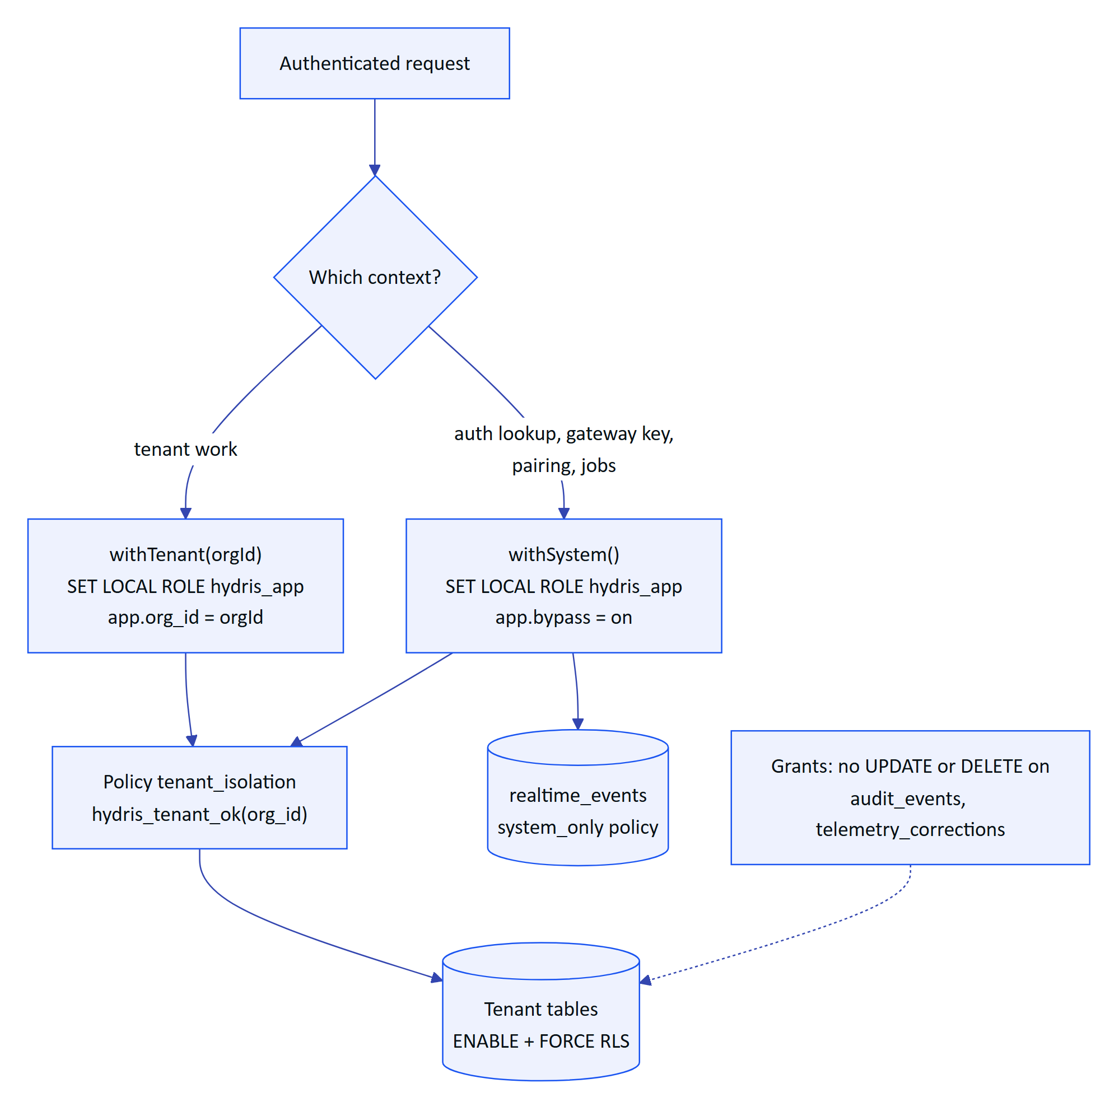
Figure 55. How a request reaches tenant rows. Both contexts run as the non-privileged hydris_app role; only the session settings differ.
The mechanics, from drizzle/0001_rls.sql, 0003, 0006, 0008 and db/tenant.ts:
- hydris_app is created NOLOGIN and without BYPASSRLS. Migration 0004_app_role_membership.sql grants the connecting owner role membership WITH SET TRUE so that managed Postgres (PG16+) allows SET ROLE.
- hydris_tenant_ok(row_org) returns true when app.bypass is on or when row_org equals app.org_id. Every tenant table has a tenant_isolation policy USING and WITH CHECK that function, so both reads and writes are checked.
- withTenant() and withSystem() each open a transaction and use SET LOCAL and set_config(..., true), so settings cannot leak to the next request on a pooled connection.
- audit_events and telemetry_corrections have UPDATE and DELETE revoked from hydris_app, and audit_document_events has only SELECT and INSERT. Even system context cannot rewrite history.
- realtime_events uses a system_only policy: clients never read it directly; the stream reads it in system context and filters per connection.
DECISION
Postgres RLS as the last line of tenant isolation. The application already filters by organization and site. RLS makes a forgotten WHERE clause a non-event instead of a data breach, and it lets a security reviewer verify isolation by reading 46 lines of SQL instead of every query. The cost is that every request runs in a transaction, and system work must be explicit (withSystem), which is a useful signal in code review.

3.6.3 Append-only records and provenance
- A manual or lab reading is stored as an ordinary immutable reading; the audit row (telemetry.manual_entry) is the provenance record of who entered it (modules/telemetry.ts).
- Corrections never overwrite telemetry_readings. A telemetry_corrections row supersedes the value for display and aggregation, and history queries compute effective values with a lateral join.
- Audit document reviews keep the first extracted value in extracted and write every confirm, correct, flag, verify and approve action to audit_document_events.
- Synthetic data is marked (synthetic = true) and ingest() refuses simulator data for any tenant that is not a demo organization (synthetic_not_allowed).

3.6.4 Migrations
Nine SQL migrations (apps/api/drizzle/0000_init.sql to 0008_audit_documents_rls.sql) are generated by drizzle-kit and applied by the Drizzle migrator. On Postgres, createDatabase().migrate() takes a session-level advisory lock (key 4872917633) on a dedicated connection, so several serverless instances cold-starting at once, or a deploy and an instance, cannot run migrations concurrently (db/client.ts). On Vercel the migrations folder is shipped with the functions through outputFileTracingIncludes in apps/web/next.config.ts and located at runtime by findMigrationsFolder().

3.7 Identity, sessions and tokens

3.7.1 Token model
Table 47. Credentials
Credential | Format and lifetime | Held by | Revocation
User access token | JWT HS256 {typ: user, sub, org, sid}, 15 min (12 h in demo mode) | Client memory only | sid is the refresh family; revoking the family invalidates access tokens on the next request
User refresh token | 48 random bytes, SHA-256 stored in auth_sessions, 7 days, cookie hg_refresh (httpOnly, SameSite=Strict, path /api/auth, Secure in production) | Browser cookie jar; Android encrypted cookie store | Rotation on every use; replay after 30 s revokes the family
MFA challenge | JWT {typ: mfa}, 5 min | Client | Single step
Device access token | JWT {typ: device, sub, org, sv}, 15 min | Device memory | devices.session_version bump, suspend, revoke, unassign
Device refresh token | hgd_ plus 40 random bytes, device_sessions, 30 days, rotating | Android Keystore-encrypted store; web localStorage | Reuse revokes the family and is audited (device.refresh_reuse_detected)
Gateway key | hgw_ prefix, SHA-256 in gateways.key_hash | Gateway | POST /api/gateways/:id/revoke
Demo session cookie | Signed JWT hg_demo | Browser | Demo mode only
Demo device refresh | hgd_z plus HMAC-signed claims (org, device, user, site, version) | Device | Demo mode only

Passwords are hashed with argon2id (memory 19456 KiB, time cost 2, parallelism 1) and a dummy verification burns equal time for unknown emails (core/crypto.ts). TOTP secrets are encrypted at rest with AES-256-GCM under DATA_KEY.

3.7.2 Refresh rotation and reuse detection
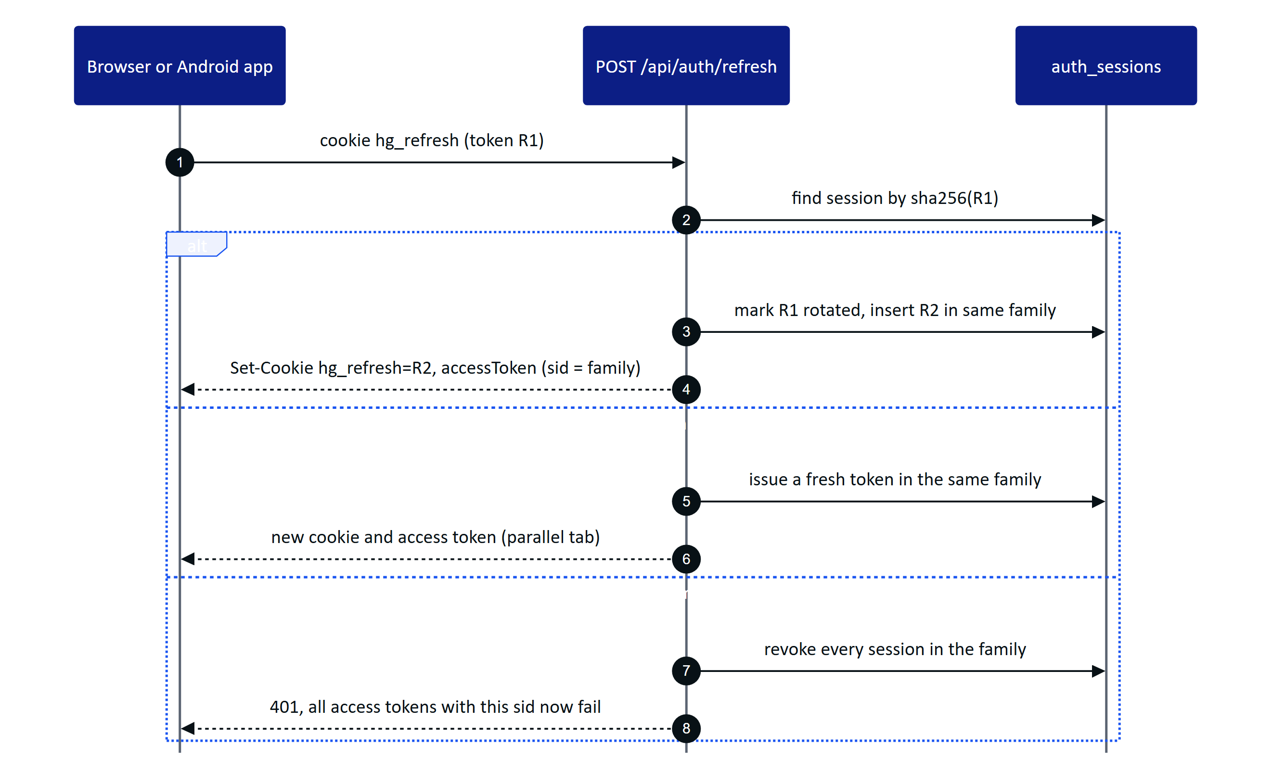
Figure 56. User refresh rotation with family revocation (modules/auth.ts). The 30 s grace absorbs parallel tabs; a later replay is treated as theft.
Clients refresh with a single-flight guard so parallel 401s trigger one refresh: refreshSession() in apps/web/src/lib/api.ts, refresh() in apps/web/src/glasses/link.ts, and a coroutine Mutex in HydrisApi.kt on Android.

3.7.3 Session and token states
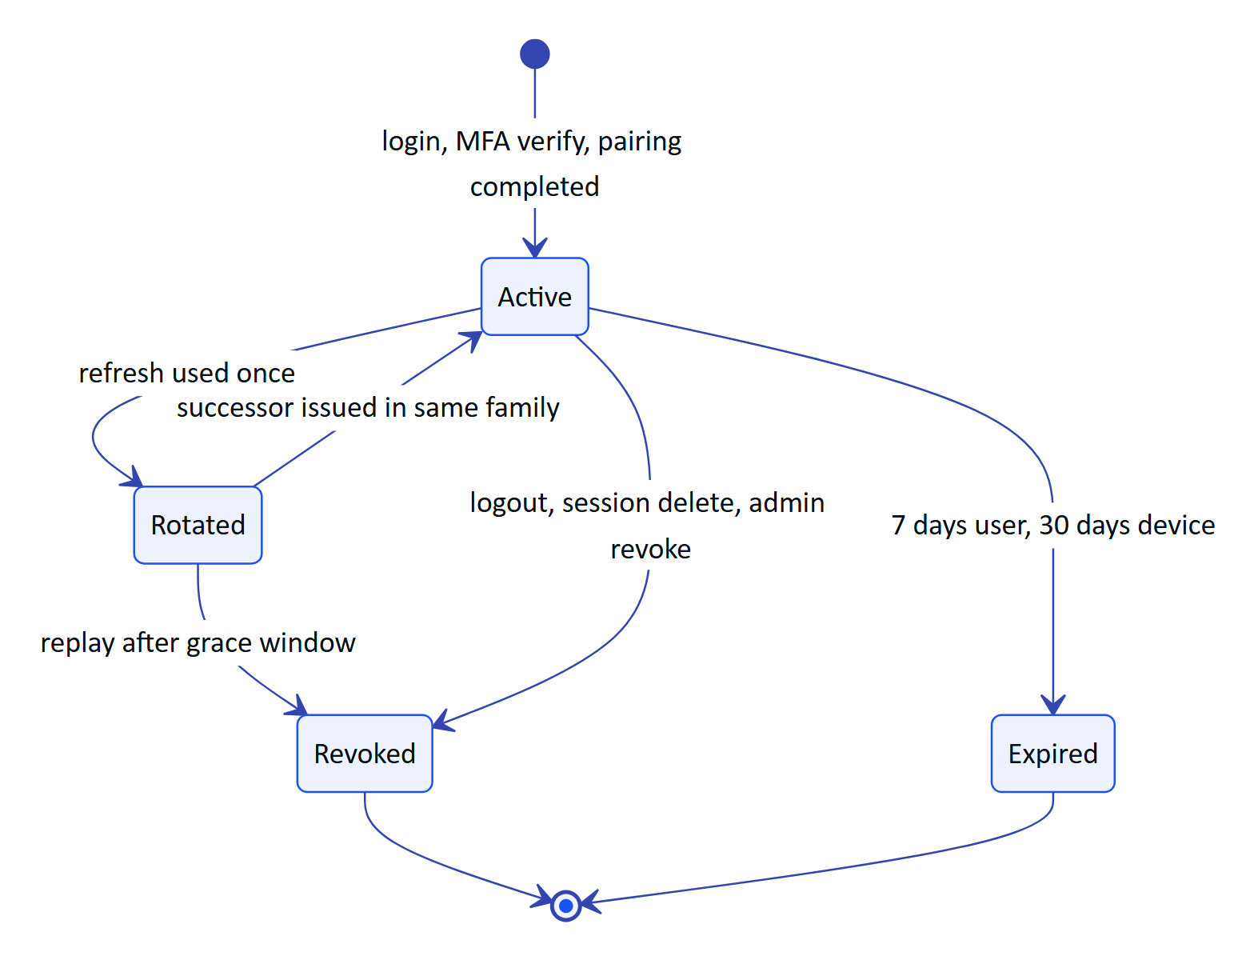
Figure 57. Lifecycle of a refresh-token family (user sessions in auth_sessions, device sessions in device_sessions).

3.7.4 Principals and permissions
A verified token becomes a Principal (core/principal.ts). Devices act on behalf of their assigned operator: a device principal carries the operator's userId, role and sites, and has() additionally requires the permission to be in DEVICE_PERMISSIONS, a fixed set of 13 permissions (read site, asset, telemetry, alarm, inspection, maintenance, document and audit document data; acknowledge alarms; execute inspections and maintenance; request maintenance; capture audit documents). Glasses therefore can never verify or approve a document, manage members or edit rules, whatever the operator's role. Audit document verification and approval add an explicit p.kind !== 'user' check on top.

3.8 Devices and pairing

3.8.1 Pairing flow
Pairing follows the shape of the OAuth 2.0 Device Authorization Grant (RFC 8628). The glasses or the app requests a challenge, shows a short code and a QR link, and a signed-in person approves it. The QR encodes only the verification URL and the short code, never a credential.
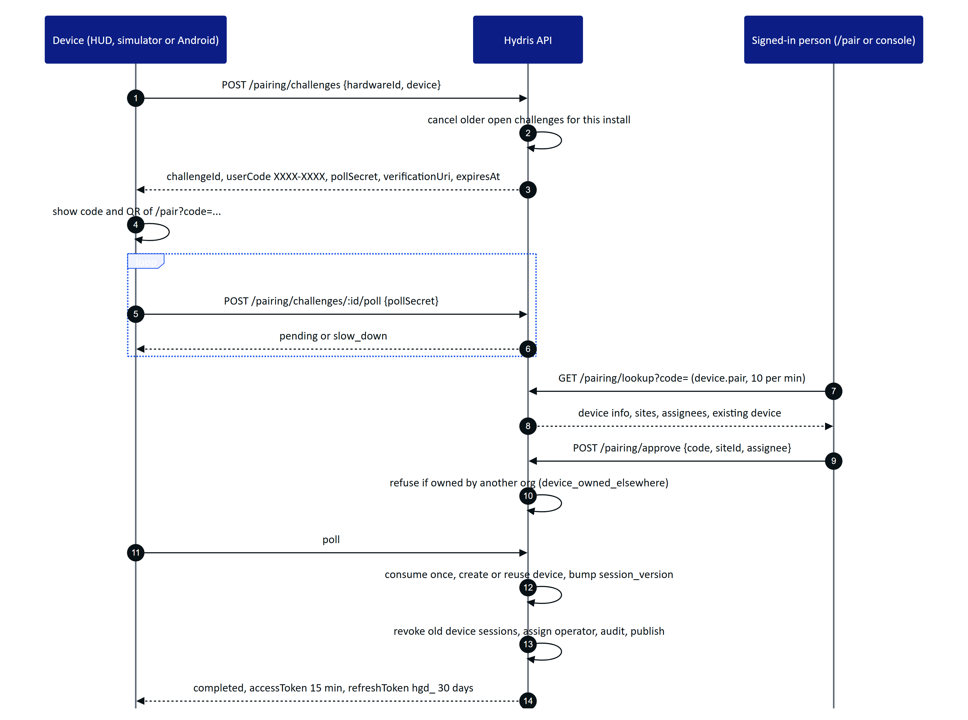
Figure 58. Device pairing (modules/devices.ts). The poll secret is never displayed; the code is single use and expires after 300 s.
The Android app uses the same endpoints but approves its own challenge with the signed-in user's session: Repository.registerGlasses() creates the challenge with the DAT hardware id, looks the code up, approves it for the first site the user can see, and polls for the tokens. The web HUD, the simulator and the companion bridge use the two-device flow shown above.
Figure 59. The pairing page on a phone: the operator enters or scans the short code and picks the site and assignee.

3.8.2 Device lifecycle
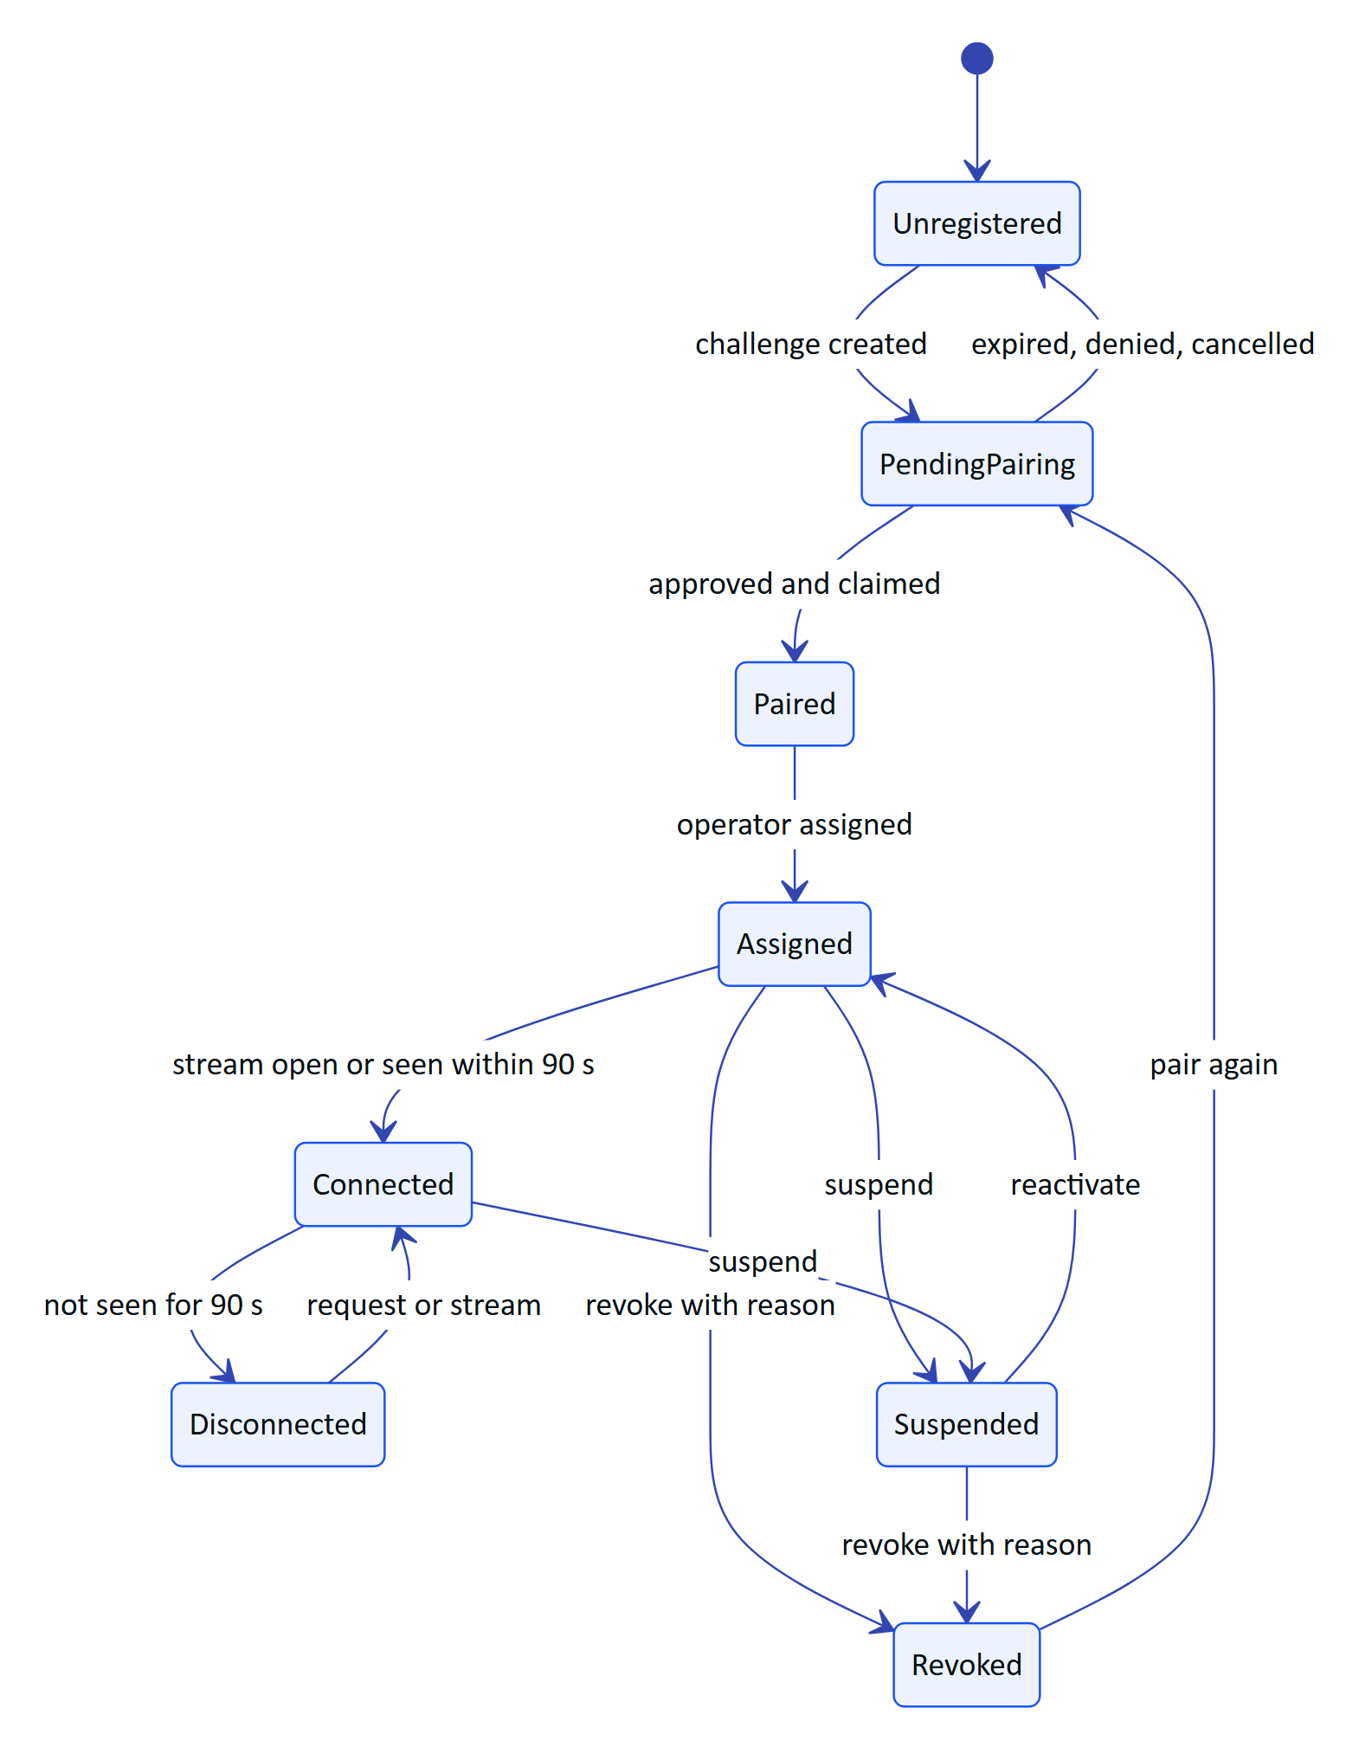
Figure 60. Device lifecycle as shown to administrators (deriveDeviceState in packages/domain/src/devices.ts). Online means an open stream or seen within 90 s.
Suspension and revocation bump nothing in the token itself; they change devices.status, which resolveTokenPrincipal() reads on every request. Revocation also revokes all device_sessions, closes the assignment and publishes device.revoked to that device only.

3.8.3 Glasses UI profiles
Administrators decide what each role or device sees on glasses without shipping an app. A profile (ui_profiles, versioned in ui_profile_versions) lists enabled screens, widgets, allowed actions, measurand filters and text scale. Assignments resolve with the precedence device, then user, then role, then organization (UI_SCOPE_PRECEDENCE in packages/domain/src/uiprofile.ts). The API enforces the effective profile on device requests through the route rule table in modules/ui-profiles.ts and caches each device's effective profile for 5 s. A change invalidates the cache and publishes device.profile_changed to the affected devices, which reload their context.

3.9 Telemetry and alarms

3.9.1 Ingestion and alarm raising
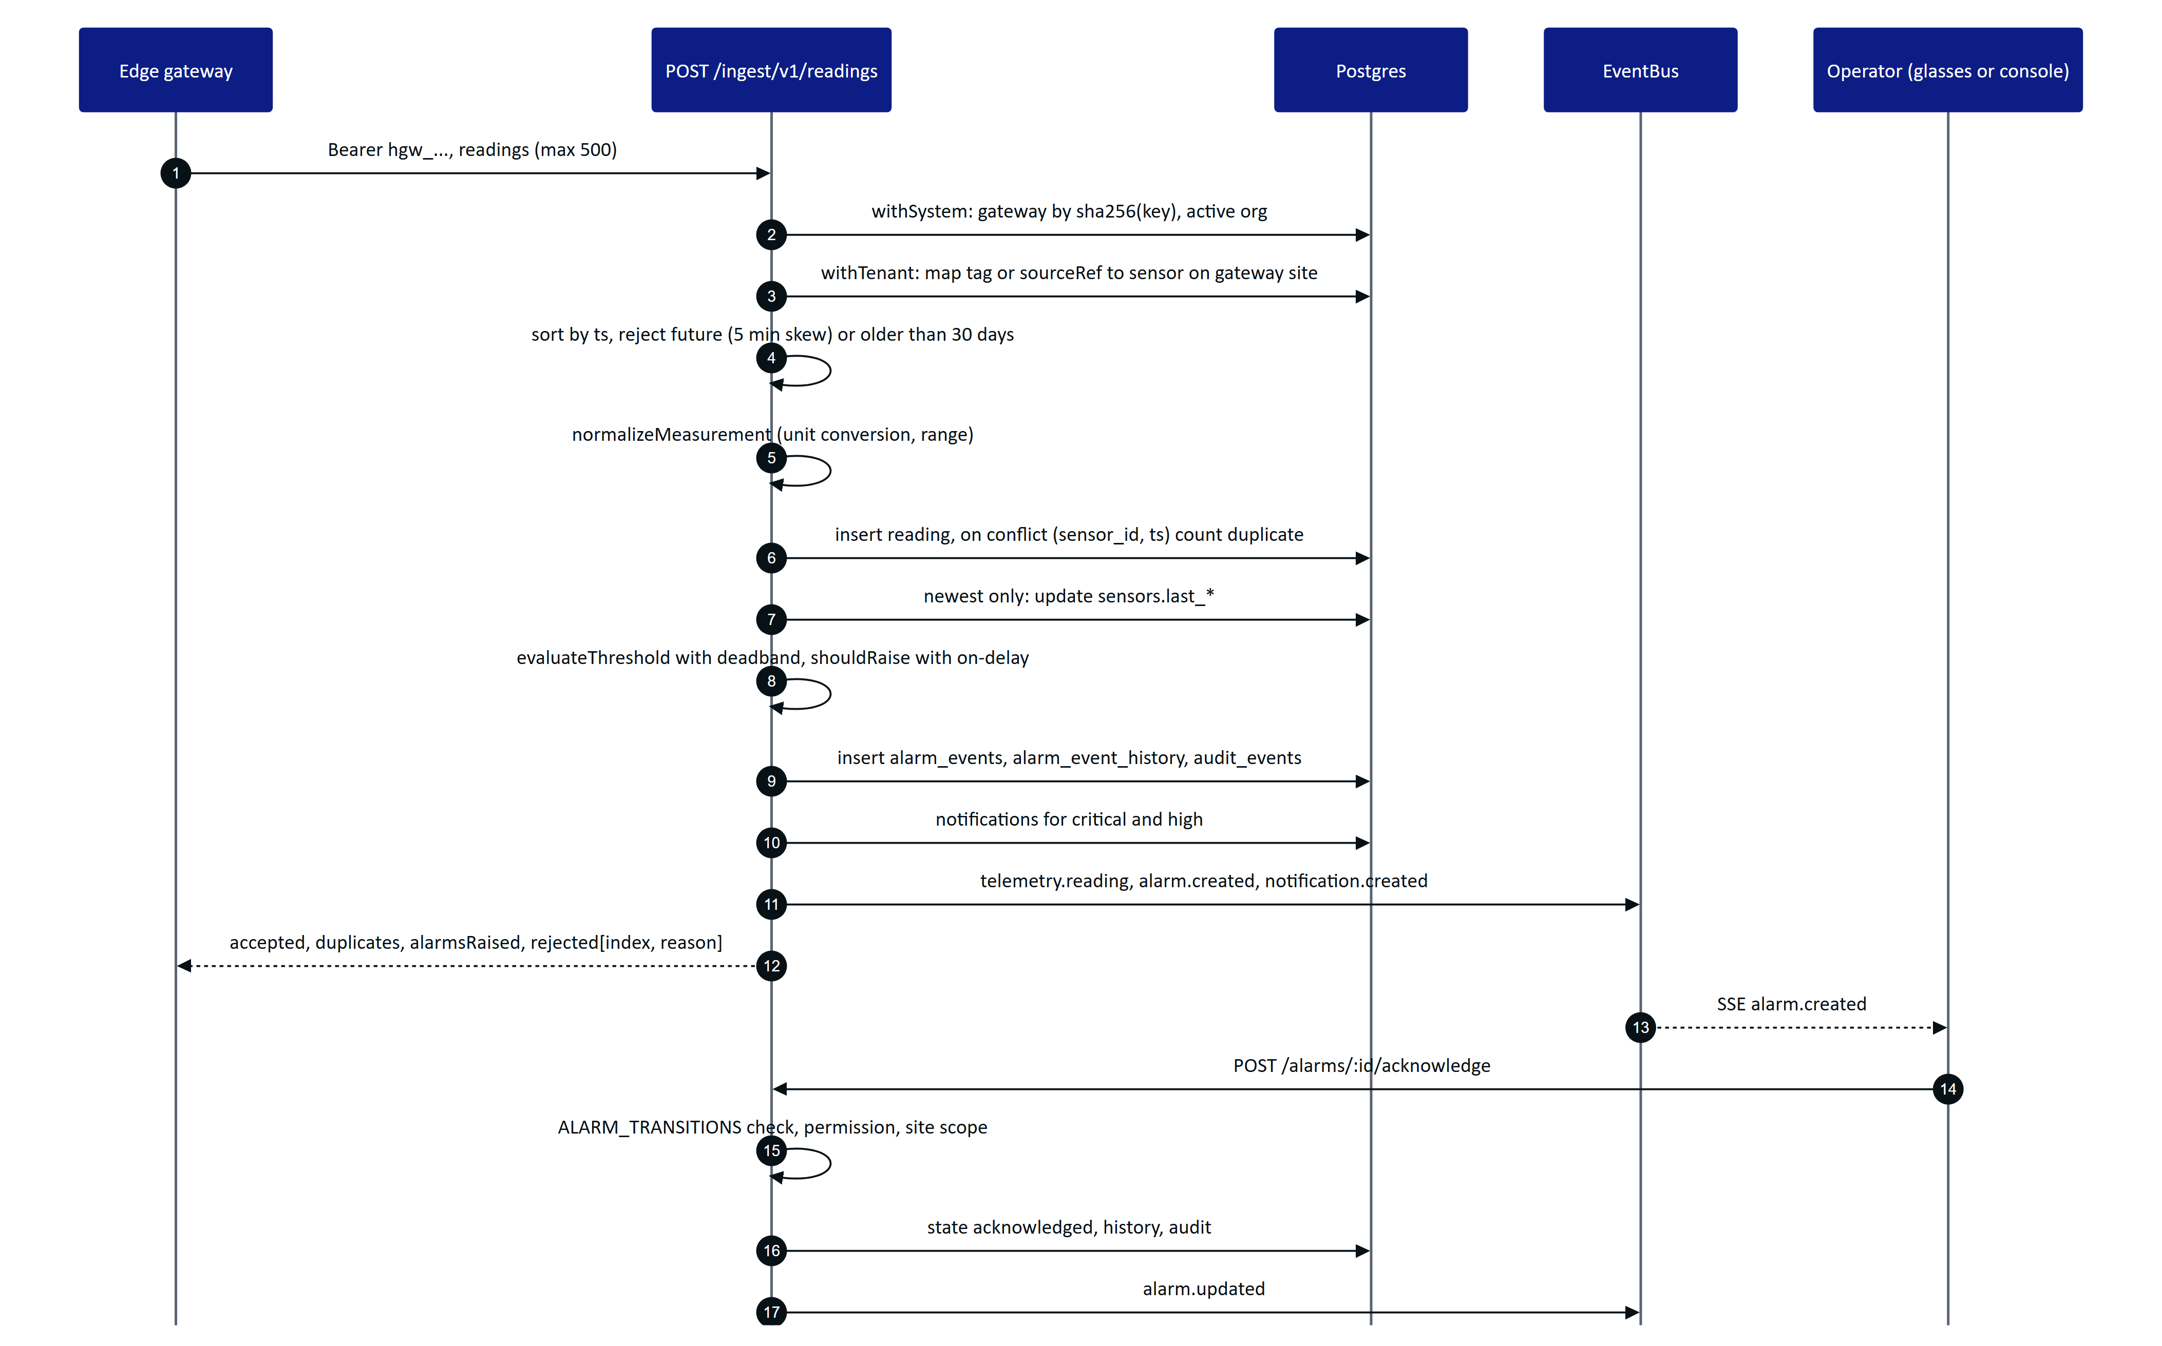
Figure 61. Telemetry ingestion, alarm raising and acknowledgement. Every source shares ingest() in modules/telemetry.ts.
Design points worth knowing:
- Out-of-order data is stored for history but does not overwrite a newer latest value or re-trigger alarm evaluation.
- Hysteresis: once in alarm, a value inside the deadband reports holding, not normal, so a noisy signal does not flap. A breach must persist for onDelayS (tracked in alarm_rules.breach_since) before an alarm is raised.
- One open event per rule: a continuing breach only updates peak_value. When the value returns to normal the event gets cleared_at but stays open for people to acknowledge and resolve.
- Bad quality readings update the latest value but skip alarm evaluation.
- Partial success: the gateway receives per-reading rejections with the original index, so it can retry or drop individual readings.

3.9.2 Stale-data alarms and background jobs
"No fresh data" rules cannot be evaluated on ingestion, because the problem is the absence of readings. evaluateStaleRules() scans all enabled stale rules across tenants in system context. jobs.ts schedules it and three other jobs.
Table 48. Background jobs
Job | Long-running server (startJobs) | Vercel (/api/cron via runScheduledJobs) | Demo mode
Stale-data rules | Every 30 s | Once per cron run: vercel.json schedules 0 3 * * * (daily) | Not ticked by DemoTicker
Pairing expiry | Every 60 s | Once per cron run | Challenges also expire by expiresAt checks
Realtime event pruning (older than 1 day) | Hourly in db mode | Once per cron run | Per instance memory
Simulation steps | setInterval per run, 5 s | Once per cron run | DemoTicker.poke() on API activity, at most every 5 s

WARNING
In the all-Vercel topology the cron runs once a day, so stale-data alarms are raised at most daily. A production plant on Vercel needs a more frequent scheduler (a higher cron tier or an external trigger calling /api/cron with CRON_SECRET) or the API in a container where startJobs runs every 30 s. This is tracked as TD-02.

3.10 Realtime

3.10.1 Server-Sent Events
Clients receive domain events over Server-Sent Events. The connection is made with fetch(), not the browser EventSource, so the bearer token travels in the Authorization header and never in a URL (apps/web/src/lib/realtime.ts). The Android app does the same with OkHttp (HydrisApi.events()).
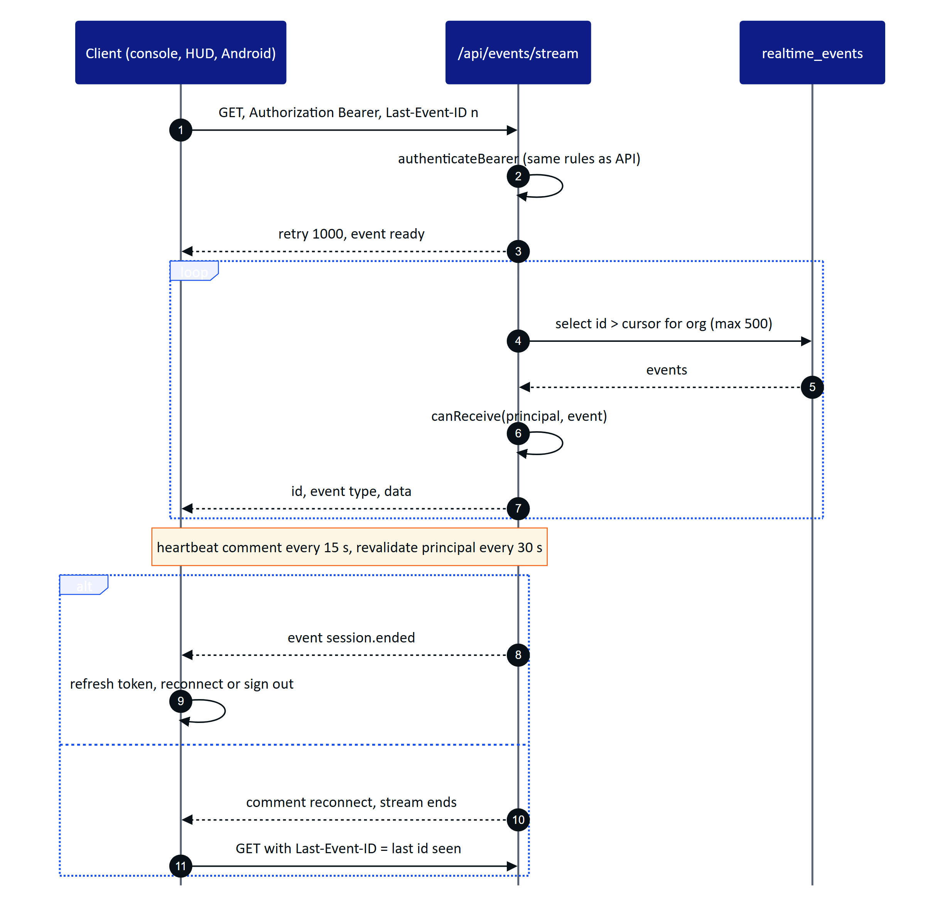
Figure 62. SSE in db mode on Vercel. Each invocation streams for about 50 s, then the client reconnects with Last-Event-ID and resumes without gaps.
Table 49. Realtime modes (REALTIME_MODE, core/events.ts)
Aspect | memory | db
Transport inside the API | In-process EventEmitter | Buffered rows in realtime_events, flushed in onSend
Fan-out across instances | No (single instance) | Yes, every instance polls the same table
Replay on reconnect | Ring buffer of the last 1,000 events | Any event id still in the table (pruned after 1 day)
Latency | Immediate | Up to the 1.5 s poll interval
Device presence | ctx.liveDevices counts open streams | devices.last_seen_at
Used by | server.ts default, Docker Compose, Render | Vercel, demo mode, any multi-instance deployment

Authorisation is per connection and per event (canReceive in modules/realtime.ts): the event's organization must match, device-targeted events go only to those devices, user-targeted events only to those users, and site and permission constraints apply. Events carry identifiers and small payloads; clients refetch through the normal API, which applies RLS again.
The console batches invalidations: Shell.tsx maps event types to API path prefixes (EVENT_PATHS) and invalidates matching TanStack Query entries every 1.5 s, while critical and high alarm.created events raise a toast immediately.
Table 50. Event types published today
Area | Events
Telemetry and alarms | telemetry.reading, telemetry.corrected, sensor.updated, alarm.created, alarm.updated
Work | inspection.updated, maintenance.updated, notification.created
Plant | asset.updated, simulation.step
Devices | pairing.completed, device.paired, device.updated, device.context_changed, device.profile_changed, device.revoked
Documents and UI | auditdoc.updated, ui_profile.updated

DECISION
SSE instead of WebSockets. All realtime traffic is server to client; client actions are ordinary authenticated HTTP calls that go through the same validation, RBAC and RLS. SSE works through the Vercel function model (a streamed response with a time budget), through corporate proxies, and with plain fetch on every client. WebSockets would need a separate stateful service on Vercel. The price is polling in db mode and a reconnect every 50 s, both acceptable at pilot scale.

3.11 Audit document scanning

3.11.1 Pipeline
Paper logbooks, lab sheets and permits become verified digital records through a pipeline that combines on-device OCR, server structuring, an optional vision model and two human steps.
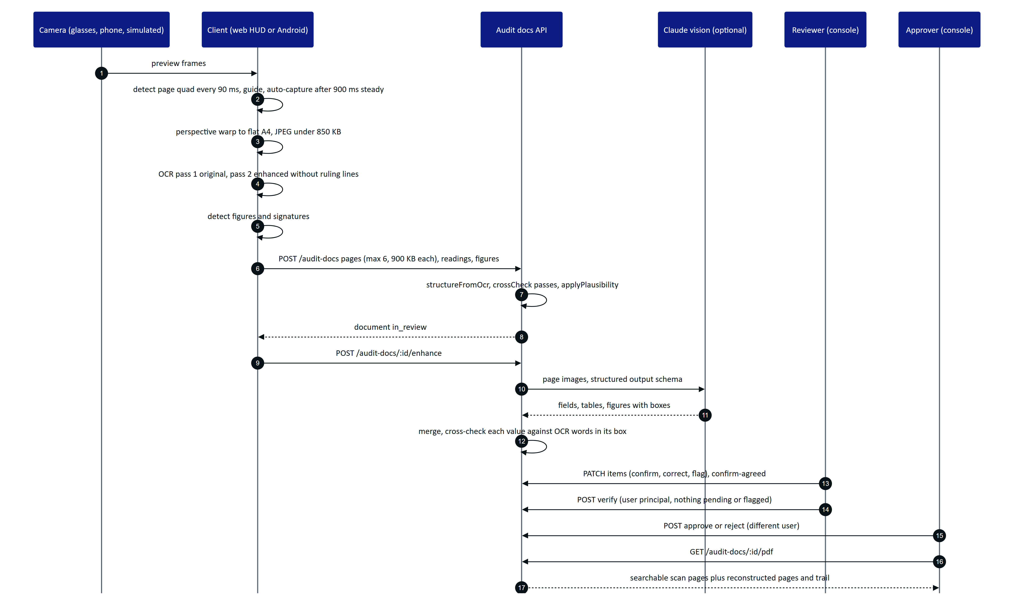
Figure 63. Audit scan pipeline from camera to approved PDF (lib/docdetect.ts, lib/ocr.ts, modules/audit-docs.ts, core/vision-extract.ts, core/audit-pdf.ts).
Key properties:
- Two independent machine readings. Each page is read twice on the device, once as captured (ocr:original) and once contrast-normalised with ruling lines removed (ocr:enhanced). The web uses Tesseract.js in WebAssembly (apps/web/src/lib/ocr.ts); Android uses ML Kit (scan/OcrEngine.kt) and emits exactly the same JSON shape. Disagreement between passes is a signal for the reviewer, which is why the server stores per-field sources and an agreement value (match, close, mismatch, single).
- No image leaves the device before upload. Detection, warping and OCR run locally. The web warp produces a 1654 px wide A4 page (warpToA4 default; the file header comment still says 1240 by 1754).
- Vision is additive. If no Anthropic credential is configured, enhance returns aiStatus: unavailable and the OCR result stands. If the model fails, aiStatus becomes failed with a short reason and the OCR result stands. Vision cannot replace an extraction once review has started (409 review_started).
- Dual human verification. Verification and approval require a user principal signed in to the console, and approval must come from a different person than the verifier. Demo tenants may self-approve, and the event records it as such.
- Optimistic concurrency. Every write is UPDATE ... WHERE revision = n; a lost race returns 409 stale and the client reloads.

3.11.2 Document states
Figure 64. Audit document states (AuditDocStatus in packages/domain/src/auditdoc.ts). Editing a verified item reopens review.
The schema also defines a processing status for server-side processing; the current upload path writes in_review directly because structuring is synchronous.
Figure 65. Audit documents in the console: agreement score, items needing attention and review progress per scan.

3.12 Voice assistant
"Hey Hydris" answers spoken questions with data from the caller's own account. The wake phrase is matched on the client (WAKE_RE in packages/domain/src/voice.ts, which tolerates common mis-transcriptions such as "hydras" or "idris"), and the question after the wake phrase goes to POST /api/assistant/ask.
Figure 66. Voice assistant with tool use (modules/voice-assistant.ts). Tools run inside the caller's tenant transaction, so RLS and site scope apply to every lookup.
The system prompt forbids estimating or inventing values, asks for the age of each reading, and states that Hydris never operates equipment. The rules engine never guesses: an unrecognised question gets a plain "I can't answer that". The response's facts[] list the readings used (label, value, unit, time, and whether they are synthetic), so the client can show what an answer was based on. The endpoint is rate limited to 60 calls per minute.
DECISION
Grounded tool use with a deterministic fallback. The model never sees the database; it can only call five read-only tools that execute inside the caller's tenant transaction. The deterministic engine keeps the feature working (with narrower coverage) when no credential is configured, the provider is unavailable, or a customer forbids external AI processing.

3.13 Client applications

3.13.1 Web application
One Next.js application serves four very different experiences from one deployment.
Figure 67. Web application components (apps/web/src). The glasses HUD and the console share the API client and realtime client but not their session model.
- Console sessions keep the access token in memory and the refresh token in the httpOnly cookie. Data is fetched with TanStack Query, where the API path is the cache key so that realtime events can invalidate by prefix (lib/query.ts).
- Glasses HUD sessions are device sessions. link.ts stores the install id and device refresh token behind a SecureStore interface (web implementation: localStorage), and keeps an offline queue of inspection step responses. Each queued operation carries a client id, and the server deduplicates on (inspection_id, client_op_id), so replays after a network drop are safe.
- Simulator (/simulator) renders the 600 by 600 additive HUD (GLASSES_DISPLAY in packages/domain/src/devices.ts) in a browser, with a simulated camera that films a sample A4 sheet so the whole scan pipeline can be demonstrated without hardware.
- Security headers come from next.config.ts: X-Frame-Options: DENY everywhere except /glasses and /simulator (SAMEORIGIN, so the website can embed the live demo), nosniff, a strict referrer policy and a permissions policy that allows only the camera for the same origin. Helmet runs in the API with its content security policy disabled.
Figure 68. Operator console overview: KPIs, open alarms by severity and live instruments for the selected site.

3.13.2 Android app: Hydris Field
Hydris Field (apps/android, package ai.hydris.field, minSdk 31 to match DAT, targetSdk 36) is the operator's phone app and the bridge to the glasses.
Figure 69. Hydris Field components. One API client carries two credential channels: the operator session and the paired glasses' device token.
- Sessions follow the web contract: an access token in memory and the rotating hg_refresh cookie (plus hg_demo in demo mode) persisted only as ciphertext in SecureStore. 401 responses refresh once under a Mutex and retry.
- Glasses are reached through the Meta Wearables Device Access Toolkit 1.0.1: Wearables.initialize, registration with the Meta AI app, an auto-selected DeviceSession, and the camera (preview stream and capturePhoto), speech (addSpeech) and inputs (capture button) capabilities. A debug-only mock device kit dependency supports development without hardware.
- Scans taken with the glasses are attributed to the glasses: Repository.uploadScan() uses the device channel (deviceCall) when the glasses are registered, so the console shows capturedVia: glasses and the device id.
- Server URL defaults to https://hydrisview.vercel.app and can be overridden in local.properties (hydris_url), as can the DAT application id and client token for production builds.
Figure 70. Hydris Field glasses screen: Meta AI registration, connected glasses and the capture and speech capabilities.
DECISION
DAT through a native app, not a WebView bridge. The first integration (apps/glasses-bridge-android) hosted the web HUD in a WebView and exposed DAT through window.HydrisNative. It works, but camera frames had to be encoded and passed across the JavaScript bridge, permissions and lifecycle were fragile, and operators need a real phone app anyway. Hydris Field calls DAT directly from Kotlin, runs OCR with ML Kit on the phone, and keeps the web HUD for the simulator, the website demo and future display glasses. The bridge remains in the repository as a fallback.

3.14 Deployment topologies
The same API code runs in four topologies. Configuration is a zod-validated environment (apps/api/src/config.ts): DATABASE_URL selects Postgres or PGlite, REALTIME_MODE selects the event bus, BLOB_READ_WRITE_TOKEN selects Vercel Blob over disk, and API_URL in the web app selects the external API over the built-in one.

3.14.1 All on Vercel (serverless)
Figure 71. All-in-Vercel topology (Built, live). Pages and the API run in the same Next.js deployment; each function instance builds the Fastify app once.
- getServerlessApi() (apps/api/src/serverless.ts) builds the app on first use, caches the promise for the life of the instance, and clears it on failure so the next request retries.
- Native and WebAssembly packages (@node-rs/argon2, pg, PGlite, Fastify plugins, @vercel/blob) are declared serverExternalPackages so they load from node_modules instead of being bundled.
- Migrations run on cold start under the advisory lock unless MIGRATE_ON_START=false. The root vercel-build script would migrate during the build, but vercel.json sets buildCommand to npm run build, so cold-start migration is what runs today.
- REALTIME_MODE=db is required; the SSE route refuses to start otherwise.

3.14.2 Self-hosted and plant edge
Figure 72. Self-hosted single host with Docker Compose (Built), suitable for an on-premises or plant-edge server.
docker-compose.yml runs Postgres 17, the API (apps/api/Dockerfile) and the web app (apps/web/Dockerfile, built with API_URL=http://api:4000). The API runs migrations as the owner and then works as hydris_app through SET LOCAL ROLE, so RLS applies. Memory realtime mode is enough on a single host, and the long-running jobs give 30 s stale-data detection. With no Anthropic key the system is fully functional offline from the internet except for vision enhancement and the language model assistant, which fall back as described.

3.14.3 Hybrid
Figure 73. Hybrid topology (Partial: render.yaml exists, not the live setup). Web on Vercel, API as a long-running container next to managed Postgres.
When API_URL is set, next.config.ts adds a beforeFiles rewrite that proxies /api/* to the external API, and the in-app route handlers are bypassed. render.yaml describes the API service (Docker, health check /api/health, 5 GB disk at /data/files, generated JWT_SECRET, simulator off). This topology removes the serverless limits: memory or db realtime, 30 s jobs, no cold-start migrations, long SSE connections.
Table 51. Topology comparison
Concern | All Vercel | Hybrid | Docker Compose | Demo mode
Status | Built, live | Partial | Built | Built, live
Database | Neon Postgres | Managed Postgres | Postgres 17 container | PGlite in memory per instance
Realtime | db, 1.5 s poll, 50 s streams | memory (one instance) or db | memory | db per instance
Jobs | Cron (daily today) | Timers (30 s) | Timers (30 s) | Lazy ticker on activity
Files | Vercel Blob private | Disk volume | Disk volume | Disk in function temp
Best for | Pilots, demos, low ops | Production cloud | On-premises, air-gapped plants | Sales and evaluation

3.14.4 Demo mode and cross-instance state
Demo mode turns on automatically on Vercel when no DATABASE_URL is set (isDemoEnv() in config.ts). Each serverless instance migrates an in-memory PGlite database and seeds the same deterministic tenant (seed/showcase.ts). Because instances share nothing, the state that must survive a hop between instances goes through a small shared key/value store (core/demo-shared.ts).
Figure 74. Demo mode across serverless instances. A guest created on instance A is rebuilt on instance B from the shared store and deterministic ids.
The shared store prefers Postgres (one table, hydris_demo_kv) when a Postgres URL is present, then the Vercel Runtime Cache, then process memory, and a Resilient wrapper falls back to memory on any error so the demo never fails because of the store. Device tokens in demo mode carry the operator and site, and demo device refresh tokens are HMAC-signed and self-contained, so any instance can rebuild a paired device. Audit documents are snapshotted into the store after each write and hydrated by revision on read.
CAUTION
Demo mode relaxes session checks (it accepts a valid token whose session family this instance has never seen) and uses public, fixed secrets. It is selected only when no database is configured or DEMO_MODE=true, logs a warning, and must never hold real plant data.

Figure 75. The browser simulator: the glasses HUD, the simulated camera and scenario controls running against the demo tenant.

3.15 Cross-cutting concerns

3.15.1 Caching and concurrency
Table 52. Caches
Cache | Scope and lifetime | Invalidation | File
Serverless API instance | Per function instance, until recycled | Cleared if the build fails | apps/api/src/serverless.ts
Effective glasses UI profile | Per API instance, 5 s | Cleared on any profile or assignment change on that instance | modules/ui-profiles.ts
Console query cache | Per browser tab | Realtime events by path prefix, batched every 1.5 s; mutations | lib/query.ts, console/Shell.tsx
OCR engine | Per page, worker created once; language data in browser cache | Never | lib/ocr.ts
Demo shared store | Postgres table, Vercel Runtime Cache (per region) or memory, with TTLs | TTL | core/demo-shared.ts

Concurrency is handled with database constraints and explicit versions rather than locks held across requests:
- Idempotent writes: readings are unique on (sensor_id, ts); inspection responses on (inspection_id, client_op_id); pairing code allocation retries up to five times on a unique violation.
- Optimistic concurrency: inspections.revision and audit_documents.revision. Audit document updates include WHERE revision = n and return 409 stale on a lost race.
- Single-flight: token refresh on every client; DemoTicker allows one step in flight and at most one step per 5 s; EventBus.flush() chains writes so batches are inserted in order.
- Serialized migrations: Postgres advisory lock.
- Connection pools: 3 connections per serverless instance and 10 for a long-running server (serverless.ts, db/client.ts).

3.15.2 Error handling and resilience
Table 53. Failure modes and responses
Failure | Behaviour | Where
API fails to build on a cold start | 503 service_unavailable with a short detail; next request retries the build | app/api/[...path]/route.ts, serverless.ts
Network drop on the glasses | Inspection responses queue locally and replay with client ids | glasses/link.ts
SSE disconnect | Reconnect with backoff 0.5 s doubling to a 15 s cap, resume from Last-Event-ID | lib/realtime.ts
Session revoked during a stream | session.ended, client tries one refresh, then signs out | modules/realtime.ts
Access token expired | One transparent refresh and retry | lib/api.ts, link.ts, HydrisApi.kt
Vision engine error or missing key | OCR extraction kept, aiStatus failed or unavailable with reason | modules/audit-docs.ts
Language model error or missing key | Deterministic rules engine answers | modules/voice-assistant.ts
One background job fails | Others still run; the cron report lists each job's result | jobs.ts
Demo shared store unreachable | Falls back to instance memory | core/demo-shared.ts
Event written for a rolled-back request | Harmless refetch hint | core/events.ts
Gateway sends bad readings | Per-reading rejection with index and reason; the rest are accepted | modules/telemetry.ts

3.15.3 Observability
Observability is basic today. Built: Fastify request logging at info level on the long-running server (server.ts) and opt-in on serverless (API_LOG=true); 5xx errors are logged with the stack; GET /api/health for load balancers and Render; the cron endpoint returns a JSON report with per-job status and duration; audit_events records security-relevant and business actions (logins, device lifecycle, alarm transitions, exports, verifications) with actor, device and IP; Vercel runtime logs capture console.error from route handlers and jobs. Planned: OpenTelemetry traces across the route handler and Fastify, metrics for ingestion rate, rejection reasons, alarm latency, SSE connections and OCR agreement, error tracking, and alerting on stale gateways.

3.15.4 Security architecture summary
Security is covered in depth in SECURITY_PRIVACY.md. Architecturally, the controls are layered:
Table 54. Security layers
Layer | Control | File
Transport and headers | HTTPS, helmet, frame and permissions policies | app.ts, next.config.ts
Abuse | Global 600 requests per minute plus stricter per-route limits (login 10, refresh 60, pairing 10, assistant 60, ingestion 1,200, inquiries 5 per 10 min) | modules/*.ts
Authentication | argon2id, TOTP MFA, lockout, short access tokens, rotating refresh families | modules/auth.ts, core/crypto.ts
Authorisation | Role permissions, device permission cap, site scope with 404, UI profile hook | core/principal.ts, modules/ui-profiles.ts
Data isolation | RLS with FORCE, non-privileged role, append-only grants | drizzle/0001_rls.sql and later
Secrets at rest | MFA secrets AES-256-GCM; token and key hashes only (SHA-256) | core/crypto.ts
Files | Random keys, private Blob store, served only through /api/attachments/:id | core/services.ts
Mobile | Keystore-backed AES-GCM for cookies and device tokens | SecureStore.kt

3.16 Architecture decision records
The decisions below are recorded here until they move to individual ADR files. Each lists the alternatives that were considered.
Table 55. Architecture decision records
ID | Decision | Alternatives considered | Consequences | Status
ADR-001 | npm workspaces monorepo for API, web, domain and Android | Separate repositories; Nx or Turborepo | Atomic cross-cutting changes; no build cache yet | Accepted
ADR-002 | Fastify modular monolith with one module per bounded area | Microservices; Next.js route handlers only | One deployable, in-process calls between modules; modules must stay disciplined | Accepted
ADR-003 | Run Fastify inside a Next.js catch-all route with app.inject | Separate API deployment only; rewrite all routes to Next handlers | One Vercel project, no network hop, same code for container mode; cold start includes app build and migration | Accepted
ADR-004 | Postgres row-level security plus application RBAC and site scope | Application filtering only; schema or database per tenant | Strong isolation with one schema; every request is a transaction | Accepted
ADR-005 | PGlite for development, tests and the demo | SQLite; Docker Postgres for tests | Real Postgres semantics (RLS, enums, date_bin) with no external service; per-instance memory in demo | Accepted
ADR-006 | Drizzle ORM with generated SQL migrations | Prisma; hand-written SQL only | Typed queries, readable SQL migrations, raw SQL where needed | Accepted
ADR-007 | Server-Sent Events over fetch for realtime | WebSockets; polling only; managed pub/sub | Works on serverless and through proxies, token stays out of URLs; polling in db mode | Accepted
ADR-008 | Two event bus modes, memory and db | Redis pub/sub; Postgres LISTEN/NOTIFY | No extra infrastructure; 1.5 s latency in db mode | Accepted, revisit at scale
ADR-009 | On-device OCR with two passes, vision model optional | Server-side OCR; vision model only | Works offline and without AI processing; vision improves layout when allowed | Accepted
ADR-010 | Meta DAT through the native Hydris Field app | WebView bridge (built first); waiting for display glasses SDK | Reliable camera, speech and button access; Android first, iOS later | Accepted
ADR-011 | RFC 8628-style pairing with short codes and poll secrets | QR containing a token; manual device enrolment by admins | No credential on screen or in a QR; works on devices without keyboards | Accepted
ADR-012 | Push-only HTTPS ingestion from an edge gateway | Hydris polling OPC UA or Modbus directly | Hydris stays outside control networks; customers or partners run the gateway | Accepted
ADR-013 | Short JWT access tokens plus rotating opaque refresh tokens checked on every request | Long-lived JWTs; server sessions only | Revocation is immediate; one database lookup per request | Accepted
ADR-014 | Demo mode as in-memory tenants with a small shared store | One shared demo database | Zero configuration, no cleanup; cross-instance logic confined to demo code paths | Accepted
ADR-015 | LLM features grounded through tenant-scoped tools, with deterministic fallbacks | Retrieval over exported data; no AI | Answers cite real readings; feature degrades gracefully | Accepted
ADR-016 | Pure domain package shared by server and web | Logic duplicated per client | One definition of state machines and rules; Android mirrors by hand for now | Accepted

DECISION
Fastify inside a Next.js route (ADR-003). The built-in API mode lets a pilot run as one Vercel project with one set of environment variables, and the same Fastify application runs unchanged as a container when a customer needs long-lived connections, frequent jobs or on-premises hosting. The trade-offs are explicit: a cold start builds the app and may run migrations, streams must end within the function budget, and in-memory state (rate limits, profile cache) is per instance.

DECISION
PGlite for development, tests and demo (ADR-005). Tests run against real Postgres semantics, including RLS policies and the hydris_app role, without Docker. The same property makes the public demo free to operate: each instance seeds its own database in memory. The cost is the cross-instance code in demo mode, which is deliberately isolated in demo.ts, core/demo-auth.ts, core/demo-guests.ts and core/demo-shared.ts.

DECISION
On-device OCR first (ADR-009). Paper records often contain personal names and signatures. Reading them on the device means the platform works without sending images to any AI provider, and the two independent passes give the reviewer a machine cross-check for free. A vision model is an opt-in enhancement, and its values are cross-checked against the OCR words inside each returned box rather than trusted on their own.

3.17 Quality attributes
Table 56. Quality attributes, tactics and evidence
Attribute | Scenario | Tactics | Evidence or target
Tenant isolation | A query in a handler forgets the organization filter | RLS FORCE, non-privileged role, SET LOCAL per transaction | drizzle/0001_rls.sql; covered by apps/api/test/platform.test.ts
Security | A refresh token is stolen and replayed | Rotation, family revocation, per-request family check | modules/auth.ts
Availability | One serverless instance fails to start | Lazy build with retry; 503 with detail; stateless instances | serverless.ts
Reliability of records | Network drops during an inspection | Offline queue, client operation ids, unique constraints | glasses/link.ts, modules/inspections.ts
Data integrity | Two reviewers edit one audit document | Revision check, 409 stale | modules/audit-docs.ts
Performance | An operator opens a 24 h chart | Server-side downsampling with date_bin to at most 2,000 points (default 240) | modules/telemetry.ts
Responsiveness | A critical alarm is raised | Event published in the same request; console toast on receipt | Target: under 3 s end to end in db mode (not yet measured)
Modifiability | A new screen is hidden for a role | Data-driven UI profiles, no app release | modules/ui-profiles.ts
Auditability | A regulator asks who changed a value | Append-only audit and corrections, actor and device recorded | audit_events, telemetry_corrections
Usability hands-free | Operator wearing gloves needs a value | Wake phrase, spoken short answers, capture button | voice.ts, GlassesManager.kt
Portability | Customer requires on-premises hosting | Same code in Compose; no cloud-only dependency on the critical path | docker-compose.yml
Testability | Change to alarm hysteresis | Pure functions in packages/domain with unit tests | packages/domain/test/domain.test.ts

Automated tests today: four domain test files and six API test files (about 69 test cases by count of test( calls), run against PGlite with npm test, plus a Playwright journey suite in tests/e2e/journeys.spec.ts. There is no CI pipeline yet.

3.18 Scalability path

3.18.1 Capacity model
The numbers below are planning estimates, not measurements. They assume one sensor reports every 60 s, a site has about 200 sensors and 10 concurrent console or glasses users, and the gateway batches up to 500 readings per request.
Figure 76. Estimated telemetry load and open SSE connections by deployment stage (planning estimates, not measured).
The bars are readings per minute in thousands (200, 2,000, 10,000 and 40,000). The line is open realtime connections in thousands (10, 100, 500 and 2,000). At 200 sensors per site, one site produces about 288,000 readings per day and about 105 million per year.
Table 57. Scaling stages
Stage | Load (estimate) | What holds | What must change
Pilot, 1 to 3 sites | Under 1,000 readings per minute, tens of users | Any topology. All-Vercel is fine if stale-data checks run more often than daily | Fix TD-02 (job frequency) and TD-01 (Android source in git)
Early fleet, about 10 sites | About 2,000 readings per minute, about 100 streams | Hybrid or Compose; Postgres with the current indexes | Shared rate-limit store (TD-03); move audit page images to object storage (TD-04); CI (TD-06)
Regional, about 50 sites | About 10,000 readings per minute, about 500 streams | Hybrid with 2 to 4 API instances in db realtime mode | Batch inserts and rule evaluation in ingest() (TD-11); time-partitioned telemetry and retention (TD-10); replace polling with LISTEN/NOTIFY or a broker (TD-07)
Enterprise, 200 sites and more | About 40,000 readings per minute, about 2,000 streams | Separate ingestion workers from the interactive API | Edge gateway with store and forward, MQTT ingestion, read replicas, regional deployments

The main bottlenecks, in the order they will be hit:
- Ingestion is row by row. ingest() inserts each reading and, for the newest reading per sensor, loads the sensor's rules and the open alarm for each rule. This is correct and simple but costs several queries per reading.
- db realtime polls per connection. Each open stream runs one query every 1.5 s. 500 streams are about 330 queries per second of polling on top of real work.
- Telemetry table growth. One table with three indexes and no partitioning will need time partitioning and retention well before a billion rows.
- Audit page images in Postgres. Up to 6 pages of up to 900 KB each per document, stored as base64 text, inflate the database and its backups.

3.19 Technical debt register
Table 58. Technical debt register
ID | Item | Impact | Severity | Proposed fix
TD-01 | The root .gitignore rule data also ignores apps/android/app/src/main/java/ai/hydris/field/data/ (HydrisApi.kt, Models.kt, Repository.kt, SecureStore.kt) | A fresh clone of the Android app does not compile | High | Anchor the rule (/data, apps/api/data) and commit the package
TD-02 | Vercel Cron runs /api/cron daily (0 3 * * *) | Stale-data alarms and pairing expiry run once a day on the all-Vercel topology | High | More frequent schedule or external trigger; or hybrid topology
TD-03 | Rate limits use the plugin's in-memory store | Limits are per instance on serverless and multi-instance deployments | Medium | Shared store (Redis or Postgres) or edge firewall rules
TD-04 | Audit page images stored as base64 text in audit_document_pages | Database and backup growth; large rows in API responses | Medium | Store in the existing Storage adapter, keep keys in the table
TD-05 | packages/contracts is empty; Android Models.kt mirrors JSON by hand | Contract drift between web, API and Android | Medium | Generate JSON Schema or OpenAPI from zod schemas; generate Kotlin models
TD-06 | No CI pipeline | Regressions found late; no automatic migration check | Medium | GitHub Actions: typecheck, unit tests on PGlite, build, e2e on preview
TD-07 | db realtime mode polls every 1.5 s per stream | Database load grows with connections | Medium at scale | LISTEN/NOTIFY fan-out per instance or a managed pub/sub
TD-08 | Email transport not wired (mail_outbox only) | Invitations and password resets need manual delivery | Medium | Provider adapter with outbox worker and retries
TD-09 | Events from rolled-back requests may be written in db mode | Spurious refetches | Low | Accepted by design; revisit with transactional outbox
TD-10 | telemetry_readings has no partitioning or retention | Index and vacuum cost at large volumes | Low now, High later | Monthly partitions or TimescaleDB, retention per tenant contract
TD-11 | Ingestion evaluates readings one by one with per-rule queries | Throughput ceiling per instance | Low now, High later | Batch insert, load rules and open alarms once per batch
TD-12 | Helmet content security policy disabled in the API; no CSP set by Next.js | Weaker defence against injected scripts | Medium | Nonce-based CSP for pages; strict CSP for API responses
TD-13 | Web HUD keeps the device refresh token in localStorage | Token exposed to any script on the origin | Medium | Native runtimes implement SecureStore; shorten web device sessions
TD-14 | UI profile cache invalidation is local to one instance | Other instances may apply an old profile for up to 5 s | Low | Accepted; or invalidate through realtime events
TD-15 | Android release build is signed with the debug keystore | Not distributable through managed app stores | Medium before rollout | Release keystore and Play App Signing
TD-16 | Comment in lib/docdetect.ts says the warp is 1240 by 1754; the default is 1654 px wide | Misleading documentation | Low | Align comment or default
TD-17 | vercel-build script is unused because vercel.json sets buildCommand | Migrations happen on cold start instead of at deploy | Low | Choose one: build-time migration with MIGRATE_ON_START=false, or remove the script
TD-18 | Observability limited to logs and the audit table | Slow diagnosis in production | Medium | OpenTelemetry, metrics, error tracking

RISK
TD-01 and TD-02 should be fixed before any pilot plant goes live: the first blocks anyone else from building the Android app, and the second means a silent gateway would go unnoticed for up to a day on the all-Vercel deployment.

3.20 Future architecture

3.20.1 Target picture
Figure 77. Target architecture (Planned). Edge collection with store and forward, a broker for high-volume ingestion, and regional deployments for data residency.

3.20.2 Planned building blocks
Table 59. Future architecture items
Item | Purpose | Builds on | Status
Hydris edge gateway | Read OPC UA and Modbus from the plant side, map tags to sourceRef, buffer during outages, push outbound only | POST /api/ingest/v1/readings, gateways.key_hash, sensors.source_ref | Planned
MQTT ingestion | Efficient high-frequency transport from many gateways | Same ingest() path behind workers | Planned
Batch ingestion workers | Separate write-heavy ingestion from the interactive API | TD-11 | Planned
Telemetry partitioning and retention | Keep queries fast and storage bounded | TD-10 | Planned
Realtime pub/sub | Remove polling, sub-second delivery across instances | EventBus interface already isolates the transport | Planned
Object storage for audit pages | Smaller database, cheaper backups | Storage adapter | Planned
Contracts package | One schema for API, web and Android | packages/contracts | Planned
Multi-region | Data residency (for example India for CPCB-regulated plants), lower latency | Stateless API, tenant pinned to one region's database | Planned
iOS app | Operators on iPhone | DAT iOS SDK, same API | Planned
Display glasses rendering | Native HUD on Meta Ray-Ban Display | Web HUD layouts, GLASSES_DISPLAY, UI profiles | Planned
Observability stack | Traces, metrics and alerts | TD-18 | Planned

The current design keeps these doors open on purpose. Ingestion has one entry point and an idempotency key, so a broker and workers can be added behind it. The event bus is an interface with two implementations, so a third (pub/sub) is a contained change. Storage is an adapter. Tenancy is enforced in the database, so splitting tenants across regions does not change application code. The API is stateless apart from caches that are already safe to lose.

4 Data Model
NOTE
HFG-DAT v2.0 · Draft for review · Owner: Engineering, Hydris. Every table, column, state, JSON shape and tenancy rule behind Hydris Field Glasses, and how the data should evolve

This document describes the persistent data of Hydris Field Glasses: what is stored, where, in which shape, who may read it, how long it lives and how it is expected to grow. It is written for engineers who change the schema, for data and analytics people who query it, and for security reviewers who need to know which tables hold personal or sensitive data.
Everything about the current product is taken from the code on main:
- Schema: apps/api/src/db/schema.ts (Drizzle ORM, one file, 42 tables).
- Migrations: apps/api/drizzle/0000_init.sql to 0008_audit_documents_rls.sql, with snapshots in apps/api/drizzle/meta/.
- Tenancy helpers: apps/api/src/db/tenant.ts and apps/api/src/context.ts.
- Shared types and enumerations: packages/domain/src/* (catalog.ts, alarms.ts, workflows.ts, devices.ts, measurands.ts, uiprofile.ts, auditdoc.ts, roles.ts).
- Seed and demo data: apps/api/src/seed/demo.ts, apps/api/src/seed/showcase.ts, apps/api/src/core/demo-shared.ts.
- Client-side storage: apps/android/app/src/main/java/ai/hydris/field/data/SecureStore.kt and apps/web/src/glasses/link.ts.
Statements are marked Built (on main), Partial or Planned. Volume and storage figures are estimates and are labelled as such.
42  Tables in the Drizzle schema  plus 1 runtime table in demo mode |  | 548  Columns  from the 0008 snapshot |  | 23  Postgres enum types  22 in 0000, 1 in 0007 |  | 9  SQL migrations  0000 to 0008

71  Indexes  23 unique, 4 of them partial |  | 130  Foreign keys  cascade from organizations |  | 36  Tables with row-level security  6 system-only tables without |  | 23  JSONB columns  typed in TypeScript, not in SQL

4.1 Data principles
The schema follows a small set of rules. New tables and columns are expected to follow them too; a review that breaks one should say why.
Table 60. Data principles and where the code enforces them
# | Principle | How it shows up in the code
P1 | Every tenant row carries org_id. Tenancy is a column, not a database or schema per customer. | orgRef() helper in schema.ts adds org_id uuid not null references organizations(id) on delete cascade to every tenant table.
P2 | Isolation is enforced by the database, not only by queries. A missing WHERE org_id = ... must not leak data. | Row-level security policy tenant_isolation on 35 tables; requests run as the non-privileged role hydris_app (0001_rls.sql, tenant.ts).
P3 | Provenance is explicit. Every measurement says where it came from and whether it is synthetic. | telemetry_readings.source, quality, synthetic plus CHECK telemetry_synthetic_source_ck; synthetic flags on alarms, inspections and maintenance tasks.
P4 | History is appended, never overwritten. Corrections, reviews and decisions add rows. | telemetry_corrections, alarm_event_history, maintenance_activity, audit_document_events, audit_events (UPDATE and DELETE revoked on three of them).
P5 | Missing data is not zero. A value without a timestamp is meaningless. | sensors.last_value and last_ts are nullable; freshness() in packages/domain/src/freshness.ts returns no_data instead of 0.
P6 | One canonical unit per measurand. Conversion happens at ingestion. | normalizeMeasurement() in measurands.ts; sensors.unit stores the canonical unit.
P7 | Snapshots protect history from later edits. | inspections.steps copies the template steps at assignment time; AuditField.extracted keeps the first extracted value.
P8 | Offline clients replay safely. | Unique (inspection_id, client_op_id) on inspection_responses; unique (sensor_id, ts) on telemetry_readings; revision counters for optimistic locking.
P9 | Secrets are stored as hashes or ciphertext. | password_hash (argon2id), token_hash, key_hash, code_hash, poll_secret_hash (SHA-256), mfa_secret_enc (AES-256-GCM with DATA_KEY).
P10 | Times are UTC timestamptz. Site and organization time zones are display settings. | ts() helper uses timestamp with time zone; sites.timezone and organizations.timezone default to UTC.

DECISION
Shared-schema multi-tenancy with RLS was chosen over a database per tenant. It keeps one migration path, one connection pool and cheap tenant creation, and moves the isolation guarantee into Postgres. The cost is that every new tenant table must be added to an RLS migration; section "Tenancy and row-level security" lists the checklist.

4.2 Domain overview
The 42 tables fall into ten domains. Each domain is owned by one API module in apps/api/src/modules/.
Figure 78. Data domains of Hydris Field Glasses and their main tables
Table 61. Domains, tables and owning modules
Domain | Tables | Owning module(s) | Status
Identity and tenancy | users, organizations, memberships, membership_sites, invitations, auth_sessions, auth_tokens, mail_outbox | auth.ts, org.ts | Built
Plant model | sites, facilities, process_areas, assets | plant.ts | Built
Telemetry | gateways, sensors, telemetry_readings, telemetry_corrections | telemetry.ts, plant.ts | Built
Alarms and procedures | alarm_rules, alarm_events, alarm_event_history, documents | alarms.ts, plant.ts, insights.ts | Built
Work | inspection_templates, inspection_routes, inspections, inspection_responses, maintenance_tasks, maintenance_activity, attachments | inspections.ts, maintenance.ts, plant.ts | Built
Devices and UI profiles | devices, device_assignments, pairing_challenges, device_sessions, ui_profiles, ui_profile_versions, ui_profile_assignments | devices.ts, ui-profiles.ts | Built
Audit documents | audit_documents, audit_document_pages, audit_document_events | audit-docs.ts | Built
Platform | audit_events, notifications, realtime_events, inquiries, simulation_runs | core/services.ts, core/events.ts, public.ts, simulation.ts | Built
Demo key/value | hydris_demo_kv (created at runtime, not in migrations) | core/demo-shared.ts | Built (demo mode only)

4.2.1 Conventions
- Primary keys are uuid with DEFAULT gen_random_uuid() (helper pk()), except the two high-volume append logs telemetry_readings and realtime_events, which use bigint GENERATED ALWAYS AS IDENTITY, and membership_sites, which has a composite key.
- Timestamps: created_at and updated_at are timestamptz not null default now(). updated_at is set by the application on every update (there are no triggers).
- Soft delete: plant objects and UI profiles use archived_at. Hard deletes are rare and guarded (an asset with sensors, alarms, inspections or tasks returns in_use; an alarm rule with events is disabled instead of deleted).
- Text-typed states: some small state sets are text columns typed with $type<...>() in TypeScript rather than Postgres enums (for example users.status, devices.kind, audit_documents.ai_status). Section "Enumerations" lists both kinds.
- Naming: tables are plural snake case; foreign keys are <entity>_id; actor columns are <verb>_by (user) and <verb>_at (time).

4.3 Entity relationship model
The full model is too large for one readable diagram, so it is split by domain. Shared entities (organizations, users, sites, assets, devices) appear as stubs with only their key where they are referenced from another domain. Every tenant table also has org_id referencing organizations.id with ON DELETE CASCADE; that edge is drawn only in the identity diagram to keep the others legible. Column types use Postgres names (timestamptz, float8 for double precision).

4.3.1 Identity and tenancy
Figure 79. Identity and tenancy: users join organizations through memberships, optionally limited to sites
users is global: one person can belong to several organizations with a different role in each. The active organization is carried in the access token (org claim) and resolved to a membership on every request. mail_outbox stands alone (no foreign keys) and is not drawn.

4.3.2 Plant model
Figure 80. Plant model: site, facility, process area and asset hierarchy
assets.site_id duplicates what can be derived through facility_id; it is kept so that site-scoped queries and site permission checks need no join.

4.3.3 Telemetry
Figure 81. Telemetry: gateways feed sensors, sensors record readings, corrections supersede readings

4.3.4 Alarms and procedures
Figure 82. Alarms and procedures: rules watch sensors, events carry the human lifecycle, documents hold SOPs

4.3.5 Inspections and maintenance
Figure 83. Work: templates and routes produce inspections, abnormal results and alarms produce maintenance tasks
attachments.owner_id is polymorphic: it points at an inspection, maintenance task, asset or alarm depending on owner_type, and therefore has no foreign key. The upload route validates the owner inside the tenant transaction before inserting (apps/api/src/modules/plant.ts).

4.3.6 Devices and UI profiles
Figure 84. Devices and UI profiles: pairing creates devices, assignments bind operators, profiles shape the glasses UI

4.3.7 Audit documents
Figure 85. Audit documents: a scan has pages with images and OCR, and an append-only review trail

4.3.8 Platform and demo storage
Figure 86. Platform tables: audit trail, notifications, realtime log, simulations, leads and the demo key/value store
inquiries and hydris_demo_kv have no relationships: inquiries are platform-owned leads from the public website, and the demo key/value store is infrastructure for demo mode only.

4.4 Data dictionary
One table per database table, listing every column. "Null" is No for NOT NULL columns. Defaults are the SQL defaults from the migrations; application-level defaults are noted in the description. Foreign keys give the target and the ON DELETE action (cascade, set null, or no action when omitted). Every id without a note is uuid with default gen_random_uuid(), and every org_id is uuid not null, FK organizations.id, cascade.

4.4.1 Identity and tenancy tables

users
Table 62. users (global identities, not tenant-scoped, no RLS)
Column | Type | Null | Default | Description
id | uuid | No | gen_random_uuid() | Primary key.
email | text | No |  | Sign-in email. Unique case-insensitively.
name | text | No |  | Display name.
password_hash | text | Yes |  | argon2id hash (core/crypto.ts). Null for accounts without a password.
is_platform_admin | boolean | No | false | Hydris staff flag; enables platform administration routes.
status | text | No | 'active' | active or disabled. Disabled users cannot authenticate.
email_verified_at | timestamptz | Yes |  | Set on verification or first password reset.
mfa_secret_enc | text | Yes |  | TOTP secret, AES-256-GCM encrypted with DATA_KEY.
mfa_enabled | boolean | No | false | TOTP required at sign-in when true.
failed_logins | integer | No | 0 | Consecutive failed sign-ins; reset on success.
locked_until | timestamptz | Yes |  | Set for 15 minutes after 5 failures (TTL in config.ts).
last_login_at | timestamptz | Yes |  | Last successful sign-in.
default_org_id | uuid | Yes |  | Preferred organization at sign-in. No FK.
created_at | timestamptz | No | now()
updated_at | timestamptz | No | now()

Indexes and constraints: users_email_lower_uq unique on lower(email).

organizations
Table 63. organizations (tenants)
Column | Type | Null | Default | Description
id | uuid | No | gen_random_uuid() | Primary key; the tenant id used in app.org_id.
name | text | No |  | Display name.
slug | text | No |  | URL-safe unique key (demo: riverbend-demo).
is_demo | boolean | No | false | Demo tenants may receive simulator telemetry; customer tenants never do.
region | text | Yes |  | Free-text region label.
timezone | text | No | 'UTC' | IANA zone for display and reports.
status | text | No | 'active' | active or suspended.
created_at | timestamptz | No | now()
updated_at | timestamptz | No | now()

Indexes and constraints: organizations_slug_uq unique on slug. RLS policy uses id instead of org_id.

memberships
Table 64. memberships (user role in an organization)
Column | Type | Null | Default | Description
id | uuid | No | gen_random_uuid() | Primary key.
org_id | uuid | No |  | Tenant.
user_id | uuid | No |  | FK users.id, cascade.
role | role | No |  | One of the six roles in roles.ts.
status | membership_status | No | 'active' | invited, active, deactivated.
all_sites | boolean | No | true | When false, access is limited to membership_sites.
title | text | Yes |  | Job title shown in the UI.
created_at | timestamptz | No | now()
updated_at | timestamptz | No | now()
deactivated_at | timestamptz | Yes |  | When access was removed.

Indexes and constraints: memberships_org_user_uq unique (org_id, user_id); memberships_user_idx on user_id.

membership_sites
Table 65. membership_sites (site scope for restricted memberships)
Column | Type | Null | Default | Description
membership_id | uuid | No |  | FK memberships.id, cascade. Part of the primary key.
site_id | uuid | No |  | FK sites.id, cascade. Part of the primary key.
org_id | uuid | No |  | Tenant.

Indexes and constraints: primary key (membership_id, site_id).

invitations
Table 66. invitations (pending invites to an organization)
Column | Type | Null | Default | Description
id | uuid | No | gen_random_uuid() | Primary key.
org_id | uuid | No |  | Tenant.
email | text | No |  | Invitee address.
name | text | Yes |  | Invitee name if known.
role | role | No |  | Role granted on acceptance.
site_ids | jsonb | No | '[]' | Array of site uuids when all_sites is false.
all_sites | boolean | No | true | Site scope on acceptance.
token_hash | text | No |  | SHA-256 of the invitation token.
expires_at | timestamptz | No |  | Seven days after creation (TTL.inviteMs).
accepted_at | timestamptz | Yes |  | Set on acceptance.
revoked_at | timestamptz | Yes |  | Set when an admin revokes.
invited_by | uuid | Yes |  | FK users.id.
created_at | timestamptz | No | now()

Indexes and constraints: invitations_token_uq unique on token_hash; invitations_org_idx on org_id.

auth_sessions
Table 67. auth_sessions (rotating refresh-token sessions for people; no RLS)
Column | Type | Null | Default | Description
id | uuid | No | gen_random_uuid() | Primary key.
user_id | uuid | No |  | FK users.id, cascade.
org_id | uuid | Yes |  | FK organizations.id, cascade. Organization of the session.
family_id | uuid | No |  | Rotation family; the access token sid claim. Revoking a family ends all its tokens.
token_hash | text | No |  | SHA-256 of the refresh token.
expires_at | timestamptz | No |  | Seven days after issue (TTL.refreshMs).
revoked_at | timestamptz | Yes |  | Logout or reuse detection.
rotated_at | timestamptz | Yes |  | Set when the token was exchanged for a new one.
user_agent | text | Yes |  | Client user agent.
ip | text | Yes |  | Client IP at issue.
created_at | timestamptz | No | now()
last_used_at | timestamptz | Yes |  | Last refresh.

Indexes and constraints: auth_sessions_token_uq unique on token_hash; auth_sessions_user_idx; auth_sessions_family_idx.

auth_tokens
Table 68. auth_tokens (single-use password reset and email verification tokens; no RLS)
Column | Type | Null | Default | Description
id | uuid | No | gen_random_uuid() | Primary key.
purpose | text | No |  | password_reset or email_verify.
user_id | uuid | No |  | FK users.id, cascade.
token_hash | text | No |  | SHA-256 of the emailed token.
expires_at | timestamptz | No |  | 30 minutes for resets (TTL.resetMs).
used_at | timestamptz | Yes |  | Set when consumed.
created_at | timestamptz | No | now()

Indexes and constraints: auth_tokens_token_uq unique on token_hash.

mail_outbox
Table 69. mail_outbox (recorded outgoing mail; no transport yet; no RLS)
Column | Type | Null | Default | Description
id | uuid | No | gen_random_uuid() | Primary key.
to | text | No |  | Recipient address.
subject | text | No |  | Subject line.
body_text | text | No |  | Plain-text body. Can contain reset and invitation links.
created_at | timestamptz | No | now()
sent_at | timestamptz | Yes |  | Reserved for a mail transport; never set today.

Indexes and constraints: none.
RISK
mail_outbox.body_text holds live password-reset and invitation links in clear text and is never purged. Until a mail transport exists, restrict database access to this table and add the purge job proposed in "Data lifecycle and retention".

4.4.2 Plant model tables

sites
Table 70. sites (physical plant locations)
Column | Type | Null | Default | Description
id | uuid | No | gen_random_uuid() | Primary key.
org_id | uuid | No |  | Tenant.
name | text | No |  | Display name.
code | text | No |  | Short code, unique per organization (demo: RIP, RTS).
address | text | Yes |  | Street address.
city | text | Yes |  | City.
country | text | Yes |  | Country.
lat | double precision | Yes |  | Latitude, WGS84.
lng | double precision | Yes |  | Longitude, WGS84.
timezone | text | No | 'UTC' | IANA zone.
layout_width_m | double precision | No | 100 | Plant layout canvas width in metres (map and route planner).
layout_height_m | double precision | No | 80 | Canvas height in metres.
archived_at | timestamptz | Yes |  | Soft delete.
created_at | timestamptz | No | now()
updated_at | timestamptz | No | now()

Indexes and constraints: sites_org_code_uq unique (org_id, code); sites_org_idx on org_id.

facilities
Table 71. facilities (treatment plants within a site)
Column | Type | Null | Default | Description
id | uuid | No | gen_random_uuid() | Primary key.
org_id | uuid | No |  | Tenant.
site_id | uuid | No |  | FK sites.id, cascade.
name | text | No |  | Display name.
code | text | No |  | Unique per site (demo: ETP-01).
kind | facility_kind | No |  | ETP, STP, WTP, CETP or other.
capacity_m3_per_day | double precision | Yes |  | Design capacity.
description | text | Yes |  | Free text.
archived_at | timestamptz | Yes |  | Soft delete.
created_at | timestamptz | No | now()
updated_at | timestamptz | No | now()

Indexes and constraints: facilities_site_code_uq unique (site_id, code); facilities_org_idx.

process_areas
Table 72. process_areas (treatment stages inside a facility)
Column | Type | Null | Default | Description
id | uuid | No | gen_random_uuid() | Primary key.
org_id | uuid | No |  | Tenant.
site_id | uuid | No |  | FK sites.id, cascade.
facility_id | uuid | No |  | FK facilities.id, cascade.
name | text | No |  | Display name.
code | text | No |  | Unique per facility.
kind | process_area_kind | No |  | Treatment stage (13 values).
sort_order | integer | No | 0 | Display order along the treatment train.
polygon | jsonb | Yes |  | Outline on the site layout, metres: [[x, y], ...].
archived_at | timestamptz | Yes |  | Soft delete.
created_at | timestamptz | No | now()
updated_at | timestamptz | No | now()

Indexes and constraints: process_areas_facility_code_uq unique (facility_id, code); process_areas_org_idx.

assets
Table 73. assets (equipment)
Column | Type | Null | Default | Description
id | uuid | No | gen_random_uuid() | Primary key.
org_id | uuid | No |  | Tenant.
site_id | uuid | No |  | FK sites.id, cascade.
facility_id | uuid | No |  | FK facilities.id, cascade.
process_area_id | uuid | Yes |  | FK process_areas.id, set null.
tag | text | No |  | Plant tag (P-101), unique per organization.
name | text | No |  | Display name.
type | asset_type | No |  | Equipment class (14 values).
manufacturer | text | Yes
model | text | Yes
serial_number | text | Yes
installed_on | text | Yes |  | Installation date as entered (ISO date string by convention).
criticality | criticality | No | 'medium' | low, medium, high.
status | asset_status | No | 'operational' | Operational state (6 values).
specs | jsonb | No | '{}' | Name to value map of nameplate data.
notes | text | Yes |  | Free text.
position_x | double precision | Yes |  | Map position in metres from the layout origin.
position_y | double precision | Yes |  | Map position in metres.
archived_at | timestamptz | Yes |  | Soft delete.
created_at | timestamptz | No | now()
updated_at | timestamptz | No | now()

Indexes and constraints: assets_org_tag_uq unique (org_id, tag); assets_site_idx (org_id, site_id); assets_area_idx on process_area_id.

4.4.3 Telemetry tables

gateways
Table 74. gateways (ingestion credentials per site)
Column | Type | Null | Default | Description
id | uuid | No | gen_random_uuid() | Primary key.
org_id | uuid | No |  | Tenant.
site_id | uuid | No |  | FK sites.id, cascade. A gateway may only write sensors on its own site.
name | text | No |  | Display name.
protocol | text | No | 'https' | https, mqtt or opcua (only HTTPS ingestion is implemented).
key_prefix | text | No |  | Visible prefix of the API key for identification.
key_hash | text | No |  | SHA-256 of the full key.
status | text | No | 'active' | active or revoked.
last_seen_at | timestamptz | Yes |  | Updated on each authenticated ingest call.
created_by | uuid | Yes |  | FK users.id.
created_at | timestamptz | No | now()
revoked_at | timestamptz | Yes

Indexes and constraints: gateways_key_uq unique on key_hash; gateways_org_idx.

sensors
Table 75. sensors (measurement points, with the latest value cached)
Column | Type | Null | Default | Description
id | uuid | No | gen_random_uuid() | Primary key.
org_id | uuid | No |  | Tenant.
site_id | uuid | No |  | FK sites.id, cascade.
asset_id | uuid | Yes |  | FK assets.id, cascade.
process_area_id | uuid | Yes |  | FK process_areas.id, set null.
gateway_id | uuid | Yes |  | FK gateways.id, set null.
tag | text | No |  | Instrument tag (VT-101), unique per organization.
name | text | No |  | Display name.
measurand | measurand | No |  | What is measured (16 values).
unit | text | No |  | Canonical unit from MEASURAND_DEFS.
method | measurement_method | No | 'continuous' | continuous, lab or manual.
expected_interval_s | integer | No | 60 | Expected reporting interval; drives freshness and stale alarms.
source_ref | text | Yes |  | Gateway-side address (demo: ETP01.VT-101).
last_value | double precision | Yes |  | Cached effective latest value.
last_ts | timestamptz | Yes |  | Observation time of last_value.
last_quality | sensor_quality | Yes |  | Quality of the latest reading.
last_source | telemetry_source | Yes |  | Source of the latest reading.
last_received_at | timestamptz | Yes |  | Server receive time of the latest reading.
enabled | boolean | No | true | Disabled sensors reject ingestion.
archived_at | timestamptz | Yes |  | Soft delete; archived sensors reject ingestion.
created_at | timestamptz | No | now()
updated_at | timestamptz | No | now()

Indexes and constraints: sensors_org_tag_uq unique (org_id, tag); sensors_asset_idx; sensors_site_idx (org_id, site_id).

telemetry_readings
Table 76. telemetry_readings (time series of measured values)
Column | Type | Null | Default | Description
id | bigint | No | identity | Primary key, GENERATED ALWAYS AS IDENTITY.
org_id | uuid | No |  | Tenant.
sensor_id | uuid | No |  | FK sensors.id, cascade.
ts | timestamptz | No |  | Observation time from the source.
value | double precision | No |  | Value in the canonical unit.
quality | sensor_quality | No | 'good' | good, uncertain, bad. Bad readings never raise alarms.
source | telemetry_source | No |  | gateway, manual, lab or simulator.
synthetic | boolean | No | false | True if and only if source = 'simulator'.
message_id | text | Yes |  | Source message id for tracing (demo: demo:VT-101:<ms>).
received_at | timestamptz | No | now() | Server receive time.

Indexes and constraints: telemetry_sensor_ts_uq unique (sensor_id, ts) (idempotent ingestion); telemetry_sensor_ts_idx (sensor_id, ts DESC); telemetry_org_ts_idx (org_id, ts); CHECK telemetry_synthetic_source_ck: synthetic = (source = 'simulator').

telemetry_corrections
Table 77. telemetry_corrections (append-only corrections; UPDATE and DELETE revoked)
Column | Type | Null | Default | Description
id | uuid | No | gen_random_uuid() | Primary key.
org_id | uuid | No |  | Tenant.
sensor_id | uuid | No |  | FK sensors.id, cascade.
reading_id | bigint | No |  | FK telemetry_readings.id, cascade.
original_value | double precision | No |  | Value of the reading at correction time.
corrected_value | double precision | Yes |  | New value (canonical unit) for correct; null for invalidate.
action | text | No |  | correct replaces the value; invalidate excludes the reading.
reason | text | No |  | Required explanation, 5 to 1,000 characters.
corrected_by | uuid | Yes |  | FK users.id.
created_at | timestamptz | No | now() | The newest correction per reading wins.

Indexes and constraints: telemetry_corrections_reading_idx (reading_id, created_at); telemetry_corrections_sensor_idx.

4.4.4 Alarm and procedure tables

alarm_rules
Table 78. alarm_rules (threshold and data-freshness rules)
Column | Type | Null | Default | Description
id | uuid | No | gen_random_uuid() | Primary key.
org_id | uuid | No |  | Tenant.
site_id | uuid | No |  | FK sites.id, cascade. Copied from the sensor.
sensor_id | uuid | No |  | FK sensors.id, cascade.
name | text | No |  | Display name (demo: VT-101 high-high).
condition | alarm_condition | No |  | high_high, high, low, low_low or stale.
threshold | double precision | Yes |  | Limit in the canonical unit; required unless stale.
deadband | double precision | No | 0 | Hysteresis band before an alarm counts as cleared.
on_delay_s | integer | No | 0 | Seconds a breach must persist before raising.
severity | alarm_severity | No |  | critical, high, medium, low.
enabled | boolean | No | true | Rules with history are disabled instead of deleted.
recommended_action | text | Yes |  | First action shown to the operator.
procedure_document_id | uuid | Yes |  | FK documents.id, set null. Linked SOP.
breach_since | timestamptz | Yes |  | Evaluation state: start of the current breach (on-delay).
created_by | uuid | Yes |  | FK users.id.
created_at | timestamptz | No | now()
updated_at | timestamptz | No | now()

Indexes and constraints: alarm_rules_sensor_idx; CHECK alarm_rules_threshold_ck: condition = 'stale' OR threshold IS NOT NULL.

alarm_events
Table 79. alarm_events (alarm instances and their human lifecycle)
Column | Type | Null | Default | Description
id | uuid | No | gen_random_uuid() | Primary key.
org_id | uuid | No |  | Tenant.
site_id | uuid | No |  | FK sites.id, cascade.
asset_id | uuid | Yes |  | FK assets.id, set null.
sensor_id | uuid | Yes |  | FK sensors.id, set null.
rule_id | uuid | Yes |  | FK alarm_rules.id, set null.
severity | alarm_severity | No |  | Copied from the rule at trigger time.
condition | alarm_condition | No |  | Copied from the rule.
state | alarm_state | No | 'active' | Human lifecycle state.
title | text | No |  | Headline.
description | text | Yes |  | Breach description (describeBreach()).
recommended_action | text | Yes |  | Copied from the rule.
trigger_value | double precision | Yes |  | Value that raised the alarm.
threshold | double precision | Yes |  | Limit at trigger time.
unit | text | Yes |  | Unit of the values.
peak_value | double precision | Yes |  | Worst value seen while the condition persisted.
triggered_at | timestamptz | No |  | Observation time of the triggering reading.
cleared_at | timestamptz | Yes |  | When the measured condition returned to normal; independent of state.
assigned_to | uuid | Yes |  | FK users.id.
acknowledged_by | uuid | Yes |  | FK users.id.
acknowledged_at | timestamptz | Yes
resolved_by | uuid | Yes |  | FK users.id.
resolved_at | timestamptz | Yes
resolution_note | text | Yes |  | Required by the resolve transition.
closed_by | uuid | Yes |  | FK users.id.
closed_at | timestamptz | Yes
synthetic | boolean | No | false | Raised from simulator data.
updated_at | timestamptz | No | now() | There is no created_at; triggered_at serves.

Indexes and constraints: alarm_events_org_state_idx (org_id, state, triggered_at); alarm_events_rule_idx (rule_id, state); alarm_events_asset_idx.

alarm_event_history
Table 80. alarm_event_history (transition and note log per alarm)
Column | Type | Null | Default | Description
id | uuid | No | gen_random_uuid() | Primary key.
org_id | uuid | No |  | Tenant.
alarm_id | uuid | No |  | FK alarm_events.id, cascade.
action | text | No |  | triggered, condition_cleared, acknowledge, investigate, resolve, close, assigned, note.
from_state | alarm_state | Yes |  | State before a transition.
to_state | alarm_state | Yes |  | State after a transition.
actor_user_id | uuid | Yes |  | FK users.id; null for the alarm engine.
actor_device_id | uuid | Yes |  | Glasses that performed the action. No FK.
note | text | Yes |  | Operator note or engine message.
at | timestamptz | No | now()

Indexes and constraints: alarm_history_alarm_idx (alarm_id, at).

documents
Table 81. documents (SOPs, manuals and safety notices; full-text searchable)
Column | Type | Null | Default | Description
id | uuid | No | gen_random_uuid() | Primary key.
org_id | uuid | No |  | Tenant.
site_id | uuid | Yes |  | FK sites.id, cascade. Null means organization-wide.
asset_id | uuid | Yes |  | FK assets.id, set null. Specific asset.
asset_type | asset_type | Yes |  | Applies to every asset of this type.
title | text | No |  | Title (demo: SOP-PMP-07 Pump vibration response).
kind | document_kind | No |  | sop, manual, datasheet, safety, troubleshooting, other.
body | text | No |  | Plain text body; searched with to_tsvector('english', ...).
version | integer | No | 1 | Document revision number.
status | document_status | No | 'draft' | Only approved documents reach the glasses and the assistant.
tags | jsonb | No | '[]' | Array of strings.
approved_by | uuid | Yes |  | FK users.id.
approved_at | timestamptz | Yes
created_by | uuid | Yes |  | FK users.id.
created_at | timestamptz | No | now()
updated_at | timestamptz | No | now()

Indexes and constraints: documents_org_idx (org_id, status); documents_asset_idx. No full-text index (see "Indexing and query patterns").

4.4.5 Work tables

inspection_templates
Table 82. inspection_templates (versioned checklists)
Column | Type | Null | Default | Description
id | uuid | No | gen_random_uuid() | Primary key.
org_id | uuid | No |  | Tenant.
key | text | Yes |  | Stable key across versions (demo: pump_routine). Not unique.
name | text | No |  | Display name.
description | text | Yes
asset_type | asset_type | Yes |  | Asset class the template is for.
version | integer | No | 1 | Template revision.
steps | jsonb | No |  | InspectionStep[] (see "JSON column schemas").
safety_notices | jsonb | No | '[]' | Array of strings shown before the first step.
estimated_minutes | integer | Yes |  | Planning estimate.
status | text | No | 'published' | draft, published or archived.
created_by | uuid | Yes |  | FK users.id.
created_at | timestamptz | No | now()
updated_at | timestamptz | No | now()

Indexes and constraints: inspection_templates_org_idx.

inspection_routes
Table 83. inspection_routes (ordered rounds through assets on a site)
Column | Type | Null | Default | Description
id | uuid | No | gen_random_uuid() | Primary key.
org_id | uuid | No |  | Tenant.
site_id | uuid | No |  | FK sites.id, cascade.
name | text | No |  | Display name (demo: Morning round · ETP-01).
description | text | Yes
asset_ids | jsonb | No | '[]' | Ordered array of asset uuids. Not foreign keys.
created_by | uuid | Yes |  | FK users.id.
created_at | timestamptz | No | now()
updated_at | timestamptz | No | now()

Indexes and constraints: inspection_routes_site_idx (org_id, site_id).

inspections
Table 84. inspections (assigned inspection instances)
Column | Type | Null | Default | Description
id | uuid | No | gen_random_uuid() | Primary key.
org_id | uuid | No |  | Tenant.
site_id | uuid | No |  | FK sites.id, cascade.
asset_id | uuid | Yes |  | FK assets.id, set null.
template_id | uuid | Yes |  | FK inspection_templates.id, set null.
template_version | integer | Yes |  | Template version at assignment.
route_id | uuid | Yes |  | FK inspection_routes.id, set null.
title | text | No |  | Display title.
steps | jsonb | No |  | Snapshot of the template steps at assignment time.
safety_notices | jsonb | No | '[]' | Snapshot of the safety notices.
status | inspection_status | No | 'scheduled' | Lifecycle state.
priority | text | No | 'normal' | normal or high.
assigned_to | uuid | Yes |  | FK users.id. Only this person may record responses.
assigned_by | uuid | Yes |  | FK users.id. Notified on submit.
due_at | timestamptz | Yes
started_at | timestamptz | Yes |  | First response or explicit start.
paused_at | timestamptz | Yes
submitted_at | timestamptz | Yes
submitted_via | text | Yes |  | console or glasses.
submitted_device_id | uuid | Yes |  | Glasses that submitted. No FK.
reviewed_by | uuid | Yes |  | FK users.id.
reviewed_at | timestamptz | Yes
review_note | text | Yes |  | Reason when returned.
revision | integer | No | 1 | Incremented on every change; optimistic lock for offline clients.
synthetic | boolean | No | false | Created by a simulation.
created_at | timestamptz | No | now()
updated_at | timestamptz | No | now()

Indexes and constraints: inspections_org_status_idx (org_id, status); inspections_assignee_idx (assigned_to, status); inspections_asset_idx.

inspection_responses
Table 85. inspection_responses (step answers; idempotent for offline replay)
Column | Type | Null | Default | Description
id | uuid | No | gen_random_uuid() | Primary key.
org_id | uuid | No |  | Tenant.
inspection_id | uuid | No |  | FK inspections.id, cascade.
step_id | text | No |  | InspectionStep.id within the snapshot.
value | jsonb | No |  | StepValue (see "JSON column schemas").
outcome | text | No |  | ok, abnormal or na, derived by stepOutcome().
note | text | Yes |  | Operator note.
recorded_at | timestamptz | No |  | Client time of the answer; at most 5 minutes in the future.
received_at | timestamptz | No | now() | Server receive time.
recorded_by | uuid | Yes |  | FK users.id.
device_id | uuid | Yes |  | Glasses that recorded the answer. No FK.
client_op_id | text | No |  | Client-generated idempotency key.

Indexes and constraints: inspection_responses_op_uq unique (inspection_id, client_op_id); inspection_responses_step_idx (inspection_id, step_id, recorded_at). A step may have several responses; the latest recorded_at is current.

attachments
Table 86. attachments (file metadata; bytes live in object storage)
Column | Type | Null | Default | Description
id | uuid | No | gen_random_uuid() | Primary key.
org_id | uuid | No |  | Tenant.
owner_type | text | No |  | inspection, maintenance, asset, document, alarm (upload route accepts all but document).
owner_id | uuid | No |  | Owner row id. Polymorphic, no FK.
filename | text | No |  | Sanitised original name, at most 120 characters.
mime | text | No |  | JPEG, PNG, WebP, PDF or plain text; magic bytes checked.
size_bytes | integer | No |  | Size in bytes.
sha256 | text | No |  | Content hash.
storage_key | text | No |  | Disk path <org>/<uuid> or private Vercel Blob key attachments/<org>/<uuid>.
uploaded_by | uuid | Yes |  | FK users.id.
device_id | uuid | Yes |  | Glasses that uploaded. No FK.
created_at | timestamptz | No | now()

Indexes and constraints: attachments_owner_idx (owner_type, owner_id).

maintenance_tasks
Table 87. maintenance_tasks (work orders)
Column | Type | Null | Default | Description
id | uuid | No | gen_random_uuid() | Primary key.
org_id | uuid | No |  | Tenant.
site_id | uuid | No |  | FK sites.id, cascade.
asset_id | uuid | Yes |  | FK assets.id, set null.
title | text | No
description | text | Yes
kind | maintenance_kind | No | 'corrective' | corrective, preventive, inspection_followup, alarm_followup.
priority | maintenance_priority | No | 'medium' | low, medium, high, urgent.
status | maintenance_status | No | 'open' | Lifecycle state.
assigned_to | uuid | Yes |  | FK users.id.
requested_by | uuid | Yes |  | FK users.id.
source_inspection_id | uuid | Yes |  | FK inspections.id, set null. Set for automatic follow-ups.
source_alarm_id | uuid | Yes |  | FK alarm_events.id, set null.
checklist | jsonb | No | '[]' | Checklist items (see "JSON column schemas").
due_at | timestamptz | Yes
started_at | timestamptz | Yes
completed_at | timestamptz | Yes
completion_note | text | Yes
synthetic | boolean | No | false | Created by a simulation.
created_at | timestamptz | No | now()
updated_at | timestamptz | No | now()

Indexes and constraints: maintenance_org_status_idx (org_id, status); maintenance_assignee_idx (assigned_to, status); maintenance_asset_idx.

maintenance_activity
Table 88. maintenance_activity (task log)
Column | Type | Null | Default | Description
id | uuid | No | gen_random_uuid() | Primary key.
org_id | uuid | No |  | Tenant.
task_id | uuid | No |  | FK maintenance_tasks.id, cascade.
action | text | No |  | Transition or event name (start, hold, complete, note, assigned, ...).
note | text | Yes
actor_user_id | uuid | Yes |  | FK users.id.
at | timestamptz | No | now()

Indexes and constraints: maintenance_activity_task_idx (task_id, at).

4.4.6 Device and UI profile tables

devices
Table 89. devices (paired glasses and simulators)
Column | Type | Null | Default | Description
id | uuid | No | gen_random_uuid() | Primary key.
org_id | uuid | No |  | Tenant.
site_id | uuid | Yes |  | FK sites.id, set null. Home site.
name | text | No |  | Display name.
kind | text | No |  | hardware or simulator.
model | text | Yes |  | Model string (demo: Vuzix M400).
hardware_id | text | No |  | Install identifier generated on the device; stable across re-pairing.
firmware_version | text | Yes
app_version | text | Yes
display_info | jsonb | Yes |  | { "width": n, "height": n }.
status | device_status | No | 'active' | active, suspended, revoked.
session_version | integer | No | 1 | Bumped on revoke, suspension or reassignment to invalidate tokens.
paired_at | timestamptz | No | now()
paired_by | uuid | Yes |  | FK users.id.
last_seen_at | timestamptz | Yes |  | Updated on every authenticated device request.
last_ip | text | Yes |  | IP of the last device request.
suspended_at | timestamptz | Yes
revoked_at | timestamptz | Yes
revoked_by | uuid | Yes |  | FK users.id.
revoke_reason | text | Yes
created_at | timestamptz | No | now()
updated_at | timestamptz | No | now()

Indexes and constraints: devices_org_idx (org_id, status); devices_hw_idx on hardware_id.

device_assignments
Table 90. device_assignments (which operator wears which device)
Column | Type | Null | Default | Description
id | uuid | No | gen_random_uuid() | Primary key.
org_id | uuid | No |  | Tenant.
device_id | uuid | No |  | FK devices.id, cascade.
user_id | uuid | No |  | FK users.id, cascade.
assigned_by | uuid | Yes |  | FK users.id.
assigned_at | timestamptz | No | now()
unassigned_at | timestamptz | Yes |  | Null while the assignment is current.
reason | text | Yes

Indexes and constraints: device_assignments_device_idx (device_id, assigned_at); device_assignments_active_uq unique (device_id) WHERE unassigned_at IS NULL.

pairing_challenges
Table 91. pairing_challenges (device authorization flow state; pre-tenant, no RLS)
Column | Type | Null | Default | Description
id | uuid | No | gen_random_uuid() | Primary key; the challengeId.
code_hash | text | No |  | SHA-256 of the 8-character user code.
poll_secret_hash | text | No |  | SHA-256 of the secret only the device holds.
hardware_id | text | No |  | Requesting install.
device_info | jsonb | No |  | Self-description sent by the device.
status | pairing_status | No | 'pending' | Flow state.
expires_at | timestamptz | No |  | 300 seconds after creation (PAIRING_TTL_S).
last_polled_at | timestamptz | Yes |  | Enforces the 3 second poll interval.
approved_by | uuid | Yes |  | FK users.id.
approved_at | timestamptz | Yes
org_id | uuid | Yes |  | FK organizations.id, cascade. Set on approval.
site_id | uuid | Yes |  | FK sites.id, set null.
assignee_user_id | uuid | Yes |  | FK users.id. Operator to assign.
device_id | uuid | Yes |  | FK devices.id, set null. Device created or re-paired.
completed_at | timestamptz | Yes
requester_ip | text | Yes
created_at | timestamptz | No | now()

Indexes and constraints: pairing_code_active_uq unique (code_hash) WHERE status IN ('pending','approved'); pairing_expires_idx on expires_at.

device_sessions
Table 92. device_sessions (rotating device refresh tokens)
Column | Type | Null | Default | Description
id | uuid | No | gen_random_uuid() | Primary key.
org_id | uuid | No |  | Tenant.
device_id | uuid | No |  | FK devices.id, cascade.
family_id | uuid | No |  | Rotation family.
token_hash | text | No |  | SHA-256 of the refresh token.
session_version | integer | No |  | Device session_version at issue; older versions are rejected.
expires_at | timestamptz | No |  | 30 days after issue (TTL.deviceRefreshMs).
revoked_at | timestamptz | Yes
rotated_at | timestamptz | Yes
created_at | timestamptz | No | now()
last_used_at | timestamptz | Yes

Indexes and constraints: device_sessions_token_uq unique on token_hash; device_sessions_device_idx.

ui_profiles
Table 93. ui_profiles (containers for versioned glasses UI configuration)
Column | Type | Null | Default | Description
id | uuid | No | gen_random_uuid() | Primary key.
org_id | uuid | No |  | Tenant.
name | text | No |  | Display name.
description | text | Yes
created_by | uuid | Yes |  | FK users.id.
archived_at | timestamptz | Yes |  | Archived profiles are skipped during resolution.
created_at | timestamptz | No | now()
updated_at | timestamptz | No | now()

Indexes and constraints: ui_profiles_org_idx.

ui_profile_versions
Table 94. ui_profile_versions (immutable published configurations)
Column | Type | Null | Default | Description
id | uuid | No | gen_random_uuid() | Primary key.
org_id | uuid | No |  | Tenant.
profile_id | uuid | No |  | FK ui_profiles.id, cascade.
version | integer | No |  | Monotonic per profile. Rollback creates a new draft from an old version.
config | jsonb | No |  | UiProfileConfig, normalised by normalizeUiProfileConfig().
status | text | No | 'draft' | draft, published or superseded; one published version per profile.
notes | text | Yes |  | Change note.
created_by | uuid | Yes |  | FK users.id.
created_at | timestamptz | No | now()
published_by | uuid | Yes |  | FK users.id.
published_at | timestamptz | Yes

Indexes and constraints: ui_profile_versions_uq unique (profile_id, version); ui_profile_versions_status_idx (profile_id, status).

ui_profile_assignments
Table 95. ui_profile_assignments (scope bindings; device beats user beats role beats org)
Column | Type | Null | Default | Description
id | uuid | No | gen_random_uuid() | Primary key.
org_id | uuid | No |  | Tenant.
profile_id | uuid | No |  | FK ui_profiles.id, cascade.
scope | text | No |  | org, role, user or device.
role | role | Yes |  | Set when scope = 'role'.
user_id | uuid | Yes |  | FK users.id, cascade. Set when scope = 'user'.
device_id | uuid | Yes |  | FK devices.id, cascade. Set when scope = 'device'.
created_by | uuid | Yes |  | FK users.id.
created_at | timestamptz | No | now()

Indexes and constraints: four partial unique indexes, one binding per subject: ui_assign_org_uq (org_id) WHERE scope='org', ui_assign_role_uq (org_id, role) WHERE scope='role', ui_assign_user_uq (org_id, user_id) WHERE scope='user', ui_assign_device_uq (org_id, device_id) WHERE scope='device'.

4.4.7 Audit document tables

audit_documents
Table 96. audit_documents (scanned paper records and their extraction)
Column | Type | Null | Default | Description
id | uuid | No | gen_random_uuid() | Primary key.
org_id | uuid | No |  | Tenant.
site_id | uuid | Yes |  | FK sites.id, set null. Defaults to the first permitted site.
asset_id | uuid | Yes |  | FK assets.id, set null.
title | text | No |  | Given, guessed from page 1 (guessTitle()), or Audit scan <date>.
doc_type | text | No | 'general' | Document class; may be refined by the vision engine.
status | audit_doc_status | No | 'in_review' | Review workflow state.
page_count | integer | No | 0 | Number of pages (1 to 6).
extraction | jsonb | No |  | AuditExtraction: fields, tables, figures, page text, warnings.
engines | jsonb | No | '[]' | Engines that contributed, for example ["mlkit", "vision:<model>"].
ai_status | text | No | 'none' | none, pending, done, failed, unavailable.
ai_error | text | Yes |  | Last vision-engine error.
captured_by | uuid | Yes |  | FK users.id.
captured_via | text | No |  | glasses, console or mobile.
device_id | uuid | Yes |  | FK devices.id, set null.
verified_by | uuid | Yes |  | FK users.id. Field reviewer.
verified_at | timestamptz | Yes
approved_by | uuid | Yes |  | FK users.id. Must differ from verified_by outside demo tenants.
approved_at | timestamptz | Yes |  | Also set on rejection.
rejected_reason | text | Yes |  | Required on rejection.
revision | integer | No | 1 | Optimistic lock; every write checks and increments it.
created_at | timestamptz | No | now()
updated_at | timestamptz | No | now()

Indexes and constraints: audit_documents_org_idx (org_id, created_at).

audit_document_pages
Table 97. audit_document_pages (page images and raw OCR)
Column | Type | Null | Default | Description
id | uuid | No | gen_random_uuid() | Primary key.
org_id | uuid | No |  | Tenant.
document_id | uuid | No |  | FK audit_documents.id, cascade.
page_no | integer | No |  | 1-based page number.
mime | text | No |  | image/jpeg or image/png; magic bytes checked.
data | text | No |  | Base64 image, under 900 KB decoded per page.
width | integer | No |  | Pixels, 50 to 6,000.
height | integer | No |  | Pixels, 50 to 6,000.
ocr | jsonb | Yes |  | { "readings": OcrReading[] }, one to three device OCR passes.
created_at | timestamptz | No | now()

Indexes and constraints: audit_document_pages_uq unique (document_id, page_no).

audit_document_events
Table 98. audit_document_events (append-only review trail; SELECT and INSERT only)
Column | Type | Null | Default | Description
id | uuid | No | gen_random_uuid() | Primary key.
org_id | uuid | No |  | Tenant.
document_id | uuid | No |  | FK audit_documents.id, cascade.
user_id | uuid | Yes |  | FK users.id.
device_id | uuid | Yes |  | FK devices.id, set null.
action | text | No |  | captured, enhanced, item.confirm, item.correct, item.flag, item.reset, items.confirm_agreed, review.reopened, verified, approved, rejected, renamed.
target | text | Yes |  | Field or table id for item actions.
before | jsonb | Yes |  | Item or title before the change.
after | jsonb | Yes |  | Item, title or summary after the change.
note | text | Yes |  | Reviewer note.
created_at | timestamptz | No | now()

Indexes and constraints: audit_document_events_doc_idx (document_id, created_at).

4.4.8 Platform tables

audit_events
Table 99. audit_events (append-only audit trail; UPDATE and DELETE revoked)
Column | Type | Null | Default | Description
id | uuid | No | gen_random_uuid() | Primary key.
org_id | uuid | Yes |  | FK organizations.id, cascade. Null for platform-level events.
actor_user_id | uuid | Yes |  | Acting person. No FK, so the trail survives user deletion.
actor_device_id | uuid | Yes |  | Acting glasses. No FK.
actor_label | text | Yes |  | Non-person actor (alarm engine, glasses).
action | text | No |  | Dotted verb, for example alarm.triggered, auditdoc.verified, device.revoke.
entity_type | text | Yes |  | Affected entity class.
entity_id | text | Yes |  | Affected id (text, so non-uuid ids fit).
summary | text | Yes |  | Human-readable one-liner.
metadata | jsonb | Yes |  | Structured detail, for example field-level changes.
ip | text | Yes |  | Request IP.
at | timestamptz | No | now()

Indexes and constraints: audit_org_at_idx (org_id, at); audit_entity_idx (entity_type, entity_id).

notifications
Table 100. notifications (per-user in-app notifications)
Column | Type | Null | Default | Description
id | uuid | No | gen_random_uuid() | Primary key.
org_id | uuid | No |  | Tenant.
user_id | uuid | No |  | FK users.id, cascade. Recipient.
kind | text | No |  | inspection_assigned, inspection_submitted, and similar.
severity | text | No | 'info' | info, success, warning, critical.
title | text | No
body | text | Yes
link | text | Yes |  | Console path.
entity_type | text | Yes
entity_id | uuid | Yes |  | No FK.
read_at | timestamptz | Yes |  | Null while unread.
created_at | timestamptz | No | now()

Indexes and constraints: notifications_user_idx (user_id, read_at, created_at).

realtime_events
Table 101. realtime_events (durable SSE event log for serverless mode; system context only)
Column | Type | Null | Default | Description
id | bigint | No | identity | Primary key and SSE cursor (Last-Event-ID).
org_id | uuid | No |  | FK organizations.id, cascade.
type | text | No |  | Event type, for example telemetry.reading, alarm.updated, auditdoc.updated.
site_id | uuid | Yes |  | Site filter. No FK.
permission | text | Yes |  | Permission a subscriber needs to receive the event.
user_ids | jsonb | Yes |  | Array of recipient user ids, or null for everyone permitted.
device_ids | jsonb | Yes |  | Array of recipient device ids.
payload | jsonb | Yes |  | Event body.
created_at | timestamptz | No | now() | Pruned after one day.

Indexes and constraints: realtime_events_created_idx on created_at. Written only when REALTIME_MODE=db (always in demo mode on serverless).

simulation_runs
Table 102. simulation_runs (demo scenario runs)
Column | Type | Null | Default | Description
id | uuid | No | gen_random_uuid() | Primary key.
org_id | uuid | No |  | Tenant (demo organizations only).
site_id | uuid | No |  | FK sites.id, cascade.
scenario_key | text | No |  | Scenario from packages/domain/src/scenarios.ts (for example normal_operations).
status | text | No | 'running' | running, stopped, completed.
step | integer | No | 0 | Last executed step; runs resume from step + 1 after a restart.
started_by | uuid | Yes |  | FK users.id.
started_at | timestamptz | No | now()
stopped_at | timestamptz | Yes

Indexes and constraints: simulation_runs_org_idx (org_id, status).

inquiries
Table 103. inquiries (public website contact and demo requests; platform-owned, no RLS)
Column | Type | Null | Default | Description
id | uuid | No | gen_random_uuid() | Primary key.
kind | text | No |  | contact or demo.
name | text | No
email | text | No
company | text | Yes
job_title | text | Yes
phone | text | Yes
site_count | text | Yes |  | Self-reported range.
message | text | Yes
consent | boolean | No |  | Must be true to submit.
consent_version | text | No |  | Version of the consent text shown.
ip_hash | text | Yes |  | SHA-256 of a secret prefix and the IP; the raw IP is not stored.
user_agent | text | Yes |  | Truncated to 200 characters.
status | text | No | 'new' | new, contacted, closed, spam.
created_at | timestamptz | No | now()

Indexes and constraints: none.

hydris_demo_kv
Table 104. hydris_demo_kv (demo-mode shared key/value store; created at runtime)
Column | Type | Null | Default | Description
k | text | No |  | Primary key. Keys: auditdoc:index:<org>, auditdoc:doc:<id>, pair:id:<id>, pair:code:<hash>, guest:<userId>.
v | jsonb | No |  | Value, for example a full audit document snapshot with pages and events.
expires_at | timestamptz | No |  | Rows past this time are ignored on read; never deleted.

This table is created with create table if not exists by PgShared in apps/api/src/core/demo-shared.ts only when demo mode runs against a Postgres DATABASE_URL. It is not part of the Drizzle schema or the migrations and has no RLS. On Vercel without Postgres the same interface uses the Vercel Runtime Cache, and locally it uses process memory.
NOTE
In demo mode every serverless instance runs its own in-memory PGlite database seeded with identical deterministic ids. hydris_demo_kv (or the runtime cache) is how a pairing approved on one instance, a guest account, or a scanned audit document becomes visible on another. It is a demo convenience, not a production pattern.

4.5 Enumerations

4.5.1 Postgres enum types
All 23 enum types are generated from the arrays in packages/domain/src, so TypeScript and SQL share one list. Adding a value needs a migration (ALTER TYPE ... ADD VALUE); removing one needs a type rebuild.
Table 105. Postgres enum types, values and source
Enum type | Values | Used by | Source
role | org_admin, factory_manager, supervisor, field_operator, maintenance_engineer, viewer | memberships, invitations, ui_profile_assignments | roles.ts
membership_status | invited, active, deactivated | memberships | catalog.ts
facility_kind | etp, stp, wtp, cetp, other | facilities | catalog.ts
process_area_kind | intake, screening, equalization, primary_treatment, aeration, clarification, filtration, disinfection, sludge_handling, chemical_dosing, discharge, utilities, other | process_areas | catalog.ts
asset_type | pump, blower, tank, valve, mixer, clarifier, filter, dosing_pump, analyzer, motor, screen, diffuser, uv_unit, other | assets, documents, inspection_templates | catalog.ts
asset_status | operational, degraded, down, maintenance, standby, decommissioned | assets | catalog.ts
criticality | low, medium, high | assets | catalog.ts
measurand | ph, temperature, dissolved_oxygen, turbidity, conductivity, flow_rate, tank_level, pressure, motor_current, vibration, runtime_hours, tss, cod, bod, ammonia, residual_chlorine | sensors | measurands.ts
measurement_method | continuous, lab, manual | sensors | schema.ts
sensor_quality | good, uncertain, bad | telemetry_readings, sensors | catalog.ts
telemetry_source | gateway, manual, lab, simulator | telemetry_readings, sensors | catalog.ts
alarm_severity | critical, high, medium, low | alarm_rules, alarm_events | alarms.ts
alarm_condition | high_high, high, low, low_low, stale | alarm_rules, alarm_events | alarms.ts
alarm_state | active, acknowledged, investigating, resolved, closed | alarm_events, alarm_event_history | alarms.ts
inspection_status | scheduled, in_progress, paused, submitted, approved, rejected, cancelled | inspections | workflows.ts
maintenance_status | open, assigned, in_progress, on_hold, completed, cancelled | maintenance_tasks | workflows.ts
maintenance_priority | low, medium, high, urgent | maintenance_tasks | workflows.ts
maintenance_kind | corrective, preventive, inspection_followup, alarm_followup | maintenance_tasks | workflows.ts
device_status | active, suspended, revoked | devices | devices.ts
pairing_status | pending, approved, completed, denied, expired, cancelled | pairing_challenges | devices.ts
document_kind | sop, manual, datasheet, safety, troubleshooting, other | documents | catalog.ts
document_status | draft, approved, archived | documents | catalog.ts
audit_doc_status | processing, in_review, verified, approved, rejected | audit_documents | schema.ts (mirrors AuditDocStatus in auditdoc.ts)

4.5.2 Text-typed value sets
These columns are text in SQL and constrained only by the TypeScript type and request validation (Zod). A direct SQL write can store any string.
Table 106. Text columns with a closed value set
Column | Allowed values
users.status | active, disabled
organizations.status | active, suspended
auth_tokens.purpose | password_reset, email_verify
gateways.protocol | https, mqtt, opcua
gateways.status | active, revoked
telemetry_corrections.action | correct, invalidate
inspection_templates.status | draft, published, archived
inspections.priority | normal, high
inspections.submitted_via | console, glasses
inspection_responses.outcome | ok, abnormal, na
attachments.owner_type | inspection, maintenance, asset, document, alarm
devices.kind | hardware, simulator
notifications.severity | info, success, warning, critical
inquiries.kind / inquiries.status | contact, demo / new, contacted, closed, spam
simulation_runs.status | running, stopped, completed
ui_profile_versions.status | draft, published, superseded
ui_profile_assignments.scope | org, role, user, device
audit_documents.ai_status | none, pending, done, failed, unavailable
audit_documents.captured_via | glasses, console, mobile

RISK
Text-typed sets drift silently: a typo in a script or a manual fix is accepted by Postgres. Planned change: add CHECK constraints for each set above in one migration (cheap, non-blocking with NOT VALID then VALIDATE).

4.6 JSON column schemas
The 23 JSONB columns are typed in TypeScript ($type<...>()) and validated with Zod at the API boundary, but not in SQL. This section documents their shapes with realistic examples taken from the seed data and the domain code.

4.6.1 Inspection steps and step values
inspection_templates.steps and the snapshot in inspections.steps hold InspectionStep[] (packages/domain/src/workflows.ts). Step kinds are check, reading, choice, text and photo.
[
{ "id": "guard", "kind": "check", "title": "Coupling guard fitted and secure", "required": true,
"caution": "Never remove guards from running equipment." },
{ "id": "leak", "kind": "choice", "title": "Mechanical seal condition", "required": true,
"options": ["No leakage", "Weeping", "Active leak"], "abnormalOptions": ["Active leak"] },
{ "id": "vib", "kind": "reading", "title": "Bearing vibration (handheld)", "measurand": "vibration",
"unit": "mm/s", "required": true, "expectedMax": 4.5,
"instruction": "Measure at the drive-end bearing, horizontal direction." }
]
inspection_responses.value holds one StepValue, discriminated by kind, which must match the step kind:
{ "kind": "check", "checked": true }
{ "kind": "reading", "value": 5.2 }
{ "kind": "choice", "option": "Weeping" }
{ "kind": "text", "text": "Slight odour near the seal" }
{ "kind": "photo", "attachmentId": "7f3c1b2e-5d4a-4c61-9a0e-2b8f6d1c9e44" }
stepOutcome() derives outcome: a reading outside expectedMin/expectedMax, an option in abnormalOptions, or an unchecked (or explicitly abnormal) check is abnormal. The reading above (5.2 against expectedMax 4.5) is abnormal, and submitting an inspection with abnormal outcomes creates an inspection_followup maintenance task.

4.6.2 Maintenance checklist
[
{ "id": "a", "label": "Isolate blower (SAFE-01)", "done": true, "doneAt": "2026-10-21T06:12:00Z", "doneBy": "<user uuid>" },
{ "id": "b", "label": "Replace filter element", "done": false },
{ "id": "c", "label": "Record differential after restart", "done": false }
]

4.6.3 Audit extraction
audit_documents.extraction holds an AuditExtraction (packages/domain/src/auditdoc.ts). Bounding boxes are normalised [x, y, width, height] in 0..1 with the origin at the top left. Each field keeps every engine reading in sources, the computed agreement, the review status, and the first extracted value in extracted, so a correction never overwrites history.
{
"title": "ETP daily log sheet",
"docType": "general",
"summary": "",
"pages": [{ "page": 1, "text": "ETP DAILY LOG\nOutlet pH: 7.4\n...", "engine": "mlkit" }],
"fields": [{
"id": "p1-outlet-ph", "label": "Outlet pH", "value": "7.4", "unit": null, "type": "number",
"page": 1, "bbox": [0.05, 0.13, 0.31, 0.03], "conf": 0.93,
"sources": [
{ "engine": "mlkit", "value": "7.4", "conf": 0.93 },
{ "engine": "mlkit-contrast", "value": "7.4", "conf": 0.9 }
],
"agreement": "match", "status": "confirmed", "extracted": "7.4",
"reviewedBy": "<user uuid>", "reviewedAt": "2026-10-21T09:40:00Z", "note": null
}],
"tables": [{
"id": "p1-t1", "title": null, "page": 1, "bbox": [0.05, 0.4, 0.9, 0.3],
"header": ["Parameter", "Inlet", "Outlet"],
"rows": [["pH", "7.9", "7.4"], ["COD mg/L", "412", "180"], ["Temperature", "31", "71"]],
"conf": 0.88, "engine": "mlkit", "status": "pending",
"issues": [{ "row": 2, "col": 2, "message": "Temperature: \"71\" - temperature outside -20..120", "suggestion": null }]
}],
"figures": [{ "id": "p1-g1", "page": 1, "bbox": [0.7, 0.85, 0.2, 0.08], "kind": "signature", "caption": "Operator signature" }],
"warnings": []
}
Table 107. Value sets inside AuditExtraction
Property | Values | Meaning
fields[].type | text, number, date, id, checkbox, signature | Inferred by inferType().
fields[].agreement | match, close, mismatch, single | Cross-engine comparison; numbers must match exactly after look-alike folding.
fields[].status, tables[].status | pending, confirmed, corrected, flagged | Human review state per item.
figures[].kind | photo, diagram, chart, signature, stamp, logo, other | Detected regions.

The engine names shown (mlkit, mlkit-contrast) are illustrative; the stored value is whatever the capturing client sends in readings[].engine (at most 40 characters). The vision engine is stored as vision:<model> (VISION_ENGINE in apps/api/src/core/vision-extract.ts).

4.6.4 OCR readings per page
audit_document_pages.ocr stores the raw device readings so the server can re-structure or merge them later (the vision merge reads them back). Request validation caps each page at 3 readings, 600 lines per reading and 400 words per line.
{
"readings": [{
"engine": "mlkit",
"text": "ETP DAILY LOG\nOutlet pH: 7.4",
"conf": 91.5,
"lines": [{
"text": "Outlet pH: 7.4", "conf": 93, "bbox": [0.05, 0.13, 0.31, 0.03],
"words": [
{ "text": "Outlet", "conf": 95, "bbox": [0.05, 0.13, 0.1, 0.03] },
{ "text": "pH:", "conf": 92, "bbox": [0.16, 0.13, 0.05, 0.03] },
{ "text": "7.4", "conf": 93, "bbox": [0.22, 0.13, 0.04, 0.03] }
]
}]
}]
}
NOTE
OCR confidences in ocr are on a 0 to 100 scale (as engines report them); the structuring code divides by 100, so conf inside extraction is 0 to 1.

4.6.5 UI profile configuration
ui_profile_versions.config holds a UiProfileConfig (packages/domain/src/uiprofile.ts, schema version 1). Any input is normalised before storage: unknown ids are dropped, missing ids are appended in default order, home and status screens are always enabled, and textScale is clamped to 0.85 to 1.4.
{
"schemaVersion": 1,
"screens": [
{ "id": "home", "enabled": true }, { "id": "alerts", "enabled": true },
{ "id": "inspections", "enabled": true }, { "id": "map", "enabled": false },
{ "id": "ai", "enabled": true }, { "id": "status", "enabled": true }
],
"widgets": [
{ "id": "alarm_summary", "visible": true }, { "id": "next_inspection", "visible": true },
{ "id": "measurements_glance", "visible": true }, { "id": "task_progress", "visible": false }
],
"measurements": {
"allow": ["ph", "dissolved_oxygen", "vibration", "tank_level"],
"orderByAssetType": { "pump": ["vibration", "pressure", "motor_current"] }
},
"actions": {
"acknowledge_alarm": true, "record_inspection": true, "submit_inspection": true,
"toggle_checklist": true, "ask_ai": true, "view_sops": true, "view_map": false,
"mark_notifications_read": true
},
"layout": { "density": "compact", "textScale": 1.15, "handedness": "right" }
}
The example lists only some screens for brevity; normalisation always stores all twelve (home, alerts, inspections, tasks, map, measurements, assets, sops, ai, scan, notifications, status).

4.6.6 Smaller JSON columns
Table 108. Smaller JSONB columns and their shapes
Column | Shape | Example
invitations.site_ids | string[] of site uuids | ["2b1c...", "9e4f..."]
process_areas.polygon | [number, number][], metres on the site layout | [[6,10],[44,10],[44,40],[6,40]]
assets.specs | Record<string, string or number> | {"Rated flow": "140 m³/h", "Motor": "15 kW / 28 A"}
documents.tags | string[] | ["vib"]
inspection_templates.safety_notices, inspections.safety_notices | string[] | ["Hearing protection required in the pump house."]
inspection_routes.asset_ids | ordered string[] of asset uuids
devices.display_info | { width, height } or null | {"width": 640, "height": 360}
pairing_challenges.device_info | { kind, model?, appVersion?, firmwareVersion?, display?, name? } | {"kind": "hardware", "model": "Ray-Ban Meta", "appVersion": "1.4.0"}
audit_documents.engines | string[] | ["mlkit", "vision:<model>"]
audit_document_events.before / after | the item, title or summary before and after | {"pages": 2, "fields": 14, "tables": 1}
audit_events.metadata | free-form object | {"changes": {"status": {"from": "operational", "to": "degraded"}}}
realtime_events.user_ids, device_ids | string[] or null
realtime_events.payload | event body | {"sensorId": "...", "value": 2.61, "unit": "mm/s", "ts": "...", "quality": "good", "source": "simulator", "synthetic": true}

4.7 State models
Status columns are guarded by transition tables in packages/domain/src and checked inside the same transaction that writes the new state. Every transition writes a history row.

4.7.1 Alarm events
alarm_events.state is the human lifecycle. The measured condition is tracked separately in cleared_at, so an alarm whose value has returned to normal stays open until people resolve it (ALARM_TRANSITIONS in alarms.ts).
Figure 87. Alarm event lifecycle (alarm_state); cleared_at records the measured condition independently
Table 109. Alarm transitions, permissions and side effects
Action | From | To | Permission | Side effects
(engine) trigger | none | active | alarm engine | Insert alarm_events, history triggered, audit_events alarm.triggered.
(engine) clear | open states | unchanged | alarm engine | Set cleared_at; history condition_cleared.
acknowledge | active | acknowledged | alarm.acknowledge | Set acknowledged_by/at.
investigate | active, acknowledged | investigating | alarm.investigate
resolve | acknowledged, investigating | resolved | alarm.resolve | Note required, stored in resolution_note.
close | resolved | closed | alarm.close | Set closed_by/at.

While an alarm is open and not cleared, a worse value updates peak_value. A new alarm for the same rule is only raised after the previous one has cleared.

4.7.2 Inspections
Figure 88. Inspection lifecycle (inspection_status) from INSPECTION_TRANSITIONS
Responses are accepted in scheduled, in_progress, paused and rejected (INSPECTION_EDITABLE). Every state change increments revision; a client that sends a stale expectedRevision receives revision_conflict. The UI labels rejected as "Returned".

4.7.3 Maintenance tasks
Figure 89. Maintenance task lifecycle (maintenance_status) from MAINTENANCE_TRANSITIONS

4.7.4 Audit documents
Figure 90. Audit document review lifecycle (audit_doc_status); processing is reserved and not yet written
Table 110. Audit document rules enforced in apps/api/src/modules/audit-docs.ts
Rule | Enforcement
Capture starts in in_review | Insert sets status = 'in_review'. processing exists in the enum and the list filter but is never written.
Vision refinement only before review starts | enhance returns review_started once any item is confirmed or corrected.
Verification needs a complete review | reviewProgress() must report no pending and no flagged items.
Verification and approval are console actions | Device principals receive forbidden.
Four-eyes approval | approved_by must differ from verified_by, except in demo tenants (recorded as self-approved in the event note).
Approved documents are locked | Item edits and renames return locked.
Editing after verification reopens the review | Status returns to in_review; verifier and approver fields are cleared; event review.reopened.
Concurrent edits | Every update matches on revision and increments it; a mismatch returns stale.

4.7.5 Pairing challenges and devices
Figure 91. Pairing challenge lifecycle (pairing_status), modelled on the OAuth device authorization grant
devices.status has only three stored values (active, suspended, revoked). The console shows a richer composite state computed by deriveDeviceState() in packages/domain/src/devices.ts:
Table 111. Composite device state derived from stored columns
Displayed state | Derived from
revoked | status = 'revoked'
suspended | status = 'suspended'
connected | active, current assignment, and an open stream or last_seen_at within 90 s
paired | active, no current assignment
assigned | active, assigned, never seen
disconnected | active, assigned, last seen more than 90 s ago
unregistered, pending_pairing | client-side states before a devices row exists

4.8 Tenancy and row-level security

4.8.1 How organization context is set
Every request runs in a database transaction that first drops to the role hydris_app and then sets a transaction-local setting. withTenant() sets app.org_id; withSystem() sets app.bypass = 'on' for the few operations that legitimately span tenants. Both use set_config(..., true) and SET LOCAL, so the context ends with the transaction and cannot leak to the next request on a pooled connection.
Figure 92. How the organization context is set for each API request
The policy function from 0001_rls.sql:
CREATE OR REPLACE FUNCTION hydris_tenant_ok(row_org uuid) RETURNS boolean
LANGUAGE sql STABLE AS $$
SELECT current_setting('app.bypass', true) = 'on'
OR row_org = nullif(current_setting('app.org_id', true), '')::uuid
$$;
If neither setting is present, current_setting(..., true) returns null, the comparison is null, and the row is invisible. A request that forgets to set context therefore sees nothing rather than everything. FORCE ROW LEVEL SECURITY makes the policy apply to the table owner as well.

4.8.2 Policy inventory
Table 112. Row-level security and grants per table
Policy or grant | Tables | Migration
tenant_isolation on org_id | memberships, membership_sites, invitations, sites, facilities, process_areas, assets, gateways, sensors, telemetry_readings, alarm_rules, alarm_events, alarm_event_history, documents, inspection_templates, inspection_routes, inspections, inspection_responses, attachments, maintenance_tasks, maintenance_activity, devices, device_assignments, device_sessions, notifications, audit_events, simulation_runs | 0001
tenant_isolation on id | organizations | 0001
tenant_isolation on org_id | telemetry_corrections, ui_profiles, ui_profile_versions, ui_profile_assignments | 0003
system_only (app.bypass = 'on') | realtime_events | 0006
tenant_isolation on org_id | audit_documents, audit_document_pages, audit_document_events | 0008
No RLS, system context only | users, auth_sessions, auth_tokens, mail_outbox, pairing_challenges, inquiries | n/a
UPDATE and DELETE revoked from hydris_app | audit_events (0001), telemetry_corrections (0003) | 0001, 0003
SELECT and INSERT only for hydris_app | audit_document_events | 0008
SELECT, INSERT, DELETE only | realtime_events | 0006

Because withSystem() also runs as hydris_app, the append-only grants hold even for background jobs: no code path in the application can rewrite the audit trail.
WARNING
Superuser and owner connections bypass RLS. Production must connect as a role that is a member of hydris_app with SET rights (0004_app_role_membership.sql and 0006_realtime_events_rls.sql grant this on PG16+ managed Postgres). Ad hoc SQL consoles connected as the owner see every tenant.

4.8.3 Checklist for a new tenant table
- Add orgId: orgRef() as a column in schema.ts.
- Generate the table migration with drizzle-kit generate.
- Write a second, hand-written migration that grants hydris_app the needed privileges, enables and forces RLS, and creates tenant_isolation with hydris_tenant_ok(org_id) (copy 0008_audit_documents_rls.sql).
- Revoke UPDATE and DELETE if the table is a log.
- Add a test that reads the table from a second organization and expects zero rows.

4.8.4 Site scoping
RLS isolates organizations, not sites. Site restrictions (memberships.all_sites = false plus membership_sites) are enforced in application code by requireSite(), siteScope() and scopedRow() in apps/api/src/core and the modules. This is Built but not defended in depth by the database.
DECISION
Site scoping stays in the application for now: it changes per request and per role, and expressing it in policies would need a per-request site list in a setting. A Planned option is an app.site_ids setting and a second policy on site-bearing tables for the most sensitive data (telemetry, audit documents).

4.9 Module access patterns
Table 113. Which modules read and write which tables
Module | Writes | Reads | Context
auth.ts | users, auth_sessions, auth_tokens, memberships, membership_sites, mail_outbox (via sendMail) | users, memberships, organizations | system for sign-in, tenant for org switching
org.ts | memberships, membership_sites, invitations, organizations | audit_events, users | tenant
plant.ts | sites, facilities, process_areas, assets, gateways, sensors, documents, attachments | all plant tables | tenant
telemetry.ts | telemetry_readings, sensors (latest value), telemetry_corrections, gateways (last_seen_at) | sensors, readings, corrections | system to resolve gateway keys, then tenant
alarms.ts | alarm_rules, alarm_events, alarm_event_history | rules, events, sensors | tenant; system for stale-rule jobs
inspections.ts | inspections, inspection_responses, maintenance_tasks (follow-ups), notifications | templates, routes, assets | tenant
maintenance.ts | maintenance_tasks, maintenance_activity | tasks, assets | tenant
devices.ts | pairing_challenges, devices, device_assignments, device_sessions | memberships, sites | system for pairing, tenant for management
ui-profiles.ts | ui_profiles, ui_profile_versions, ui_profile_assignments | same | tenant
audit-docs.ts | audit_documents, audit_document_pages, audit_document_events | same, sites, users | tenant; system for demo hydration
insights.ts | none | documents (full text), assets, sensors, users, alarms, inspections | tenant
voice-assistant.ts | none | sensors, alarms, inspections, tasks, documents | tenant
simulation.ts | simulation_runs, telemetry (through ingest), maintenance_tasks, assets | scenarios | tenant
public.ts | inquiries | none | system
core/services.ts | audit_events, notifications, mail_outbox | none | caller's transaction
core/events.ts, realtime.ts | realtime_events | realtime_events | system
jobs.ts | pairing_challenges (expire), alarm tables (stale), realtime_events (prune) | simulation_runs | system

4.10 Indexing and query patterns
The 71 indexes are all B-tree. They follow the main read paths of the console and glasses:
Table 114. Main query patterns and the indexes that serve them
Query pattern | Example route or code | Index
Latest values per site | overview, glasses measurements | sensors_site_idx plus cached sensors.last_* (no time-series scan)
Sensor history for a range | GET /sensors/:id/history with date_bin buckets | telemetry_sensor_ts_uq and telemetry_sensor_ts_idx
Idempotent ingest | INSERT ... ON CONFLICT (sensor_id, ts) DO NOTHING | telemetry_sensor_ts_uq
Effective value with corrections | effectiveReadings() lateral join, newest correction first | telemetry_corrections_reading_idx
Open alarms for an org | alarm list, overview counters | alarm_events_org_state_idx
Open alarm for a rule during evaluation | evaluateSensor() | alarm_events_rule_idx
My inspections and tasks | glasses home, mobile work tab | inspections_assignee_idx, maintenance_assignee_idx
Latest response per step | inspection view | inspection_responses_step_idx
Unread notifications | bell counter | notifications_user_idx
Audit log by time or by entity | console audit view, entity history | audit_org_at_idx, audit_entity_idx
Realtime replay since cursor | SSE id > lastEventId | primary key on realtime_events.id
Token lookups | refresh, invite, reset, device refresh, gateway key | unique token_hash, key_hash, code_hash indexes

Known gaps, all Planned:
- Full-text search on documents computes to_tsvector('english', title || ' ' || body) on every query (insights.ts). Add a generated tsvector column with a GIN index once a tenant holds more than a few hundred documents.
- audit_document_pages has no org_id index; reads go through document_id, which is covered by the unique index, so this is acceptable.
- Telemetry at scale needs time partitioning (monthly) or TimescaleDB hypertables, plus BRIN on ts for archive partitions. See "Volumes and growth".
- telemetry_org_ts_idx serves organization-wide time scans (exports, reports). It costs one index entry per reading; review it once reports move to rollup tables.
TIP
RLS adds hydris_tenant_ok(org_id) to every scan. Indexes that lead with org_id (sites, assets, sensors, alarm events, inspections, maintenance, audit) let the planner combine the policy and the filter in one index range. Lead with org_id for new tenant indexes unless the first column is already tenant-unique.

4.11 Data quality rules
Data quality is enforced at three points: ingestion, the review workflows, and display. All rules below are Built unless marked otherwise.

4.11.1 Telemetry ingestion
ingest() in apps/api/src/modules/telemetry.ts validates every reading before storage and returns a per-item rejection reason. Accepted gateway batches hold up to 500 readings.
Table 115. Telemetry ingestion checks and rejection reasons
Check | Rule | Rejection reason
Synthetic isolation | source = 'simulator' only for is_demo organizations; also enforced by CHECK on synthetic | synthetic_not_allowed
Sensor exists in the organization, not archived | lookup by id within the tenant | unknown_sensor
Sensor enabled | sensors.enabled | sensor_disabled
Gateway site | a gateway may only write sensors on its own site | sensor_not_on_gateway_site
Clock skew | ts at most 5 minutes in the future | timestamp_in_future
Late data | ts at most 30 days old, except lab | timestamp_too_old
Finite value | not NaN or infinite | not_finite
Known unit | canonical or a listed alternative unit | unknown_unit
Physical plausibility | value within validRange after conversion | out_of_range
Duplicate | same (sensor_id, ts) | counted as duplicate, not an error

Table 116. Physical plausibility ranges in canonical units (MEASURAND_DEFS)
Measurand | Unit | Valid range | Typical band
ph | pH | 0 to 14 | 6.5 to 8.5
temperature | °C | -20 to 120 | 10 to 35
dissolved_oxygen | mg/L | 0 to 25 | 1.5 to 3
turbidity | NTU | 0 to 4,000 | 0 to 10
conductivity | µS/cm | 0 to 200,000 | 200 to 3,000
flow_rate | m³/h | 0 to 100,000 | none
tank_level | % | 0 to 100 | 20 to 80
pressure | bar | -1 to 100 | none
motor_current | A | 0 to 2,000 | none
vibration | mm/s | 0 to 100 | 0 to 4.5
runtime_hours | h | 0 to 1,000,000 | none
tss | mg/L | 0 to 50,000 | none
cod | mg/L | 0 to 100,000 | none
bod | mg/L | 0 to 50,000 | none
ammonia | mg/L | 0 to 2,000 | 0 to 5
residual_chlorine | mg/L | 0 to 20 | 0.2 to 1

Out-of-order readings are stored for history but do not overwrite a newer cached latest value or re-trigger alarms. Readings with quality bad are stored but never evaluated against alarm rules.

4.11.2 Freshness
freshness() classifies the age of sensors.last_ts relative to expected_interval_s: live up to 2 times the interval, delayed up to 5 times, stale beyond, and no_data without a timestamp. Stale values must be visibly marked and are excluded from health roll-ups. Stale alarm rules (condition = 'stale') are evaluated by a background job every 30 seconds on the long-running server, or per cron pass on serverless.

4.11.3 Corrections
A correction needs a reason of at least 5 characters, the corrected value is normalised and range-checked like an ingested reading, and the original reading row is never modified. The newest correction per reading defines the effective value; invalidate excludes the reading from charts, aggregates and the cached latest value (recomputeLatest()). CSV exports show original value, effective value, status, reason, author and time.

4.11.4 Inspections
Readings outside expectedMin/expectedMax and abnormal options set outcome = 'abnormal'. Response timestamps more than 5 minutes in the future and values whose kind does not match the step are rejected as conflicts.

4.11.5 Audit documents
Table 117. Audit document quality rules (packages/domain/src/auditdoc.ts)
Rule | Behaviour
Plausibility ranges | pH 0 to 14; dissolved oxygen 0 to 25 mg/L; temperature -20 to 120; percentages 0 to 100; turbidity 0 to 4,000 NTU. Out-of-range fields get confidence capped at 0.4 and a note.
Table cell checks | Numeric cells are range-checked against the row label; when a labelled field with the same digits passes, it is offered as a suggestion (catches a dropped decimal point).
Engine agreement | Numbers must match exactly after folding look-alike characters (O to 0, l to 1, S to 5); text may differ slightly (close at similarity 0.85 or more).
Needs attention | mismatch or confidence below 0.75 is shown to the reviewer first.
Bulk confirm | Only pending fields with more than one source, match agreement and confidence of at least 0.8.
Low-quality capture | A page with OCR confidence below 60 adds a warning to rescan.

RISK
Two engines can agree on a wrong value. Plausibility checks cover the common water-quality parameters only; COD, BOD and flow values in scanned sheets are not range-checked. Planned: reuse MEASURAND_DEFS.validRange for field labels that map to a measurand.

4.12 Data lifecycle and retention

4.12.1 Current behaviour
Only one table is pruned today: realtime_events, older than one day, by pruneRealtimeEvents() (hourly on the long-running server in db mode, each cron pass on serverless). Pairing challenges are marked expired every minute but not deleted. Everything else is kept indefinitely. Deleting an organization cascades to every tenant row.

4.12.2 Recommended policy
Retention should be configurable per organization, with defaults that meet typical record-keeping obligations for effluent and sewage treatment. The periods below are proposals, not legal advice; confirm each against the customer's consent-to-operate conditions and applicable law before enforcement.
Figure 93. Recommended data lifecycle by age (Planned, except where marked Built)
Table 118. Retention by table, current and recommended
Data | Current | Recommended (Planned)
realtime_events | Pruned after 1 day (Built) | Keep.
telemetry_readings | Indefinite | 2 years online in monthly partitions, then archive (cold storage or compressed partitions) for at least 5 years; keep hourly rollups online.
telemetry_corrections | Indefinite | Same as the readings they correct.
alarm_events, alarm_event_history | Indefinite | At least 5 years; history follows its event.
inspections, inspection_responses, maintenance_* | Indefinite | At least 5 years, configurable.
audit_documents, audit_document_pages | Indefinite, images in Postgres | Approved records for the customer's record period (at least 5 years); page images in object storage with lifecycle rules; rejected scans 1 year.
audit_events, audit_document_events | Indefinite, append-only | At least 7 years, then export to WORM storage before deletion.
notifications | Indefinite | Read notifications 1 year.
auth_sessions, device_sessions, auth_tokens | Expired rows remain | Purge 30 days after expiry or revocation.
pairing_challenges | Expired rows remain | Purge 30 days after expiry.
invitations | Indefinite | Purge 90 days after expiry, acceptance or revocation.
mail_outbox | Indefinite, contains live links | Purge after send or 7 days.
inquiries | Indefinite | 24 months, or on consent withdrawal (DPDP Act 2023, GDPR).
simulation_runs | Indefinite | 90 days after stop.
hydris_demo_kv | Expired rows ignored, never deleted | Delete rows past expires_at daily.

IMPORTANT
Retention jobs must run in system context as hydris_app. Because UPDATE and DELETE are revoked on the audit logs, purging them needs a dedicated maintenance role and a documented, audited procedure. That is intentional.

4.13 Volumes and growth

4.13.1 Telemetry
Telemetry dominates storage. Rows per day per sensor follow directly from the reporting interval:
Table 119. Telemetry rows per sensor by reporting interval
Interval | Rows per sensor per day | Rows per sensor per year | Typical use
5 s | 17,280 | 6.3 million | Demo simulator (SIM_STEP_SECONDS = 5)
10 s | 8,640 | 3.2 million | Fast online analysers
60 s | 1,440 | 525,600 | Default expected_interval_s
300 s | 288 | 105,120 | Slow process values
1 day | 1 | 365 | Lab parameters (COD, BOD, TSS)

Figure 94. Estimated telemetry rows per year at the default 60 s interval (estimate, not measured)
Storage estimate: a reading row is about 100 to 130 bytes of heap (tuple header, bigint, two uuid, two timestamptz, double, two enums, boolean and a short message_id), plus about 40 to 50 bytes in each of the three indexes. Roughly 250 bytes per reading in total is a reasonable planning figure (estimate). At 60 s that is about 130 MB per sensor-year, so a 200-sensor plant adds about 26 GB per year and 1,000 sensors about 130 GB per year. Dropping message_id for gateways that do not need it and moving cold months to compressed partitions are the main levers.
RISK
A single unpartitioned telemetry_readings table will slow down vacuum, index maintenance and range scans beyond a few hundred million rows. Partition by month before the first customer passes about 200 sensors at 60 s.

4.13.2 Other tables
Table 120. Growth estimates for one mid-size site (estimate, not measured)
Table | Driver | Estimate per site per year
alarm_events and history | 5 to 20 alarms a day, 3 to 5 history rows each | 2,000 to 7,000 events; 10,000 to 35,000 history rows
inspections, inspection_responses | 10 to 30 inspections a day, 5 to 10 steps | 4,000 to 11,000 inspections; 20,000 to 110,000 responses
maintenance_tasks | 2 to 10 a day | 700 to 3,700
audit_events | every write action | 50,000 to 200,000
realtime_events | every published event, pruned daily | bounded at about one day of events
audit_documents and pages | 5 to 20 scans a day, 1 to 3 pages | 2,000 to 7,000 documents; 0.6 to 4 GB of base64 page data in Postgres

4.13.3 Demo tenant
The showcase seed produces a known volume, useful for performance tests: 27 simulated signals at 10-minute resolution over 7 days (27 × 1,008 = 27,216 readings), 30 lab readings, 2 sites, 15 assets and 30 sensors.

4.14 Binary and image storage
Two storage paths exist today:
- Attachments (attachments) store only metadata in Postgres. Bytes go to local disk (STORAGE_DIR) or a private Vercel Blob store (attachments/<org>/<uuid>) through createStorage() in apps/api/src/core/services.ts. Files are only served through the authorised /api/attachments/:id route. Built.
- Audit page images (audit_document_pages.data) are stored as base64 text inside Postgres, together with the OCR JSON. The device downscales scans (the schema comment targets about 600 KB) and the API rejects pages over 900 KB decoded and documents over 6 pages. Built.
RISK
Base64 in Postgres costs about 37 % more space than the binary, is mostly incompressible (JPEG), inflates backups and logical replication, and every SELECT * on pages drags megabytes through the pool. A six-page document can approach 7 MB of row data. In demo mode, the same snapshot is also copied into hydris_demo_kv.

4.14.1 Proposed migration to object storage
Planned. Move page images to the same storage adapter as attachments and keep only a reference in Postgres.
Figure 95. Proposed migration of audit page images from Postgres to object storage (Planned)
Migration steps:
- Add nullable columns storage_key text, sha256 text and size_bytes integer to audit_document_pages; make data nullable.
- Write new captures to object storage; keep ocr in Postgres (it is queried during review and vision merge).
- Backfill existing rows in batches in system context: decode, upload, record hash and key, verify by re-reading, then set data to null.
- Serve images through an authorised route that checks tenancy and site scope, like attachments.
- After a full release cycle with no reads of data, drop the column and VACUUM FULL (or repack) the table.
- Apply bucket lifecycle rules that mirror the record retention policy, with object lock for approved records.

4.15 Migrations

4.15.1 Process
Schema changes start in apps/api/src/db/schema.ts. npm run db:generate (Drizzle Kit, config in apps/api/drizzle.config.ts) writes a numbered SQL file and a snapshot into apps/api/drizzle/. Policy, grant and role changes are hand-written migrations in the same folder, registered in meta/_journal.json. npm run db:migrate applies pending migrations; the API also migrates on start-up.
On Postgres, createDatabase().migrate() in apps/api/src/db/client.ts takes a session-level advisory lock (pg_advisory_lock(4872917633)) on one dedicated connection, so several cold-starting serverless instances never migrate concurrently. PGlite (tests, demo) migrates in process.
Table 121. Migration history
Migration | Kind | Content
0000_init | generated | 22 enums, 34 tables, foreign keys, indexes, 2 CHECK constraints
0001_rls | hand-written | hydris_app role, grants, hydris_tenant_ok(), RLS on 27 tenant tables and organizations, audit_events append-only
0002_corrections_ui_profiles | generated | telemetry_corrections, ui_profiles, ui_profile_versions, ui_profile_assignments
0003_rls_new_tables | hand-written | Grants and RLS for the four new tables; corrections append-only
0004_app_role_membership | hand-written | Grant hydris_app to the migrating user (WITH SET TRUE on PG16+)
0005_realtime_events | generated | realtime_events
0006_realtime_events_rls | hand-written | system_only policy; re-check SET capability on PG16+
0007_audit_documents | generated | audit_doc_status enum, audit_documents, pages, events
0008_audit_documents_rls | hand-written | Grants (events insert-only) and RLS for audit tables

4.15.2 Rules for schema changes
- Expand, then contract. Add nullable columns or new tables first, deploy code that writes both shapes, backfill, then remove the old shape in a later release. Serverless instances of two versions run side by side during a deploy.
- No destructive change in a generated migration without review. Drizzle Kit can emit DROP COLUMN; a reviewer must confirm a backfill exists.
- Every new tenant table gets an RLS migration (see the checklist above). Tests run on PGlite with the same migrations, so a missing policy fails the cross-tenant test.
- Enum values are append-only. Renaming or removing a value needs a new type and a data migration.
- Large tables (telemetry_readings, audit_events) need CREATE INDEX CONCURRENTLY in a hand-written migration outside a transaction once they are big.

4.16 Seed and demo data
Table 122. Seed entry points
Entry point | What it creates | Used by
npm run seed (apps/api/src/seed/cli.ts) | Platform admin from SEED_ADMIN_EMAIL and SEED_ADMIN_PASSWORD (12+ characters) | New environments
npm run seed -- --demo | Plus the Riverbend demo tenant with 7 role accounts at @demo.hydris.local (password SEED_DEMO_PASSWORD) | Staging, sales environments
seedDemoShowcase() (seed/showcase.ts) via bootDemo() | Full showcase tenant on every instance in demo mode | Public demo, tests

The demo tenant is the organization Riverbend Process Industries (Demo) (slug riverbend-demo, is_demo = true, time zone Asia/Kolkata). Every row has a deterministic UUID v5 from demoId() in seed/ids.ts, so separate in-memory databases on separate serverless instances agree on every identifier.
Table 123. Demo showcase content
Area | Content
Sites | Riverbend Industrial Park (RIP, ETP-01, 3,000 m³/day, 5 process areas) and Riverbend Township STP (RTS, STP-02, 5,000 m³/day, 4 process areas)
Assets and sensors | 7 + 8 assets; 15 + 12 continuous sensors and 3 lab sensors (COD, BOD, TSS)
Telemetry | 7 days at 10-minute resolution for 27 signals, source = 'simulator', synthetic = true; 10 lab samples per lab parameter over 14 days, source = 'lab', including one COD exceedance (262 mg/L)
Rules and alarms | Threshold rules from SIM_PLANT.thresholds, two stale rules, alarm events across all states with history
Documents | Approved SOPs and a lockout/tagout safety notice, linked to rules as procedures
Work | 5 inspection templates, routes, inspections in several states with responses, maintenance tasks with activity
Devices | 5 devices: two active hardware glasses, a browser simulator, one suspended and one revoked unit
UI profiles | Profiles with published, superseded and draft versions and assignments at several scopes
People and trail | Owner account, role accounts, notifications and audit events

Live data in demo mode comes from DemoTicker (apps/api/src/demo.ts): at most every 5 seconds a request advances running simulations and feeds the second site's instruments through the normal ingest() path, so alarms and realtime events behave exactly as with a gateway.
IMPORTANT
Synthetic data is labelled at every level: organizations.is_demo, telemetry_readings.synthetic (tied to source by a CHECK constraint), and synthetic flags on alarms, inspections and maintenance tasks. Ingestion rejects simulator data for customer tenants. Analytics must filter on these flags.

4.17 Privacy classification
Each table is classified by the most sensitive data it holds. PII means personal data about an identifiable person; Secret means credentials or material that grants access; Sensitive means business or compliance data a customer would treat as confidential; Operational means plant data without personal content.
Table 124. Privacy classification per table
Table | Class | Personal or sensitive fields | Notes
users | PII, Secret | email, name, password_hash, mfa_secret_enc, last_login_at | Global; erasure must keep audit references (actor ids have no FK).
memberships, membership_sites | PII | role, title
invitations | PII, Secret | email, name, token_hash
auth_sessions | PII, Secret | ip, user_agent, token_hash
auth_tokens | Secret | token_hash
mail_outbox | PII, Secret | recipient, body with live links | Purge (Planned).
inquiries | PII | name, email, phone, company, job_title, message | Consent recorded; IP hashed.
devices | PII (indirect) | last_ip, hardware_id, link to wearer
device_assignments | PII | who wore which device when | Workforce monitoring sensitivity.
device_sessions, pairing_challenges | Secret | token, code and poll-secret hashes, requester_ip
notifications | PII | per-person content
audit_events | PII, Sensitive | actor ids, ip, metadata | Legal record.
alarm_event_history, maintenance_activity | PII | actor ids, notes
inspections, inspection_responses | PII, Sensitive | assignee, recorded_by, notes, photos via attachments
attachments | PII possible | photos may show people | Bytes in object storage.
audit_documents, audit_document_pages, audit_document_events | Sensitive, PII possible | scanned names and signatures, compliance values | Page images may contain handwriting and signatures.
telemetry_readings, telemetry_corrections | Sensitive | discharge quality values | Compliance evidence; corrected_by is PII.
alarm_rules, alarm_events | Sensitive | limits and exceedances | assigned_to and actor columns are PII.
documents | Sensitive | procedures
organizations, sites, facilities, process_areas, assets, gateways, sensors | Operational | site coordinates, gateway key hashes | gateways.key_hash is Secret.
ui_profiles, ui_profile_versions, ui_profile_assignments | Operational |  | User and device scope rows are PII by link.
realtime_events | Sensitive, transient | payloads | Pruned after 1 day.
simulation_runs, hydris_demo_kv | Operational | demo only

NOTE
Hydris processes field workers' personal data as a processor for its customers. Data subject requests (access, correction, erasure) are handled per organization; a user erasure should anonymise users and keep the trail rows whose actor ids no longer resolve to a name. The full control mapping is in the Security and Privacy document (HFG-SEC).

4.18 Mobile and client-side data

4.18.1 Android app
The native Android app (apps/android) keeps no local database. Screens load from the API on demand. The only persisted data is credentials in SecureStore (data/SecureStore.kt): an encrypted key/value store on top of SharedPreferences file hydris.secure.
Table 125. Android SecureStore entries
Key | Content | Written by
cookies | Session cookies for the API (refresh cookie), one per line | HydrisApi cookie jar
device.access | Glasses device access token | Pairing, device refresh
device.refresh | Glasses device refresh token (30 days) | Pairing, device refresh
device.id, device.name | Paired device identity | Pairing

Each value is encrypted with AES-256-GCM using a non-exportable Android Keystore key (alias hydris.secure.v1); the stored string is Base64 of a 12-byte IV followed by ciphertext and a 128-bit tag. Nothing secret reaches SharedPreferences in plain text. Scanned pages are held in memory until upload, then sent as base64 with their OCR readings (ScanUpload in data/Models.kt, source = "mobile"). The Kotlin models mirror the API responses and ignore unknown keys, so the server can add fields without breaking the app.

4.18.2 Web glasses app
The browser-based glasses app (apps/web/src/glasses) is offline-first for inspections and stores in localStorage:
Table 126. Web glasses app local storage
Key | Content
hydris.glasses.hw | Install identifier used as hardware_id at pairing
hydris.glasses.refresh | Device refresh token
hydris.glasses.queue | Offline queue of inspection responses { inspectionId, op: { opId, stepId, value, note, recordedAt } }
hydris.glasses.cache.ctx, hydris.glasses.cache.docs, hydris.glasses.cache.doc.<id> | Last good context and SOPs with a timestamp, shown as stale when offline

Queued operations replay idempotently because opId becomes client_op_id and the server ignores duplicates.
RISK
localStorage is readable by any script on the origin. A device refresh token there is acceptable for the browser simulator but not for production hardware; link.ts defines a SecureStore interface so a native runtime can supply hardware-backed storage. Planned for production glasses runtimes.

4.19 Analytics and event model
Planned. There is no analytics pipeline today. Product and operational analytics are currently answered from the transactional tables and audit_events. The proposal below keeps analytics out of the request path and reuses events the API already produces.

4.19.1 Principles
- Analytics read from a replica or an export, never from the primary during business hours.
- Every analytic row carries org_id, site_id where relevant, and the synthetic flag; demo and synthetic data are excluded by default.
- No free text and no names leave the tenant boundary; people are referenced by pseudonymous ids.

4.19.2 Proposed event schema
Table 127. Proposed analytics event envelope
Field | Type | Description
event_id | uuid | Unique id for deduplication.
event_type | text | alarm.acknowledged, inspection.submitted, auditdoc.verified, assistant.answered, glasses.session_started, ...
occurred_at | timestamptz | When it happened.
org_id | uuid | Tenant.
site_id | uuid | Optional.
actor_ref | text | Pseudonymous actor id (keyed hash of user id per org).
surface | text | console, glasses, mobile, gateway, engine.
entity_type, entity_id | text | Subject of the event.
properties | jsonb | Typed per event type, no free text.
synthetic | boolean | From the source row.

Sources: audit_events already captures most state changes with actor and entity; realtime_events captures telemetry and alarm updates. A nightly job (or logical replication) copies them into an analytics store, and rollup tables answer the product questions.
Table 128. Proposed rollups and the questions they answer
Rollup | Grain | Answers
telemetry_hourly | sensor, hour: min, max, avg, count, invalidated count | Long-range charts and compliance summaries without scanning raw readings.
alarm_daily | site, severity, day: raised, acknowledged, time to acknowledge, time to resolve | Alarm burden and response performance.
inspection_daily | site, template, day: due, done on time, abnormal steps | Round completion and findings.
auditdoc_daily | site, day: scanned, verified, approved, items corrected, engine agreement | Scanning adoption and OCR quality.
surface_usage_daily | org, surface, day: active users and devices | Adoption of glasses vs console vs mobile.

4.20 Future schema changes
All items in this section are Planned and listed in priority order. Each one should follow the expand and contract rules in "Migrations".
Table 129. Planned schema changes
# | Change | Why | Size
1 | Move audit_document_pages.data to object storage (storage_key, sha256, size_bytes) | Database size, backup time, pool pressure | M
2 | Partition telemetry_readings by month; add telemetry_hourly rollup | Scale beyond about 100 million rows | L
3 | Retention jobs (sessions, tokens, pairing, mail_outbox, demo kv) and per-org retention settings | Privacy, table hygiene | M
4 | CHECK constraints for every text-typed value set | Integrity under manual fixes | S
5 | Generated tsvector column and GIN index on documents | Search latency | S
6 | Foreign keys or validation for actor_device_id, submitted_device_id, inspection_responses.device_id, attachments.device_id (set null) | Referential integrity | S
7 | Document versions table (document_versions) so approved SOP text is immutable and inspections can cite the version used | Compliance traceability | M
8 | Sample and laboratory model (samples, lab_results with chain of custody) instead of lab readings in telemetry | Lab provenance, OCEMS reporting | L
9 | Compliance limits per discharge point (consent_limits) separate from alarm rules | Exceedance reporting | M
10 | Voice assistant conversation log (opt-in, assistant_turns with grounding references, short retention) | Quality review of answers | M
11 | Optional site-level RLS (app.site_ids) for telemetry and audit documents | Defence in depth for restricted memberships | M
12 | Push notification tokens per device and user (push_tokens) | Mobile alerts | S
13 | Use processing status for asynchronous OCR or vision on the server | Large documents, retries | S
14 | Mail transport sets mail_outbox.sent_at, then purges | Operational correctness | S

DECISION
TimescaleDB is attractive for item 2, but managed Postgres offerings used for Hydris deployments may not support the extension. Native declarative partitioning is the default plan; TimescaleDB stays an option per deployment.

4.21 Open questions and unverified facts
Table 130. Items to verify before this document leaves draft
# | Item | Status
1 | Retention periods for discharge-monitoring and audit records under each customer's consent to operate (India CPCB and state boards) | Needs legal confirmation
2 | Per-row storage figure (about 250 bytes per reading) and per-site growth figures | Estimates; measure on a staging dataset
3 | Engine names written by the Android and web OCR clients (mlkit and similar in examples) | Illustrative; confirm against apps/android/.../scan/OcrEngine.kt and the web scan code
4 | Whether production deployments run REALTIME_MODE=db (and therefore write realtime_events) outside demo mode | Depends on deployment configuration
5 | Exact list of maintenance_activity.action values written by maintenance.ts beyond transitions and notes | Verify in code

5 API Reference
NOTE
HFG-API v2.0 · Draft for review · Owner: Engineering, Hydris. Every Hydris endpoint, payload, permission, error code and realtime event, as implemented in the code

The Hydris API is the single back end behind every Hydris Field Glasses surface: the operator console, the glasses app, the native Android app and the public website. It is a Fastify 5 application in apps/api/src. app.ts builds the server, registers global plugins (Helmet, cookies, rate limiting, JWT, multipart) and mounts fifteen route modules from apps/api/src/modules/*.ts under the /api prefix. Request bodies, query strings and path parameters are validated with zod. Every tenant read and write runs inside a Postgres transaction with row-level security (RLS) bound to the caller's organization.
This reference is generated by reading the code, not the other way round. Where the code and this document disagree, the code wins and this document has a bug. Each chapter names the file it describes. Status labels follow the house convention: Built means the behaviour is in the code today, Partial means some of it is, and Planned means it is not built yet.
148  HTTP endpoints  146 module routes, plus health and cron |  | 15  route modules  registered in apps/api/src/app.ts |  | 18  domain event types  on the SSE stream, plus ready and session.ended |  | 38  permissions  across 6 roles, 13 usable by glasses

600  requests per minute  global per-IP limit (stricter on auth and pairing) |  | 15 min  user access token  12 h in demo mode |  | 7 days  user refresh session  rotating httpOnly cookie |  | 30 days  glasses refresh session  rotating hgd_ token

5.1 How to read this reference
The reference is organized in three layers. The first chapters describe what is common to every call: base URLs, conventions, authentication, authorization, errors, rate limits, idempotency and the realtime stream. The middle chapters cover one route module each, in the order app.ts registers them, with a captioned summary table followed by one entry per endpoint. The last chapters cover background jobs, client libraries, the change history and the planned public API.

5.1.1 Endpoint entry format
Each endpoint entry lists the same facts in the same order so that entries can be scanned quickly.
Table 131. Fields of an endpoint entry
Field | Meaning
Auth | Which credential the route accepts: public (none), user (console session access token), device (paired glasses access token), any (user or device), cookie (refresh cookie), gateway (hgw_ API key), cron (CRON_SECRET) or platform (platform administrator)
Permission | The permission from packages/domain/src/roles.ts checked by the handler. "Scope only" means no permission is checked beyond site scope
Limit | A route-specific rate limit. Routes without one share the global 600 per minute per IP
Request | Path parameters, query parameters and the JSON body, with the zod rules that apply
Response | Status code and body shape. JSON examples use illustrative values
Errors | The error.code values the handler can return, with their HTTP status
Side effects | Audit events written, SSE events published, notifications created

NOTE
JSON examples use realistic but illustrative identifiers and values. Field names, types, status codes and error codes are exact. Response objects that return a full database row include every column of that table; the examples show the fields clients rely on and abbreviate the rest.

5.1.2 Module map
The pie chart shows how the 146 module routes divide across the fifteen modules. Plant hierarchy and records is the largest module because it owns sites, facilities, process areas, assets, sensors, gateways, documents, attachments, history and the hierarchy tree.
Figure 96. Routes per API module (146 module routes, counted from apps/api/src/modules)

5.2 Overview and conventions

5.2.1 Base URLs and deployment shapes
The API is served at the same origin as the console. Browsers, the glasses app and the Android app call relative or absolute /api/... paths, never a separate API host.
Table 132. Base URLs by environment
Environment | Base URL | How the API runs
Live demo | https://hydrisview.vercel.app/api | Next.js route handler apps/web/src/app/api/[...path]/route.ts forwards each request in-process to Fastify with app.inject (no network hop). Demo mode: in-memory database per serverless instance
Vercel production | https://<your-deployment>/api | Same in-process route handler, Postgres via DATABASE_URL, REALTIME_MODE=db, Vercel Blob for attachments
Local development | http://localhost:3000/api | Next.js proxies /api to the Fastify server on port 4000 (API_PORT)
Standalone API | http://<host>:4000/api | apps/api/src/server.ts, long-running process with in-memory event bus and interval jobs

Two paths are served by dedicated Next.js route handlers rather than by the catch-all forwarder: the SSE stream (apps/web/src/app/api/events/stream/route.ts) and the cron entry (apps/web/src/app/api/cron/route.ts). The Fastify app also registers GET /api/events/stream for long-running deployments; both implementations apply the same authorization function canReceive from apps/api/src/modules/realtime.ts.
Figure 97. Request path on Vercel: the Next.js route forwards to Fastify in-process, and every tenant query runs under RLS

5.2.2 Versioning
The API is versioned as a whole with the product; there is no version segment in most paths. The one exception is the edge ingestion endpoint POST /api/ingest/v1/readings, which carries v1 because gateway firmware is deployed in the field and upgrades slowly. The console, glasses app and Android app ship from the same repository as the API, so breaking changes to unversioned routes are made in the same commit as the client changes. The deprecation policy for routes that third parties may depend on is described in the chapter on change history.

5.2.3 Content types
Table 133. Content types accepted and produced
Direction | Content type | Where
Request | application/json | Every JSON route. Global body limit 1 MB (bodyLimit in app.ts)
Request | application/json up to 8 MB | POST /api/audit-docs (base64 page images)
Request | multipart/form-data | POST /api/attachments: one file, at most 10 MB
Response | application/json | Default for every route
Response | text/csv; charset=utf-8 | Sensor export, report exports
Response | application/pdf | Searchable audit document PDF
Response | image/jpeg, image/png, image/webp, text/plain | Attachment and audit page downloads (stored MIME type)
Response | text/event-stream; charset=utf-8 | GET /api/events/stream

Send content-type: application/json with every JSON body. Action endpoints that take an optional body (for example POST /api/alarms/:id/acknowledge) accept an empty object {}; the clients always send one.

5.2.4 Identifiers
Every entity identifier is a UUID (version 4, generated by Postgres defaultRandom()), with three exceptions: telemetry reading ids and realtime event ids are 64-bit integers (bigint identity columns), and checklist item ids inside a maintenance task are 8-character strings. Path parameters named :id are validated with z.uuid() and a malformed id returns 400 validation_failed, not 404.
Human-facing codes are separate from ids. Site codes, facility codes, process area codes, asset tags and sensor tags are 1 to 24 characters of letters, digits, dot, dash or underscore, unique within their scope. Pairing codes are eight characters from the alphabet 23456789ABCDEFGHJKMNPQRSTVWXYZ and are displayed as XXXX-XXXX.

5.2.5 Timestamps and time zones
Timestamps in responses are ISO 8601 strings in UTC with millisecond precision, for example 2026-10-22T08:14:03.512Z. Timestamps in requests are accepted in two forms:
- Fields validated with z.iso.datetime({ offset: true }) (telemetry ts, inspection recordedAt) require an ISO 8601 string and accept an explicit offset such as +05:30. Timestamps more than 5 minutes in the future are rejected.
- Query parameters and date fields validated with z.coerce.date() (from, to, dueAt, before) accept anything JavaScript's Date parses. Send ISO 8601 to avoid ambiguity.
Sites and organizations carry an IANA timezone for display; the API never converts timestamps into local time.

5.2.6 Lists, filtering and pagination
List endpoints return a named array inside an object ({ "alarms": [...] }), with one exception: GET /api/audit-docs returns a bare array. Most lists are bounded rather than paginated, because operational lists are small and are always filtered by site scope.
Table 134. List bounds and pagination styles
Style | Endpoints | Parameters
Fixed cap | Inspections (300), maintenance (300), audit documents (200), notifications (50), device context sections (20) | None
Limit | Alarms | limit 1 to 500, default 200
Limit and time cursor | Audit log | limit 1 to 500, default 100, plus before (exclusive timestamp cursor)
Limit and offset | Sensor readings | limit 1 to 200, default 50, offset 0 to 1,000,000, response carries total
Downsampling | Sensor history | points 10 to 2000, default 240: the server buckets readings with date_bin
Range | Reports, CSV export | from and to. Reports default to the last 30 days and cap at 5000 rows; sensor CSV export spans at most 93 days

Boolean query parameters are strings: "true" or "false". Enumerated filters reject unknown values with 400 validation_failed.

5.2.7 Tenancy and site scope
Every authenticated request carries exactly one organization: the org claim of a user token or the organization of the paired device. The handler opens a transaction with withTenant() (apps/api/src/db/tenant.ts), which switches to the non-privileged hydris_app role and sets app.org_id, so RLS policies hide every other tenant's rows even if a query forgets a filter.
Inside a tenant, members are either organization-wide (allSites: true) or limited to a list of sites. Site scope is enforced in the handlers with siteScope(), requireSite() and scopedRow() from apps/api/src/core/principal.ts. A record outside the caller's sites returns 404 not_found, never 403, so a caller cannot probe which ids exist.

5.3 Authentication and sessions
Hydris has four credential types. Console users hold a short-lived bearer access token plus a rotating refresh cookie. Paired glasses hold a device access token plus a rotating device refresh token. Edge gateways hold a static API key. The Vercel cron caller holds a shared secret. All implementations live in apps/api/src/modules/auth.ts, apps/api/src/modules/devices.ts, apps/api/src/context.ts and apps/api/src/config.ts.
Table 135. Credential types
Credential | Format | Lifetime | Transport | Issued by
User access token | JWT, claims typ: "user", sub (user id), org, sid (session family) | 15 minutes, 12 hours in demo mode | Authorization: Bearer | Login, MFA verify, demo login, refresh, switch org, invitation accept, password change
User refresh token | 48 random bytes, base64url, stored as SHA-256 hash in auth_sessions | 7 days, rotated on every refresh | Cookie hg_refresh, httpOnly, SameSite=Strict, Secure in production, path /api/auth | Same as above
Demo session cookie | JWT, typ: "demo_session" | 7 days | Cookie hg_demo, same attributes | Demo mode only
MFA challenge token | JWT, typ: "mfa", sub | 5 minutes | JSON body | POST /api/auth/login when MFA is enabled
Device access token | JWT, claims typ: "device", sub (device id), org, sv (session version); demo mode adds uid and site | 15 minutes, 12 hours in demo mode | Authorization: Bearer | Pairing completion, device refresh
Device refresh token | hgd_ plus 40 random bytes (demo mode: hgd_z plus an HMAC-signed body) | 30 days, rotated on every refresh | JSON body of POST /api/device/refresh | Same as above
Gateway API key | hgw_ plus 32 random bytes, stored as SHA-256 hash with a 10-character prefix | Until revoked | Authorization: Bearer hgw_... | POST /api/gateways (shown once)
Cron secret | Value of CRON_SECRET | Until rotated | Authorization: Bearer <CRON_SECRET> | Deployment configuration

Access tokens are signed with JWT_SECRET (at least 32 characters) through @fastify/jwt. Every request re-checks revocation state in the database: for a user token the session family must still have a non-revoked row and the membership and organization must be active; for a device token the device must be active, its sessionVersion must equal the token's sv claim, and an operator must still be assigned. Revoking a session family or bumping a device's session version therefore invalidates outstanding access tokens immediately, not when they expire.

5.3.1 Password sign-in
POST /api/auth/login verifies the password with argon2id (memory 19,456 KiB, 2 iterations). Unknown emails burn the same verification time against a dummy hash so response timing does not reveal which emails exist. Five consecutive failures lock the account for 15 minutes (423 account_locked). A successful login picks the user's default organization (or the first active membership), writes an auth.login audit event, stores a refresh session and returns the session view.
Figure 98. Password sign-in, with the MFA branch taken when the user has TOTP enabled
The session view returned by login, MFA verify, demo login, refresh, switch org, password change and invitation accept has the same shape:
{
"accessToken": "eyJhbGciOiJIUzI1NiIsInR5cCI6IkpXVCJ9...",
"user": { "id": "7c1e...", "name": "Tarun KM", "email": "tarun@hydris.ai", "isPlatformAdmin": false, "mfaEnabled": false },
"memberships": [
{ "orgId": "0b6f...", "orgName": "Hydris Demo Utilities", "role": "org_admin", "isDemo": true, "allSites": true }
],
"org": { "id": "0b6f...", "name": "Hydris Demo Utilities", "isDemo": true },
"role": "org_admin",
"permissions": ["org.manage", "site.read", "site.manage", "..."],
"siteScope": "all"
}
siteScope is the string "all" for organization-wide members and an array of site ids otherwise. permissions is the full list for the active role; clients use it only to decide what to show, the API re-checks on every call.

5.3.2 Multi-factor authentication
MFA is TOTP (RFC 6238: SHA-1, 30-second step, 6 digits, one step of clock tolerance either side). Enrolment is two calls: POST /api/auth/mfa/setup generates a 20-byte secret, stores it encrypted with AES-256-GCM under DATA_KEY and returns the secret and an otpauth:// URI for an authenticator app; POST /api/auth/mfa/enable turns MFA on once the user proves a valid code. POST /api/auth/mfa/disable needs both the password and a current code. When MFA is on, POST /api/auth/login returns { "mfaRequired": true, "mfaToken": "..." } instead of a session, and the client completes sign-in with POST /api/auth/mfa/verify.

5.3.3 Demo sign-in
The live demo runs in demo mode (DEMO_MODE=true, or automatically on Vercel when DATABASE_URL is unset). In demo mode POST /api/auth/demo with a name creates a named guest account in the synthetic demo tenant. The account id is derived deterministically from the normalized name (guestUserId() in apps/api/src/core/demo-guests.ts), so the same name always maps to the same account, and the guest receives a personal copy of the demo owner's open inspections and maintenance tasks. Guests are organization administrators of the demo tenant with access to all sites.
Figure 99. Demo sign-in creates or reuses a named guest and starts a normal session plus a signed demo cookie
Because each serverless instance in demo mode has its own in-memory database, demo mode relaxes three stateful checks (documented in apps/api/src/demo.ts): a user access token whose session family is unknown on the instance is accepted (a family that is known and revoked is still rejected); POST /api/auth/refresh falls back to the signed hg_demo cookie and re-creates the session family locally; and device tokens carry the operator and site so any instance can rebuild the device record.
WARNING
Demo mode uses fixed public secrets (DEMO_SECRETS in apps/api/src/config.ts) when JWT_SECRET and DATA_KEY are not configured. It exists for the synthetic demo tenant only and must never serve a real plant.

5.3.4 Refresh and rotation
POST /api/auth/refresh reads the hg_refresh cookie, marks the presented session row as rotated, and issues a new row in the same family with a new cookie and a new access token. Rotation detects theft: if a refresh token that was already rotated is presented again more than 30 seconds after its rotation, the API revokes the whole family, writes auth.refresh_reuse_detected and returns 401 session_revoked. Inside the 30-second grace window a replay issues another successor instead, which keeps several open tabs that refresh at the same moment from logging each other out.
Figure 100. Refresh token rotation with a 30-second reuse grace window and family-wide revocation on replay
The web client (apps/web/src/lib/api.ts) and the Android client (HydrisApi.kt) both serialize refreshes so that a burst of parallel 401 responses triggers one refresh call.

5.3.5 Glasses pairing
Glasses never see a user password. Pairing follows the shape of the OAuth 2.0 Device Authorization Grant (RFC 8628). The glasses request a challenge and display a short user code and a QR code that encodes only the verification URL with that code. A signed-in person approves the code on a phone or console, choosing the site and (with device.manage) the operator. The glasses, which hold a separate poll secret that is never displayed, poll until the challenge is approved and then receive device credentials exactly once.
Figure 101. Glasses pairing in the shape of RFC 8628: code on the glasses, approval by a signed-in person, single-use claim
Security properties of the flow, all implemented in apps/api/src/modules/devices.ts:
- The code is drawn with a CSPRNG from a 30-character unambiguous alphabet, stored only as a SHA-256 hash, valid for 300 seconds and usable once. Code lookups and approvals are limited to 10 per minute per IP.
- The poll secret (32 random bytes) is stored as a hash and compared in constant time; a wrong secret returns 404.
- Requesting a new challenge from the same hardwareId cancels any open challenge from that install.
- Glasses registered to another organization cannot be approved until revoked there (409 device_owned_elsewhere).
- Re-pairing the same install within the same organization reuses the device record, bumps its session version and revokes its previous device sessions.
- A background job marks pending and approved challenges past their expiry as expired.

5.3.6 Device token refresh
POST /api/device/refresh exchanges a device refresh token for a new access token and a new refresh token. Unlike user refresh there is no grace window: presenting a device refresh token that was already rotated revokes the entire device session family, writes device.refresh_reuse_detected and returns 401 device_session_invalid. The glasses then need to be paired again.
Figure 102. Device refresh rotation, with revocation, suspension and unassignment checks

5.3.7 Ending sessions
Sessions end in several ways, and each one is enforced on the very next request because principals are re-resolved from the database on every call and every 30 seconds on open SSE streams.
Figure 103. Every way a user or device session ends, and the mechanism that enforces it
POST /api/device/logout is the glasses-initiated unpair: it revokes the device's refresh sessions and bumps its session version, so the same glasses can be paired again by anyone. Console-initiated revocation (POST /api/devices/:id/revoke) is final for that device record: it also releases the operator assignment, and the glasses must pair again to obtain a new credential.

5.4 Authorization
Authorization has four layers, applied in this order on every authenticated route:
- Authentication. authenticate(ctx) resolves the bearer token into a principal (user or device) or returns 401 unauthenticated.
- Role permission. requirePerm(p, permission) checks the role matrix in packages/domain/src/roles.ts. For device principals the permission must also be in DEVICE_PERMISSIONS (apps/api/src/core/principal.ts), so a paired glasses device can never do more than its operator, and never anything administrative. Failure returns 403 forbidden.
- Site scope. Records on sites outside the principal's scope return 404 not_found.
- Glasses UI profile. For device principals only, a hook installed by installProfileEnforcement() (apps/api/src/modules/ui-profiles.ts) checks that the device's effective UI profile enables the screen and action the route serves. Failure returns 403 profile_forbidden.
Figure 104. Authorization decision for an authenticated request
Some rules are expressed in the handler rather than as a single permission. The most important ones: inspections are recorded only by their assignee and reviewed only by someone else; audit documents are approved by a different person from the verifier (except in demo tenants, where self-approval is recorded as such); maintenance executors can start, hold and complete only tasks assigned to them; and members can grant only roles listed by assignableRoles() (organization administrators grant any role, factory managers grant supervisor, field operator, maintenance engineer and viewer).

5.4.1 Role and permission matrix
Table 136. Permissions by role (Y = granted). The last column marks the 13 permissions a paired glasses device may use on behalf of its operator
Permission | Org admin | Factory manager | Supervisor | Field operator | Maintenance engineer | Viewer | Glasses
org.manage | Y
site.read | Y | Y | Y | Y | Y | Y | Y
site.manage | Y | Y
asset.read | Y | Y | Y | Y | Y | Y | Y
asset.manage | Y | Y
sensor.manage | Y | Y
telemetry.read | Y | Y | Y | Y | Y | Y | Y
gateway.manage | Y | Y
alarm.read | Y | Y | Y | Y | Y | Y | Y
alarm.acknowledge | Y | Y | Y | Y | Y |  | Y
alarm.assign | Y | Y | Y
alarm.investigate | Y | Y | Y |  | Y
alarm.resolve | Y | Y | Y |  | Y
alarm.close | Y | Y | Y
alarm_rule.manage | Y | Y
inspection.read | Y | Y | Y | Y | Y | Y | Y
inspection.manage | Y | Y | Y
inspection.execute | Y |  | Y | Y | Y |  | Y
inspection.review | Y | Y | Y
maintenance.read | Y | Y | Y | Y | Y | Y | Y
maintenance.request | Y | Y | Y | Y | Y |  | Y
maintenance.manage | Y | Y | Y
maintenance.execute | Y |  |  |  | Y |  | Y
member.read | Y | Y | Y
member.manage | Y | Y
device.read | Y | Y | Y
device.pair | Y | Y | Y | Y | Y
device.manage | Y | Y
document.read | Y | Y | Y | Y | Y | Y | Y
document.manage | Y | Y
report.read | Y | Y | Y |  |  | Y
report.export | Y | Y | Y
audit.read | Y | Y
simulation.control | Y | Y
auditdoc.read | Y | Y | Y | Y | Y | Y | Y
auditdoc.capture | Y | Y | Y | Y | Y |  | Y
auditdoc.verify | Y | Y | Y
auditdoc.approve | Y | Y

The glasses column is an upper bound: a device holds the intersection of this column and its operator's role. Glasses assigned to a viewer, for example, cannot acknowledge alarms. Factory managers deliberately lack inspection.execute and maintenance.execute: they plan and review work rather than record it.
NOTE
Platform administration (/api/platform/*) is outside the role matrix. It requires users.isPlatformAdmin, which is resolved from the user token even when the user has no membership in any organization.

5.5 Errors

5.5.1 Error envelope
Every error produced by the API has the same JSON envelope. The error handler is registered in apps/api/src/app.ts; handlers throw HttpError (apps/api/src/core/errors.ts) and zod throws ZodError.
{
"error": {
"code": "validation_failed",
"message": "Some fields are invalid",
"details": [
{ "path": "readings.0.ts", "message": "Invalid ISO datetime" }
]
}
}
- code is stable and machine-readable. Clients branch on code, never on message.
- message is a human-readable sentence suitable for display. It may change between releases.
- details is optional. For validation_failed it is an array of { path, message } with dotted paths; a few handler errors put a structured object here instead (for example the inspection progress on incomplete, or the current state on invalid_transition).
Errors that do not originate in a handler are mapped as follows: a status of 429 becomes rate_limited; any status of 500 or more becomes internal_error with the message "Unexpected server error" (the real error is logged, never returned); other Fastify errors keep their own code (for example FST_ERR_CTP_BODY_TOO_LARGE with status 413).
NOTE
Requests to a path that matches no route are answered by Fastify's default not-found handler, which does not use the Hydris envelope. The Next.js route handlers have their own failure codes: service_unavailable (503) when the API cannot start, internal (500) when forwarding fails, and unauthorized (401) on the cron and stream routes.

5.5.2 HTTP status codes
Table 137. HTTP status codes used by the API
Status | Meaning in Hydris
200 | Success with a body
201 | Resource created (invitation, site, asset, sensor, rule, inspection, task, audit document, pairing challenge, assignment)
204 | Success without a body (POST /api/device/logout)
400 | Validation failure or a business rule the request breaks (missing note, incomplete checklist, weak password)
401 | Missing, invalid, expired or revoked credential
403 | Authenticated but not permitted (role, device cap, UI profile, four-eyes rule)
404 | Not found, or outside the caller's site scope
409 | Conflict with current state: invalid transition, stale revision, duplicate, already used
413 | Body or file larger than the configured limit
423 | Account locked after repeated failed logins
429 | Rate limit exceeded
500 | Unexpected server error
503 | Pairing code allocation failed, or the serverless API could not start

5.5.3 Error code catalogue
The table lists every error.code the API emits, collected from the handlers. Codes are grouped by status.
Table 138. Error codes by HTTP status
Status | Code | Raised by | Meaning
400 | validation_failed | All routes (zod), plus asset, sensor, rule, document and maintenance edits | Body, query or path parameters are invalid. details lists each field
400 | weak_password | Change password, reset, invitation accept | Fewer than 12 characters, more than 200, or one repeated character
400 | wrong_password | Change password, MFA disable, invitation accept | Current password is incorrect
400 | invalid_token | Password reset complete | Reset link invalid, used or expired (30 minutes)
400 | invalid_invitation | Invitation preview and accept | Invitation invalid, used, revoked or expired (7 days)
400 | invalid_mfa_code | MFA enable and disable | TOTP code is not valid
400 | mfa_already_enabled | MFA setup | MFA is already on
400 | sites_required | Create invitation | allSites is false and no site was chosen
400 | invalid_sites | Create invitation | A site id does not exist in the organization
400 | forbidden_scope | Create site, document scope | Only organization-wide managers may do this
400 | invalid_process_area | Create asset | Process area is not in the asset's facility
400 | file_required | Upload attachment | No file part in the multipart body
400 | unsupported_type | Upload attachment | MIME type is not JPEG, PNG, WebP, PDF or plain text
400 | content_mismatch | Upload attachment | File signature does not match the declared MIME type
400 | method_mismatch | Manual reading | Lab entry against an online (continuous) instrument
400 | reading_rejected | Manual reading | The ingestion pipeline rejected the value; details.reason gives why
400 | invalid_range | Sensor history, reports | from is not before to
400 | range_too_large | Sensor CSV export | More than 93 days requested
400 | note_required | Alarm resolve, inspection reject, maintenance complete | A note is mandatory for this transition
400 | invalid_assignee | Alarms, inspections, maintenance, devices, pairing | Assignee is not an active member, or cannot execute inspections
400 | assignee_no_site_access | Pairing approve | The chosen operator has no access to the chosen site
400 | threshold_required | Create alarm rule | Non-stale rules need a threshold
400 | invalid_template | Create inspection | Template missing or not published
400 | invalid_asset | Create inspection | Asset not found
400 | invalid_assets | Inspection routes | A route stop is not an asset on the route's site
400 | site_required | Create inspection, create maintenance task | Neither an asset nor a site was given
400 | incomplete | Inspection submit | Required steps are unanswered; details carries the progress object
400 | invalid_alarm | Create maintenance task | sourceAlarmId does not exist
400 | checklist_incomplete | Maintenance complete | Checklist items are still open
400 | reason_required | Device revoke, audit document reject | A reason is mandatory
400 | invalid_code | Pairing lookup and approve | Code is not 8 valid characters
400 | page_too_large | Audit document capture | A page image is over 900 KB
400 | invalid_image | Audit document capture | Page bytes are not a JPEG or PNG
400 | value_required | Audit item correct | Corrected field value missing
400 | rows_required | Audit item correct | Corrected table rows missing
400 | flagged_items | Audit document verify | Flagged items must be resolved first
400 | review_incomplete | Audit document verify | Items are still pending review
400 | no_draft | UI profile publish | There is no draft to publish
400 | cannot_rollback_to_draft | UI profile rollback | Target version is the open draft
400 | invalid_profile, invalid_user, invalid_device | UI profile assignment | Target not found in the organization
400 | subject_required | Effective UI profile | Neither deviceId nor userId given
400 | too_fast | Public enquiry | Form submitted less than 2.5 s after it was opened
401 | unauthenticated | Every authenticated route | No token, invalid token, or session no longer live
401 | invalid_credentials | Login | Email or password incorrect (also for inactive accounts)
401 | mfa_expired | MFA verify | The 5-minute MFA token expired
401 | invalid_mfa_code | MFA verify | TOTP code is not valid
401 | no_session | Refresh | No cookie, unknown or revoked session
401 | session_expired | Refresh | Refresh session older than 7 days
401 | session_revoked | Refresh | Replay of a rotated token; whole family revoked
401 | device_revoked | Device refresh | Device revoked by an administrator
401 | device_session_invalid | Device refresh | Unknown, revoked or replayed device refresh token
401 | device_session_expired | Device refresh | Device refresh session older than 30 days
401 | invalid_gateway_key | Edge ingestion | Missing, wrong, revoked key or suspended organization
403 | forbidden | Every permission check | Role, device cap or handler rule denies the action
403 | device_suspended | Device refresh | Device is suspended
403 | device_unassigned | Device refresh | No operator assigned to the device
403 | profile_forbidden | Glasses routes | The device's UI profile disables this screen or action
404 | not_found | Every lookup | Record missing or outside site scope; /api/auth/demo outside demo mode
409 | slug_taken | Create organization | Slug already used
409 | already_member | Create invitation | Email belongs to an active member
409 | code_taken | Sites, facilities, process areas | Code already used in scope
409 | tag_taken | Assets, sensors | Tag already used
409 | source_ref_taken | Update sensor | Gateway reference already used on the site
409 | in_use | Delete asset | Asset has sensors, alarms, inspections or tasks: archive instead
409 | duplicate_reading | Manual reading | A reading already exists at that sensor and timestamp
409 | no_change | Reading correction, template status | Nothing would change
409 | already_invalidated | Reading correction | Reading is already invalidated
409 | invalid_transition | Alarms, inspections, maintenance, devices | Action not allowed from the current state
409 | stale_state | Alarm transitions, maintenance transitions | State changed between read and write
409 | revision_conflict | Inspection transitions | expectedRevision does not match, or concurrent write
409 | not_editable | Inspection and maintenance edits | Record is closed
409 | archived | Template update | Template must be restored before editing
409 | not_running | Simulation stop | No simulation is running
409 | already_used | Pairing approve | Code was approved concurrently
409 | device_owned_elsewhere | Pairing approve | Glasses registered to another organization
409 | device_not_active | Device assign | Only active devices can be reassigned
409 | device_revoked | Device suspend, reactivate, revoke | Device is already revoked
409 | review_started | Audit enhance | Human review has begun
409 | stale | Audit document writes | Revision changed underneath the caller
409 | locked | Audit document edits | Approved documents are locked
409 | not_in_review | Audit confirm-agreed and verify | Document is not in review
409 | not_verified | Audit approve | Document must be verified first
409 | profile_archived | UI profile draft and publish | Archived profiles cannot change
409 | profile_assigned | UI profile archive | Remove assignments first
409 | already_published | UI profile rollback | Target version is already live
413 | FST_ERR_CTP_BODY_TOO_LARGE | Any JSON route | Body over 1 MB (8 MB for audit capture)
423 | account_locked | Login | Five failed attempts; locked 15 minutes
429 | rate_limited | Any route | Rate limit exceeded
500 | internal_error | Any route | Unexpected error (logged server-side)
503 | pairing_unavailable | Pairing challenge | No unique code after five attempts

5.6 Rate limiting
Rate limits use @fastify/rate-limit, keyed by client IP. Fastify runs with trustProxy: true, and the Vercel route handler passes the first x-forwarded-for address as the remote address, so the key is the real client IP rather than the platform's proxy. A global limit of 600 requests per minute applies to every route; the routes below set a stricter limit of their own.
Table 139. Route-specific rate limits
Route | Limit | Window | Reason
POST /api/auth/login | 10 | 1 minute | Credential stuffing
POST /api/auth/mfa/verify | 10 | 1 minute | TOTP guessing
POST /api/auth/demo | 20 | 1 minute | Guest creation
POST /api/auth/refresh | 60 | 1 minute | Token churn
POST /api/auth/password-reset/request | 5 | 1 minute | Mail abuse, enumeration
POST /api/auth/password-reset/complete | 10 | 1 minute | Token guessing
GET /api/auth/invitations/:token | 30 | 1 minute | Token probing
POST /api/auth/invitations/accept | 10 | 1 minute | Token guessing
POST /api/pairing/challenges | 10 | 1 minute | Code exhaustion
POST /api/pairing/challenges/:id/poll | 40 | 1 minute | Polling every 3 s with headroom
POST /api/pairing/challenges/:id/cancel | 20 | 1 minute
GET /api/pairing/lookup | 10 | 1 minute | Pairing code guessing
POST /api/pairing/approve, POST /api/pairing/deny | 10 | 1 minute | Pairing code guessing
POST /api/device/refresh | 30 | 1 minute | Token churn
POST /api/assistant/ask | 60 | 1 minute | Language model cost
POST /api/ingest/v1/readings | 1200 | 1 minute | Gateway throughput (each call carries up to 500 readings)
POST /api/public/inquiries | 5 | 10 minutes | Website form spam
All other routes | 600 | 1 minute | Global ceiling

When a limit is exceeded the API returns 429 rate_limited. The plugin also sets its standard rate limit headers on responses (limit, remaining and reset, plus retry-after on 429); clients should back off for the indicated time. Tests build the app with relaxedLimits, which raises every limit except the assistant's.
WARNING
The rate limit store is the plugin's in-process memory store. On Vercel each serverless instance counts separately, so the effective limit across a burst that fans out to several instances is a multiple of the configured value. A shared store (Redis or Postgres) is needed before the limits can be treated as hard guarantees.

The pairing poll endpoint has a second, application-level throttle: polling the same challenge again less than two seconds after the previous poll returns { "status": "slow_down", "pollIntervalS": 3 } without consuming the approval.

5.7 Idempotency and concurrency
Hydris does not use a generic Idempotency-Key header. Instead each write that can be retried by an intermittently connected client is idempotent by design, and each write that races with other people uses optimistic concurrency.
Table 140. Idempotency and concurrency mechanisms
Operation | Mechanism | Replay or race outcome
Edge ingestion | Unique (sensor_id, ts) on telemetry_readings | A repeated reading counts in duplicates, nothing is stored twice
Manual reading | Same unique key | 409 duplicate_reading: correct the existing reading instead
Inspection step responses | Client-generated opId (8 to 80 characters), unique per inspection | Replayed ops count in duplicates
Inspection transitions | revision counter, optional expectedRevision in the body | 409 revision_conflict
Alarm transitions | WHERE state = <state read> on update | 409 stale_state
Maintenance transitions | WHERE status = <status read> on update | 409 stale_state
Audit document writes | revision counter, optional expectedRevision | 409 stale
Pairing claim | approved to completed update guarded by status | Second claim returns completed with error: "already_claimed" and no tokens
Pairing approve | pending to approved update guarded by status | 409 already_used
UI profile assignment | One assignment per org, role, user or device | Re-posting replaces the previous assignment (200 instead of 201)
Device assign | Same operator already assigned | 200 { "ok": true, "unchanged": true }

The glasses app keeps an offline queue of inspection step operations in apps/web/src/glasses/link.ts and replays them grouped by inspection when connectivity returns. Because each operation carries its opId, replays are safe. Operations for an inspection that was closed in the meantime come back in conflicts with a reason such as inspection_submitted.

5.8 Realtime events
The API pushes domain events over Server-Sent Events at GET /api/events/stream. Events are refetch hints: they tell a client that something changed and carry enough data to update a list row, but the REST endpoints remain the source of truth.

5.8.1 Connecting
Clients connect with fetch() rather than EventSource so the access token travels in the Authorization header and never in a URL. Resumption uses the standard Last-Event-ID request header (a lastEventId query parameter is also accepted). A fresh connection with no last id starts at the current head of the log.
curl -N https://hydrisview.vercel.app/api/events/stream \
-H "authorization: Bearer $TOKEN" \
-H "accept: text/event-stream" \
-H "last-event-id: 1842"
The stream begins with a ready event and a retry hint, then delivers events as they occur, with a comment line heartbeat every 15 seconds.
retry: 1000
event: ready
data: {"kind":"user","serverTime":"2026-10-22T08:14:03.512Z"}

id: 1843
event: alarm.created
data: {"id":"5f0c...","severity":"high","state":"active","title":"High Vibration · P-101","_at":"2026-10-22T08:14:05.101Z"}

: hb 1761120860000
Each event's data is its payload object with an _at field (the server time the event was published) added.

5.8.2 Delivery modes
Table 141. Realtime delivery modes (REALTIME_MODE)
Mode | Used by | Mechanism | Replay
memory | Long-running API (server.ts) | In-process EventEmitter, pushed immediately | Ring buffer of the last 1000 events
db | Vercel and any multi-instance deployment, always in demo mode | Events appended to realtime_events after the request finishes (onSend hook); streams poll every 1.5 s | Everything still in the table (pruned after 24 hours)

On Vercel the stream route ends each response after about 50 seconds with a : reconnect comment, so every invocation finishes inside the 60-second function limit. The retry: 1000 hint makes clients reconnect within a second, and Last-Event-ID resumes without gaps. Both client libraries reconnect automatically with backoff.
Figure 105. SSE stream lifecycle in db mode: authorize per event, heartbeat, revalidate, reconnect before the function limit

5.8.3 Per-connection authorization
Every event names its organization and optionally a site, a permission, a list of user ids or a list of device ids. canReceive() in apps/api/src/modules/realtime.ts delivers an event to a connection only when all of these hold:
- the event's organization is the principal's organization;
- if the event names devices, the connection is one of those devices (device-targeted events go to nobody else);
- if the event names users, the principal is one of them;
- if the event names a site, the site is in the principal's scope;
- if the event names a permission, the principal holds it (with the device cap applied for glasses).
The stream re-resolves the principal every 30 seconds and sends session.ended when the user or device session is no longer valid, so a revoked device stops receiving data within half a minute even if its stream stays open.

5.8.4 Event catalogue
Table 142. SSE event types, their audience and payload
Event | Published by | Audience filter | Payload
ready | Stream start | The connection | kind (user or device), serverTime
session.ended | Stream revalidation | The connection | {}
alarm.created | Alarm engine on breach or stale data | Site, alarm.read | Full alarm event row
alarm.updated | Transitions, assignment, condition cleared, peak update | Site, alarm.read | Full row, or { id, clearedAt } when the condition clears
telemetry.reading | Ingestion (newest reading only) | Site, telemetry.read | sensorId, assetId, tag, value, unit, ts, quality, source, synthetic
telemetry.corrected | Reading correction | Site, telemetry.read | sensorId, readingId, action
sensor.updated | Sensor edit | Site, telemetry.read | id
asset.updated | Asset edit, simulator offline event | Site, asset.read | id, status
inspection.updated | Create, edit, responses, transitions | Site, inspection.read | id, status, assignedTo or progressChanged
maintenance.updated | Create, edit, checklist, transitions, inspection follow-up | Site, maintenance.read | id, status
auditdoc.updated | Capture, enhance, review, verify, approve, rename | Site, auditdoc.read | id, status, title
notification.created | Any personal notification | That user | Full notification row
device.paired | Pairing completion | Site, device.read | id, name
device.updated | Assign, suspend, reactivate, revoke | Site, device.read | id, optionally status
device.context_changed | Reassign, site change, suspend, reactivate, operator deactivated | That device | reason
device.revoked | Device revoke | That device | reason: "revoke"
device.profile_changed | UI profile publish, rollback, assignment change | Affected devices | profileId, version or reason
ui_profile.updated | Same as above | device.read | profileId, reason, affectedDevices
pairing.completed | Pairing completion | The approving user | challengeId, deviceId
simulation.step | Demo simulator | Site, telemetry.read | runId, scenario, step, events

Glasses react to device.context_changed, device.revoked and device.profile_changed by refetching GET /api/device/context or returning to the pairing screen. The console invalidates its query cache by event type.
NOTE
A code comment in the Android client names an alarm.raised event. The server publishes alarm.created; there is no alarm.raised event.

5.9 Health
app.ts registers one route outside the modules.

GET /api/health
Liveness probe. Does not touch the database.
- Auth: public. Permission: none.
- Response: 200 { "ok": true, "time": "2026-10-22T08:14:03.512Z" }.

5.10 Authentication module
File: apps/api/src/modules/auth.ts. All routes run in system context (withSystem) because they act on users and sessions, which are not tenant-partitioned. The refresh and demo cookies are scoped to the path /api/auth, so they are sent only to this module.
Table 143. Authentication endpoints
Method | Path | Auth | Limit | Purpose
POST | /api/auth/demo | public (demo mode) | 20/min | One-click sign-in as a named guest
POST | /api/auth/login | public | 10/min | Email and password sign-in
POST | /api/auth/mfa/verify | MFA token | 10/min | Complete sign-in with a TOTP code
POST | /api/auth/refresh | cookie | 60/min | Rotate the refresh cookie, new access token
POST | /api/auth/logout | cookie | global | End the session family
GET | /api/auth/me | user or platform admin | global | Current session view
POST | /api/auth/switch-org | user | global | Start a session in another organization
POST | /api/auth/change-password | user | global | Change password, end other sessions
POST | /api/auth/password-reset/request | public | 5/min | Email a reset link
POST | /api/auth/password-reset/complete | public | 10/min | Set a new password from a reset link
GET | /api/auth/invitations/:token | public | 30/min | Preview an invitation
POST | /api/auth/invitations/accept | public | 10/min | Accept an invitation, create or join account
POST | /api/auth/mfa/setup | user | global | Generate a TOTP secret
POST | /api/auth/mfa/enable | user | global | Turn MFA on
POST | /api/auth/mfa/disable | user | global | Turn MFA off
GET | /api/auth/sessions | user | global | List active sessions
DELETE | /api/auth/sessions/:id | user | global | Revoke one session

POST /api/auth/demo
Creates (or reuses) a named guest account in the demo tenant and signs it in. Available only when the server runs in demo mode; otherwise the route answers 404 not_found as if it did not exist.
- Auth: public. Limit: 20 per minute.
- Request: name, 2 to 40 characters after trimming. Whitespace is collapsed and the name is NFKC-normalized.
- Response: 200 session view (see the authentication chapter) plus Set-Cookie: hg_refresh and hg_demo.
- Errors: 404 not_found (demo mode off), 400 validation_failed ("Enter your name").
- Side effects: audit auth.login with metadata.demoGuest: true; the guest receives copies of the demo owner's scheduled inspections and open maintenance tasks.
curl -s -c cookies.txt -X POST https://hydrisview.vercel.app/api/auth/demo \
-H "content-type: application/json" \
-d '{"name":"Priya Raman"}' | jq -r .accessToken

POST /api/auth/login
Signs in with email and password. Returns either a session or an MFA challenge.
- Auth: public. Limit: 10 per minute.
- Request: email (trimmed, lower-cased, valid email), password (1 to 200 characters).
- Response: 200 session view with Set-Cookie: hg_refresh, or 200 { "mfaRequired": true, "mfaToken": "..." }.
- Errors: 401 invalid_credentials (unknown email, wrong password, inactive account), 423 account_locked.
- Side effects: audit auth.login or auth.login_failed; failure counter and lockout (5 failures, 15 minutes).
{ "email": "tarun@hydris.ai", "password": "correct horse battery staple" }

POST /api/auth/mfa/verify
Completes a sign-in that returned mfaRequired.
- Auth: the mfaToken from login, in the body. Limit: 10 per minute.
- Request: { "mfaToken": "...", "code": "123456" }.
- Response: 200 session view with Set-Cookie: hg_refresh.
- Errors: 401 mfa_expired (token older than 5 minutes or invalid), 401 unauthenticated (wrong token type), 401 invalid_mfa_code.
- Side effects: audit auth.login with metadata.mfa: true.

POST /api/auth/refresh
Rotates the refresh session and issues a new access token. Send it with credentials (cookies) included and no body.
- Auth: hg_refresh cookie (demo mode also accepts hg_demo). Limit: 60 per minute.
- Response: 200 session view with a new access token and new cookies.
- Errors: 401 no_session, 401 session_expired, 401 session_revoked. Every 401 clears the cookies.
- Side effects: on replay outside the 30-second grace window, revokes the family and writes auth.refresh_reuse_detected.

POST /api/auth/logout
Revokes the session family of the presented refresh cookie and clears the cookies. Always succeeds.
- Auth: hg_refresh cookie (optional). Response: 200 { "ok": true }.
- Side effects: audit auth.logout when a session was found.

GET /api/auth/me
Returns the session view for the bearer token. Unlike other user routes it also answers for platform administrators who have no organization membership (with org: null, role: null and empty permissions).
- Auth: user access token. Response: 200 session view without accessToken.
- Errors: 401 unauthenticated.

POST /api/auth/switch-org
Moves the caller to another organization they belong to. The current session family is revoked and a new one is started; the target becomes the user's default organization.
- Auth: user. Request: { "orgId": "<uuid>" }.
- Response: 200 session view for the new organization, new cookie.
- Errors: 403 forbidden ("Not a member of that organization").

POST /api/auth/change-password
- Auth: user. Request: { "currentPassword": "...", "newPassword": "..." }. The new password must be 12 to 200 characters and not one repeated character.
- Response: 200 session view. Every other session of the user is revoked; this call starts a fresh one.
- Errors: 400 weak_password, 400 wrong_password.
- Side effects: audit auth.password_changed.

POST /api/auth/password-reset/request
Sends a reset link valid for 30 minutes. The response is identical whether or not the account exists.
- Auth: public. Limit: 5 per minute. Request: { "email": "..." }.
- Response: 200 { "ok": true }.
- Side effects: a message in mail_outbox (the development mail transport), audit auth.password_reset_requested for existing active accounts.

POST /api/auth/password-reset/complete
- Auth: public. Limit: 10 per minute. Request: { "token": "...", "password": "..." } (token at least 10 characters).
- Response: 200 { "ok": true }. Clears the lockout, marks the email verified and revokes every session.
- Errors: 400 weak_password, 400 invalid_token.
- Side effects: audit auth.password_reset.

GET /api/auth/invitations/:token
Previews an invitation before the person accepts it.
- Auth: public. Limit: 30 per minute.
- Response: 200 { "email", "name", "role", "orgName", "existingAccount" }. existingAccount tells the page to ask for the existing password instead of a new one.
- Errors: 400 invalid_invitation.

POST /api/auth/invitations/accept
Accepts an invitation. Accepting doubles as email verification. If an account with the invited email exists, its password is required; otherwise a new account is created with the given password.
- Auth: public. Limit: 10 per minute.
- Request: { "token": "...", "name": "Priya Raman", "password": "..." } (name optional, 2 to 120 characters).
- Response: 200 session view in the inviting organization.
- Errors: 400 invalid_invitation, 400 wrong_password, 400 weak_password.
- Side effects: membership created or reactivated with the invited role and site scope; audit member.invitation_accepted.

POST /api/auth/mfa/setup
- Auth: user. Response: 200 { "secret": "JBSWY3DPEHPK3PXP...", "otpauthUrl": "otpauth://totp/Hydris:..." }.
- Errors: 400 mfa_already_enabled.
- Notes: the secret is stored encrypted but MFA is not on until mfa/enable succeeds.

POST /api/auth/mfa/enable
- Auth: user. Request: { "code": "123456" }. Response: 200 { "ok": true }.
- Errors: 400 invalid_mfa_code. Side effects: audit auth.mfa_enabled.

POST /api/auth/mfa/disable
- Auth: user. Request: { "password": "...", "code": "123456" }. Response: 200 { "ok": true }.
- Errors: 400 wrong_password, 400 invalid_mfa_code. Side effects: secret deleted, audit auth.mfa_disabled.

GET /api/auth/sessions
Lists the caller's live sessions (not revoked, not rotated, not expired), newest first.
- Auth: user.
- Response: 200 { "sessions": [{ "id", "userAgent", "ip", "createdAt", "current" }] }. id is the session family id; current marks the caller's own session.

DELETE /api/auth/sessions/:id
Revokes one session family of the caller (for example "sign out my tablet").
- Auth: user. Response: 200 { "ok": true }. Side effects: audit auth.session_revoked.

5.11 Organization module
File: apps/api/src/modules/org.ts. Covers platform administration, organization settings, members and invitations, personal notifications and the audit log.
Table 144. Organization endpoints
Method | Path | Auth | Permission | Purpose
GET | /api/platform/organizations | platform | platform admin | List all tenants
POST | /api/platform/organizations | platform | platform admin | Create a tenant and invite its first admin
POST | /api/platform/organizations/:id/status | platform | platform admin | Suspend or reactivate a tenant
GET | /api/org | any | none | Current organization
PATCH | /api/org | user | org.manage | Rename, region, timezone
GET | /api/members | user | member.read | Members, pending invitations, assignable roles
GET | /api/members/:userId | user | member.read | Member detail with devices and work
POST | /api/invitations | user | member.manage | Invite a person
DELETE | /api/invitations/:id | user | member.manage | Revoke an invitation
PATCH | /api/members/:userId | user | member.manage | Role, title, site scope, status
GET | /api/notifications | any | none | Own notifications
POST | /api/notifications/read | any | none | Mark own notifications read
GET | /api/audit | user | audit.read | Organization audit log

5.11.1 Platform administration

GET /api/platform/organizations
- Auth: user token of a platform administrator (membership not required). Errors: 401 unauthenticated.
- Response: 200 { "organizations": [{ "id", "name", "slug", "isDemo", "status", "region", "createdAt", "members", "sites" }] }.

POST /api/platform/organizations
Creates an organization and an invitation for its first organization administrator.
- Auth: platform administrator.
- Request:
{
"name": "Coimbatore Municipal STP",
"slug": "cbe-stp",
"region": "Tamil Nadu",
"timezone": "Asia/Kolkata",
"isDemo": false,
"admin": { "name": "Anand Kumar", "email": "anand@example.org" }
}
- Response: 201 { "organization": { ... }, "adminInvitationLink": "https://.../invite/<token>" }.
- Errors: 409 slug_taken, 400 validation_failed (slug must match ^[a-z0-9-]{2,40}$).
- Side effects: invitation email to mail_outbox, audit organization.created.

POST /api/platform/organizations/:id/status
- Auth: platform administrator. Request: { "status": "active" | "suspended" }.
- Response: 200 { "organization": { ... } }. Errors: 404 not_found.
- Notes: a suspended organization fails principal resolution for every member and device, and its gateway keys stop working. Audit organization.suspended or organization.reactivated.

5.11.2 Organization settings

GET /api/org
- Auth: any. Response: 200 { "organization": { "id", "name", "slug", "isDemo", "status", "region", "timezone", ... } }.

PATCH /api/org
- Auth: user. Permission: org.manage.
- Request: any of name (2 to 120), region (up to 80, nullable), timezone (up to 60).
- Response: 200 { "organization": { ... } }. Side effects: audit organization.updated.

5.11.3 Members and invitations

GET /api/members
- Auth: user. Permission: member.read.
- Response: 200 { "members": [...], "invitations": [...], "assignableRoles": [...] }. Each member carries membershipId, userId, name, email, role, status, allSites, siteIds, title, lastLoginAt, mfaEnabled, devices (active assigned glasses), openInspections and openTasks. Pending invitations are included only for organization administrators and factory managers.

GET /api/members/:userId
- Auth: user. Permission: member.read.
- Response: 200 { "member", "devices", "inspections", "tasks", "sessions" } with the ten most recent inspections and tasks. sessions (live session families) is filled only for organization administrators.
- Errors: 404 not_found.

POST /api/invitations
Invites a person by email. The link is also returned so administrators can share it when mail delivery is not configured.
- Auth: user. Permission: member.manage.
- Request:
{ "email": "karthik@example.org", "name": "Karthik S", "role": "field_operator", "allSites": false, "siteIds": ["2d4c..."] }
- Response: 201 { "invitationLink": "https://.../invite/<token>" }.
- Errors: 403 forbidden (role not assignable by the caller, or sites outside the caller's scope), 400 sites_required, 400 invalid_sites, 409 already_member.
- Notes: any open invitation for the same email is revoked first. Invitations expire after 7 days. Audit member.invited.

DELETE /api/invitations/:id
- Auth: user. Permission: member.manage. Response: 200 { "ok": true }.
- Errors: 404 not_found (unknown or already accepted). Side effects: audit member.invitation_revoked.

PATCH /api/members/:userId
Changes a member's role, title, site scope or status.
- Auth: user. Permission: member.manage.
- Request: any of role, title (up to 80, nullable), allSites, siteIds (replaces the list), status (active or deactivated).
- Response: 200 { "ok": true }.
- Errors: 403 forbidden (changing your own role or status, managing a role you cannot assign, granting sites outside your scope), 404 not_found.
- Side effects: deactivation takes effect at once: the member's sessions in this organization are revoked, their glasses are unassigned and each device's session version is bumped, with device.context_changed (reason operator_deactivated) sent to each device. Audit member.deactivated or member.updated.

5.11.4 Notifications

GET /api/notifications
Returns the caller's 50 most recent notifications and the unread count. Glasses need the notifications screen enabled in their UI profile.
- Auth: any. Response: 200 { "notifications": [{ "id", "kind", "title", "body", "link", "severity", "entityType", "entityId", "readAt", "createdAt" }], "unread": 3 }.

POST /api/notifications/read
Marks notifications read. Without ids, marks all of the caller's unread notifications.
- Auth: any. Request: { "ids": ["<uuid>", ...] } (optional, up to 200). Response: 200 { "ok": true }.
- Notes: glasses need the notifications screen and the mark_notifications_read action.

5.11.5 Audit log

GET /api/audit
Searches the append-only audit trail of the organization, newest first.
- Auth: user. Permission: audit.read.
- Query: action (prefix match, for example alarm.), entityType, q (summary or actor name contains), from, to, limit (1 to 500, default 100), before (exclusive cursor: pass the at of the last row).
- Response: 200 { "events": [{ "id", "action", "entityType", "entityId", "summary", "metadata", "ip", "at", "actorUserId", "actorDeviceId", "actorName" }] }. actorName falls back to the actor label (alarm engine, simulator, glasses) for non-human actors.

5.12 Plant hierarchy and records module
File: apps/api/src/modules/plant.ts. The plant is modelled as site, facility, process area, asset and sensor. This module also owns edge gateway credentials, documents (SOPs, manuals, datasheets), file attachments, per-record change history and the navigator tree. Codes and tags (site code, facility code, process area code, asset tag, sensor tag) are 1 to 24 characters from [A-Za-z0-9._-]. Delete is offered only for assets without history; everything else is archived with an archived flag so operational history stays intact.
Table 145. Plant endpoints
Method | Path | Auth | Permission | Purpose
GET | /api/sites | any | scope only | Sites with counts
POST | /api/sites | user | site.manage (organization-wide) | Create a site
GET | /api/sites/:id | any | scope only | Site with facilities, areas, assets, gateways
PATCH | /api/sites/:id | user | site.manage | Edit a site
POST | /api/sites/:id/archive | user | site.manage | Archive or restore
POST | /api/facilities | user | site.manage | Create a facility
PATCH | /api/facilities/:id | user | site.manage | Edit, archive or restore
POST | /api/process-areas | user | site.manage | Create a process area
PATCH | /api/process-areas/:id | user | site.manage | Edit, archive or restore
GET | /api/assets | any | scope only | Filtered asset list with health
POST | /api/assets | user | asset.manage | Create an asset
GET | /api/assets/:id | any | scope only | Asset detail with sensors, alarms, work, documents, files
PATCH | /api/assets/:id | any | asset.manage, or inspection.execute for status and notes only | Edit, archive or restore
DELETE | /api/assets/:id | user | asset.manage | Delete an asset without history
GET | /api/sensors | any | scope only | Sensors with freshness
POST | /api/sensors | user | sensor.manage | Create a sensor
GET | /api/sensors/:id | any | telemetry.read | Sensor detail, including archived
PATCH | /api/sensors/:id | user | sensor.manage | Edit, bind gateway, archive or restore
POST | /api/gateways | user | gateway.manage | Create an edge gateway, returns its key once
POST | /api/gateways/:id/revoke | user | gateway.manage | Revoke a gateway key
GET | /api/documents | any | document.read | Search documents
GET | /api/documents/:id | any | document.read | One document
POST | /api/documents | user | document.manage | Create a document
PATCH | /api/documents/:id | user | document.manage | Edit, approve, archive
POST | /api/attachments | any | depends on owner type | Upload a file
GET | /api/attachments/:id | any | tenant | Download a file
GET | /api/history/:entityType/:entityId | any | depends on entity type | Change history of one record
GET | /api/hierarchy | any | scope only | Site to sensor navigator tree

5.12.1 Sites

GET /api/sites
- Auth: any. Permission: site scope only.
- Query: archived ("true" includes archived sites; default "false").
- Response: 200 { "sites": [{ ...site, "facilities": 2, "assets": 31, "openAlarms": 4, "criticalAlarms": 1 }] }. Site fields include id, name, code, address, city, country, lat, lng, timezone, layoutWidthM, layoutHeightM, archivedAt.

POST /api/sites
- Auth: user. Permission: site.manage, and the caller must be organization-wide.
- Request:
{ "name": "Ukkadam STP", "code": "UKD", "city": "Coimbatore", "country": "India", "lat": 10.99, "lng": 76.96, "timezone": "Asia/Kolkata", "layoutWidthM": 240, "layoutHeightM": 160 }
- Response: 201 { "site": { ... } }.
- Errors: 400 forbidden_scope, 409 code_taken. Side effects: audit site.created.
- Notes: layoutWidthM and layoutHeightM (10 to 5000 metres) size the plant map shown on the glasses.

GET /api/sites/:id
- Auth: any. Permission: site scope.
- Response: 200 { "site", "facilities", "processAreas", "assets", "gateways" }. Assets carry the same health summary as GET /api/assets. Gateways show keyPrefix but never the key.
- Errors: 404 not_found.

PATCH /api/sites/:id
- Auth: user. Permission: site.manage and site scope. Request: any site field.
- Response: 200 { "site": { ... } }. Side effects: audit site.updated.

POST /api/sites/:id/archive
- Auth: user. Permission: site.manage. Request: { "archived": true } or false to restore.
- Response: 200 { "site": { ... } }. Side effects: audit site.archived or site.restored.

5.12.2 Facilities and process areas

POST /api/facilities
- Auth: user. Permission: site.manage and scope over siteId.
- Request: siteId, name, code, kind (etp, stp, wtp, cetp, other), optional capacityM3PerDay and description.
- Response: 201 { "facility": { ... } }. Errors: 404 not_found (site), 409 code_taken.
- Side effects: audit facility.created.

PATCH /api/facilities/:id
- Auth: user. Permission: site.manage. Request: any facility field except siteId, plus archived.
- Response: 200 { "facility": { ... } }. Side effects: audit facility.updated.

POST /api/process-areas
- Auth: user. Permission: site.manage.
- Request: facilityId, name, code, kind (intake, screening, equalization, primary_treatment, aeration, clarification, filtration, disinfection, sludge_handling, chemical_dosing, discharge, utilities, other), optional sortOrder and polygon (3 to 64 [x, y] points in metres on the site layout).
- Response: 201 { "processArea": { ... } }. The site is taken from the facility.
- Errors: 404 not_found, 409 code_taken. Side effects: audit process_area.created.

PATCH /api/process-areas/:id
- Auth: user. Permission: site.manage. Request: any field except facilityId, plus archived.
- Response: 200 { "processArea": { ... } }. Side effects: audit process_area.updated.

5.12.3 Assets

GET /api/assets
- Auth: any. Permission: site scope.
- Query: siteId, facilityId, processAreaId, type, status, q (tag, name or manufacturer contains), archived.
- Response: 200 { "assets": [...] }, ordered by tag. Each asset adds areaName, facilityName, siteName, openAlarms, worstSeverity, sensorCount and openTasks to its row.
{
"assets": [
{
"id": "a91f...", "tag": "P-101", "name": "Raw sewage lift pump 1", "type": "pump", "status": "operational",
"criticality": "high", "siteName": "Ukkadam STP", "facilityName": "STP 1", "areaName": "Intake",
"openAlarms": 1, "worstSeverity": "high", "sensorCount": 3, "openTasks": 0
}
]
}

POST /api/assets
- Auth: user. Permission: asset.manage.
- Request: facilityId, tag, name, type (pump, blower, tank, valve, mixer, clarifier, filter, dosing_pump, analyzer, motor, screen, diffuser, uv_unit, other), optional processAreaId, manufacturer, model, serialNumber, installedOn, criticality (low, medium, high), status, specs (string to string or number map), notes, positionX, positionY (metres on the site layout).
- Response: 201 { "asset": { ... } }.
- Errors: 404 not_found (facility), 400 invalid_process_area, 409 tag_taken.
- Side effects: audit asset.created.

GET /api/assets/:id
- Auth: any. Permission: site scope.
- Response: 200 { "asset", "sensors", "alarms", "maintenance", "inspections", "documents", "attachments" }. Sensors carry freshness (live, delayed, stale, no_data). Alarms, tasks and inspections are the 20 most recent. Documents are approved ones linked to the asset or to its asset type.
- Errors: 404 not_found.

PATCH /api/assets/:id
- Auth: any. Permission: asset.manage; a body containing only status and notes needs only inspection.execute, so operators can record an asset as degraded from the field.
- Request: any asset field except facilityId, plus archived.
- Response: 200 { "asset": { ... } }.
- Errors: 400 validation_failed (process area in another facility), 409 tag_taken.
- Side effects: audit asset.updated, asset.archived or asset.restored with field-level changes; SSE asset.updated.

DELETE /api/assets/:id
- Auth: user. Permission: asset.manage. Response: 200 { "ok": true }.
- Errors: 409 in_use when sensors, alarms, inspections or maintenance tasks reference the asset.
- Side effects: audit asset.deleted.

5.12.4 Sensors

GET /api/sensors
- Auth: any. Permission: site scope. Glasses need the measurements or assets screen.
- Query: siteId, assetId, measurand, q, archived ("false" default, "true" all, "only" archived).
- Response: 200 { "sensors": [...] }. Each sensor adds assetTag, assetName, openAlarms, rules (enabled rule count) and freshness; the row carries lastValue, lastTs, lastQuality, lastSource, unit, method and expectedIntervalS.

POST /api/sensors
- Auth: user. Permission: sensor.manage.
- Request: assetId, tag, name, measurand (16 values: ph, temperature, dissolved_oxygen, turbidity, conductivity, flow_rate, tank_level, pressure, motor_current, vibration, runtime_hours, tss, cod, bod, ammonia, residual_chlorine), optional method (continuous, lab, manual), expectedIntervalS (1 s to 30 days), gatewayId, sourceRef, enabled.
- Response: 201 { "sensor": { ... } }. The unit comes from the measurand definition; method and interval default to the measurand's (60 seconds for continuous, one day otherwise).
- Errors: 404 not_found (asset), 409 tag_taken. Side effects: audit sensor.created.

GET /api/sensors/:id
Returns one sensor, including archived ones, with what the edit form needs.
- Auth: any. Permission: telemetry.read and site scope.
- Response: 200 { "sensor", "asset", "gateway", "gateways", "counts" }. sensor adds freshness, label and decimals; gateways lists the site's active gateways; counts gives rules, readings and corrections.

PATCH /api/sensors/:id
- Auth: user. Permission: sensor.manage. Request: any field except assetId and measurand, plus archived.
- Response: 200 { "sensor": { ... } }.
- Errors: 400 validation_failed (gateway on another site or revoked), 409 source_ref_taken, 409 tag_taken.
- Side effects: audit sensor.updated, sensor.archived or sensor.restored; SSE sensor.updated.
- Notes: sourceRef is the identifier a gateway sends instead of the tag (for example a PLC register name); it must be unique on the site against both tags and other source references.

5.12.5 Gateways

POST /api/gateways
Creates an edge gateway credential for one site.
- Auth: user. Permission: gateway.manage and site scope.
- Request: { "siteId": "<uuid>", "name": "STP-1 edge box", "protocol": "https" }. protocol is https (default), mqtt or opcua; only HTTPS ingestion exists today (see the planned API chapter).
- Response:
{ "gateway": { "id": "e3b7...", "name": "STP-1 edge box", "keyPrefix": "hgw_Zk3pQ" }, "apiKey": "hgw_Zk3pQ...full key..." }
- Side effects: audit gateway.created.
IMPORTANT
apiKey is returned exactly once. Only its SHA-256 hash and a 10-character prefix are stored. A lost key cannot be recovered: revoke the gateway and create a new one.

POST /api/gateways/:id/revoke
- Auth: user. Permission: gateway.manage. Response: 200 { "ok": true }.
- Side effects: the key stops working on the next request; audit gateway.revoked.

5.12.6 Documents
Documents are SOPs, manuals, datasheets, safety notes and troubleshooting guides. They are versioned: editing the body of an approved document increments version and returns it to draft until approved again. Field operators, viewers and glasses see approved documents only.

GET /api/documents
- Auth: any. Permission: document.read. Glasses need the sops screen and view_sops action.
- Query: q (title contains or full-text match on the body), kind, assetId, status (draft, approved, archived).
- Response: 200 { "documents": [{ "id", "title", "kind", "status", "version", "assetId", "assetType", "siteId", "tags", "updatedAt", "approvedAt" }] }. Organization-wide documents (no site) are visible to every site.

GET /api/documents/:id
- Auth: any. Permission: document.read. Glasses need view_sops.
- Response: 200 { "document": { ..., "body": "markdown" } }.
- Errors: 404 not_found (missing, out of scope, or not approved for operators, viewers and devices).

POST /api/documents
- Auth: user. Permission: document.manage.
- Request: title (3 to 160), kind, body (up to 100,000 characters), optional siteId, assetId, assetType, tags (up to 20).
- Response: 201 { "document": { ... } } in draft. Side effects: audit document.created.

PATCH /api/documents/:id
- Auth: user. Permission: document.manage.
- Request: any document field plus status. Setting status: "approved" records the caller as approver.
- Response: 200 { "document": { ... } }.
- Errors: 404 not_found, 400 forbidden_scope (making a document organization-wide without organization-wide scope), 400 validation_failed (asset on another site).
- Side effects: audit document.approved, document.archived, document.restored or document.updated with field changes, contentChanged and the new version.

5.12.7 Attachments

POST /api/attachments
Uploads one evidence file and links it to an inspection, maintenance task, asset or alarm.
- Auth: any. Content type: multipart/form-data with fields ownerType (inspection, maintenance, asset, alarm), ownerId and one file (at most 10 MB).
- Permission: by owner type: inspection.execute, maintenance.request, asset.manage or alarm.acknowledge; the owner record must be in scope.
- Response: 201 { "attachment": { "id", "ownerType", "ownerId", "filename", "mime", "sizeBytes", "sha256", "uploadedBy", "deviceId", "createdAt" } }.
- Errors: 400 file_required, 400 unsupported_type, 400 content_mismatch, 404 not_found.
- Notes: allowed types are JPEG, PNG, WebP, PDF and plain text, verified against the file's magic bytes. Files are stored under a random key on disk or in a private Vercel Blob store and are never exposed as public URLs. Audit attachment.uploaded.
curl -X POST https://hydrisview.vercel.app/api/attachments \
-H "authorization: Bearer $TOKEN" \
-F ownerType=maintenance -F ownerId=4be1... -F file=@seal-leak.jpg

GET /api/attachments/:id
Streams a stored file with its MIME type, content-disposition: inline and x-content-type-options: nosniff.
- Auth: any. Errors: 404 not_found.
- Notes: the lookup runs under the tenant's RLS. The handler does not re-check the site scope of the owning record, so any authenticated member of the organization who knows an attachment id can download it. Clients use the authenticated blob helper so the token never appears in a URL.

5.12.8 History and hierarchy

GET /api/history/:entityType/:entityId
Returns the audit events of one record, newest first, for the "History" panels in the console.
- Auth: any. Path: entityType is one of asset, sensor, alarm_rule, maintenance, document, inspection_template.
- Permission: asset.read, telemetry.read, alarm.read, maintenance.read, document.read or inspection.read respectively; the record must be in scope. Non-approved documents need document.manage.
- Query: limit (1 to 500, default 100).
- Response: 200 { "events": [{ "id", "action", "summary", "metadata", "at", "actor": { "id", "name" } }] }. Actors are users, devices (named "Device" or their label) or the system.

GET /api/hierarchy
Returns the full navigator tree for the caller's active sites in one call: sites, facilities, process areas, assets (with openAlarms and worstSeverity), each asset's sensors (with lastValue, lastTs and freshness), and per facility the unassignedAssets that have no process area.
- Auth: any. Permission: site scope.
- Response: 200 { "sites": [{ "id", "name", "code", "facilities": [{ ..., "processAreas": [{ ..., "assets": [...] }], "unassignedAssets": [...] }] }] }.

5.13 Telemetry module
File: apps/api/src/modules/telemetry.ts. Every reading, whatever its source, goes through one function, ingest(): validation, unit normalization, idempotent storage, out-of-order handling, alarm evaluation and realtime fan-out. The sources are edge gateways (gateway), people entering values in the console (manual and lab) and the demo simulator (simulator). Stored readings are never modified; corrections are appended in a separate table and the effective value of a reading is its most recent correction.
Figure 106. The single ingestion pipeline shared by gateways, manual and lab entry, and the demo simulator
Readings are processed in timestamp order within a batch. A reading older than the sensor's latest is stored for history and exports but does not overwrite the latest value or re-trigger alarms. Readings with quality bad update the latest value but are not evaluated against alarm rules.
Table 146. Telemetry endpoints
Method | Path | Auth | Permission | Purpose
POST | /api/ingest/v1/readings | gateway | gateway key | Batch ingestion from an edge gateway
POST | /api/telemetry/manual | user or device | inspection.execute (manual) or sensor.manage (lab) | Record one reading by hand
GET | /api/telemetry/sensors/:id/history | any | telemetry.read | Downsampled chart series
GET | /api/telemetry/sensors/:id/export.csv | any | report.export | Raw readings as CSV
GET | /api/telemetry/sensors/:id/readings | any | telemetry.read | Paged raw readings with provenance
POST | /api/telemetry/readings/:readingId/corrections | user | sensor.manage | Correct or invalidate a reading

POST /api/ingest/v1/readings
Accepts a batch of up to 500 readings from an edge gateway. The gateway identifies sensors by tag or by sourceRef, and only sensors on the gateway's own site are accepted.
- Auth: Authorization: Bearer hgw_.... The key must be active and its organization active.
- Limit: 1200 requests per minute per IP.
- Request:
{
"readings": [
{ "sensor": "PT-101-VIB", "ts": "2026-10-22T13:44:00+05:30", "value": 7.4, "unit": "mm/s", "quality": "good", "messageId": "plc1-000918" },
{ "sensor": "40001", "ts": "2026-10-22T13:44:00+05:30", "value": 6.92 }
]
}
- Response: 200. rejected[].index refers to the position in the request array.
{ "accepted": 1, "duplicates": 0, "alarmsRaised": 1, "rejected": [{ "index": 1, "reason": "unknown_sensor" }] }
- Errors: 401 invalid_gateway_key, 400 validation_failed (ts must be ISO 8601 with offset, 1 to 500 readings).
- Side effects: gateway lastSeenAt updated; sensor latest values; alarm events and notifications; SSE telemetry.reading and alarm.created.
- Notes: a partially bad batch still returns 200; inspect rejected. Rejection reasons are unknown_sensor, sensor_disabled, sensor_not_on_gateway_site, timestamp_in_future, timestamp_too_old, unknown_unit, out_of_range and not_finite. messageId is stored for traceability; deduplication is by sensor and timestamp.

POST /api/telemetry/manual
Records one reading entered by a person, for example a lab COD result or a hand-held pH reading.
- Auth: user or device. Permission: inspection.execute for source: "manual", sensor.manage for source: "lab"; the sensor must be in scope.
- Request: { "sensorId": "<uuid>", "value": 182, "unit": "mg/L", "ts": "2026-10-22T09:00:00+05:30", "source": "lab" } (ts defaults to now, source to manual).
- Response: 201 { "accepted": 1, "duplicates": 0, "alarmsRaised": 0, "rejected": [], "readingId": 99812, "recordedBy": { "id": "..." } }.
- Errors: 400 method_mismatch, 400 reading_rejected (with details.reason), 409 duplicate_reading.
- Side effects: audit telemetry.manual_entry (the provenance record of who entered the value).

GET /api/telemetry/sensors/:id/history
Returns a chart-ready series. When the range holds more readings than points, the server averages them into equal time buckets and returns min, max and count per bucket; otherwise it returns the raw readings. Invalidated readings are excluded and corrected readings use their corrected value.
- Auth: any. Permission: telemetry.read. Glasses need the measurements or assets screen.
- Query: from (default to minus 24 hours), to (default now), points (10 to 2000, default 240).
- Response:
{
"sensor": { "id": "c0d1...", "tag": "PT-101-VIB", "unit": "mm/s", "freshness": "live", "label": "Vibration", "decimals": 1, "typicalRange": [0, 4.5] },
"from": "2026-10-21T08:00:00.000Z", "to": "2026-10-22T08:00:00.000Z",
"bucketSeconds": 360, "totalReadings": 1440,
"points": [{ "t": "2026-10-21T08:00:00.000Z", "v": 3.12, "min": 2.9, "max": 3.4, "n": 6 }],
"corrections": { "corrected": 1, "invalidated": 2 }
}
- Errors: 400 invalid_range, 404 not_found. bucketSeconds is null when raw readings are returned.

GET /api/telemetry/sensors/:id/export.csv
Exports raw readings with original and effective values and the latest correction of each.
- Auth: any. Permission: report.export.
- Query: from and to (both required, at most 93 days apart).
- Response: 200 text/csv, file name sensor-<id>.csv, columns timestamp_utc, sensor_tag, original_value, effective_value, unit, quality, source, synthetic, status, correction_reason, corrected_by, corrected_at_utc. Cells that start with =, +, - or @ and are not numbers are prefixed with a quote to defuse spreadsheet formula injection.
- Errors: 400 range_too_large. Side effects: audit report.exported.

GET /api/telemetry/sensors/:id/readings
Pages through raw readings newest first, with who recorded manual values and the full correction trail.
- Auth: any. Permission: telemetry.read.
- Query: limit (1 to 200, default 50), offset, from, to, source (gateway, manual, lab, simulator), status (all, corrected, invalidated).
- Response: 200 { "sensor", "total", "limit", "offset", "readings": [...] }. Each reading has id (integer), ts, receivedAt, quality, source, synthetic, originalValue, effectiveValue (null when invalidated), status (original, corrected, invalidated), recordedBy and corrections[].

POST /api/telemetry/readings/:readingId/corrections
Appends a correction or invalidation to one stored reading. The original row is never changed.
- Auth: user. Permission: sensor.manage and scope over the sensor.
- Request: { "action": "correct", "correctedValue": 7.1, "unit": "pH", "reason": "Probe recalibrated after drift" } or { "action": "invalidate", "reason": "Sensor was out of the tank during cleaning" }. reason is 5 to 1000 characters; correctedValue is required for correct and forbidden for invalidate.
- Response: 201 { "correction": { ... }, "effectiveValue": 7.1 }.
- Errors: 404 not_found, 400 validation_failed (value implausible for the measurand), 409 no_change, 409 already_invalidated.
- Side effects: audit telemetry.reading_corrected or telemetry.reading_invalidated; the sensor's latest value is recomputed if this reading was the latest; SSE telemetry.corrected.

5.14 Alarms module
File: apps/api/src/modules/alarms.ts. Alarm rules are thresholds on one sensor: high_high, high, low, low_low with a deadband and an on-delay, or stale (no fresh data for five expected intervals). The engine raises one alarm event per breach and tracks two independent things: the measured condition (clearedAt is set when the value returns to normal) and the human lifecycle below. A cleared alarm stays open until people resolve it.
Figure 107. Alarm lifecycle (ALARM_TRANSITIONS in packages/domain/src/alarms.ts) with the permission each action needs
Critical and high alarms notify every active member with an operational role who has access to the site. Assignment notifies the assignee.
Table 147. Alarm endpoints
Method | Path | Auth | Permission | Purpose
GET | /api/alarms | any | alarm.read | Filtered alarm list, most urgent first
GET | /api/alarms/:id | any | alarm.read | Alarm with history, rule, procedure, follow-ups, allowed actions
POST | /api/alarms/:id/:action | any | per action | acknowledge, investigate, resolve, close
POST | /api/alarms/:id/assign | user | alarm.assign | Assign or unassign
POST | /api/alarms/:id/notes | any | alarm.acknowledge | Add a note to the history
GET | /api/alarm-rules | any | alarm.read | List rules
POST | /api/alarm-rules | user | alarm_rule.manage | Create a rule
PATCH | /api/alarm-rules/:id | user | alarm_rule.manage | Edit, enable or disable a rule
DELETE | /api/alarm-rules/:id | user | alarm_rule.manage | Delete, or disable if it has history

GET /api/alarms
- Auth: any. Permission: alarm.read. Glasses need the alerts screen.
- Query: state (one of the five states, or open for active, acknowledged and investigating), severity (critical, high, medium, low), siteId, assetId, assignedToMe, from, to (on triggeredAt), limit (1 to 500, default 200).
- Response: 200 { "alarms": [...] } ordered by state (active first), then severity, then newest. Each alarm adds assetTag, assetName, sensorTag and assigneeName.
curl -s "https://hydrisview.vercel.app/api/alarms?state=open&severity=critical" \
-H "authorization: Bearer $TOKEN" | jq '.alarms[] | {id, title, state, triggerValue, unit}'
{
"alarms": [
{
"id": "5f0c2a7e-...", "siteId": "2d4c...", "assetId": "a91f...", "sensorId": "c0d1...", "ruleId": "77aa...",
"severity": "critical", "condition": "high_high", "state": "active",
"title": "High-high Vibration · P-101", "description": "Vibration 9.8 mm/s is above the high-high limit 9 mm/s",
"recommendedAction": "Stop the pump and check the coupling", "triggerValue": 9.8, "threshold": 9, "unit": "mm/s",
"peakValue": 10.2, "triggeredAt": "2026-10-22T08:10:00.000Z", "clearedAt": null, "assignedTo": null,
"synthetic": false, "assetTag": "P-101", "assetName": "Raw sewage lift pump 1", "sensorTag": "PT-101-VIB", "assigneeName": null
}
]
}

GET /api/alarms/:id
- Auth: any. Permission: alarm.read and site scope. Glasses need the alerts screen.
- Response: 200 { "alarm", "history", "rule", "procedure", "followUps", "assignee", "allowedActions", "canAssign" }. history lists triggered, condition_cleared, transitions, assignments and notes with actor names (Hydris for the engine). procedure is the SOP linked to the rule. allowedActions lists the transitions valid from the current state that the caller holds the permission for, so clients render exactly the right buttons.
- Errors: 404 not_found.

POST /api/alarms/:id/:action
Moves an alarm through its lifecycle. action is acknowledge, investigate, resolve or close.
- Auth: any. Permission: alarm.acknowledge, alarm.investigate, alarm.resolve or alarm.close. Glasses need the alerts screen, and for acknowledge also the acknowledge_alarm action.
- Request: { "note": "..." } (optional, up to 2000; required for resolve).
- Response: 200 { "alarm": { ...updated row } }.
- Errors: 409 invalid_transition (with details.state), 400 note_required, 409 stale_state, 404 not_found.
- Side effects: acknowledge records acknowledgedBy and acknowledgedAt; investigate self-assigns if unassigned; resolve records the resolution note; history row; audit alarm.<action> with via: user | device; SSE alarm.updated.
curl -s -X POST https://hydrisview.vercel.app/api/alarms/5f0c2a7e-.../acknowledge \
-H "authorization: Bearer $TOKEN" -H "content-type: application/json" -d '{}'

POST /api/alarms/:id/assign
- Auth: user. Permission: alarm.assign.
- Request: { "userId": "<uuid>" | null, "note": "..." }.
- Response: 200 { "alarm": { ... } }.
- Errors: 409 invalid_transition (closed alarms), 400 invalid_assignee, 404 not_found.
- Side effects: history assigned, audit alarm.assigned, notification alarm_assigned, SSE alarm.updated.

POST /api/alarms/:id/notes
- Auth: any. Permission: alarm.acknowledge. Request: { "note": "Coupling guard loose, tightened" } (1 to 2000). Response: 200 { "ok": true }.
- Notes: adds a note history row attributed to the user and, from glasses, the device. No audit event.

GET /api/alarm-rules
- Auth: any. Permission: alarm.read. Query: sensorId, siteId.
- Response: 200 { "rules": [{ ...rule, "sensorTag", "sensorName", "unit", "assetTag" }] }. Rule fields: id, sensorId, siteId, name, condition, threshold, deadband, onDelayS, severity, enabled, recommendedAction, procedureDocumentId, breachSince.

POST /api/alarm-rules
- Auth: user. Permission: alarm_rule.manage.
- Request:
{ "sensorId": "c0d1...", "name": "Pump vibration high-high", "condition": "high_high", "threshold": 9, "deadband": 0.5, "onDelayS": 30, "severity": "critical", "recommendedAction": "Stop the pump and check the coupling", "procedureDocumentId": "d3e4..." }
- Response: 201 { "rule": { ... } }.
- Errors: 400 threshold_required, 404 not_found (sensor).
- Side effects: audit alarm_rule.created and sensor.threshold_added (so the sensor's own history shows it).
- Notes: onDelayS (0 to 86,400) is how long a breach must persist before an alarm is raised. deadband is the hysteresis before a breach counts as cleared.

PATCH /api/alarm-rules/:id
- Auth: user. Permission: alarm_rule.manage. Request: any rule field except sensorId.
- Response: 200 { "rule": { ... } }. Any pending breach timer is reset.
- Errors: 400 validation_failed (missing threshold, unknown procedure document), 404 not_found.
- Side effects: audit alarm_rule.updated, alarm_rule.enabled or alarm_rule.disabled with before and after, plus sensor.threshold_changed.

DELETE /api/alarm-rules/:id
- Auth: user. Permission: alarm_rule.manage.
- Response: 200 { "ok": true, "disabled": false }. A rule that has raised alarms is disabled instead of deleted ("disabled": true) so past alarm events keep their context.
- Side effects: audit alarm_rule.deleted or alarm_rule.disabled.

5.15 Inspections module
File: apps/api/src/modules/inspections.ts. Templates define the steps of an inspection; routes group assets into a round; inspections are the assigned work items. Each inspection stores a snapshot of its template's steps and safety notices at creation, so editing a template never changes work in progress. Step kinds are check, reading, choice, text and photo; a response is abnormal when a check fails or is flagged, a reading falls outside expectedMin to expectedMax, or a choice is in abnormalOptions.
Figure 108. Inspection lifecycle (INSPECTION_TRANSITIONS in packages/domain/src/workflows.ts)
Submitting an inspection with abnormal findings automatically opens an inspection_followup maintenance task (priority high for more than one finding, otherwise medium) unless the client sends createFollowUp: false.
Table 148. Inspection endpoints
Method | Path | Auth | Permission | Purpose
GET | /api/inspection-templates | any | inspection.read | List templates
POST | /api/inspection-templates | user | inspection.manage | Create a template
PUT | /api/inspection-templates/:id | user | inspection.manage | Replace a template (versioned)
GET | /api/inspection-templates/:id | any | inspection.read | Template with usage counts
POST | /api/inspection-templates/:id/status | user | inspection.manage | Publish, unpublish, archive, restore
GET | /api/inspection-routes | any | inspection.read | List routes
POST | /api/inspection-routes | user | inspection.manage | Create a route
PUT | /api/inspection-routes/:id | user | inspection.manage | Replace a route
POST | /api/inspection-routes/:id/dispatch | user | inspection.manage | Create one inspection per stop
GET | /api/inspections | any | inspection.read | List inspections
POST | /api/inspections | user | inspection.manage | Create an inspection
GET | /api/inspections/:id | any | inspection.read | Inspection with responses and progress
PATCH | /api/inspections/:id | user | inspection.manage | Reassign, due date, priority
POST | /api/inspections/:id/responses | any | inspection.execute (assignee) | Sync step responses
POST | /api/inspections/:id/:action | any | per action | start, pause, submit, approve, reject, cancel

5.15.1 Templates

GET /api/inspection-templates
- Auth: any. Permission: inspection.read. Response: 200 { "templates": [...] } ordered by name.

POST /api/inspection-templates
- Auth: user. Permission: inspection.manage.
- Request:
{
"name": "Lift pump daily check",
"assetType": "pump",
"estimatedMinutes": 10,
"safetyNotices": ["Do not open the guard while the pump is running"],
"status": "draft",
"steps": [
{ "id": "noise", "kind": "check", "title": "No abnormal noise", "required": true },
{ "id": "vib", "kind": "reading", "title": "Vibration at drive end", "required": true, "measurand": "vibration", "unit": "mm/s", "expectedMin": 0, "expectedMax": 4.5 },
{ "id": "seal", "kind": "choice", "title": "Seal condition", "required": true, "options": ["Dry", "Weeping", "Leaking"], "abnormalOptions": ["Leaking"] },
{ "id": "photo", "kind": "photo", "title": "Photo of the gland", "required": false }
]
}
- Response: 201 { "template": { ... } } with version: 1.
- Errors: 400 validation_failed (1 to 60 steps, step ids unique and up to 40 characters, up to 10 safety notices).
- Side effects: audit inspection_template.created.

PUT /api/inspection-templates/:id
Replaces the template with the same body as create. The content version increments only when steps or safety notices change.
- Auth: user. Permission: inspection.manage. Response: 200 { "template": { ... } }.
- Errors: 404 not_found, 409 archived (archived templates must be restored first unless the body sets status to draft or published).
- Side effects: audit inspection_template.updated with field changes, stepsChanged and step counts.

GET /api/inspection-templates/:id
- Auth: any. Permission: inspection.read.
- Response: 200 { "template", "usage": { "total": 42, "open": 3 } }.

POST /api/inspection-templates/:id/status
- Auth: user. Permission: inspection.manage. Request: { "status": "draft" | "published" | "archived" }.
- Response: 200 { "template": { ... } }. Only published templates can be used for new inspections.
- Errors: 409 no_change, 404 not_found.
- Side effects: audit inspection_template.published, .archived, .restored or .unpublished.

5.15.2 Routes

GET /api/inspection-routes
- Auth: any. Permission: inspection.read. Query: siteId. Response: 200 { "routes": [...] }.

POST /api/inspection-routes
- Auth: user. Permission: inspection.manage and site scope.
- Request: { "siteId": "...", "name": "Morning round STP-1", "description": "...", "assetIds": ["...", "..."] } (1 to 100 stops, in walking order).
- Response: 201 { "route": { ... } }. Errors: 400 invalid_assets. Side effects: audit inspection_route.created.

PUT /api/inspection-routes/:id
- Auth: user. Permission: inspection.manage. Request: as create without siteId.
- Response: 200 { "route": { ... } }. Side effects: audit inspection_route.updated.

POST /api/inspection-routes/:id/dispatch
Creates one inspection per stop for one person. Each stop uses the published template whose assetType matches the asset's type, falling back to fallbackTemplateId.
- Auth: user. Permission: inspection.manage.
- Request: { "assignedTo": "<uuid>", "dueAt": "2026-10-22T11:00:00+05:30", "fallbackTemplateId": "<uuid>" }.
- Response: 201 { "created": 6, "inspectionIds": ["...", "..."] }.
- Side effects: per inspection: audit inspection.created, notification inspection_assigned, SSE inspection.updated.

5.15.3 Inspections

GET /api/inspections
- Auth: any. Permission: inspection.read. Glasses need the inspections screen.
- Query: status (a status, open for editable ones, or review for submitted), mine, siteId, assetId, overdue.
- Response: 200 { "inspections": [{ "id", "title", "status", "priority", "dueAt", "siteId", "assetId", "assignedTo", "startedAt", "submittedAt", "submittedVia", "routeId", "synthetic", "revision", "stepCount", "answered", "assetTag", "assetName", "assigneeName", "siteName" }] }, up to 300, work in progress first.
- Notes: callers without inspection.manage or inspection.review see only inspections assigned to them.

POST /api/inspections
- Auth: user. Permission: inspection.manage.
- Request: templateId, plus assetId or siteId, optional assignedTo, dueAt, priority (normal, high), title (defaults to template name and asset tag).
- Response: 201 { "inspection": { ... } } in scheduled.
- Errors: 400 invalid_template, 400 invalid_asset, 400 site_required, 400 invalid_assignee.
- Side effects: audit inspection.created, notification inspection_assigned, SSE inspection.updated.

GET /api/inspections/:id
- Auth: any. Permission: inspection.read. Glasses need the inspections screen.
- Response:
{
"inspection": {
"id": "91b2...", "title": "Lift pump daily check · P-101", "status": "in_progress", "revision": 4, "priority": "normal",
"steps": [{ "id": "noise", "kind": "check", "title": "No abnormal noise", "required": true }],
"safetyNotices": ["Do not open the guard while the pump is running"],
"asset": { "id": "a91f...", "tag": "P-101", "name": "Raw sewage lift pump 1", "type": "pump", "status": "operational", "positionX": 42, "positionY": 18 },
"assignee": { "id": "7c1e...", "name": "Karthik S" },
"progress": { "total": 4, "required": 3, "answered": 2, "requiredAnswered": 2, "abnormal": 0, "complete": false, "percent": 50 },
"responses": { "noise": { "value": { "kind": "check", "checked": true }, "outcome": "ok", "note": null, "recordedAt": "2026-10-22T08:02:11.000Z", "deviceId": "e0f1..." } },
"attachments": []
},
"followUps": [],
"permissions": { "execute": true, "manage": false, "review": false }
}
- Errors: 404 not_found (also when an executor asks for someone else's inspection).

PATCH /api/inspections/:id
- Auth: user. Permission: inspection.manage.
- Request: any of assignedTo (nullable), dueAt (nullable), priority.
- Response: 200 { "inspection": { ... } } with revision incremented.
- Errors: 409 not_editable (only scheduled, in progress, paused or returned inspections).
- Side effects: audit inspection.updated, notification to a new assignee, SSE inspection.updated.

POST /api/inspections/:id/responses
Batch sync of step responses, designed for glasses that work offline. Each operation carries a client-generated id and the time it was recorded on the device. The latest response per step (by recordedAt) wins.
- Auth: any. Permission: inspection.execute, and the caller must be the assignee. Glasses need the inspections screen and the record_inspection action.
- Request:
{
"ops": [
{ "opId": "op-1761120131-01", "stepId": "noise", "value": { "kind": "check", "checked": true }, "recordedAt": "2026-10-22T13:32:11+05:30" },
{ "opId": "op-1761120131-02", "stepId": "vib", "value": { "kind": "reading", "value": 5.2 }, "note": "Rising since last week", "recordedAt": "2026-10-22T13:33:40+05:30" }
]
}
- Response: 200 { "applied": 2, "duplicates": 0, "conflicts": [], "inspection": { ...view } }. Conflict reasons: unknown_step, kind_mismatch, timestamp_in_future, or inspection_<status> when the inspection is no longer editable (all ops are then returned as conflicts).
- Errors: 403 forbidden (not the assignee).
- Side effects: the first applied response moves a scheduled, paused or returned inspection to in_progress; SSE inspection.updated with progressChanged.

POST /api/inspections/:id/:action
action is start, pause, submit, approve, reject or cancel.
- Auth: any. Permission: start, pause and submit need inspection.execute and the assignee; approve and reject need inspection.review and someone other than the assignee; cancel needs inspection.manage. Glasses need the inspections screen and submit_inspection (for submit) or record_inspection (other actions).
- Request: { "note": "...", "expectedRevision": 4, "createFollowUp": true }, all optional. note is required for reject.
- Response: 200 { "inspection": { ...view }, "followUpId": "<uuid>" | null }.
- Errors: 403 forbidden, 409 revision_conflict, 409 invalid_transition, 400 note_required, 400 incomplete (with the progress object in details).
- Side effects: audit inspection.start, .pause, .submitted, .approved, .returned or .cancel; submit records submittedVia (glasses or console), may create the follow-up task (audit maintenance.created, SSE maintenance.updated) and notifies whoever assigned the work; approve and reject notify the assignee; SSE inspection.updated.

5.16 Maintenance module
File: apps/api/src/modules/maintenance.ts. Maintenance tasks are corrective, preventive, inspection follow-up or alarm follow-up work with an optional checklist. Anyone with maintenance.request can raise a task; planners (maintenance.manage) assign and edit; the assigned engineer (maintenance.execute) starts, holds and completes.
Figure 109. Maintenance task lifecycle (MAINTENANCE_TRANSITIONS in packages/domain/src/workflows.ts)
Reopening returns a task to assigned instead of open when it still has an assignee.
Table 149. Maintenance endpoints
Method | Path | Auth | Permission | Purpose
GET | /api/maintenance | any | maintenance.read | List tasks
POST | /api/maintenance | any | maintenance.request | Raise a task
GET | /api/maintenance/:id | any | maintenance.read | Task with activity log
PATCH | /api/maintenance/:id | user | maintenance.manage | Edit, assign, edit checklist
POST | /api/maintenance/:id/checklist/:itemId | any | manager, or assignee with execute rights | Tick or untick an item
POST | /api/maintenance/:id/notes | any | maintenance.read plus involvement | Add a note
POST | /api/maintenance/:id/:action | any | maintenance.manage, or assignee for start, hold, complete | Transition

GET /api/maintenance
- Auth: any. Permission: maintenance.read. Glasses need the tasks screen.
- Query: status (a status or open_all), priority (low, medium, high, urgent), siteId, assetId, mine.
- Response: 200 { "tasks": [{ ...task, "assetTag", "assetName", "assigneeName", "siteName" }] }, up to 300, in-progress and urgent first.

POST /api/maintenance
- Auth: any. Permission: maintenance.request; setting assignedTo needs maintenance.manage.
- Request:
{
"title": "Replace gland packing on P-101",
"description": "Seal leaking during morning round",
"assetId": "a91f...",
"kind": "corrective",
"priority": "high",
"assignedTo": "b2c3...",
"dueAt": "2026-10-23T12:00:00+05:30",
"sourceAlarmId": null,
"checklist": ["Isolate and lock out", "Replace packing", "Run and check for leaks"]
}
- Response: 201 { "task": { ... } }. Status is assigned with an assignee, otherwise open. A sourceAlarmId forces kind: "alarm_followup". Checklist items (up to 40) get 8-character ids.
- Errors: 400 site_required, 403 forbidden ("Only planners can assign maintenance"), 400 invalid_assignee, 400 invalid_alarm, 404 not_found.
- Side effects: activity created, audit maintenance.created, notification maintenance_assigned (severity critical for urgent), SSE maintenance.updated.

GET /api/maintenance/:id
- Auth: any. Permission: maintenance.read. Glasses need the tasks screen.
- Response: 200 { "task": { ..., "asset", "assignee", "attachments" }, "activity": [{ "action", "note", "actorName", "at" }], "permissions": { "manage", "execute" } }.

PATCH /api/maintenance/:id
- Auth: user. Permission: maintenance.manage.
- Request: any of title, description, priority, assignedTo, dueAt, kind, assetId, checklist. checklist is the full list: items with an existing id keep their completion state, items without an id are added, missing ids are removed.
- Response: 200 { "task": { ... } }.
- Errors: 409 not_editable (completed or cancelled), 400 validation_failed (inactive assignee, asset on another site, unknown checklist id).
- Side effects: activity assigned, updated and checklist_edited; audit maintenance.updated with changes; notification to a new assignee; SSE maintenance.updated.

POST /api/maintenance/:id/checklist/:itemId
- Auth: any. Permission: maintenance.manage, or the assignee holding maintenance.execute or inspection.execute. Glasses need the tasks screen and toggle_checklist action.
- Request: { "done": true }.
- Response: 200 { "task": { ... } }. The first tick moves an open or assigned task to in_progress.
- Errors: 403 forbidden, 409 not_editable, 404 not_found (item).
- Side effects: activity checklist_done or checklist_undone; SSE maintenance.updated.

POST /api/maintenance/:id/notes
- Auth: any. Permission: maintenance.read, and the caller must manage maintenance, be the assignee or be the requester. Request: { "note": "Waiting for packing from stores" }. Response: 200 { "ok": true }.

POST /api/maintenance/:id/:action
action is start, hold, complete, cancel or reopen.
- Auth: any. Permission: maintenance.manage for every action; the assignee with maintenance.execute may also start, hold and complete.
- Request: { "note": "..." }; required for complete.
- Response: 200 { "task": { ... } }.
- Errors: 403 forbidden, 409 invalid_transition, 400 checklist_incomplete, 400 note_required, 409 stale_state.
- Side effects: activity row, audit maintenance.<action>, notification maintenance_completed to the requester, SSE maintenance.updated.

5.17 Devices and pairing module
File: apps/api/src/modules/devices.ts. The pairing flow and device token rotation are described in the authentication chapter; this chapter lists the endpoints. Device records have three stored statuses (active, suspended, revoked); the console shows a derived state (paired, assigned, connected, disconnected, suspended, revoked) computed from status, assignment, lastSeenAt (90-second window) and open SSE streams.
Table 150. Device and pairing endpoints
Method | Path | Auth | Permission | Limit | Purpose
POST | /api/pairing/challenges | public | none | 10/min | Glasses request a pairing code
POST | /api/pairing/challenges/:id/poll | poll secret | none | 40/min | Glasses poll for approval and claim tokens
POST | /api/pairing/challenges/:id/cancel | poll secret | none | 20/min | Glasses cancel a challenge
GET | /api/pairing/lookup | user | device.pair | 10/min | Look up a code before approving
POST | /api/pairing/approve | user | device.pair (device.manage for others) | 10/min | Approve a code
POST | /api/pairing/deny | user | device.pair | 10/min | Deny a code
POST | /api/device/refresh | device refresh token | none | 30/min | Rotate device tokens
POST | /api/device/logout | device | none | global | Unpair from the glasses
GET | /api/device/context | device | none | global | Glasses home screen data
GET | /api/devices | user | device.read | global | Fleet list
GET | /api/devices/:id | user | device.read | global | Device detail and diagnostics
PATCH | /api/devices/:id | user | device.manage | global | Rename or move site
POST | /api/devices/:id/assign | user | device.manage | global | Reassign operator
POST | /api/devices/:id/suspend | user | device.manage | global | Suspend
POST | /api/devices/:id/reactivate | user | device.manage | global | Reactivate a suspended device
POST | /api/devices/:id/revoke | user | device.manage | global | Revoke permanently

POST /api/pairing/challenges
- Auth: public. Request: hardwareId (16 to 80 characters of [A-Za-z0-9_-], stable per install) and device with kind (hardware or simulator), optional model, name, appVersion, firmwareVersion, display (width, height).
- Response:
{
"challengeId": "3a9e...", "userCode": "K7RM-4QXT", "pollSecret": "q2Vt...", "expiresAt": "2026-10-22T08:19:03.000Z",
"pollIntervalS": 3, "verificationUri": "https://hydrisview.vercel.app/pair",
"verificationUriComplete": "https://hydrisview.vercel.app/pair?code=K7RM-4QXT"
}
- Errors: 503 pairing_unavailable. Notes: open challenges of the same hardwareId are cancelled.

POST /api/pairing/challenges/:id/poll
- Auth: { "pollSecret": "..." } in the body.
- Response: { "status": "pending", "expiresAt" }, { "status": "slow_down", "pollIntervalS": 3 }, { "status": "expired" | "denied" | "cancelled" }, or on approval { "status": "completed", "device": { "id", "name" }, "accessToken", "refreshToken" }. A second claim returns { "status": "completed", "error": "already_claimed" } without tokens.
- Errors: 404 not_found (unknown id or wrong secret).
- Side effects: creates or reuses the device, assigns the operator, audit device.paired, SSE device.paired and pairing.completed.

POST /api/pairing/challenges/:id/cancel
- Auth: poll secret. Response: 200 { "ok": true }. Errors: 404 not_found.

GET /api/pairing/lookup
- Auth: user. Permission: device.pair. Query: code (with or without the dash).
- Response: 200 { "challenge": { "code", "device", "requestedAt", "expiresAt" }, "organization", "sites", "assignees", "canAssignOthers", "existingDevice" }. Without device.manage, assignees contains only the caller.
- Errors: 400 invalid_code, 404 not_found (expired or used).

POST /api/pairing/approve
- Auth: user. Permission: device.pair; assigning someone else needs device.manage.
- Request: { "code": "K7RM-4QXT", "siteId": "<uuid>", "assigneeUserId": "<uuid>", "deviceName": "Karthik's glasses" }.
- Response: 200 { "ok": true, "challengeId": "..." }.
- Errors: 403 forbidden, 400 invalid_assignee, 400 assignee_no_site_access, 404 not_found, 409 device_owned_elsewhere, 409 already_used. Side effects: audit device.pairing_approved.

POST /api/pairing/deny
- Auth: user. Permission: device.pair. Request: { "code": "..." }. Response: 200 { "ok": true }.
- Side effects: audit device.pairing_denied; the glasses' next poll returns denied.

POST /api/device/refresh
- Auth: { "refreshToken": "hgd_..." } (up to 120 characters).
- Response: 200 { "accessToken", "refreshToken" }.
- Errors: 401 device_revoked, 401 device_session_invalid, 401 device_session_expired, 403 device_suspended, 403 device_unassigned.

POST /api/device/logout
- Auth: device (a user token returns 403 forbidden). Response: 204.
- Side effects: device sessions revoked and session version bumped.

GET /api/device/context
Everything the glasses need for the home screen in one call, filtered by the device's effective UI profile: sections for disabled screens are omitted on the server, not just hidden.
- Auth: device.
- Response: 200 { "device", "operator", "organization", "site", "role", "profile", "inspections", "alarms", "tasks", "map", "assets", "measurements", "serverTime" }. inspections, alarms and tasks hold up to 20 open items of the operator and site; map gives the site layout in metres, process area polygons and asset pins; each measurement carries freshness and threshold (alarm, out_of_range, normal).

GET /api/devices
- Auth: user. Permission: device.read.
- Response: 200 { "devices": [{ ...device, "siteName", "assignee": { "id", "name", "since" }, "streamOpen", "state" }] }. hardwareId is never returned.

GET /api/devices/:id
- Auth: user. Permission: device.read.
- Response: 200 { "device", "assignments", "activeSessions", "events", "diagnostics", "canManage", "effectiveProfile" }. diagnostics.battery is null: the current integration does not expose hardware sensors.

PATCH /api/devices/:id
- Auth: user. Permission: device.manage. Request: name (2 to 60), siteId.
- Response: 200 { "device" }. Side effects: audit device.updated; a site change sends device.context_changed (site_changed).

POST /api/devices/:id/assign
- Auth: user. Permission: device.manage. Request: { "userId": "<uuid>", "reason": "Shift handover" }.
- Response: 200 { "ok": true } or { "ok": true, "unchanged": true }.
- Errors: 409 device_not_active, 400 invalid_assignee, 404 not_found.
- Side effects: session version bumped (the glasses refresh into the new operator), audit device.reassigned, SSE device.context_changed and device.updated.

POST /api/devices/:id/suspend, /reactivate, /revoke
- Auth: user. Permission: device.manage. Request: { "reason": "Lost on site" }; required for revoke.
- Response: 200 { "ok": true, "status": "suspended" | "active" | "revoked" }.
- Errors: 409 device_revoked, 409 invalid_transition (reactivate only from suspended), 400 reason_required.
- Side effects: session version bumped; revoke also ends device sessions and the assignment; audit device.suspended, device.reactivated or device.revoked; SSE device.revoked or device.context_changed, and device.updated.

5.18 Realtime module
File: apps/api/src/modules/realtime.ts, with the serverless variant in apps/web/src/app/api/events/stream/route.ts.

GET /api/events/stream
- Auth: any, as Authorization: Bearer. Request: optional Last-Event-ID header or lastEventId query.
- Response: 200 text/event-stream, described in the realtime chapter.
- Errors: 401 unauthorized, 503 realtime_misconfigured (serverless route without REALTIME_MODE=db).

5.19 Insights module
File: apps/api/src/modules/insights.ts. Dashboards, reports, grounded procedure retrieval and search.
Table 151. Insights endpoints
Method | Path | Auth | Permission | Purpose
GET | /api/overview | any | scope only | Overview dashboard
GET | /api/reports/:kind | any | report.read, report.export for CSV | Reports
GET | /api/assist | any | document.read | Approved procedure passages and live asset data
GET | /api/search | any | scope only | Command palette search

GET /api/overview
- Query: siteId (optional).
- Response: 200 { "generatedAt", "alarms": { "active", "critical", "open", "last24h" }, "inspections": { "due", "overdue", "review", "done7d" }, "maintenance": { "open", "urgent" }, "devices": { "registered", "connected" }, "activeOperators", "sites", "assetHealth", "metrics", "recentAlarms", "activity", "alarmTrend" }. alarmTrend covers 14 days; metrics are up to 12 continuous pH, DO, turbidity, flow, level and vibration sensors.

GET /api/reports/:kind
- Path: kind is inspections, alarms, maintenance, devices or operators.
- Query: from, to (default last 30 days), siteId, assetId, userId, severity, format (json or csv).
- Response: JSON { "kind", "from", "to", "rows", "summary" } (up to 5000 rows) or a CSV attachment. Summaries include median minutes to acknowledge (alarms), completion and on-time rates (inspections) and median hours to complete (maintenance).
- Errors: 400 invalid_range. Side effects: CSV writes audit report.exported.

GET /api/assist
Grounded retrieval only: it never generates procedures or issues commands. Glasses need ask_ai or view_sops.
- Query: q (2 to 200), assetId (optional).
- Response: 200 { "query", "sources": [{ "id", "title", "kind", "version", "rank", "passage" }], "asset", "telemetry", "glossary", "notice" }, up to five approved documents ranked by Postgres full-text search, with a safety notice.

GET /api/search
- Query: q (1 to 80). Response: 200 { "assets", "sensors", "documents", "people" }, each with id, label, sub.

5.20 Voice assistant module
File: apps/api/src/modules/voice-assistant.ts. "Hey Hydris" answers spoken questions from the caller's own data. With an Anthropic credential configured it uses Claude (claude-opus-5-5) with five read-only tools (readings, open alarms, my work, asset status, procedure search), all scoped by RLS and site scope. Otherwise, or if the model call fails, a deterministic intent engine answers. Neither engine can change data.

POST /api/assistant/ask
- Auth: any. Limit: 60 per minute.
- Request: { "text": "what is the current pH", "history": [{ "role": "user", "text": "..." }] } (text 1 to 500, up to 8 history turns).
- Response:
{
"answer": "Current pH at Aeration tank 1 is 7.12, measured 40 seconds ago, within the typical range.",
"facts": [{ "label": "pH · Aeration tank 1", "value": "7.12", "unit": "pH", "at": "2026-10-22T08:13:20.000Z", "source": "sensor", "ref": "AT-101-PH" }],
"intent": "reading",
"engine": "hydris-rules"
}
- Notes: engine is claude-opus-5-5 or hydris-rules; intent is llm for model answers, otherwise alarms, my_work, reading, asset, procedure, help or unknown.
curl -s -X POST https://hydrisview.vercel.app/api/assistant/ask \
-H "authorization: Bearer $TOKEN" -H "content-type: application/json" \
-d '{"text":"Do I have any critical alarms?"}'

5.21 Audit documents module
File: apps/api/src/modules/audit-docs.ts. Paper records (lab sheets, logs, permits) are captured as page images with on-device OCR, optionally refined by a vision model, cross-checked value by value, reviewed by a person, verified and then approved by a different person, and exported as a searchable PDF.
Figure 110. Audit document lifecycle: capture, review, verification and independent approval
Table 152. Audit document endpoints
Method | Path | Auth | Permission | Purpose
GET | /api/audit-docs/capabilities | any | none | Engine availability and limits
GET | /api/audit-docs | any | auditdoc.read | List (bare array)
GET | /api/audit-docs/:id | any | auditdoc.read | Detail with extraction and events
GET | /api/audit-docs/:id/pages/:pageNo | any | auditdoc.read | Page image
GET | /api/audit-docs/:id/pdf | any | auditdoc.read | Searchable PDF
POST | /api/audit-docs | any | auditdoc.capture | Capture
POST | /api/audit-docs/:id/enhance | any | auditdoc.capture | Run the vision engine
PATCH | /api/audit-docs/:id/items/:itemId | any | auditdoc.verify or auditdoc.capture | Review one field or table
POST | /api/audit-docs/:id/confirm-agreed | any | auditdoc.verify or auditdoc.capture | Bulk-confirm agreed values
POST | /api/audit-docs/:id/verify | user | auditdoc.verify | Sign off the review
POST | /api/audit-docs/:id/approve | user | auditdoc.approve | Approve or reject
PATCH | /api/audit-docs/:id | any | auditdoc.verify or auditdoc.capture | Rename

GET /api/audit-docs/capabilities
- Response: 200 { "vision": true, "visionEngine": "vision:claude-opus-5-5", "maxPages": 6, "maxPageBytes": 921600 }.

GET /api/audit-docs
- Query: status (processing, in_review, verified, approved, rejected), mine.
- Response: 200 [{ "id", "title", "docType", "status", "siteName", "pageCount", "capturedVia", "capturedBy", "engines", "aiStatus", "agreement", "fields", "tables", "figures", "review", "attention", ... }], up to 200.

GET /api/audit-docs/:id
- Response: the summary plus extraction, revision, aiError, verifiedBy, approvedBy, rejectedReason, pages, events (with viaGlasses) and permissions (review, verify, approve).

GET /api/audit-docs/:id/pages/:pageNo and GET /api/audit-docs/:id/pdf
- Response: the page image (private, max-age=3600) or application/pdf attachment with OCR text, extracted values and sign-off record.

POST /api/audit-docs
- Body limit: 8 MB. Request: title, siteId, assetId (optional), source (mobile, optional) and pages (1 to 6): each with mime (image/jpeg or image/png), base64 data (at most 900 KB decoded), width, height, readings (1 to 3 OCR passes with engine, text, confidence and word boxes) and optional figures.
curl -s -X POST https://hydrisview.vercel.app/api/audit-docs \
-H "authorization: Bearer $TOKEN" -H "content-type: application/json" \
--data-binary @scan.json
- Response: 201 summary with status: "in_review" and aiStatus pending or unavailable.
- Errors: 400 page_too_large, 400 invalid_image, 404 not_found (site).
- Side effects: capturedVia is glasses, mobile or console; audit auditdoc.captured; SSE auditdoc.updated.

POST /api/audit-docs/:id/enhance
- Response: 200 summary, or { "aiStatus": "unavailable" | "failed", "message" }.
- Errors: 409 review_started, 409 stale.

PATCH /api/audit-docs/:id/items/:itemId
- Request: action (confirm, correct, flag, reset), value and unit (fields), header and rows (tables), note, expectedRevision.
- Response: 200 { "revision", "status", "review", "item" }. The first extracted value is kept in extracted.
- Errors: 409 locked, 409 stale, 400 value_required, 400 rows_required, 404 not_found.
- Notes: editing a verified or rejected document reopens the review.

POST /api/audit-docs/:id/confirm-agreed
Confirms pending fields read by more than one engine that agree with confidence of at least 0.8.
- Response: 200 { "revision", "review" }. Errors: 409 not_in_review, 409 stale.

POST /api/audit-docs/:id/verify
- Auth: user only. Request: { "note": "..." } optional. Response: 200 { "status": "verified", "revision" }.
- Errors: 409 not_in_review, 400 flagged_items, 400 review_incomplete. Side effects: audit auditdoc.verified.

POST /api/audit-docs/:id/approve
- Auth: user only. Request: { "decision": "approve" | "reject", "note": "..." } (note required to reject).
- Response: 200 { "status", "revision" }.
- Errors: 409 not_verified, 403 forbidden (same person as verifier, outside demo tenants), 400 reason_required. Side effects: audit auditdoc.approved or auditdoc.rejected.

PATCH /api/audit-docs/:id
- Request: { "title": "..." } (2 to 160). Response: 200 { "title", "revision" }. Errors: 409 locked.

5.22 Glasses UI profiles module
File: apps/api/src/modules/ui-profiles.ts. UI profiles control which screens, widgets, measurements and actions the glasses show. Profiles are versioned (one draft, one published, superseded history) and assigned by organization, role, user or device; the most specific assignment wins (device, user, role, organization, built-in default). Reading requires an organization administrator or factory manager; editing requires an organization administrator.
Table 153. UI profile endpoints
Method | Path | Access | Purpose
GET | /api/ui-profiles | read | Profiles with published version and draft flag
POST | /api/ui-profiles | edit | Create (optionally copy another)
GET | /api/ui-profiles/:id | read | Versions with change lists, assignments
PATCH | /api/ui-profiles/:id | edit | Rename, describe
POST | /api/ui-profiles/:id/archive | edit | Archive an unassigned profile
PUT | /api/ui-profiles/:id/draft | edit | Save the draft config
DELETE | /api/ui-profiles/:id/draft | edit | Discard the draft
POST | /api/ui-profiles/:id/publish | edit | Publish the draft
POST | /api/ui-profiles/:id/rollback | edit | Republish an earlier version as a new version
GET | /api/ui-profile-assignments | read | List assignments
POST | /api/ui-profile-assignments | edit | Create or replace an assignment
DELETE | /api/ui-profile-assignments/:id | edit | Remove an assignment
GET | /api/ui-profiles-effective | read | Resolve the profile for a device or user

PUT /api/ui-profiles/:id/draft
- Request:
{
"config": {
"schemaVersion": 1,
"screens": [{ "id": "map", "enabled": false }],
"widgets": [{ "id": "alarm_summary", "visible": true }],
"measurements": { "allow": ["ph", "dissolved_oxygen", "vibration"], "orderByAssetType": { "pump": ["vibration", "motor_current"] } },
"actions": { "acknowledge_alarm": true, "record_inspection": true, "submit_inspection": true, "toggle_checklist": true, "ask_ai": true, "view_sops": true, "view_map": false, "mark_notifications_read": true },
"layout": { "density": "compact", "textScale": 1.1, "handedness": "right" }
},
"notes": "Hide the map for STP-1 operators"
}
- Response: 200 { "draft": { ... } }. Errors: 409 profile_archived.
- Notes: screens are home, alerts, inspections, tasks, map, measurements, assets, sops, ai, scan, notifications, status.

POST /api/ui-profiles/:id/publish and /rollback
- Request: publish { "notes": "..." }; rollback { "versionId": "<uuid>", "notes": "..." }.
- Response: 200 { "version", "affectedDevices": 4 }.
- Errors: 400 no_draft, 409 profile_archived, 400 cannot_rollback_to_draft, 409 already_published.
- Side effects: audit ui_profile.published or ui_profile.rolled_back; SSE device.profile_changed to affected glasses and ui_profile.updated.

POST /api/ui-profile-assignments
- Request: { "scope": "org" | "role" | "user" | "device", "profileId", "role" | "userId" | "deviceId" }.
- Response: 201 (new) or 200 (replaced) { "assignment", "replaced", "affectedDevices" }.
- Errors: 400 invalid_profile, 400 invalid_user, 400 invalid_device.

Other UI profile routes
POST /api/ui-profiles takes { name, description?, copyFromProfileId? } and returns 201 { profile } with a v1 draft. PATCH takes { name?, description? }. Archive returns 409 profile_assigned while assignments exist. DELETE .../draft returns 404 not_found without a draft. GET /api/ui-profiles-effective?deviceId=&userId= returns { subject, effective: { profileId, name, version, source, config } } or 400 subject_required. Every write is audited under ui_profile.*.

5.23 Simulation module
File: apps/api/src/modules/simulation.ts. Demo tenants only: deterministic scenarios feed synthetic readings through the normal ingestion pipeline, which refuses simulator data for customer tenants.

GET /api/simulation
- Auth: any. Response: 200 { "available", "canControl", "scenarios", "stepSeconds": 5, "running" }. Scenarios: normal_operations, pump_vibration, tank_high_level, abnormal_ph, scheduled_inspection, equipment_offline, glasses_network_loss, high_priority_alert, maintenance_checklist, device_reassignment.

POST /api/simulation/start
- Permission: simulation.control. Request: { "scenario": "pump_vibration", "siteId": "<uuid>" }.
- Response: 201 { "run" }. Runs on the same site are stopped first.
- Errors: 403 forbidden (not a demo organization, simulator disabled), 404 not_found.

POST /api/simulation/stop
- Permission: simulation.control. Response: 200 { "ok": true }. Errors: 409 not_running.

5.24 Public website module
File: apps/api/src/modules/public.ts.

POST /api/public/inquiries
- Auth: public. Limit: 5 per 10 minutes.
- Request: kind (contact or demo), name, email, optional company, jobTitle, phone, siteCount (1, 2-5, 6-20, 20+), message, consent: true (required), website (honeypot, must be empty), startedAt (epoch milliseconds when the form opened).
- Response: 201 { "ok": true }. Errors: 400 too_fast, 400 validation_failed.
- Notes: the IP is stored only as a salted hash; consent version 2026-10 is recorded.

5.25 Background jobs and cron
File: apps/api/src/jobs.ts. Hydris has no outbound webhooks today (see the planned API chapter). Background work runs inside the API.
Table 154. Background jobs
Job | Long-running server | Serverless (Vercel)
Stale-data alarm rules | Every 30 s | Each cron call
Expire pairing challenges | Every 60 s | Each cron call
Prune realtime_events older than 24 h | Hourly (db mode) | Each cron call
Advance running simulations | Timers every 5 s | Each cron call, plus lazily on API activity in demo mode

GET /api/cron
- Auth: Authorization: Bearer <CRON_SECRET>, compared in constant time. The root vercel.json schedules it daily at 03:00 UTC (0 3 * * *, a Hobby plan constraint; Pro deployments can run it every minute).
- Response: 200 { "ok": true, "ms": 412, "report": { "staleRules": "ok", "pairingExpiry": "ok", "realtimePruned": 120, "simulationSteps": 1 } }.
- Errors: 401 unauthorized.

5.26 Client libraries

5.26.1 Web console fetch wrapper
apps/web/src/lib/api.ts. The access token lives only in memory; the refresh token is the httpOnly cookie, which page scripts cannot read. api() adds the bearer header, and on a 401 performs one single-flight POST /auth/refresh and retries once; if refresh fails it calls the session-lost handler. Errors become ApiError(status, code, message, details) from the envelope. apiBlob() and download() fetch images, PDFs and CSVs with the header so tokens never appear in URLs. apps/web/src/lib/realtime.ts reads the SSE stream through fetch, tracks Last-Event-ID, refreshes on 401 or session.ended, and reconnects with backoff capped at 15 seconds.

5.26.2 Glasses device link
apps/web/src/glasses/link.ts and data.ts. DeviceLink owns the install hardwareId, the pairing flow, the device refresh token (in localStorage in the browser runtime; a native runtime should supply a hardware-backed SecureStore), single-flight refresh, one retry on 401, and the offline queue of inspection operations. Responses for read screens are cached so the glasses keep showing the last known data offline.

5.26.3 Android OkHttp client
apps/android/app/src/main/java/ai/hydris/field/data/HydrisApi.kt and Repository.kt. One OkHttpClient with a persistent, encrypted cookie jar for hg_refresh and hg_demo (15 s connect, 90 s read timeouts for uploads). A mutex-serialized refresh() handles 401s, except on login and demo calls. A second credential channel, deviceCall(), uses stored device tokens and /device/refresh, so scans taken with paired Ray-Ban Meta glasses are attributed to the device. events() reads SSE on a separate client without read timeout and resumes with Last-Event-ID.

5.27 Change history and deprecation policy
Table 155. API change history (from the git log)
Date | Change
2026-10-15 | Whole stack on Vercel: in-process API route, DB-backed realtime, cron, Blob storage. Demo mode with POST /api/auth/demo
2026-10-21 | Named demo guests; pairing shared across instances; POST /api/device/logout
2026-10-21 | Audit documents module (12 routes); voice assistant POST /api/assistant/ask
2026-10-22 | Android client; audit capture accepts source: "mobile"

Deprecation policy for this API:
- Additive changes (new routes, optional fields, new event types, new error codes) ship without notice. Clients must ignore unknown fields and events.
- Removing or renaming a route, field or error code used by a shipped client needs a release in which old and new coexist, and a changelog entry here.
- Versioned paths (/api/ingest/v1) are kept for at least 12 months after a successor is published, because gateway firmware updates slowly.
- The future public integration API will carry a version segment and a published sunset header policy.

5.28 Planned API
NOTE
Everything in this chapter is Planned. None of it exists in the code today.

- Public REST API for integrations. A versioned /api/v1 surface for CMMS, ERP and historian integrations with organization-scoped API clients (client credentials), read access to sites, assets, readings, alarms and work, and scoped writes for work orders.
- OpenAPI generation. Generate an OpenAPI 3.1 document from the existing zod schemas and publish it with the public API, so integrators get typed clients and this reference can be checked against it automatically.
- MQTT and OPC UA ingestion. Gateways already record protocol (https, mqtt, opcua), but only HTTPS ingestion exists. Planned: an MQTT bridge and an OPC UA client that feed the same ingest() pipeline.
- Outbound webhooks. Signed callbacks for alarm and work events, with retries and a delivery log.
- Shared rate-limit store. Redis or Postgres-backed limits so serverless instances enforce one shared budget.

6 Mobile App Specification
NOTE
HFG-MOB v2.0 · Draft for review · Owner: Mobile engineering, Hydris. What the native Hydris Field Android app does today, how it is built, and what it must do before pilot rollout

Hydris Field is the native Android app that field operators carry on shift. It signs in with the same Hydris account as the web console, shows the plant dashboard, alarms, work and live sensor charts, scans paper audit records into verified digital documents, answers spoken questions ("Hey Hydris") from live plant data, and connects Ray-Ban Meta glasses through Meta's Wearables Device Access Toolkit (DAT). This specification describes the app as it exists in apps/android on main, and marks every capability Built, Partial or Planned.
The previous edition of this document (version 1) described a target architecture before any code existed. Version 2 replaces it: the app is now written, and where the code differs from the earlier plan (no Hilt, no Room, no ViewModels yet, a single Gradle module), this document follows the code and records the earlier plan as Planned work.
5  Bottom tabs  Home, Work, Scan, Hydris, Glasses |  | 7  Navigation routes  `Root.kt` NavHost |  | 2  OCR passes per page  original and enhanced, on device |  | 31  Minimum SDK  Android 12

NOTE
Source of truth for this document: apps/android/app/build.gradle.kts, AndroidManifest.xml and the Kotlin sources under apps/android/app/src/main/java/ai/hydris/field/. File names are given relative to that package unless stated otherwise. Screenshots in this document were taken from a debug build on an Android emulator against the demo deployment, so the Glasses screen shows the "Meta AI app not installed" state.

6.1 Product summary and goals

6.1.1 Who the app is for
The primary user is the field operator (role field_operator): the person walking rounds in an effluent or sewage treatment plant, reading gauges, acknowledging alarms and filling paper logs. Secondary users are maintenance engineers (work orders, checklists) and supervisors who want the plant status in their pocket. All of them already have a Hydris console account; the app adds no new identity.

6.1.2 Goals
ID | Goal | Status | Evidence
MOB-G01 | One account everywhere: sign in with the console credentials and see the same organization, sites and data | Built | HydrisApi.login, Repository calls the shared /api
MOB-G02 | Plant status at a glance: open alarms, inspections due, maintenance, live measurements, alarm trend, asset health | Built | HomeScreen.kt over GET /overview
MOB-G03 | Act on alarms from the field: acknowledge, investigate, resolve, close | Built | AlarmDetailScreen in WorkScreen.kt
MOB-G04 | Turn a paper record into a verified digital document in under a minute | Built | ScanScreen.kt, scan/DocDetect.kt, scan/OcrEngine.kt
MOB-G05 | Hands-free questions answered from live data, spoken back | Built | AskScreen.kt, voice/VoiceEngine.kt
MOB-G06 | Glasses are optional: every glasses feature has a phone fallback | Built | Phone camera, phone microphone and phone speaker paths in ScanScreen.kt and VoiceEngine.kt
MOB-G07 | Connect Ray-Ban Meta glasses and register them as a Hydris device so scans are attributed | Built (not verified on hardware) | glasses/GlassesManager.kt, Repository.registerGlasses
MOB-G08 | Critical and high alarms reach the operator's phone in real time | Partial (foreground process only) | SSE in Root.kt, channel in HydrisApp.kt
MOB-G09 | Work offline on a round and sync later | Planned | No local cache or outbox yet

6.1.3 Non-goals
- Replacing the Meta AI app. It is impossible under DAT and is not attempted (see the next chapter).
- Equipment control. The app never writes set points or commands to plant equipment. It reads telemetry and records human actions.
- Administration. Members, roles, sites, alarm rules, UI profiles and device revocation stay in the web console.
- Audit document review and approval. Reviewers confirm each value against the paper in the console. The app captures and sends; it does not approve.
- iOS in this release. The web glasses viewport already supports an iOS host through window.HydrisWearables, but there is no native iOS app.
- Rendering a HUD on the glasses. Ray-Ban Meta and Oakley Meta glasses have no display. On them the phone is the screen and the glasses are a camera, microphone, speaker and button.

6.1.4 Success measures (targets, not measured results)
Measure | Target | How it will be measured
Time from opening Scan to "Sent" for a one-page A4 record | Under 60 s on a mid-range phone | Pilot telemetry (Planned event logging) and stopwatch tests in QA
Share of scans that auto-capture without "Capture now" | Above 70 % | Planned client event scan.autocapture
Critical alarm to phone notification | Under 5 s while the app process is alive | QA with the alarm simulator
Spoken answer latency after the question ends | Under 3 s on 4G | QA script with fixed questions
Crash-free sessions in pilot | Above 99.5 % | Play Console vitals (Planned)

6.2 Relationship to the Meta AI app

6.2.1 What Meta requires
Ray-Ban Meta glasses are paired to a phone in Meta's Meta AI app (Android package com.facebook.stella). Meta's DAT FAQ states that "the Meta AI app must be used to pair your glasses", including for apps that process data elsewhere. Developer Mode, which lets an unpublished app connect to the glasses, is also switched on inside the Meta AI app. Meta's setup guide describes the toggle as hidden: Settings, App Info, then tap the app version number five times. Glasses firmware is updated through the Meta AI app, and DAT publishes a version dependency table that the Meta AI app and firmware must satisfy.
When Hydris Field calls Wearables.startRegistration(activity), the Meta AI app opens so the wearer can approve Hydris, then returns to Hydris Field. The same happens when Hydris asks for a glasses capability permission (camera or microphone) through Wearables.RequestPermissionContract().

6.2.2 Product position
DECISION
Hydris Field does not replace the Meta AI app. The Meta AI app stays installed and signed in on every operator phone that uses glasses. It pairs the glasses, approves Hydris as a connected app, grants camera and microphone access and updates firmware. After that one-time setup, operators open only Hydris Field; the Meta AI app works in the background as the connection broker.

The app makes this dependency visible instead of hiding it:
- GlassesManager.metaAiInstalled() checks for com.facebook.stella through the package manager. The manifest declares a <queries> entry for that package so the check works on Android 11 and later.
- If the Meta AI app is missing, "Connect glasses" does not call DAT. It shows: "Install the Meta AI app and pair your glasses in it first - Hydris connects through it." (see the Glasses screen chapter).
- Step 1 on the Glasses screen is titled "Link with the Meta AI app" and tells the user to keep it installed.
Table 156. Which app owns which responsibility
Responsibility | Meta AI app | Hydris Field
Bluetooth pairing of the glasses to the phone | Owns | Never touches
Glasses firmware updates | Owns | Shows errors reported by DAT
Developer Mode toggle | Owns | Documents the step
Approving Hydris as a connected app (registration) | Shows the prompt | Starts it with startRegistration
Camera and microphone permission for Hydris | Shows the prompt | Requests it with RequestPermissionContract
Camera stream, photo capture, capture button, speech | Brokers the link | Consumes through DAT sessions
Hydris account, plant data, scans, alarms, voice answers | Not involved | Owns
Registering the glasses as a Hydris device | Not involved | Owns (pairing endpoints)

Figure 111. Where Hydris Field sits between the operator, Meta's stack and the Hydris platform

6.3 Architecture

6.3.1 Technology stack
Table 157. Technology choices as built (apps/android/app/build.gradle.kts, settings.gradle.kts)
Concern | Choice | Version | Status
Language | Kotlin, JVM target 17 | 2.2.21 | Built
Build | Android Gradle Plugin, Gradle wrapper | AGP 8.11.1, Gradle 8.14.3 | Built
SDK levels | minSdk 31 (Android 12), compileSdk and targetSdk 36 |  | Built
UI | Jetpack Compose, Material 3, Material icons extended | Compose BOM 2026.05.01 | Built
Navigation | navigation-compose, single activity | 2.9.5 | Built
Concurrency | Kotlin coroutines and Flow | 1.10.2 | Built
Serialization | kotlinx-serialization-json | 1.9.0 | Built
HTTP and SSE | OkHttp (one client, one SSE client without read timeout) | 4.12.0 | Built
Secrets | Android Keystore AES-256-GCM over SharedPreferences (data/SecureStore.kt) | Platform | Built
Preferences | datastore-preferences | 1.1.7 | Partial: declared, not used yet
Camera | CameraX camera2, lifecycle, view | 1.4.2 | Built
OCR | ML Kit Text Recognition (Latin) | 16.0.1 | Built
Image metadata | androidx.exifinterface | 1.4.2 | Built
Glasses | Meta DAT mwdat-core, mwdat-camera, mwdat-speech, mwdat-inputs; mwdat-mockdevice in debug | 1.0.1 | Built (not hardware-verified)
Charts | Hand-drawn Compose Canvas (Sparkline, LineChart, Bars, Donut) |  | Built
Dependency injection | None: app-wide singletons on HydrisApp |  | Built (Hilt is Planned)
Local database | None |  | Planned (Room)
Push | None (SSE only) |  | Planned (FCM)

NOTE
Meta's setup guide lists Android 10 as the DAT minimum. Hydris Field sets minSdk = 31 (Android 12) on purpose: it matches the DAT sample apps and the existing bridge app, and Android 12 introduced the BLUETOOTH_CONNECT runtime permission the app is designed around.

6.3.2 Layers
The app is one Gradle module (:app) organized in packages. Screens are composable functions that hold their own UI state and call the Repository through a small rememberLoad helper. There is no ViewModel layer yet; long-lived state (session, glasses link, voice) lives in singletons created once in HydrisApp.onCreate.
Figure 112. Layers and packages in apps/android

6.3.3 Package and file inventory
Table 158. Kotlin sources and their responsibilities
File | Lines (approx.) | Responsibility
MainActivity.kt | 64 | Single activity. Edge-to-edge dark system bars. Launches Bluetooth and notification permissions on every onStart. Bridges DAT permission requests (Meta AI app round trip) and phone camera or microphone permissions into suspend functions
HydrisApp.kt | 31 | Application. Creates HydrisApi, Repository, GlassesManager, VoiceEngine; registers the alarms notification channel
data/HydrisApi.kt | 179 | HTTP client, session refresh, encrypted cookie jar, device token channel, SSE event stream
data/Repository.kt | 71 | Every API call the screens use; scan upload; glasses registration flow
data/Models.kt | 119 | @Serializable DTOs mirroring apps/api/src/modules
data/SecureStore.kt | 53 | Encrypted key/value store
scan/DocDetect.kt | 226 | A4 page detection, guidance, motion, homography warp (port of apps/web/src/lib/docdetect.ts)
scan/OcrEngine.kt | 115 | Upload sizing, two ML Kit passes, image enhancement
glasses/GlassesManager.kt | 305 | DAT initialization, registration, session, camera, photo, capture button, speech
voice/VoiceEngine.kt | 132 | Speech input (glasses or phone) and TextToSpeech output
ui/Root.kt | 142 | Session restore, login gate, bottom navigation, realtime alarm notifications
ui/theme/Theme.kt | 58 | Hx colour tokens, Material colour scheme, typography
ui/components/Components.kt | 208 | Cards, chips, KPI tiles, progress bar, charts, time formatting
ui/screens/*.kt | 1,300 | Seven screens plus Common.kt (rememberLoad)

6.3.4 Core classes
Figure 113. Main classes and how they depend on each other

6.3.5 State management pattern
Screens load data through rememberLoad in ui/screens/Common.kt. It returns a Loadable with three Compose states (data, error, nonce) and runs the loader in a LaunchedEffect keyed on the caller's keys and the nonce. When refreshMs is set, it loops with delay(refreshMs) for as long as the screen is composed, which is how live screens poll. reload() increments the nonce to force a reload, for example after an alarm action or a checklist toggle.
Table 159. Polling intervals per screen (from the refreshMs arguments)
Screen or tab | Loader | Refresh
Home | overview() | 15 s
Work, Alarms tab | alarms() without closed alarms | 15 s
Work, Inspections tab | inspections() | On open only
Work, Maintenance tab | tasks() without completed and cancelled | On open and after each toggle
Work, Sensors tab | sensors() | 10 s
Work, Audit docs tab | auditDocs() | 20 s
Sensor detail | history(id, hours) | 15 s
Alarm detail | alarm(id) | On open and after each action
Scan menu, recent scans | auditDocs().take(4) | On open only

DECISION
Polling plus SSE is deliberate for the pilot. It keeps every screen correct after network drops without a local database, at the cost of extra requests while a screen is visible. The Planned offline work (Room cache and outbox) will move these loaders behind ViewModels and repositories that serve cached data first.

6.4 Navigation

6.4.1 Navigation map
Root.kt decides between three top-level states: restoring a session, signed out (Login) and signed in (Main). Main hosts a Scaffold with a Material 3 NavigationBar and a NavHost whose start destination is home. Tab navigation pops back to home with saved and restored state, so each tab keeps its scroll position.
Figure 114. Navigation map of the app as built
Table 160. Routes registered in the NavHost
Route | Screen | Arguments | Entry points
home | HomeScreen | none | Start destination, Home tab
work | WorkScreen | none | Work tab, Home KPI tiles, Home "All sensors" link
scan | ScanScreen | none | Scan tab
ask | AskScreen | none | Hydris tab
glasses | GlassesScreen | none | Glasses tab, Home "Field glasses" tile
alarm/{id} | AlarmDetailScreen | alarm UUID | Home recent alarms, Work alarms tab
sensor/{id} | SensorScreen | sensor UUID | Home live measurements, Work sensors tab

WARNING
Known gap: the Home "All sensors" link navigates to work, which opens on the Alarms tab, not the Sensors tab. The fix is to pass the tab index as a route argument (work?tab=3). Planned for the next build.

6.4.2 Session gate
Figure 115. Top-level session states in Root.kt
While Restoring, the app shows a centred progress indicator on the Deep Midnight background. HydrisApi.resume() calls refresh() (which sends the stored hg_refresh cookie) and then GET /auth/me. If either fails, the user lands on Login. onSessionLost is installed after restore, so any later 401 that cannot be refreshed returns the user to Login.

6.5 Screen specifications
Each screen below lists its purpose, layout, data, state model, actions and status. Screenshots are from the demo deployment (hydrisview.vercel.app).

6.5.1 Login
Purpose. Sign in with the console account, or start a personal demo account.
Figure 116. Login screen with work email and password
Layout. Hydris mark and "Hydris Field" title, eyebrow "Field glasses · console · one account", "Sign in" headline and a one-line explanation. Email field (email keyboard), password field (masked), primary button "Sign in" (54 dp high, Signal Blue), outlined button "Enter demo mode". The configured server URL (BuildConfig.HYDRIS_URL) is printed at the bottom so pilots can see which deployment the build points at.
Demo mode. Tapping "Enter demo mode" swaps the form for a single "Your name" field with the explanation "Demo mode creates a personal account with synthetic plant data, your own inspections and tasks." "Start demo" is enabled when the trimmed name has at least two characters and calls POST /auth/demo {name}.
Figure 117. Demo mode asks only for a name
Table 161. Login states
State | Trigger | UI
Idle | Screen opens | Buttons enabled when email is not blank and password is not empty
Busy | Sign in or Start demo tapped | Button text "Signing in…" or "Starting…", buttons disabled
Error | API error | ErrorNote with the server message (for example invalid credentials or lockout)
MFA required | Session.mfaRequired = true | Error text: sign in on the web console first
Signed in | Session returned | Root switches to Main

IMPORTANT
In-app MFA is Planned. The API supports POST /auth/mfa/verify, and Session already carries mfaRequired and mfaToken, but the app does not yet show a code entry step. Accounts with TOTP enabled cannot sign in on the phone today. This blocks pilots where MFA is mandatory and is the first item in the release checklist.

Also Planned on this screen: organization switching for users with several memberships (POST /auth/switch-org), a server URL picker for multi-deployment pilots (today the URL is fixed at build time), and password reset links.

6.5.2 Home
Purpose. The operator's dashboard: what needs attention now on the sites they can see.
Figure 118. Home dashboard with KPI tiles, alarm trend and asset health
Data. GET /overview, refreshed every 15 s, plus the glasses link state from GlassesManager.state.
Layout, top to bottom.
- Header: organization name eyebrow, time-of-day greeting with the first name ("Good morning, Meera."), a "Demo" chip for demo organizations and a sign-out icon.
- Status line: "N critical alarms need attention." in Alert Orange, or "N open alarms, none critical.", or "All quiet on your sites."
- Four KPI tiles in two rows: Open alarms (critical and unacknowledged counts, orange when any are critical), Inspections (due, overdue, in review; amber when overdue), Maintenance (open, high or urgent), Field glasses (connected over registered across the organization, with "Ray-Ban Meta linked" when this phone's glasses are registered with DAT).
- Alarm trend: total for the last 14 days, count in the last 24 h, and a bar chart where the latest day is full Signal Blue.
- Asset health: donut of asset statuses (operational, degraded, down, maintenance, standby) with a legend.
- Live measurements: one card per metric with label, asset tag, freshness dot and age, "synthetic" when the source is the simulator, and the value with unit.
- Recent alarms: severity dot, title, state and age, severity chip; critical alarms get an orange card border.
- Activity: the last eight audit events with actor and age.
Table 162. Home interactions
Element | Action
Open alarms, Inspections, Maintenance tiles | Navigate to Work
Field glasses tile | Navigate to Glasses
Live measurement card | Open Sensor detail
Recent alarm card | Open Alarm detail
Sign-out icon | Stop voice, POST /auth/logout, clear cookies, return to Login

States. Loading (spinner) until the first overview arrives; error note if it fails with no cached value; content otherwise. A failed refresh keeps the last overview on screen and only shows an error when nothing has loaded yet.

6.5.3 Hydris assistant
Purpose. Ask questions about readings, alarms, work or an asset, by typing or by voice, and get answers grounded in live plant data.
Figure 119. Hydris assistant answering with facts from live data
Layout. Eyebrow "Answers from your live plant data" in Insight Purple, a "Hey Hydris" switch with a status line ("Hey Hydris off", "listening · glasses mic", "listening · phone mic" or "starting…"), the conversation list, a row of suggestion chips ("What is the current pH?", "Any open alarms?", "What are my tasks?", "Dissolved oxygen", "Status of P-101"), a text field with a Send button and a Talk button.
Answers. POST /assistant/ask {text, history} with the last six turns. The answer bubble shows the text, up to four facts ("7.3 · Outlet pH"), and the engine label ("from live data" for the rules engine hydris-rules, otherwise the engine name). If the call fails, the bubble says "Sorry, I couldn't get that answer" with the error message.
Voice behaviour. The wake phrase regex is the same as WAKE_RE in packages/domain/src/voice.ts: "hey", "hi", "hay", "ok", "okay" or "a", followed by one of the common recognitions of "Hydris" ("hydris", "hydras", "hydrus", "hydrous", "high dris", "hi dris", "hydra", "idris"). A stop phrase ("stop", "cancel", "thanks", "thank you", "never mind", "that's all", "bye") ends the follow-up window. Answers are spoken only when Hey Hydris is on.
Figure 120. Wake-phrase state machine in AskScreen.kt
NOTE
The native app keeps the follow-up window open until a stop phrase or the switch is turned off. The glasses web viewport (apps/web/src/glasses/VoiceAssistant.tsx) closes it after 8 s of silence. Aligning the two (an 8 s timeout on the phone) is Planned.

6.5.4 Work
Purpose. Everything assigned or open, in five tabs: Alarms, Inspections, Maintenance, Sensors and Audit docs (PrimaryScrollableTabRow).
Figure 121. Work screen on the Alarms tab
Table 163. Work tabs
Tab | Data | Row content | Actions | Status
Alarms | GET /alarms, closed alarms hidden, 15 s refresh | Severity dot, title, state, age, assignee, severity chip; orange border when critical and active | Open Alarm detail | Built
Inspections | GET /inspections | Title, status chip, assignee, site, overdue marker, progress bar of answered over total steps | None (read-only) | Partial: running an inspection on the phone is Planned
Maintenance | GET /maintenance, completed and cancelled hidden | Title, priority chip, status, assignee, checks done; expands to description and checklist | Toggle checklist items (POST /maintenance/{id}/checklist/{itemId}) | Built; start, hold and complete are Planned
Sensors | GET /sensors, 10 s refresh | Name, freshness dot, tag, age, open alarm count, value in orange when alarmed | Open Sensor detail | Built
Audit docs | GET /audit-docs, 20 s refresh | Title, status chip, values, tables, capture route, author, age, review progress and engine agreement | None (review stays in the console) | Built

Empty states are explicit: "No open alarms.", "No inspections.", "No open maintenance tasks.", "No sensors.", and "No audit documents yet - scan one from the Scan tab."

6.5.5 Alarm detail
Purpose. Understand one alarm and move it through its lifecycle.
Figure 122. Alarm detail with reading, limit, recommended action and actions
Layout. Back button; severity chip (filled), state chip and "synthetic" chip for simulator alarms; title and description; a Reading card with the trigger value in the severity colour, unit, limit and peak, asset, sensor tag and age; a Recommended action card; then action buttons for the current state. The first action is a filled button, the second an outlined button.
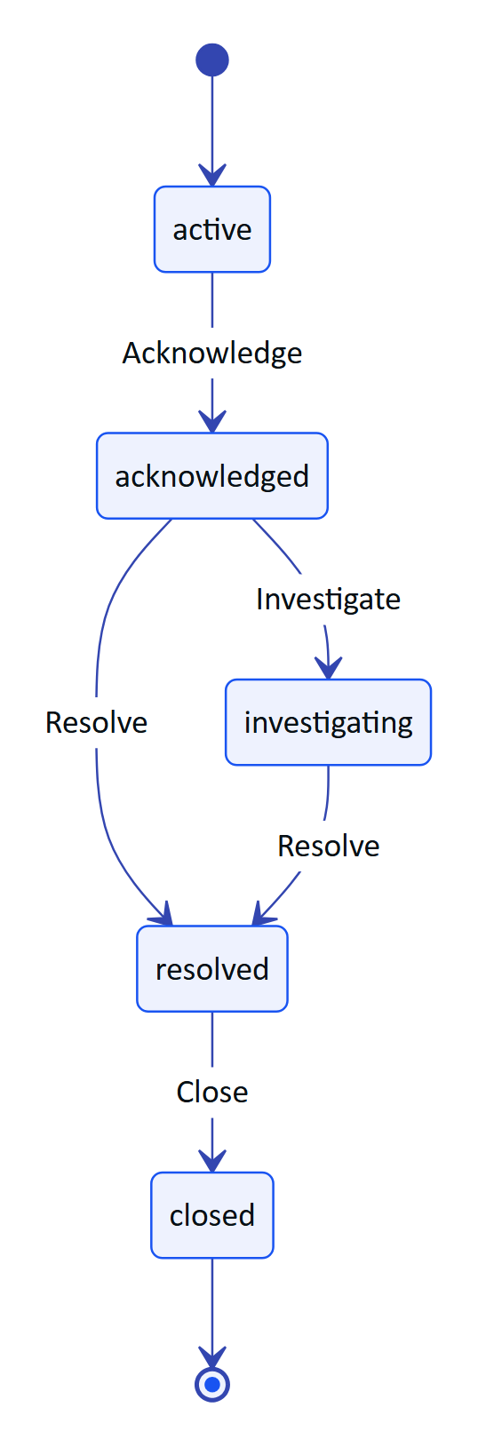
Figure 123. Alarm actions offered by state (AlarmDetailScreen)
Each button calls POST /alarms/{id}/{action} and reloads the alarm. Server rules still apply: if the user lacks the permission for an action, or another user already moved the alarm, the API error message is shown in an ErrorNote and the reloaded alarm shows the real state.
Planned on this screen: resolution notes (the repository already accepts a note), the alarm history timeline, the SOP link, assignment, and a "pending" marker for actions taken offline.

6.5.6 Sensor detail
Purpose. Trend of one sensor with its typical range.
Data. GET /telemetry/sensors/{id}/history?from=…&points=144 with from set to 6, 24 or 168 hours ago (filter chips "6 h", "24 h", "7 d"), refreshed every 15 s.
Layout. Tag and measurand label, sensor name, the last value in 44 sp, freshness and the number of readings, the range chips, a 220 dp line chart with a gradient fill, the typical range shaded in green when the API provides typicalRange, min, typical and max labels, and a "What this measures" card when the API returns an explanation.
Status. Built. Thresholds overlay, CSV export and pinch zoom are Planned.

6.5.7 Scan
The Scan tab is the app's most complex screen. Its pipeline is described in detail in the "Audit scan pipeline" chapter; this section covers the UI.
Figure 124. Scan menu with glasses, phone and import options
Menu. Eyebrow "Paper record → verified digital audit", title "Audit scan", explanation, and three source cards:
- Scan with glasses camera (Signal Blue border). Subtitle shows the glasses name and "or press the capture button" when DAT registration is complete, otherwise "Connect your glasses first (Glasses tab)".
- Scan with phone camera: guided A4 framing with CameraX. Asks for the camera permission in context.
- Import a photo: Android photo picker (PickVisualMedia, images only). Also the path on devices without a usable camera.
Below the cards, up to four recent scans with their status.
Guided capture. A status bar shows the guidance message with a coloured dot (green when ready, grey with no document, orange otherwise) and a source chip ("phone" or "Ray-Ban Meta"). The preview fills the remaining height with an A4 guide rectangle (86 % of the frame height), the detected page outline, corner dots and a green progress bar while the auto-capture timer runs. "Capture now" forces a capture; "Cancel" returns to the menu or to the review.
Figure 125. Guided capture waiting for an A4 sheet
Review. "N page(s) read on this phone", thumbnails of every page with the first pass's mean confidence, and a "Lines read (pass 1)" card with up to eight label and value pairs from the latest page. Buttons: "Send for verification", "Add page" (disabled at six pages) and "Discard".
Figure 126. Review of a captured page with label and value pairs
Sent. Eyebrow "Sent · awaiting dual verification", the document title detected by the server, chips for values, tables, engine agreement and items to check, the capture route, and "Scan another document".
Figure 127. Scan sent for dual verification
Figure 128. Scan screen stages (sealed interface Stage in ScanScreen.kt)
Capture button. While the menu or review is showing, a short press of the glasses capture button starts a glasses scan. During guided capture with the glasses source, it takes the photo.

6.5.8 Glasses
Purpose. One place to connect Ray-Ban Meta glasses, test them and register them with Hydris.
Figure 129. Glasses screen before the Meta AI app is installed
Status card. Glasses name (or "Waiting for glasses" or "Not connected"), status dot (green when registered and a device is visible, amber when registered with no device, grey otherwise), "Meta link" registration state and "session" state, and three chips: camera live or idle, mic state, and "in Hydris console" or "not registered".
Table 164. Glasses setup steps
Step | Done when | Action | Notes
1 Link with the Meta AI app | DAT registrationState is REGISTERED | "Connect glasses" initializes DAT if needed and calls startRegistration; "Disconnect" calls startUnregistration | Fails early with a clear message if the Meta AI app is missing
2 Allow camera and microphone | Camera streaming or speech listening | "Test camera" starts and stops a preview; "Test microphone" starts and stops speech | Each test triggers the Meta AI permission prompt the first time
3 Register in the Hydris console | A device refresh token is stored | "Register glasses" runs the pairing flow; "Unregister" logs the device out and forgets its tokens | Requires the device.pair permission on the server

Below the steps, a card lists what the glasses do in Hydris (audit scan, capture button, Hey Hydris, alarm notifications) and a "Connection log" card shows the latest eight of up to 30 DAT log lines kept in memory.
The DAT flows behind this screen are specified in the Glasses Integration document (HFG-GLS). The registration with Hydris is described under "Data layer and networking" below.

6.6 Data layer and networking

6.6.1 API client
HydrisApi talks to ${BuildConfig.HYDRIS_URL}/api. HYDRIS_URL comes from hydris_url in local.properties and defaults to https://hydrisview.vercel.app. Every request sends accept: application/json; JSON bodies use application/json; non-GET requests without a body send {}.
Table 165. HTTP client configuration
Setting | Value | Why
Connect timeout | 15 s | Fail fast on dead networks
Read timeout | 90 s | OCR uploads with server-side vision extraction can take a while
SSE read timeout | 0 (none) | The event stream is long-lived; the server sends heartbeats
JSON | ignoreUnknownKeys, explicitNulls = false, encodeDefaults | The API can add fields without breaking older app builds
Errors | ApiException(status, code, message) parsed from {error:{code,message}} | Screens show the server's message

6.6.2 Session model
The app follows the web session contract exactly, so the server needed no mobile-specific auth:
- A short-lived access token returned by /auth/login, /auth/demo and /auth/refresh is kept in memory only (@Volatile accessToken).
- A rotating refresh cookie (hg_refresh, path /api/auth) and, for demo accounts, the demo session cookie are stored by an OkHttp CookieJar whose backing store is the encrypted SecureStore entry cookies.
- The cookie jar only sends cookies to the configured host and drops expired cookies on load and on save.
Figure 130. Session restore on app start

6.6.3 Refresh on 401 with a mutex
raw() retries a 401 once after a successful refresh, except for /auth/login and /auth/demo. refresh() is wrapped in a coroutine Mutex, so when several screens hit a 401 at the same moment the refresh calls run one after another and the server sees each rotated cookie in order. This matters because the API revokes the whole refresh family when a cookie is reused outside its grace window.
Figure 131. Parallel 401s share one refresh at a time
NOTE
The second waiter performs its own refresh rather than reusing the first result. That is correct but costs one extra rotation. A Planned improvement is to skip the refresh when the access token changed while waiting for the lock.

If the retry still returns 401, or the refresh fails, onSessionLost fires and the user returns to Login with "Session ended. Please sign in again."

6.6.4 Device credential channel
When the glasses are registered, a second credential set is stored in SecureStore: device.access, device.refresh, device.name. deviceCall() sends a request with the device access token and, on 401, exchanges the device refresh token at POST /device/refresh for a new pair and retries once. Scans captured with the glasses are uploaded through this channel so the console attributes them to the device (capturedVia set by the server from the principal), while every other call uses the user's token.
RISK
The device refresh in deviceCall() is not serialized by a mutex. Two concurrent glasses uploads could both rotate the device token and trigger reuse detection. Today only one upload runs at a time (the Scan screen is modal), so the risk is low; adding a lock is Planned.

6.6.5 Repository
Table 166. Repository functions and endpoints
Function | Method and path | Used by
overview() | GET /overview | Home
alarms() | GET /alarms | Work alarms tab
alarm(id) | GET /alarms/{id} | Alarm detail
alarmAction(id, action, note) | POST /alarms/{id}/{action} | Alarm detail
inspections() | GET /inspections | Work inspections tab
tasks() | GET /maintenance | Work maintenance tab
toggleChecklist(task, item, done) | POST /maintenance/{id}/checklist/{itemId} | Work maintenance tab
sensors() | GET /sensors | Work sensors tab
history(id, hours) | GET /telemetry/sensors/{id}/history | Sensor detail
notifications() | GET /notifications | Not used by a screen yet
ask(text, history) | POST /assistant/ask | Hydris assistant
auditDocs() | GET /audit-docs | Work audit docs tab, Scan menu
uploadScan(upload, viaGlasses) | POST /audit-docs, then POST /audit-docs/{id}/enhance when aiStatus is pending | Scan
registerGlasses(hw, name, model) | POST /pairing/challenges, GET /pairing/lookup, POST /pairing/approve, POST /pairing/challenges/{id}/poll | Glasses
unregisterGlasses() | POST /device/logout (device token) | Glasses

6.6.6 Registering glasses as a Hydris device
The console already pairs display glasses with an RFC 8628-style device authorization flow: the device asks for a challenge and shows a code, a signed-in user approves the code on /pair, and the device polls until it receives tokens. The phone plays both roles in one go: it creates the challenge for the glasses and immediately approves it as the signed-in user.
Figure 132. Self-approved registration of the glasses (Repository.registerGlasses)
Rules enforced by the server (apps/api/src/modules/devices.ts): the approver needs device.pair; pairing to another user needs device.manage; glasses registered to another organization must be revoked there first (device_owned_elsewhere); challenges expire after 300 s; polling faster than every 3 s returns slow_down. The hardware ID is rbm- followed by the first 16 bytes (hex) of SHA-256 over hydris-glasses: plus the DAT device identifier, so the raw Meta identifier never leaves the phone and re-registering the same glasses reuses the console's device record.
WARNING
The app assigns the glasses to the first site returned by /pairing/lookup. Users with access to several sites cannot choose. A site picker is Planned before multi-site pilots.

6.6.7 Realtime events (SSE)
HydrisApi.events() returns a cold Flow<Pair<event, data>> backed by a daemon thread. It connects to GET /api/events/stream with the bearer token and accept: text/event-stream, and sends last-event-id after the first event so the server can replay missed events. The parser handles event:, data: and id: lines and emits on each blank line.
Figure 133. SSE connection loop in HydrisApi.events()
The server (apps/api/src/modules/realtime.ts) sends a ready event with retry: 3000, comment heartbeats every 15 s, and ends long-lived streams cleanly so clients reconnect with Last-Event-ID.

6.7 Audit scan pipeline

6.7.1 End-to-end flow
Figure 134. Audit scan pipeline on the phone

6.7.2 Page detection (DocDetect)
scan/DocDetect.kt is a line-by-line Kotlin port of apps/web/src/lib/docdetect.ts with the same thresholds, so the phone, the glasses web viewport and the console guide the wearer identically.
Table 167. Detection algorithm
Step | What it does | Constant
Downscale | Scale the frame to 200 px wide, keep aspect | DW = 200
Grayscale | Luma with integer weights 299, 587, 114 per 1000
Threshold | Otsu's threshold on the histogram, floored | at least 90
Region | 4-connected flood fill of bright pixels; keep the largest region | Region must cover at least 6 % of pixels
Corners | Extremes of x+y (top-left, bottom-right) and x−y (top-right, bottom-left)
Coverage | Quad area over frame area
Aspect | Longer over shorter mean side | A4 is √2 (1.414)
Skew | Largest deviation of a corner angle from 90°
Tilt | Angle of the top edge
Edge contact | Region pixels on the frame border over the perimeter | More than 8 % means cut off
Sharpness | Variance of the Laplacian inside the quad's bounding box

6.7.3 Guidance
DocDetect.guide() checks conditions in a fixed order and returns the first message that applies. The order matters: there is no point asking the wearer to straighten a page that is half out of frame.
Figure 135. Guidance decision order (DocDetect.guide)

6.7.4 Stability and auto-capture
GuidedCapture runs detection at most every 90 ms. A frame is "still" when every corner moved less than 0.012 of the frame size since the previous detection (DocDetect.motion). Four still detections in a row make the page stable. When the guidance is "Ready", a timer starts; after 900 ms of continuous readiness the app captures automatically. Any non-ready frame resets the timer. The green progress bar shows the timer.

6.7.5 Capture and flattening
On capture the app takes a full-resolution photo: CameraX ImageCapture in CAPTURE_MODE_MAXIMIZE_QUALITY (rotated by the reported rotation degrees), or GlassesManager.capturePhoto() for the glasses (EXIF orientation applied). Detection runs again on the full photo. If it finds a page with coverage over 20 % that does not touch the edges, that quad is used; otherwise the last quad from the preview is used; if there is none, the photo is kept as is.
warpToA4 maps the unit square onto the quad with a projective homography (squareToQuad), insets the quad by 0.4 % to drop the page border, and samples the source bilinearly into a 1654 x 2339 bitmap: A4 at 200 dpi. Pixels outside the source are white.
NOTE
A comment in apps/web/src/lib/docdetect.ts still mentions 1240 x 1754 at 150 dpi, but the code in both the web and Android versions defaults to outW = 1654. The comment is stale.

6.7.6 On-device OCR (OcrEngine)
scan/OcrEngine.kt reads each page twice with ML Kit Text Recognition on the device. No image leaves the phone until the user taps "Send for verification".
Figure 136. Two-pass OCR and upload sizing in OcrEngine.scan
Table 168. OCR details
Item | Behaviour
Size budget | Longest side at most 2400 px; JPEG at quality 85, then 75, then 65; if still over 850 KB, scale by 0.8 and retry, up to six times, else fail with "This image is too large to upload"
Pass 1 | ocr:original: the encoded bitmap as captured
Pass 2 | ocr:enhanced: grayscale, 1 % contrast stretch at both ends, Bradley adaptive threshold (window radius max(8, min(W,H)/32), factor 0.85), then removal of horizontal black runs of at least 20 % of the width and vertical runs of at least 2.8 % of the height, so table borders and underlines do not merge cells
Output format | OcrReading{engine, text, conf, lines[]} with words; boxes normalized to [x, y, w, h] in 0..1; confidences scaled to 0..100 to match the Tesseract-compatible web format in apps/web/src/lib/ocr.ts
Line order | Sorted by top edge, then left edge
Progress | "Preparing image" 5 %, "Reading text (pass 1 of 2)" 15 %, "Reading text (pass 2 of 2)" 55 %, "Done" 100 %

The two readings are the machine half of Hydris's dual verification: the server compares them field by field (agreement) and flags disagreements for the reviewer.

6.7.7 Label and value pairing on the review card
ML Kit often returns a form's label column and value column as separate lines. labelValues() takes every line that contains a colon. If text follows the colon, that is the value. Otherwise it looks for the nearest line to the right (starting beyond 90 % of the label's width) whose vertical centre is within 60 % of the label's height, and uses it as the value. The card shows the first eight pairs. This is display only; the server does its own structuring.

6.7.8 Upload limits
Table 169. Upload limits (apps/api/src/modules/audit-docs.ts and OcrEngine.kt)
Limit | Server | App
Pages per document | 6 (MAX_PAGES) | "Add page" disabled at 6
Bytes per page image | 900 KB (MAX_PAGE_BYTES) | Encodes under 850 KB to leave headroom
Request body | 8 MB | 6 pages of up to 850 KB in base64 fit
Image types | JPEG or PNG, checked by magic bytes | Always JPEG
Source tag | source field | "mobile"

After a successful upload, if the server reports aiStatus = "pending", the app calls POST /audit-docs/{id}/enhance to start the optional vision extraction. Failures of that call are ignored; the document is already saved.

6.8 Voice

6.8.1 Speech sources
voice/VoiceEngine.kt provides one transcript stream to the assistant regardless of where the audio comes from.
Table 170. Speech engines
Source | Recognition | Restart behaviour | Self-hearing protection
Glasses | DAT Speech capability on the glasses microphone; partial and final transcripts | GlassesManager restarts the speech capability when it reports STOPPED after having started, while listening is wanted | Transcripts are dropped while TTS is speaking
Phone | Android SpeechRecognizer, free-form model, partial results on, device locale | Restarts 150 ms after results, no match or speech timeout; 1200 ms after other errors | Recognizer is cancelled during TTS and restarted after
None | Not available | Not applicable | Not applicable

6.8.2 Speech output
Answers are spoken with Android TextToSpeech in the device locale, QUEUE_FLUSH, with a 30 s safety timeout. When the glasses are the active Bluetooth audio output, Android routes the speech to their open-ear speakers; the app does not route audio itself. speak() waits up to 1.5 s for the TTS engine to initialize the first time.
NOTE
The phone microphone needs RECORD_AUDIO, which the assistant requests when Hey Hydris is turned on. The glasses microphone needs the DAT MICROPHONE permission, approved in the Meta AI app.

6.8.3 Language
Recognition and speech use Locale.getDefault(). The assistant's answers come from the server in English. Hindi and other Indian languages for questions and answers are Planned and depend on server-side support in voice-assistant.ts.

6.9 Notifications
Built. HydrisApp creates a notification channel alarms ("Plant alarms", importance high, description "Critical and high alarms on your sites"). While the signed-in UI is composed, Root.kt collects the SSE stream and, for every alarm.created event whose state is active and whose severity is critical or high, posts a notification titled "Critical alarm" or "High alarm" with the alarm title, using the Hydris mark as the small icon and auto-cancel on tap.
Figure 137. Alarm notification path
Table 171. Notification gaps
Gap | Effect | Plan
No push service | Notifications arrive only while the app process and signed-in UI are alive | FCM with a server-side sender (Planned)
Notification ID is the title's hash | Two alarms with the same title replace each other | Use the alarm ID (Planned)
Tap opens the app, not the alarm | Operator must find the alarm | Deep link alarm/{id} in the pending intent (Planned)
Permission asked on every start | Users who deny it are asked again on each onStart | Ask once, explain in Settings (Planned)
GET /notifications not shown | The in-app inbox is console only | Notifications screen (Planned)

6.10 Permissions

6.10.1 Permission matrix
Table 172. Android and DAT permissions
Permission | Kind | Declared in | Requested when | Used for | If denied
BLUETOOTH | Normal (install time) | Manifest | Always granted | DAT link | Not applicable
BLUETOOTH_CONNECT | Runtime (Android 12+) | Manifest | Every MainActivity.onStart, with the other two | DAT reaches the glasses through the Meta AI app | DAT is not initialized; glasses features unavailable, phone features work
POST_NOTIFICATIONS | Runtime (Android 13+) | Manifest | Every onStart | Alarm notifications | No notifications
INTERNET | Normal | Manifest | Always granted | API and SSE | Not applicable
CAMERA | Runtime | Manifest | Tapping "Scan with phone camera" | CameraX scan | "Camera permission is needed to scan with the phone"; import still works
RECORD_AUDIO | Runtime | Manifest | Turning Hey Hydris on | Phone microphone | Switch turns back off; typing still works
DAT CAMERA | Glasses capability | DAT | First glasses preview or photo | Glasses camera | "Camera permission denied in Meta AI"
DAT MICROPHONE | Glasses capability | DAT | First glasses speech start | Glasses microphone | "Microphone permission denied in Meta AI"; falls back to phone microphone

The manifest marks android.hardware.camera as not required, so the app installs on devices without a camera.

6.10.2 Glasses permission round trip
MainActivity registers Wearables.RequestPermissionContract() and exposes requestGlassesPermission(permission) as a suspend function guarded by a Mutex, so only one Meta AI prompt is open at a time. GlassesManager.ensurePermission() first calls Wearables.checkPermissionStatus() and only launches the prompt when the permission is not granted. The full sequence is in the Glasses Integration document.

6.11 Design system

6.11.1 Colour tokens
The Hx object in ui/theme/Theme.kt holds the brand palette shared with the website, console and glasses HUD. The app is dark only.
Table 173. Hx colour tokens
Token | Hex | Use
Hx.Midnight (Deep Midnight) | #081116 | App and window background, status bar
Hx.Surface | #0E1A21 | Cards, navigation bar, text fields
Hx.Surface2 | #13222B | Raised surfaces, step numbers, Talk button
Hx.Line | white at 12 % alpha | Card borders, dividers, chart grid
Hx.Signal (Signal Blue) | #1954F1 | Primary buttons, chart lines, progress
Hx.Core (Core Blue) | #1746E4 | Primary container
Hx.SignalText | #6F93FF | Blue text and icons on dark, selected tab
Hx.Alert (Alert Orange) | #FF2800 | Critical severity, errors
Hx.High | #F26414 | High severity, stale data, warnings
Hx.Medium | #F5B83D | Medium severity, delayed data
Hx.Ok (Active Green) | #00FE21 | Ready states, done steps (on dark only)
Hx.OkSoft | #34D27A | Live data, success chips, checklist done
Hx.Insight (Insight Purple) | #8A60F0 | AI surfaces, synthetic markers, maintenance health
Hx.Text | #F2F5F7 | Primary text
Hx.Text2 | #B7C2CA | Secondary text
Hx.Muted | #7D8B95 | Captions, inactive icons

Table 174. Semantic colour mappings
Mapping | Values
Hx.severity() | critical: Alert, high: High, medium: Medium, anything else: SignalText
Hx.freshness() | live: OkSoft, delayed: Medium, stale: High, anything else: Muted
Asset health (Home) | operational: OkSoft, degraded: High, down: Alert, maintenance: Insight, standby: Muted
Audit doc status | approved: OkSoft, rejected: Alert, verified: SignalText, others: Medium

6.11.2 Typography, shape and spacing
Table 175. Type scale (Material 3 Typography overrides)
Style | Size | Weight | Use
displaySmall | 34 sp | SemiBold | "Sign in"
headlineSmall | 24 sp | SemiBold | Screen titles
titleLarge | 20 sp | SemiBold | Section titles
titleMedium | 16 sp | Medium | Card titles
bodyLarge | 16 sp | Regular | Long text
bodyMedium | 14 sp | Regular | Body
bodySmall | 12.5 sp | Regular | Captions
labelSmall | 11 sp | Medium, 1.4 sp tracking | Uppercase eyebrows

Cards use a 22 dp corner radius and a 1 dp border; chips are fully rounded; text fields use 16 dp corners; primary buttons are 52 to 54 dp tall. KPI numbers are 34 sp. The app uses the system font; bundling Outfit to match the web is Planned.

6.11.3 Components
Table 176. Shared components (ui/components/Components.kt)
Component | Purpose
HCard | Rounded card with optional accent border and click
Eyebrow | Uppercase small label
SectionTitle | Section heading with optional action link
Chip | Rounded label, tinted or filled
Dot | Status dot
KpiTile | Label, large value, sub line, optional icon
ProgressBar | 6 dp rounded bar
Loading, ErrorNote | Standard loading and error states
Sparkline, LineChart, Bars, Donut | Canvas charts with no chart library
ago(), fmt(), label() | Relative time, number and label formatting

6.12 Accessibility
Field use means gloves, glare, noise and one free hand. The requirements below are written against that context.
Table 177. Accessibility requirements
Requirement | Status | Notes
Text scales with the system font size | Built | All text uses sp
Primary actions at least 48 dp tall | Built | Buttons are 52 to 54 dp; tabs use Material defaults
Touch targets of 56 dp for gloved use on primary flows | Partial | Main buttons meet it; chips, checklist rows and the sign-out icon do not
Content descriptions on actionable icons | Partial | Back, Sign out, Send and Talk have labels; source cards rely on their text
Colour is never the only signal | Partial | Severity has text chips; freshness also has text; scan guidance has text; the alarm card border is colour only
Contrast on Deep Midnight | Built for text | Hx.Text and Hx.Text2 are high contrast; Hx.Muted captions should be checked at 4.5:1
Voice alternative for the main question flow | Built | Hey Hydris and Talk button
Screen reader pass (TalkBack) | Planned | Not yet audited
Reduced motion | Not applicable | The app uses no decorative animation
Light theme for office use | Planned | Dark only today

6.13 Performance budgets
IMPORTANT
The numbers below are targets for pilot acceptance. None has been measured yet on reference hardware. QA will record results in the QA test plan (HFG-QA) on a mid-range reference phone.

Table 178. Performance targets
Metric | Target | Notes
Cold start to Home with a valid session | Under 2.0 s | Includes refresh and /auth/me
Home overview refresh | Under 800 ms on 4G | One request every 15 s
SSE alarm to notification | Under 2 s after the server publishes | Foreground process
Detection per preview frame | Under 25 ms | 200 px frame on the main thread; moving it off the main thread is Planned
Warp to A4 | Under 1.5 s | 3.9 MP output with bilinear sampling in Kotlin
OCR, two passes, one A4 page | Under 6 s | ML Kit on device
Upload, one page | Under 900 KB | Enforced by OcrEngine
Peak memory during a six-page scan | Under 300 MB | Pages are kept as full bitmaps for thumbnails; downsampling thumbnails is Planned
Glasses camera on | Only while the scan camera is open | See the battery gap below
APK size (release, minified) | Under 45 MB | ML Kit bundled model and DAT included

RISK
Battery: GlassesManager.stopPreview() stops forwarding frames but does not stop the DAT camera stream; the stream ends only when the session stops. On hardware this may keep the glasses camera and LED on after leaving the scan screen. Stopping the stream on stopPreview is a Planned fix that must be verified on real glasses.

6.14 Offline behaviour and sync

6.14.1 Today
Table 179. Offline behaviour as built
Situation | Behaviour
Network lost on a loaded screen | The last loaded data stays on screen; the next refresh fails silently because error is only shown when nothing has loaded
Network lost on a new screen | Loading spinner, then the error message
App restarted offline | Session restore fails and the user sees Login (the cookie is kept, so sign-in works once online again after restart)
Alarm action offline | Fails with the network error; nothing is queued
Checklist toggle offline | Fails silently (runCatching), the list reloads and shows the real state
Scan offline | Capture and OCR work fully offline; upload fails and the pages stay in the review until the user retries or discards, but are lost if the app process ends
Voice offline | Phone recognition may still work (device dependent); the answer fails with an error bubble

6.14.2 Planned
- Room cache of assigned inspections with step snapshots, tasks, sensor last values and the device context, with "last updated" shown on every cached screen.
- Outbox for inspection responses (with clientOpId, made idempotent by the server's unique index), checklist toggles, alarm acknowledgements, notes and scans (pages written to app-private storage until accepted).
- WorkManager replay with exponential backoff when connectivity returns. Conflicts (409, invalid transition) shown as "updated by someone else"; local edits never silently dropped. Offline alarm acknowledgements shown as "pending" until confirmed.
- The glasses web viewport already implements the inspection response queue (apps/web/src/glasses/link.ts, flush()), which is the reference behaviour for the native outbox.

6.15 Security
Table 180. Security controls
Control | Status | Detail
Access tokens in memory only | Built | HydrisApi.accessToken, never persisted
Refresh cookies and device tokens encrypted at rest | Built | SecureStore: AES-256-GCM, non-exportable Android Keystore key alias hydris.secure.v1, random 12-byte IV stored before the ciphertext, 128-bit tag; only ciphertext in SharedPreferences hydris.secure
Undecryptable values treated as absent | Built | get() returns null if decryption fails (for example after a key reset), which forces a new sign-in
Backups disabled | Built | android:allowBackup="false"
HTTPS only | Built by default | No usesCleartextTraffic; the default for target SDK 28 and later blocks cleartext
Cookies scoped to the Hydris host | Built | Cookie jar ignores other hosts
Raw glasses identifier not sent | Built | SHA-256 derived rbm- hardware ID
Images kept in memory, never written to the gallery | Built | Pages are bitmaps in the Scan screen state
Sign out revokes the server session | Built | POST /auth/logout, then local cookies cleared
FLAG_SECURE on scan review | Planned | Prevents screenshots and recents thumbnails of documents
Certificate pinning with a backup pin | Planned | For production hosts
Release signing key | Planned | Release builds are currently signed with the debug key
Biometric re-entry after long inactivity | Planned
Managed configuration (MDM) for server URL | Planned | app_restrictions.xml
Device integrity signals | Planned | Informational only for pilots

CAUTION
Until the release signing configuration is replaced, any build produced with assembleRelease is signed with a debug key and must not be distributed outside the team.

The Hydris-wide threat model, data classification and retention are in the Security and Privacy document (HFG-SEC).

6.16 Build and release

6.16.1 Project setup
Table 181. Gradle setup
Item | Value
Root project | hydris-field, one module :app
Namespace and application ID | ai.hydris.field
Version | versionName 1.0.0, versionCode 1
Repositories | Google (Android and Google groups only), Maven Central, Gradle Plugin Portal; FAIL_ON_PROJECT_REPOS
Gradle JVM | -Xmx4g
Java and Kotlin target | 17
Build features | Compose, BuildConfig
Packaging | Excludes META-INF/AL2.0 and LGPL2.1
Release build | R8 minify on, proguard-android-optimize.txt plus proguard-rules.pro (kotlinx.serialization keep rules; DAT and ML Kit ship consumer rules)

Table 182. Build-time configuration in local.properties (not committed)
Key | Default | Purpose
sdk.dir | none | Android SDK path
hydris_url | https://hydrisview.vercel.app | API base URL compiled into BuildConfig.HYDRIS_URL
mwdat_application_id | 0 | DAT application ID manifest placeholder
mwdat_client_token | 0 | DAT client token manifest placeholder

cd apps/android
./gradlew assembleDebug
adb install app/build/outputs/apk/debug/app-debug.apk
NOTE
DAT artifacts (com.meta.wearable:mwdat-*) are not on Maven Central or Google Maven. The bridge README and Meta's distribution use a GitHub Packages Maven repository that needs a token with read:packages. The settings.gradle.kts in apps/android lists only Google and Maven Central, so the build relies on that repository being configured in the developer's Gradle user settings or on a local Maven cache. Adding the repository declaration explicitly is Planned.

6.16.2 DAT credentials and Developer Mode
With the placeholders set to 0, the app runs against glasses only when Developer Mode is enabled in the Meta AI app. DAT logs that it read no credentials; that is expected in Developer Mode. For production, the Wearables Developer Center issues an application ID and client token, which go into local.properties and the manifest placeholders.

6.16.3 Release channels
Figure 138. Release path from build to operators
Table 183. Distribution status
Channel | What it covers | Status
Direct APK (sideload) | Team devices and demos | In use
Google Play internal and closed testing | Phone features for pilot users | Planned (needs release signing and the Play data safety form)
Managed Google Play (private app) | Enterprise rollout through the customer's MDM | Planned
Wearables Developer Center release channels | Invite-only testing of the glasses features without publishing review | Planned (needs a Developer Center organization and app)
Public listing with DAT features | General availability | Blocked: Meta's FAQ says submissions are not open yet and will open "soon"

RISK
Full Wearables Developer Center access is limited to countries where Meta AI glasses are supported. Eligibility for Hydris's Indian pilots must be confirmed with Meta before planning a production glasses rollout. Phone features are not affected.

The Play data safety declaration must cover: camera images (processed on device, uploaded when the user sends a scan), audio (recognized on device or by the system recognizer; transcripts sent to Hydris), account information, and crash diagnostics once added.

6.17 Testing

6.17.1 Current state
There are no automated tests in apps/android yet (no src/test or src/androidTest). The scanning algorithm is shared with the web, where the same thresholds are exercised by the web test suite and the simulated glasses camera in apps/web/src/glasses/camera.ts. The bridge app README states that the page side was tested end to end with a stand-in bridge, and that DAT calls are type-checked but not yet run on physical glasses.

6.17.2 Test plan
Table 184. Planned test layers
Layer | Scope | Tooling
Unit | DocDetect (guidance, warp corners, parity with web fixtures), OcrEngine.prepare sizing, labelValues, wake and stop regexes, cookie jar expiry | JUnit, Robolectric for Bitmap
Networking | Refresh on 401, mutex ordering, session lost, device token refresh, SSE parsing and Last-Event-ID | OkHttp MockWebServer, Turbine
UI | Login states, alarm actions per state, scan stages, glasses steps | Compose UI tests
Screenshots | Every screen at font scale 1.0 and 1.3 | Roborazzi or Paparazzi
Glasses without hardware | Registration, permissions, camera stream, photo, capture button | DAT Mock Device Kit (mwdat-mockdevice, already a debug dependency)
Hardware | Ray-Ban Meta Gen 2 and Oakley Meta, phone matrix | Manual, per the QA test plan (HFG-QA)
End to end | Demo deployment, scripted round | Manual for pilot, automated later

NOTE
Meta's FAQ states that the Mock Device Kit does not support display glasses. That does not affect Hydris Field, which targets camera glasses.

6.18 Feature status and roadmap

6.18.1 Status summary
Table 185. Feature status
Feature | Status
Sign in, demo mode, session restore, sign out | Built
MFA, org switch, server picker | Planned
Home dashboard | Built
Alarms list, detail and lifecycle actions | Built
Alarm notes, history, SOP links | Planned
Inspections list | Built (read-only)
Running inspections on the phone | Planned
Maintenance list and checklist toggles | Built
Maintenance start, hold, complete | Planned
Sensors list and history chart | Built
Audit scan: phone camera, glasses camera, import, guided capture, two-pass OCR, upload | Built
Audit document list | Built
Audit review and approval in the app | Planned (console only)
Hydris assistant: text, Hey Hydris on phone and glasses, spoken answers | Built
Voice Invocations ("Hey Meta, start Hydris") in the native app | Planned (implemented in the bridge app only)
Glasses connect, test, register, unregister | Built, not verified on hardware
Realtime alarm notifications while open | Built
Push notifications when closed | Planned
Offline cache and outbox | Planned
Automated tests | Planned
Release signing and Play distribution | Planned

Figure 139. Mobile roadmap (indicative quarters)

6.18.2 Open questions
- Should the phone app become the only companion for display glasses as well, replacing apps/glasses-bridge-android, or should the WebView bridge remain for Meta Ray-Ban Display web apps? (See the Glasses Integration document.)
- Which customer MDMs must be supported at pilot (Intune, Workspace ONE, Google endpoint management)?
- Is MFA mandatory for field operators at the first pilot site? If so, in-app MFA moves to the top of the plan.

7 Glasses Integration
NOTE
HFG-GLS v2.0 · Draft for review · Owner: Engineering, Hydris. How Hydris connects to Ray-Ban Meta and other smart glasses through Meta's Device Access Toolkit, the WebView bridge and the glasses web viewport

Hydris puts live plant data, guided paper capture and a voice assistant in front of field operators who need their hands free. This document explains how Hydris talks to smart glasses: which glasses, which capabilities, which software stack, and what is built, partial or planned. It covers three runtimes that share one backend and one account model:
- Hydris Field (apps/android), the native Android app, which uses Meta's Wearables Device Access Toolkit (DAT) directly.
- Hydris Glasses bridge (apps/glasses-bridge-android), a WebView host that loads the glasses web app and exposes DAT to it through a JavaScript bridge.
- The glasses web viewport (apps/web/src/glasses/*, served at /glasses), which runs as a heads-up display (HUD) in the browser simulator and as a full-screen phone layout inside the bridge.
4  DAT modules used  core, camera, speech, inputs (1.0.1) |  | 0  Displays on Ray-Ban Meta  the phone is the screen |  | 3  Camera bridge shapes  JS interface, injected API, postMessage |  | 300 s  Pairing code lifetime  `PAIRING_TTL_S`

IMPORTANT
No Hydris build has yet been run against physical Meta glasses. All DAT calls compile and are type-checked against DAT 1.0.1, and the page side of the bridge was tested end to end with a stand-in bridge (apps/glasses-bridge-android/README.md). Every hardware behaviour in this document is therefore Built, not hardware-verified unless stated otherwise. The first hardware run is the top item on the roadmap.

7.1 Scope and status
Table 186. Integration status at a glance
Capability | Native app | Bridge app | Web viewport alone
Register with the Meta AI app | Built | Built | Not possible
Glasses camera preview for guided A4 capture | Built | Built | Not possible
Full-resolution glasses photo | Built | Built | Not possible
Capture button | Built | Built | Keyboard and simulator only
Glasses microphone ("Hey Hydris") | Built | Built | Browser microphone
Spoken answers on the glasses speakers | Built (phone TTS over Bluetooth) | Built | Browser speech synthesis
Voice Invocations ("Hey Meta, start Hydris") | Planned | Built | Not possible
Register glasses as a Hydris device | Built (self-approved) | Built (code and QR via the viewport) | Built (code and QR)
HUD on glasses with a display | Not applicable | Not applicable | Built in the simulator; on-glasses Planned

7.1.1 Terminology
Table 187. Terms used in this document
Term | Meaning
DAT | Meta Wearables Device Access Toolkit: the Android and iOS SDK that lets phone apps use supported Meta glasses
Meta AI app | Meta's phone app (Android package com.facebook.stella) that pairs the glasses, updates firmware and approves third-party apps
Registration | DAT's approval that Hydris may connect to the glasses, confirmed in the Meta AI app
Session | A DAT DeviceSession with one device; camera, speech and inputs are capabilities added to it
Pairing | Hydris's own device authorization flow that turns the glasses into a Hydris device record
HUD | The 600 x 600 display layout of the web viewport
Phone mode | The full-screen phone layout of the web viewport used inside the bridge

7.2 Hardware and capabilities

7.2.1 Supported glasses
Meta's DAT FAQ lists Ray-Ban Meta (Gen 1 and Gen 2), Meta Ray-Ban Display, Oakley Meta HSTN and Oakley Meta Vanguard as supported, and says capability availability varies by device. Meta's setup guide additionally lists Ray-Ban Meta Optics and "Meta glasses". Hydris's primary target is Ray-Ban Meta Gen 2.
Table 188. Capability matrix by glasses family
Capability | Ray-Ban Meta (Gen 1, Gen 2) | Oakley Meta (HSTN, Vanguard) | Meta Ray-Ban Display | Browser simulator
Supported by DAT | Yes (Meta FAQ) | Yes (Meta FAQ) | Yes (Meta FAQ) | Not applicable
Camera stream and photo to the phone app | Yes via DAT | Yes via DAT, unverified by Hydris | Yes via DAT, unverified by Hydris | Simulated camera
Microphone and speech | Yes via DAT Speech | Unverified by Hydris | Unverified by Hydris | Web Speech API
Open-ear speakers | Phone TTS over Bluetooth | Phone TTS over Bluetooth | Phone TTS over Bluetooth | speechSynthesis
Capture button input | DAT Inputs | Unverified by Hydris | Unverified by Hydris | Keyboard, hydris:input
Display | None | None | Yes | 600 x 600 HUD
Hydris UI | On the phone | On the phone | On the phone today; on-glasses Planned | HUD
Hydris status | Primary target, not yet run on hardware | Expected to work, untested | Phone path expected to work; display Planned | Built

NOTE
Vendor hardware figures (camera megapixels, battery life, microphone count) are deliberately not quoted here. Take them from Meta's current specification sheets when talking to customers.

7.2.2 Display glasses from other vendors
The console's demo data (apps/api/src/seed/showcase.ts) contains device records for Vuzix M400 and RealWear Navigator 520 units, plus a browser simulator. These records show how a fleet of display glasses appears in the console (status, firmware, app version, assignment). Hydris has no native app for Vuzix or RealWear yet. The web viewport is designed for such devices: a 600 x 600 additive display, large type and directional input. The simulator offers 600 x 600, 640 x 480 and 480 x 480 viewports (apps/web/src/app/simulator/page.tsx).
Table 189. Other display glasses
Device | Where it appears | Status
Vuzix M400 | Demo device records | Planned: run /glasses in the device browser or a thin Android host; not tested
RealWear Navigator 520 | Demo device records | Planned: as above, with voice-first navigation; not tested
Browser simulator | /simulator, device kind simulator | Built

7.3 Runtimes and architecture
Figure 140. The three glasses runtimes and the shared Hydris backend

7.3.1 Meta's stack
Figure 141. Layers between Hydris code and the glasses
Table 190. DAT artifacts used (com.meta.wearable, version 1.0.1)
Artifact | What Hydris uses
mwdat-core | Wearables.initialize, registrationState, registrationErrorStream, startRegistration, startUnregistration, devices, devicesMetadata, checkPermissionStatus, RequestPermissionContract, createSession(AutoDeviceSelector()), isVoiceInvocationsIntent
mwdat-camera | session.addCamera(StreamConfiguration(VideoQuality.MEDIUM, 24)), stream.videoStream, stream.start, stream.state, stream.capturePhoto, PhotoData.Bitmap and PhotoData.HEIC
mwdat-speech | session.addSpeech(), transcriptions, state, errors, start, stop
mwdat-inputs | session.addInputs(InputsConfiguration(CAPTURE_BUTTON)), InputEvent.Capture with CapturePressType.SHORT_PRESS
mwdat-mockdevice | Debug dependency only; not yet used by tests

The bridge README notes that Speech, Inputs and Voice Invocations are experimental in DAT and must be enabled for the app in the Wearables Developer Center. Hydris treats them as optional at runtime: failures are logged and the phone fallbacks remain.

7.4 The Meta AI app dependency
Meta's documentation is explicit: "the Meta AI app must be used to pair your glasses". Developer Mode, which lets an unpublished app connect, is enabled in the Meta AI app (Settings, App Info, tap the app version five times, then turn on Developer Mode); connected apps then appear under Meta AI settings, App connections, Developer mode apps. Firmware versions must meet DAT's version dependency table, and firmware is updated through the Meta AI app.
DECISION
Hydris does not attempt to replace the Meta AI app. It must stay installed and signed in. Hydris checks for it (GlassesManager.metaAiInstalled() looks up com.facebook.stella, declared in the manifest <queries>) and tells the user to install it and pair the glasses there first.

Developer Mode builds use the manifest placeholders mwdat_application_id = "0" and mwdat_client_token = "0" (both apps' build.gradle.kts). DAT logs that it read no credentials, which is expected. Production builds put the values issued by the Wearables Developer Center in local.properties.

7.5 DAT lifecycle
The native GlassesManager and the bridge's MainActivity implement the same lifecycle. Differences are noted where they matter.

7.5.1 Initialization
DAT is initialized only after Android grants the Bluetooth permissions. The native app requests BLUETOOTH, BLUETOOTH_CONNECT and POST_NOTIFICATIONS on every onStart and initializes when BLUETOOTH_CONNECT is not denied. The bridge requests BLUETOOTH, BLUETOOTH_CONNECT and INTERNET and initializes only if all are granted.
Figure 142. DAT initialization in the native app
The device name comes from devicesMetadata and falls back to "Ray-Ban Meta" when empty. The state holds the registration state, the device list, the session state, camera streaming, speech state, the last error and a log of the latest 30 messages.

7.5.2 Registration through the Meta AI app
Figure 143. Registration hands off to the Meta AI app and returns
Each app declares a callback URL scheme in its manifest for the return from the Meta AI app: hydrisfield for the native app and hydrisglasses for the bridge. The native app starts registration only from the Glasses screen. The bridge also starts it automatically when the page needs a session and the app is not registered, and exposes HydrisNative.connectGlasses(). Unregistration uses startUnregistration (native "Disconnect").

7.5.3 Permissions
Camera and microphone access on the glasses are DAT permissions, separate from Android permissions, and are approved in the Meta AI app.
Figure 144. Requesting a glasses permission
The mutex ensures only one prompt is open at a time. A cancelled or failed result is treated as Denied.

7.5.4 Session
One DeviceSession is shared by camera, speech and inputs. It is created lazily with createSession(AutoDeviceSelector()) the first time a capability is needed, started, and reused while its state is STARTED. A CompletableDeferred lets concurrent callers wait for the same session.
Figure 145. Device session lifecycle
On STOPPED both apps drop the camera, speech and inputs objects so the next request creates a fresh session. Session errors are logged ("Session: ...").

7.5.5 Camera stream for guided capture
Figure 146. Glasses preview frames feeding page detection
DAT documents raw frames as YUV pixel data without fixing the chroma layout. Every planar or semi-planar 4:2:0 layout starts with the full-resolution luma plane, so Hydris reads luma only. The row stride is inferred from the buffer size (total bytes over height times 1.5), and frames are subsampled to at most 640 px wide. Compressed frames are skipped. The native app forwards at most one frame per 100 ms; the bridge encodes one JPEG (quality 70) per 120 ms and calls window.__hydrisCameraFrame.
RISK
Two parts of this path are unverified on hardware: stride inference, and the battery cost of the stream. stopPreview() stops forwarding frames but does not stop the DAT stream, which ends only with the session. Stopping the stream explicitly is Planned and must be checked against the capture LED behaviour.

7.5.6 Photo capture
capturePhoto() works only on an active stream, so both apps wait until the stream reports STREAMING (or stops) before capturing.
Figure 147. Full-resolution photo from the glasses
The bridge also handles EXIF flips and transposes, then encodes the photo as JPEG at quality 92 and calls window.__hydrisCameraPhoto(requestId, base64). The native app handles rotations only; adding flips is Planned.

7.5.7 Capture button
When a session starts, both apps add the Inputs capability with sources = {CAPTURE_BUTTON} and consumeBack = false. Only InputEvent.Capture with SHORT_PRESS is used.
Figure 148. What a short press of the capture button does
The capture press decomposition (which presses DAT reports as short) is unverified on hardware.

7.5.8 Speech
Figure 149. Always-on glasses speech with restart after silence
Transcriptions arrive as text with an isFinal flag. The native VoiceEngine drops them while text-to-speech is playing. The bridge forwards them with window.__hydrisSpeech(text, isFinal) and reports states with window.__hydrisSpeechState(state, detail). Answers are spoken by the phone's TextToSpeech; Android plays them on the glasses when they are the Bluetooth audio output.

7.5.9 Voice Invocations
The bridge checks every launch and new intent with isVoiceInvocationsIntent(intent) and, when it matches, dispatches hydris:voice-activate to the page, which opens the assistant. The native app does not handle Voice Invocations yet (Planned).

7.5.10 Errors
Table 191. Error sources and handling
Source | Example message | Handling
Registration | "Meta AI: ..." | Shown on the Glasses screen
Missing Meta AI app | "Install the Meta AI app and pair your glasses in it first" | Registration not started
Not registered | "Connect Hydris in the Meta AI app first" | No session created
Session | "No glasses session: ..." | Deferred fails, next call retries
Camera permission | "Camera permission denied in Meta AI" | Preview and capture fail; phone camera still available
Camera stream | "Stream failed: ..." | Logged; scan shows the error
Microphone permission | "Microphone permission denied in Meta AI" | Phone microphone used instead
Inputs | "Capture button unavailable: ..." | Logged only

7.6 Web bridge contract
The bridge app (ai.hydris.glassesbridge, version 0.2.0, minSdk 31) loads ${HYDRIS_URL}/glasses in a WebView with JavaScript and DOM storage enabled and adds a HydrisNative JavaScript interface. The page detects the bridge and switches to phone mode.
Figure 150. Bridge app structure

7.6.1 Page to host
Table 192. window.HydrisNative methods
Method | Effect
startPreview() | Turn preview forwarding on and ensure the camera stream
stopPreview() | Stop forwarding preview frames
capturePhoto(requestId) | Take a full-resolution photo and answer with the same ID
deviceName() | Returns "Ray-Ban Meta" (constant today)
startSpeech() | Start always-on glasses speech
stopSpeech() | Stop speech
speak(text) | Speak with phone TTS
connectGlasses() | Start DAT registration
status() | DAT registration state as text

7.6.2 Host to page
Table 193. Callbacks and events the host calls
Callback or event | Arguments | Meaning
window.__hydrisCameraFrame | JPEG base64, width, height | Preview frame (about 8 fps)
window.__hydrisCameraPhoto | request ID, JPEG base64 | Photo result
window.__hydrisCameraError | request ID, message | Photo failed
window.__hydrisSpeech | text, isFinal | Transcript
window.__hydrisSpeechState | state, detail | listening, idle or error
window.__hydrisSpoken | none | TTS finished
hydris:glasses-capture-button | CustomEvent | Capture button short press
hydris:voice-activate | CustomEvent, optional question | Open the assistant

The page rejects a photo request after 20 s ("The glasses did not return a photo"). For speech output it resolves after __hydrisSpoken or a timeout of 1.5 s plus 70 ms per character (at most 20 s).

7.6.3 Other host shapes
apps/web/src/glasses/camera.ts also supports an injected promise API for iOS WKWebView hosts, window.HydrisWearables (capturePhoto(): Promise<{dataUrl}>, optional startPreview(onFrame), stopPreview(), deviceName), and a postMessage protocol for any embedding host (React Native WebView or a parent frame).
Table 194. postMessage protocol
Direction | Message | Fields
Host to page | hydris:camera-ready | deviceName (announces a bridged camera)
Page to host | hydris:camera-start | none
Host to page | hydris:camera-frame | dataUrl
Page to host | hydris:camera-capture | requestId
Host to page | hydris:camera-photo | requestId, dataUrl
Host to page | hydris:camera-error | requestId, message
Page to host | hydris:camera-stop | none
Simulator to page | hydris:input | key: up, down, left, right, select, back (same origin only)
Simulator to page | hydris:network | online (simulated loss)
Console to page | hydris:profile | config (demo preview only)
Page to console | hydris:preview-ready | none
Page to simulator | hydris:event | event, detail, at (event log)

Figure 151. Camera source selection in openCamera()
The simulated camera draws the sample A4 audit sheet moving through too close, too far, tilted and finally square, so every guidance state is exercised without hardware. Its stills are 2016 x 1512.
WARNING
Bridge hardening is Planned: the WebView grants every page permission request (onPermissionRequest grants all resources) and does not restrict navigation away from HYDRIS_URL. The JavaScript interface would be exposed to any page loaded. Restrict navigation to the Hydris origin before distributing the bridge outside the team.

7.7 Glasses web viewport

7.7.1 HUD and phone modes
useViewportLayout in apps/web/src/glasses/hud.tsx picks the layout.
Figure 152. Choosing HUD or phone layout
Table 195. HUD versus phone mode
Aspect | HUD mode | Phone mode
Canvas | 600 x 600, scaled to the window | 540 design units wide, full device height
Target | Display glasses, simulator | Bridge app, portrait phones
Navigation | Directional keys, swipes, hydris:input; hint bar for the configured hand | Bottom tab bar: Home or Back, Scan, Hey Hydris, Alerts
Design rules | Additive display: black is transparent, light strokes, type at 20 px or more, a lime focus ring, one primary action per screen | Same components, safe-area insets

7.7.2 Phases and screens
Figure 153. Viewport phases (GlassesApp.tsx)
Screens: home, alerts and alert detail, inspections and the inspection runner, tasks and task detail, asset context, assist, status, notifications, Hydris AI, plant map, audit scan, measurements, assets, SOP library and reader. Each screen is gated by the organization's UI profile (screenPermitted), so administrators decide in the console what each role sees on the glasses.

7.7.3 Voice assistant on the viewport
Figure 154. Hey Hydris on the viewport (VoiceAssistant.tsx)
The engine order is the bridge (meta-glasses), then the browser Web Speech API, then none (typed questions). Offline, demo and cached answers come from answerFromContext using the same rules as the API.

7.7.4 Audit scan on the viewport
AuditScan.tsx follows the same steps as the native app: guided capture (apps/web/src/lib/GuidedCapture.tsx, 900 ms ready time, stability threshold 0.012), A4 warp to 1654 px wide, two OCR passes in the browser, review of up to six pages and upload. The capture button shoots while framing and starts a scan from the menu or review.

7.8 Pairing with the Hydris account
Glasses become Hydris devices through an RFC 8628-style device authorization flow (apps/api/src/modules/devices.ts). Two variants exist.

7.8.1 Code and QR (viewport and bridge)
Figure 155. Pairing from the glasses viewport
The viewport's hardware ID is hg- plus a random UUID kept in local storage; the refresh token is stored in local storage too (link.ts), which the code marks as the integration boundary for a hardware-backed store.

7.8.2 Self-approval (native app)
The native app creates the challenge and approves it as the signed-in user in one step, assigning the glasses to that user and the first site the user can see. Its hardware ID is rbm- plus a SHA-256 digest of the DAT device identifier. Details are in the Mobile App Specification (HFG-MOB).
Table 196. Pairing rules and constants
Rule | Value
Code length and alphabet | 8 characters from 23456789ABCDEFGHJKMNPQRSTVWXYZ
Challenge lifetime | 300 s
Poll interval | 3 s; faster polls return slow_down
Statuses | pending, approved, completed, denied, expired, cancelled
Approver permission | device.pair; pairing to another person needs device.manage
Cross-organization | device_owned_elsewhere until revoked in the other organization
A new challenge for the same hardware | Cancels older pending or approved ones
Device states seen by the viewport | active, suspended, revoked, unassigned

7.9 Setup guide

7.9.1 Developer setup
- Create an organization and app in the Wearables Developer Center (confirm country eligibility).
- Install the Meta AI app on an Android 12 or later phone, sign in, pair the glasses and update the firmware.
- In the Meta AI app, open Settings, App Info, tap the version five times and turn on Developer Mode.
- Configure the GitHub Packages Maven repository for com.meta.wearable with a token that has read:packages.
- Set sdk.dir and hydris_url in local.properties; leave the DAT placeholders at 0 for Developer Mode.
- Build and install: ./gradlew assembleDebug, then adb install.
- Enable the experimental Speech, Inputs and Voice Invocations capabilities for the app in the Developer Center.

7.9.2 Operator setup (native app)
Figure 156. Operator setup journey
- Open Hydris Field, sign in and allow Bluetooth and notifications.
- Glasses tab, step 1: Connect glasses, approve Hydris in the Meta AI app, return.
- Step 2: Test camera and Test microphone, approving each in the Meta AI app the first time.
- Step 3: Register glasses. The glasses now appear in the console under Field glasses.
- Scan tab: Scan with glasses camera, or press the capture button.

7.10 Troubleshooting
Table 197. Troubleshooting
Symptom | Likely cause | Fix
"Install the Meta AI app and pair your glasses in it first" | Meta AI app missing | Install it, sign in, pair the glasses
Meta link stays "unavailable" | DAT not initialized (Bluetooth permission denied) | Allow Nearby devices for Hydris in Android settings, reopen the app
Connect does nothing or returns unregistered | Developer Mode off, or firmware below DAT requirements | Enable Developer Mode, update firmware in the Meta AI app
"Camera permission denied in Meta AI" | Prompt declined | Run Test camera again and approve, or change it in Meta AI app connections
"No glasses session" | Glasses off, out of range or connected elsewhere | Wake the glasses, keep them near the phone, retry
Preview is black or garbled | Stride inference wrong on this firmware | Report the device and firmware; use the phone camera meanwhile
Capture button ignored | Inputs not enabled for the app, or not on the scan screen | Enable Inputs in the Developer Center; open Scan
Hey Hydris uses the phone microphone | Glasses not registered or speech failed | Check step 1 and the microphone permission
Answers play on the phone speaker | Glasses not the Bluetooth audio output | Reconnect audio in Android Bluetooth settings
"Your account has no site to assign the glasses to" | User has no site access | Ask an admin for site access
device_owned_elsewhere | Glasses registered in another organization | Revoke them there first
Viewport shows "Device revoked" | Admin revoked the device | Pair again

7.11 Limitations and known gaps
- Not yet run on physical glasses; preview stride, capture press decomposition and speech restart are unverified.
- The DAT camera stream is not stopped when the preview ends (battery and capture LED impact).
- Preview frames reach the phone over the wireless link, so preview resolution and frame rate are far below on-glasses recording; detection runs on about 200 px frames and the photo is full resolution.
- The native app assigns registered glasses to the first available site.
- Voice Invocations are handled only by the bridge.
- deviceName() in the bridge is a constant.
- The bridge WebView needs navigation and permission hardening.
- Hardware gestures (Neural Band, temple touchpad) are not delivered to the web runtime; input.ts keeps a placeholder.
- The Mock Device Kit does not support display glasses (Meta FAQ), and Hydris has no automated DAT tests yet.
- Public publishing of DAT apps is not open yet (Meta FAQ); pilots rely on Developer Mode and release channels.
- Full Developer Center access is limited to countries where Meta AI glasses are supported.

7.12 Glasses state model and console view

7.12.1 GlassesState fields
GlassesManager.state is the single source of truth the native UI reads. Every field is written by DAT callbacks or by Hydris's own calls, never by the screens.
Table 198. GlassesState fields (glasses/GlassesManager.kt)
Field | Type | Written by | Shown as
initialized | Boolean | initialize() | Gates the Connect button (initializes on demand)
registration | Text | registrationState collector | "Meta link: ..." on the status card
registered | Boolean | registrationState is REGISTERED | Step 1 done, Home tile text, Scan menu subtitle
devices | List of IDs | Wearables.devices | Status dot colour; input to the hardware ID
deviceName | Text | devicesMetadata (fallback "Ray-Ban Meta") | Card title, scan chip, registration name
session | Text | Session state collector | "session: ..." on the status card
cameraStreaming | Boolean | Camera stream state after start | "camera live" chip, step 2 done
speech | Text | Speech state collector | "mic listening" chip, step 2 done
lastError | Text | fail() | Error note on the Glasses screen
log | List, latest 30 | log() and fail() | Connection log card (latest 8)

Separate flows carry the data path: frame (latest preview bitmap), captureButton (short presses) and speech (transcripts with the final flag). The shared flows have small extra buffers (4 presses, 16 transcripts) so a slow collector drops nothing in normal use.

7.12.2 What the console sees
Once registered, the glasses are an ordinary Hydris device record. The console's Field glasses page lists them with status, assignment, site, last seen time and app version; supervisors can assign, suspend or revoke them. Scans uploaded with the device token are attributed to the device. Domain events device.paired and device.updated are published on the realtime bus with the device.read permission, so open consoles update live.
Table 199. Device records created by each runtime
Runtime | Kind | Model | Hardware ID | App version reported
Native app | hardware | "Ray-Ban Meta" | rbm- plus SHA-256 prefix | android-1.0.0
Bridge viewport | hardware | "Web viewport" | hg- plus random UUID | 0.2.0
Simulator viewport | simulator | "Hydris browser simulator" | hg- plus random UUID | 0.2.0

NOTE
The same physical glasses paired once through the native app and once through the bridge produce two device records, because the hardware IDs are derived differently. Pilots should use one runtime per pair of glasses. Unifying the ID is Planned.

7.13 Data flows and network use
Table 200. What crosses which link
Data | Glasses to phone | Phone to Hydris | Notes
Preview frames | Raw YUV over the Meta link | Never | Luma only, processed in memory
Page photo | Bitmap or HEIC | JPEG under 850 KB per page, only on "Send" | Two OCR readings attached
Speech | Transcripts from DAT | Question text only | Audio is not sent to Hydris
Spoken answers | Phone TTS over Bluetooth audio | Answer text received from /assistant/ask
Capture button | Input events | Never
Device identifier | DAT device ID | SHA-256 derived hardware ID | Native app only

Table 201. Timing targets for the first hardware run (targets, not measured)
Path | Target
First preview frame after opening the glasses scan | Under 3 s with an existing session
Preview rate reaching detection | 8 to 10 frames per second
Photo returned after capture | Under 4 s
Wake phrase to listening card | Under 1 s after the transcript arrives
Speech restart gap after silence | Under 1 s

Results will be recorded in the QA test plan (HFG-QA).

7.14 Hardware acceptance tests
The first hardware run must answer the open questions in this document. Failures become issues against GlassesManager.kt or the bridge.
Table 202. Hardware test checklist
ID | Test | Expected result
GLS-T01 | Connect glasses with the Meta AI app installed and Developer Mode on | Meta AI app opens, approval returns to Hydris, Meta link "registered"
GLS-T02 | Connect with Developer Mode off | Clear error from DAT shown, no crash
GLS-T03 | Test camera, first time | Meta AI permission prompt, then "Glasses camera is streaming"
GLS-T04 | Guided scan of an A4 sheet on a dark desk | Preview correct (not sheared), guidance changes, auto-capture within 10 s of a steady pose
GLS-T05 | Leave the scan screen | Preview stops; record whether the capture LED and stream stay on
GLS-T06 | Capture photo in different head poses | Bitmap upright after EXIF rotation
GLS-T07 | Short press of the capture button on the Scan menu | Glasses scan starts
GLS-T08 | Long press of the capture button | Ignored by Hydris; record what DAT reports
GLS-T09 | Hey Hydris through the glasses microphone for 10 minutes | Listening resumes after each silence; no transcripts of Hydris's own answers
GLS-T10 | Answer playback | Speech heard on the open-ear speakers
GLS-T11 | Register glasses | Device appears in the console with the right name and site
GLS-T12 | Revoke the device in the console, then upload a glasses scan | Upload fails with a clear message; Unregister clears local tokens
GLS-T13 | Turn the glasses off mid-session | Session stops, state resets, next scan recreates the session
GLS-T14 | Bridge: tests T03 to T10 inside the WebView | Same results through the JavaScript bridge
GLS-T15 | Battery over a simulated four-hour shift with periodic scans and Hey Hydris on | Recorded for phone and glasses

7.15 Frequently asked questions
Can an operator use Hydris without the Meta AI app? Yes, without glasses. Every glasses feature has a phone fallback: the phone camera, microphone and speaker. With Ray-Ban Meta or Oakley Meta glasses, the Meta AI app is mandatory.
Why does Hydris need its own pairing when the glasses are already paired in the Meta AI app? The Meta AI app pairs the glasses to the phone. Hydris pairing makes the glasses a managed device in the customer's organization: assigned to a person and a site, visible to supervisors, revocable, and credited for the scans it captures.
Why not run Hydris as a Web App on Meta Ray-Ban Display? Meta's Web Apps cannot use the camera or capture microphone audio, so audit scans and Hey Hydris on the glasses microphone need a phone app with DAT. A Web App could still show the HUD, which is a Planned option.
Does Hydris record video? No. It uses preview frames in memory for framing and takes single photos of documents.
Which runtime should a pilot use? The native Hydris Field app. The bridge exists for the web viewport and for development comparison; it is not planned for general distribution.
Can one phone serve several pairs of glasses? DAT selects a device with AutoDeviceSelector. Hydris assumes one pair per phone and uses the first device it sees.

7.16 Privacy
IMPORTANT
Glasses cameras raise bystander concerns in plants. Hydris keeps capture deliberate, local and visible.

- Deliberate capture. The glasses camera runs only on the Scan screen or the camera test. Photos are taken by auto-capture after the page is aligned, by "Capture now" or by the capture button. There is no background recording and no video upload.
- Capture LED. Meta glasses show a capture LED when the camera is in use; Hydris cannot and does not try to control it. Whether the LED is lit during DAT preview streaming is to be confirmed on hardware.
- On-device processing. Page detection and both OCR passes run on the phone. Images leave the phone only when the operator taps "Send for verification".
- Minimal identifiers. The raw DAT device identifier is hashed before it reaches Hydris.
- Audio. Glasses speech is recognized through DAT; Hydris receives transcripts, not audio, and sends only the question text to /assistant/ask.
- Bystanders. Pilot sites should brief staff, mark scan points, and avoid scanning near people; scans target A4 documents and the warp crops to the page.
- Retention and access. Scans follow the audit document retention and permissions described in the Security and Privacy document (HFG-SEC).

7.17 Roadmap
Figure 157. Glasses integration roadmap (indicative)
Table 203. Planned display work
Item | Status | Basis
Use the display of Meta Ray-Ban Display through DAT | Planned, unverified | Meta's documentation index says DAT apps can use "the display on Meta Ray-Ban Display glasses"; the API details are not yet reviewed
Run the viewport as a Web App on Meta Ray-Ban Display | Planned, unverified | Meta Web Apps run in a Chromium-based browser on the glasses over HTTPS; they cannot use the camera or capture microphone audio, and receive speech only as dictated text or WebMCP tool calls
Native device adapter for display glasses with neural band input | Planned | Listed on the Hydris website roadmap (apps/web/src/site/content.ts)
Vuzix M400 and RealWear Navigator 520 | Planned | Device records in demo data only

Audit scans from glasses will always need a phone app with DAT, because Web Apps cannot use the camera.

8 Design System and UX Guidelines
NOTE
HFG-DSN v1.0 · Draft for review · Owner: Design, Hydris. The tokens, components, layouts and interaction rules that make every Hydris surface safe, glanceable and consistent in the field

Hydris Field Glasses is used by people standing next to running pumps, aeration basins and chemical dosing skids, often wearing gloves, ear defenders and safety glasses, sometimes in bright sun and sometimes in a dark pump room. The design system exists so that every surface (the marketing website, the operator console, the glasses heads-up app, the browser simulator and the native Android app) shows plant state the same way, uses colour for the same meaning, and never asks an operator to read more than they can take in at a glance.
This document describes the system as it is built today, with every token and component traced to the file that defines it, and it marks the gaps honestly. Where the code and the intended design differ, the difference is called out as a finding with a recommended fix. Status labels follow the house convention: Built (in the code and working), Partial (in the code with known gaps), Planned (designed or intended, not yet in the code).
5  surfaces  website, console, glasses HUD, simulator, Android app |  | 3  token sources  globals.css, site.css brand layer, Android Theme.kt |  | 4  severity levels  critical, high, medium, low, one colour each |  | 19.05:1  primary text contrast  white on Deep Midnight (WCAG AAA)

8.1 Design principles
The principles below are ranked. When two of them conflict, the one higher in the list wins. Every design review and every QA pass (see the design QA checklist chapter) checks a screen against them in this order.

8.1.1 Safety first
Hydris is an information and records tool. It does not operate equipment, and the interface must never suggest that it does. That rule is visible in the product today:
- The glasses task screen states "Records only" and that Hydris does not operate equipment (apps/web/src/glasses/GlassesApp.tsx, TaskDetail). Built.
- The glasses Acknowledge action carries the inline hint "does not change equipment" (AlertDetail). Built.
- Recommended actions on alarms are labelled "Next step (approved procedure)" so the operator knows the text comes from an approved SOP, not from a model (AlertDetail). Built.
- Inspection runs show safety notices before the first step and render step cautions in the medium (amber) tone with a shield icon (InspectionRunner). Built.
IMPORTANT
No Hydris screen may present a control that looks like it starts, stops, opens, closes or sets plant equipment. Buttons are verbs about records: Acknowledge, Record, Submit, Resolve, Send for verification.

8.1.2 The one-glance rule
An operator should get the answer to "is anything wrong, and what do I do next?" from a single glance of under two seconds. In practice that means:
- One primary action per HUD screen and one focus indicator (apps/web/src/glasses/hud.tsx header comment). Built.
- Numbers are shown large, with their unit and their freshness, never as a bare value.
- Severity is carried by colour and by a word (Critical, High) and, on the HUD, by a border. Colour alone is never the only signal.
- Lists on the HUD are one column, short labels, with secondary meta in a smaller, dimmer line.

8.1.3 Advisory only
The voice assistant and the audit-scan OCR are advisory. Answers from "Hey Hydris" are grounded in the account's live data and shown with the facts (value, unit, label) they used (apps/android/.../ui/screens/AskScreen.kt shows up to four facts per answer). Scanned audit values always go to a human reviewer and then to a second approver in the console; the Android scan flow says so on its confirmation screen (ScanScreen.kt). The design must keep that distinction: model output is shown in Insight Purple contexts or with explicit "verify" copy, and is never styled as a confirmed record.

8.1.4 Never hide state
Every value has a state, and the state is always visible:
- Freshness. A reading is only meaningful together with when it was observed. The domain defines live, delayed, stale and no_data (packages/domain/src/freshness.ts), and missing data is reported as no_data, never as zero. The console renders this with FreshnessBadge (apps/web/src/ui/index.tsx). Built.
- Connectivity. The glasses app shows an offline strip ("Offline · showing data cached ...") and a queued-steps counter in the status bar (GlassesApp.tsx, StatusBar). Built.
- Synthetic data. Simulator-generated values carry a dashed purple "Synthetic" chip on every surface (SyntheticBadge in ui/index.tsx, the synthetic chip on Android alarm detail, "· synthetic" on the HUD), and the console shows a demo banner for demo tenants (console/Shell.tsx). Built.
- Permissions. When a UI profile blocks an action, the glasses app shows a dashed "not permitted by your profile" note instead of silently removing the control (Blocked in GlassesApp.tsx). Built.

8.1.5 Dark first for the glasses
Display glasses use an additive display: pure black renders as transparent. The HUD therefore uses a black canvas, light strokes, large type (at least 20 px for body content) and no large filled areas (hud.tsx). The glasses route is forced dark regardless of the user's theme (FORCED_DARK_RE in apps/web/src/ui/theme-script.ts). The console and website default to dark (THEME_DEFAULT_MODE = 'dark') and offer a full light theme; the Android app is dark only today.

8.1.6 Consistency across surfaces
The same alarm should look like the same alarm on the console, the phone and the glasses: same severity colour family, same state words, same order of information (title, value and unit, asset, time, recommended action). The token chapter below shows where the surfaces currently drift and how to close the gaps.

8.2 Design system architecture
The system has four layers. Brand decisions flow down into tokens; tokens are implemented per platform; components consume only tokens; screens compose components.
Figure 158. Design system layers, from brand book to screens
Table 204. Where the design system lives in the code
Layer | Web console and website | Glasses HUD and phone mode | Android app | Status
Colour, radius, shadow, motion tokens | apps/web/src/app/globals.css (@theme, :root, :root[data-theme='light']) | Inherits globals.css; severity tints hard-coded in apps/web/src/glasses/hud.tsx and GlassesApp.tsx | apps/android/app/src/main/java/ai/hydris/field/ui/theme/Theme.kt (object Hx) | Partial (three sources, some drift)
Website brand overrides | apps/web/src/site/site.css (.hx scope) | Not used | Not used | Built
Typography roles | .t-display to .t-kpi-sm in globals.css; Outfit via next/font in app/layout.tsx | Tailwind pixel sizes in hud.tsx | Material 3 Typography in Theme.kt | Built
Components | apps/web/src/ui/index.tsx, ui/charts.tsx, ui/overlay.tsx, ui/theme.tsx | hud.tsx primitives plus screens in GlassesApp.tsx | ui/components/Components.kt | Built
Icons | lucide-react 1.57.0 | lucide-react | material-icons-extended (Outlined set) | Built
Theme switching | ui/theme.tsx, ui/theme-script.ts | Forced dark | Dark only | Partial
Shared token package | None | None | None | Planned

RISK
Tokens are defined three times and the HUD uses inline hex values. The values were aligned by hand, and several have drifted (see the severity mapping table). Until a single token source generates all three platforms (Planned, see the future chapter), every colour change must be made in all three files in the same pull request.

8.3 Brand and colour system

8.3.1 Brand palette
The brand palette comes from the Hydris AI brand book and is quoted in the header comments of globals.css and site.css. Core Blue is the dominant brand colour on the website; Signal Blue is the action colour in product surfaces. Deep Intelligence Blue (navy) is used for pressed states and deep brand panels.
Table 205. Brand palette
Name | Hex | Role | Where defined
Hydris Core Blue | #1746E4 | Brand fills, hover on primary, chart series 1, website accent | --color-brand (globals.css), --hx-blue (site.css), Hx.Core
Deep Intelligence Blue | #0C1E85 | Pressed primary, deep brand panels, logo navy | --color-brand-deep, --hx-deep
Signal Blue | #1954F1 | Primary buttons, focus fills, selected state, links on paper | --color-signal, --color-lime, Hx.Signal
Signal tint (accent text) | #6F93FF | Accent text and focus ring on dark backgrounds | --color-accent, Hx.SignalText
Deep Midnight | #081116 | App background (dark) | --color-bg, Hx.Midnight
Graphite Black | #222222 | Print and brand graphite | --color-graphite
Pure White | #FFFFFF | Primary text on dark, ink on blue | --color-text
Alert Orange | #FF2800 | Critical severity only | --color-critical, --color-orange, Hx.Alert
Active Green | #00FE21 | OK and live: dots and text only, never large fills | --color-ok, Hx.Ok
Hydris Insight Purple | #8A60F0 | AI, information, secondary data series, synthetic data | --color-purple, --color-cobalt, Hx.Insight

NOTE
The token names lime, lime-2, lime-3 and cobalt are historical. In the code today lime means the brand blue role with white ink, and cobalt means Insight Purple (globals.css header comment). New code should use signal, brand, brand-deep and purple. Renaming the legacy roles is part of the token pipeline work.

8.3.2 Web neutral and surface tokens (dark and light)
The console defines every semantic token for both themes. The dark values live in @theme; the light values in :root[data-theme='light']. Components refer only to the semantic names, so a theme switch needs no JavaScript.
Table 206. Web surface and text tokens (apps/web/src/app/globals.css)
Token | Dark | Light | Semantic role
--color-bg | #081116 | #F6F8FC | Page background
--color-bg-2 | #0C161C | #EEF2F8 | Inset areas, input wells
--color-surface | #121A20 | #FFFFFF | Cards, menus, dialogs
--color-surface-2 | #1A2229 | #F2F5FA | Secondary buttons, chips, hover
--color-surface-3 | #252E35 | #E5EAF2 | Pressed, disabled primary, progress track
--color-line | white 7.5 % | slate 8.5 % | Hairline borders
--color-line-2 | white 14 % | slate 15 % | Strong borders, inputs
--color-text | #FFFFFF | #1B2129 | Primary text
--color-text-2 | #C5CCD2 | #46505B | Secondary text
--color-muted | #8D979F | #66717D | Labels, meta, captions
--color-paper | #EEF1F4 | #FFFFFF | KPI paper cards (light island on dark page)
--color-ink / --color-ink-2 | #081116 / #4C5862 | #1B2129 / #545F6B | Text on paper
--color-accent | #6F93FF | #1746E4 | Accent text, focus ring
--color-scrim | midnight 72 % | slate 38 % | Modal backdrop
--color-field | #0C161C | #FFFFFF | Input background
--color-placeholder | #67727B | #8A949F | Input placeholder
--color-chart-grid | white 7 % | slate 7 % | Chart gridlines

8.3.3 Android tokens
The Android app maps the same palette into a Material 3 dark colour scheme (Theme.kt). primary is Signal Blue, secondary is Insight Purple, tertiary is a softer green (OkSoft), error is Alert Orange.
Table 207. Android Hx tokens (apps/android/.../ui/theme/Theme.kt)
Token | Hex | Material role | Use
Hx.Midnight | #081116 | background, surfaceContainerLow | Screen background
Hx.Surface | #0E1A21 | surface, surfaceContainer | Cards, navigation bar
Hx.Surface2 | #13222B | surfaceVariant, surfaceContainerHigh | Raised containers
Hx.Line | white 12 % | outline | Card borders, progress track
Hx.Signal | #1954F1 | primary | Primary buttons, progress, spinner
Hx.Core | #1746E4 | primaryContainer | Pressed and selected
Hx.SignalText | #6F93FF | (direct) | Accent text, selected tab
Hx.Alert | #FF2800 | error | Critical severity
Hx.High | #F26414 | (direct) | High severity, stale data, error notes
Hx.Medium | #F5B83D | (direct) | Medium severity, delayed data
Hx.Ok | #00FE21 | (direct) | Active Green (reserved)
Hx.OkSoft | #34D27A | tertiary | Live data, typical-range band
Hx.Insight | #8A60F0 | secondary | AI, synthetic chip
Hx.Text / Hx.Text2 / Hx.Muted | #F2F5F7 / #B7C2CA / #7D8B95 | onBackground, onSurfaceVariant | Text hierarchy

8.3.4 HUD colour values
The HUD inherits globals.css, so lime (focus border, selected pill) is Signal Blue #1954F1. Severity tints on the HUD are lighter than the console's, because they must read as thin strokes and text on an additive display. They are currently inline hex values in hud.tsx and GlassesApp.tsx.
Table 208. HUD colour values (apps/web/src/glasses/hud.tsx, GlassesApp.tsx)
Use | Border | Text | Notes
Critical | #FF5A4E | #FF8A80 | HudPill tone="critical", AlertInterrupt border
High | #F26414 | #FF9A5C | Matches Android Hx.High border
Medium | #F5B83D | #F7C96A | Step cautions, safety notices icon
OK | #4ED98E | #7FE6AE | Softer than Active Green to avoid glare
Neutral line | white 25 % | white 80 % | Default pill
Focus / selected | lime (#1954F1) | #141714 on fill | See the contrast findings below
Critical banner background | n/a | n/a | #2A0D0B (critical), #2A1608 (high and offline strip)

8.3.5 Severity and status colour mapping
Severity colours are semantic and are never reused as decoration (globals.css header). The table shows how each surface renders each severity today, which is where the drift is easiest to see.
Table 209. Severity colour mapping by surface
Severity | Web console fill / text (dark) | Web light text | Website .hx | Android Hx.severity() | HUD border / text
Critical | #FF2800 / #FF7A5C | #C41F00 | #FF2800 | #FF2800 | #FF5A4E / #FF8A80
High | #FF9F1C / #FFB547 | #A35200 | #FF5A1F | #F26414 | #F26414 / #FF9A5C
Medium | #F5C542 / #F7D36E | #7F6000 | (inherits) | #F5B83D | #F5B83D / #F7C96A
Low | #8FB0FF / #B3C9FF | #1746E4 | (inherits) | #6F93FF | neutral line
OK / live | #00FE21 / #00FE21 | #0B7A1F | #00FE21 | #34D27A (live), #00FE21 | #4ED98E / #7FE6AE

DECISION
The canonical High colour is #F26414 (the brand-adjacent orange already used on Android and the HUD). The console's amber #FF9F1C and the website's #FF5A1F will move to it, with a lighter text tint for small text on dark. Critical stays Alert Orange #FF2800 everywhere, with surface-specific text tints for legibility. Status: Planned (token alignment).

The same colours drive object states through StateChip (ui/index.tsx). The mapping rule: red family for "needs attention now", amber for "seen, not finished", purple for "someone is working on it", green for "done or healthy", outline for "neutral or historical".
Table 210. State to tone mapping used by StateChip (apps/web/src/ui/index.tsx)
Tone | States
Critical | active (alarm), down, revoked, urgent
Medium | acknowledged, paused, on_hold, degraded, disconnected
Cobalt (Insight Purple) | investigating, in_progress, assigned, maintenance
OK | resolved, approved, completed, operational, connected
High | rejected, suspended
Brand blue (lime) | submitted
Outline | closed, scheduled, cancelled, open, standby, draft, archived and other neutral states

Figure 159. Choosing a colour for a value or element

8.3.6 Contrast audit
Contrast ratios below were computed with the WCAG 2.x relative luminance formula from the hex values in the code (script run during authoring; alpha tints were not composited and are excluded). The target for all product text is WCAG 2.2 AA: 4.5:1 for normal text and 3:1 for large text (24 px regular or 18.66 px bold and above) and for non-text UI components.
Table 211. Contrast ratios for key colour pairs (computed from code values)
Foreground | Background | Ratio | Result | Where used
White #FFFFFF | Midnight #081116 | 19.05:1 | AAA | Primary text, console and HUD
text-2 #C5CCD2 | surface #121A20 | 10.84:1 | AAA | Secondary text in cards
muted #8D979F | surface #121A20 | 5.91:1 | AA | Labels, meta
muted #8D979F | bg #081116 | 6.41:1 | AA | Captions on page
Signal #1954F1 | Midnight #081116 | 3.25:1 | Large text only | Why accent text uses #6F93FF
Accent #6F93FF | Midnight #081116 | 6.62:1 | AA | Links, selected tab, focus ring
White | Signal #1954F1 | 5.87:1 | AA | Primary button label
White | Core Blue #1746E4 | 6.92:1 | AA | Hover primary, brand panel
White | Deep Blue #0C1E85 | 13.64:1 | AAA | Pressed primary
White | Danger solid #E02400 | 4.75:1 | AA | btn-danger-solid
critical-text #FF7A5C | surface #121A20 | 6.86:1 | AA | Critical chip text
high-text #FFB547 | surface | 10.01:1 | AAA | High chip text
ok-text #00FE21 | surface | 12.73:1 | AAA | OK chip text
purple-text #B69CFF | surface | 7.69:1 | AAA | Insight and synthetic chips
Ink #081116 | paper #EEF1F4 | 16.81:1 | AAA | KPI paper cards
Light text #1B2129 | White | 16.20:1 | AAA | Light theme body
Light muted #66717D | bg #F6F8FC | 4.68:1 | AA | Light theme labels
Light critical #C41F00 | White | 5.93:1 | AA | Light theme critical text
Light high #A35200 | White | 5.58:1 | AA | Light theme high text
Light ok #0B7A1F | White | 5.50:1 | AA | Light theme OK text
Android Text2 #B7C2CA | Surface #0E1A21 | 9.75:1 | AAA | Secondary text
Android Muted #7D8B95 | Surface #0E1A21 | 5.05:1 | AA | Meta lines
Android Insight #8A60F0 | Surface #0E1A21 | 4.22:1 | Fails AA (normal) | Synthetic chip text
White | Android Alert #FF2800 | 3.78:1 | Fails AA (normal) | Filled critical chip, 12 sp
White | Android High #F26414 | 3.18:1 | Fails AA (normal) | Filled high chip, 12 sp
HUD critical #FF8A80 | Black | 9.20:1 | AAA | HUD critical text
HUD white 55 % (about #8C8C8C) | Black | 6.25:1 | AA | HUD meta lines
HUD ink #141714 | Signal #1954F1 | 3.08:1 | Large text only | Selected pill, View button, digit entry

Figure 160. Contrast of selected text pairs against the 4.5:1 AA threshold
WARNING
Three contrast failures exist in shipped code. (1) HUD selected pill and View button: #141714 ink on Signal Blue is 3.08:1. The ink colour is a leftover from when the lime role was a light lime green. Fix: white ink on the blue fill (5.87:1) in HudPill tone="lime", AlertInterrupt and the digit-entry cell in GlassesApp.tsx. (2) Android filled severity chips: white on #FF2800 (3.78:1) and on #F26414 (3.18:1) at 12 sp. Fix: use the tinted chip style (coloured text on a 14 % fill) or dark ink on the fill. (3) Android synthetic chip: Insight #8A60F0 text on Surface is 4.22:1. Fix: add an Hx.InsightText tint equivalent to the web #B69CFF. Status: Planned fixes, tracked in the QA checklist.

8.4 Typography

8.4.1 Typefaces
Table 212. Typefaces by surface
Surface | Typeface in code | Source | Status
Console, website, glasses web app, simulator | Outfit (300, 400, 500, 600) | next/font/google in apps/web/src/app/layout.tsx, exposed as --font-outfit | Built
Monospace (IDs, codes) | System UI monospace stack | --font-mono in globals.css | Built
Android app | Platform default (Roboto on most devices) | Material 3 Typography without a custom FontFamily | Built
Word and PDF product documents | Arial and Calibri | docs/product/tools/build.js theme | Built
Brand typefaces Unison Pro (display) and Eloquia Text (body) | Not in any product surface | Brand book | Planned (licensing for web and app embedding)

DECISION
Product UI keeps Outfit and the platform font until web and app embedding licences for Unison Pro and Eloquia Text are confirmed. When they are, Unison Pro is limited to display roles (t-display, t-hero, website headings) and Eloquia Text replaces Outfit for body roles. Numerals in KPIs keep tabular figures (.num), whichever face is used.

All numeric values use tabular, lining figures (.num in globals.css: font-variant-numeric: tabular-nums lining-nums) so live values do not jitter as digits change. HUD metrics and digit-entry cells apply .num too.

8.4.2 Web type scale
Table 213. Web typography roles (apps/web/src/app/globals.css)
Role class | Size | Line height | Tracking | Weight | Use
t-display | clamp 44 to 92 px | 1.02 | -0.04 em | 600 | Website hero
t-hero | clamp 36 to 64 px | 1.04 | -0.035 em | 600 | Website section heroes
t-page | clamp 30 to 44 px | 1.06 | -0.03 em | 600 | Console page titles
t-section | 21 px | 1.25 | -0.02 em | 600 | Card groups, dialog titles
t-card | 16.5 px | 1.3 | -0.012 em | 600 | Card titles
body (.input, table) | 14 to 14.5 px | 1.5 | normal | 400 | Body text, tables, inputs
t-label | 13 px | 1.35 | 0.005 em | 400 | Field labels, KPI labels
t-eyebrow | 11.5 px | 1.4 | 0.16 em, uppercase | 500 | Section eyebrows
t-kpi | clamp 38 to 54 px | 0.95 | -0.045 em | 300 | KPI numerals
t-kpi-sm | 28 px | 1.05 | -0.035 em | 300 | Secondary KPI numerals
Table header | 11.5 px | n/a | 0.08 em, uppercase | 500 | .table th

8.4.3 Android type scale
Table 214. Android typography (apps/android/.../ui/theme/Theme.kt)
Material role | Size | Weight | Tracking | Use
displaySmall | 34 sp / 38 sp | SemiBold | -0.8 sp | Large greetings
headlineSmall | 24 sp | SemiBold | -0.4 sp | Screen titles ("Audit scan", "Glasses")
titleLarge | 20 sp | SemiBold | -0.2 sp | Section titles
titleMedium | 16 sp | Medium | 0 | List item titles, option rows
bodyLarge | 16 sp / 22 sp | Regular | 0 | Primary body
bodyMedium | 14 sp / 20 sp | Regular | 0 | Secondary body, KPI labels
bodySmall | 12.5 sp / 17 sp | Regular | 0 | Meta lines
labelSmall | 11 sp | Medium | 1.4 sp | Eyebrows (uppercase)
KPI value (inline) | 34 sp | SemiBold | -1 sp | KpiTile value
Alarm reading (inline) | 36 sp | SemiBold | 0 | Alarm detail reading

Sizes are in sp, so the app follows the operator's system font-size setting. Built.

8.4.4 HUD type scale
The HUD is designed on a 600 by 600 canvas. All sizes below are canvas units, scaled to the display.
Table 215. HUD typography (apps/web/src/glasses/hud.tsx, GlassesApp.tsx)
Role | Size | Weight | Use
HudTitle | 38 | Regular, -0.03 em | Screen title
HudMetric value | 52 | Light, tabular | Key reading
Digit entry cell | 56 | Light, tabular | Inspection numeric input
Alert interrupt title | 34 | Regular | Full-screen alarm
HudItem row | 23 | Regular | List rows, actions
Body and instructions | 19 to 22 | Regular | Step instructions, SOP text
Status bar | 18 | Regular | Connection, queue, operator
HudPill | 18 | Medium | Status pills
Eyebrow | 17 | Uppercase, 0.14 em | Section and step labels
Meta line | 17 | Regular, white 55 % | Secondary row text
Hint bar | 16 | Regular, white 45 % | Control hints

TIP
The HUD comment sets the floor at 20 px for content. Meta lines, eyebrows and hints at 16 to 18 are allowed because they are secondary and never carry the only copy of a safety-relevant value. A UI profile can raise everything with layout.textScale (0.9, 1, 1.15, 1.3; clamped to 0.85 to 1.4) in packages/domain/src/uiprofile.ts; the glasses app applies it with CSS zoom in GlassesApp.tsx. Built.

8.5 Spacing, radius and elevation

8.5.1 Spacing
Web layouts use the Tailwind 4 spacing scale (4 px base) without custom spacing tokens. The recurring values are documented here so new screens stay on the rhythm.
Table 216. Spacing rhythm in use
Context | Web console | Android | HUD
Page gutter | 16 px mobile, 32 px from md (px-4 md:px-8) | 16 dp (padding(horizontal = 16.dp)) | 32 units HUD, 24 units phone mode (px-8 / px-6)
Card padding | 24 px (.card), 18 px tight, 20 to 24 px KPI | 16 dp default, 14 dp list cards | 16 to 24 units
Gap between cards | 12 to 16 px | 12 dp (Row2, spacedBy(12.dp)) | 12 units
Section top spacing | 32 px (pt-8) | 20 dp (SectionTitle) | 20 units (HudTitle margin)
Max content width | 1440 px (max-w-[1440px]) | Full width | 600 units (HUD) / 540 units (phone)

8.5.2 Radius
Table 217. Radius tokens
Token | Value | Use
--radius-xs | 6 px | Small tags, kbd
--radius-sm | 10 px | Skeletons
--radius-md | 14 px | Inputs, selects
--radius-lg | 18 px | Inset cards, menus
--radius-xl | 24 px | Cards, panels, empty states
--radius-2xl | 32 px | Centered dialogs
Pill | 9999 px | Buttons, chips, capsules, icon buttons
Android CardShape | 22 dp | HCard
Android chip / progress | 50 % | Chip, ProgressBar
HUD row | 26 units | HudItem
HUD alert | 34 units | AlertInterrupt

8.5.3 Elevation
Elevation on dark surfaces comes from a top-edge sheen and graded surface colours more than from shadows.
Table 218. Elevation tokens (globals.css)
Token | Dark | Light | Use
--sheen | inset 1 px white 4.5 % | soft 1 to 2 px shadow | Every card and capsule
--shadow-1 | 1 px plus 8 px blur, black 20 to 30 % | slate 5 % | Resting raised elements
--shadow-2 | 6 px plus 28 px, black 30 to 35 % | slate 6 to 9 % | Hover lift, glass panels
--shadow-3 | 12 px plus 72 px, black 35 to 55 % | slate 8 to 16 % | Menus, dialogs, mobile tab bar
Brand panel glow | 18 px 48 px Core Blue 22 % | 18 % | .card-lime focal panel

Android cards are flat (tonalElevation = 0 on the navigation bar, no shadow on HCard), separated by a 1 dp Hx.Line border. The HUD uses no shadows at all, since shadows are invisible on an additive display.

8.6 Iconography
Table 219. Icon systems
Surface | Library | Style | Default sizes | Status
Console and website | lucide-react 1.57.0 | 1.5 to 2 px stroke, rounded | 19 px navigation, 16 to 18 px buttons, 14 px inline | Built
Glasses HUD and phone mode | lucide-react | Same | 22 to 28 units | Built
Android | androidx.compose.material:material-icons-extended | Outlined set (Icons.Outlined.*, Icons.AutoMirrored.Outlined.*) | 18 to 24 dp | Built

The two libraries are visually close (outlined, geometric), which keeps the surfaces consistent without sharing assets. Use the same concept for the same meaning:
Table 220. Icon concept mapping across surfaces
Concept | Lucide (web, HUD) | Material Outlined (Android)
Home / overview | LayoutGrid, Glasses (HUD home tab) | Dashboard
Alarms | Siren (console nav), AlertTriangle (HUD) | Warning
Inspections | ClipboardCheck | FactCheck
Maintenance | Wrench | Build
Audit scan | ScanLine | DocumentScanner
Voice / Hydris AI | Mic, Sparkles | AutoAwesome, Mic, MicOff
Glasses / devices | Glasses | Visibility
Back | ChevronLeft | AutoMirrored.Outlined.ArrowBack
Camera | n/a | PhotoCamera
Safety notice | ShieldAlert | n/a
Not permitted | Ban | n/a

Rules: icons never stand alone for an action on the HUD or phone (always with a label); icon-only buttons on the web carry an aria-label and a Tooltip (IconButton in ui/index.tsx); decorative icons are aria-hidden.

8.7 Component library

8.7.1 Component inventory
Table 221. Component inventory
Component | Purpose | Surfaces | States | Status
Button, ButtonLink | Actions: primary, secondary, ghost, light, cobalt, danger, danger-solid | Web | default, hover, active, focus, disabled, busy (aria-busy) | Built
IconButton | Circular icon actions with label and badge | Web | default, light, lime, ghost, outline, on-paper, danger; sm, md, lg | Built
Material Button, OutlinedButton | Primary and secondary actions, 52 to 54 dp tall | Android | enabled, disabled (busy) | Built
Card | Section container (dark, paper, lime focal) | Web | default, tight, hover lift | Built
HCard | Card with optional click and accent border | Android | default, clickable, accent | Built
KpiCard | KPI island: label, value plus unit, sub line, open link | Web | paper, dark, lime; critical, high, ok accent | Built
KpiTile | KPI tile: label, 34 sp value, sub line, icon | Android | accent colour, clickable | Built
HudMetric | Large reading with unit and label | HUD | tone colour | Built
Chip, SeverityChip, StateChip | Status and category labels | Web | 10 tones including synthetic | Built
Chip (Compose) | Status label | Android | tinted, filled | Partial (filled contrast)
HudPill | Status pill on HUD | HUD | line, lime, critical, high, ok, medium | Partial (lime contrast)
FreshnessBadge | Live, delayed, stale, no data with time | Web | 4 freshness states, pulsing live dot | Built
SyntheticBadge | Marks simulator data | Web, HUD text, Android chip | n/a | Built
Capsule | Segmented control and filters | Web | selected, hover, counts, lime variant | Built
Input, PasswordInput, Select, Textarea, Field | Forms with label, hint, error | Web | hover, focus, invalid, disabled | Built
Switch | Boolean settings | Web | on, off, disabled | Built
DataTable | Sortable, clickable tables | Web | hover, focus, selected, dense, empty | Built
Timeline | Event history | Web | lime, critical, ok, muted, cobalt | Built
KeyValues | Definition grid | Web | 1 to 3 columns | Built
Progress | Progress bar with ARIA | Web | lime, ok, critical | Built
ProgressBar | 6 dp progress bar | Android | colour | Built
Dialog, ConfirmDialog | Modal, side panel, bottom sheet; confirmation with optional required note | Web | open, destructive, note required | Built
Toasts (ToastProvider, useToast) | Transient confirmations with timer | Web | info, error | Built
EmptyState, ErrorState, LoadingBlock, Skeleton, QueryView | Data states | Web | empty, not found, forbidden, error with retry, loading | Built
Loading, ErrorNote | Data states | Android | spinner, error note | Built
HudItem | Focusable HUD row | HUD | active (focus), disabled, tone | Built
HudTitle | Screen title with eyebrow | HUD | n/a | Built
PhoneTabBar | Bottom tab bar in phone mode | Glasses phone mode | active, back, badge | Built
HintBar | Control hints aligned to handedness | HUD | left, right | Built
AlertInterrupt | Full-screen critical or high alarm | HUD | critical, high, synthetic | Partial (button contrast)
GuidedCapture | Live A4 framing with guidance and auto-capture | Glasses, web | 8 guidance codes, ready progress | Built
Web charts (ui/charts.tsx) | Sparkline, Sparkbars, BarStrip, Gauge, RadialGauge, Donut, StackedBar, BarList, Heatmap, BulletBar, RangeBar, Delta, MiniTrend, Funnel, StatusStrip, TrendChart | Web | empty state, screen-reader table | Built
Android charts | Sparkline, LineChart, Bars, Donut (Canvas) | Android | fewer than 2 points draws nothing | Partial (no accessible description)
ThemeToggle | System, light, dark | Web | checked, compact | Built
Haptic feedback | Confirm critical actions by vibration | Android, glasses | n/a | Planned

8.7.2 Cards
Web Card (ui/index.tsx, .card in globals.css): surface background, 1 px line border, 24 px radius, 24 px padding, sheen. Three tones: default dark; paper (light island on a dark page, used for KPIs so numbers pop); lime, the focal brand panel, a radial gradient of Core Blue with white type. Use at most one focal panel per view. Interactive cards opt into .lift (2 px rise on hover, settle on press).
Android HCard (Components.kt): Hx.Surface, 22 dp radius, 1 dp Hx.Line border, 16 dp padding. Passing accent tints the border at 55 % alpha; the home screen uses this for critical alarm cards and the alarm detail uses a Signal accent for the recommended action card.
Figure 161. Android home: KPI tiles, accent-bordered alarm cards and sparkline rows

8.7.3 KPI tiles
Table 222. KPI tile specification
Property | Web KpiCard | Android KpiTile | HUD HudMetric
Minimum height | 124 px, 148 px from sm | Content height | Content height
Label | 13.5 px, 75 % opacity, top left | bodyMedium, Text2, single line | 17, white 60 %, below value
Value | t-kpi (38 to 54 px, light 300) | 34 sp SemiBold | 52 light
Unit | 15 px, 60 % opacity, baseline aligned | Inline in value or sub | 20, white 60 %
Accent | kpi-accent-critical, -high, -ok; deepened on paper for AA | accent colours the value | tone colours the value
Link | OpenLink arrow, top right | Whole tile clickable | Not interactive
Sub line | 13 px, 70 % opacity | bodySmall, Muted | n/a

Rules: a KPI value is a fact with a unit and a time context ("in the last 24 h"); never show a KPI computed from stale data without saying so; never use the accent colour unless the number itself is the alert.
Figure 162. Console overview: paper KPI islands, focal blue panel and live charts

8.7.4 Chips and badges
Web chips are 28 px tall pills, 12.5 px medium text, with a 1 px tinted border and a 12 to 15 % tinted fill per tone. Clickable chips get a 44 px hit area through an ::after pseudo-element. SeverityChip adds a dot in the severity colour plus the word. chip-synthetic is a dashed purple outline so simulated data is recognisable even in greyscale.
Android Chip is 12 sp medium text with 10 by 4 dp padding on a 14 % tint, or a solid fill when filled = true (alarm severity on the alarm detail screen). The HUD HudPill is 34 units tall with a 2 unit border and 18 unit text; on the HUD, outlines are preferred to fills.

8.7.5 Buttons
Table 223. Button specification (globals.css)
Variant | Fill | Text | Hover | Use
btn-primary | Signal #1954F1 | White | Core Blue plus blue glow; pressed Deep Blue | One per view: the main record action
btn-secondary | surface-2 | text | surface-3 | Secondary actions
btn-ghost | transparent | text-2 | surface-2 | Tertiary, toolbars
btn-light | White | ink | paper | On the blue focal panel
btn-cobalt | Core Blue | White | Deep Blue | Brand emphasis on the website
btn-danger | transparent, orange border | critical-text | 12 % orange fill | Reversible destructive actions
btn-danger-solid | #E02400 | White | #C41F00 | Irreversible destructive confirmation

Sizes: btn-sm 36 px (with an invisible 44 px hit area), default 44 px, btn-lg 52 px. All buttons scale to 0.97 on press, show 50 % opacity when disabled (the disabled primary turns into a neutral surface so it reads as "not yet" rather than a faded blue), and set aria-busy while an action is in flight. Android primary actions are Material Button at 52 to 54 dp height and full width in task flows (alarm detail, scan review), with OutlinedButton for secondary actions.

8.7.6 Inputs and forms
Inputs are at least 46 px tall, 14 px radius, 14.5 px text, on --color-field with a line-2 border. Focus shows a Signal Blue border plus a 4 px Signal glow at 22 %; invalid inputs show a critical border and a field-error line prefixed by a small critical dot (so the error is not colour-only). Field always renders a visible label, an optional hint and an error, linked by id. Glove-friendly rules: never rely on small inline controls in the field apps; on Android use full-width text fields (the Ask screen uses a 26 dp radius pill field) and full-width buttons.

8.7.7 Tables
.table (globals.css) and DataTable (ui/index.tsx): sticky uppercase 11.5 px headers, 13 px row padding (10 px dense), hover wash, a 2 px Signal inset on the first cell of clickable rows, keyboard focus outline, and a 14 % Signal fill for the selected row. Sorting uses aria-sort on the header. Tables belong to the console only; phones and the HUD use lists.
Figure 163. Console alarms list: severity chips, state chips and clickable rows

8.7.8 Alarm rows
An alarm row shows, in this order: severity (chip or coloured border plus word), title, value with unit, asset tag, state, and time since it was raised. Synthetic alarms add the synthetic marker.
Table 224. Alarm row anatomy by surface
Element | Console table row | Android list card | HUD HudItem
Severity | SeverityChip (dot plus word) | Accent border (critical) plus severity colour | tone colours the text, pill on detail
Title | Primary text | titleMedium | 23 unit row text
Value and unit | Column | Meta line | Detail screen, 24 unit
State | StateChip | Chip on detail | Meta line ("active · 3m ago")
Time | Relative | ago() (just now, 5m ago) | timeAgo
Synthetic | SyntheticBadge | Purple chip | "· synthetic"
Open | Row click | Card click to alarm/{id} | Select to alert screen

Figure 164. Android work list with alarms grouped by severity
Figure 165. Android alarm detail: reading, limit, recommended action and the next lifecycle action

8.7.9 Charts
Web charts (apps/web/src/ui/charts.tsx) are hand-built SVG microcharts, plus TrendChart built on Recharts AreaChart. Every chart reads colours from CSS variables, is an accessible image (role="img" with aria-label), can render a screen-reader data table (SrTable), and shows an explicit empty state instead of inventing numbers. Android charts are drawn on Compose Canvas without a chart library (Components.kt; the mobile spec's Vico choice was not adopted).
Table 225. Chart specifications
Chart | Web | Android | Specification
Sparkline | Sparkline: default 40 px tall, stroke --color-lime | Sparkline: 2 dp round stroke, range padded 7.5 % top and bottom | No axes; trend only; always next to the current value
Line / trend | TrendChart (Recharts area, 260 px, thresholds as reference lines, typical band); MiniTrend with band and limits | LineChart: typical range shaded in OkSoft 8 %, 3 gridlines, 28 % gradient fill, end-point dot | Thresholds and typical range always drawn when known
Bars | Sparkbars (peak emphasis), BarStrip, BarList, StackedBar | Bars: 4 dp gaps, 4 dp radius, last bar full colour, others 45 % | Highlight only the bar that matters (latest or peak)
Donut | Donut: 156 px, 14 px ring, centre value, legend with percentages | Donut: 14 dp stroke, 2 degree gaps, starts at 12 o'clock, centre slot | Compositions only; at most 5 segments
Gauges | Gauge, RadialGauge with marks and band | n/a | Single value against a range
Heatmap | Heatmap (week by hour) | n/a | Event density
Progress | Progress, BulletBar (target) | ProgressBar | Fraction of a known total

Figure 166. Console telemetry: trend chart with thresholds and freshness

8.7.10 Empty, loading and error states
Table 226. Data state patterns
State | Web | Android | HUD
Loading | LoadingBlock skeleton rows with shimmer, role="status"; QueryView keeps last good data while refetching | Loading: Signal Blue spinner | "Generating…", "Context will load when the connection returns"
Empty | EmptyState: dashed border, concentric art, title, body, action | Inline text ("No ..."), per screen | Plain 22 unit sentence ("This alert is no longer open.")
Not found | ErrorState turns 404 and invalid ids into "We couldn't find that record" with a back link | n/a | n/a
Forbidden | "You do not have access to this" with admin guidance | Server error text | NotPermitted screen and Blocked notes
Error | Red-tinted role="alert" panel with message and Retry | ErrorNote: High tint panel with message | Banner (role="status") in critical or high tone
Offline | Realtime status in shell | Error notes | Offline strip plus queued counter

8.8 Data visualisation guidelines
- Show the value, its unit and its time together. A number without freshness is not shown. Use FreshnessBadge (web) or Hx.freshness() (Android: live OkSoft, delayed Medium, stale High, no data Muted).
- Never plot invented data. Missing readings are gaps, not zeros (freshness.ts); charts render their empty state ("No data", "No records").
- Limits and typical ranges are context, not decoration. Draw thresholds as reference lines and typical ranges as a faint band (Android LineChart, web MiniTrend and TrendChart).
- One highlight per chart. Emphasise the latest or peak bar; mute the rest (Sparkbars emphasise, Android Bars 45 % alpha).
- Severity colours only for severity. Series colours come from the brand set (Signal, Core Blue, Insight Purple, text-2) in that order; Alert Orange is reserved for critical.
- Every chart has a text equivalent. Web: aria-label plus optional SrTable. Android: Planned (Modifier.semantics { contentDescription } on chart canvases).
- Tabular figures for every numeric axis, legend and value.
- HUD: no charts beyond a single sparkline. On the glasses, a reading and its state word beat any chart.

8.9 Layout grids

8.9.1 Console desktop
The console shell (apps/web/src/console/Shell.tsx) has a fixed 84 px icon rail on the left from the md breakpoint, a sticky blurred header with the search trigger (Ctrl or Cmd K command palette), theme toggle and account menu, an optional demo banner, and a main column capped at 1440 px with 32 px gutters. Below md the rail becomes a floating bottom capsule bar with four primary items (Overview, Alarms, Sensors, Inspections) and More, which opens an "All modules" bottom sheet.
Figure 167. Console desktop layout regions (md breakpoint and wider)
Table 227. Console breakpoints and grid behaviour
Breakpoint (Tailwind) | Navigation | KPI row | Content grid
Below sm (640 px) | Bottom capsule bar plus More sheet | 1 to 2 columns | Single column; dialogs become bottom sheets
sm to md | Bottom capsule bar | 2 columns | Single column; centred dialogs
md (768 px) and up | 84 px rail | 2 columns | Two-column card layouts begin
lg (1024 px) | Rail | 2 to 3 columns | Main plus side column
xl (1280 px) and up | Rail | 4 columns (xl:grid-cols-4) | Full dashboard grid, max 1440 px

Figure 168. Console devices: table layout inside the 1440 px content column

8.9.2 Phone (glasses phone mode and Android)
The glasses web app switches to phone mode for portrait phones, the Ray-Ban Meta companion app and any page with ?mode=phone (useViewportLayout in hud.tsx). Phone mode keeps a 540-unit design width (PHONE_DESIGN_WIDTH), scales by window width / 540, and grows to the full device height so screens fill the phone instead of sitting in a letterboxed square. Safe areas are respected with env(safe-area-inset-top) on the status bar and env(safe-area-inset-bottom) on the tab bar.
Figure 169. Phone mode layout, 540-unit design width with safe areas
The Android app follows the same structure natively: statusBarsPadding(), 16 dp horizontal padding, a LazyColumn of cards with 12 dp spacing, and a Material NavigationBar with five tabs (Home, Work, Scan, Hydris, Glasses) on Hx.Surface, selected items in SignalText with an 18 % Signal indicator (ui/Root.kt).
Figure 170. Glasses app in phone mode: pairing screen on a phone

8.9.3 HUD 600 by 600
The HUD canvas is 600 by 600 units scaled to fit (useFitScale, useViewportLayout). The simulator also offers 640 by 480 and 480 by 480 viewports (apps/web/src/app/simulator/page.tsx) to test other display shapes.
Figure 171. HUD 600 by 600 layout regions
Table 228. HUD layout rules
Rule | Value | Source
Canvas | 600 by 600 units, black (renders transparent) | hud.tsx
Gutters | 32 units (HUD), 24 units (phone) | GlassesApp.tsx
Columns | One | hud.tsx header comment
Focus | One focused HudItem with Signal border and 10 % Signal fill | HudItem
Row height | 14 units vertical padding (comfortable), 9 units (compact) | HudItem, layout.density
Primary actions | One per screen | hud.tsx header comment
Hint bar | Right or left aligned per layout.handedness | HintBar
Text scale | layout.textScale 0.85 to 1.4 | uiprofile.ts

Figure 172. Glasses simulator: HUD viewport, device frame, input pad and event console

8.9.4 UI profiles shape the layout
Administrators control what the glasses show through versioned UI profiles (packages/domain/src/uiprofile.ts): 12 screens (Home and Device and session can never be disabled), 4 home widgets, 8 actions, a measurement allow-list and per-asset-type order, plus layout density, text scale and handedness. The most specific published assignment wins entirely: device, then user, then role, then organisation, then the built-in default. Designers must design every glasses screen for both densities, all four text scales and both hands.

8.10 Navigation patterns

8.10.1 Console information architecture
Figure 173. Console information architecture (navigation groups in Shell.tsx)
Navigation items are filtered by permission (perm on each NavItem), so an operator never sees a module they cannot open. The command palette searches assets, sensors, documents and people from every page.
Figure 174. Console plant map and rounds
Figure 175. Console inspections
Figure 176. Console audit documents: review and approval of scanned records

8.10.2 Glasses app information architecture
The glasses app is a stack: Home is the root, every selection pushes a screen, and Back pops. Screens are gated by the UI profile (screenAllowed logic at the top of GlassesApp.tsx).
Figure 177. Glasses app navigation stack (profile-gated screens)

8.10.3 Android app navigation
Figure 178. Android app navigation (ui/Root.kt)
Tab switches pop to Home with saved state and launchSingleTop, so returning to a tab restores its scroll position. Detail screens show a back arrow at top left (Icons.AutoMirrored.Outlined.ArrowBack), and the system back gesture works everywhere.
Figure 179. Android login
Figure 180. Android demo sign-in: choose a display name

8.11 Interaction patterns

8.11.1 Input model
The glasses app reduces every input to six keys: up, down, left, right, select, back (apps/web/src/glasses/input.ts). Keyboard arrows, Enter or Space, Escape or Backspace, touch swipes of at least 40 px, and simulator postMessage controls all map onto that vocabulary. Hardware gestures (neural band pinch and swipe, frame touchpad) plug in once their delivery to the web runtime is verified on a device (Planned). Phone mode adds direct touch on rows and the bottom tab bar.
Table 229. Input vocabulary and its meaning
Key | HUD meaning | Phone mode | Android
Up / Down | Move focus between HudItems; change a digit in numeric entry | Swipe up or down | Scroll
Left / Right | Move between digits; right also opens | Swipe right to open, left for back | n/a
Select | Activate focused item | Tap | Tap
Back | Pop the stack; dismiss interrupt | Back tab or swipe left | Back arrow or system back
Voice | "Hey Hydris" | Hey Hydris tab | Mic toggle on Hydris tab
Capture button | n/a on display glasses | n/a | Ray-Ban Meta short press triggers a scan capture

8.11.2 Voice first: "Hey Hydris"
The wake phrase is matched by WAKE_RE in packages/domain/src/voice.ts, which tolerates common mishearings ("hey hydras", "ok hydrus", "hi dris"). A question can follow in the same breath ("Hey Hydris, what's the pH?"). Answers come from the account's live data through POST /assistant/ask, are shown as a card and spoken through the glasses speakers or the device's speech synthesis (VoiceAssistant.tsx).
Figure 181. Hey Hydris voice states (VoiceAssistant.tsx)
Design rules for voice:
- Always show what was heard (Android renders the transcript in SignalText quotes) before the answer arrives.
- The thinking state has copy ("Checking your plant data…") so silence is never ambiguous.
- Answers list their facts with value, unit and label, so the operator can check the source.
- The mic state is always visible: "Hey Hydris" (listening for wake), "Voice off", "No mic" (VoiceAssistant.tsx).
- Voice never performs a state change on its own. Acknowledging or submitting stays an explicit select or tap.
Figure 182. Android Hydris assistant: grounded answer with facts

8.11.3 Capture button and audit scan
On Ray-Ban Meta glasses the physical capture button is surfaced through the Meta Wearables Device Access Toolkit: a SHORT_PRESS capture event is emitted on GlassesManager.captureButton and the scan screen uses it to capture a page (apps/android/.../glasses/GlassesManager.kt). The scan menu offers three sources: glasses camera, phone camera with guided A4 framing, and photo import (ScanScreen.kt).
Figure 183. Audit scan with the glasses capture button
Figure 184. Android scan menu: glasses camera, phone camera or import

8.11.4 Guided capture feedback
GuidedCapture (apps/web/src/lib/GuidedCapture.tsx, with logic in lib/docdetect.ts; ported to Kotlin in apps/android/.../scan/DocDetect.kt) shows one instruction at a time. Detection runs every 90 ms; the detected sheet is outlined in Signal Blue while guidance is pending, in orange #FF6A3D when it touches the edge or is skewed, and in Active Green once ready. After 900 ms of continuous readiness it captures automatically.
Figure 185. Guided A4 capture guidance (docdetect.ts guide function)
Table 230. Guidance messages (lib/docdetect.ts)
Code | Message shown | Outline colour
no_document | Place the A4 sheet in view, on a dark surface | None
move_back | Move back - show all four corners of the page | Orange
move_closer | Move closer - fill the frame with the page | Signal Blue
rotate | Turn the sheet to portrait (long side vertical) | Signal Blue
straighten | Look straight down at the page - reduce the tilt | Orange
level | Level the page - rotate it left or right until upright | Orange
flatten | Hold the sheet flat and square to your view | Signal Blue
hold_still | Hold still… | Signal Blue
ready | Perfect - capturing | Active Green, with fill progress

Figure 186. Android guided capture: live outline and single instruction
Figure 187. Android scan review: pages, confidence and detected values
Figure 188. Android scan sent: next steps for reviewer and approver

8.11.5 Back navigation
- HUD: Back key or swipe left pops one screen; a Back pill sits bottom left when the stack is deeper than Home.
- Phone mode: the first tab becomes Back whenever the stack is deeper than Home, otherwise Home (PhoneTabBar). This keeps back reachable with a thumb at the bottom of the screen.
- Android: top-left back arrow on detail screens and the system back gesture.
- Console: breadcrumbs and BackLink; ErrorState defaults back to the parent list.
- Back never discards recorded work: inspection steps are saved as they are recorded and queued offline.

8.11.6 Alarm acknowledgement and lifecycle
The alarm lifecycle is defined once in packages/domain/src/alarms.ts and enforced by the API. Each surface shows only the next valid actions.
Figure 189. Alarm lifecycle and the actions each surface offers
Table 231. Acknowledgement and lifecycle patterns by surface
Surface | Interrupt | Acknowledge | Resolve | Status
Glasses HUD | AlertInterrupt full-screen overlay for critical and high, View or Dismiss | Single focused HudItem, disabled offline with "(needs connection)" | Not offered (console or phone) | Built
Android | None (push notifications Planned) | Full-width primary button | Button shown, but no note is collected | Partial
Console | Realtime toast for critical alarms | Button on detail | ConfirmDialog with required note "What was done to resolve the condition" | Built

WARNING
On Android the Resolve button posts the action without a note (WorkScreen.kt calls alarmAction(id, "resolve")), but the API rejects resolve without one (note_required in apps/api/src/modules/alarms.ts). The operator sees an error note. Fix: a bottom sheet that collects the note, matching the console's ConfirmDialog. Status: Planned.

8.11.7 Operator experience journey
Figure 190. Field operator shift journey with Hydris (target experience)
Figure 191. Android glasses screen: connection checklist and registration

8.12 Motion
Motion explains change; it never decorates. All motion tokens are in globals.css.
Table 232. Motion tokens and patterns
Token or class | Value | Use
--speed-fast | 150 ms | Colour and border changes, press feedback
--speed | 240 ms | Lifts, fades
--ease-out | cubic-bezier(0.22, 1, 0.36, 1) | Default easing
--ease-spring | cubic-bezier(0.34, 1.4, 0.64, 1) | Theme toggle icon only
.page-enter | 360 ms fade and 8 px rise | Route change in console
.pop-in | 220 ms | Popovers, centred dialogs
.sheet-up | 320 ms | Bottom sheets
.slide-in-right | 320 ms | Side panels
.stagger | 40 ms steps up to 200 ms | Card grids on load
.pulse-dot | 1.8 s | Live freshness dot only
.skeleton | 1.6 s shimmer | Loading
Chart transitions | 600 to 700 ms | Bars and arcs growing to value
Theme switch | 300 ms colour cross-fade | html.theme-switching

Rules:
- prefers-reduced-motion: reduce disables animations and transitions globally, stops the pulse dot and hides the toast timer (globals.css). Built on web.
- The HUD uses colour transitions only; no movement on an additive display, where motion pulls the eye from the task. Built.
- Android uses Material defaults; honouring the system "remove animations" setting is inherent to Compose animation APIs. Custom motion is not used. Built.
- Alarms never animate in a way that could be mistaken for normal motion; the interrupt simply appears.

8.13 Accessibility

8.13.1 Targets
Table 233. Accessibility targets
Area | Target | Status
Text contrast | WCAG 2.2 AA (4.5:1, 3:1 large) on every surface and theme | Partial (3 failures listed in the contrast audit)
Non-text contrast | 3:1 for borders of inputs, focus rings, chart marks | Built (focus ring #6F93FF 6.62:1 on bg)
Target size | WCAG 2.5.8: at least 24 by 24 px; Hydris standard 44 by 44 px | Built on web (::after hit areas on btn-sm, icon-btn-sm, chips, links) and Android (48 dp Material, 52 dp buttons)
Focus visible | 2 px outline, 2 px offset, colour follows surface | Built (:focus-visible in globals.css)
Keyboard | Every console action reachable by keyboard; HUD fully key-driven | Built
Screen readers | Labels on icon buttons; charts as images with text tables; live region for route changes | Built on web, Partial on Android charts
Forced colours | Selected capsule outlined in CanvasText | Built
Text resize | Web reflow to 320 px; Android sp; HUD textScale | Built
Reduced motion | Respect user preference | Built (web)
Haptics | Vibration for critical alarms and confirmed actions | Planned

8.13.2 Gloves, noise and outdoor light
- Gloves. Field targets are 52 dp or larger on Android task flows and the full width of the screen where possible; the phone-mode tab bar is 92 units tall with 28-unit icons. Avoid swipe-only actions in phone flows: every swipe has a tap equivalent.
- Noise. Voice is a convenience, never the only path. Every voice capability has a button or tap equivalent, and answers are shown as text as well as spoken. On Ray-Ban Meta glasses the microphone is the glasses microphone over Bluetooth, which sits closer to the mouth than the phone.
- Outdoor light. Dark themes with near-white text (19:1) survive glare better than mid-grey palettes. Minimum sizes outdoors: 16 sp body on Android, 20 units body on the HUD, KPI values at 34 sp or larger. Operators can raise text size through the system setting (Android) or the UI profile (glasses).
- Safety glasses and polarised lenses. Do not rely on subtle tints; severity is always paired with a word and, on the HUD, a 2 to 3 unit border.

8.13.3 Haptics (Planned)
No haptic feedback exists in the code today (no vibration calls on web or Android). The planned pattern: one short pulse when a step is recorded, a double pulse when an action is rejected, and a long pulse for a critical alarm interrupt on Android. Haptics complement, never replace, visible state.

8.14 Content and voice guidelines
Hydris copy is short, specific and calm. It names the equipment, the value and the next step. It never overstates what the system does.
Table 234. UX writing do and don't
Do | Don't | Why
"Acknowledge" with hint "does not change equipment" | "Fix", "Clear alarm" | Hydris records; it does not operate equipment
"VT-101 vibration high-high · 7.4 mm/s" | "Problem detected on pump" | Name the tag, measurand and value
"Offline · showing data cached 4m ago" | "Error" | Say what still works and how old the data is
"Next step (approved procedure): ..." | "AI recommends ..." | Attribute guidance to the approved SOP
"Send for verification" | "Submit final" | A reviewer and approver still confirm the record
"We couldn't find that record" plus a way back | "404 Not Found" | Plain language with a recovery path
"Ticking checklist items · not permitted by your profile" | Hiding the control silently | Never hide state
"Checking your plant data…" | Silent spinner | Explain waits longer than a moment
"Synthetic" | "Test", "Fake" | Consistent term for simulator data
"Step 3 of 8 · optional" | "Question 3" | Orientation and obligation in one line

Rules:
- Sentence case for every label and title. Uppercase only through the eyebrow style.
- Units follow numbers with a space ("7.4 mm/s"); pH is the exception and leads the value ("pH 6.8").
- Relative times for recent events ("5m ago"), absolute times in tooltips and audit records.
- No em dashes in product copy or documents; use a colon, a comma, a middle dot or two sentences. The guided capture messages currently use a spaced hyphen, which is acceptable on screen.
- Button labels are verbs; one to three words on the HUD.

8.15 Localisation
The product ships in English only today: the web root sets lang="en" (apps/web/src/app/layout.tsx) and no string catalogue or i18n library exists on web or Android.
Table 235. Localisation plan
Item | Detail | Status
String extraction | Web: message catalogues per route; Android: strings.xml resources | Planned
Hindi (hi-IN) | First additional language; Devanagari font fallback for Outfit (Noto Sans Devanagari) | Planned
Tamil (ta-IN), Marathi, Gujarati, Telugu, Kannada | Pilot regions in India | Planned
Voice | Wake phrase stays "Hey Hydris"; recognition and TTS locale follow the operator | Planned
OCR | ML Kit Devanagari model for Hindi labels on audit sheets (per mobile spec) | Planned
Numbers and units | Locale digit grouping in tables; SI units unchanged; decimal separator follows locale | Planned
Layout tolerance | Labels must survive 40 % expansion; HUD rows truncate with an ellipsis, never wrap into two actions | Rule (applies now)

NOTE
Indic scripts need taller line heights than Latin. When Hindi or Tamil is added, HUD row padding and the 0.95 line height of t-kpi must be rechecked; numerals stay Latin (tabular) in every locale.

8.16 Dark and light themes
Table 236. Theme support by surface
Surface | Default | Light theme | Mechanism | Status
Console | Dark | Full token set | data-theme on <html> set by a blocking script before paint; ThemeToggle (system, light, dark); stored in localStorage key hydris.theme | Built
Website | Dark | Shared tokens plus .hx brand layer | Same | Built
Glasses app and simulator viewport | Dark, forced | None (by design) | FORCED_DARK_RE | Built
Android | Dark | None | darkColorScheme only | Planned (light scheme for office use)
Word and PDF documents | Light | n/a | Build theme | Built

Rules: the blue focal panel, brand blue fills and Alert Orange are identical in both themes; semantic text tints are redefined for light so they stay AA (for example critical text #C41F00 on white, 5.93:1); KPI accent numerals deepen on paper and light surfaces (kpi-accent-* overrides).
Figure 192. Website home: brand layer over the shared tokens

8.17 Design QA checklist
Use this list on every pull request that changes UI. Items checked here are true of the current code base; open items are known gaps to close.
- ☑ Uses semantic tokens only; no new hex values in components (web)
- ☑ Every value shows unit and freshness, and missing data shows "No data"
- ☑ Severity is shown with a word or icon as well as colour
- ☑ Synthetic data carries the Synthetic marker on every surface
- ☑ Interactive targets are at least 44 by 44 px (web) or 48 dp (Android)
- ☑ Focus is visible and follows the surface colour
- ☑ Charts have an accessible name and an empty state (web)
- ☑ prefers-reduced-motion respected (web)
- ☑ HUD screen has one column and one primary action
- ☑ Blocked actions are explained, not hidden (glasses)
- ☐ HUD selected pill, View button and digit cell use white ink on Signal Blue (contrast 5.87:1)
- ☐ Android filled severity chips meet 4.5:1 or use the tinted style
- ☐ Android synthetic chip uses a lighter Insight text tint
- ☐ Android Resolve collects a note before posting
- ☐ High severity colour aligned to #F26414 across console, website, Android and HUD
- ☐ HUD severity colours moved from inline hex to tokens
- ☐ Android chart canvases have content descriptions
- ☐ Haptic patterns implemented for record, reject and critical alarm
- ☐ Strings extracted for localisation
- ☐ Tested at UI profile text scale 1.3 in both densities and both hands

8.18 Governance and contribution
The design system is owned by Design, Hydris, with one engineering maintainer per platform (web, Android). Changes follow the same review discipline as code: the Markdown in this folder and the token files are the source of truth.
Figure 193. Contribution process for a design system change
Table 237. Contribution rules
Rule | Detail
Tokens before components | A new colour, size or radius is added as a token in globals.css and Theme.kt (and the HUD) in the same pull request
No one-off severity colours | Severity and status colours come only from the severity tokens
All surfaces or a ticket | A change to a shared pattern ships on every surface, or opens a tracked gap with a Partial label here
Contrast proof | New colour pairs include their computed ratio in the pull request description
Simulator check | Glasses changes are checked in the simulator at 600 by 600, 640 by 480 and 480 by 480, in phone mode, and at text scale 1.3
Screenshots | Updated screenshots go into docs/product/images/ (web shots refresh with node screenshots.js)
Versioning | This document versions with minor bumps for additions and major bumps for breaking token renames

8.19 Future work
Figure 194. Design system roadmap (targets, not commitments)
Table 238. Future work items
Item | Description | Status
Token pipeline | One JSON token source (for example in packages/domain or a new packages/tokens) that generates globals.css variables, Theme.kt Hx and a HUD palette module | Planned
Figma library | Components, tokens as Figma variables, HUD frame templates at 600 by 600 and phone 540-unit width, linked to code | Planned
Legacy role renames | lime to signal, cobalt to purple across classes and utilities | Planned
Android component parity | StateChip, FreshnessBadge, empty states and a severity chip that matches the web | Planned
Push notification design | Critical alarm notification layout and channels on Android | Planned
Hardware gesture mapping | Neural band and frame touchpad onto the six-key vocabulary | Planned
Field usability study | Glove, glare and noise trials with pilot operators; results to update this document | Planned

EXAMPLE
A token entry in the planned pipeline: color.severity.high = { value: "#F26414", text.dark: "#FF9A5C", text.light: "#A35200" } generates --color-high and --color-high-text for web, Hx.High and Hx.HighText for Android, and the HUD pill and border values, so one change updates every surface.

9 Deployment and Infrastructure
NOTE
HFG-DEP v2.0 · Draft for review · Owner: Platform engineering, Hydris. Where Hydris Field Glasses runs today, the topologies we will support for customers, and how we build, release, observe, recover and pay for it

This document describes how Hydris Field Glasses is deployed today and how it will be deployed for paying customers. It covers the hosted platform on Vercel, the managed Postgres database, the two Android apps, the release pipeline that ships them, and the operational practices (observability, backup, disaster recovery, capacity, cost and data residency) that turn a working demo into a dependable service for wastewater and effluent treatment plants.
Every statement about the current system is grounded in the repository and names the file it comes from. Status labels follow the house rule: Built means it is in the code and exercised, Partial means it exists but has a known gap, and Planned means it is a design that is not yet implemented. Targets are labelled as targets. Costs and capacity numbers are indicative estimates, not measurements or quotes.
1  Vercel project  website, console, glasses app and API in one deployment |  | 9  SQL migrations  `apps/api/drizzle/0000` to `0008`, applied under an advisory lock |  | 0  CI workflows  no `.github/` directory yet; the pipeline in this document is proposed |  | 1  daily cron  `/api/cron` at `0 3 * * *` (root `vercel.json`)

IMPORTANT
The live deployment at https://hydrisview.vercel.app is a demonstration environment. It runs in demo mode with synthetic data and public demo secrets. It must never receive real plant data. The production topologies in this document are what a customer pilot runs on.

9.1 Deployment at a glance
Hydris is a TypeScript monorepo (package.json workspaces packages/* and apps/*, Node 22.x in engines). Three deployable units come out of it:
Unit | Source | Runtime | Status
Web and API | apps/web (Next.js 16) with apps/api (Fastify) compiled in | Vercel serverless functions, Node.js runtime | Built
Hydris Field (native Android) | apps/android (Kotlin, Jetpack Compose) | Android 12+ phones, package ai.hydris.field | Partial (release signing not configured)
Hydris Glasses bridge (Android) | apps/glasses-bridge-android (WebView plus Meta Wearables DAT 1.0.1) | Android 12+ phones paired to Ray-Ban Meta glasses, package ai.hydris.glassesbridge | Partial (not yet run on physical glasses, per its README)

Two further artefacts exist for non-Vercel hosting and are used by the target topologies:
Artefact | File | Purpose | Status
API container image | apps/api/Dockerfile | Long-running Fastify server (src/server.ts) with timers, SSE and local disk storage | Built, not used in production
Web container image | apps/web/Dockerfile | Next.js server that proxies /api to API_URL | Built, not used in production
Compose stack | docker-compose.yml | Postgres 17, API and web on one host | Built, used for local production-like tests
Render blueprint | render.yaml | API as a Render web service with a 5 GB disk | Built, not deployed

NOTE
Both Dockerfiles use node:24-slim, while the root package.json pins engines.node to 22.x and docs/operations/vercel.md asks for Node 24 in the Vercel project settings. Pick one major version for all runtimes before the pilot. This document assumes Node 22 because that is what engines enforces.

9.2 Where Hydris runs today

9.2.1 The current production topology
The whole product is one Vercel project connected to the GitHub repository tarun-km/hydrisview. Every push to main triggers a production build and deployment to https://hydrisview.vercel.app. The root vercel.json sets the framework (nextjs), the install command (npm ci --include=dev), the build command (npm run build, which builds only @hydris/web), the output directory (apps/web/.next) and a single cron job.
Figure 195. Current deployment: one Vercel project serves the website, console, glasses app and the API in-process
The API is not a separate service. apps/web/src/app/api/[...path]/route.ts lazily imports @hydris/api/serverless, builds the Fastify application once per function instance and forwards each request with app.inject (no network hop). Next.js treats it as an ordinary route handler with runtime = 'nodejs', dynamic = 'force-dynamic' and maxDuration = 60. The next.config.ts file keeps native and runtime-plugin packages (@node-rs/argon2, pg, @electric-sql/pglite, fastify and its plugins, @vercel/blob) out of the bundle via serverExternalPackages, and ships the SQL migrations with the functions via outputFileTracingIncludes.
Figure 196. Request path for an API call in the built-in API mode
Two route handlers bypass app.inject because they need host-level behaviour:
- apps/web/src/app/api/events/stream/route.ts streams Server-Sent Events from the realtime_events table for up to 50 seconds, then ends with a retry: hint so the client reconnects with Last-Event-ID. It refuses to run unless REALTIME_MODE=db, because an in-memory event bus cannot span serverless instances. Built.
- apps/web/src/app/api/cron/route.ts runs one pass of the background jobs when called with Authorization: Bearer $CRON_SECRET, compared in constant time. Built.
When API_URL is set (or in next dev), next.config.ts adds a beforeFiles rewrite that proxies /api/* to that URL instead, so the same web build can front an external API container. This switch is the hinge between the serverless topology and the container topologies below.

9.2.2 Demo mode and how it is selected
apps/api/src/config.ts decides at start-up whether the instance is a demo. isDemoEnv returns true when DEMO_MODE=true, false when DEMO_MODE=false, and otherwise true when running on Vercel (VERCEL set) without a DATABASE_URL. In demo mode demoDefaults forces DATABASE_URL=memory:// (an in-memory PGlite database per instance) unless DEMO_PERSIST=true and a Postgres URL are both present, fills in the public DEMO_SECRETS for any missing or invalid JWT_SECRET and DATA_KEY (and logs a warning), derives PUBLIC_APP_URL from VERCEL_PROJECT_PRODUCTION_URL or VERCEL_URL, and forces SIMULATOR_ENABLED=true and REALTIME_MODE=db.
Figure 197. How config.ts chooses between demo mode and a real deployment
Demo mode always behaves as serverless (no interval timers). Its access tokens live 12 hours instead of 15 minutes (accessTokenTtl) because sessions live per instance. Each instance seeds the same deterministic synthetic tenant on cold start (bootDemo in apps/api/src/demo.ts).

9.2.3 Cross-instance demo state
Because every demo instance has its own database, short-lived state that must be seen by more than one instance (a pairing challenge and its approval, a named guest account) goes through a tiny key/value store, apps/api/src/core/demo-shared.ts. It selects a backend in order of preference and wraps it so that a failure never breaks the demo.
Backend | When | Scope | Persistence | Status
Postgres hydris_demo_kv | A Postgres DATABASE_URL is present | All instances using that database | Until expires_at | Built
Vercel Runtime Cache | On Vercel without Postgres | All instances in one region | Best effort, TTL based | Built
Process memory | Local development and tests | One process | Until restart | Built

WARNING
Demo mode relaxes several security properties on purpose (public signing secrets, 12-hour access tokens, self-contained device refresh tokens, self-approval in demo tenants). That is acceptable only because demo data is synthetic and flagged is_demo. The Security and Privacy document (HFG-SEC) lists these relaxations.

9.2.4 What exists and what does not
Table 239. Demo shared-state backends in apps/api/src/core/demo-shared.ts
Capability | Status | Evidence
Git-driven deploys to Vercel (preview per branch, production on main) | Built | Vercel Git integration, root vercel.json
In-process API on serverless functions | Built | apps/web/src/app/api/[...path]/route.ts, apps/api/src/serverless.ts
Migrations on cold start under an advisory lock | Built | createDatabase().migrate in apps/api/src/db/client.ts
Migrations in the build step | Built, optional | npm run vercel-build with MIGRATE_ON_START=false
Private attachment storage on Vercel Blob | Built | createStorage in apps/api/src/core/services.ts
Realtime over SSE with database polling | Built | apps/web/src/app/api/events/stream/route.ts
Scheduled jobs via Vercel Cron | Partial | runs daily only (0 3 * * *)
CI pipeline (tests, type checks, Android builds) | Planned | no .github/ directory
Production Postgres for a customer | Planned | demo uses in-memory PGlite
Error tracking, metrics, tracing, uptime checks | Planned | only function logs and /api/health
Email delivery | Planned | sendMail writes to mail_outbox only
Retention and purge jobs | Planned | runScheduledJobs prunes only realtime_events
Android release signing | Planned | apps/android/app/build.gradle.kts signs release with the debug key

9.3 Target topologies
Hydris will be offered in four topologies. They share one codebase and one database schema; they differ in where the API process runs, where data lives and how the plant connects. Choosing a topology is a commercial and regulatory decision as much as a technical one, so it is fixed in the customer's order form.

9.3.1 Topology A: managed SaaS on Vercel and Neon
This is the default for pilots and for most commercial customers. It is the current architecture with a real database and production secrets.
Figure 198. Topology A, managed SaaS: Vercel functions with Neon Postgres and private Blob storage
Table 240. Current infrastructure capability status
Setting | Value
Vercel plan | Pro (Hobby is limited to non-commercial use and daily crons)
Function region | Same region as the database (one region per deployment)
Database | Neon Postgres, pooled connection string, sslmode=require
Connections | 3 per function instance (poolMax: config.serverless ? 3 : 10 in serverless.ts)
Realtime | REALTIME_MODE=db
Attachments | Private Blob store (BLOB_READ_WRITE_TOKEN)
Cron | /api/cron every minute (requires Vercel Pro)
Tenancy | Many organizations per database, isolated by RLS

Topology A suits customers without strict residency requirements, and customers whose residency needs are met by an India region (see below). Its main limits are function duration (60 seconds), per-instance rate limiting and polling-based realtime with up to about 1.5 seconds of latency (docs/operations/vercel.md).

9.3.2 Topology A-IN: India region
Topology A deployed with every data-bearing component in India. The application code is identical; the differences are region choices and subprocessor configuration.
Table 241. Topology A configuration
Component | India option | Notes
Functions | Vercel region bom1 (Mumbai) | Set in Project, Settings, Functions. Static assets are still served from the global edge network
Database | Neon in an India region if offered, otherwise AWS RDS or Aurora Postgres in ap-south-1 (Mumbai) or ap-south-2 (Hyderabad) | Confirm Neon region availability at contract time
Object storage | AWS S3 in ap-south-1 behind the Storage interface | Vercel Blob region control must be confirmed; S3 is the safe default
Logs | Log drain to a store in India | Needed for CERT-In 180-day log retention in Indian jurisdiction
AI processing | Off by default for strict-residency tenants | Anthropic processing location is outside India; see HFG-SEC
Backups | Same region plus a second Indian region | Mumbai primary, Hyderabad secondary

DECISION
For Indian public-sector and municipal customers the default is Topology A-IN with AI features switched off until the customer signs an explicit addendum covering processing outside India. This keeps the default deployment inside India without forking the product.

9.3.3 Topology B: Vercel web with a container API
For larger tenants, long-lived SSE connections, or where background jobs must run every few seconds, the API runs as a long-lived container and the web build proxies /api to it by setting API_URL. The container entry point is apps/api/src/server.ts, which starts the timer-driven jobs in startJobs (stale rules every 30 seconds, pairing expiry every 60 seconds, realtime pruning every hour in db mode).
Figure 199. Topology B, Vercel web with an API container on Render, Fly.io or AWS ECS
The render.yaml blueprint is a ready starting point: a Docker web service with healthCheckPath: /api/health, a 5 GB disk mounted at /data/files, SIMULATOR_ENABLED=false and a generated JWT_SECRET. Two changes are required before running more than one container: set REALTIME_MODE=db (the in-memory bus is per process) and replace disk storage with S3-compatible object storage, because a disk volume cannot be shared between replicas.

9.3.4 Topology C: on-premises or plant-edge install
Some plants, especially those under strict OT security policies, cannot send data to a public cloud at all. For them Hydris runs on a server inside the plant network using docker-compose.yml (Postgres 17, API, web). The phones and the glasses bridge connect over the plant Wi-Fi to a local hostname. Nothing leaves the site.
Figure 200. Topology C, air-gapped plant install: everything on one server inside the plant network
Table 242. India region component choices
Concern | Air-gapped approach | Status
Install | Versioned container images delivered as a signed archive, loaded with docker load | Planned
TLS | Reverse proxy (Caddy or nginx) with a certificate from the plant's internal CA | Planned
Updates | Quarterly offline bundles with migration notes; migrations run on API start (server.ts) | Partial
AI features | Disabled (no ANTHROPIC_API_KEY); rules-based assistant and on-device OCR remain | Built (automatic fallback)
Android apps | Installed from the customer MDM with hydris_url pointing at the local hostname | Partial (hydris_url is a build-time property today)
Meta glasses | DAT needs the Meta AI app, which needs internet at registration time | Constraint: confirm with Meta before quoting air-gapped glasses
Backups | Nightly pg_dump to a plant NAS plus a weekly offline copy | Planned
Support access | Escorted remote session on request; no standing vendor access | Policy

RISK
The Ray-Ban Meta glasses depend on the Meta AI companion app and Meta's Wearables Device Access Toolkit. A fully air-gapped plant may therefore support the phone apps and console but not the glasses. This must be stated in the proposal, not discovered at commissioning.

9.3.5 Topology D: hybrid with an edge gateway
The common case for industrial customers: the application runs in the cloud (A or A-IN) and a small gateway in the plant pushes telemetry outward. The gateway reads from the historian, PLC data server or OPC UA endpoint on the OT side and posts batches of up to 500 readings to POST /api/ingest/v1/readings with a gateway key (hgw_ prefix, stored only as a SHA-256 hash in gateways.key_hash; apps/api/src/modules/telemetry.ts). Hydris never connects into the plant.
Figure 201. Topology D, hybrid: an edge gateway pushes telemetry outward through the plant DMZ
The ingest endpoint is idempotent per sensor and timestamp (unique (sensor, ts) index) and accepts an optional messageId, so the gateway can retry safely after a network outage. The gateway itself (store-and-forward software, hardware choice, OPC UA client) is Planned; the API contract it targets is Built.

9.3.6 Choosing a topology
Figure 202. Topology selection for a new customer
Table 243. Plant-edge install considerations
Topology | Best for | Data location | Ops burden | AI features | Glasses | Status
A | Pilots, private industry | Chosen cloud region | Low (Hydris) | Opt-in | Yes | Partial (needs prod DB and cron fix)
A-IN | Indian PSUs, municipal STPs | India | Low (Hydris) | Off by default | Yes | Planned
B | Large multi-plant groups | Chosen region | Medium (Hydris) | Opt-in | Yes | Planned (artefacts built)
C | Air-gapped plants | Customer premises | High (shared) | Off | Phone yes, glasses to confirm | Planned (compose built)
D | Any customer with online instruments | Gateway in plant, data in A, A-IN or B | Medium (shared) | n/a | n/a | Planned (API built)

9.4 Environment matrix
Hydris uses five environments. They differ in data, secrets, who can reach them and which mobile builds point at them. Demo is deliberately separate from staging: a demo is a sales tool and resets itself, staging is a release gate.
Table 244. Topology comparison
Environment | Purpose | URL | Database | Secrets | Simulator | Mobile builds | Status
dev | Local development (npm run dev) | localhost:3000, API on :4000 | PGlite at ./data/pglite | Local .env | On | Debug APKs with hydris_url set locally | Built
preview | One per pull request | Vercel preview URL | Neon branch per preview (target) or demo mode | Preview scope in Vercel | On | None | Partial (demo mode today)
staging | Release candidate, hardware tests, pilot rehearsal | staging. subdomain (target) | Neon staging branch, seeded demo tenant | Staging scope | On for demo tenant only | Play internal track, DAT test channel | Planned
prod | Customer tenants | Customer-facing domain | Neon production, region pinned, PITR on | Production scope, managed secrets | Off (false) | Play closed track or MDM | Planned
demo | Public sales demo | hydrisview.vercel.app | In-memory PGlite per instance | Public demo secrets | On | Debug builds for demos | Built

Today main deploys straight to the demo URL. The target separates them into two Vercel projects pointing at the same repository: a demo project that tracks main with no DATABASE_URL, and a production project that deploys only on release tags after the staging gate. This keeps sales demos current without coupling them to customer releases.
TIP
Neon branches make per-preview databases cheap: each preview deployment gets a copy-on-write branch of the staging database, migrations run against it on the first request, and the branch is deleted when the pull request closes. This is the single biggest improvement to review quality we can make cheaply.

9.5 Configuration reference
All server configuration is read from environment variables. apps/api/src/config.ts validates the core set with zod and refuses to start on invalid values; a handful of operational variables are read directly with process.env elsewhere. In development the API also loads .env from the repository root or the working directory with process.loadEnvFile.

9.5.1 Variables validated by config.ts
Table 245. Environment matrix
Variable | Required | Default | Validation | Purpose
NODE_ENV | No | development | development, test or production | production sets isProd, which marks refresh cookies Secure
API_PORT | No | 4000 | integer | Listen port for the container server
HOST | No | 127.0.0.1 | string | Listen address; set 0.0.0.0 in containers
DATABASE_URL | Yes in prod | ./data/pglite | string | postgres://... for Postgres, a directory path for PGlite, or memory://
JWT_SECRET | Yes | demo value in demo mode | at least 32 characters | Signs every JWT (user, device, MFA challenge, demo session)
DATA_KEY | Yes | demo value in demo mode | exactly 64 hex characters | AES-256-GCM key for MFA secrets at rest
PUBLIC_APP_URL | Yes in prod | http://localhost:3000 | URL | Base of pairing, invitation and reset links
STORAGE_DIR | Containers | ./data/files | string | Disk storage for attachments when Blob is not configured
SEED_ADMIN_EMAIL | Seed only | none | optional | First platform admin for apps/api/src/seed/cli.ts
SEED_ADMIN_PASSWORD | Seed only | none | optional | Its password (12+ characters)
SEED_DEMO_PASSWORD | Seed only | none | optional | Password for seeded demo role accounts
SIMULATOR_ENABLED | No | true | true or false | Enables the demo-tenant simulator; false in production
REALTIME_MODE | No | memory | memory or db | db is required on serverless or with more than one instance
BLOB_READ_WRITE_TOKEN | On Vercel | none | optional | Switches attachments to a private Vercel Blob store
CRON_SECRET | On Vercel | none | optional | Bearer secret required by /api/cron
SERVERLESS | No | none | 1 or true | Forces serverless behaviour (no interval timers)
VERCEL | Auto | set by Vercel | optional | Detects Vercel: serverless behaviour and demo auto-detection
DEMO_MODE | No | auto | true or false | Forces demo mode on or off

9.5.2 Variables read directly from the environment
Table 246. Configuration validated by apps/api/src/config.ts
Variable | Read in | Purpose
DEMO_PERSIST | config.ts (demoDefaults) | With DEMO_MODE and a Postgres URL, seeds the demo into that database instead of memory
ANTHROPIC_API_KEY | core/vision-extract.ts (visionAvailable) | Enables Claude vision extraction for audit scans and the Claude engine of the voice assistant
ANTHROPIC_AUTH_TOKEN | core/vision-extract.ts | Alternative Anthropic credential; either one enables the AI features
MIGRATE_ON_START | serverless.ts | false skips cold-start migrations (when npm run vercel-build runs them)
HYDRIS_MIGRATIONS_DIR | serverless.ts (findMigrationsFolder) | Overrides where the bundle looks for drizzle/meta/_journal.json
API_LOG | serverless.ts | true enables Fastify request logging at info level
API_URL | apps/web/next.config.ts | Switches the web build to proxy /api to an external API
VERCEL_PROJECT_PRODUCTION_URL, VERCEL_URL | config.ts | Demo mode only: derives PUBLIC_APP_URL
POSTGRES_PASSWORD | docker-compose.yml | Password for the compose database owner

9.5.3 Android build properties
The Android apps are configured at build time through local.properties (not committed), read in each app/build.gradle.kts:
Table 247. Operational variables outside the zod schema
Property | App | Default | Purpose
hydris_url | both | https://hydrisview.vercel.app | Server the app talks to (BuildConfig.HYDRIS_URL)
mwdat_application_id | both | 0 | Meta Wearables application ID (0 in DAT Developer Mode)
mwdat_client_token | both | 0 | Meta Wearables client token
sdk.dir | both | none | Android SDK path

WARNING
Because hydris_url is compiled in, a customer on Topology A-IN, B or C needs a separate build today. The target is an MDM managed-configuration key (hydris_url) read at run time, with the build value as fallback, so one signed APK serves every customer.

9.5.4 Secrets handling rules
- Generate JWT_SECRET, DATA_KEY and CRON_SECRET with 32 random bytes each (node -e "console.log(require('crypto').randomBytes(32).toString('hex'))").
- Store them only in the Vercel project's environment variables (production scope separate from preview), or in the cloud provider's secrets manager for containers. Never in the repository, never in NEXT_PUBLIC_*.
- DATA_KEY is not rotatable without re-encrypting every users.mfa_secret_enc value. Losing it disables MFA for every user. Keep an offline escrow copy under two-person control.
- Rotating JWT_SECRET signs everyone out (all access tokens and the MFA step become invalid; refresh cookies remain valid because they are random tokens checked against hashes). It also changes the salt used for the hashed IP on website inquiries (modules/public.ts).
- Preview deployments must not share production secrets or the production database.

9.6 Build and release pipeline

9.6.1 How a release happens today
There is no CI. A merge or push to main triggers Vercel's Git integration, which installs, builds and deploys. Tests and type checks are run by developers locally (npm test, npm run typecheck, npm run test:e2e). The Android apps are built from Android Studio or Gradle on a developer machine and installed with adb.
Table 248. Android build-time properties
Step | Command | Where defined | Notes
Install | npm ci --include=dev | root vercel.json | Dev dependencies are needed for the TypeScript build
Build | npm run build (runs npm run build -w @hydris/web) | root package.json | API is compiled into the web build via transpilePackages
Migrate | On first request per instance, or npm run vercel-build | serverless.ts, root package.json | Advisory lock key 4872917633
Seed | npx tsx apps/api/src/seed/cli.ts [--demo] from an operator machine | docs/operations/vercel.md | Creates the platform admin; safe to rerun

The weaknesses are clear: a type error or failing test can reach production, and a migration can run in production before anyone has run it against realistic data. Vercel's instant rollback protects the web tier but not the database.

9.6.2 Release versioning
Table 249. Current build and release steps
Artefact | Version source | Target scheme
Web and API | root package.json version (0.2.0) | Semantic version tag vX.Y.Z on main; tag triggers production
Database schema | Drizzle journal apps/api/drizzle/meta/_journal.json | Monotonic migration index, never edited after release
Hydris Field app | versionCode = 1, versionName = "1.0.0" | versionCode from the CI run number, versionName from the tag
Glasses bridge | versionCode = 1 | Same as above

9.6.3 Release train
Table 250. Versioning of release artefacts
Cadence | What ships | Gate
Continuous | Web and API fixes behind no flag | CI green, one reviewer
Fortnightly | Features, migrations | CI green, staging soak 48 hours, release notes
Monthly | Android apps to the pilot track | Staging hardware test on real glasses
Quarterly | Offline bundle for Topology C | Signed archive, upgrade rehearsal

9.7 Proposed CI/CD with GitHub Actions
The pipeline below is Planned. It uses only commands that already exist in the repository's package.json scripts and Gradle wrappers, so it can be added without code changes.

9.7.1 Pipeline design
Figure 203. Proposed GitHub Actions workflow: jobs and gates
Table 251. Target release cadence
Job | Runs | Commands | Blocks merge | Target time
install | Every PR and push | npm ci with npm cache keyed on package-lock.json | Yes | 1 min
typecheck | Every PR | npm run typecheck | Yes | 2 min
lint | Every PR | npm run lint | Yes | 1 min
unit | Every PR | npm test (domain, then API against PGlite) | Yes | 3 min
build | Every PR | npm run build | Yes | 4 min
e2e | Every PR | npx playwright install chromium, npm run test:e2e against a demo-mode server | Yes | 6 min
security | Every PR, nightly | npm audit --omit=dev --audit-level=high, CodeQL, secret scanning | High and critical only | 5 min
android | PRs touching apps/android*, tags | ./gradlew lint testDebugUnitTest assembleRelease in both apps | Yes | 8 min
migrate | Tags | npm run db:migrate against staging, then production after approval | n/a | 1 min
deploy | Tags | vercel deploy --prebuilt --prod or promote the staging deployment | n/a | 3 min
publish-android | Tags | Sign with upload key, upload AAB to Play internal track | n/a | 4 min

Figure 204. Target duration of the pipeline stages for a release tag (minutes from start)

9.7.2 Example workflow
# .github/workflows/ci.yml (proposed)
name: ci
on:
pull_request:
push:
branches: [main]
tags: ['v*']
jobs:
verify:
runs-on: ubuntu-latest
steps:
- uses: actions/checkout@v4
- uses: actions/setup-node@v4
with: { node-version: 22, cache: npm }
- run: npm ci
- run: npm run typecheck
- run: npm test
- run: npm run build
e2e:
needs: verify
runs-on: ubuntu-latest
env: { DEMO_MODE: 'true' }
steps:
- uses: actions/checkout@v4
- uses: actions/setup-node@v4
with: { node-version: 22, cache: npm }
- run: npm ci
- run: npx playwright install --with-deps chromium
- run: npm run test:e2e
android:
runs-on: ubuntu-latest
strategy:
matrix: { app: [apps/android, apps/glasses-bridge-android] }
steps:
- uses: actions/checkout@v4
- uses: actions/setup-java@v4
with: { distribution: temurin, java-version: 21 }
- run: ./gradlew lint testDebugUnitTest assembleRelease
working-directory: ${{ matrix.app }}

9.7.3 Gates and policies
Table 252. Proposed CI jobs
Gate | Rule
Branch protection | main requires a pull request, one approving review and all required checks
Migrations | Any change under apps/api/drizzle/ needs a second reviewer from platform engineering
Secrets | Production secrets live in a GitHub environment production with required reviewers
Dependencies | Renovate or Dependabot weekly; lockfile changes go through CI like code
Provenance | Release tags signed; build logs retained 90 days
Smoke test | After deploy, /api/health returns ok and a scripted login and alarm list succeed
Automatic rollback | If the smoke test fails, promote the previous Vercel deployment (schema permitting, see below)

NOTE
playwright.config.ts starts npm run dev as its web server. In CI the e2e job should start a production build in demo mode instead (next start with DEMO_MODE=true) so the tests exercise the same code path as Vercel. The comment in the config already anticipates CI use.

9.8 Database migrations and rollback

9.8.1 How migrations run
Migrations are plain SQL files generated by Drizzle Kit (npm run db:generate) and stored in apps/api/drizzle/ with a journal in meta/_journal.json. There are nine today: the base schema (0000_init), row-level security (0001_rls), corrections and UI profiles (0002), RLS for those tables (0003), role membership for managed Postgres (0004), the realtime event log (0005, 0006) and audit documents (0007, 0008).
On Postgres, createDatabase().migrate in apps/api/src/db/client.ts takes a dedicated connection, acquires a session-level advisory lock (pg_advisory_lock(4872917633)), runs Drizzle's migrator and releases the lock. This serializes concurrent migrators: several serverless instances cold-starting together, or a deploy step racing a running instance.
Table 253. Release gates
Mode | How | When to use
Cold start (default) | migrate() in serverless.ts unless MIGRATE_ON_START=false | Demo, small pilots
Build step | npm run vercel-build runs db:migrate then build; set MIGRATE_ON_START=false | Topology A production
Pipeline step | CI migrate job before promotion | Target for all production deploys
Container start | server.ts migrates on boot (Dockerfile comment) | Topologies B and C

WARNING
Running migrations in the Vercel build step means a migration is applied before the new deployment is promoted, and is not undone if the build later fails. That is safe only if every migration is backward compatible with the code currently in production. The expand and contract rule below makes that true.

9.8.2 Managed Postgres prerequisites
Migration 0001_rls.sql creates the NOLOGIN role hydris_app, grants it table privileges, revokes UPDATE and DELETE on audit_events, and enables and forces RLS on every tenant table. Migration 0004 grants hydris_app to the connecting user WITH SET TRUE so the application can SET LOCAL ROLE hydris_app (needed on Postgres 16 and later). If the provider forbids it, an administrator runs once: GRANT hydris_app TO <app_user> WITH SET TRUE; (docs/operations/vercel.md).
The comment in 0001_rls.sql is important for production: owner and superuser connections bypass RLS, so the application must always switch to hydris_app, which withTenant and withSystem in apps/api/src/db/tenant.ts do for every transaction. The target is a separate migration user (owner) and runtime user (member of hydris_app, no ownership), so a code path that forgets to switch role still cannot bypass RLS.

9.8.3 Expand and contract
Every schema change ships in two releases so that the old and new application versions both work against the schema in between.
Figure 205. Expand and contract keeps every deployment rollback-safe
Table 254. Migration execution modes
Change | Allowed in one release | Needs expand and contract
Add table, add nullable column, add index concurrently | Yes | No
Add NOT NULL column with default | Yes on Postgres 11+ | No
Rename column or table | No | Yes (add, dual write, switch, drop)
Change column type | No | Yes
Drop column or table | No | Yes, only after no deployed code reads it
New RLS policy on a new table | Yes, in the same migration as the table | No
Tighten an existing RLS policy | Review required | Test against staging data first

9.8.4 Rollback
Table 255. Migration safety rules
Situation | Action | Data impact
Bad web or API code, schema unchanged | Vercel instant rollback to the previous deployment | None
Bad code after an expand migration | Roll back code; leave the additive schema in place | None
Bad migration caught on staging | Fix forward with a new migration; never edit a released migration file | None
Bad migration in production, data intact | Write a forward migration that reverses it; deploy through the normal pipeline | None
Migration corrupted or deleted data | Neon point-in-time restore to a branch just before the migration, verify, then switch DATABASE_URL or copy rows back | Writes after the restore point must be replayed or accepted as lost

Drizzle migrations are forward-only. We do not write down migrations; the fix for a bad migration is another migration. Point-in-time restore is the last resort and is rehearsed quarterly (see backup and disaster recovery).

9.9 Background jobs and scheduling

9.9.1 Jobs that exist
apps/api/src/jobs.ts defines one pass of every background job in runScheduledJobs, and a timer-driven version for long-running servers in startJobs.
Table 256. Rollback playbook
Job | Function | Container interval (startJobs) | Serverless trigger | Status
Stale-data alarms | evaluateStaleRules (modules/alarms.ts) | 30 s | /api/cron | Built
Pairing expiry | expirePairings | 60 s | /api/cron | Built
Realtime log pruning (1 day) | pruneRealtimeEvents (core/events.ts) | 1 h in db mode | /api/cron | Built
Demo simulation steps | SimulationEngine.advanceAll | continuous | /api/cron, and lazily on requests in demo mode (DemoTicker) | Built
Resume running simulations after restart | in startJobs | on boot | n/a | Built
Expired session and pairing purge | none | none | none | Planned
Mail delivery from mail_outbox | none | none | none | Planned
Retention and archival | none | none | none | Planned
Audit page image migration to object storage | none | none | none | Planned

Each job is wrapped in its own catch, so one failure is reported in the JSON (staleRules: "error: ...") and does not stop the others. That JSON report is the only job telemetry today.

9.9.2 The daily cron problem
The root vercel.json schedules /api/cron once a day at 03:00 UTC. On Vercel, stale-data alarms ("no reading for 15 minutes") therefore fire up to 24 hours late, and expired pairing challenges are only marked expired once a day (pairing codes are still rejected when used after their 300-second TTL, because the poll and approve paths check expiresAt).
CAUTION
Stale-data alarms are a safety-relevant feature for operators: a silent instrument looks like a healthy one. Before any customer pilot on Topology A, change the schedule to * * * * * on Vercel Pro, or run the jobs from an external scheduler, or use Topology B. This is the first item on the go-live checklist.

Table 257. Background jobs
Option | Frequency | Cost | Trade-off
Vercel Pro cron * * * * * | 1 min | Included in Pro | Simplest; one invocation per minute
External scheduler (GitHub Actions schedule, cron-job.org, cloud scheduler) calling /api/cron | 1 to 5 min | Low | Another moving part; GitHub schedules can drift by minutes
Topology B container | 30 to 60 s | Container cost | Best freshness; more operations

9.9.3 Job design rules for new jobs
- Every job is idempotent and safe to run concurrently on two instances (use UPDATE ... WHERE predicates or advisory locks, as the migration code does).
- Every job runs through withSystem so RLS and append-only grants still apply.
- Batch large work (purges, backfills) into chunks under 10 seconds so a 60-second function limit is never hit.
- Report counts in the cron JSON and emit a metric per job (see observability).

9.10 Android app distribution
Hydris ships two Android apps. Hydris Field (apps/android, ai.hydris.field) is the native operator app with camera capture, on-device ML Kit OCR and the Meta DAT integration. The Glasses bridge (apps/glasses-bridge-android, ai.hydris.glassesbridge) hosts the /glasses web app in a WebView and connects the Ray-Ban Meta camera, capture button and microphone through DAT 1.0.1. Both target SDK 36 with a minimum of SDK 31 (Android 12), matching Meta's DAT requirement.

9.10.1 Distribution channels
Figure 206. Android distribution channels by stage
Table 258. Options for job frequency on Vercel
Channel | Audience | DAT requirement | Use | Status
Debug APK with adb | Hydris developers | Developer Mode in the Meta AI app (IDs 0/0) | Daily development | Built (a debug APK is checked in at apps/glasses-bridge-android/hydris-glasses-debug.apk)
Play internal testing | Up to 100 named testers | Developer Mode until the app is registered | Pilot rehearsals, staging | Planned
Meta Wearables Developer Center release channel | Named DAT testers who are not developers | Registered app ID and client token | Glasses features for pilot users | Planned
Play closed testing | Pilot plant staff | Registered app | Pilot | Planned
Managed Google Play private app | Enterprise fleets via MDM (Intune, Workspace ONE, Knox) | Registered app | Commercial rollout | Planned
Public Play listing | General availability | Meta publishing approval | Later | Planned

NOTE
A debug APK is committed to the repository. Remove it from version control and attach builds to CI artefacts or releases instead; binaries in Git bloat the repository and cannot be traced to a commit reliably.

9.10.2 Signing keys
Table 259. Android distribution channels
Key | Purpose | Holder | Storage | Status
Debug key | Local builds | Each developer | Android SDK default | Built
Upload key | Signs AABs uploaded to Play | CI | GitHub environment secret (base64 keystore plus passwords), offline backup under two-person control | Planned
App signing key | Signs APKs delivered to devices | Google (Play App Signing) | Google-managed | Planned
Enterprise sideload key | Signs APKs for air-gapped MDM without Play | Hydris release manager | HSM or offline vault | Planned (Topology C only)
Meta DAT credentials | mwdat_application_id, mwdat_client_token | CI | GitHub environment secret, injected into local.properties at build | Planned

CAUTION
apps/android/app/build.gradle.kts currently signs the release build type with the debug key (signingConfig = signingConfigs.getByName("debug"), with a comment to replace it). A release signed with a debug key cannot be uploaded to Play and must never be distributed to customers. Configure the upload key from CI secrets before the first pilot build.

9.10.3 Enterprise MDM configuration
Table 260. Android signing and credential inventory
Managed configuration key | Type | Purpose | Status
hydris_url | string | Server URL for this customer (A, A-IN, B or C) | Planned
org_hint | string | Pre-selects the organization on the sign-in screen | Planned
allow_ai_features | boolean | Hides AI-assisted extraction where the org has opted out | Planned
kiosk_mode | boolean | Device-owner mode for shared phones at a plant | Planned

Shared phones (one phone per shift, not per person) are common in plants. The app already encrypts credentials with an Android Keystore key and disables backup (android:allowBackup="false" in both manifests), so a shared device does not leak the previous user's session to a backup. Sign-out on shift change is a process requirement documented in the Operations Runbook.

9.11 Observability

9.11.1 Current state
Table 261. Proposed MDM managed configuration
Signal | Today | Where
Logs | Vercel function logs; Fastify logs only when API_LOG=true; 5xx errors logged by the error handler; route handlers log start failures | serverless.ts, app.ts, route.ts
Health | GET /api/health returns ok and server time | apps/api/src/app.ts
Job results | JSON report from /api/cron | apps/web/src/app/api/cron/route.ts
Business signals | Audit events and alarm history in the database | audit_events, alarm_event_history
Metrics, traces, error tracking, uptime | None | Planned

/api/health does not touch the database, so it reports the function as up even when Postgres is unreachable. A deep health check (/api/health?deep=1 running select 1 and checking the migration journal) is Planned.

9.11.2 Target architecture
Figure 207. Target observability pipeline
Table 262. Observability today
Signal | Tooling (proposed) | Content | Residency note
Logs | Vercel log drain to Grafana Loki, Datadog or an India-hosted store | Structured JSON with request id, org id, route, status, duration; no tokens, no bodies | CERT-In requires 180 days of logs in India for Indian service providers
Metrics | OpenTelemetry metrics or log-derived metrics | Request rate, error rate, latency, cold starts, DB pool waits, job counts
Traces | OpenTelemetry for Fastify and pg | Span per request and per query | Sample 10% in production
Errors | Sentry (or equivalent) for web, console and Android | Stack traces with PII scrubbing and IP anonymisation | Choose EU or self-hosted for strict tenants
Uptime | External synthetic checks every minute | /api/health, login, SSE connect, cron freshness

9.11.3 Key metrics
Table 263. Target observability stack
Metric | Why it matters | Alert threshold (target)
API 5xx rate | Overall health | Over 1% for 5 min
p95 API latency | Console and glasses responsiveness | Over 800 ms for 10 min
Ingest lag (now minus newest reading per gateway) | Live telemetry is the core promise | Over 5 min for any active gateway
Cron last success age | Stale alarms depend on it | Over 3 min (after the per-minute fix)
SSE reconnect rate | Realtime health | Over 3 per client per 5 min
auth.login_failed rate | Credential stuffing | 10x baseline
auth.refresh_reuse_detected, device.refresh_reuse_detected | Token theft | Any occurrence
Postgres connections in use | Pool exhaustion with many instances | Over 80% of the pooler limit
Anthropic error rate | AI features degrade to rules engine | Over 20% for 15 min

9.11.4 Service level objectives
SLOs are targets for the pilot and the first commercial year. They are not measured results.
Table 264. Key metrics and alert thresholds
SLI | SLO target | Window | Error budget
Availability of /api/* (non-5xx, excluding 429) | 99.5% | 30 days | 3.6 hours
Latency: p95 of read API calls | Under 500 ms | 30 days | 5% of requests may exceed
Telemetry freshness: readings visible within 60 s of ingest | 99% | 30 days | 1% of readings
Stale-data alarm raised within 2 min of the configured threshold | 99% | 30 days | 1% of evaluations
Realtime delivery: event visible on an open console within 5 s | 99% | 30 days | 1% of events
Audit scan upload success | 99% | 30 days | 1% of uploads
Cron success | 99.9% of runs | 30 days | about 43 failed runs at 1 per min

Error budget policy: while less than half of the monthly budget is consumed, releases proceed normally. Between half and all of it, risky changes need approval from the platform lead. Once the budget is exhausted, feature releases freeze and only reliability work ships until the 30-day window recovers, and every budget-exhausting incident gets a post-incident review.
NOTE
The SLOs exclude scheduled maintenance announced 72 hours ahead, customer-side network outages and the Anthropic API (AI features degrade to the rules engine by design, see answerWithRules in apps/api/src/modules/voice-assistant.ts).

9.12 Backup and disaster recovery

9.12.1 Objectives
Table 265. Service level objectives (targets)
Tier | Data | RPO target | RTO target | Mechanism
1 | Postgres (all tenant records, audit trail, telemetry) | 15 min | 4 h | Neon point-in-time restore plus daily logical dump
1 | Audit page images (today inside Postgres) | 15 min | 4 h | Same as Postgres
2 | Attachments in Blob or S3 | 24 h | 8 h | Object versioning and daily copy to a second region
2 | Secrets (JWT_SECRET, DATA_KEY, CRON_SECRET, gateway keys are hashed in DB) | n/a | 1 h | Secrets manager plus offline escrow of DATA_KEY
3 | Application code and build | 0 | 1 h | Git, Vercel deployment history
3 | Logs | 24 h | best effort | Log drain retention

The pilot targets are RPO 15 minutes and RTO 4 hours. The commercial target after the first year is RPO 5 minutes and RTO 1 hour for Topology A.

9.12.2 Backup schedule
Table 266. Recovery objectives (pilot targets)
Backup | Frequency | Retention | Location | Status
Neon point-in-time history | Continuous | 7 days (Launch) to 30 days (Scale), by plan | Same region | Planned (no production DB yet)
Logical dump (pg_dump -Fc) | Daily | 35 daily, 12 monthly | Object storage, same jurisdiction, different account | Planned
Object storage versioning | Continuous | 30 days of non-current versions | Same bucket | Planned
Cross-region copy | Daily | 35 days | Second region in the same country | Planned
Topology C local dump | Nightly | 14 nightly, 8 weekly | Plant NAS, weekly offline copy | Planned

9.12.3 Disaster scenarios
Figure 208. Disaster recovery decision flow

9.12.4 Restore runbook
- Declare the incident and assign an incident lead (see HFG-SEC incident response).
- Freeze writes if corruption is spreading: suspend affected organizations with POST /api/platform/organizations/:id/status (modules/org.ts), or put the project behind Vercel's maintenance page.
- Identify the restore point from the audit trail (audit_events.created_at of the first bad action) or the migration time in the deployment log.
- Create a Neon branch at that point. Never restore over the live branch.
- Run verification queries on the branch: row counts per organization, newest telemetry timestamp per site, latest audit_events id, and a login with a test account.
- Decide: switch the production DATABASE_URL to the restored branch, or copy specific rows back.
- Redeploy so every function instance reconnects. Run the smoke test.
- Reconcile: gateways replay buffered readings (ingest is idempotent per sensor and timestamp); users are told which window of manual entries must be re-entered.
- Record timings against RPO and RTO; file the post-incident review within five business days.
IMPORTANT
A restore drill runs every quarter on staging, timed end to end, with results recorded. A backup that has never been restored is not a backup.

9.13 Scaling and capacity

9.13.1 What limits scale today
Table 267. Backup schedule
Component | Limit | Mitigation | Status
Serverless function duration | 60 s (maxDuration) | SSE streams end at 50 s and resume; batch jobs | Built
Postgres connections | 3 per instance; many instances can exhaust the pooler | Neon pooled endpoint; alert at 80% | Built (pool), Planned (alert)
Realtime | DB polling every 1.5 s per open stream | Topology B with in-memory or Redis bus for large tenants | Partial
Rate limiting | @fastify/rate-limit is in memory per instance | Shared store (Redis or Vercel Firewall rules) | Partial
Telemetry table growth | Unbounded; unique (sensor, ts) index | Monthly partitions or TimescaleDB beyond about 50 M rows | Planned
Audit page images | Base64 in audit_document_pages.data (up to 6 pages of 900 KB each per document) | Move to object storage, keep a key in Postgres | Planned
Request body | 1 MB global, 8 MB for audit uploads | Direct-to-storage uploads for large media | Built limits

9.13.2 Capacity model
The model assumes a typical plant with 40 online instruments reporting every 60 seconds, 15 active users, 2 pairs of glasses and 20 audit scans a day. These are planning estimates, not measurements.
Table 268. Scaling constraints
Scale | Plants | Readings per day | Telemetry rows per year | Audit scan storage per year | Peak API req/s
Pilot | 2 | 115 k | 42 M | 30 GB | 5
Early commercial | 10 | 576 k | 210 M | 150 GB | 20
Growth | 50 | 2.9 M | 1.05 B | 750 GB | 90
Scale | 200 | 11.5 M | 4.2 B | 3 TB | 350

Figure 209. Estimated telemetry rows per year by number of plants (millions, planning estimate)
Practical thresholds from the model:
- Up to about 10 plants, Topology A with a single Neon database and no partitioning is comfortable.
- Between 10 and 50 plants, partition telemetry_readings by month, move audit images to object storage, add downsampled rollups for charts (the history endpoint already aggregates by bucket in modules/telemetry.ts), and move realtime for the largest tenants to Topology B.
- Beyond 50 plants, consider a time-series extension (TimescaleDB) or a dedicated telemetry store, and shard large tenants into their own database.

9.14 Cost model
All figures are indicative monthly costs in US dollars at 2026 list prices, before tax, for planning only. They must be checked against current vendor pricing and are not quotes.
Table 269. Capacity estimates by scale (planning assumptions)
Line item | Demo | Pilot (2 plants, 20 users) | Early commercial (10 plants, 150 users) | Growth (50 plants, 750 users)
Vercel | 0 (Hobby, non-commercial) | 40 (Pro, 2 seats) | 150 (Pro, usage) | 800 (Pro or Enterprise)
Postgres (Neon) | 0 | 70 | 300 | 1,200
Object storage and egress | 0 | 5 | 30 | 150
Anthropic (vision and assistant) | 0 to 20 | 150 | 600 | 2,500
Observability (logs, errors, uptime) | 0 | 50 | 200 | 700
Email delivery | 0 | 0 to 20 | 20 | 50
CI minutes and artefacts | 0 | 0 to 20 | 50 | 100
Total (approximate) | under 20 | about 350 | about 1,350 | about 5,500

Figure 210. Indicative cost split at early commercial scale (estimate)
Observations:
- AI usage is the largest variable cost. It scales with audit scans and voice questions, not with users. Each organization needs a monthly AI budget with alerts, and the rules engine remains the free fallback.
- Database cost grows with telemetry retention. Downsampling raw data after 2 years (see HFG-SEC retention) is the main cost lever.
- Topology C shifts infrastructure cost to the customer but adds support cost on our side (offline upgrades, on-site visits). Price it as an annual licence plus a support fee.
- Topology A-IN may cost 10 to 30% more than the same footprint in a larger region because of regional pricing and the switch from Vercel Blob to S3.

9.15 India data residency and regulatory hosting
Hydris is an Indian company whose first customers are Indian plants. Residency is a selling point and in some cases a hard requirement.
Table 270. Indicative monthly infrastructure cost (USD, estimates)
Source | What it says (summary) | Effect on hosting
Digital Personal Data Protection Act 2023 | No blanket localisation; the government may restrict transfer of personal data to notified countries | Personal data (user names, emails, IPs) may leave India unless a restriction applies; keep it in India by default for public-sector buyers
DPDP Rules 2025 | Operational rules on notice, consent, security safeguards, breach reporting and retention, with phased commencement | Breach-reporting and log retention processes must be in place before the obligations apply
CERT-In Directions (April 2022) | Report specified incidents within 6 hours; keep ICT system logs for a rolling 180 days within Indian jurisdiction | Log drain to an India-hosted store; incident process with a 6-hour clock
CPCB and State Pollution Control Board consent conditions | Continuous monitoring data must be retrievable and unaltered; some boards require OCEMS feeds to their servers | Hydris is not the regulatory OCEMS feed; it must preserve records, provenance and audit trails
Customer contracts (PSUs, municipal corporations, smart city SPVs) | Frequently require data in India and named subprocessors | Topology A-IN or C; subprocessor list in the DPA
MeitY cloud empanelment | Government departments may require empanelled cloud service providers | Use an empanelled provider (AWS, Azure, Google Cloud India regions) for government tenders; Vercel and Neon empanelment must be checked

WARNING
This table is an engineering summary to guide design, not legal advice. Residency commitments in contracts must be reviewed by counsel, and dates in the DPDP Rules phase-in must be confirmed against the official gazette.

9.15.1 Residency design
Figure 211. Data flows for a strict-residency tenant on Topology A-IN
Rules for a strict-residency tenant:
- All stores (database, objects, logs, backups) are in India.
- AI features are off unless the customer accepts processing outside India in writing. The organization record already has a region field (modules/org.ts); a per-organization AI switch keyed on it is Planned.
- On-device OCR (ML Kit on the phone) keeps working without any cloud AI.
- Meta glasses connectivity uses Meta services; disclose it as a subprocessor for glasses features.
- Support staff access production data only from India or under a documented exception.

9.16 Customer onboarding and provisioning

9.16.1 Provisioning flow
A new customer organization is created by a Hydris platform administrator through POST /api/platform/organizations (apps/api/src/modules/org.ts). The call creates the organization with its name, slug, region and timezone, creates an org_admin invitation for the customer's first administrator, writes an organization.created audit event, and returns the invitation link. Because email is not wired yet, the platform admin currently sends that link to the customer by a separate secure channel.
Figure 212. Customer provisioning from contract to first live reading

9.16.2 Onboarding steps and owners
Table 271. Indian regulatory considerations for hosting (summary, not legal advice)
Step | Owner | Done when
Contract, DPA, topology and region chosen | Hydris sales and customer | Signed order form names topology and AI setting
Environment ready | Hydris platform engineering | Production project, database, secrets and cron verified
Organization created | Hydris platform admin | organization.created audit event
First admin activated with MFA | Customer admin | member.invitation_accepted, auth.mfa_enabled events
Plant model built (sites, areas, assets, sensors, alarm rules) | Customer with Hydris solutions engineer | Plant map and sensor list complete
Users invited with site scopes | Customer admin or factory manager | All pilot users active
Gateway installed and keyed | Customer OT team with Hydris | First readings within freshness window
Phones enrolled in MDM, apps installed | Customer IT | Apps open and sign in
Glasses paired and assigned | Customer supervisor | Devices show as active in the console
Procedures and inspection templates loaded | Customer | First guided inspection completed
Training and go-live sign-off | Customer and Hydris | Signed acceptance

9.17 Go-live checklist
The checklist below gates the first customer pilot on Topology A. Items already true in the code are ticked.

9.17.1 Platform
- ☑ API runs in-process on Vercel with migrations under an advisory lock
- ☑ Refresh cookies are HttpOnly, SameSite=Strict, Secure in production
- ☑ Attachments use a private store served only through authorized routes
- ☐ Separate production Vercel project; demo project keeps hydrisview.vercel.app
- ☐ Production Neon database in the agreed region, PITR enabled, pooled URL
- ☐ Runtime database user is not the owner; RLS verified with a cross-tenant test
- ☐ JWT_SECRET, DATA_KEY, CRON_SECRET generated, stored, DATA_KEY escrowed offline
- ☐ DEMO_MODE=false set explicitly in production; SIMULATOR_ENABLED=false
- ☐ REALTIME_MODE=db, PUBLIC_APP_URL set to the customer-facing domain
- ☐ Cron schedule changed to every minute (Vercel Pro) or external scheduler in place
- ☐ Vercel function region matches the database region
- ☐ Custom domain with TLS; HSTS confirmed

9.17.2 Pipeline
- ☐ GitHub Actions CI with required checks on main
- ☐ Migrations run as a pipeline step with approval
- ☐ Release tags and changelog
- ☐ Android upload key in CI; release builds no longer signed with the debug key
- ☐ Meta DAT application ID and client token injected in CI

9.17.3 Operations
- ☐ Log drain, error tracking and uptime checks live
- ☐ Alerts for 5xx, ingest lag, cron age and token reuse routed to on-call
- ☐ Deep health check covering the database
- ☐ Backup dump job and first restore drill completed and timed
- ☐ Incident response contacts and CERT-In reporting path documented
- ☐ Email provider wired for invitations and password reset

9.17.4 Customer
- ☐ DPA signed with subprocessor list (Vercel, Neon, Anthropic if enabled, Meta for glasses)
- ☐ AI processing choice recorded per organization
- ☐ Gateway tested end to end with buffered replay
- ☐ Training delivered; site privacy signage for glasses in place

9.18 Known gaps and decisions
Table 272. Onboarding steps
ID | Gap | Impact | Plan | Priority
DEP-01 | No CI pipeline | Regressions and unsafe migrations can reach production | Add the proposed workflow | High
DEP-02 | Cron runs daily on Vercel | Stale-data alarms up to 24 h late | Per-minute cron on Pro or external scheduler | High
DEP-03 | Release APK signed with debug key | Cannot distribute through Play | Upload key in CI | High
DEP-04 | Email not wired | Invitations and resets need manual link delivery | Transactional email provider, purge mail_outbox after send | High
DEP-05 | No metrics, tracing or alerting | Incidents found by users | Observability stack | High
DEP-06 | Audit page images in Postgres as base64 | Database bloat, backup size, cost | Move to object storage | Medium
DEP-07 | No retention or purge jobs | Unbounded growth of sessions, mail and telemetry | Retention jobs per HFG-SEC schedule | Medium
DEP-08 | hydris_url compiled into Android builds | One build per customer | MDM managed configuration | Medium
DEP-09 | Node version mismatch (22 in engines, 24 in Dockerfiles and Vercel guide) | Inconsistent runtime behaviour | Standardize | Low
DEP-10 | Per-instance rate limiting | Limits weaker under many instances | Shared limiter or edge firewall rules | Medium
DEP-11 | Demo and production share one project today | Customer data could be added to a demo by mistake | Split projects | High
DEP-12 | Debug APK committed to the repository | Untraceable binaries | Move to CI artefacts | Low

DECISION
Topology A on Vercel and Neon remains the default for pilots. Topology B is adopted per customer only when the capacity model or a realtime requirement demands it. Topology C is offered to air-gapped plants with the glasses constraint stated up front. All production deployments wait for DEP-01, DEP-02, DEP-03 and DEP-11.

10 Security and Privacy
NOTE
HFG-SEC v2.0 · Draft for review · Owner: Security, Hydris. How Hydris Field Glasses protects plant records, personal data and the people in front of the camera, what is built today, and what must be closed before customers rely on it

Hydris Field Glasses puts live plant data, procedures, audit-record scanning and a voice assistant into the hands (and the field of view) of wastewater and effluent treatment operators. That makes it a system of record for regulated environmental data, an identity system for plant staff, and a camera worn in an industrial workplace. This document describes how each of those responsibilities is met.
Statements about the current product name the file that implements them. Status follows the house rule: Built (in the code and exercised), Partial (exists with a known gap) and Planned (designed, not implemented). Compliance entries are mappings and targets, never claims of certification.
3  layers of access control  RBAC, site scope and Postgres row-level security |  | 15 min  access token lifetime  refresh tokens rotate with reuse detection |  | 0  write paths to plant control  Hydris is read-only to PLC, SCADA and DCS |  | 2  people per approved audit record  verifier and a different approver

IMPORTANT
The public demo at https://hydrisview.vercel.app runs in demo mode with public signing secrets and synthetic data (apps/api/src/config.ts). Its security properties are deliberately weaker and are listed in this document. Real plant data must only ever be placed in a production deployment (see HFG-DEP).

10.1 Security principles
- Read-only to the plant. No endpoint writes to PLC, SCADA or DCS. Telemetry arrives by outbound push from a gateway (POST /api/ingest/v1/readings). The voice assistant prompt states that Hydris never operates equipment (apps/api/src/modules/voice-assistant.ts).
- Defence in depth for tenancy. Permission checks in the API, site scoping in queries, and row-level security in Postgres, so one missing check does not leak another customer's data.
- Records are evidence. Audit trails are append-only at the database grant level; corrections preserve the original value; audit documents need two different people.
- Least privilege for devices. Glasses act for one assigned operator with a fixed permission ceiling and can be suspended or revoked instantly.
- Secrets are never stored in the clear. Passwords use argon2id; refresh, device, gateway, invitation and reset tokens are stored as SHA-256 hashes; MFA seeds are AES-256-GCM encrypted.
- AI assists, people decide. AI output is grounded in tenant data, labelled, cross-checked and verified by humans before it becomes a record.
- Capture on intent only. The camera captures when a person asks it to. There is no continuous recording.
- Privacy by default. Collect the minimum personal data, keep it in the customer's jurisdiction, and delete it when its purpose ends.
Figure 213. Security and privacy principles grouped by concern

10.2 System overview and trust boundaries
The data flow diagram shows every component that handles customer data and the trust boundaries between them. A trust boundary is anywhere data crosses from a party or runtime we do not control to one we do, or the reverse.
Figure 214. Data flow diagram with trust boundaries
Table 273. Deployment gaps register
Boundary | Crossing | Main controls
Devices to platform | All user and glasses traffic | TLS, JWT verification, revocation check per request, rate limits, zod validation
Plant to platform | Telemetry batches | Hashed gateway key, outbound-only, 500 readings per call, site-restricted sensors
Platform to database | Every query | Transaction runs as hydris_app with app.org_id; RLS forced
Platform to Anthropic | Audit page images, voice questions and tool results | Only when a key is configured; per-org opt-out Planned
Glasses to Meta | Camera, microphone, button events through DAT | Vendor platform; disclosed as a subprocessor

10.3 Data classification
Table 274. Trust boundary crossings
Class | Examples | Where stored | Handling rules
Restricted secrets | Password hashes (argon2id), MFA seeds (AES-256-GCM with DATA_KEY), refresh, device, gateway, invitation and reset token hashes, JWT_SECRET, DATA_KEY, CRON_SECRET | Postgres, platform secrets | Never logged, never returned; raw tokens shown once
Regulated operational records | Telemetry, corrections, alarm history, inspections, maintenance, audit documents and their events | Postgres, Blob | Tenant RLS, append-only trails, retention per permit
Personal data | Names, emails, IPs in auth_sessions and audit_events, device last_ip, website inquiries (IP stored as a salted hash) | Postgres | Minimise, DPDP and GDPR rights, short retention outside records
Sensitive imagery | Page photos that may show signatures, names, faces or the plant | audit_document_pages, attachments | Capture on intent, authorized routes only, no public URLs
Voice content | Question text after "Hey Hydris" | Request body only, not persisted by /assistant/ask | Audio never uploaded to Hydris
Device-cached data | Glasses context cache and offline queue in localStorage (apps/web/src/glasses/data.ts, link.ts) | Phone browser storage | Cleared on logout; encryption Planned
Public | Website content, product documentation | Web | None

10.4 Threat model
The threat model uses STRIDE per component. "Controls" lists what is in the code; "Gaps" lists what is missing.

10.4.1 Web console and authentication
Table 275. Data classification
Threat | Scenario | Controls | Gaps
Spoofing | Password guessing, credential stuffing | argon2id (core/crypto.ts), lockout after 5 failures for 15 min, login limit 10 per min, timing-equal dummy verify, optional TOTP | No breached-password check, no SSO, MFA not enforceable per org
Tampering | Changing role or org in a token | JWT signed with JWT_SECRET; membership and role reloaded from the database on every request (context.ts) | None known
Repudiation | Denying a change | audit_events with actor, IP and action; append-only grant | No hash chain or WORM export
Information disclosure | Cross-tenant reads, user enumeration | RLS, 404 for out-of-scope records, identical reset responses | CSP disabled in helmet (contentSecurityPolicy: false)
Denial of service | Login floods | Rate limits, 1 MB body limit | Limits are per function instance
Elevation of privilege | Manager invites an admin | assignableRoles (packages/domain/src/roles.ts) | None known

10.4.2 Glasses runtime and bridge app
Table 276. STRIDE for the web console and authentication
Threat | Scenario | Controls | Gaps
Spoofing | Rogue device pairs into an org | Pairing requires a signed-in user with device.pair to approve a short code; poll secret hashed | Code TTL 300 s, no device attestation
Tampering | Injected page calls native bridge | Bridge loads only BuildConfig.HYDRIS_URL + "/glasses" | Default WebViewClient allows navigation elsewhere with HydrisNative still exposed; onPermissionRequest grants everything
Repudiation | "The glasses did it" | Audit events record actorDeviceId and assigned user | None known
Information disclosure | Stolen phone exposes refresh token | 30-day device sessions, revocation | Web runtime keeps the device refresh token in localStorage
Denial of service | Pairing spam | 10 challenges per min, 40 polls per min | Per-instance limits
Elevation of privilege | Device calls admin endpoints | DEVICE_PERMISSIONS ceiling (core/principal.ts); verify and approve require a user principal | None known

10.4.3 Native Android app
Table 277. STRIDE for the glasses runtime
Threat | Scenario | Controls | Gaps
Information disclosure | Token theft from storage or backup | AES-256-GCM with a non-exportable Android Keystore key (SecureStore.kt); allowBackup="false" | No user-authentication binding on the key
Tampering | Man-in-the-middle on hostile Wi-Fi | System TLS validation | Certificate pinning Planned
Spoofing | Repackaged app | Play signing (Planned) | Release currently signed with the debug key; no Play Integrity

10.4.4 API, database and ingest
Table 278. STRIDE for the native app
Threat | Scenario | Controls | Gaps
Spoofing | Forged gateway | hgw_ keys hashed, gateway and org must be active | No key expiry or IP allow-list
Tampering | Silent edit of readings | Corrections in append-only telemetry_corrections; original kept | No signed export
Information disclosure | SQL leak across tenants | withTenant sets role and org per transaction, FORCE RLS | Owner connection would bypass RLS; separate runtime user Planned
Denial of service | Ingest flood | 1,200 calls per min per instance, 500 readings per call | Shared limiter Planned
Elevation | Code path forgets withTenant | withSystem still runs as hydris_app with append-only grants | Review checklist only

10.4.5 AI provider and cron
Table 279. STRIDE for the API, database and ingest
Threat | Scenario | Controls | Gaps
Information disclosure | Plant documents sent to a third party | Only with a configured key; images sent per request | Per-org opt-out Planned; no zero-retention agreement recorded
Tampering | Prompt injection in a scanned page | Structured output schema, cross-check against on-device OCR, human review | No explicit injection classifier
Spoofing | Unauthenticated cron calls | CRON_SECRET bearer compared with timingSafeEqual | None known

10.5 Authentication and sessions

10.5.1 Tokens in use
Table 280. STRIDE for the AI provider and cron
Token | Format | Lifetime | Storage (client) | Storage (server) | Revocation
User access token | JWT typ: user with sid family | 15 min (12 h in demo) | Memory | None | Family revocation checked per request
User refresh token | 48 random bytes | 7 days | hg_refresh cookie, HttpOnly, SameSite=Strict, path /api/auth, Secure in production | SHA-256 in auth_sessions | Logout, password change, reuse detection, session list
MFA challenge | JWT typ: mfa | 5 min | Memory | None | Expiry
Device access token | JWT typ: device with sv session version | 15 min | Memory | None | session_version bump
Device refresh token | hgd_ plus 40 random bytes | 30 days | Keystore (native) or localStorage (web) | SHA-256 in device_sessions | Revoke, suspend, logout, reuse detection
Gateway key | hgw_ random | Until revoked | Gateway config | SHA-256 in gateways | POST /gateways/:id/revoke
Invitation and reset tokens | Random | 7 days and 30 min | Link | SHA-256 | Single use

10.5.2 Sign-in with MFA
Figure 215. Password sign-in with optional TOTP second factor
Failed logins increment failed_logins; at five the account locks for 15 minutes and an auth.login_failed event is written each time. Unknown emails run a dummy argon2 verification so response time does not reveal which accounts exist. Passwords must be 12 to 200 characters and not a repeated character (passwordProblems).

10.5.3 Refresh rotation and reuse detection
Every refresh rotates the token within the same family. A rotated token presented again more than 30 seconds later (the grace window for several tabs) is treated as theft: the whole family is revoked and auth.refresh_reuse_detected is audited. Because each access token carries the family id and the API checks the family on every request, logout and reuse detection end outstanding access tokens immediately.
Figure 216. Refresh token family lifecycle
Table 281. Token inventory (apps/api/src/config.ts TTL, modules/auth.ts, modules/devices.ts)
Event | Effect | Status
Logout | Revokes the family | Built
Password change or reset | Revokes all sessions of the user | Built
Org switch | Revokes the current family, starts a new one | Built
Session list and remote revoke | GET and DELETE /auth/sessions | Built
User deactivated | Next request fails membership check | Built
SSO (SAML or OIDC) | Enterprise identity | Planned
Org-enforced MFA | Admin policy | Planned

10.6 Device and glasses security

10.6.1 Pairing
Glasses use a device-authorization flow modelled on OAuth device grant. The device requests a challenge and displays an 8-character code from an unambiguous alphabet (packages/domain/src/devices.ts); a signed-in user approves it on /pair. The QR code encodes only the /pair URL with the short code, never a credential.
Figure 217. Glasses pairing with code approval
Table 282. Session control events
Control | Value | Source
Code length and alphabet | 8 characters, 30 symbols, CSPRNG | core/crypto.ts, packages/domain/src/devices.ts
Code TTL | 300 s | PAIRING_TTL_S
Code stored | SHA-256 only | pairing_challenges.code_hash
Poll secret | 32 random bytes, hashed, constant-time compare | modules/devices.ts
Rate limits | 10 challenges, 40 polls, 10 lookups and approvals per min | modules/devices.ts
Approver | User with device.pair and site scope | modules/devices.ts
Previous challenges | Cancelled when the same hardware id asks again | modules/devices.ts

10.6.2 Device lifecycle and lost devices
Figure 218. Device states and token effects
Every transition bumps devices.session_version, so outstanding device access tokens stop working at once. Revocation also ends all device sessions and releases the operator assignment, writes device.revoked with the reason, and pushes a device.revoked realtime event so an online device signs itself out.
Lost device procedure:
- The operator reports the loss to a supervisor.
- The supervisor revokes the device in the console with a reason (POST /devices/:id/revoke).
- If the phone also held a user session, the user signs in elsewhere and revokes it in the session list, or an admin deactivates and re-invites the user.
- If the phone is enrolled in MDM, IT issues a remote wipe.
- Security reviews audit_events for the device since the last known good time.
Table 283. Pairing controls
Storage of the device refresh token | Runtime | Status
Android Keystore AES-GCM (SecureStore.kt) | Hydris Field native app | Built
localStorage (apps/web/src/glasses/link.ts) | Glasses web app, including inside the bridge WebView | Partial (gap SEC-03)

10.7 Authorization

10.7.1 Roles and permissions
packages/domain/src/roles.ts is the single source of truth for six roles and 38 permissions. The API enforces it; clients only use it to decide what to show.
Table 284. Device credential storage
Role | Highlights
org_admin | All permissions
factory_manager | Plant model, gateways, alarm rules, members (not admins), devices, reports, audit log, audit-doc verify and approve
supervisor | Alarm workflow, inspection management and review, maintenance, devices
field_operator | Read, acknowledge alarms, execute inspections, request and execute maintenance, capture audit docs
maintenance_engineer | Maintenance execution and read access
viewer | Read-only

10.7.2 Layered enforcement
Figure 219. Every request passes three independent authorization layers
Out-of-scope records return 404, not 403, so their existence is not disclosed (requireSite in core/principal.ts).

10.7.3 Row-level security
Migration 0001_rls.sql enables and forces RLS on every tenant table with one policy:
CREATE POLICY tenant_isolation ON <table>
USING (hydris_tenant_ok(org_id)) WITH CHECK (hydris_tenant_ok(org_id));
-- hydris_tenant_ok: app.bypass = 'on' OR row_org = app.org_id
REVOKE UPDATE, DELETE ON audit_events FROM hydris_app;
Later migrations add the same policy to corrections, UI profiles (0003), realtime events (0006) and audit documents (0008), revoke UPDATE and DELETE on telemetry_corrections, and grant only SELECT, INSERT on audit_document_events. System work (login, pairing, jobs) uses withSystem, which sets app.bypass but still runs as hydris_app, so append-only grants hold everywhere.
WARNING
Owner and superuser connections bypass RLS. Production must connect as a runtime user that is a member of hydris_app and not the table owner. Today the same owner user runs migrations and the application.

10.8 API security
Table 285. Role summary
Control | Setting | Source | Status
Global rate limit | 600 per min per IP | app.ts | Built
Login, MFA | 10 per min | modules/auth.ts | Built
Password reset request | 5 per min | modules/auth.ts | Built
Refresh | 60 per min | modules/auth.ts | Built
Website inquiries | 5 per 10 min, honeypot, minimum fill time | modules/public.ts | Built
Voice assistant | 60 per min | modules/voice-assistant.ts | Built
Ingest | 1,200 per min, 500 readings per call | modules/telemetry.ts | Built
Body size | 1 MB default, 8 MB audit upload, 900 KB per page, 6 pages, 10 MB multipart | app.ts, modules/audit-docs.ts | Built
Input validation | zod on every body and parameter, 400 with field details | all modules | Built
Error hygiene | 5xx returns a generic message; stack only in logs | app.ts | Built
Shared rate-limit store | Limits are per instance |  | Planned

Table 286. API protections
Header | Value | Source
X-Content-Type-Options | nosniff | next.config.ts, helmet
Referrer-Policy | strict-origin-when-cross-origin | next.config.ts
Permissions-Policy | camera=(self), microphone=(), geolocation=() | next.config.ts
X-Frame-Options | DENY, SAMEORIGIN for glasses and simulator | next.config.ts
Helmet defaults (HSTS and others) | On, CSP off | app.ts
X-Powered-By | Removed | poweredByHeader: false
Content Security Policy | None | Planned

NOTE
Permissions-Policy sets microphone=(), which disables the microphone for the site's own pages. That may block the browser speech engine on /glasses; the Meta DAT speech path does not use the browser microphone. Verify and, if needed, set microphone=(self) for the glasses routes only.

Fastify runs with trustProxy: true. On Vercel the client address comes from the platform's x-forwarded-for; on a container deployment without a trusted proxy, a client could spoof the header and evade per-IP limits. Set trustProxy to the load balancer address in Topology B and C.

10.9 Secrets management
Table 287. Security headers
Secret | Purpose | Rotation impact | Store
JWT_SECRET | Signs all JWTs | All users and devices must refresh; MFA steps in flight fail; inquiry IP hash salt changes | Vercel env, production scope
DATA_KEY | Encrypts MFA seeds | Requires re-encryption of every mfa_secret_enc | Vercel env plus offline escrow
CRON_SECRET | Authorizes /api/cron | Update Vercel cron header | Vercel env
ANTHROPIC_API_KEY | AI features | None | Vercel env
BLOB_READ_WRITE_TOKEN | Attachment storage | Reconnect store | Injected by Vercel
DATABASE_URL | Database credentials | Rotate in Neon, redeploy | Injected by Vercel
Gateway keys | Ingest | Issue new key, revoke old | Hash only in DB
Android upload key, DAT token | Mobile release | Play key reset process | CI environment secret (Planned)

Figure 220. Target secret lifecycle
Rules: no secret in the repository or NEXT_PUBLIC_*; preview deployments use their own secrets; demo secrets in DEMO_SECRETS are public and only used in demo mode; annual rotation of JWT_SECRET and CRON_SECRET with a planned re-encryption tool for DATA_KEY (Planned).

10.10 Mobile security
Table 288. Secret inventory
Control | Hydris Field (apps/android) | Glasses bridge (apps/glasses-bridge-android)
Credential storage | Keystore AES-256-GCM SecureStore, cookies persisted encrypted | WebView localStorage (gap)
Backup | allowBackup="false" | allowBackup="false"
Minimum OS | Android 12 (SDK 31) | Android 12 (SDK 31)
Code shrinking | R8 on release | Not configured
Release signing | Debug key today (gap) | Debug build distributed
Cookie scope | Sent only to the configured host | n/a
Certificate pinning | Planned | Planned
Play Integrity attestation | Planned | Planned
WebView hardening | n/a | Origin allow-list and per-origin permission grants Planned
Cleartext traffic | Default (blocked on SDK 28+) | Default

Planned hardening for the bridge: override shouldOverrideUrlLoading to keep navigation on the Hydris origin, grant WebView camera permission only for that origin, and move the device refresh token behind a native bridge call backed by the Keystore so the web page never holds it.

10.11 AI safety

10.11.1 What is sent to Anthropic
AI features are enabled only when ANTHROPIC_API_KEY or ANTHROPIC_AUTH_TOKEN is set (visionAvailable() in core/vision-extract.ts). Without a key, audit scans keep on-device OCR results and the assistant uses the deterministic rules engine.
Table 289. Mobile security controls
Feature | Data sent | Model | Trigger
Audit scan enhancement | Page images (up to 6), optional operator hint | claude-opus-5-5 | User presses enhance, before review starts
Voice assistant | Question text (max 500 chars), up to 8 history turns, tool results with tenant data | claude-opus-5-5 | /assistant/ask

Figure 221. Grounded voice answer: the model only sees data returned by tenant-scoped tools

10.11.2 Controls
Table 290. Data sent to the AI provider
Risk | Control | Status
Hallucinated values | System prompt allows only tool values; facts returned with source and time; rules fallback never guesses | Built
Cross-tenant data in prompts | Tools run inside the caller's tenant transaction and site scope | Built
Prompt injection from scanned text | Vision output is a strict schema of fields and tables, not instructions; values are cross-checked with on-device OCR; nothing is executed from extracted text | Built
Unreviewed AI output becoming a record | Every field must be confirmed or corrected; flagged items block verification; a different approver signs off | Built
Unsafe operational advice | Prompt says Hydris never operates equipment and points to procedures and supervisors | Built
Excess data to the provider | Per-org opt-out, AI usage log, zero-retention terms | Planned

Figure 222. Audit document states: AI output becomes a record only after two people

10.12 Camera and bystander privacy
Figure 223. Camera use happens only on explicit intent
Table 291. AI safety controls
Commitment | Status
No background or continuous recording; no video stored | Built
Preview frames stay on the phone; only the final page is uploaded | Built
Meta glasses capture LED cannot be disabled by apps (vendor firmware) | Vendor control
Guided capture crops to the page quad | Built
Wake phrase matched on transcripts; only text after "Hey Hydris" is sent; audio never uploaded to Hydris | Built
Browser speech engines may send audio to the browser vendor | Disclosed; prefer DAT speech
Face and badge redaction before upload | Planned
Camera-free zones per site | Planned
Site signage and works council consultation | Customer process

10.13 Worker privacy and monitoring ethics
Hydris records who did what to a plant record because regulators require it. It is not a productivity surveillance tool, and we design to keep it that way.
- Device last_seen_at and last_ip exist for connectivity and security, not attendance. No location tracking.
- No continuous audio or video. No keystroke or gaze analytics.
- Reports on individual performance are not built and are not on the roadmap; aggregated workload views will be site-level only.
- Workers can see their own actions in the audit log through their supervisor; access requests are handled under DPDP and GDPR rights.
- Customers agree in the DPA not to use Hydris data for disciplinary monitoring without a lawful basis and worker consultation.

10.14 Compliance mapping
The table maps requirements to product controls. It is a mapping and a target, not a certification.
Table 292. Camera and bystander commitments
Framework | Relevant requirements | Hydris controls | Position
India DPDP Act 2023 and DPDP Rules 2025 | Notice and consent, security safeguards, breach notice to the Board and principals, erasure, retention limits | Consent version on inquiries, encryption and RLS, audit trail | Partial; retention and rights tooling Planned
CPCB and SPCB consent conditions, OCEMS guidance | Unaltered, retrievable monitoring records | Provenance, append-only corrections, CSV export, freshness | Mapping; Hydris is not the regulatory feed
CERT-In Directions 2022 | 6-hour incident reporting, 180-day logs in India | Incident plan; log drain Planned | Target
ISO/IEC 27001:2022 | ISMS and Annex A controls | Many technical controls in code | Target: ISMS build 2027
SOC 2 | Security, availability, confidentiality criteria | Same | Target: Type I after first commercial year
IEC 62443 | Zones and conduits, secure development | Read-only, outbound-only conduit from the DMZ gateway | Mapping; 4-1 practices as target
GDPR (exports, EU users) | Lawful basis, DPA, subprocessors, 72-hour breach notice | DPA, subprocessor list | Mapping

Figure 224. Compliance roadmap (targets)

10.15 Retention schedule
Retention below is the recommended default, configurable per organization (Planned). Today no purge job exists except realtime_events (1 day).
Table 293. Compliance mapping (targets, not certifications)
Data | Current | Recommended
Telemetry readings | Indefinite | Raw 2 years online, then archive; discharge data at least 5 years or per consent
Audit events, audit document events, alarm history | Indefinite, append-only | At least 7 years, then WORM export
Audit page images | Indefinite in Postgres | Object storage with lifecycle per record retention
Sessions, device sessions, pairing challenges | Not purged | Purge 30 days after expiry
Mail outbox (contains reset links) | Indefinite | Purge after send or 7 days
Inquiries | Indefinite | 24 months or on consent withdrawal
Realtime events | 1 day | Keep
Logs | Vercel default | 180 days in India for Indian tenants

10.16 Audit logging
Table 294. Retention schedule
Category | Example actions
Authentication | auth.login, auth.login_failed, auth.logout, auth.mfa_enabled, auth.password_reset, auth.refresh_reuse_detected, auth.session_revoked
Membership | member.invitation_accepted, role and scope changes
Devices | device.pairing_denied, device.suspended, device.revoked, device.refresh_reuse_detected
Records | auditdoc.verified, auditdoc.approved, auditdoc.rejected, telemetry corrections
Platform | organization.created, organization.suspended

Each event records org, actor user or device, action, entity, summary, metadata and IP (audit() in core/services.ts). Admins and managers read it through GET /api/audit. Planned: hash chaining, export to WORM storage and SIEM forwarding.

10.17 Vulnerability management
Table 295. Audit event catalogue (examples)
Activity | Cadence | Status
Dependency audit and updates | Weekly, CI gate on high and critical | Planned
Static analysis (CodeQL) and secret scanning | Every PR | Planned
Third-party penetration test | Before first commercial customer, then yearly | Planned
Responsible disclosure address and security.txt | Ongoing | Planned

Table 296. Vulnerability management
Severity | Fix target
Critical | 72 hours
High | 14 days
Medium | 60 days
Low | Next planned release

10.18 Incident response
Figure 225. Incident response flow
Table 297. Remediation targets
Severity | Definition | Response | Customer notice
SEV1 | Confirmed cross-tenant exposure, data breach or secret compromise | Immediate, all hands | Within 24 h
SEV2 | Exploitable vulnerability or prolonged outage | Within 1 h | Within 48 h if affected
SEV3 | Contained issue, no data exposure | Same business day | Release notes
SEV4 | Hardening finding | Backlog | None

Containment tools already built: session revocation (/auth/sessions), device revoke, gateway revoke, organization suspension (/platform/organizations/:id/status), and JWT_SECRET rotation to sign everyone out.

10.19 Security roadmap
Figure 226. Security roadmap

10.20 Known gaps register
Table 298. Incident severity
ID | Gap | Likelihood | Impact | Rating | Plan
SEC-01 | No CI security gates | High | Medium | High | CI with audit, CodeQL, secrets
SEC-02 | Email not wired; reset links in mail_outbox | Medium | Medium | Medium | Provider and purge
SEC-03 | Glasses web device refresh token in localStorage | Medium | High | High | Native Keystore bridge
SEC-04 | Audit page images base64 in Postgres | Low | Medium | Medium | Object storage, encryption
SEC-05 | No purge or retention jobs | High | Medium | High | Retention jobs
SEC-06 | E-signature (re-auth, meaning) not built | Medium | Medium | Medium | Signature step on approve
SEC-07 | Pairing code TTL 300 s with no attestation | Low | Medium | Low | Shorter TTL, attestation
SEC-08 | Bridge WebView: open navigation, blanket permission grant | Medium | High | High | Origin allow-list
SEC-09 | CSP disabled | Medium | Medium | Medium | Strict CSP
SEC-10 | Owner connection could bypass RLS | Low | High | Medium | Separate runtime user
SEC-11 | Per-instance rate limits | Medium | Low | Low | Shared limiter
SEC-12 | Release APK signed with debug key | High | High | High | Upload key
SEC-13 | No per-org AI opt-out | Medium | Medium | Medium | Org setting

Figure 227. Gaps by likelihood and impact
DECISION
SEC-03, SEC-08, SEC-10 and SEC-12 block any pilot with real plant data. The remaining items are scheduled in the roadmap above.

11 QA and Test Plan
NOTE
HFG-QA v2.0 · Draft for review · Owner: Quality engineering, Hydris. How Hydris proves that the console, glasses app, Android app and API are correct, safe and fit for a pilot plant

Hydris Field Glasses is used where a wrong number has consequences: a discharge reading that reaches a regulator, an alarm that is acknowledged but never resolved, a lab sheet whose decimal point moved during scanning. This plan describes how quality is built in and proven for every surface of the product: the operator console, the glasses web app and its simulator, the native Android app "Hydris Field", the API and the public website.
The plan separates what exists today from what is proposed. Every statement about the current product names the test file or source file it comes from. Counts in this document come from running npm test at the repository root on 22 October 2026 against commit 07cca23. Targets are labelled as targets; nothing in this plan is a measured field result unless it says so.
71  automated tests on main  26 domain, 41 API, 4 Playwright journeys |  | 67 / 67  unit and API tests passing  `npm test`, 22 Oct 2026 |  | 0  CI pipelines  No `.github/` directory yet |  | 0  Android unit tests  Manual verification on a Pixel 7 emulator only

11.1 Purpose, scope and principles

11.1.1 What this plan covers
This plan is the single reference for test strategy, environments, acceptance criteria, non-functional testing, defect handling and release gates for the Hydris Field Glasses platform up to and including the first customer pilot. It is written for the people who will execute it (QA and engineering), the people who rely on it (product, customer success) and the people who will audit it (pilot customer quality, EHS and IT security leads).
Table 299. Surfaces and components in scope
Surface or component | Location in the repository | Primary users | Test levels that apply
Domain rules (roles, alarms, workflows, units, audit structuring, voice parsing) | packages/domain/src | All surfaces | Unit
API (Fastify, Drizzle, Postgres or PGlite, RLS) | apps/api/src | All clients | Integration, contract, security, load
Operator console | apps/web/src/console, apps/web/src/app/console | Supervisors, managers, admins | E2E, accessibility, exploratory
Glasses web app and simulator | apps/web/src/glasses, /glasses, /simulator | Field operators | E2E, layout, field trial
Audit scanning (browser) | apps/web/src/lib/docdetect.ts, ocr.ts, GuidedCapture.tsx | Operators, verifiers | Unit (proposed), accuracy benchmark, manual
Native Android app "Hydris Field" | apps/android | Operators, engineers | Unit (proposed), instrumented UI (proposed), manual, field trial
WebView bridge companion | apps/glasses-bridge-android | Legacy bridge path | Contract parity, manual
Public website and enquiry form | apps/web/src/app/(site) | Prospects | Smoke, accessibility
Deployment (Vercel, demo mode, cron) | vercel.json, apps/api/src/serverless.ts, apps/api/src/jobs.ts | Platform engineering | Smoke, configuration tests

11.1.2 Out of scope
- Control of plant equipment. Hydris is read-only to the plant (see Security and Privacy), so there is no PLC, SCADA or DCS write path to test. Tests assert that no such path exists.
- Validation for FDA-regulated GxP use. Hydris applies Part 11 concepts (audit trail, four-eyes approval) but is not a validated system, and this plan does not produce an IQ/OQ/PQ package.
- Meta firmware, the Meta AI app and the Wearables Device Access Toolkit (DAT) themselves. They are treated as dependencies whose behaviour is observed and recorded, not tested.

11.1.3 Quality principles
- Missing data is never a value. Any test that touches telemetry must check freshness states (live, delayed, stale, no_data) and assert that a missing reading never renders as a number.
- Acknowledgement is not resolution. Alarm tests check that each lifecycle step is separate, permissioned and audited.
- Machines propose, people verify. OCR and voice outputs are suggestions until a person confirms them. Tests assert that unverified values cannot reach an approved record.
- Tenancy is enforced twice. API role checks and Postgres row-level security are both tested, including queries without a WHERE clause.
- Deterministic first. Demo seeds and simulation scenarios are deterministic, so a failing test reproduces.
- Field reality wins. A feature is not pilot-ready until it has passed a trial with gloves, noise, sunlight and a weak network on the real hardware.

11.2 Quality strategy and test pyramid

11.2.1 Levels of testing
The strategy follows a conventional pyramid weighted towards fast, deterministic tests on the domain package and the API, with a thin layer of browser journeys and a deliberate, structured layer of manual and field testing on top. Field testing is not an afterthought for this product: glasses, gloves and plant noise create failure modes that no emulator reproduces.
Figure 228. Hydris test pyramid: fast deterministic tests at the base, field trials at the top
Table 300. Test levels, tools and ownership
Level | Tooling | Runs where | Typical duration | Owner | Status
Domain unit | node:test with tsx, packages/domain/test | Laptop, CI (proposed) | Under 1 s (728 ms measured) | Engineering | Built
API integration | node:test, Fastify app.inject, PGlite in memory, apps/api/test | Laptop, CI (proposed) | About 75 s (73.4 s measured) | Engineering | Built
Browser journeys | Playwright 1.64, tests/e2e/journeys.spec.ts, local Chrome channel | Laptop with dev stack | 2 to 4 min (estimate) | QA | Built (4 journeys)
Android unit and UI | JUnit, Compose UI test, Robolectric (proposed) | Gradle, emulator | To be measured | Mobile | Planned
OCR accuracy benchmark | Ground-truth set plus scoring script (proposed) | Laptop, nightly | 10 to 20 min (estimate) | QA, ML | Planned
Voice utterance benchmark | Recorded and synthetic utterances plus scoring script (proposed) | Laptop, nightly | 10 min (estimate) | QA | Planned
Load and soak | k6 (proposed) | Staging | 30 to 60 min | Platform | Planned
Security | OWASP ZAP baseline, tenant fuzzing, npm audit, MobSF (proposed) | Staging, CI | 15 to 45 min | Security | Planned
Accessibility | axe-core with Playwright, TalkBack, manual (proposed) | Laptop, device | 15 min | QA, design | Planned
Manual charters | Session-based exploratory testing | Lab, emulator, devices | 60 to 90 min per charter | QA | Partial (ad hoc today)
Field trials | Scripted rounds at a pilot site | Pilot plant | Half day per trial | QA, customer success | Planned

11.2.2 Entry and exit for each level
- Domain and API: every pull request (once CI exists) must keep all tests green. New behaviour in packages/domain/src or an API module ships with tests in the matching file.
- Journeys: run before every deployment to the pilot environment and after any change to authentication, pairing, routing or the glasses shell.
- Benchmarks: run nightly and before every release candidate. A regression beyond the tolerance in Audit scanning or Voice assistant blocks the release.
- Manual and field: run per release candidate against the hardware matrix, with the charter list in Manual test charters.

11.3 Current automated coverage

11.3.1 Summary
The repository has 71 automated tests in three suites. npm test runs the domain and API suites; Playwright runs the browser journeys against a running development stack (npx playwright test, which starts npm run dev through the webServer block in playwright.config.ts and uses the local Chrome channel unless CI is set). The Playwright suite was not executed for this edition; its last recorded state is the "E2E: exact password locator, deterministic inspection ordering" fix in commit f77464d.
Figure 229. Automated tests on main by suite and file (count of test cases, 22 October 2026)

11.3.2 Domain package: packages/domain/test
These tests exercise pure functions with no database or network. They are the fastest feedback loop and the right home for any rule that can be expressed without I/O.
Table 301. domain.test.ts scenarios (12 tests)
Test name (abridged) | What it proves | Source under test
permission matrix: least privilege | Each role has only the permissions in the matrix; viewers cannot mutate | roles.ts
role assignment never escalates | assignableRoles never lets an inviter grant a role above their own | roles.ts
unit normalization converts and validates | Measurand units convert to canonical units; invalid units are rejected | measurands.ts
freshness never treats missing data as a value | live, delayed, stale, no_data derived from timestamps; missing data has no value | measurands.ts
threshold evaluation with deadband (hysteresis) | Values oscillating inside the deadband do not re-trigger | alarms.ts
on-delay suppresses transient breaches | A breach shorter than the on-delay raises no alarm | alarms.ts
alarm lifecycle: acknowledgement is not resolution | Transitions follow ALARM_TRANSITIONS; resolve needs a note and cannot start from active | alarms.ts
inspection and maintenance state machines | INSPECTION_TRANSITIONS and MAINTENANCE_TRANSITIONS allow only legal moves | workflows.ts
step outcome and progress | Step results (pass, fail, reading, choice) roll up into progress correctly | workflows.ts
device state derivation | Device state from record status, last seen and session | devices.ts
pairing codes: format and normalization | 8 characters from PAIRING_CODE_ALPHABET, display grouping, lower case and separators normalized | devices.ts
scenarios are deterministic and produce expected excursions | Simulation scenarios generate the same series every run and include the designed breaches | scenarios

Table 302. auditdoc.test.ts scenarios (9 tests)
Test name (abridged) | What it proves
key/value lines become typed fields with units | Outlet pH: 7.4 becomes a number field; 412 mg/L keeps its unit; dates and text are typed
aligned rows become a table with header | Rows aligned by x position become a table with a header row
two OCR passes cross-check values | A numeric disagreement (7.4 vs 7.1) is a mismatch; a one-letter name difference is close; O and 0 fold in numbers
helpers | splitUnit, similarity, reviewProgress behave as documented
decimal points matter; thousands separators do not | 7.4 vs 74 is a mismatch; 18,857 vs 18857 is a match
table columns returned as separate OCR blocks are re-joined | Column-wise OCR output becomes row-wise table data
values both engines agree on are still range-checked | pH 71 agreed by both passes is still flagged as implausible (dropped decimal)
table cells are range-checked; a matching labelled value is offered as the fix | An implausible cell is flagged and a labelled value elsewhere on the page is suggested
label and value columns returned as separate lines (ML Kit) pair up by visual row | Android ML Kit output, where labels and values arrive as separate blocks, pairs correctly

Table 303. uiprofile.test.ts and voice.test.ts scenarios (5 tests)
File | Test | What it proves
uiprofile.test.ts | precedence device > user > role > org | The most specific usable profile wins; unusable profiles fall through
uiprofile.test.ts | normalization keeps required screens and fills defaults | A profile cannot hide required screens; missing settings take defaults
uiprofile.test.ts | measurement filter/order and diff summary | Measurement lists honour filters and order; the diff summary lists changes
voice.test.ts | wake phrase variants and the question after it | WAKE_RE accepts "hey Hydris" and common mis-transcriptions (hydras, hydrus, idris) and extracts the question
voice.test.ts | measurand detection prefers specific phrases | "outlet pH" beats "pH"; filler words are ignored

11.3.3 API: apps/api/test
API tests boot the real Fastify application with an in-memory PGlite database, run the real migrations including the row-level security policies in drizzle/0001_rls.sql, and drive it through app.inject. Shared setup lives in apps/api/test/helpers.ts.
Table 304. platform.test.ts scenarios (14 tests)
Test | Requirements exercised
no session, no data: data endpoints reject anonymous calls | Authentication on every data route
login, refresh rotation, reuse detection, logout invalidates access immediately | FR-001, FR-003, FR-009
database boundary: RLS isolates tenants even without WHERE clauses | FR-008
API tenant isolation and invitation onboarding of a second organization | FR-004, FR-006, FR-008
role-based access including privilege escalation attempts | FR-004, FR-007
gateway ingestion: normalization, idempotency, validation and alarm generation | FR-021, FR-022, FR-030
alarm lifecycle: acknowledgement separate from resolution, permissions enforced | FR-031, FR-032
glasses pairing, inspection on glasses, sync to console, review, revocation | FR-040 to FR-042, FR-050 to FR-053
expired and denied pairing challenges cannot be used | FR-050
deactivated members lose access immediately | FR-009
password reset via e-mailed single-use token | FR-005 (token flow; email transport is not wired)
deterministic simulation scenario drives alarms through the real pipeline (demo tenant only) | FR-084
public enquiry: validation, consent and spam controls | Website enquiry form
overview and reports are scoped and exportable | FR-025, FR-081

Table 305. demo-mode.test.ts scenarios (11 tests)
Test | What it proves
demo defaults | DEMO_MODE yields an in-memory database, the demo flag, REALTIME_MODE=db and the simulator on
owner logs in | The owner account is org admin of the demo org and platform admin
seeding is deterministic across instances | Two cold starts create identical IDs, so tokens and links survive instance changes
overview, reports, assist, telemetry history and UI profiles have content | The seed is rich enough for a demonstration
a token issued on one instance is accepted on another | Cross-instance access tokens in demo mode
glasses paired on one instance work on another | Device rebuilt from token claims
lazy ticker advances live data through the ingestion pipeline | Simulation without cron on serverless
demo guest: named account works on every instance and owns personal work | POST /auth/demo named guests
demo pairing across instances, guest name and tasks, logout and re-pair cycles | Pairing state shared through the demo store
demo audit scans are visible and reviewable from every instance | Audit snapshot sharing
voice assistant answers from the connected account (user and paired glasses) | FR-071, FR-072 with the rules engine

Table 306. ui-profiles.test.ts, console-edit.test.ts, audit-docs.test.ts and realtime-db.test.ts scenarios (16 tests)
File | Test | Requirements
ui-profiles.test.ts | only org_admin edits; factory_manager reads; operators denied | FR-054
ui-profiles.test.ts | device context defaults to built-in profile | FR-054
ui-profiles.test.ts | publish versioning, SSE to affected devices, enforcement, rollback | FR-054, FR-080
ui-profiles.test.ts | precedence via the effective endpoint | FR-054
ui-profiles.test.ts | assignment validation and cross-tenant isolation | FR-008, FR-054
console-edit.test.ts | readings list exposes provenance; manual entries record who entered them | FR-023
console-edit.test.ts | corrections are append-only, validated, permissioned, drive history and latest value | FR-024
console-edit.test.ts | cross-tenant correction attempts and history lookups return 404 | FR-008
console-edit.test.ts | asset and sensor archive and restore with validation, permissions and history | FR-020
console-edit.test.ts | templates, tasks, rules and documents: edit, status changes and history | FR-030, FR-040, FR-043, FR-082
audit-docs.test.ts | capture, review, verify, independent approval, PDF | FR-061 to FR-066
audit-docs.test.ts | self-approval only in demo tenants (recorded); viewers cannot capture | FR-065
audit-docs.test.ts | vision output is cross-checked against OCR text inside each value box | FR-063
realtime-db.test.ts | DB mode: events persisted after the request and filtered per principal | FR-080
realtime-db.test.ts | realtime_events is not visible in tenant context | FR-008, FR-080
realtime-db.test.ts | cron job pass prunes old events and reports each job | Background jobs

11.3.4 Browser journeys: tests/e2e/journeys.spec.ts
Table 307. Playwright journeys (4 tests)
Journey | Steps | Requirements
anonymous visitors cannot reach the console | Open /console, expect redirect to /login | Authentication
sign in, overview, logout invalidates the session | Sign in, see the overview, log out, confirm the old session no longer works | FR-001, FR-003
glasses pairing by code, guided inspection on glasses, revocation | Second browser context opens the glasses app, reads the code, the console approves it, the operator completes an inspection, the admin revokes the device | FR-041, FR-050, FR-052
operators cannot reach administration they lack permission for | Operator signs in and is blocked from admin pages | FR-007

11.3.5 Coverage map and known gaps
Figure 230. Where automated coverage exists today (solid) and where it is missing (dashed)
Table 308. Automated coverage gaps and the proposed fix
Gap | Risk if left | Proposed test | Priority
docdetect.ts and ocr.ts run only in the browser | Page detection or pass enhancement regress silently | Node unit tests with canvas fixtures (@napi-rs/canvas) and a stored set of frames | P1
GuidedCapture and AuditScan.tsx UI | Auto-capture never fires, or fires on a blurred frame | Playwright with a fake camera stream (--use-file-for-fake-video-capture) | P1
VoiceAssistant.tsx UI | Wake phrase ignored or card cannot close | Playwright with a stubbed SpeechRecognition | P2
/assistant/ask with the Claude engine | Tool misuse, a number not present in facts | API test with a mocked Anthropic client returning scripted tool calls | P1
Vision engine for audit scans | Vision text accepted without the OCR cross-check | API test with a mocked vision response that disagrees with OCR | P1
Android app (apps/android) | Regressions found only by hand | JUnit for OcrEngine parsing and DocDetect, Compose UI tests for login, home, alarms, scan | P1
Maintenance actions end to end | Hold, complete, reopen broken in the UI | Playwright journey | P2
MFA enrolment and step-up | Lockout of admins | Playwright journey with a TOTP helper | P2
Accessibility | WCAG 2.2 AA failures on console and mobile | axe-core in Playwright, Android Accessibility Test Framework | P2
Load | Ingestion or SSE fall over at pilot scale | k6 scripts | P2

IMPORTANT
The single biggest quality gap is not a missing test but the missing CI pipeline. Tests that only run on a laptop decay. The proposed pipeline in Proposed CI test pipeline is the first task of the hardening phase in the Roadmap.

11.4 Test environments and data

11.4.1 Environments
Figure 231. Test environments, from a developer laptop to the pilot plant
Table 309. Environment catalogue
Environment | Database | Realtime | Data | Purpose | Status
Unit and API tests | PGlite memory:// per test file | Memory, DB mode in realtime-db.test.ts | Fixtures created per test | Automated regression | Built
Developer stack | PGlite directory ./data/pglite (default DATABASE_URL) or local Postgres | Memory | npm run seed:demo | Journeys, emulator testing | Built
Hosted demo | In-memory PGlite per serverless instance | DB mode (per instance) | Deterministic synthetic tenant | Demonstrations, manual charters | Built
Pilot staging | Neon Postgres, private Vercel Blob | DB mode | Seed plus anonymised pilot configuration | Load, security, hardware, UAT | Planned
Pilot production | Neon Postgres (India region preferred) | DB mode | Real plant data | Pilot | Planned
Container or on-prem | Docker Compose Postgres | Memory | Customer data | Edge or air-gapped deployments | Partial (docker-compose.yml, not tested)

11.4.2 Demo mode as a test environment
Demo mode (apps/api/src/demo.ts, apps/api/src/config.ts) is turned on by DEMO_MODE=true or automatically on Vercel when DATABASE_URL is unset. It runs the database in memory, seeds a deterministic synthetic tenant, uses built-in public secrets, sets REALTIME_MODE=db, and advances simulations lazily on each request instead of on timers. Access tokens last 12 hours in demo mode (accessTokenTtl).
Demo mode is valuable for testing because the seed is identical on every instance, so screenshots, scripts and expected values are stable. It also hides some production behaviour, which testers must keep in mind:
WARNING
Demo mode differs from production in ways that matter for testing. Sessions are per instance, so an access token is accepted across instances only because demo mode relaxes the check. Data resets on every cold start. Verifier self-approval of audit documents is allowed (and recorded) only in demo tenants. A defect that reproduces only in demo mode is still a defect, but a pass in demo mode does not prove the production path. Every release candidate is therefore also tested on pilot staging.

11.4.3 Accounts and seed data
The demo seed (apps/api/src/seed, seedDemoShowcase) creates an owner account and one account per role in the demo organization. The account list and shared demo password are documented in the documentation index and the Operations Runbook; this plan does not repeat them. Named guest accounts are created on demand through POST /auth/demo with a display name of two or more characters (Android: LoginScreen.kt, "Enter demo mode").
Table 310. Test personas mapped to seeded roles
Persona | Role | Used in charters for
Owner | org_admin plus platform admin | Platform organization management, UI profiles, devices
Org admin | org_admin | Members, invitations, sites, profiles
Manager | factory_manager | Rules, reports, audit approval
Supervisor | supervisor | Dispatch, inspection review, audit verification
Operator (two accounts) | field_operator | Rounds on glasses, alarms acknowledgement, scanning
Engineer | maintenance_engineer | Maintenance tasks, alarm investigation and resolution
Viewer | viewer | Read-only checks, negative permission tests
Named guest | Guest in the demo org | Personal work, cross-instance pairing

11.4.4 Test data sets
Table 311. Curated data sets used across the plan
Data set | Contents | Location | Status
Simulation scenarios | Deterministic signals with designed excursions (for example normal_operations) | packages/domain scenarios, seed/showcase | Built
Audit OCR ground truth | Photographed log sheets and lab reports with hand-keyed truth files | tests/fixtures/audit/ (proposed) | Planned
Voice utterance set | Questions per intent, recorded by several speakers in quiet and noisy conditions | tests/fixtures/voice/ (proposed) | Planned
Tenant fuzz IDs | Random and cross-tenant UUIDs for every :id route | Generated per run | Planned
Load profiles | Gateway batches of up to 500 readings, SSE client counts | tests/load/ (proposed) | Planned

11.5 Manual test charters by surface
Manual testing is session-based: each charter has a mission, a time box, a set of areas to explore and a short report (what was tested, bugs, questions, coverage notes). Charters are run per release candidate. Exploratory notes become automated tests when a defect is found.
Table 312. Console charters
ID | Mission | Time box | Focus areas
CH-C01 | Explore member management for privilege escalation | 60 min | Invite each role from each role, role change, deactivation, site scoping
CH-C02 | Explore alarm triage under load | 60 min | Alarm list with 50 or more active alarms, filters, acknowledge, investigate, resolve with note, close, history
CH-C03 | Explore inspection dispatch and review | 60 min | Templates, route dispatch, review queue, return with comment, approval
CH-C04 | Explore audit document review and approval | 90 min | Field confirm, correct, flag; table cells; verify blocked while pending; approval by another user; PDF
CH-C05 | Explore device fleet management | 45 min | Pair, assign, suspend, reactivate, revoke, reassign, history
CH-C06 | Explore UI profile publishing | 45 min | Draft, publish, rollback, scoped assignments, live update on a paired simulator
CH-C07 | Explore telemetry corrections | 45 min | Correct and invalidate, provenance, history, CSV export
CH-C08 | Explore light and dark themes and narrow windows | 30 min | Contrast, truncation, tables at 1280 px and 1024 px

Table 313. Glasses web app and simulator charters
ID | Mission | Time box | Focus areas
CH-G01 | Explore pairing from a cold start | 45 min | Code display, QR, expiry, cancel, re-pair after revoke, logout and unpair menu
CH-G02 | Explore a full round on the HUD layout | 60 min | Home, next task, steps of each type, offline queue, resume after reload
CH-G03 | Explore the phone layout | 45 min | Safe areas, bottom tab bar, back navigation never leaving the app, voice card overlap
CH-G04 | Explore guided capture | 60 min | Page detection, auto-capture, manual capture, 6-page limit, retake, upload progress
CH-G05 | Explore the voice assistant | 45 min | Wake phrase, questions per intent, "can't answer" path, card close, offline
CH-G06 | Explore alarm interrupts | 30 min | Critical alarm banner over a task, acknowledge from glasses, return to the task
CH-G07 | Explore text scale and density profiles | 30 min | UI_TEXT_SCALES 0.9 to 1.3, handedness, compact density

Table 314. Android app "Hydris Field" charters
ID | Mission | Time box | Focus areas
CH-A01 | Explore sign-in and session restore | 45 min | Login, demo guest, process death, restart restores from the encrypted cookie store, logout
CH-A02 | Explore home, work and sensor screens | 45 min | Overview, inspections, maintenance, sensor history, pull to refresh, empty states
CH-A03 | Explore alarms | 45 min | List order by severity, acknowledge, realtime arrival over SSE, permission errors
CH-A04 | Explore scanning with the phone camera | 60 min | CameraX preview, page detection, ML Kit OCR, import from photo, upload of extracted values
CH-A05 | Explore the assistant | 30 min | Typed and spoken questions, TTS output, glasses speaker routing when connected
CH-A06 | Explore glasses registration | 60 min | Meta AI app link, DAT registration state, registering glasses as a Hydris device, revoke from console
CH-A07 | Explore poor connectivity | 45 min | Airplane mode mid-action, slow network, retry on 401, error messaging

Table 315. Website and platform charters
ID | Mission | Time box | Focus areas
CH-W01 | Explore the enquiry form | 30 min | Validation, consent, spam controls, rate limit (5 per 10 min)
CH-W02 | Explore the public glasses demo (/glasses?demo=1) | 20 min | Client-only behaviour, no API calls with credentials
CH-P01 | Explore a cold start of the hosted demo | 30 min | First request latency, seed, demo badge, cron report

11.6 Hardware and device matrix

11.6.1 Matrix
Hardware testing has not yet been run on physical Meta glasses. The DAT bridge and the native app's glasses integration are code-complete but unverified on hardware (Glasses Integration, "Limitations and known gaps"). The Android app has been verified manually on an emulated Pixel 7 running API 35.
Figure 232. Hardware and environment dimensions covered by the matrix
Table 316. Hardware configurations (H-codes are stable test identifiers)
ID | Glasses | Phone | Android | Path | Key cases | Status
H0 | None | Emulator Pixel 7 | 15 (API 35) | Native app, phone camera | Login, demo, home, assistant, alarm acknowledge, scan import, upload | Verified manually
H1 | Ray-Ban Meta Gen 2 | Pixel 8 | 15 or 16 | Native app plus DAT | Registration, camera permission, preview frame rate, capture button, 6-page scan, wake word in noise, TTS audibility, Bluetooth reconnect, 4 h battery | Planned
H2 | Ray-Ban Meta Gen 1 | Samsung A-series | 14 | Native app plus DAT | As H1 with the mid-range performance budget | Planned
H3 | Oakley Meta (HSTN or Vanguard) | Pixel | 15 | Native app plus DAT | Camera field of view, inputs | Planned
H4 | Meta Ray-Ban Display | Pixel | 15 | DAT, glasses web app HUD (future) | Display rendering, Neural Band input | Planned
H5 | None | Rugged Samsung XCover or Zebra TC | 13 to 14 | Native app, CameraX, SpeechRecognizer | Gloves, sunlight, offline round | Planned
H6 | Ray-Ban Meta Gen 2 | Any supported | 12 or later | WebView bridge glasses-bridge-android | Bridge contract parity with the native app | Planned
H7 | None | Desktop Chrome | n/a | /simulator | HUD and pairing regression | Built (manual)
H8 | None | Android 12 device | 12 (API 31) | Native app | minSdk 31 floor: camera, speech, Keystore | Planned

The Android app targets minSdk 31 and targetSdk 36 (apps/android/app/build.gradle.kts), so the matrix covers API 31 as the floor and API 36 as the ceiling.

11.6.2 Environmental conditions
Table 317. Environmental conditions and pass criteria for field trials
Condition | How it is produced | Pass criterion (target)
Direct sunlight | Outdoor clarifier deck at midday | Phone screen readable; guided capture still detects an A4 page within 5 s
Dim interior | Pump house, under 50 lux | Capture produces a readable page; OCR field agreement within 10 points of the lab baseline
Noise | Blower room, 85 dB(A) or higher, measured with a sound meter app | Wake phrase accepted at least 80 % of attempts at normal speaking voice
Gloves | Nitrile and leather work gloves | Every primary action reachable; touch targets at least 48 dp
Rain | Light spray (Ray-Ban Meta is IPX4 per Meta) | No functional loss; no water damage claims by testers
No network | Airplane mode mid-round | Steps queue; replay after reconnect without duplicates
Weak network | Throttled 2G or 3G class profile | Pages load in under 10 s; uploads resume or fail visibly

11.7 Acceptance criteria by feature
Acceptance criteria are written in Given/When/Then form. Each criterion has an identifier (AC-area-number) used in the traceability matrix. Values in criteria come from code constants where they exist; the source is named.

11.7.1 Glasses pairing
Pairing follows a device-authorization flow (apps/api/src/modules/devices.ts, packages/domain/src/devices.ts). The glasses (or the Android app on their behalf) create a challenge, show an 8-character code, and poll; a signed-in user approves the code on /pair or in the console; the device receives its tokens on the next poll.
Figure 233. Pairing flow with the timing constants that acceptance tests check
Table 318. Pairing constants under test
Constant | Value | Source
Code alphabet | 23456789ABCDEFGHJKMNPQRSTVWXYZ (no 0, 1, I, L, O, U) | PAIRING_CODE_ALPHABET
Code lifetime | 300 s | PAIRING_TTL_S
Poll interval | 3 s; polls closer than 2 s return slow_down | PAIRING_POLL_INTERVAL_S, devices.ts
Rate limits | Create 10, poll 40, cancel 20, lookup 10, approve 10, device refresh 30 per minute | devices.ts limit()
Device access token | 15 min (12 h for the demo-mode sign-in path) | TTL.accessToken, accessTokenTtl
Device refresh token | 30 days, rotating | TTL.deviceRefreshMs

NOTE
docs/operations/vercel.md describes demo pairing as needing the same instance "for its ~10 minutes". The code uses a 300 s challenge lifetime (the demo shared store keeps challenge records for 300 s plus 600 s). The acceptance criteria use 300 s. The documentation mismatch is tracked as a defect in the Roadmap tech-debt list.

AC-PAIR-01 Code format. Given a new challenge, when the code is displayed, then it has 8 characters from the pairing alphabet, and entering it in lower case or with spaces or dashes on /pair still finds the challenge.
AC-PAIR-02 Expiry. Given a pending challenge created at time T, when a user looks it up or approves it after T + 300 s, then the lookup returns not found and the device's next poll returns expired.
AC-PAIR-03 Polling discipline. Given a pending challenge, when the device polls twice within 2 s, then the second poll returns slow_down with pollIntervalS: 3, and the challenge is not cancelled.
AC-PAIR-04 Approval. Given a signed-in user with device.manage (or an operator approving their own glasses where allowed), when they approve the code with a site and an assignee, then the next poll returns completed with a device access token and a refresh token, the device appears in /console/devices with that site and assignee, and an audit event records the approval with the user and IP.
AC-PAIR-05 Single use. Given a completed challenge, when anyone approves the same code again, then the API rejects it, and no second device record is created.
AC-PAIR-06 Denial. Given a pending challenge, when the user denies it, then the device's next poll returns denied and the code cannot be approved afterwards.
AC-PAIR-07 Revocation. Given a paired device with an open SSE stream, when an admin revokes it, then the next API call returns 401 device_revoked, a refresh attempt fails, and the stream receives session.ended within 30 s.
AC-PAIR-08 Re-pair. Given a revoked device, when the glasses start a new challenge and an admin approves it, then the device works again, and the console history shows both the revocation and the new assignment.
AC-PAIR-09 Logout and unpair from glasses. Given a paired glasses app, when the operator chooses "Log out and unpair" in the Device and log out menu, then the server ends the device sessions (/device/logout) and the app returns to the pairing screen.
AC-PAIR-10 Brute force. Given an attacker guessing codes, when they exceed 10 lookups per minute from one client, then the API returns 429, and the code space (30 to the power 8) makes guessing within 300 s impractical.

11.7.2 Demo accounts and demo mode
AC-DEMO-01 Zero configuration. Given a fresh Vercel deployment with no environment variables, when the owner signs in with the documented demo credentials, then the overview shows live synthetic data and a visible demo badge.
AC-DEMO-02 Named guest. Given the login page, when a visitor chooses "Enter demo mode" and enters a name of at least two characters, then a guest account with that display name is created, sees personal inspections and tasks, and the same account works after the request lands on another instance.
AC-DEMO-03 Determinism. Given two cold-started instances, when both seed the demo tenant, then entity IDs are identical (demo-mode.test.ts).
AC-DEMO-04 Live data without cron. Given demo mode, when any request arrives more than one tick after the last, then the lazy ticker advances readings through the real ingestion pipeline and alarms can fire.
AC-DEMO-05 Isolation from production. Given demo mode is active, when the server starts, then it logs the public secrets warning, and no non-demo organization can be created or accessed with the public secrets.
AC-DEMO-06 Reset. Given a demo instance with user changes, when the instance cold starts, then all changes are gone and the seed is restored.

11.7.3 Alarms
Figure 234. Alarm lifecycle as enforced by ALARM_TRANSITIONS (packages/domain/src/alarms.ts)
AC-ALM-01 Rule evaluation. Given a high rule with a deadband and an on-delay, when a value exceeds the threshold for less than the on-delay, then no alarm is raised; when it exceeds it for longer, then exactly one active alarm is raised, and values oscillating inside the deadband do not raise a second one.
AC-ALM-02 Stale data. Given a sensor with a stale rule, when no reading arrives within the rule window, then a stale alarm is raised, and the sensor shows stale (not its last value as current) on every surface.
AC-ALM-03 Acknowledge is not resolve. Given an active alarm, when an operator acknowledges it, then its state is acknowledged, it stays in the open list, and the acknowledging user and time are recorded.
AC-ALM-04 No shortcut to resolved. Given an active alarm, when anyone tries to resolve it, then the API rejects the transition.
AC-ALM-05 Resolution note. Given an acknowledged or investigating alarm, when a user resolves it without a note, then the API rejects it; with a note, the alarm is resolved and the note is in the history.
AC-ALM-06 Permissions. Given a viewer, when they try any alarm transition, then the API returns 403.
AC-ALM-07 Realtime delivery. Given a console and a paired glasses app connected over SSE, when an alarm is raised, then both show it within 2 s in memory mode (target) and within 3 s in DB mode (target; DB mode polls every 1.5 s).
AC-ALM-08 Glasses interrupt. Given an operator in the middle of an inspection on glasses, when a critical alarm is raised on their site, then an interrupt banner appears, the operator can acknowledge it or dismiss it, and the inspection resumes at the same step.
AC-ALM-09 Android acknowledge. Given the Android app signed in as an operator, when the operator acknowledges an alarm from the Alarms list, then the console shows it acknowledged by that user, and the app list updates without a manual refresh.

11.7.4 Inspections and maintenance
Figure 235. Inspection state machine (INSPECTION_TRANSITIONS in packages/domain/src/workflows.ts)
AC-INS-01 Next task. Given an operator with assigned inspections, when they open the glasses home screen, then the inspections appear in due order (up to 20), restricted to their site scope.
AC-INS-02 Step types. Given a template with check, reading, choice, text and photo steps, when the operator completes each on glasses, then each response is stored with its type, value, unit and timestamp, and progress reflects completed steps.
AC-INS-03 Offline replay. Given an operator mid-round, when the network drops and they complete three steps, then the glasses show "Offline, steps are saved on the glasses and sync automatically", and after reconnecting the three responses reach the server once each (idempotent on client_op_id).
AC-INS-04 Review. Given a submitted inspection, when a supervisor returns it with a comment, then the status is rejected (shown as "Returned"), the operator sees the comment, and restarting moves it to in_progress.
AC-INS-05 Illegal transitions. Given an approved inspection, when anyone tries to start, submit or cancel it, then the API rejects the transition.
AC-MNT-01 Follow-up creation. Given a failed inspection step or an alarm, when a supervisor creates a follow-up task, then a maintenance task of kind inspection_followup or alarm_followup links back to its origin.
AC-MNT-02 Maintenance lifecycle. Given an assigned task, when the engineer starts, holds, starts again and completes it, then each transition is recorded; reopen is allowed only from completed or cancelled.

11.7.5 Audit scanning
Audit scanning turns a paper log sheet or lab report into a verified, searchable record (FR-060 to FR-068). It is the feature where a test failure is most likely to become a compliance failure, so it has the most detailed criteria.
Figure 236. Audit scanning pipeline and where each check happens
Figure 237. Audit document status (audit_doc_status enum in apps/api/src/db/schema.ts)
AC-AUD-01 Guided capture. Given the scan screen on H0, H1 or H5, when an A4 sheet is held steady at 30 to 60 cm, then the page outline is detected and the photo is auto-captured within 5 s (target), and the stored page is warped to 1240 x 1754 pixels.
AC-AUD-02 Limits. Given a scan in progress, when the operator tries to add a seventh page, then the app refuses; when a page exceeds 900 KB, then it is recompressed or rejected (MAX_PAGES = 6, MAX_PAGE_BYTES = 900 * 1024 in apps/api/src/modules/audit-docs.ts).
AC-AUD-03 Dual pass. Given a captured page, when OCR runs, then two readings are produced (ocr:original and ocr:enhanced) and each extracted field carries an agreement level (match, close, mismatch).
AC-AUD-04 Decimal correctness. Given a page where one pass reads 7.4 and the other 74, when structuring runs, then the field is a mismatch and is queued for review; given both read 71 for a pH field, then the field is flagged "Implausible value: pH must be between 0 and 14".
AC-AUD-05 Vision cross-check. Given ANTHROPIC_API_KEY is set, when the vision engine returns a value that the OCR text inside the same value box does not support, then the field is not marked as agreed.
AC-AUD-06 Review rules. Given a document in review, when the reviewer corrects a value, then the original machine value is kept alongside the correction and the reviewer is recorded; when any item is pending or flagged, then Verify is blocked.
AC-AUD-07 Four eyes. Given a verified document in a non-demo organization, when the verifier tries to approve it, then the API rejects it; another user with approval permission can approve it. In a demo tenant self-approval is allowed and recorded as such.
AC-AUD-08 Viewer restriction. Given a viewer, when they try to capture, then the API returns 403.
AC-AUD-09 PDF. Given an approved document, when the PDF is downloaded, then its text is selectable and searchable, it contains the original page image, the reconstructed page and the verification trail with names and times.
AC-AUD-10 Android import. Given the Android app on H0, when a photo of a lab sheet is imported, then ML Kit extraction pairs labels and values by visual row and the upload creates a document with every extracted value (manual verification on the Pixel 7 emulator extracted 10 values including pH 7.3 correctly).

OCR accuracy test set design
The OCR benchmark measures how often the machine gets a value right before a human touches it, and, more importantly, how often it gets a value wrong without flagging it. The second number is the safety metric.
Table 319. OCR ground-truth set composition (target for the first benchmark, 120 pages)
Stratum | Pages | Examples | Why
Printed lab reports | 30 | NABL lab COD, BOD, TSS, pH reports | Highest regulatory weight
Printed log templates filled by hand | 40 | Shift logbooks, round sheets | The main paper source on site
Fully handwritten logbook pages | 20 | Ruled registers | Hardest case; sets the floor
Tables with merged cells or multiple columns | 15 | Weekly summaries | Table reconstruction
Degraded captures | 15 | Glare, shadow, crease, 20 degree skew, low light | Robustness

Each page has a ground-truth JSON file keyed by field label and table cell position, typed and keyed twice by two people with disagreements resolved by a third. Ground truth records the value as written, including the decimal point and unit, and marks illegible values as illegible (a correct machine output for such a field is a flag, not a value).
Table 320. OCR metrics and release tolerances (targets)
Metric | Definition | Target for pilot | Release blocker if
Field-level accuracy | Fields whose final machine value equals ground truth, divided by all fields | 90 % printed, 75 % handwritten | Drops more than 3 points vs last release
Machine agreement rate | Fields marked match by the dual pass, divided by all fields | 90 % printed (PRD KPI) | Drops more than 5 points
Silent error rate | Fields marked match and not flagged by range checks, but wrong | Under 0.5 % | Any increase above 0.5 %
Decimal correctness | Numeric fields whose decimal point position is right, among fields with a decimal in ground truth | 99 % | Below 98 %
Unit capture rate | Fields with a unit in ground truth where the unit is captured | 95 % | Below 90 %
Table cell accuracy | Cells equal to ground truth, divided by all cells, after row and column alignment | 90 % printed | Drops more than 3 points
Range-check recall | Planted implausible values that are flagged | 100 % | Any miss
Time per page | Capture to review-ready on a mid-range phone | 15 s or less (PRD) | Above 20 s

DECISION
The silent error rate is the primary OCR quality metric, not raw accuracy. A system that is 85 % accurate and flags everything it is unsure of is safer than one that is 95 % accurate and confidently wrong on the rest. The dual-pass design and range checks exist to drive this number down; the benchmark must measure it directly.

Dual-verification workflow tests
Table 321. Dual-verification scenarios
Scenario | Setup | Expected
Clean printed page | All fields match | Reviewer confirms all; Verify enabled; second user approves
One mismatch | One field mismatch | Verify disabled until the field is corrected or confirmed
Planted dropped decimal | pH written as 7.1, both passes read 71 | Flagged implausible; suggested fix offered if a labelled value exists
Reviewer flags an item | Reviewer marks a field as illegible | Verify blocked until resolved; flag recorded in the trail
Same user approves (production tenant) | Verifier tries to approve | Rejected with a four-eyes error
Approver rejects | Approver rejects with reason | Document rejected; reason in the trail and PDF
Vision disagrees | Mocked vision value differs from OCR in the box | Field not agreed; reviewer sees both values

11.7.6 Voice assistant
The voice assistant ("Hey Hydris") answers questions about the operator's own plant from tenant data (apps/api/src/modules/voice-assistant.ts). Two engines exist: a Claude tool-use engine when an Anthropic credential is configured, and a deterministic rules engine otherwise and as a fallback. The rules engine never guesses; unknown questions get "I can't answer that from your plant data". Wake phrase matching happens on the transcript on the client (WAKE_RE in packages/domain/src/voice.ts); audio is never uploaded.
Figure 238. Voice assistant decision path and the checks applied at each step
AC-VOX-01 Grounded reading. Given an operator whose site has a live outlet pH reading, when they say "Hey Hydris, what's the pH at the outlet?", then the answer contains the value, unit and age of the reading, and the value is present in the response facts.
AC-VOX-02 Unknown question. Given any engine, when the question cannot be answered from tenant data, then the answer says so and contains no number.
AC-VOX-03 Scope. Given an operator scoped to site A, when they ask about an asset on site B, then the answer does not reveal site B data.
AC-VOX-04 Glasses principal. Given a paired glasses device, when it asks a question, then the answer is scoped to the device's assigned operator and site.
AC-VOX-05 Fallback. Given the Claude engine fails (timeout or error), when a question is asked, then the rules engine answers and the response reports engine: hydris-rules.
AC-VOX-06 Latency. Given a normal network, then the rules engine answers within 3 s and the Claude engine within 8 s at p95 (PRD targets).

Utterance test set
Table 322. Voice utterance set design (target 600 utterances for the first benchmark)
Intent | Example | Utterances | Notes
Reading | "What's the outlet pH?" | 150 | Every measurand in measurands.ts, with and without location words
Alarms | "Any critical alarms?" | 80 | Severities, sites
My work | "What's my next task?" | 60 | Inspections and maintenance
Asset status | "How is blower two doing?" | 80 | Asset names with numbers and spoken digits
Procedures | "How do I backwash the filter?" | 60 | Must cite an approved SOP
Out of scope | "Who won the match?" | 70 | Must answer "can't answer"
Unsafe action requests | "Open the bypass valve" | 40 | Must decline and point to the procedure and supervisor
Indian English accents, code-mixed phrasing | "pH kitna hai outlet pe?" | 60 | Measures current English-only behaviour; Hindi is a Roadmap item

Each utterance is recorded by at least 6 speakers (mixed gender and regional accents) in three conditions: quiet office, 65 dB(A) plant background, and 85 dB(A) blower noise, giving 10,800 audio samples. Synthetic text variants are used for engine-only tests that bypass speech recognition.
Table 323. Voice metrics and targets
Metric | Definition | Target (pilot)
Intent accuracy | Correct intent on transcripts | 95 %
Answer with facts rate | Answerable questions answered with facts (PRD KPI) | 85 %
Hallucinated numbers | Numbers in answers not present in facts | 0
Unsafe compliance | Unsafe action requests the assistant appears to carry out | 0
Wake false reject rate | Wake phrases not detected, per condition | Under 10 % quiet, under 20 % at 85 dB(A)
Wake false accept rate | Wake detections in 8 h of recorded plant conversation without the phrase | Under 1 per hour
End-to-end latency | Wake detected to first spoken word | p95 under 4 s rules, under 9 s Claude

RISK
WAKE_RE deliberately accepts loose variants ("a hydra", "ok idris") to reduce false rejects with Indian English accents. That trades against false accepts in conversation. Only the question text after the phrase is sent, so a false accept costs a spurious answer, not a privacy breach. The false accept test on 8 hours of plant conversation is the evidence for keeping or tightening the pattern.

11.7.7 Android app
The native app (apps/android, Kotlin and Jetpack Compose) has no automated tests yet. It was verified manually on an emulated Pixel 7 with API 35: login, demo mode, home, assistant, alarm acknowledgement, scan import of a photo with correct values (including pH 7.3), and upload of 10 extracted values.
AC-AND-01 Session security. Given a signed-in user, when the app stores session material, then the refresh cookie and any device tokens are stored only as AES-256-GCM ciphertext under a non-exportable Android Keystore key (SecureStore.kt).
AC-AND-02 Session restore. Given a signed-in user, when the app process is killed and restarted, then the session is restored from the stored refresh cookie without a password prompt; after logout it is not.
AC-AND-03 Parallel 401s. Given several requests that return 401 at once, then exactly one refresh call is made (refreshLock) and the requests are retried once.
AC-AND-04 Demo. Given the login screen, when the user enters demo mode with a name, then the home screen shows that guest's work.
AC-AND-05 Alarms over SSE. Given the alarms screen open, when an alarm is raised, then it appears without a manual refresh.
AC-AND-06 Scan to upload. Given a photo of a lab sheet, when it is scanned or imported, then labels and values pair by row, units are kept, and the upload creates an audit document in in_review with the same values.
AC-AND-07 Glasses registration. Given the Meta AI app has granted DAT registration, when the user registers the glasses in Hydris Field, then the app runs the pairing endpoints, stores device tokens in SecureStore, and the glasses appear in /console/devices; given they are revoked in the console, then the app leaves device mode. (FR-057; code exists, hardware verification pending.)
AC-AND-08 Speech output routing. Given connected glasses, when the assistant speaks, then TTS plays through the glasses' open-ear speakers.

11.7.8 Glasses web app layout and overlap checks
The glasses app has two layouts in apps/web/src/glasses/GlassesApp.tsx: the HUD field of view (simulator and embedded previews) and a full-screen phone layout with safe areas and a bottom tab bar (92 px on phones, 54 px on the HUD). Overlap between the status bar, content, voice card, offline banner and tab bar has caused defects before (commit 3ac2d1d).
Table 324. Layout overlap checks (automatable with Playwright screenshots and bounding-box assertions)
Check | Viewports | Pass criterion
Content never under the status bar | 360 x 800, 393 x 852, 412 x 915, HUD | Content top at or below safe-area-inset-top + 68 px on phones
Content never under the tab bar | Same | Content bottom at or above safe-area-inset-bottom + 92 px
Voice card above the tab bar | Same | Card bottom at bottomBar + 10 px; close button visible and 44 px or larger
Offline banner does not hide actions | Same, offline | Banner sits directly above the tab bar; primary action still visible
Text scale 1.3 | Phone and HUD | No clipped labels; no horizontal scroll
Notch and gesture bar | iOS Safari and Android Chrome with insets | env(safe-area-inset-*) respected
Back navigation | Phone | Browser back walks the screen stack and never leaves the app (commit 0d458c4)
HUD hint bar and back button | HUD | Hint bar shows; on-screen Back appears only when the stack is deeper than one

11.8 Non-functional testing

11.8.1 Performance
Table 325. Performance targets (targets, not measurements)
Area | Metric | Target | Method
API reads | p95 latency in region | Under 300 ms (PRD) | k6 against pilot staging
Ingestion | POST /ingest/v1/readings with 500 readings | p95 under 800 ms | k6
Realtime | Alarm to client | 2 s memory mode, 3 s DB mode | Timestamped probe client
Console | Largest Contentful Paint on the overview | Under 2.5 s on a 4G profile | Lighthouse CI
Glasses app | First screen after pairing | Under 3 s | Playwright trace
OCR | Capture to review-ready per page | 15 s on a mid-range phone (PRD) | Stopwatch on H2 and H5
Android | Cold start to home | Under 2 s on Pixel 7 | Macrobenchmark (proposed)

11.8.2 Load and soak
Table 326. Load scenarios and targets
Scenario | Profile | Target | Status
Gateway ingestion | 20 gateways, each 1,200 requests per minute, 50 readings per request, 30 min | Error rate under 0.1 %, no duplicate rows | Planned
SSE fan-out | 500 concurrent clients (container mode), 200 (serverless DB mode) | Delivery within targets, memory stable | Planned
Pilot day | 30 operators, 10 supervisors, 3 sites, 8 h soak | No 5xx bursts; p95 within targets | Planned
Audit burst | 20 scans of 6 pages in 5 min | All processed; database growth within plan | Planned
Cold start | Demo and production, 20 cold starts | First response under 10 s demo, under 3 s production | Planned

CAUTION
Audit page images are stored as base64 in audit_document_pages.data (see Deployment). The audit burst scenario will show database growth of roughly 1.37 times the image bytes. Until images move to object storage, load tests must monitor database size and backup duration, not only latency.

11.8.3 Security testing
Table 327. Security test activities
Activity | Scope | Pass criterion | Status
Tenant fuzzing | Every :id route with IDs from another organization | 404 for every cross-tenant ID; no data in body | Partial (several routes covered in console-edit.test.ts, ui-profiles.test.ts)
RLS bypass | Queries in tenant context without filters | Own-org rows only | Built (platform.test.ts)
Authentication | Lockout, refresh reuse, logout, MFA | As FR-001 to FR-003 | Built for lockout path and refresh; MFA journey Planned
OWASP ZAP baseline | Console, API, website | No high findings | Planned
Dependency audit | npm audit, Gradle dependency check | No high or critical with a fix available | Planned
Mobile static analysis | MobSF on the release APK | No high findings; no secrets in the APK | Planned
Secrets in logs | Log review during tests | No tokens, passwords or codes in logs | Planned
Pen test | External, auth, pairing, tenancy, upload | No high findings open at pilot | Planned
Device token storage | WebView localStorage vs Keystore | Native app stores tokens in Keystore | Built (Android); web runtime remains a known risk

11.8.4 Accessibility
- Console and website: axe-core in Playwright on every console route, plus a keyboard-only pass. Target WCAG 2.2 AA (PRD).
- Android: TalkBack pass on all screens, font scale 1.3 and 2.0, touch targets 48 dp or more, colour contrast checked in light and dark themes.
- Glasses: text scales 0.9 to 1.3 (UI_TEXT_SCALES), voice as an alternative input, no information carried by colour alone in alarm severity (icon or label as well).

11.8.5 Field trials
Field trials run the full product in a plant with operators who did not build it. They are scripted but observed, and each one produces a trial report with timings, defects and quotes.
Figure 239. Field trial journey for one operator shift (target experience scores, 1 to 5)
Table 328. Field trial measurements
Measurement | How | Target
Time per inspection | Stopwatch vs paper baseline | 30 % faster than paper (PRD KPI)
Steps completed with gloves without removing them | Observation | 90 %
Wake phrase success in the blower room | Count of attempts | 80 %
Scan pages needing retake | Count | Under 20 %
Operator satisfaction | 5-point survey after shift | 4 or higher average

11.8.6 Battery and thermal on glasses
The PRD battery target is a 4-hour shift on Ray-Ban Meta Gen 2 with 20 scans or fewer. Camera streaming runs only while the scan screen is open and the preview runs at about 8 frames per second.
Table 329. Battery and thermal tests (planned on H1 and H2)
Test | Procedure | Pass criterion (target)
Shift endurance | Scripted 4 h round: 20 scans, 40 voice questions, idle between | Glasses battery 20 % or more at end; phone 30 % or more
Scan heat | 10 consecutive 6-page scans | No thermal shutdown or capture throttling message
Stream release | Leave the scan screen | Camera stream stopped within 2 s (verified by DAT state and the LED)
Speech session cost | Assistant enabled for 1 h idle | Phone battery drain under 8 % per hour
Reconnect | Walk out of Bluetooth range for 2 min and back | Reconnects without app restart

11.9 Defect management

11.9.1 Defect workflow
Figure 240. Defect lifecycle used in the issue tracker
Every defect report contains: build or commit, environment (demo, staging, device ID from the hardware matrix), account role, steps, expected and actual results, evidence (screenshot, trace, logs with tokens removed), and the affected requirement ID if known. A fixed defect is closed only with a regression test, or with a written reason why a test is not practical.

11.9.2 Severity and priority
Table 330. Severity definitions
Severity | Definition | Examples
S1 Critical | Wrong data presented as right, safety or compliance impact, security breach, data loss | Cross-tenant data visible; a wrong value approved without a flag; alarm never delivered; missing reading shown as a number
S2 Major | Core workflow blocked with no workaround | Pairing impossible; inspection cannot be submitted; audit Verify never enables
S3 Moderate | Workflow impaired with a workaround | Voice card overlaps the tab bar; filter resets
S4 Minor | Cosmetic or wording | Truncated label in dark mode

Table 331. Severity and priority matrix (resolution targets during pilot)
Severity | Pilot-critical surface (P1) | Supporting surface (P2) | Rarely used (P3)
S1 Critical | Fix now, hotfix within 24 h | Fix now, hotfix within 24 h | Fix within 3 days
S2 Major | Fix within 3 days | Next release | Next release
S3 Moderate | Next release | Backlog, review monthly | Backlog
S4 Minor | Backlog | Backlog | Backlog or reject

11.10 Release quality gates and pilot exit criteria

11.10.1 Gates
Figure 241. Quality gates from pull request to pilot release
Table 332. Gate criteria
Gate | Criteria | Evidence
Gate 1 | npm run typecheck, npm test all green; new behaviour has tests | CI run
Gate 2 | npm run build; Playwright journeys green; axe no serious violations; npm audit no high with fix | CI run, reports
Gate 3 | OCR and voice benchmarks within tolerance; load targets met on staging; ZAP no high; MobSF no high | Benchmark report, k6 summary, scan reports
Gate 4 | Hardware matrix rows H1 and H5 passed; zero open S1 and S2; known issues list reviewed by product and the customer | Signed readiness review

11.10.2 Pilot exit criteria
The following checklist must be complete before the first external pilot. Checked items are true on main today.
- ☑ Domain and API suites pass locally (67 of 67, 22 October 2026)
- ☑ Tenant isolation proven at the database boundary (platform.test.ts)
- ☑ Four-eyes approval for audit documents enforced outside demo tenants (audit-docs.test.ts)
- ☑ Android app manually verified on the Pixel 7 API 35 emulator for login, demo, home, assistant, alarms and scan
- ☐ CI pipeline running gates 1 and 2 on every pull request
- ☐ Email transport wired, so invitations and password resets reach users (FR-086)
- ☐ Vercel cron schedule fixed so stale-data rules run every minute, not daily
- ☐ Playwright journeys green in CI, including a new maintenance journey and an MFA journey
- ☐ OCR benchmark of 120 pages run, silent error rate under 0.5 %
- ☐ Voice benchmark run, zero hallucinated numbers, wake false accept under 1 per hour
- ☐ Android unit and Compose UI tests for login, alarms and scan
- ☐ Hardware rows H1 (Ray-Ban Meta Gen 2) and H5 (rugged phone) passed
- ☐ Load scenarios "gateway ingestion" and "pilot day" passed on staging
- ☐ External pen test with no open high findings
- ☐ Zero open S1 and S2 defects
- ☐ Field trial completed at the pilot site with the measurements in Field trials

11.10.3 Exit criteria for general availability
- ☐ All pilot exit criteria remain true on the GA candidate
- ☐ Pilot KPIs reviewed against PRD targets for at least 8 weeks of use
- ☐ Offline outbox in the Android app tested for 24 h without network
- ☐ Push notifications (FR-034) tested on the matrix phones
- ☐ Accessibility audit (WCAG 2.2 AA) passed on console and Android
- ☐ Disaster recovery restore test from point-in-time backup completed

11.11 Traceability from requirements to tests
The matrix maps each functional requirement in the PRD to its acceptance criteria and tests. "Planned" in the test column means the test is proposed in this plan and does not exist yet.
Table 333. Traceability matrix (FR to acceptance criteria and tests)
FR | Requirement (short) | Acceptance criteria | Automated tests today | Planned tests
FR-001 | Login and lockout | Journey 2 | platform.test.ts login; journeys.spec.ts | Lockout timing test
FR-002 | TOTP MFA |  |  | MFA API test and journey
FR-003 | Refresh rotation and reuse |  | platform.test.ts
FR-004 | Invitations without escalation |  | platform.test.ts, domain.test.ts
FR-005 | Password reset |  | platform.test.ts (token) | Email delivery test
FR-006 | Multi-org and switch |  | platform.test.ts
FR-007 | Site-scoped permissions |  | platform.test.ts, journeys.spec.ts
FR-008 | RLS tenant isolation |  | platform.test.ts, realtime-db.test.ts, console-edit.test.ts, ui-profiles.test.ts | Full tenant fuzz
FR-009 | Sessions and revocation |  | platform.test.ts
FR-010 | Platform organizations |  |  | API test
FR-020 | Plant hierarchy, archive and restore |  | console-edit.test.ts
FR-021 | Sensors and unit normalization |  | domain.test.ts, platform.test.ts
FR-022 | HTTPS gateway ingestion |  | platform.test.ts | k6 load
FR-023 | Manual and lab entry with provenance |  | console-edit.test.ts
FR-024 | Append-only corrections |  | console-edit.test.ts
FR-025 | History and CSV export |  | platform.test.ts
FR-026 | Freshness states | AC-ALM-02 | domain.test.ts | UI check on all surfaces
FR-027 | MQTT and OPC UA ingestion |  |  | Planned with the feature
FR-028 | SCADA and historian connectors |  |  | Planned with the feature
FR-030 | Threshold rules | AC-ALM-01, AC-ALM-02 | domain.test.ts, platform.test.ts
FR-031 | Alarm lifecycle | AC-ALM-03 to AC-ALM-06 | domain.test.ts, platform.test.ts
FR-032 | Assignment, notes, SOP |  | platform.test.ts
FR-033 | Realtime push | AC-ALM-07, AC-AND-05 | realtime-db.test.ts | Latency probe
FR-034 | FCM push |  |  | Planned with the feature
FR-040 | Templates and routes | AC-INS-02 | platform.test.ts, console-edit.test.ts
FR-041 | Glasses execution, offline replay | AC-INS-01, AC-INS-03 | platform.test.ts, journeys.spec.ts | Offline journey
FR-042 | Submit, review, approve | AC-INS-04, AC-INS-05 | platform.test.ts, domain.test.ts
FR-043 | Maintenance tasks | AC-MNT-01, AC-MNT-02 | domain.test.ts, console-edit.test.ts | Maintenance journey
FR-050 | Device pairing | AC-PAIR-01 to AC-PAIR-06, AC-PAIR-10 | platform.test.ts, domain.test.ts, journeys.spec.ts | Expiry timing test
FR-051 | Device tokens | AC-PAIR-04 | platform.test.ts, demo-mode.test.ts
FR-052 | Suspend, revoke, reassign | AC-PAIR-07, AC-PAIR-08 | platform.test.ts, journeys.spec.ts | SSE session.ended timing
FR-053 | Device permission ceiling |  | platform.test.ts
FR-054 | UI profiles | CH-C06 | ui-profiles.test.ts, uiprofile.test.ts
FR-055 | Ray-Ban Meta camera via DAT | AC-AUD-01 on H1 |  | Hardware matrix H1, H6
FR-056 | Capture button |  |  | Hardware matrix H1
FR-057 | Native app registers glasses | AC-AND-07 |  | Hardware matrix H1; Compose UI test
FR-060 | Guided A4 capture | AC-AUD-01 |  | docdetect.ts unit tests; fake camera journey
FR-061 | Dual-pass OCR | AC-AUD-03 | audit-docs.test.ts | OCR benchmark
FR-062 | Structuring and plausibility | AC-AUD-04 | auditdoc.test.ts | OCR benchmark
FR-063 | Vision engine cross-check | AC-AUD-05 | audit-docs.test.ts | Mocked vision API test
FR-064 | Field review rules | AC-AUD-06 | audit-docs.test.ts
FR-065 | Independent approval | AC-AUD-07 | audit-docs.test.ts
FR-066 | PDF with trail | AC-AUD-09 | audit-docs.test.ts | Text extraction check on the PDF
FR-067 | Page limits | AC-AUD-02 |  | API limit test
FR-068 | Electronic signature |  |  | Planned with the feature
FR-070 | Grounded SOP retrieval |  | demo-mode.test.ts (assist content)
FR-071 | Wake phrase and spoken answers | AC-VOX-01 | voice.test.ts, demo-mode.test.ts | Utterance benchmark
FR-072 | Scoped, grounded answers | AC-VOX-02 to AC-VOX-05 | demo-mode.test.ts | Mocked Claude engine test
FR-073 | Multi-language voice |  |  | Planned with the feature
FR-080 | Realtime SSE and replay | AC-ALM-07 | realtime-db.test.ts, ui-profiles.test.ts | Last-Event-ID replay test
FR-081 | Reports and export |  | platform.test.ts
FR-082 | Append-only audit trail |  | console-edit.test.ts | Grant check test
FR-083 | Demo mode | AC-DEMO-01 to AC-DEMO-06 | demo-mode.test.ts | Hosted smoke test
FR-084 | Deterministic simulation | AC-DEMO-04 | domain.test.ts, platform.test.ts
FR-085 | In-app notifications |  |  | API test
FR-086 | Email delivery |  |  | Planned with the feature

NOTE
FR-002, FR-010, FR-067 and FR-085 are built but have no automated test. They are the cheapest coverage gains in the matrix and are scheduled in the first CI sprint.

11.12 Proposed CI test pipeline
There is no CI configuration in the repository (no .github/ directory; see Deployment). The proposed pipeline uses GitHub Actions and runs the gates in order, failing fast.
Figure 242. Proposed GitHub Actions pipeline (planned, not built)
Table 334. Pipeline jobs, triggers and budgets
Job | Trigger | Time budget (target) | Blocks merge
Install, typecheck, lint | Every pull request | 3 min | Yes
Domain and API tests | Every pull request | 3 min | Yes
Web build | Every pull request | 4 min | Yes
Playwright journeys and axe | Every pull request touching apps/web or apps/api | 8 min | Yes
Android unit tests, lint, debug build | Every pull request touching apps/android | 10 min | Yes
OCR and voice benchmarks | Nightly and release candidates | 30 min | Release only
ZAP baseline, npm audit, MobSF | Nightly | 30 min | Release only
k6 smoke against staging | Nightly | 10 min | Release only

Notes for implementation:
- Playwright already supports CI: when CI is set it drops the local Chrome channel; the job must run npx playwright install chromium and provide .env values directly.
- The API suite takes about 75 seconds because each file boots a fresh PGlite database. Run files in parallel jobs if it grows beyond 3 minutes.
- Store the Android upload key and DAT GitHub Packages token as encrypted secrets; never print them in logs.

11.13 Quality metrics dashboard
The QA dashboard tracks a small set of numbers per release. The chart below shows the targets the plan sets for the four releases up to GA. They are targets for planning, not measured values.
Figure 243. Example quality targets per release (planning targets, not measurements)
In the chart, the bars are requirement coverage by automated tests (share of FRs with at least one automated test), the first line is OCR field-level accuracy on printed pages, and the second line is the voice answer-with-facts rate.
Table 335. Dashboard metrics
Metric | Source | Cadence | Target at pilot
Automated tests passing | CI | Every run | 100 %
FRs with an automated test | Traceability matrix | Per release | 75 %
Open S1 and S2 defects | Issue tracker | Daily | 0
Defect escape rate | Defects found in pilot divided by all defects in the release | Per release | Under 15 %
Mean time to fix S1 | Issue tracker | Monthly | Under 24 h
OCR silent error rate | Benchmark | Nightly | Under 0.5 %
Voice hallucinated numbers | Benchmark | Nightly | 0
Flaky test rate | CI reruns | Weekly | Under 2 %
API p95 latency | Staging monitoring | Daily | Under 300 ms

11.14 Risk-based testing
Test effort is weighted by risk: likelihood of a defect times the impact on safety, compliance or trust. The quadrant below positions the main feature areas; the top-right quadrant receives the deepest testing and the strictest gates.
Figure 244. Risk map of feature areas used to weight test effort (team assessment, October 2026)
Table 336. Risk register for testing
Risk | Likelihood | Impact | Test response
A wrong value approved in an audit document | Medium | Critical | OCR benchmark with silent error metric; four-eyes tests; planted-error drills in UAT
Cross-tenant data exposure | Low | Critical | RLS tests, tenant fuzz, pen test
Alarm not delivered to the field | Medium | High | Realtime latency probe, cron schedule fix, SSE reconnect tests
DAT behaviour differs from documentation | High | Medium | Hardware matrix H1 to H4 early; phone-camera fallback kept
Wake word unusable in noise | High | Medium | Utterance benchmark at 85 dB(A); push-to-talk fallback
Offline replay duplicates or loses steps | Medium | High | Offline journey; idempotency tests on client_op_id
Demo behaviour masks a production defect | Medium | Medium | Every release candidate tested on staging

11.15 Schedule, roles and open questions

11.15.1 QA schedule
Figure 245. QA activity plan to pilot (plan, dates indicative)

11.15.2 Roles
Table 337. Roles and responsibilities
Role | Responsibilities
Quality engineering lead | Owns this plan, gates, dashboard and readiness review
Engineers | Unit and API tests with every change; fix defects with regression tests
Mobile engineer | Android tests, hardware matrix execution with QA
QA analyst | Charters, benchmarks, defect triage, traceability
Product manager | Acceptance of criteria, deferral decisions, pilot go or no-go
Customer success | Field trial logistics, operator feedback
Pilot customer quality and EHS | Witness field trials, sign the readiness review

11.15.3 Open questions
- Will the pilot customer provide real (redacted) log sheets for the OCR ground-truth set, and under what data agreement?
- Is recording plant conversation for the wake false-accept test acceptable to the customer and its workforce?
- Which Ray-Ban Meta generation and which rugged phone will the pilot actually use? The matrix assumes Gen 2 and an XCover-class phone.
- Can DAT capabilities be enabled for testers in India in time for hardware testing (see Glasses Integration)?
- Who signs the readiness review on the customer side: the plant manager, the EHS lead, or both?

12 Operations and Support Runbook
NOTE
HFG-OPS v1.0 · Draft for review · Owner: Customer success and operations, Hydris. How Hydris and its customers run, support and change the Field Glasses platform day to day

This runbook is the working manual for everyone who keeps Hydris Field Glasses running for a customer: the Hydris support tiers, customer success, the engineer on call, and the customer's own administrators and plant supervisors. It covers onboarding a new plant, the routine checks that keep data and devices healthy, the procedures for glasses, audit documents and alarms, troubleshooting decision trees for the problems we see most, incident handling, releases, training and the operational KPIs.
Every procedure is grounded in the current code. Where a step depends on behaviour in the API, the console, the glasses web app or the Android app, the file is named so that support staff can confirm it and engineers can keep this document honest. Each capability carries a status:
- Built: present in the code on main and usable today.
- Partial: works, with a known gap that the procedure works around.
- Planned: not in the code yet. The procedure describes the intended practice or a manual stopgap.
All targets in this document (response times, SLAs, KPIs) are targets, not measured results. No production KPI data exists yet; the numbers are proposals for the first pilot and will be revised from pilot data.
IMPORTANT
Hydris is read-only to the plant. No endpoint writes to a PLC, SCADA or DCS. Acknowledging an alarm in Hydris records that a person has seen it; it never changes the physical process (packages/domain/src/alarms.ts). Every support conversation about an alarm must keep this distinction clear: the plant's own control system and procedures remain the authority.

12.1 Operating model

12.1.1 Platform surfaces
Support staff should be able to name which surface a user is on before troubleshooting, because the failure modes differ.
Table 338. Platform surfaces and where they live in the code
Surface | Users | Code | Notes
Operator console | Admins, managers, supervisors, viewers | apps/web/src/app/console | Overview, sites, assets, telemetry, map, alarms, inspections, maintenance, documents, audit documents, devices, glasses profiles, operators, reports, audit, settings, platform
Glasses web app | Operators on display glasses or the phone layout | apps/web/src/glasses, routes /glasses, /simulator, /pair | Device refresh token in localStorage (glasses/link.ts)
Hydris Field Android app | Operators with Ray-Ban Meta glasses | apps/android (ai.hydris.field, minSdk 31, DAT mwdat-core 1.0.1) | Connects to the glasses through the Meta AI app
API | All of the above, gateways | apps/api (Fastify, Postgres with RLS), served in-process on Vercel at /api | /api/health, daily cron /api/cron
Telemetry gateways | Plant edge | POST /api/ingest/v1/readings with an hgw_ key | Created in the console (POST /gateways)

The hosted deployment is https://hydrisview.vercel.app (vercel.json, framework Next.js). The Android app points there by default through hydris_url in apps/android/local.properties (apps/android/app/build.gradle.kts).

12.1.2 Roles
Hydris operations uses five human roles. Two sit with the customer and map to roles in the product (packages/domain/src/roles.ts); three sit with Hydris.
Table 339. Operating roles and what each one owns
Role | Organisation | Product role | Owns
Hydris support L1 | Hydris customer success | None in the tenant | First response, triage, known-issue fixes, guided procedures, ticket hygiene
Hydris support L2 | Hydris operations | Platform admin when needed (req.platformUserId, apps/api/src/modules/org.ts) | Tenant configuration, device and account recovery, data exports, cron and health checks, Vercel logs
Hydris support L3 | Hydris engineering on call | Platform admin, database access | Code defects, database operations, secret rotation, restores, releases and rollbacks
Customer admin | Customer | org_admin (all permissions) or factory_manager | Users and roles, sites, assets, sensors, gateways, UI profiles, SOPs, device fleet
Plant supervisor | Customer | supervisor | Daily alarm handling, inspection review, audit document verification, pairing approvals

Product roles and their permissions are fixed in code. Field operators (field_operator) and maintenance engineers (maintenance_engineer) are the glasses wearers; viewers (viewer) read only. A factory manager can assign only supervisor, field_operator, maintenance_engineer and viewer; only an org admin can create another org admin (assignableRoles). Everyone except the org admin is limited to the sites on their membership by default (SITE_SCOPED_BY_DEFAULT).

12.1.3 Support tiers and routing
L1 handles anything that a documented procedure in this runbook resolves. L2 handles anything that needs configuration access, logs or a platform-admin action. L3 handles code, data and infrastructure. The customer admin is always the first line inside the plant: operators go to their supervisor, the supervisor to the customer admin, the customer admin to Hydris.
Figure 246. Support routing from the operator to Hydris engineering

12.1.4 RACI
R is responsible (does the work), A is accountable (one per row), C is consulted, I is informed.
Table 340. RACI for recurring operational activities
Activity | L1 | L2 | L3 | Customer admin | Plant supervisor
Create organisation and first admin | I | A, R | C | I
Sites, assets, sensors, gateways | C | C |  | A, R | C
Users, roles and site scope | C |  |  | A, R | C
UI profiles for glasses | C | C |  | A, R | C
SOP and document upload |  |  |  | A | R
Glasses procurement and setup | C | R |  | A | C
Pairing approval | C |  |  | A | R
Lost or stolen device revocation | C | R |  | A | R
Alarm acknowledgement and resolution |  |  |  | A | R
Audit document verification and approval |  |  |  | A | R
Telemetry ingestion health | I | R | C | A | I
Daily health check and cron report |  | A, R | C
Sev 1 and Sev 2 incidents | R | R | A | C | I
Release and rollback | I | C | A, R | I
Data export, deletion and DPDP requests | R | R | C | A
Training delivery | C | R |  | A | R

12.2 Customer onboarding
Onboarding takes a customer from a signed pilot to operators using glasses on shift. The order matters: devices cannot be paired to a site that does not exist, and pairing approval needs a member with device.pair on that site.

12.2.1 End-to-end flow
Figure 247. Customer onboarding from organisation creation to go-live

12.2.2 Organisation creation
Built. A platform admin creates the tenant with POST /api/platform/organizations (apps/api/src/modules/org.ts). The response carries adminInvitationLink, an invitation for the first org_admin with access to all sites. The same action is available in the console under Platform (apps/web/src/app/console/platform).
- L2 confirms the legal entity name, the plant list and the first admin's name and email.
- L2 signs in to the console as a platform admin and creates the organisation.
- L2 sends the invitation link to the customer admin over the agreed channel. The link is valid for 7 days (TTL.inviteMs in apps/api/src/config.ts).
- The customer admin opens the link (/invite/<token>), sets a password and signs in.
WARNING
Email delivery is Partial. sendMail in apps/api/src/core/services.ts writes to the mail_outbox table; there is no outbound mail transport yet. Invitation links are returned to the inviter in the API response so they can be shared by hand. Password-reset links are written only to mail_outbox, so a user who forgets a password needs L2 help (see the sign-in troubleshooting tree). Treat mail_outbox rows as sensitive.

The first platform admin for a new environment is created with the seed script, which also applies migrations:
SEED_ADMIN_EMAIL=ops@hydris.ai SEED_ADMIN_PASSWORD='<12+ characters>' npm run seed

12.2.3 Sites, assets and sensors
Built. The customer admin (or a factory manager) builds the plant hierarchy in the console under Sites and Assets: site, facility, process area, asset, sensor (apps/api/src/modules/plant.ts). Points to check with the customer:
- Each sensor's expected interval is realistic. Freshness is derived from it: live within 2 times the interval, delayed within 5 times, stale beyond that (packages/domain/src/freshness.ts). An interval that is too short makes healthy sensors show as stale.
- Lab and manual parameters get long intervals (hours or days) and are entered with manual telemetry (POST /api/telemetry/manual).
- Asset tags match the tags on the plant floor and on the SOPs, because operators ask the voice assistant by tag.
- Process area polygons are drawn on the Map so the glasses map and console map agree.
Figure 248. Console map with sites and process areas

12.2.4 Gateways and telemetry
Built. For live data, the customer admin creates a gateway in the console (POST /api/gateways, protocol https, mqtt or opcua). The key starts with hgw_ and is shown once; only its hash is stored. The gateway posts batches of up to 500 readings to POST /api/ingest/v1/readings with Authorization: Bearer hgw_.... The route is rate limited to 1,200 requests a minute per client (apps/api/src/modules/telemetry.ts).
Before go-live, L2 confirms on the Telemetry page that every sensor shows Live, and that a deliberately paused sensor turns Delayed then Stale at the expected times.
Figure 249. Console telemetry view with freshness states
For a pilot without a live gateway, the simulator (/simulator, apps/api/src/modules/simulation.ts) drives synthetic scenarios such as pump_vibration, tank_high_level, abnormal_ph and equipment_offline (packages/domain/src/scenarios.ts). Simulated readings are flagged as synthetic in the database and must never be mixed into a customer's compliance reporting.

12.2.5 Alarm rules
Built. Threshold rules (high_high, high, low, low_low) with a deadband, and stale rules that raise No fresh data when a sensor stops reporting (apps/api/src/modules/alarms.ts). The customer's process engineer owns the thresholds; Hydris only helps enter them. Every critical sensor should have a stale rule, because a silent sensor is more dangerous than a noisy one.

12.2.6 Users, roles and site scope
Built. Under Operators, the customer admin invites each person with a role, a title and the sites they cover (POST /api/invitations). Members can later be deactivated (PATCH /api/members/:userId with status: deactivated), and nobody can change their own role or status.
Table 341. Recommended role mapping for a typical effluent treatment plant
Plant job | Product role | Typical surface
Plant head, EHS head | factory_manager | Console
Shift in-charge | supervisor | Console and phone
ETP operator | field_operator | Glasses
Maintenance fitter or electrician | maintenance_engineer | Glasses
Auditor, corporate EHS, consultant | viewer | Console
Customer IT or digital lead | org_admin | Console

Encourage admins and managers to enable two-step verification (TOTP, POST /api/auth/mfa/setup). Note the Android limitation in the sign-in troubleshooting tree.

12.2.7 UI profiles for glasses
Built. A UI profile controls which screens and actions the glasses show (apps/api/src/modules/ui-profiles.ts, packages/domain/src/uiprofile.ts). Profiles are edited as drafts, published as numbered versions and can be rolled back. Assignment precedence is most specific first: device, then user, then role, then org, then the built-in default. Configure them under Glasses profiles in the console.
Recommended starting set: one profile per glasses role (field_operator, maintenance_engineer), assigned by role. Use device-level assignments only for exceptions, because they are easy to forget when a device changes hands.

12.2.8 SOPs and inspection templates
Built. SOPs, method statements and other references are uploaded under Documents (POST /api/documents, permission document.manage) and linked to a site or asset. Only approved documents appear in search results on the glasses (apps/api/src/modules/insights.ts). Inspection templates and routes are built under Inspections and dispatched to operators (POST /api/inspection-routes/:id/dispatch). Attachments are limited to 10 MB per file (apps/api/src/app.ts).

12.2.9 Glasses procurement and phone setup
Two glasses paths are supported:
Table 342. Glasses paths and what each needs
Path | Hardware | Software | Status
Ray-Ban Meta | Ray-Ban Meta glasses plus an Android 12 or later phone per operator | Meta AI app (pairs glasses, grants permissions, updates firmware) and Hydris Field (apps/android) | Built for camera, capture button and voice through DAT. Distribution needs Developer Mode until Meta approves the app
Display glasses or phone | Android display glasses with a browser, or a phone | Browser at /glasses | Built

Per operator for the Ray-Ban Meta path, L2 prepares a kit: glasses, charging case, a dedicated Android phone, a protective case and a lanyard. The setup procedure is in the fleet chapter.

12.2.10 Pairing and training
Each device is paired to a site and assigned to an operator (see the fleet chapter). Training follows the curriculum in the training chapter. Go-live happens when every item below is ticked.
- ☐ Every sensor shows Live or has a documented reason
- ☐ Stale rules exist on every critical sensor
- ☐ Every operator has an account, the right role and the right sites
- ☐ UI profiles published and assigned by role
- ☐ SOPs for the pilot assets uploaded and approved
- ☐ Every device paired, named after its holder or station, and assigned
- ☐ A test audit document scanned, verified and approved by two different people
- ☐ A test alarm raised, acknowledged, resolved with a note and closed
- ☐ Supervisors and the customer admin trained and signed off
- ☐ Escalation contacts exchanged and the support channel tested

12.2.11 Typical pilot rollout
The plan below is a plan, not a commitment: a six-week pilot for one plant with up to ten operators.
Figure 250. Typical six-week pilot rollout (plan)

12.3 Routine operations

12.3.1 Daily checklist
Owner shown in brackets. Hydris tasks assume one hosted deployment; repeat per deployment.
- ☐ (L2) GET /api/health returns {"ok":true,...} from the production domain
- ☐ (L2) Vercel Cron Jobs shows the last /api/cron run with ok: true, and every field in report is ok or a number (staleRules, pairingExpiry, realtimePruned, simulationSteps)
- ☐ (L2) Vercel function logs: no new spike of 5xx responses, 503 API is starting or misconfigured, or realtime_misconfigured
- ☐ (L2) No unexpected auth.refresh_reuse_detected or device.refresh_reuse_detected events in the audit log
- ☐ (Supervisor) Console Overview: no open critical or high alarm older than its target, no sensor stale without a known reason
- ☐ (Supervisor) Audit documents: review queue within the verification SLA
- ☐ (Supervisor) Devices: every glasses device on shift is Connected; anything Disconnected is explained
- ☐ (Operator) Glasses charged, phone charged, Hydris Field signed in, wake phrase tested once at shift start
Figure 251. Console overview used for the daily check

12.3.2 Weekly checklist
- ☐ (Customer admin) Review Operators: leavers deactivated, role changes applied, site scope correct
- ☐ (Customer admin) Review Devices: suspended devices either reactivated or revoked, assignments match the shift roster
- ☐ (Supervisor) Export the alarm report (GET /api/reports/alarms?format=csv) and review repeat offenders and long acknowledgement times
- ☐ (Supervisor) Rejected audit documents rescanned or closed out
- ☐ (L2) Review open tickets older than 5 business days and escalate
- ☐ (L2) Check Meta AI app and DAT release notes for changes that affect pairing or permissions
- ☐ (L2) Confirm the cron schedule still matches the plan (see monitoring chapter)

12.3.3 Monthly checklist
- ☐ (Customer admin) Access review: every org_admin and factory_manager still needs that role; MFA enabled for them
- ☐ (Customer admin) UI profile review: drafts published or discarded, no stale device-level overrides
- ☐ (Customer admin) SOP review: superseded documents archived, new revisions approved
- ☐ (L2) Device report (GET /api/reports/devices?format=csv): devices not seen for 30 days investigated
- ☐ (L2) KPI pack for the customer (operations KPIs chapter)
- ☐ (L3) Dependency and security advisories reviewed; release planned if needed
- ☐ (L3) Restore drill on staging once a quarter (DEPLOYMENT.md backup targets: RPO 15 minutes, RTO 4 hours, both targets)

12.4 Glasses fleet management

12.4.1 Device lifecycle
A device record is active, suspended or revoked. The console shows a derived state (deriveDeviceState in packages/domain/src/devices.ts): a device counts as Connected if it has an open realtime stream or was seen in the last 90 seconds.
Table 343. Device states shown in the console and what support should do
State | Meaning | Support action
Pending pairing | Challenge created, not yet approved | Approve within 5 minutes or generate a new code
Paired | Paired, no operator assigned | Assign an operator; the glasses cannot refresh tokens without one
Assigned | Assigned, never seen | Ask the operator to open the app and sign in on the glasses
Connected | Seen in the last 90 s | None
Disconnected | Assigned, seen before, not in the last 90 s | Check battery, phone, network
Suspended | Temporarily blocked | Reactivate when the reason is cleared
Revoked | Permanently blocked; sessions ended | Pair again as a new device if the hardware is recovered

Figure 252. Console devices page

12.4.2 Pairing
Built. Pairing follows the shape of the OAuth 2.0 device authorization grant (apps/api/src/modules/devices.ts, packages/domain/src/devices.ts):
- The glasses request a challenge and show an 8-character code as XXXX-XXXX plus a QR code. The alphabet excludes easily confused characters (no 0, O, 1, I, L, U).
- The code lives for 300 seconds (PAIRING_TTL_S). The glasses poll every 3 seconds; faster polling receives slow_down.
- The QR encodes only PUBLIC_APP_URL/pair?code=XXXX-XXXX, never a credential.
- An authenticated person with device.pair approves the code, picks the site and optionally the operator and a device name.
- Code lookups are rate limited (PAIRING_MAX_LOOKUPS_PER_MINUTE is 10).
- The glasses then receive a device access token (15 minutes, 12 hours in demo mode) and a device refresh token (30 days, TTL.deviceRefreshMs).
Figure 253. Pairing a glasses device with a supervisor approving on a phone
On the Ray-Ban Meta path, pairing happens from the Glasses tab in Hydris Field ("Register as Hydris device"). On display glasses, the /glasses route shows the code; /simulator does the same in a desktop browser for demos.
Figure 254. Phone layout of the glasses web app showing a pairing code

12.4.3 Reassigning a device
Built. Under Devices, open the device and choose a new operator (POST /api/devices/:id/assign). Only active devices can be reassigned. Reassignment closes the previous assignment, records the reason, invalidates outstanding device tokens and pushes a device.context_changed event so the glasses reload the new operator's work. The operator does not need to re-pair.
Use reassignment for shift handovers of shared glasses. Use revocation only when the hardware is lost or leaves the organisation.

12.4.4 Suspending, revoking and logging out
Built.
- Suspend (POST /api/devices/:id/suspend): blocks the device immediately. Use when a device is temporarily missing or an operator is on leave. Reactivate with POST /api/devices/:id/reactivate.
- Revoke (POST /api/devices/:id/revoke, reason required): final. Ends every device session, releases the assignment and invalidates tokens. A revoked device must be paired again as a new device. Glasses owned by another organisation cannot be paired until revoked there.
- Logout or unpair from the glasses (POST /api/device/logout): the wearer ends the device's own sessions so it can be paired again by anyone. Use when moving a device between people without console access.
Lost or stolen device procedure:
- The operator tells the supervisor immediately.
- The supervisor or customer admin suspends the device in the console within 15 minutes (target).
- If it is not found by the end of the shift, the customer admin revokes it with the reason "lost" or "stolen".
- If the device was a Ray-Ban Meta pair, the customer also removes the glasses from the Meta AI app account and, for a stolen phone, uses their mobile device management to wipe it.
- L1 records the ticket; L2 confirms in the device detail that active sessions is empty.

12.4.5 Battery, charging and diagnostics
Partial. The device detail page shows last seen time, last IP, app version, firmware version and display info. Battery level is not available: the API returns battery: null with the note that battery and hardware sensors are not exposed by the current device integration (GET /api/devices/:id). Operational rules until it is:
- Glasses go back in the charging case at every break. The phone charges on a shift-start dock.
- Supervisors check the case LED at handover.
- Continuous voice listening and camera streaming drain both glasses and phone; operators turn listening off when not needed.

12.4.6 Firmware and the Meta AI app
Glasses firmware and DAT permissions are owned by Meta's tooling, not by Hydris. The Meta AI app must stay installed and signed in on every operator phone: it pairs the glasses, registers Hydris as a permitted integration, grants camera access and delivers firmware updates (GLASSES_INTEGRATION.md). The Meta AI app and glasses firmware must meet the DAT version dependencies.
Firmware procedure (L2, monthly or when Meta releases):
- Test the new firmware on one spare kit with the current Hydris Field build: connect, capture, voice.
- If it passes, ask the customer admin to update the fleet in the Meta AI app between shifts.
- Record the firmware version from the device detail page after the update.

12.4.7 Developer Mode
Partial. Until Hydris Field is approved in the Meta Wearables Developer Center, DAT features work only with Developer Mode enabled in the Meta AI app, using the development identifiers (mwdat_application_id and mwdat_client_token both 0 in apps/android/local.properties). Production builds need the identifiers issued by Meta. Enable Developer Mode on each phone in the Meta AI app settings during phone setup, and re-check it after any Meta AI app update.
RISK
Developer Mode is a per-phone setting outside Hydris control. A Meta AI app update or a phone reset can turn it off, and the glasses then stop connecting with no change on the Hydris side. Put "Developer Mode on" at the top of every glasses troubleshooting call.

12.4.8 Phone setup procedure
Per operator phone (L2 or customer admin):
- Android 12 or later (minSdk 31). Update the OS.
- Install the Meta AI app, sign in with the customer's Meta account, pair the glasses, update firmware, enable Developer Mode.
- Install Hydris Field (see distribution below).
- Open Hydris Field and sign in with the operator's Hydris account.
- Glasses tab: connect Hydris in the Meta AI app, approve camera and microphone, then "Register as Hydris device" and have a supervisor approve the code.
- Test: guided capture of one page, "Hey Hydris, what alarms are open?".
Figure 255. Hydris Field glasses tab

12.5 Android app distribution and updates
Partial. The app is ai.hydris.field, versionName 1.0.0, versionCode 1 (apps/android/app/build.gradle.kts). There is no CI pipeline in the repository yet, so builds are produced by hand.
Table 344. Android distribution channels
Channel | When | Status
Debug or release APK installed with adb | Internal testing, first pilot | Built (manual)
Google Play internal testing (up to 100 testers) | Pilots | Planned
Meta Wearables Developer Center release channel | DAT features for non-developers | Planned
Managed Google Play through the customer's MDM | Enterprise rollout | Planned

Update procedure for the pilot (L3 builds, L2 distributes):
- L3 bumps versionCode and versionName, builds the release APK and records the commit.
- L2 installs it on the spare kit and runs the smoke test: sign in, connect glasses, capture, voice, pairing.
- L2 installs it on the fleet between shifts. The device detail page shows the new app version once the phone checks in.
- Keep the previous APK so a phone can be downgraded if the new build fails (uninstall, then install the old APK; the operator signs in and the device is reassigned if needed).
cd apps/android
./gradlew assembleDebug
adb install -r app/build/outputs/apk/debug/app-debug.apk

12.6 Audit document operations

12.6.1 Pipeline and states
Built. Operators capture paper records (log sheets, lab reports, calibration certificates) with guided capture on the glasses or phone. Two independent OCR readings are taken on the device (the original image and a contrast-normalised copy, apps/android/app/src/main/java/ai/hydris/field/scan/OcrEngine.kt). The server structures key and value fields, tables and figures, optionally refined by a vision model when ANTHROPIC_API_KEY is set (GET /api/audit-docs/capabilities reports whether vision is on). Each value is cross-checked between engines, then reviewed by a person, verified, and independently approved (apps/api/src/modules/audit-docs.ts).
Limits: up to 6 pages per document, each page under 900 KB, request body 8 MB.
Figure 256. Audit document states and the two-person rule
Rules enforced in code:
- Verify needs auditdoc.verify and a signed-in user (not a device). Every item must be reviewed and no item may be flagged.
- Approve or reject needs auditdoc.approve. The approver must be a different person from the verifier, except in demo tenants where self-approval is allowed and recorded as such.
- Reject needs a reason.
- Any change after verification re-opens the review and clears the verifier and approver.
- Approved documents are locked: no edits, no renames.
- Corrections keep the extracted value (extracted); history is never overwritten.
Only org_admin and factory_manager hold auditdoc.approve. Supervisors can verify but not approve. Plan the approver roster accordingly: every site needs at least two people who can complete the chain.

12.6.2 Review queue
The console Audit documents page lists documents by status (GET /api/audit-docs?status=in_review). Items flagged as needing attention are those where the engines disagree (mismatch) or confidence is below 0.75 (needsAttention). Reviewers can bulk-confirm items where both engines agree and confidence is at least 0.8 (POST /api/audit-docs/:id/confirm-agreed), then work through the rest by hand.
Figure 257. Console audit documents review

12.6.3 Verification SLAs
Table 345. Audit document turnaround targets (targets, not measured)
Step | Owner | Target
Scan to first review action | Supervisor | Same shift
Scan to verified | Supervisor | 1 business day
Verified to approved or rejected | Factory manager or org admin | 2 business days
Rejected to rescanned or closed | Supervisor and operator | 3 business days
Compliance-critical record (discharge, consent condition) scan to approved | Customer admin | 1 business day

12.6.4 Rejected scans
When a document is rejected, the reason is stored in rejectedReason. The supervisor decides between:
- Correct in place: if the problem is a misread value, correct the item; the document returns to review and goes through verify and approve again.
- Rescan: if the image is unusable (cut off, blurred, glare), the operator scans the paper again. The rejected record stays as evidence; reference it in the new document title.

12.6.5 PDF archive
Built. GET /api/audit-docs/:id/pdf produces a PDF with the page images, the extracted values and the verification trail (who captured, verified, approved, when, and the engines used; apps/api/src/core/audit-pdf.ts). Archive procedure (customer admin, weekly): download PDFs for approved documents and store them in the customer's document management system per their retention policy. A retention configuration inside Hydris is Planned.

12.7 Alarm operations and escalation

12.7.1 Alarm lifecycle
Built. Alarms have severity critical, high, medium or low and condition high_high, high, low, low_low or stale (packages/domain/src/alarms.ts). Transitions are permission-checked in the API, and resolution requires a note.
Figure 258. Alarm states and the permission each transition needs
Field operators can only acknowledge. Maintenance engineers can acknowledge, investigate and resolve. Supervisors and above can do everything including assignment (POST /api/alarms/:id/assign) and closing. Notes are added with POST /api/alarms/:id/notes. If two people act at once, the second gets stale_state and must refresh.
Figure 259. Console alarms page

12.7.2 Escalation matrix
Hydris does not page anyone outside the product yet: escalation beyond the console and glasses notifications is a customer procedure (Planned: SMS or call escalation). The matrix below is the recommended plant procedure; all times are targets.
Table 346. Alarm escalation matrix (targets)
Severity | Acknowledge within | First escalation | Second escalation | Resolve or hand to plant procedure within
Critical | 5 minutes | Supervisor at 5 minutes, by phone | Plant head at 15 minutes | 1 hour
High | 15 minutes | Supervisor at 15 minutes | Plant head at 1 hour | 4 hours
Medium | 1 hour | Supervisor at end of shift | None | 1 business day
Low | End of shift | None | None | 1 week
Stale (no fresh data) | 30 minutes | Customer admin (data path) | Hydris L1 if gateway or platform suspected | 4 hours

A stale alarm is a data problem first: follow the "data not updating" tree before assuming a plant fault, but never assume the plant is fine because the data stopped.

12.7.3 Alarm hygiene
Weekly, the supervisor reviews the alarm report for: alarms resolved without a meaningful note, repeat alarms on the same sensor (threshold or deadband needs tuning), and alarms closed by the same person who resolved them without review. Rule changes go through the customer's management of change; alarm_rule.manage is held only by org_admin and factory_manager.

12.8 Support procedures and troubleshooting

12.8.1 Ticket intake
L1 records for every ticket: customer, site, user email, role, surface (console, glasses web app, Hydris Field), device name, app version, time of the problem with time zone, and what the user saw (exact message or screenshot). Never ask for or record passwords, MFA codes, refresh tokens, gateway keys or CRON_SECRET.
Table 347. Support response targets by priority (targets)
Priority | Example | First response | Update cadence | Target resolution
P1 | Nobody can sign in; all telemetry stale | 30 minutes | Hourly | 4 hours
P2 | One site cannot pair glasses; audit approval blocked | 2 hours | Every 4 hours | 1 business day
P3 | One operator's voice not working | 1 business day | Daily | 3 business days
P4 | Question, how-to, feature request | 2 business days | Weekly | Best effort

12.8.2 Cannot sign in
Facts from the code (apps/api/src/modules/auth.ts, apps/api/src/config.ts): wrong email or password returns invalid_credentials. Five failures lock the account for 15 minutes (account_locked). Access tokens last 15 minutes and refresh tokens 7 days; reuse of a rotated refresh token revokes the family. On the Android app, an account with two-step verification sees "This account uses two-step verification - sign in on the web console first." Partial: MFA is not completed inside the Android app.
Figure 260. Troubleshooting tree for a user who cannot sign in
Password reset links expire after 30 minutes (TTL.resetMs). Because email is not wired, L2 confirms the request with the customer admin, reads the latest reset link for that address from mail_outbox, and gives it to the user over a verified channel. Delete the row afterwards.

12.8.3 Pairing fails or code expired
Figure 261. Troubleshooting tree for pairing failures
Common causes in pilots: the approver walked to a desk and took longer than five minutes; the approver has no site in scope; the glasses lost Wi-Fi while polling. After approval, if the glasses show "No operator is assigned to this device" (device_unassigned), assign an operator in the console.

12.8.4 Glasses not connecting (Ray-Ban Meta)
Messages in Hydris Field (apps/android/app/src/main/java/ai/hydris/field) point to the step that failed: "Install the Meta AI app and pair your glasses in it first", "Connect Hydris in the Meta AI app first (Glasses, Connect)", "Camera permission denied in Meta AI", "The glasses are not registered".
Figure 262. Troubleshooting tree for Ray-Ban Meta glasses that will not connect

12.8.5 Camera not available
The camera can come from the glasses (DAT stream) or, as a fallback, the phone. Messages: "Glasses camera not available", "Camera unavailable: ...", "Camera permission is needed to scan with the phone", "No usable camera on this phone". On display glasses and the web app, the browser camera permission applies (apps/web/src/glasses/camera.ts).
Figure 263. Troubleshooting tree when the camera is not available for a scan

12.8.6 OCR results are poor
Guided capture checks the page before it auto-captures (DocDetect.kt): it asks the wearer to move closer if the page covers less than 28 percent of the frame, to move back if it touches the edge or covers more than 92 percent, to rotate to portrait, to straighten if a corner is skewed more than 10 degrees, to level if tilted more than 8 degrees, to flatten if the shape is far from A4, and to hold still if the image is not sharp. It then warps the page to a flat A4 image at about 200 dpi.
Figure 264. Troubleshooting tree for poor OCR results on audit documents
Correcting values in review is normal and expected; the two-person rule exists because OCR is never perfect. Tell operators that a poor scan costs the reviewer time, so a ten-second rescan is cheaper than a ten-minute correction.
Figure 265. Guided capture on the phone

12.8.7 Voice assistant not hearing
"Hey Hydris" uses the glasses microphone (DAT speech) when the glasses are connected and the phone microphone through Android SpeechRecognizer otherwise. Answers play through text to speech on the glasses speakers when they are the Bluetooth audio device (apps/android/app/src/main/java/ai/hydris/field/voice/VoiceEngine.kt). The wake phrase is matched on the transcript on the device; only the question after it is sent to POST /api/assistant/ask. Without an Anthropic key, a deterministic intent engine answers measurements, alarms, my work, asset status and procedures, and says it cannot answer anything else.
Figure 266. Troubleshooting tree when the voice assistant does not respond
Figure 267. Voice assistant screen on the phone

12.8.8 Data not updating (telemetry stale)
Figure 268. Troubleshooting tree for telemetry that is stale or not updating
Two behaviours to remember:
- On Vercel, stale-data rules are evaluated only when /api/cron runs. vercel.json schedules it daily at 03:00 UTC (0 3 * * *), so a stale alarm can take up to a day to appear on the hosted deployment. The console's freshness badges are computed on read and are always current. On a long-running container the job runs every 30 seconds (apps/api/src/jobs.ts).
- In REALTIME_MODE=db, the console polls the realtime_events table, so updates can lag by about 1.5 seconds. That is normal.

12.8.9 Console slow
Figure 269. Troubleshooting tree for a slow operator console

12.9 Incident management

12.9.1 Severity levels
Table 348. Incident severity levels (targets)
Severity | Definition | Examples | Response | Customer update
Sev 1 | Platform down or data at risk for one or more customers | /api/health failing; cross-tenant data exposure; data loss | L3 engaged within 15 minutes, all hands | Within 1 hour, then hourly
Sev 2 | Major function down for a customer, no workaround | No telemetry ingest; nobody can pair; audit approval broken | L3 engaged within 1 hour | Within 2 hours, then every 4 hours
Sev 3 | Function degraded, workaround exists | Voice down but console works; one site's gateway down | Next business day | Daily
Sev 4 | Minor or cosmetic | Label wrong, slow export | Planned release | On release

A suspected security or personal data breach is always Sev 1 until ruled out and follows SECURITY_PRIVACY.md: customers within 24 hours, CERT-In within 6 hours for reportable incidents, the Data Protection Board and affected data principals per the DPDP Rules, and GDPR authorities within 72 hours where applicable.

12.9.2 Incident lifecycle
Figure 270. Incident lifecycle from detection to postmortem
Containment levers available today (all Built): revoke a user session (DELETE /api/auth/sessions/:id), suspend or revoke a device, revoke a gateway (POST /api/gateways/:id/revoke), suspend an organisation (POST /api/platform/organizations/:id/status), roll back the Vercel deployment, and as a last resort rotate JWT_SECRET, which signs everyone out. Never rotate DATA_KEY without re-encrypting MFA secrets: losing it disables MFA for every user.

12.9.3 Communication templates
Initial notice (within the update target for the severity):
Subject: [Hydris] Sev <n> incident: <short description>

We are investigating an issue affecting <surface> for <customer or "some customers">
since <time, time zone>. Impact: <what users see>. Plant equipment and control
systems are not affected; Hydris is read-only to the plant.

Workaround: <if any, otherwise "none yet">.
Next update: <time>.
Incident lead: <name>, Hydris.
Update:
Subject: [Hydris] Update <n>: <short description>

Status: <investigating | identified | fix in progress | monitoring>.
What we know: <one or two sentences>.
What we are doing: <one or two sentences>.
Next update: <time>.
Resolution:
Subject: [Hydris] Resolved: <short description>

The issue affecting <surface> was resolved at <time>. Duration: <duration>.
Cause: <one sentence>. Data: <"no data was lost" or what was affected and how
it was recovered>. A postmortem will follow by <date>.

12.9.4 Postmortem template
Title, date, severity, incident lead, authors

Summary: two or three sentences a plant manager can understand.
Impact: customers, sites, users, duration, data affected.
Timeline: detection, declaration, key actions, resolution (with time zone).
Root cause: technical cause and contributing factors.
Detection: how we found out; how we should have found out sooner.
What went well / what went badly.
Action items: owner, due date, ticket link. Blameless language throughout.

12.10 Monitoring and health checks

12.10.1 Health endpoint
Built. GET /api/health returns {"ok": true, "time": "<ISO timestamp>"} (apps/api/src/app.ts). It confirms that the function starts and the API is registered. It does not prove that the database is reachable; for that, check that the console overview loads, or call an authenticated endpoint such as GET /api/overview. An external uptime check on /api/health is Planned; until then L2 runs it in the daily check.

12.10.2 Scheduled jobs
Built. runScheduledJobs (apps/api/src/jobs.ts) performs one pass of: stale-data rule evaluation, pairing challenge expiry, pruning realtime_events older than 24 hours (apps/api/src/core/events.ts), and one simulation step for each running scenario when SIMULATOR_ENABLED=true.
Table 349. Background jobs by deployment type
Job | Long-running container | Vercel
Stale-data rules | Every 30 s | On each /api/cron run
Pairing expiry | Every 60 s | On each cron run (challenges also expire on poll and lookup)
Realtime pruning | Hourly when REALTIME_MODE=db | On each cron run
Simulation | Continuous, resumes running scenarios at start | One step per cron run, or lazily per request in demo mode

The cron route (apps/web/src/app/api/cron/route.ts) accepts only Authorization: Bearer $CRON_SECRET and returns {"ok": true, "ms": <duration>, "report": {...}}. A 401 means CRON_SECRET is missing or changed. A report field that starts with error: names the failing job.
DECISION
The schedule in vercel.json is daily (0 3 * * *). For a production pilot with live telemetry, stale alarms evaluated once a day are not acceptable. Before a production pilot, either move to a plan that allows a per-minute cron (* * * * *) or call /api/cron every minute from an external scheduler with the secret. Owner: L3. Status: open.

12.10.3 Signals to watch
Table 350. Monitoring signals and where to find them today
Signal | Source today | Threshold to act (target) | Status
API up | /api/health | Any failure | Built (manual check)
Cron success | Vercel cron log JSON | Any error: field | Built (manual check)
5xx rate | Vercel function logs | More than 1 percent over 15 minutes | Partial (no alerting)
Refresh token reuse | audit_events actions auth.refresh_reuse_detected, device.refresh_reuse_detected | Any | Built (query)
Login failures | audit_events action auth.login_failed | Spike against baseline | Built (query)
Ingest lag | Sensor freshness on Telemetry | Any critical sensor stale | Built
Tracing, error tracking, uptime alerts | OpenTelemetry, Sentry, uptime monitor |  | Planned

12.11 Data requests

12.11.1 Exports
Built. All exports are scoped to the caller's organisation and sites, and CSV exports are audited (report.exported).
Table 351. Data export paths
Data | Path | Permission
Alarms, inspections, maintenance, devices, operators | GET /api/reports/:kind?format=csv | report.export
Sensor readings | GET /api/telemetry/sensors/:id/export.csv | telemetry.read
Approved audit document with trail | GET /api/audit-docs/:id/pdf | auditdoc.read
Audit log | GET /api/audit (console Audit) | audit.read
Change history of an entity | GET /api/history/:entityType/:entityId | Read permission on the entity

A full tenant export (all tables, all files) is Planned; until then L3 produces it from the database on a signed request from the customer admin.

12.11.2 Deletion and DPDP requests
India's DPDP Act 2023 and the DPDP Rules 2025 give data principals rights to access, correction and erasure, and to grievance redressal. For a plant, most personal data is the names and emails of members, IP addresses in sessions and audit events, and names attached to records.
Table 352. Handling data principal requests
Request | Procedure | Status
Access | Customer admin exports member record and their activity (/api/audit filtered by user); L2 assists | Partial (manual)
Correction | Member updates their name in Account; admin updates title and role | Built
Stop access | Admin deactivates the member (PATCH /api/members/:userId) and revokes their devices | Built
Erasure | No self-service deletion. L3 pseudonymises the user record on written request after legal review. Records that form part of a regulated record (alarm notes, inspection sign-offs, audit document approvals) are kept with the customer's retention period and the name pseudonymised where the law allows | Planned (manual today)
Grievance | Logged as a P2 ticket; answered within the statutory period | Built (process)

CAUTION
Hydris is usually the processor; the customer is the data fiduciary. Act on a data principal's request only through the customer admin, unless the request concerns Hydris's own website inquiries (/public/inquiries, where Hydris is the fiduciary). Never hard-delete audit trails: audit_events, telemetry_corrections and audit_document_events are append-only by design.

12.12 Demo environment management
Built. Demo mode turns on when DEMO_MODE=true, or automatically on Vercel when no DATABASE_URL is set (isDemoEnv in apps/api/src/config.ts). In demo mode:
- Each serverless instance runs its own in-memory database seeded with the same deterministic synthetic tenant. A cold start resets it. DEMO_PERSIST=true with a Postgres URL seeds into Postgres instead.
- Built-in public demo secrets are used if none are configured, and a warning is logged. Demo mode must never hold real plant data.
- "Enter demo mode" asks for a name and creates a personal guest account (POST /api/auth/demo, apps/api/src/core/demo-guests.ts): an org admin on all sites with its own copy of open inspections and maintenance tasks. The same name always maps to the same account. Guest names are kept for 30 days.
- State that must survive across instances (pairing challenges and approvals, guest names) goes into a shared store (apps/api/src/core/demo-shared.ts): Postgres when available, otherwise Vercel Runtime Cache, otherwise process memory.
- Access tokens last 12 hours, the simulator is on and the realtime mode is db.
- Self-approval of audit documents is allowed and recorded as such.
Before a sales demo (L1 or sales engineer):
- ☐ Open the demo URL 10 minutes early to warm an instance
- ☐ Enter demo mode with the presenter's name; check the overview loads
- ☐ Start a scenario on /simulator (for example pump_vibration) and confirm an alarm appears
- ☐ Pair the simulator or phone glasses view and confirm the operator's name shows
- ☐ Run one audit scan end to end
Figure 271. Simulator used in demos
If the demo misbehaves mid-session, reload: a new instance reseeds. Do not try to repair demo data. For a customer who wants a longer evaluation, set up a separate Postgres-backed tenant with npm run seed:demo rather than relying on the in-memory demo.

12.13 Release and change management

12.13.1 Environments and the path to production
DEPLOYMENT.md defines dev (local, PGlite), preview (per pull request), staging and production. Vercel deploys previews per pull request and production from main. There is no CI configuration in the repository yet, so the checks below are run by the releasing engineer (Partial).
Pre-release checklist (L3):
- ☐ npm run typecheck, npm test and npm run build pass locally
- ☐ npm run test:e2e (Playwright) passes against the preview
- ☐ Migrations reviewed: additive only, or a written plan for destructive steps
- ☐ Preview deployment smoke test: sign in, overview, pairing via /simulator, alarm transition, audit scan
- ☐ Release note written for customers if behaviour changes
- ☐ Android: new APK tested on the spare kit if the API contract changed
Migrations run on the first request of each new function instance under a Postgres advisory lock, or during the build with npm run vercel-build and MIGRATE_ON_START=false (docs/operations/vercel.md).

12.13.2 Maintenance windows
Table 353. Change classes and windows (targets)
Change | Window | Notice to customers
Web and API release, no migration | Any time outside shift changes | Release note after
Release with additive migration | Weekdays 14:00 to 16:00 IST | 2 business days
Release with destructive migration or data backfill | Sunday 06:00 to 08:00 IST | 5 business days
Android APK rollout | Between shifts, per site | 2 business days
Glasses firmware | Between shifts, after spare-kit test | 2 business days
Secret rotation (JWT_SECRET, CRON_SECRET) | Planned window or incident | Users will need to sign in again for JWT_SECRET

12.13.3 Rollback
- Web and API: promote the previous production deployment in Vercel (instant rollback). Because migrations are additive, the previous code runs against the newer schema.
- Destructive migration: do not roll back code alone. Restore from Neon point-in-time recovery to a branch, verify, then switch; this is an L3 decision and a Sev 2 incident at least.
- Android: reinstall the previous APK (kept with every release).
- UI profile: use Rollback on the profile (POST /api/ui-profiles/:id/rollback); glasses reload the earlier version.
- Alarm rule change: edit the rule back; the audit log shows the previous values.

12.14 Training curriculum

12.14.1 Curriculum
Table 354. Training modules by audience
Module | Audience | Duration | Format | Covers
Platform overview | All | 30 min | Classroom | What Hydris does and does not do; read-only to the plant
Glasses basics | Operators, maintenance | 45 min | Hands-on | Wearing, charging, Hydris Field home, work list, alarms on glasses
Guided capture | Operators | 45 min | Hands-on on real log sheets | Lighting, flattening, holding still, multi-page scans
Hey Hydris | Operators, maintenance | 30 min | Hands-on on the floor | Wake phrase, asking by tag, limits of the assistant
Alarm handling | Operators, supervisors | 45 min | Scenario on simulator | Acknowledge vs resolve, notes, escalation matrix
Inspections and maintenance | Operators, supervisors | 45 min | Hands-on | Executing routes, checklists, requesting maintenance
Review and verification | Supervisors, managers | 60 min | Hands-on in console | Review queue, bulk confirm, verify, approve, reject, PDF
Fleet administration | Customer admin, supervisors | 45 min | Hands-on | Pairing approval, assign, suspend, revoke, UI profiles
Tenant administration | Customer admin | 90 min | Workshop | Sites, assets, sensors, gateways, users, roles, SOPs, reports
Support and escalation | Customer admin, supervisors | 30 min | Classroom | When and how to contact Hydris, what to include

12.14.2 Operator journey
The journey below shows the target experience for an operator in their first week, with scores from 1 (poor) to 5 (good) as the expected experience, to be validated in the pilot.
Figure 272. Operator learning journey in the first week (expected experience)
Sign-off: an operator is signed off after one full shift in which they completed an inspection route, scanned at least one document that was verified without a rescan, and acknowledged a drill alarm. Supervisors are signed off after verifying five documents and completing a pairing approval and a device reassignment.

12.15 Operations KPIs
All values are targets for the first pilot. Measurement sources are named so the numbers can be produced from the product rather than estimated.
5 min  Time to pair  Target from code shown to Connected |  | 1 day  Scan to verified  Target for routine records |  | 5 min  Critical alarm acknowledge  Target, median |  | 99.5%  Monthly availability  Target for /api/health

Table 355. Operations KPIs, targets and measurement sources
KPI | Target | Measured from
Time to pair (challenge created to device connected) | Median under 5 minutes | pairing_challenges.created_at to completed_at; device last_seen_at
Pairing success on first code | Over 90 percent | Completed vs expired challenges
Scan to verified | Median 1 business day | audit_documents.created_at to verified_at
Verified to approved | Median 2 business days | verified_at to approved_at
Rescan rate | Under 10 percent of documents | Rejected documents over total
Critical alarm acknowledge time | Median under 5 minutes | Alarm events (raised to acknowledged)
High alarm acknowledge time | Median under 15 minutes | Alarm events
Alarms resolved with a note | 100 percent (enforced in code) | requiresNote on resolve
Sensors live | Over 98 percent of sensor-hours | Freshness on telemetry history
Devices connected on shift | Over 95 percent | Device report
Support first response | Per priority table | Ticket system
Platform availability | 99.5 percent monthly | External uptime check (Planned)

12.16 Support contact and escalation templates
Support contacts are confirmed per customer at kickoff and recorded in the customer's account plan.
Table 356. Support contact details (to be completed per customer)
Channel | Use | Hours
Support email (to be confirmed) | P3 and P4 tickets | Business hours IST
Support phone (to be confirmed) | P1 and P2 | 24 by 7 for P1 during pilots (target)
Shared chat channel | Day-to-day coordination | Business hours IST
Customer success manager | Account, training, KPIs | Business hours IST

Customer admin to Hydris (ticket template):
Subject: [<Customer> / <Site>] <P1-P4>: <short description>

Who is affected: <user emails or "all users at site X">
Surface: <console | glasses web app | Hydris Field app> <app version if known>
Device: <device name from the Devices page, if relevant>
Since: <date and time, time zone>
What happened: <steps and the exact message shown>
What we tried: <steps from the runbook>
Screenshots: attached (no passwords, codes or keys)
L1 to L2 or L3 escalation:
Ticket: <id> Priority: <P1-P4> Customer: <name> Site: <name>
Summary: <one sentence>
Evidence: <health result, cron report, log lines with timestamps, request ids>
Runbook trees followed: <names and where they ended>
Suspected area: <auth | pairing | devices | telemetry | audit docs | voice | infra>
Customer impact and workaround: <text>
Ask: <what you need from the next tier>

12.17 Appendices

12.17.1 Glossary
Table 357. Glossary
Term | Meaning
DAT | Meta Wearables Device Access Toolkit; the SDK Hydris Field uses to reach Ray-Ban Meta glasses
Developer Mode | Meta AI app setting that lets an unpublished app such as Hydris Field register with the glasses
Device token | Access and refresh tokens issued to a paired glasses device, separate from user sessions
Freshness | Live, delayed, stale or no data, derived from a sensor's expected interval
Gateway | Plant-side system that posts readings with an hgw_ key
Pairing challenge | Short-lived (300 s), single-use code that links glasses to a site
RLS | Postgres row-level security; isolates tenants at the database
Stale rule | Alarm rule that raises "No fresh data" when a sensor stops reporting
Two-person verification | Verify by one person, approve by a different person (audit documents)
UI profile | Versioned configuration of the glasses screens and actions, assigned by device, user, role or org
Demo mode | Self-contained deployment with synthetic data, guest accounts and in-memory database
DPDP | India's Digital Personal Data Protection Act 2023 and Rules 2025

12.17.2 Command cheat sheet
Health and cron (replace the domain for other environments):
curl -s https://hydrisview.vercel.app/api/health
curl -s -H "Authorization: Bearer $CRON_SECRET" https://hydrisview.vercel.app/api/cron
Local development, database and seed (repository root):
npm install
npm run dev # API on :4000, web on :3000
npm run db:migrate
npm run seed # needs SEED_ADMIN_EMAIL and SEED_ADMIN_PASSWORD (12+ chars)
npm run seed:demo # also needs SEED_DEMO_PASSWORD (12+ chars)
npm run typecheck && npm test && npm run build
npm run test:e2e
Demo mode locally:
DEMO_MODE=true npm run dev
Reports and exports with a console access token:
curl -s -H "Authorization: Bearer $TOKEN" "https://hydrisview.vercel.app/api/reports/alarms?format=csv" -o alarms.csv
curl -s -H "Authorization: Bearer $TOKEN" "https://hydrisview.vercel.app/api/reports/devices?format=csv" -o devices.csv
curl -s -H "Authorization: Bearer $TOKEN" "https://hydrisview.vercel.app/api/audit-docs/$DOC_ID/pdf" -o audit-doc.pdf
Device actions:
curl -s -X POST -H "Authorization: Bearer $TOKEN" -H "Content-Type: application/json" \
-d '{"reason":"lost on site"}' "https://hydrisview.vercel.app/api/devices/$DEVICE_ID/suspend"
curl -s -X POST -H "Authorization: Bearer $TOKEN" -H "Content-Type: application/json" \
-d '{"reason":"stolen"}' "https://hydrisview.vercel.app/api/devices/$DEVICE_ID/revoke"
Android build, install and logs:
cd apps/android
./gradlew assembleDebug
adb install -r app/build/outputs/apk/debug/app-debug.apk
adb logcat | grep -i hydris
Database checks (L3, read-only role, production only with approval):
select action, at, ip from audit_events
where action in ('auth.refresh_reuse_detected', 'device.refresh_reuse_detected')
order by at desc limit 50;
select status, count(*) from pairing_challenges
where created_at > now() - interval '7 days' group by status;

13 Product Roadmap and Future Features
NOTE
HFG-RMP v2.0 · Draft for review · Owner: Product, Hydris. Where Hydris Field Glasses goes next, in what order, why, and how we will know it worked

Hydris Field Glasses already does something no other product in Indian water and wastewater does end to end: it puts live plant state, the next task, the approved procedure and a grounded voice assistant in an operator's line of sight, and it turns paper log sheets into verified, searchable records. The minimum viable product is built and runs as a zero-configuration demo. The next twelve months are about turning it into something a plant can rely on every shift, then into something a regulator, a maintenance system and a control room can rely on too.
This roadmap is a plan, not a commitment. Everything dated is an estimate that assumes the current team and no major change in Meta's developer programme. Status labels follow the house rule: Built is on main (commit 07cca23), Partial exists in code but is incomplete or unverified, Planned does not exist yet. Effort, reach and impact numbers are team estimates and are labelled as such.
5  quarters planned  Q4 2026 to Q4 2027 |  | 8  themes  From hardening to ecosystem |  | 19  future features analysed  Each with problem, outcome and dependencies |  | 1 to 2  pilot plants targeted  ETP or STP, Q1 2027 (target)

13.1 How to read this roadmap

13.1.1 Horizons, not dates
The roadmap is organised in three horizons. Now is committed work for the current and next quarter, with named owners and acceptance criteria in the QA and Test Plan. Next is planned for the following two quarters; scope may still change after pilot feedback. Later is direction: we believe these features matter and have designed their shape, but they will be re-prioritised with evidence from the pilot.
Table 358. Confidence by horizon
Horizon | Window (plan) | Confidence in scope | Confidence in dates | What changes it
Now | Q4 2026 to Q1 2027 | High | Medium | Pilot customer dates, Meta DAT access
Next | Q2 to Q3 2027 | Medium | Low | Pilot KPIs, customer requests, team size
Later | Q4 2027 and beyond | Low | Very low | Market, partners, regulation, hardware

13.1.2 Planning assumptions
- The team stays roughly at its current size until a pilot converts; dates assume no new hires before Q2 2027.
- Meta keeps the Wearables Device Access Toolkit (DAT) available to developers, and India-based testers can use it (unconfirmed; see Dependencies and risks).
- The first customers are Indian ETPs, STPs and CETPs with English-literate supervisors and mixed-language operators.
- Hydris remains read-only to the plant: no feature in this roadmap writes to a PLC, SCADA or DCS.

13.2 Where the product is today
The MVP covers every surface: website, console, glasses web app with a simulator, native Android app, and the API. The inventory below is grounded in the PRD requirement statuses and the code.
Figure 273. Capability map today (Built, Partial, Planned)
Table 359. Current state by product area
Area | What exists | Status | Evidence
Identity and tenancy | Login with lockout, TOTP MFA, refresh rotation, invitations, site scoping, Postgres RLS | Built | FR-001 to FR-010, platform.test.ts
Telemetry | 16 measurands, HTTPS gateway ingestion, manual and lab entry, append-only corrections, freshness | Built | FR-020 to FR-026
Industrial protocols | gateways.protocol enum only | Planned | FR-027, FR-028
Alarms | Rules with deadband and on-delay, lifecycle, realtime over SSE | Built | FR-030 to FR-033
Push to phones | None | Planned | FR-034
Inspections and maintenance | Templates, routes, glasses execution with offline queue, review, maintenance tasks | Built | FR-040 to FR-043
Devices | Pairing, tokens, revocation, permission ceiling, UI profiles | Built | FR-050 to FR-054
Meta glasses hardware | DAT bridge and native app integration, not run on physical glasses | Partial | FR-055 to FR-057
Audit scanning | Guided capture, dual-pass OCR, structuring, optional vision, review, four-eyes, PDF | Built | FR-060 to FR-067
E-signature | None | Planned | FR-068
Assistance and voice | SOP retrieval, "Hey Hydris", grounded answers with rules fallback | Built (English) | FR-070 to FR-072
Multilingual voice | None | Planned | FR-073
Platform | SSE replay, reports, audit trail, demo mode, simulation, in-app notifications | Built | FR-080 to FR-085
Email | Messages written to mail_outbox, never sent | Planned | FR-086
Android app | Login, demo, home, work, sensors, alarms, scan with CameraX and ML Kit, assistant, glasses screen | Built (manually verified on emulator) | apps/android
CI | None | Planned | No .github/ directory

13.3 Vision and horizons

13.3.1 Product vision
Every operator in a water or wastewater plant gets the live state of the plant, the next task and the right procedure in their line of sight, hands free, and every reading, check and paper record they touch becomes a trustworthy digital record. Over the next horizons that vision widens from the operator to the plant: the same trusted record feeds compliance reporting, maintenance systems and predictive models.
Figure 274. Three horizons: make it reliable, make it indispensable, make it the plant's system of record
Table 360. Horizon goals and exit conditions
Horizon | Goal | Exit condition
Now | A pilot plant uses Hydris every shift without engineering support on site | Pilot exit criteria in the QA plan all checked; 4 weeks of daily use
Next | A customer can buy, deploy and audit Hydris without Hydris engineers | GA release; SOC 2 Type I report; Play or MDM distribution; second paying site
Later | Hydris is the system of record for field work and compliance evidence at multi-site customers | Compliance reports generated from Hydris accepted by a regulator; one CMMS integration live

13.4 Timeline Q4 2026 to Q4 2027
The timeline and Gantt chart below are the plan as of October 2026. They are re-baselined at the end of every quarter.
Figure 275. Quarterly milestones (plan, October 2026)
Figure 276. Quarter plan as a Gantt chart (plan; bars are estimates)
Table 361. Quarter summary (plan)
Quarter | Headline | Key deliverables | Exit signal
Q4 2026 | Make it reliable | CI, email transport, cron schedule, audit images to object storage, purge jobs, Android pilot build | Gates 1 and 2 green on every PR
Q1 2027 | Prove it in a plant | DAT hardware matrix, pilot plant 1, field trial, KPI baseline | Pilot exit criteria met
Q2 2027 | Make it buyable | GA: FCM push, offline outbox, SSO, MDM, SOC 2 Type I readiness, India-region production | Second site signed
Q3 2027 | Make it compliant and connected | E-signatures, edge gateway (MQTT, OPC UA, Modbus), Hindi voice | First e-signed record approved at a customer
Q4 2027 | Make it intelligent | SOP copilot, gauge reading, first CMMS connector, OCEMS report drafts | Copilot used weekly by 50 % of operators (target)

13.5 Themes and epics

13.5.1 Theme overview
Figure 277. Share of planned engineering capacity by theme, Q4 2026 to Q4 2027 (estimate)
Each epic below states the problem, the outcome we want, the scope, the dependencies and the status. Epic IDs (EP-xx) are stable and are used in the prioritisation table.

13.5.2 Hardening and tech debt
EP-01 CI and quality gates. Problem: tests run only on laptops; nothing stops a regression reaching the demo. Outcome: every pull request runs typecheck, unit, API, build, Playwright and Android checks. Scope: GitHub Actions pipeline as specified in the QA and Test Plan. Dependencies: none. Status: Planned (Q4 2026).
EP-02 Email delivery. Problem: invitations and password resets are written to mail_outbox and never sent (FR-086), so a real customer cannot onboard users without manual help. Outcome: transactional email with delivery status and purge after send. Scope: SES or Resend adapter, templates, bounce handling, outbox purge. Dependencies: domain verification. Status: Planned (Q4 2026).
EP-03 Storage and retention. Problem: audit page images are base64 inside Postgres; expired sessions, pairing challenges and outbox rows are never purged (Data Model). Outcome: images in object storage with lifecycle rules; purge jobs on a schedule. Scope: migrate audit_document_pages.data to Blob or S3, purge jobs in apps/api/src/jobs.ts. Status: Planned (Q4 2026).

13.5.3 Mobile and glasses
EP-04 Android app to pilot quality. Problem: the native app is built and manually verified on an emulator but has no automated tests and has not run with glasses. Outcome: a signed pilot build on a Play internal track with unit and UI tests. Scope: tests, crash reporting, settings, diagnostics screen, release signing. Status: Partial.
EP-05 Ray-Ban Meta hardware validation. Problem: the DAT camera, capture button and glasses speech paths are unverified on hardware. Outcome: hardware matrix rows H1, H2 and H5 passed. Dependencies: DAT access for India-based testers, Meta AI app on test phones. Status: Planned (Q4 2026 to Q1 2027).
EP-06 Offline-first and push. Problem: operators walk through basements and pump houses with no signal; the Android app has no outbox and no push. Outcome: rounds and alarm acknowledgements work offline and sync safely; alarms reach a pocket phone in seconds. Scope: see Offline-first sync and FR-034. Status: Planned (Q2 2027).
EP-07 Display glasses. See Meta display glasses and other displays. Status: Planned (Later).

13.5.4 Pilot and field success
EP-08 Pilot programme. Problem: no plant has used Hydris on a real shift. Outcome: one to two Indian plants using it daily with measured KPIs. Scope: onboarding kit, site survey, camera policy pack, training, weekly KPI review, field trial. Dependencies: EP-01 to EP-05. Status: Planned (Q1 2027).

13.5.5 Enterprise and security
EP-09 SSO and MDM. Problem: enterprise IT will not manage another password list or side-loaded APKs. Outcome: SAML and OIDC sign-in, managed Android deployment. Status: Planned (Q2 2027).
EP-10 Certifications. Problem: due diligence questionnaires stall deals. Outcome: SOC 2 Type I, then Type II and ISO/IEC 27001. Status: Planned (Q2 2027 onward).

13.5.6 Compliance and records
EP-11 Electronic signatures (FR-068). See E-signatures. Status: Planned (Q3 2027).
EP-12 OCEMS and pollution control board reporting. See OCEMS and CPCB and SPCB compliance automation. Status: Planned.

13.5.7 Integrations
EP-13 Edge gateway and protocols (FR-027, FR-028). See Edge gateway and industrial protocols. Status: Planned (Q3 2027).
EP-14 CMMS and marketplace. See Marketplace and CMMS integrations. Status: Planned (Q4 2027).

13.5.8 Intelligence
EP-15 Multilingual voice (FR-073). EP-16 SOP copilot. EP-17 Gauge and meter reading. EP-18 Predictive maintenance. Each is described in depth in the next chapter. Status: Planned.

13.6 Future features in depth

13.6.1 Meta display glasses and other displays
Problem. Today's Ray-Ban Meta glasses have a camera, microphones and open-ear speakers but no display, so the Hydris HUD runs on the phone. Operators still have to look down. Display glasses (Meta Ray-Ban Display with the Neural Band, and industrial head-mounted displays) would put the live value and the next step in view.
Outcome. The same glasses web app, with its existing HUD layout and UI profiles (FR-054), renders on a display device, and input comes from the device's native gestures as well as voice.
Approach. Treat displays as rendering targets behind a small adapter: the HUD layout already exists in apps/web/src/glasses/GlassesApp.tsx, and input is abstracted in glasses/input.ts (which holds a placeholder for hardware gestures today). Candidate targets, in order: Meta Ray-Ban Display (dependent on Meta exposing display and Neural Band input to third parties), Android-based industrial headsets such as RealWear Navigator (voice-driven, hard-hat mounted), and Vuzix-class smart glasses.
Figure 278. Display adapter design for future display glasses (planned)
Dependencies. Meta display APIs (not available to us today; Mock Device Kit does not simulate display glasses), device availability in India. Status: Planned (Later). Effort: 3 to 5 person-months per target (estimate).

13.6.2 Offline-first sync
Problem. Plants have dead zones. The web glasses app already queues inspection responses and replays them idempotently (client_op_id, FR-041), but the Android app has no persistent outbox, and alarm acknowledgements and readings fail without a network.
Outcome. Every field action works offline for a full shift and syncs exactly once, with clear conflict rules.
Scope. Room database cache of the operator's context (tasks, assets, latest readings, SOPs), an outbox of commands with client operation IDs, background sync with WorkManager, conflict policy (server wins for alarm state; append-only merge for readings and steps), visible "queued" counts.
Figure 279. Offline outbox and idempotent replay (planned for Android; the web app already replays inspection steps)
Dependencies. Server endpoints accept client_op_id for alarm actions (inspections already do). Status: Planned (Q2 2027). Effort: 3 person-months (estimate).

13.6.3 Edge gateway and industrial protocols
Problem. Plants publish instrument data on Modbus, OPC UA and MQTT, often through a SCADA or historian. Hydris accepts HTTPS batches only (POST /ingest/v1/readings, FR-022), so each customer needs custom integration.
Outcome. A Hydris Edge gateway installed in the plant network reads tags and forwards readings outbound over HTTPS, preserving the read-only and outbound-only security model.
Scope. Containerised gateway (Docker on an industrial PC), connectors for OPC UA (subscription), MQTT (including Sparkplug B payloads), and Modbus TCP and RTU (polling), a tag mapping UI in the console, store-and-forward buffering, and read-only historian connectors (FR-028).
Figure 280. Edge gateway architecture (planned): outbound only, never writes to the plant
DECISION
The gateway is read-only by construction: connectors are built without write function codes or method calls, and configuration cannot enable them. This keeps Hydris outside IEC 62443 control zones, as stated in Security and Privacy.

Dependencies. Pilot customer network policy, a test rig with a PLC simulator. Status: Planned (Q3 2027). Effort: 5 person-months (estimate).

13.6.4 Predictive maintenance and anomaly detection
Problem. Blowers, pumps and dosing systems fail with warning signs (rising current, vibration, runtime drift) that nobody watches continuously.
Outcome. Hydris flags assets whose behaviour departs from their own normal, and creates maintenance tasks with evidence, before the failure.
Approach. Start simple and explainable: per-asset baselines and seasonal residuals, then multivariate models once there is enough labelled history. Every prediction becomes an advisory, never an automatic action, and links to the evidence charts.
Figure 281. Anomaly detection pipeline (planned)
Dependencies. Edge gateway for high-frequency data, 6 or more months of history per asset. Status: Planned (Later). Effort: 6 person-months for the first version (estimate).

13.6.5 SOP copilot with retrieval over procedures
Problem. Today /assist retrieves approved SOPs and the voice assistant answers from tenant data via scoped tools (FR-070, FR-072). Operators also ask "how" and "why" questions that need the content of long procedures, manuals and past incident notes.
Outcome. A copilot that answers from the customer's approved documents with citations, in the field, and never invents a step.
Approach. Retrieval-augmented generation: chunk and embed approved documents per tenant, retrieve with RLS-scoped queries, generate with citations, and refuse when retrieval confidence is low. Safety rule kept from today: Hydris does not control equipment; for safety-critical actions it points to the approved procedure and the supervisor.
Figure 282. Copilot answer flow with retrieval and citation checks (planned)
Dependencies. Document version control (exists: document status draft, approved, archived), LLM data residency decision for Indian customers, per-org opt-out of third-party processing (planned in Security and Privacy). Status: Planned (Q4 2027). Effort: 3 person-months (estimate).

13.6.6 Multilingual voice
Problem. Many operators think and speak in Hindi, Tamil, Marathi, Gujarati, Telugu or Kannada, and mix languages in one sentence. The assistant is English-only (FR-073 Planned).
Outcome. Operators ask in their language and hear answers in it, with numbers and units spoken correctly.
Scope. Speech recognition with Indic language support (Android on-device recognizers and cloud options such as models trained on Indian languages), language-aware intent detection, localised wake phrase handling, TTS voices, localised UI strings, and a code-mixed test set (the QA utterance set already includes code-mixed questions).
Table 362. Language rollout order (plan)
Wave | Languages | Why first | Target
1 | Hindi | Largest operator population in early pipeline | Q3 2027
2 | Tamil, Marathi | Pilot regions (assumed) | Q4 2027
3 | Gujarati, Telugu, Kannada, Bengali | Industrial clusters | 2028

Dependencies. Recognizer accuracy in noise, numeric normalisation per language. Status: Planned. Effort: 2 person-months for Hindi, then 1 per language (estimate).

13.6.7 Computer vision for gauges and meters
Problem. Many plants still have analogue pressure gauges, flow totalisers and level indicators that are read by eye and written down, which is where transcription errors start.
Outcome. The operator looks at a gauge, says "read this", and Hydris proposes a value with confidence; the operator confirms it, and it is stored with the photo as provenance, like an audit scan field.
Approach. Reuse the audit scan pattern: capture on intent, machine proposes, human confirms, original kept. Dial gauge reading via needle detection and scale calibration per registered gauge; digit recognition for seven-segment and odometer-style totalisers; QR or tag on the gauge to link the asset and its calibration.
Dependencies. DAT camera validated (EP-05), labelled image set from pilot sites. Status: Planned (Q4 2027). Effort: 5 person-months (estimate). Target accuracy: within 2 % of full scale on 95 % of reads (target).

13.6.8 OCEMS and CPCB and SPCB compliance automation
Problem. CPCB requires online continuous effluent and emission monitoring (OCEMS) for 17 categories of highly polluting industries and for CETPs, and state boards (SPCBs) set consent conditions with periodic returns. Plants assemble these reports by hand from instruments, lab sheets and logbooks.
Outcome. Hydris assembles compliance evidence (continuous data with provenance and freshness, verified lab sheets, approved logs) and drafts the periodic reports, with every number traceable to its source.
Figure 283. Compliance reporting pipeline (planned)
Scope. Consent-limit library per site, exceedance and data-availability calculations, report templates, export formats. Direct submission to CPCB or SPCB systems only where an official interface exists (to be confirmed per state).
Dependencies. E-signatures (EP-11), edge gateway for continuous data, regulator acceptance of Hydris-generated records (PRD open question). Status: Planned (Q3 to Q4 2027). Effort: 4 person-months (estimate).

13.6.9 E-signatures
Problem. The audit trail is append-only and approval is four-eyes (FR-065), but there is no signature manifestation: re-authentication at the moment of signing, a stated meaning ("reviewed", "approved"), and the signer's name and time bound to the record (FR-068).
Outcome. Signatures that meet Part 11-style expectations for audit documents, inspections and compliance returns, without claiming GxP validation.
Figure 284. E-signature flow on a record (planned, FR-068)
Scope. Re-auth with password or MFA, signature meanings, record hash bound to the signature, manifestation on the PDF, signature report, lockout on repeated failures. Status: Planned (Q3 2027). Effort: 2 person-months (estimate).

13.6.10 Digital twin and plant map
Problem. The console has a plant map (console/map, glasses/PlantMap.tsx) with asset positions, but it is a schematic, not a living model of process flow.
Outcome. A process-flow view of the plant where each unit shows live state, open alarms, overdue tasks and data freshness, and where an operator's glasses position (by QR or BLE beacon check-in) shows nearby assets.
Scope. Process-flow layout editor, live overlays, asset check-in, "what is near me" on glasses, mass-balance views later. Status: Planned (Later). Effort: 4 person-months (estimate).

13.6.11 Remote expert video assist
Problem. When a junior operator faces an unfamiliar fault, the expert is often at another site or vendor office.
Outcome. The operator starts a call from the glasses; the expert sees the glasses camera view, talks to the operator and annotates frames; the session summary is saved against the asset.
Figure 285. Remote assist session (planned)
Dependencies. DAT video streaming bandwidth over the phone link, plant network uplink, consent for recording. Status: Planned (Later). Effort: 3 person-months (estimate).

13.6.12 iOS app
Problem. Some customers' supervisors and managers carry iPhones. Operators in Indian plants mostly use Android.
Outcome. An iOS companion for supervisors first (alarms, reviews, approvals), then operators if Meta's iOS DAT support and customer demand justify it.
Status: Planned (Later; PRD open question 5). Effort: 6 person-months (estimate).

13.6.13 Mobile device management
Problem. Pilot phones are set up by hand. Enterprises require managed devices, app configuration and remote wipe.
Outcome. Hydris Field supports Android Enterprise managed configuration (server URL, SSO, kiosk options), works in work profiles, and is distributable through managed Google Play.
Status: Planned (Q2 2027). Effort: 1.5 person-months (estimate).

13.6.14 Multi-site analytics
Problem. Reports today are per organization and per site (FR-081). Groups that run many STPs (municipal bodies, CETP operators, facility managers) need comparisons.
Outcome. Cross-site dashboards: compliance status, alarm response times, round completion, data availability, and benchmarks across sites.
Status: Planned (Later). Effort: 3 person-months (estimate).

13.6.15 Marketplace and CMMS integrations
Problem. Large customers run maintenance in SAP Plant Maintenance or IBM Maximo. Hydris maintenance tasks (FR-043) would otherwise duplicate work orders.
Outcome. Two-way sync of work orders and asset master data with the customer's CMMS, plus outbound webhooks for other systems (LIMS, ERP, ticketing).
Figure 286. CMMS integration pattern (planned)
Status: Planned (Q4 2027 onward). Effort: 4 person-months for the first connector (estimate).

13.6.16 Certifications
Table 363. Certification plan (targets)
Certification | Why | Target
SOC 2 Type I | Customer due diligence for SaaS | Q2 2027 readiness
SOC 2 Type II | Operating effectiveness over time | 2028
ISO/IEC 27001:2022 | Common Indian enterprise and PSU requirement | 2028
IEC 62443-4-1 practices for the edge gateway | Industrial customers' OT security reviews | Assessment with the gateway
Intrinsically safe hardware | Not a Hydris certification; depends on glasses and phone vendors for hazardous zones | Customer-specific

13.7 Prioritisation

13.7.1 RICE scoring
RICE = Reach x Impact x Confidence / Effort. Reach is operators or users affected per quarter after launch; impact is on a 0.25 to 3 scale; effort is person-months. All values are team estimates (October 2026). Hardening epics (EP-01 to EP-03) are prerequisites and are not scored.
Table 364. RICE scores for candidate epics (estimates)
Epic | Reach | Impact | Confidence | Effort | RICE
FCM push | 300 | 1 | 90 % | 1 | 270
SSO | 300 | 1 | 90 % | 1.5 | 180
Offline-first sync | 300 | 2 | 80 % | 3 | 160
MDM | 300 | 0.5 | 80 % | 1.5 | 80
E-signatures | 100 | 2 | 80 % | 2 | 80
SOP copilot | 300 | 1 | 70 % | 3 | 70
Multilingual voice | 250 | 2 | 50 % | 4 | 63
Edge gateway | 200 | 2 | 60 % | 5 | 48
OCEMS reporting | 80 | 3 | 50 % | 4 | 30
CMMS connector | 100 | 2 | 50 % | 4 | 25
Remote assist | 100 | 1 | 60 % | 3 | 20
Digital twin map | 150 | 1 | 50 % | 4 | 19
Multi-site analytics | 40 | 2 | 70 % | 3 | 19
Gauge reading | 200 | 1 | 40 % | 5 | 16
Display glasses HUD | 50 | 2 | 40 % | 4 | 10
iOS app | 60 | 1 | 70 % | 6 | 7
Predictive maintenance | 50 | 2 | 30 % | 6 | 5

NOTE
RICE ranks within a horizon; it does not override dependencies or strategy. OCEMS reporting scores low on reach but is scheduled in Q3 to Q4 2027 because it is a buying reason for the highest-value segment (17 categories and CETPs).

13.7.2 Value versus effort
Figure 287. Value versus effort for candidate epics (team estimates)

13.8 Known gaps and tech debt to close
These items come from the product documents and the code. Most block an external pilot.
Table 365. Gaps and tech debt
Item | Where | Impact | Fix | Target
No CI pipeline | No .github/ | Regressions reach the demo | EP-01 | Q4 2026
Email not wired | mail_outbox, FR-086 | Invites and resets never arrive | EP-02 | Q4 2026
Cron runs daily on Vercel | vercel.json 0 3 * * * | Stale-data alarms evaluated once a day | Per-minute schedule (Pro plan) or external scheduler | Q4 2026
Device refresh token in localStorage | Web glasses runtime glasses/link.ts | Token theft on a compromised device | Native app (Keystore, built); shorter TTL or bound tokens for web | Q1 2027
Audit images as base64 in Postgres | audit_document_pages.data | Database bloat, slow backups | Object storage with lifecycle | Q4 2026
No purge jobs | auth_sessions, device_sessions, pairing_challenges, mail_outbox | Personal data kept indefinitely | Purge 30 days after expiry; outbox after send | Q4 2026
No e-signature | FR-068 | Regulated customers hesitate | EP-11 | Q3 2027
Pairing TTL documentation mismatch | docs/operations/vercel.md says about 10 minutes; code PAIRING_TTL_S = 300 | Support confusion | Correct the doc to 5 minutes | Q4 2026
Mobile spec status outdated | MOBILE_APP_SPEC.md says apps/android not on main | Misleads readers | Update spec | Q4 2026
No Android automated tests | apps/android | Manual regression only | EP-04 | Q4 2026
DAT paths unverified on hardware | FR-055 to FR-057 | Glasses features may fail on device | EP-05 | Q1 2027
No per-org opt-out of third-party AI processing | Security and Privacy | Blocks some customers | Org setting | Q2 2027
No device attestation | Native app | Spoofed clients | Play Integrity | Q2 2027
Audit log not hash-chained | audit_events | Weaker tamper evidence | Hash chain or WORM export | Q3 2027

- ☐ CI pipeline with gates 1 and 2
- ☐ Email transport and outbox purge
- ☐ Cron schedule fixed
- ☐ Audit images moved to object storage
- ☐ Purge jobs for expired sessions and challenges
- ☐ Pairing TTL documentation corrected
- ☐ Mobile spec status updated
- ☑ Native app stores tokens in Android Keystore (SecureStore.kt)

13.9 Dependencies and risks
Figure 288. Key dependencies between epics (plan)
Table 366. Roadmap risks
Risk | Likelihood | Impact | Mitigation
Meta DAT not available to India-based developers or publishing stays gated | Medium | High | Pilot via release channels and Developer Mode; phone-camera path works without DAT
Meta AI app dependency causes support load | High | Medium | Onboarding checklist, version check screen
Pilot customer delays (approvals, camera policy) | High | High | Site camera policy pack early; second pilot candidate in parallel
Regulators do not accept Hydris records as primary | Medium | High | E-signatures, PDF with trail, engage SPCBs early
LLM data residency required | Medium | Medium | Rules engine fallback exists; region-pinned provider
Small team spread across too many surfaces | High | High | Strict horizon discipline; Later items stay unstarted until GA
Display glasses APIs never open to third parties | Medium | Low | Industrial Android headsets as alternative target

13.10 Success metrics per horizon
Table 367. Success metrics (targets)
Horizon | Metric | Target
Now | Pilot exit criteria complete | 100 %
Now | Round completion on time at pilot | 95 % (PRD)
Now | Median alarm acknowledgement time | Under 5 min (PRD)
Now | Audit fields machine-agreed | 90 % (PRD)
Next | Weekly active operators / licensed | 70 % (PRD)
Next | Paying sites | 3
Next | Offline actions synced without duplicates | 100 %
Next | SOC 2 Type I | Report issued
Later | Compliance reports generated in Hydris | 1 regulator accepted
Later | Copilot answers with citations | 90 % of answered questions
Later | Multi-site customers | 2

Figure 289. Adoption targets by quarter (planning targets, not measurements)
In the chart, bars are weekly active operators and the line is sites x 10 (so 90 means 9 sites). Both are targets.

13.11 Release cadence
Table 368. Release cadence (plan)
Surface | Cadence | Channel | Notes
API and web (console, glasses web app, website) | Continuous to staging; weekly to production after gates | Vercel | Hotfix within 24 h for S1
Android app | Every 2 weeks | Play internal, then closed track, then managed Play | Glasses features behind remote flags
Edge gateway | Monthly | Signed container images | Customer-controlled upgrade window
Documentation | With each release | docs/product and Word editions | Version and change line updated

Every release carries release notes listing requirement IDs changed, known issues and migration notes. Major features ship behind organization-level flags so pilots can opt in.

13.12 Open questions
- Is India among Meta's supported countries for full DAT capabilities, and when do store submissions open?
- Which pilot plants (ETP, STP or CETP) and which state boards will shape the first compliance pack?
- Will customers accept glasses cameras in plant areas, and which zones must be camera-free?
- Is a region-pinned LLM provider required before the copilot ships?
- Which CMMS do the first enterprise prospects use: SAP PM, Maximo or something else?

